2152 Chapter 5: Saving and Investment in the Open Economy
- In an open economy, desired national saving and desired investment do not have to be equal to each other.
- Instead, we show that when a country’s desired national saving exceeds desired investment, the country will be a lender in the international capital market, and will have a current account surplus.
- Similarly, when a country’s desired national savings is less than desired investment, the country will be an international borrower, and will have a current account deficit.

5.1: Balance of Payments Accounting
- Examining the factors that affect international trade and lending first requires a understanding of the basics of balance of payments accounting.
- The balance of payments accounts, which are part of national income accounts, are the record of a countries transactions.
- Any transaction that involves a flow of funds into Canada is a credit item and is entered with a plus sign, any transaction that involves a flow of funds out of Canada, is a debit item and is entered with a minus sign.
Table 5.1
Current Account
Net Exports |  |  | -36.2
Exports |  | 546.6
Goods | 462.5
Services | 84.1
Imports |  | -582.8
Goods | -474.5
Services | -108.3
Net Investment income from abroad (NFP) |  |  | -23.7
Income receipts on investments |  | 71.4
Income payments on investments |  | -95.1
Current Transfers |  |  | -2.3
Current Account Balance (CA) |  |  |  | -62.2
Capital and Financial Account
Increase in Canadian-owned assets abroad |  |  | -120.8
CDN Official reserve assets |  | -1.7
Other CDN assets |  | -119.1
Increase in foreign-owned assets in CAN |  |  | 184.6
Financial Account |  |  | 63.8
Capital Account |  |  | -0.1
Capital and Financial Account Balance (KA) |  |  |  | 63.7
Statistical Discrepancy |  |  |  | -1.5

The Current Account:
- The current account (CA), measures a country’s trade in currently produced goods or services, along with net transfers between countries.
- For convenience, we divide the CA into 3 separate components:
- Net Exports of Goods and Services:
- Net exports are often divided into 2 categories: Merchandise (goods), and services.
- Merchandise consists of currently produced goods, such as American soybeans, French perfume, or Japanese cars.
- When a Canadian buys a Japanese car, for example, the transaction is recorded as a merchandise import for Canada (debit because funds flow out), and a merchandise export for Japan (credit)
- The difference between a country’s merchandise exports and its merchandise imports is called the merchandise trade balance.
- Internationally traded services include transportation, tourism, insurance, education, and financial services, among others.
- When a Canadian family spends a week’s vacation in Mexico, the family’s expenditures for accommodations, food, sightseeing, tours, and so on are counted in the Canadian current account as an import of tourism services (a debit item because funds are flowing out of Canada). The family’s expenditure count as an export of tourism services for Mexico (a credit in the Mexican current account)

- Investment Income from Assets Abroad:
- Investment income received from assets abroad include interest payments, dividends, royalties, and other returns that residents of a country receive from assets (bonds, stocks) that they own outside their own country.
- For example, the interest that a Canadian saver receives from a French government bond he/she owns, or the profits of a Canadian company receives from a foreign subsidiary, are income receipts from assets abroad.
- These are credit items in the current account because the receipts are payments from foreigners to domestic residents.
- Payment of investment income to foreign owners of assets in a country are debit items because they represent funds that flow out of the country.
- Net investment income from assets equals investment income received from assets minus investment income paid to foreign owners of domestic assets.

- Current Transfers:
- Current transfers are payments from one country to another that do not correspond to the purchase of any good, service, or asset.
- Examples are official foreign aid, pension payments, etc.
- When Canada makes a transfer to another country, the amount of the transfer is a debit item because funds flow out of Canada.
- A country’s current transfers equal transfers received by the country minus transfers flowing out of the country. Negative value of current transfers in Table 5.1, shows that Canada was a net payer of transfers to other countries.

Current Account Balance:
- Adding all the credit items and subtracting all the debit items in the current account yields a number called the current account balance.
- If the CA is positive – value of credits exceeding debits – the country has a current account surplus. If the CA is negative – value of debits exceeding credits – the country has a CA deficit.

The Capital Account:
- The current account includes only the trade of currently produced goods and services. A 10 year old house is an existing asset rather than a currently produced good/service, so its sale is not part of CA.
- Trade between countries in existing assets, either real or financial, is recorded in the capital and financial account.
- When the home country sells an asset to another country, the transaction is recorded as a financial inflow for the home country and as a credit item in the capital account.
- For example, if a Canadian bond is sold to Italian investors, the transaction is counted as a capital inflow to Canada and as a credit item in the Canadian Capital account.
- Similarly, when the home country buys an asset from abroad – the transaction is a financial outflow from the home country, and a debit item in the home country’s capital account.
- The financial account records direct and portfolio investment, where the capital account records migrants’ funds, inheritances, and transactions in intellectual property, such as patents.
- Economists usually refer to the capital and financial account simply as the capital account.
- The capital account balance equals the value of credit items minus the debit items. When residents of a country sell more assets to foreigners than they buy from foreigners, the capital account balance is positive, creating a capital account surplus.
- When residents of the home country purchase more assets from foreigners than they sell, the capital account balance is negative, creating a capital account deficit.

The Official Settlements Balance:
- Held by central banks, official reserve assets are assets, other than domestic money or securities, that can be used in making international payments.
- The official reserves of central banks also include government securities of major industrialized economies, foreign bank deposits, and special assets created by the IMF.
- Central banks can change the quantity of official reserve assets they hold by buying or selling reserve assets on open markets.
- For example, the BoC could increase its reserve assets by using dollars to buy gold. According to Table 5.1, in 2012, the Canadian central bank purchased $1.7 billion of official reserve assets.
- The official settlements balance is the net increase (domestic minus foreign) in a country’s official reserve assets.
- Country that increases its net holdings of reserve assets during a year has a balance of payments surplus, vice versa, balance of payments deficit.

The Relationship Between the Current Account and the Capital Account:
- Except for errors arising from problems of measurement, in each period, the current account balance and the capital account balance must sum to zero. That is, if
CA = Current Account balance,
KA = Capital Account balance,
Then
CA + KA = 0 (equation 5.1)
- In practice, problems in measuring international transactions prevent this relationship from holding exactly. The amount that would have to be added to the sum of the CA and KA balances for this sum to reach its theoretical zero value is called the statistical discrepancy.

Net Foreign Assets and the Balance of Payments Accounts:
- We define the net foreign assets of a country as the foreign assets held by the country’s residents minus the country’s foreign liabilities.
- The total value of a country’s net foreign assets can change in 2 ways: (1) the value of existing foreign assets and foreign liabilities can change, as occurs when stock held by a Canadian in a foreign corporation increases in value or the value of Canadian farmland owned by a foreigner declines; and (2) the country can acquire new foreign assets or incur new foreign liabilities.
- What determines the quantity of new foreign assets that a country can acquire?
- In any period, the net amount of new foreign assets that a country acquires equals its current account surplus.
- For example, suppose a country exports $10 billion more in goods and services than it imports, thus, runs a $10 billion CA surplus.
- The country must then use this $10 billion to acquire foreign assets or reduce foreign liabilities. In this case, we say that the country has undertaken net foreign lending of $10 billion.
- Because CA + KA =0, if a country has a current account surplus, it must have an equal capital deficit. In turn, a capital account deficit implies that the country is experiencing capital outflows, or a net increase in holding of foreign assets.
- Summary table 7 present some equivalent ways of describing a country’s current account position and its acquisition of foreign assets.
Summary Table 7:
Each item describes the same situation:
A current account surplus of $10 billion
A capital account deficit of $10 billion
Net acquisition of foreign assets of $10 billion
Net foreign lending of $10 billion
Net exports of $10 billion (if NFP, and current transfers = 0)
- In evaluating the significance of a country’s foreign assets or debt, you must remember that net foreign assets are only one component of national wealth, the other being domestic physical assets.

5.2: Goods Market Equilibrium in an Open Economy:
- We are now ready to investigate the economic forces that determine international trade and borrowing.
- The open economy version of the condition that desired national saving equals desired investment is derived from the national income accounting identity:
S = I + CA = I + (NX + NFP) [eq 5.2]
- Equation 5.2 is a version of the uses-of-saving identity. It states that national saving (S) has two uses: (1) to increase the nation’s stock of capital by funding investment I, and (2) to increase the nation’s stock of net foreign assets by lending foreigners.
- Equation 5.2 also reminds us that (assuming no current transfers) the current account CA is the sum of net exports NX and net factor payments from abroad NFP.
- Because equation 5.2 is an identity, it must always hold (by definition). For the economy to be in goods market equilibrium, actual national saving and investment must also equal their desired levels.
- If actualy desried levels are equal, Eq (5.2) becomes
S^{d} = I^{d} + CA = I^{d} + (NX + NFP) [eq 5.3]
- Equation (5.3) is the goods market equilibrium condition for an open economy, in which CA equals net lending to foreigners, or capital outflows. Hence Eq. (5.3) states that in goods market equilibrium in an open economy, the desired amount of national saving must equal the desired amount of domestic investment I^{d} plus the amount lent abroad CA.
- For simplicity, we assume that NFP are zero, the CA now equals net exports and the goods market equilibrium condition, Eq. (5.3) becomes;
S^{d} = I^{d} + NX
- Eq. (5.4) is the form of the goods market equilibrium condition that we will work under. Because NX is now zero, we can use it interchangeably as net exports or as the CA balance.
- In an open economy, where NX are part of the aggregate demand for goods, this alternative condition for goods market equilibrium is:
Y = C^{d} + I^{d} + G + NX (eq 5.5)
- Where C^{d} is desired consumption spending, and G is government purchases. This way of writing the goods market equilibrium condition is equivalent to the condition in Eq. (5.4):
NX = Y – (C^{d} + I^{d} + G) (eq 5.6)
- Eq (5.6) states that in goods market equilibrium, the amount of NX a country sends abroad equals the country’s total output, Y, less total desired spending by domestic residents.
- Total spending by domestic residents is called absorption. Thus eq. (5.6) states that an economy in which output exceeds absorption will send goods abroad and have a CA surplus and that an economy that absorbs more than it produces will be a net importer.

5.3: Saving and Investment in a Small Open Economy:
- A small open economy is an economy that is too small to affect the world real interest rate (r^{w}). The world real interest rate is the real interest rate that prevails in the international capital market, the market in which individuals, businesses, and governments borrower and lend across national border.
- We make the following assumptions: the interest rate is fixed, markets for financial capital are open to all savers and borrowers regardless of where they live.
- In a small open economy with open financial markets, the domestic real interest rate will adjust in the long run to equal the (expected) world real interest rate.

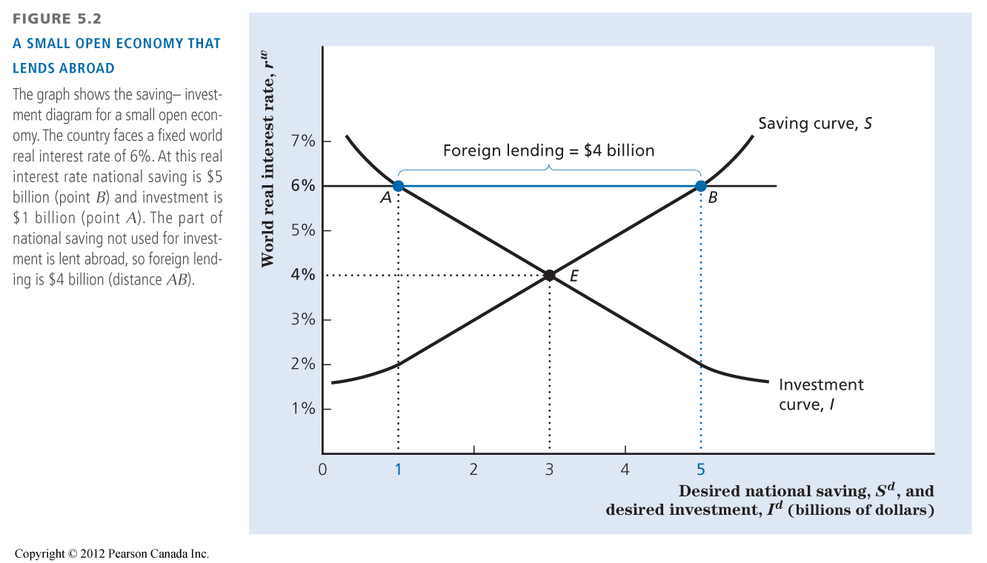
- Fig 5.2 shows a goods market equilibrium in a closed economy.
- In an open economy, desired national saving need not equal desired investment.
- If the small open economy faces a fixed world real interest rate higher than 4%, desired national saving will be greater than desired investment.
- For example, if r^{w} is 6$, desired national saving is $5 billion and desired investment is $1 billion, so desired national saving exceeds desired investment by $4 billion.
- Can the economy be in equilibrium when desired national saving exceeds desired investment by $4 billion?
- In an open economy, the excess $4 billion of saving can be used to buy foreign assets. This capital outflow uses up the excess national saving so that there is no disequilibrium. Instead, the goods market is in equilibrium with desired national saving of $5 billion, desired investment of $1 billion, and net foreign lending of $4 billion.
- For the opposite situation look to page 144 figure 5.3

The Effects of Supply Shocks in a Small Open Economy:
- The saving curve is drawn for given values of current output, Y, expected future output, wealth, government purchases G, and taxes T, all of which are determinants of desired national saving.
- The investment curve is drawn for given levels of the effective tax rate and the expected future marginal product of capital, the determinants of desired national investment.
- Any change that increases desired national saving relative to desired investment at a given world real interest rate will increase net foreign lending, the current account balance, and net exports (which are all equivalent).
- A decline in desired national saving relative to desired investment will reduce those quantities.

Example 1: A Temporary Adverse Supply Shock:
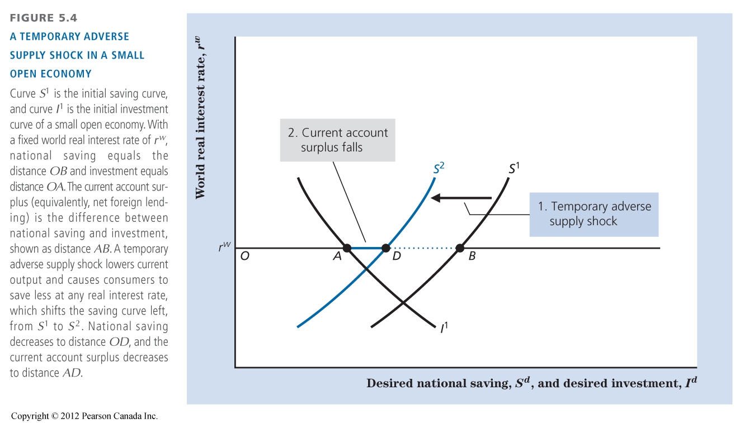
- Suppose that a small open economy is hit with a severe drought that temporarily lowers output. The effects of the drought are shown in Fig 5.4.
- Initial net foreign lending is the distance between AB.
- The drought brings with it a temporary decline in income. A drop in current income causes people to reduce their saving at any prevailing real interest rate, so the saving curve shifts left.
- If the supply shock is temporary, as we assume, the expected future marginal product of capital is unchanged. As a result, desired investment at any real interest rate is unchanged, and the investment curve does not shift.
- In the new equilibrium, net foreign lending and the current account have shrunk to distance AD. The current account shrinks because the country saves less and thus is not able to lend abroad as much as before.
- In this example, we assumed that the country started with a current account surplus, which is reduced by the drought. If instead, the country had begun with a current account deficit, the drough would have made the deficit larger.

Example 2: An Increase in the Expected Future Marginal Product of Capital:
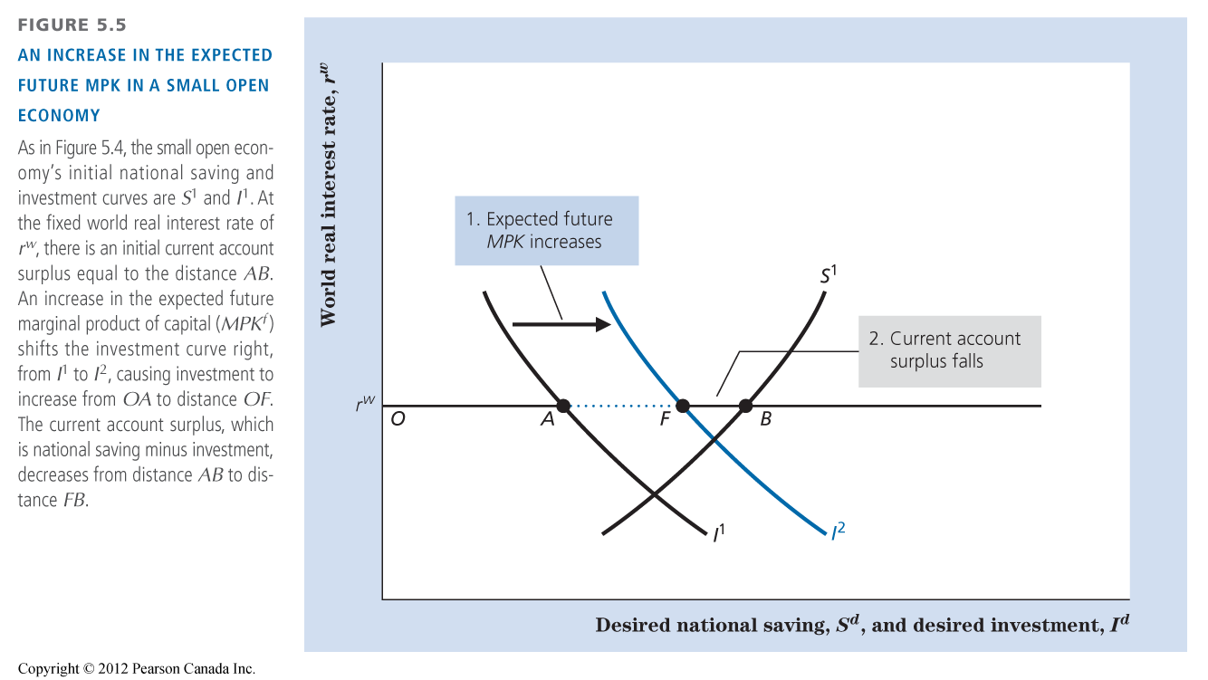
- Suppose that technological innovations increase the expected future marginal product of current capital investments.
- The effects of a small open economy are shown in fig 5.5.
- An increase in MPK^{f} raises the capital stock that domestic firms desire to hold so that desire investment rises at every real interest rate level. The investment curve shifts rightward.
- The current account and net foreign lending shrink to length FB. Why does CA FALL?
- Given that building capital has become more profitable in the home country, more of the country’s output is absorbed by domestic investment, leaving less to send abroad.

A Developing Country and CA Deficit:
- In the early years of development, the capital stock is low, so the MPK^{f} is high and the desired investment is high. Likewise, income is low, so desired saving is low.
- The combination of high desired investment and low desired saving gives a high domestic real interest rate.
- Since the domestic real interest rate is lower than the world real interest rate the capital inflow is high and the CA is in deficit.

Lessons from the Financial Crises:
- Large CA deficits alone do not need to lead to crises.
- The Mexican bailout in 1995 could have created moral hazard among investors. Fiscal expansion might be better to fight a recession after a crisis.
- The policy choices to be made by governments are:
- Control over capital flows and banking system;
- Exchange rate policy.

5.4: Saving and Investment in Large Open Economies:
- We can readily adapt the analysis of the small open economy to the case of a large open economy, that is, an economy large enough to affect the world real interest rate.
- To begin, let’s think of the world as compromising of two large economies: (1) the home or domestic economy, and (2) the foreign economy (representing the economies of the rest of the world combined).

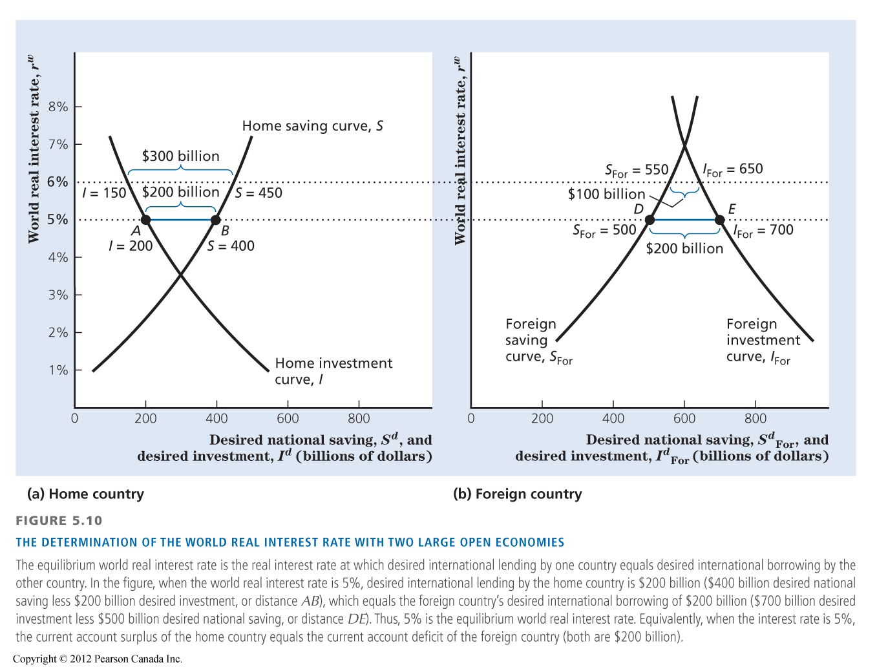
- Figure 5.7(a) shows the saving curve S and the investment curve I of the home economy. Figure 5.7 (b) displays the saving curve S_{For} and the investment curve I_{For} of the foreign economy.
- Instead of taking the world real interest rate as given, we determine the world real interest rate within the model for a large open economy.
- What determines the value of the world real interest rate?
- In the case of two large open economies, the world real interest rate will be such that desired international lending by one country equals desired international borrowing by the other country.
- At this real interest rate, desired world saving equals desired world investment.
- Suppose, that a real world interest rate is 6%. Does this rate result in a goods market equilibrium?
- Fig 5.7(a) shows that at a 6% real interest rate, in the home country, desired national saving is $450 billion and desired investment is $150 billion. Because desired national saving exceeds desired investment by $300 billion, the amount that the home country would like to lend abroad is $300 billion.
- To find how much the foreign country wants to borrow, we turn to fig 5.7(b). When the real interest rate is 6%, desired national saving is $550 billion and desired investment is $650 billion. Thus, at a 6% real interest rate, the foreign country wants to borrow $100 billion.
- Because this amount is less than the $300 billion the home country wants to lend, 6% isn’t the real interest rate that is consistent with equilibrium in the international capital market.
- Try a real interest rate of 5%. Fig 5.7(a) shows that the home country now wants to lend $200 billion. In Fig 5.7(b), with a real interest rate of 5%, the foreign country wants to borrow $200 billion. The satisfying real world interest rate is now known at 5%.
- Equivalently, we can define equilibrium in terms of international flows of goods and services. The amount the lending country desires to lend (distance AB in Fig 5.7(a)) is the same as its current account surplus. The amount the borrowing country wants to borrow (distance DE in Fig 5.7(b)) equals its CA deficit.
- In summary, for a large open economy the equilibrium world real interest rate is the rate at which the desired international lending by one country equals the desired international borrowing of the other country.
- Equivalently, it is the real interest rate at which the lending country’s current account surplus equals the borrowing country’s CA deficit.
- Generally, any factor that increases desired international lending relative to desired international borrowing at the initial world real interest rate causes the world real interest rate to fall.
- A Change that reduces desired international lending relative to desired international borrowing at the initial world real interest rate will cause the world real interest rate to rise.

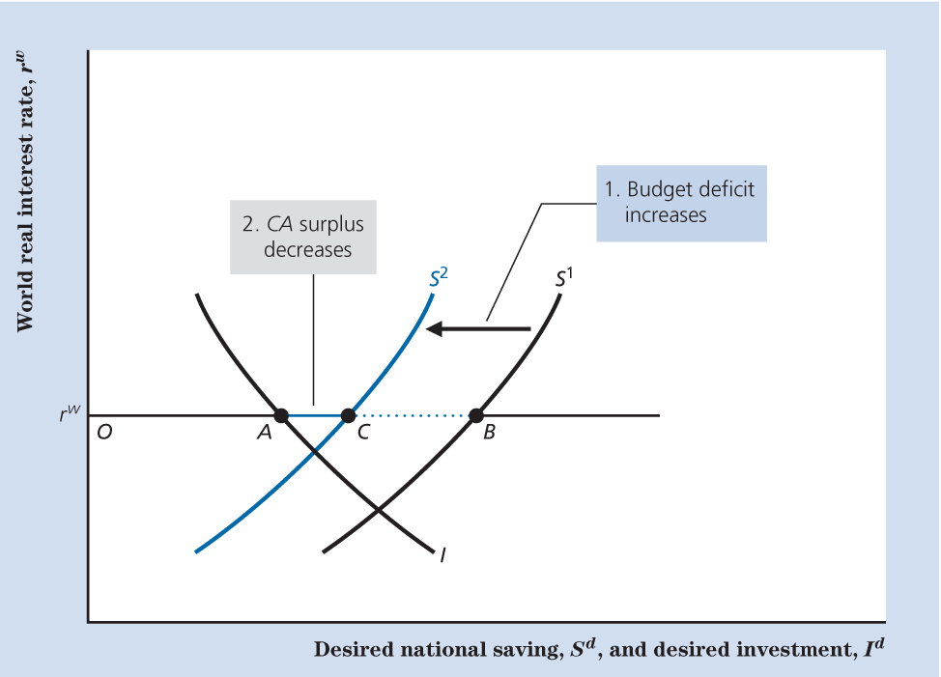
Section 5.5: The Twin Deficits:
- Are the government budget deficit and the current account deficit closely linked? (twin deficit).

The Critical Factor: The Response of National Saving:
- In theory, the issue of whether there is a link between the government budget deficit and the CA deficit revolves around the following proposition: An increase in the government budget deficit will raise the current account deficit only if the increase in the budget deficit reduces desired national saving.
- Fig 5.8 shows the case of the small open economy.
- This figure has been drawn so the country is running a CA surplus, represented by length AB.
- Suppose the government budget deficit rises. Hence, as Fig 5.8 shows, the government deficit increase wil change the current account balance only if it affects desired national saving.
- If it does, the increase in the government deficit shifts the desired national saving curve to the left. The country still has a current account surplus, now equal to distance AC, butit is less than the original surplus AB.
- We conclude that in a small open economy, an increase in the government budget deficit reduces the current account balance by the same amount that it reduces desired national saving.

The Government Budget Deficit and National Saving:
- Let’s now turn to the link between the budget deficit and saving and consider 2 cases: a budget deficit arising from an increase in government purchases, and a deficit arising from a cut in taxes.

A Deficit Cause by Increased Government Purchases:
- Suppose that the source of the government budget deficit is a temporary increase in government purchases, perhaps owing to a war.
- With output, Y, held constant at its full-employment level, an increase in government purchases G, directly reduces desired national saving, S^{d} = Y – C^{d} – G.
- Economists agree that a deficit resulting from increased government purchases reduces the nation’s account balance.

A Deficit Resulting from a Tax Cut:
- With government purchases G, unchanged and with output Y held constant at its full employment level, the tax cut will cause desired national saving, S^{d} = Y – C^{d} – G, to fall only if it causes C^{d} to rise.
- Will a tax cut cause people to consume more?
- Believers in the Ricardian equivalence proposition argue that a lump-sum tax change (with current and future government purchases held constant) will not affect desired consumption or desired national saving. These economists point out with a tax cut, a future tax hike will come.
- Overall, according to this argument, a tax cut does not benefit consumers and, thus, will not increase their desired consumption.
- If for any reason consumers do respond to a tax cut by consuming more, the deficit resulting from a tax cut will reduce national saving, and thus, will also reduce the current account balance.

