PSY Midterm 2 Notes
- Midterm Material:
  - Chapter 12; Stress and Health (pages 488-513)
  - Chapter 14; Personality (pages 571-605)
  - Chapter 15; Psychological Disorders (pages 609- 653)

Emotions are a mix of bodily arousal (heart pounding); expressive behaviours (quickened pace); and conscious experience, including thoughts (“is this a kidnapping?”) and feelings (panic, fear, joy)
Emotion a response of the whole organism, involving (1) physiological arousal, (2) expressive behaviors, and (3) conscious experience.
Insula- a neural center deep inside the brain. The insula is activated when we experience various social emotions, such as lust, pride, and disgust
Catharsis emotional release. In psychology, the catharsis hypothesis maintains that “releasing” aggressive energy (through action or fantasy) relieves aggressive urges.
Feel-Good, Do-Good Phenomenon- people’s tendency to be helpful when already in a good mood
Subjective Well-Being- self-perceived happiness or satisfaction with life. Used along with measures of objective well-being (for example, physical and economic indicators) to evaluate people’s quality of life.
Adaptation-Level Phenomenon- our tendency to form judgments (of sounds, of lights, of income) relative to a neutral level defined by our prior experience.
Relative Deprivation- the perception that one is worse off relative to those with whom one compares oneself.
Health Psychology- a subfield of psychology that provides psychology’s contribution to behavioral medicine.
Stress- the process by which we perceive and respond to certain events, called stressors, that we appraise as threatening or challenging.
Stress Appraisal- the events of our lives flow through a psychological filter. How we appraise an event influences how much stress we experience and how effectively we respond.
3 Types of Stressors: catastrophes, significant life changes, and daily hassles.
General Adaptation Syndrome (GAS)- Selye’s concept of the body’s adaptive response to stress in three phases—alarm, resistance, exhaustion.
Tend and Befriend- under stress, people (especially women) often provide support to others (tend) and bond with and seek support from others (befriend).
Psychophysiological Illness- literally, “mind-body” illness; any stress-related physical illness, such as hypertension and some headaches.
Psychoneuroimmunology- the study of how psychological, neural, and endocrine processes together affect the immune system and resulting health.
Lymphocytes the two types of white blood cells that are part of the body’s immune system: B lymphocytes form in the bone marrow and release antibodies that fight bacterial infections; T lymphocytes form in the thymus and other lymphatic tissue and attack cancer cells, viruses, and foreign substances
Coronary Heart Disease- the clogging of the vessels that nourish the heart muscle; the leading cause of death in many developed countries.
Type A- Friedman and Rosenman’s term for competitive, hard-driving, impatient, verbally aggressive, and anger-prone people.
Type B- Friedman and Rosenman’s term for easygoing, relaxed people.
Coping- alleviating stress using emotional, cognitive, or behavioral methods.
Problem-Focused Coping- attempting to alleviate stress directly—by changing the stressor or the way we interact with that stressor.
Emotion-Focused Coping- attempting to alleviate stress by avoiding or ignoring a stressor and attending to emotional needs related to one’s stress reaction.
Aerobic Exercise- sustained exercise that increases heart and lung fitness; may also alleviate depression and anxiety.
Personality- an individual’s characteristic pattern of thinking, feeling, and acting.
Psychodynamic Theories- view personality with a focus on the unconscious and the importance of childhood experiences.
Free Association- in psychoanalysis, a method of exploring the unconscious in which the person relaxes and says whatever comes to mind, no matter how trivial or embarrassing.
Psychoanalysis- Freud’s theory of personality that attributes thoughts and actions to unconscious motives and conflicts; the techniques used in treating psychological disorders by seeking to expose and interpret unconscious tensions.
Unconscious- according to Freud, a reservoir of mostly unacceptable thoughts, wishes, feelings, and memories. According to contemporary psychologists, information processing of which we are unaware.
Id- a reservoir of unconscious psychic energy that, according to Freud, strives to satisfy basic sexual and aggressive drives. The id operates on the pleasure principle, demanding immediate gratification.
Ego- the largely conscious, “executive” part of personality that, according to Freud, mediates among the demands of the id, superego, and reality. The ego operates on the reality principle, satisfying the id’s desires in ways that will realistically bring pleasure rather than pain.
Superego- the part of personality that, according to Freud, represents internalized ideals and provides standards for judgment (the conscience) and for future aspirations.
Psychosexual Stages- the childhood stages of development (oral, anal, phallic, latency, genital) during which, according to Freud, the id’s pleasure- seeking energies focus on distinct erogenous zones.
Oedipus complex- according to Freud, a boy’s sexual desires toward his mother and feelings of jealousy and hatred for the rival father.
Oral (0–18 months) | Pleasure centers on the mouth—sucking, biting, chewing
Anal (18–36 months) | Pleasure focuses on bowel and bladder elimination; coping with demands for control
Phallic (3–6 years) | Pleasure zone is the genitals; coping with incestuous sexual feelings
Latency (6 to puberty) | A phase of dormant sexual feelings
Genital (puberty on) | Maturation of sexual interests

Identification- the process by which, according to Freud, children incorporate their parents’ values into their developing superegos.
Fixation- according to Freud, a lingering focus of pleasure-seeking energies at an earlier psychosexual stage, in which conflicts were unresolved.
Defense Mechanisms- in psycho-analytic theory, the ego’s protective methods of reducing anxiety by unconsciously distorting reality.
Repression- in psychoanalytic theory, the basic defense mechanism that banishes anxiety-arousing thoughts, feelings, and memories from consciousness.
Collective Unconscious- Carl Jung’s concept of a shared, inherited reservoir of memory traces from our species’ history.
Projective Test- a personality test, such as the Rorschach, that provides ambiguous stimuli designed to trigger projection of one’s inner dynamics.
Rorschach Inkblot Test- the most widely used projective test, a set of 10 inkblots, designed by Hermann Rorschach; seeks to identify people’s inner feelings by analyzing their interpretations of the blots.
Terror-Management Theory- a theory of death-related anxiety; explores people’s emotional and behavioral responses to reminders of their impending death.
Humanistic Theories- view personality with a focus on the potential for healthy personal growth.
Self-Actualization- according to Maslow, one of the ultimate psychological needs that arises after basic physical and psychological needs are met and self-esteem is achieved; the motivation to fulfill one’s potential.
Unconditional Positive Regard- according to Rogers, an attitude of total acceptance toward another person.
Self-Concept- all our thoughts and feelings about ourselves, in answer to the question, “Who am I?”
Trait- a characteristic pattern of behavior or a disposition to feel and act, as assessed by self-report inventories and peer reports.
Factor Analysis- the statistical procedure used to identify clusters of test items that tap basic components of intelligence (such as spatial ability or verbal skill)
Personality Inventory- a questionnaire (often with true-false or agree-disagree items) on which people respond to items designed to gauge a wide range of feelings and behaviors; used to assess selected personality traits.
Minnesota Multiphasic Personality Inventory (MMPI)- the most widely researched and clinically used of all personality tests. Originally developed to identify emotional disorders (still considered its most appropriate use), this test is now used for many other screening purposes.
Empirically Derived Test- a test (such as the MMPI) developed by testing a pool of items and then selecting those that discriminate between groups.
Person-Situation Controversy- we look for genuine personality traits that persist over time and across situations.
The Big Five Factor- (CANOE) Conscientiousness, Agreeableness, Neuroticism, Openness, and Extraversion
Social-Cognitive Perspective- views behavior as influenced by the interaction between people’s traits (including their thinking) and their social context.
Reciprocal Determinism- Bandura’s view on the person-environment interaction “Behavior, internal personal factors, and environmental influences, all operate as interlocking determinants of each other”
Personal Control- the extent to which we perceive control over our environment.
External Locus of Control- the perception that chance or outside forces beyond our personal control determine our fate.
Internal Locus of Control- the perception that you control your own fate.
Self-Control- the ability to control impulses and delay short-term gratification for greater long-term rewards.
Learned Helplessness- the hopelessness and passive resignation an animal or human learns when unable to avoid repeated aversive events.
Positive Psychology- the scientific study of optimal human functioning; aims to discover and promote strengths and virtues that enable individuals and communities to thrive
Self- in contemporary psychology, assumed to be the center of personality, the organizer of our thoughts, feelings, and actions.
Spotlight Effect- overestimating others’ noticing and evaluating our appearance, performance, and blunders (as if we presume a spotlight shines on us).
Self-Esteem- one’s feelings of high or low self-worth.
Self-Serving Bias- a readiness to perceive oneself favorably.
Narcissism- excessive self-love and self-absorption.
Two Dimensions of Emotion- arousal (low versus high) and valence (pleasant versus unpleasant feeling) - James Russell, David Watson, Auke Tellegen, and others
Psychological Disorder- deviant, distressful, and dysfunctional patterns of thoughts, feelings, or behaviors.
Attention-Deficit Hyperactivity Disorder (ADHD)- a psychological disorder marked by the appearance by age 7 of one or more of three key symptoms: extreme inattention, hyperactivity, and impulsivity.
Medical Model- the concept that diseases, in this case psychological disorders, have physical causes that can be diagnosed, treated, and, in most cases, cured, often through treatment in a hospital.
The Biopsychosocial Approach- Negative emotions contribute to physical illness, and physical abnormalities contribute to negative emotions. We are mind embodied and socially embedded.
Biological, psychological, and social-cultural influences combine to produce psychological disorders. This broad perspective helps us understand that our well- being is affected by our genes, brain functioning, inner thoughts and feelings, and the influences of our social and cultural environment
DSM-IV-TR- the American Psychiatric Association’s Diagnostic and Statistical Manual of Mental Disorders, Fourth Edition, with an updated “text revision”; a widely used system for classifying psychological disorders.
Anxiety Disorders- psychological disorders characterized by distressing, persistent anxiety or maladaptive behaviors that reduce anxiety.
Generalized Anxiety Disorder- an anxiety disorder in which a person is continually tense, apprehensive, and in a state of autonomic nervous system arousal.
Panic Disorder- an anxiety disorder marked by unpredictable, minutes-long episodes of intense dread in which a person experiences terror and accompanying chest pain, choking, or other frightening sensations.
Phobia- an anxiety disorder marked by a persistent, irrational fear and avoidance of a specific object, activity, or situation.
Obsessive-compulsive disorder (OCD)- an anxiety disorder characterized by unwanted repetitive thoughts (obsessions) and/or actions (compulsions).
Post-Traumatic Stress Disorder (PTSD)- an anxiety disorder characterized by haunting memories, nightmares, social withdrawal, jumpy anxiety, and/ or insomnia that lingers for four weeks or more after a traumatic experience.
Post-Traumatic Growth- positive psychological changes as a result of struggling with extremely challenging circumstances and life crises.

The Anxiety Learning Perspective
Fear Conditioning- When bad events happen unpredictably and uncontrollably, anxiety often develops
Observational Learning- We may also learn fear through observational learning—by observing others’ fears
Cognition- our interpretations and irrational beliefs also make for anxiety.

Epigenetic Effects- where a genetic vulnerability could be expressed as a result of a long-term trauma such as child abuse

Mood Disorders- psychological disorders characterized by emotional extremes. See major depressive disorder, mania, and bipolar disorder.
Major Depressive Disorder- a mood disorder in which a person experiences, in the absence of drugs or another medical condition, two or more weeks of significantly depressed moods or diminished interest or pleasure in most activities, along with at least four other symptoms.
Mania a mood disorder marked by a hyperactive, wildly optimistic state.
Bipolar Disorder- a mood disorder in which a person alternates between the hopelessness and lethargy of depression and the overexcited state of mania. (Formerly called manic- depressive disorder.)
Schizophrenia- a group of severe disorders characterized by disorganized and delusional thinking, disturbed perceptions, and inappropriate emotions and behaviors.
Psychosis- a psychological disorder in which a person loses contact with reality, experiencing irrational ideas and distorted perceptions.
Delusions- false beliefs, often of persecution or grandeur, that may accompany psychotic disorders.
Dissociative Disorders- disorders in which conscious awareness becomes separated (dissociated) from previous memories, thoughts, and feelings.
Dissociative Identity Disorder (DID)- a rare dissociative disorder in which a person exhibits two or more distinct and alternating personalities. Formerly called multiple personality disorder.
Anorexia Nervosa- an eating disorder in which a person (usually an adolescent female) maintains a starvation diet despite being significantly (15 percent or more) underweight.
Bulimia Nervosa- an eating disorder in which a person alternates binge eating (usually of high-calorie foods) with purging (by vomiting or laxative use), or fasting.
Binge-Eating Disorder- significant binge-eating episodes, followed by distress, disgust, or guilt, but without the compensatory purging or fasting, that marks bulimia nervosa.
Personality Disorders- psychological disorders characterized by inflexible and enduring behavior patterns that impair social functioning.
Avoidant Personality Disorder- a fearful sensitivity to rejection
Schizoid Personality Disorder- eccentric or odd behaviors, such as emotionless disengagement
Histrionic Personality Disorder- dramatic or impulsive behaviors
Narcissistic Personality Disorder- self-focused and self-inflating
Antisocial Personality Disorder- a personality disorder in which a person (usually a man) exhibits a lack of conscience for wrongdoing, even toward friends and family members. May be aggressive and ruthless or a clever con artist.

Maslow’s Hierarchy of Needs
- Physiological
- Safety/Security
- Love/Belonging
- Self-Esteem
- Self-Actualization-the process of fulfilling our potential) and self-transcendence (meaning, purpose, and communion beyond the self).

A Growth-Promoting Climate Requires 3 Conditions (Carl Rogers-1980):
- Genuineness
- Acceptance
- Empathy

6 Defense Mechanisms
- Regression- Retreating to a more infantile psychosexual stage, where some psychic energy remains fixated (ex. A little boy reverts to the oral comfort of thumb sucking in the car on the way to his first day of school)

- Reaction Formation- Switching unacceptable impulses into their opposites (ex. Repressing angry feelings, a person displays exaggerated friendliness).

- Projection- Disguising one’s own threatening impulses by attributing them to others

- Rationalization- Offering self-justifying explanations in place of the real, more threatening unconscious reasons for one’s actions.

- Displacement- Shifting sexual or aggressive impulses toward a more acceptable or less threatening object or person (ex. A little girl kicks the family dog after her mother sends her to her room)

- Denial- Refusing to believe or even perceive painful realities.

Emotion Theories
James-Lange theory- arousal comes before emotion
- We observe our heart racing after a threat and then feel afraid
- ex. My feeling of fear followed my body’s response

Cannon-Bard theory- arousal and emotion occur simultaneously
- Our bodily responses and experienced emotions occur separately but simultaneous
- ex. Our heart races as we experience fear

Two Factor Theory- Arousal fuels emotion; cognition channels it.
- The Schachter- Singer theory that to experience emotion one must have two ingredients: physical arousal and cognitive appraisal

Cortex- analysis and then transmission
Amygdala- instant emotional reaction

The brain’s pathways for emotions:
- In the two-track brain, sensory input may be routed to the
  - Cortex (via the thalamus) for analysis and then transmission to the amygdala
OR
  - Directly to the amygdala (via the thalamus) for an instant emotional reaction.
- The amygdala sends more neural projections up to the cortex than it receives back, which makes it easier for our feelings to hijack our thinking than for our thinking to rule our feelings
- Our brains process vast amounts of information without our conscious awareness, and some emotional responses do not require conscious thinking. Much of our emotional life operates via the automatic, speedy low road.
- The autonomic nervous system arouses the body in a crisis and calms it when danger passes. Elated excitement and panicky fear involve similar physiological arousal. That allows us to flip rapidly between the two emotions.
- When you experience negative emotions such as disgust, your right prefrontal cortex tends to be more active than the left. Depression-prone people, and those with generally negative personalities, also show more right frontal activity. Positive moods tend to trigger more left frontal lobe activity.

Personality Theories
Psychoanalytic- Emotional disorders spring from unconscious dynamics, such as unresolved sexual and other childhood conflicts, and fixation at various developmental stages. Defense mechanisms fend off anxiety (Freud) - Free association, projective tests, dream analysis

Psychodynamic- The unconscious and conscious minds interact. Childhood experiences and defense mechanisms are important (Adler, Horney, Jung)- Projective tests, therapy sessions

Humanistic- Rather than examining the struggles of sick people, it’s better to focus on the ways healthy people strive for self- realization (Rogers, Maslow) - Questionnaires, therapy sessions

Trait- We have certain stable and enduring characteristics, influenced by genetic predispositions (Allport, Eysenck, McCrae, Costa) - Personality inventories (ONLY ONE)

Social-Cognitive- Our traits and the social context interact to produce our behaviors (Bandura) - Considering our past behavior in similar situations

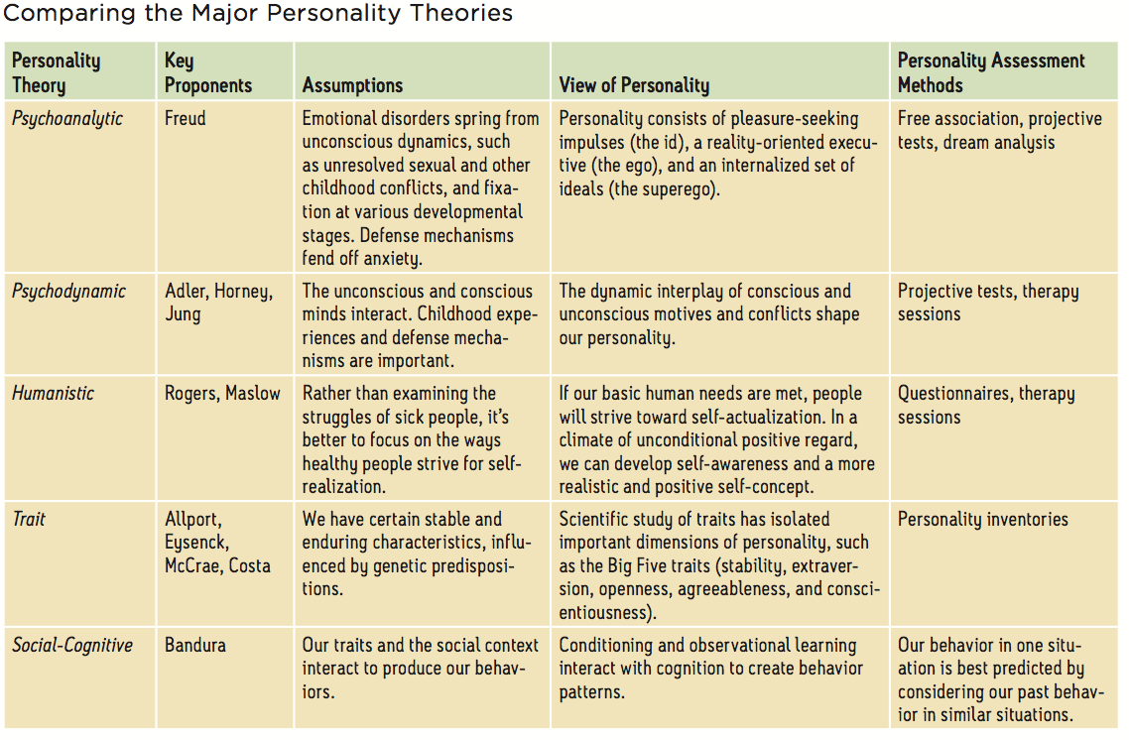

Brain Abnormalities in Patients with Schizophrenia
Dopamine Over-Activity- Researchers discovered one such key when they examined schizophrenia patients’ brains after death and found an excess of receptors for dopamine
Abnormal Brain Activity and Anatomy- Modern brain-scanning techniques reveal that many people with chronic schizophrenia have abnormal activity in multiple brain areas
Maternal Virus During Mid-pregnancy- Consider another possible culprit: a mid- pregnancy viral infection that impairs fetal brain development

Subtypes of Schizophrenia
Paranoid- Preoccupation with delusions or hallucinations, often with themes of persecution or grandiosity
Disorganized- Disorganized speech or behavior, or flat or inappropriate emotion
Catatonic- Immobility (or excessive, purposeless movement), extreme negativism, and/ or parrot-like repeating of another’s speech or movements
Undifferentiated- Many and varied symptoms
Residual- Withdrawal, after hallucinations and delusions have disappeared

