Psychology Midterm 1 Notes

By: Patrick Gleason

Content: Pages 1-13 from chapter 1, chapter 2, chapter 3, and appendix B

Chapter 1

Psychology – the study of mental processes and behaviour

Mental processes:
- The activities of our brain
- Include:
  - Thinking
  - Observing the environment
  - Using language
- In psychology’s early history, mental processes were explored through the observation of external behaviour
- Behaviour:
  - External
  - Observable activities of an organism, often in response to environmental cues

Psychologists study mental processes and behaviour with one of 4 goals in mind:
- Description
- Explanation
- Prediction
- Control
- DEPC

3 levels of analysis in psychology:
- The brain – how mental processes work (how brain structure and brain cell activity differ from person to person and situation to situation)
- The individual – how mental processes affect behaviour
- The group – how behaviour is affected by social and cultural environments (culture: a set of shared beliefs and practices)

Psychology’s roots in philosophy:
- For thousands of years philosophy and physiology scholars have studied questions about the mind
- Until 1878 psychology was not scientific (same as philosophy)
- Mythology
- What’s the connection between the mind and the body?
- Hippocrates (ca. 460-377 BCE):
  - Health is influenced by excess or a lock of bodily humours
  - 4 fluid bodily humours in total
Psychology’s roots in and physiology psychophysics:
- In the 1600s modern science began to thrive
- Rene Descartes (1593-1650):
  - Believed the natural world could be studied through science
  - The mind and the body are separate (the mind lives on after death)

The early days of psychology:
- Wilhelm Wundt (1832-1920):
  - In 1879 opened a laboratory in Germany for psychology for experiments
  - Father of experimental psychology
  - Consciousness – personal awareness of mental processes, behaviours, and environmental events
  - Voluntarism – explains that a lot of human behaviour is motivated and that attention is focused for explicit purposes
- Charles Darwin (1809-1882):
  - Natural selection
  - The origin of species
  - Shifted his attention towards human behaviour
- Edward Titchener (1867-1927):
  - Structuralism – the structure of conscious experience, identify all the elements of consciousness (e.g. sensation or feelings)
  - Relied on introspection:
    - How simple thoughts expand into complex ideas
    - Had problems including diverse findings
  - Only observed and described, but didn’t explain, predict, or control
- William James (1842-1910):
  - Functionalism – how mental processes function to adapt to the changing environment (used empirical methods)
  - Wrote “Principles of Psychology”
  - Mental processes are a fluid “stream of consciousness”, not fixed elements
  - Studied animals, children, and individuals with mental disorders
- Gestalt psychology:
  - Consciousness cannot be broken down into elements
  - The whole is more important than its parts
  - We perceive things as whole units
  - Learning is tied to what we perceive

Chapter 2

Scientific principles:
- The universe operates according to laws
- These laws are discoverable and testable (empirically – of the senses)

The scientific attitude:
- Curiosity – passion for exploration
- Skepticism – doubting and questioning
- Humility – humbleness to accept when wrong
- Use critical thinking

Deductive reasoning:
- Reasoning from broad basic principle applied to specific situations
- Theory > predictions > observations/experiments
- Bias since you want your theory to be true

Inductive reasoning:
- Reasoning from small specific situations to more general truths
- Observation/experiments > predictions > theory
- Avoids bias

Hypothetico-deductive reasoning:
- More common nowadays as it takes the best of both deductive and inductive reasoning
- Starts with a hypothesis – a general statement about how variables relate that can be proven wrong
- Observational definitions – used to describe what is meant by each variable (used in hypotheses)
- Hypothesis >observation/experiments > hypothesis is supported or not

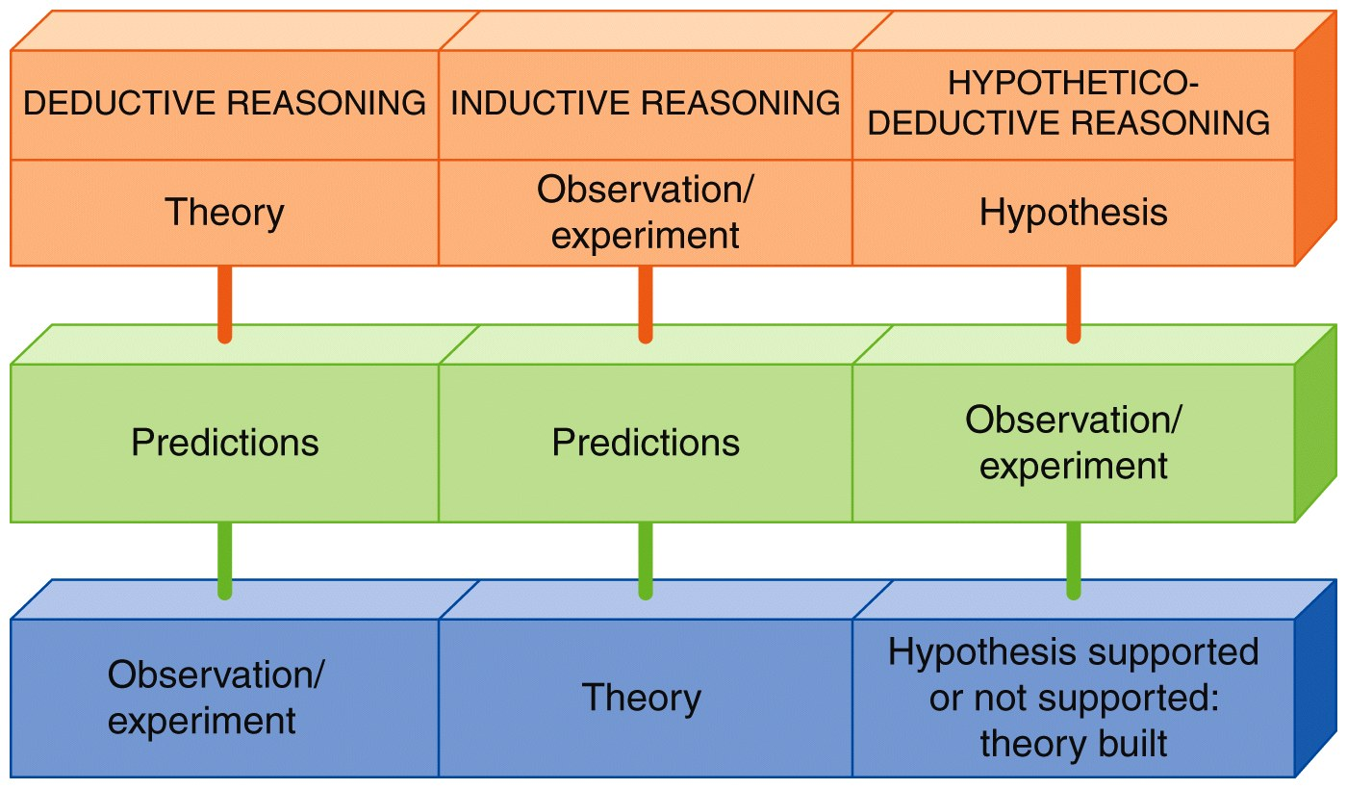
Scientific approach:
- Observe
- Develop a hypothesis
- Test the hypothesis
- Build a theory

Goals of psychology:
- Find factors that affect behaviour (observable)
- Isolate the affect of each factor
- Find how the relate and come together
- Pseudopyschology – doesn’t use the scientific method, based on certain beliefs (e.g. religion or morals)

How do psychologists conduct research?
- Find two variable – one independent and one dependant
- Operationalize the 2 variables – give them precise definitions that allow you to measure and test them (can be done in many ways)

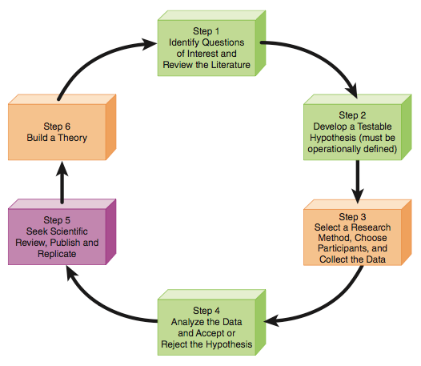

Choosing participants:
- You often have to pick a sample – a subset of the population
- Use random selection (everyone in the population has an equal chance) to minimize sampling bias

Pick a research method:
- Differ in their goals, samples, and the ability of researchers to generalize their results
- Descriptive research – allow researchers to demonstrate the relationship between two variables, without specifying a casual relationship
  - Case studies:
    - A study focusing on a single person
    - Researcher bias
  - Naturalistic observation:
    - A study in which people are observed as they behave normally
    - Also subject to researcher bias (can be fixed with multiple observers)
    - Hawthorne effect – people who are being observed will “improve” their behaviour
  - Surveys:
    - A study in which researchers give participants a questionnaire or interview them
    - Allows researchers to obtain previously unattainable information
    - Can see how strong a relationship is
    - Participant bias
    - Can’t tell the direction of the relationship (e.g. video games > violence or violence > video games?)
- Experimental research – allow researchers to explain causes of behaviour
  - Controlled observation in which researchers manipulate the independent variable and see how the dependant variable is affected
  - Experimental group – exposed to the independent variable
  - Control group – not exposed (avoid placebo effect, comparison)
  - Groups should be created using random assignment
  - Demand characteristic – changes participants behaviour
  - To avoid bias use the double-blind procedure where neither the participants or researchers know what treatment or procedure the participants are receiving
  - Variations:
    - Manipulate more than one independent variable – allows for study of interactions between variables
    - Use more than one dependent variable – obtains a more complete picture of effect of the independent variable

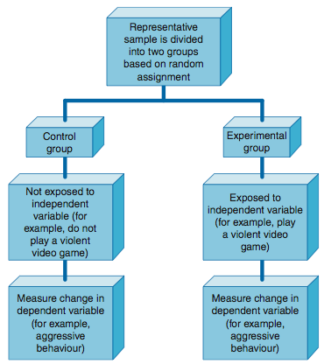

Descriptive |  | Experimental
Observe, collect, and record data | Describe | Identify cause and affect | Explain
Pros:  - Good for developing early ideas  - More reflective of actual behaviour  - Easier | Cons:  - No or little control over variables  - Bias  - No explanation of cause and effect | Pros:  - Control over variables  - Can explain cause and affect | Cons:  - Ethical concerns  - Practical limits  - Artificiality of lab conditions  - Bias  - Confounding variables (common cause)

How do psychologists make sense of research results?
- Correlation – predictable relationship between two variables (not causation)
- Correlation coefficient – statistic illustrating the strength and nature of a relationship (from -1 to +1, 1 = strong relationship, 0 = no relationship)
- Positive correlation – variables increase together
- Negative correlation – as one increases, the other decreases
- Perfect correlation – exactly related (absolute value of the coefficient is 1)
- Illusory correlation – the perception of a relationship where none exists, people focus selectively on confirmatory evidence (e.g. adoption and conception)
- Mean – the average
- Standard deviation – a measure of the variance of a set of data
- Replication – repeated testing of a hypothesis to ensure that the results aren’t due to chance

Ethical guidelines in research:
- Research ethics board (REB) – a oversight group that evaluates research to protect participants
- Informed consent – researchers must give as much information about the purpose, procedure, risks and benefits
- Debriefing – provide full information to participants after they’ve finished participating
- Confidential and voluntary
- No deception or incomplete disclosure
- Canadian council on animal care – minimize pain, number of animals, etc.

Appendix B

2 main types of statistics:
- Descriptive – used to organize and summarize data to provide some sort of overview
- Inferential – use the laws of probability to allow researchers to interpret data and draw conclusions

Frequency distributions:
- An organized tabulation showing the number of individuals in each category on the scale of measurement
- Shows the categories and the frequency
- Ungrouped frequency distribution – frequencies correspond to one value on the scale
- Grouped frequency distribution – frequencies correspond values within given ranges (individual scores cannot be retrieved, the greater the intervals the more information that is lost)
- Categories in left column, frequencies on the right
- The sum of all the frequencies is N

Histograms:
- Represent all scores on the x-axis (from minimum to maximum)
- Include scores with a frequency of zero
- Frequency on the y-axis

Polygons:
- Same as a histogram but use dots, and connect with a line
- Close the polygon by connecting the line at either side to y = 0
- Created by connecting the midpoints of each class of data

Measures of central tendency (descriptive statistics):
- Numbers used to summarize a data set
- Mean – average number (can be misleading due to outliers)
- Median – middle number
- Mode – more frequent number
- All measures equal when the distribution is symmetric (or a normal distribution/bell curve), but not when skewed (positively or negatively)

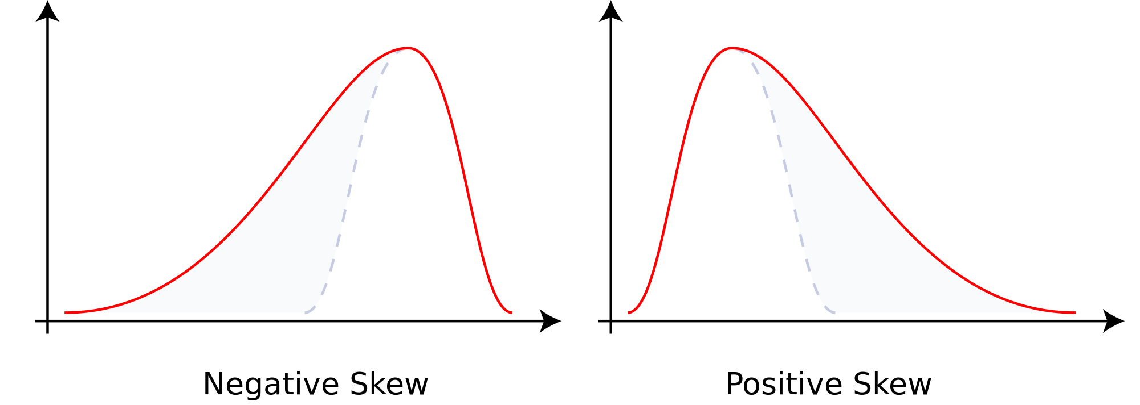
Measures of association – descriptive statistics that quantify the degree of the relationship or association between two variables

Scatterplot – a graph that shows the values of one variable associated with the values of another variable

Positive/direct relationship – both increase/decrease together
Negative/inverse relationship – as one increases, the other decreases

Pearson product-moment correlation coefficient (r) – statistic that quantifies the association or relationship between two variables (from -1 to 1)

Coefficient of determination (r²) – the degree to which a value of one variable can be predicated based off its correlations with another (e.g. r=0.80, r²=0.64 or with 64% accuracy r is true)

Measures of variability:
- Range – distance covered by the scores in a data set (based only on 2 scores, therefore, imprecise and unreliable)
- Standard deviation:
  - The average distance from the mean
  - Describe how close or clustered the data set it
  - Calculations differ between populations and samples
- Normal distribution:
  - Often found in psychological tests
  - How many human characteristics are distributed in populations
  - System used to compare people
  - The scores under the normal distribution are dispersed in a fixed pattern:
    - The standard deviation serves as the unit of measurement (about 68% of scores fall within 1 SD from the mean)
    - Therefore, if you know the mean and standard deviation of a distribution, you can make comparisons
  - Test scores can be converted to percentile scores for ease of interpretation
    - A percentile score indicates the percentage of people who score at or below the score you obtained

The Wechsler IQ test:
- 68% fall within 1 SD
- Only 4% are 2 or more SDs away

Inferential statistics:
- To interpret data and draw conclusions
- Population vs. sample due to practicality (ideally use random sampling)
- Hypothesis testing – testing a claim about a population using a sample (looking at experiment and control group differences)
- Null hypothesis (H₀) – assuming that there is no difference between the experimental and the control group in the population
- Alternative hypothesis (H₁) – assuming there is a difference (claim you’re testing)
- Sampling distribution – the distribution of a sample statistic (e.g. the difference between two sample means)
- When you reject the null hypothesis you have evidence that supports the alternative hypothesis, but you haven’t proved it
- Significance level or rejection level – the level of risk of making an incorrect conclusion (p < 0.05 or p < 0.01)
  - Expect to get this example 5 out of 100 times
  - Higher the level, the less significance
- Effect size – a standardized measure that shows the degree of the relationship or the size of the difference between two or more variables (strength of the effect)
  - Often use r (the correlation coefficient)
  - Sometimes use Cohen’s d, which is a standardized measure of the difference between sample means

Chapter 3

Neuroscience – the study of the brain and the nervous system

How do scientists study the nervous system?
- Examining autopsy tissue
- Testing the behaviour of patients with damage to certain parts of the brain:
  - Damage to a certain area
  - Loss of a certain function
  - Suggests that the affected area performed that specific function
- Recording brain activity by attaching electrodes to the scalp:
  - EEG – Not as detailed, more general, detect and localize electrical activity in the brain
  - ERP – shows when and where in the brain
- Animal studies:
  - Lesioning – damaging a part of the brain and observing the effect
  - TMS – sending a pulse to a part of the brain to disrupt its function

Neuroimaging – visual imaging in awake humans of brain processes and structure
- CT/CAT scan (computerized axial tomography) – Clear and 2D, but better at detecting problems in certain areas
- MRI and fMRI – structure of brain/abnormalities, clearer 3D images (fMRI detects oxygen)
- EEG – recording of electrical waves
- DTI scan – diffusion tensor imaging, analyzes white matter
- PET scan – radioactive form of glucose injected into brain that shows brain activity

Chronic traumatic encephalopathy (CTE):
- “Mild” brain injury
- Death of neurons
- Build-up of protein called tau
- Blind areas of the brain associated with memory, learning, and emotion
- Form repetitive head injuries (e.g. in athletes form sports)
- Not all athletes with injuries get CTE so the cause is unclear
- Led to new rules in many sports to avoid head injuries in the future

How does the nervous system work?
- Neuron:
  - A nerve cell
  - Work together in groups called networks
  - Sensory – gather information
  - Motor – communicate the information to muscles using chemical and electrical signals
  - Interneuron – carries information between neurons in the brain and the spinal cord
  - Glia:
    - The cells that, in addition to neurons, make up the nervous system
    - Buffer neurons from the rest of the body
    - Control nutrient suppler
    - Destroy and remove bad neurons
    - Provide myelin sheath for axon (oligodendroglia)
    - Modulate neurotransmitters (chemical messengers, e.g. serotonin which regulates mood)
    - E.g. astroglia – blood-brain barrier
  - Parts:
    - Cell body – life support
    - Dendrites – receive
    - Axon – carry
    - Myelin sheath – protects axon and speeds up the process
    - Terminal branches/axon terminal – end of axon that form junctions with other cells and release neurotransmitters
    - Terminal button – end of axon, secrete neurotransmitters
    - Nodes of Ranvier – bare parts of the axon not covered by myelin (action potentials jump from node to node)
    - Neurotransmitter receptors – bind to neurotransmitters
  - Synapse – point at which neurons interconnect (very small gap)
  - Synaptic vesicles – where neurotransmitters are stored in the axon terminals

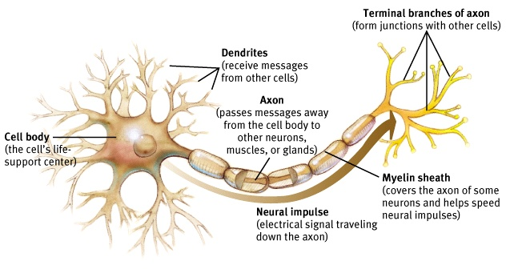
How do neurons work?
- Basic cells in the central nervous system (CNS)
- The action potential:
  - Ions are atoms and molecules with an imbalance of protons and electrons
  - Difference in the positive/negative ratio between the ions in the intracellular fluid (cytoplasm) and the extracellular fluid
  - Membrane potential – difference in charge along the neuron membrane
  - Polarized – a neuron in it’s normal state (relatively negative)
  - Resting potential – electrical charge when a neuron is at rest
  - Concentration gradient – difference in concentration of sodium
  - Ion channels – pores that open up in the membrane to allow certain ions to go in and out (negative ions get trapped inside
  - Sodium-potassium pump – push sodium (Na) in and potassium out (K)
  - Action potential:
    - Neuron fires pores
    - More positive for a short amount of time
    - Triggers axon terminals to release neurotransmitters
  - Threshold of excitation – the relative effect of other neurons causes another neuron to reach action potential
  - Depolarization – inside becomes less negative
  - Hyperpolarization – inside becomes more negative
  - Absolute refractory period – after action potential the neuron can’t fire again for a brief period
  - Relative refractory period – right after the absolute refractory period where a neuron can only reach action potential if it receives a stimulus higher than its usual threshold
  - All-or-none principle – a neuron is either ready to reach action potential or can’t at all (refractory period)
  - Postsynaptic potentials – electrical events that occur in postsynaptic neurons

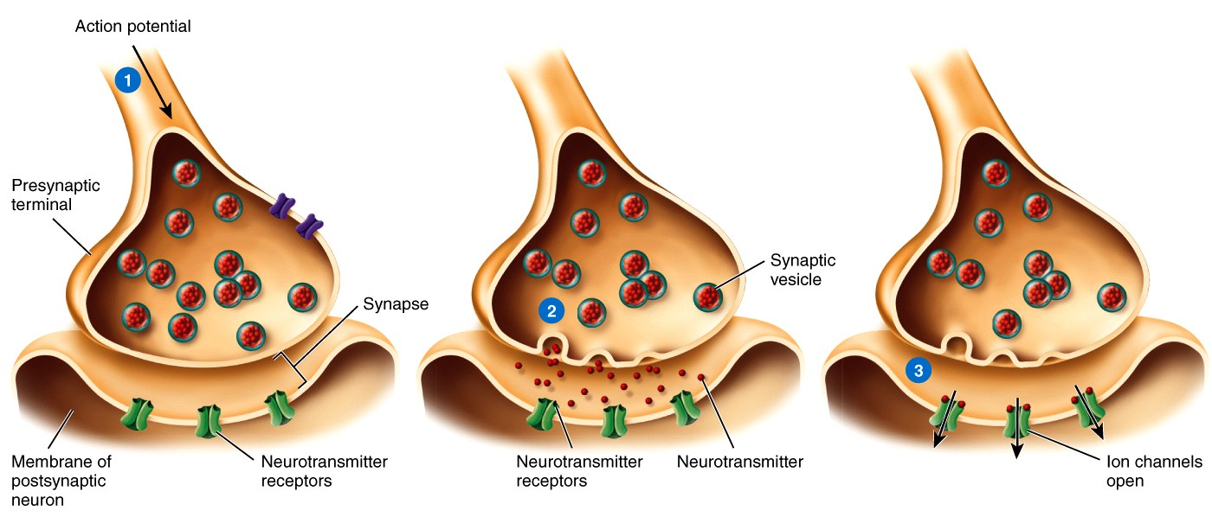
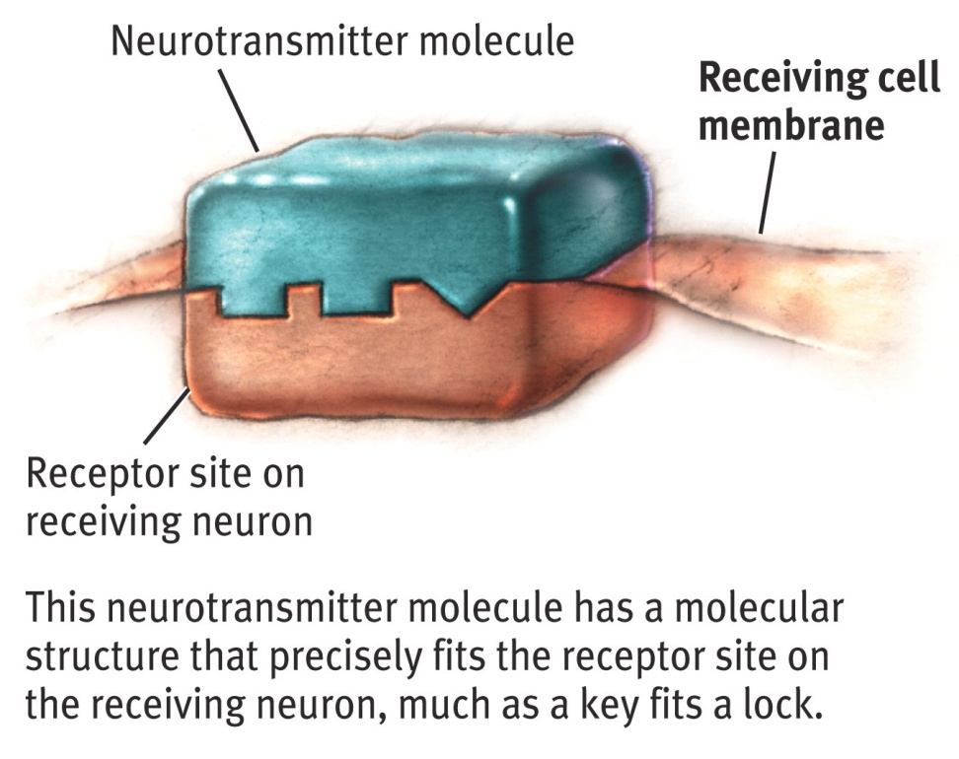

Neurotransmitters and their functions:
- Glutamate – learning and movement
- GABA – anxiety
- Acetylcholine – learning and attention
- Dopamine – movement and reward learning
- Serotonin – mood
- Norepinephrine – attention

Neural networks:
- Stem cells – can become anything including neurons
- Neurons form neural circuits/networks
- Neuroplasticity – the ability to create new neural pathways as a result of experience or after and injury
  - Occurs in the olfactory bulb, hippocampus, cerebellum and the prefrontal cortex
- Synaptic plasticity – plasticity at the synapse from repeated release of neurotransmitters

How is the nervous system organized?
- Afferent neurons – body to CNS
- Efferent neurons – CNS to the PNS, muscles, and glands
- Interneurons – relay between different types of neurons

The peripheral nervous system (PNS):
- Somatic nervous system – peripheral nerves that transmit information about sensation and movement to and form the CNS
- Autonomic nervous system – part of the peripheral nervous system
  - Sympathetic nervous system – under stress, flight or fight
  - Parasympathetic nervous system – during restful times

The central nervous system (CNS):
- Spinal cord – extends form the base of the brain, sensory and motor information (when injured causes paralysis)

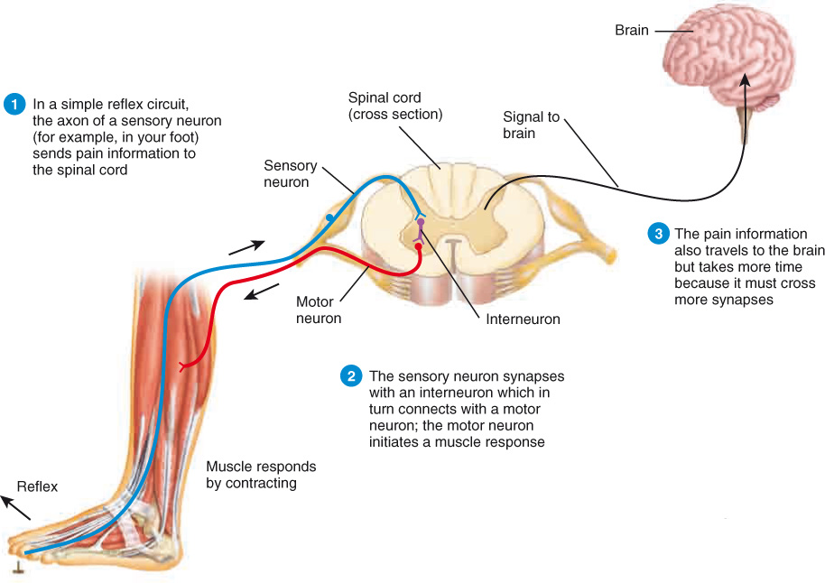

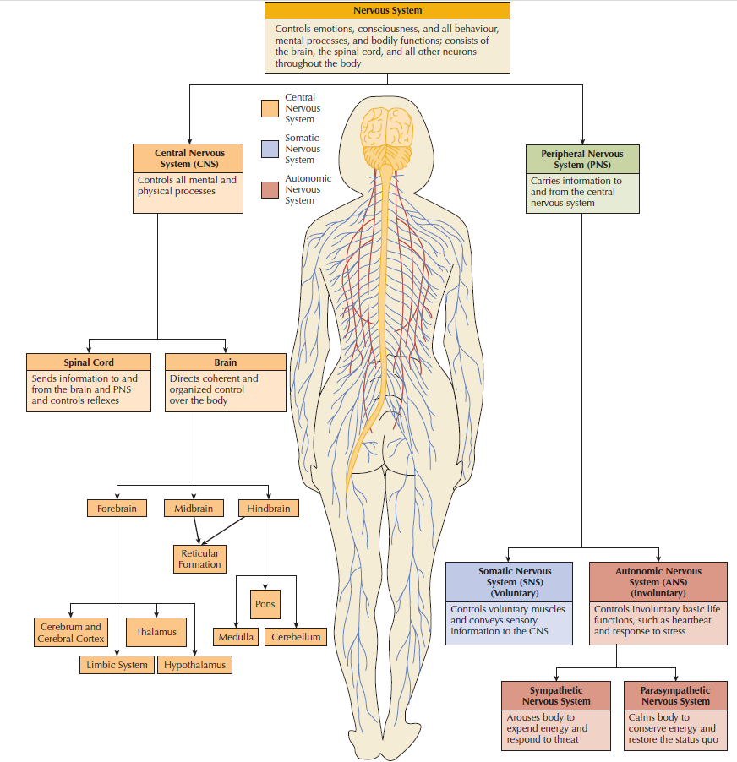
Structures of the brain:
- Hindbrain:
  - Closest to the spinal cord
  - Basic bodily functions
  - Medulla:
    - Basic bodily processes (heartbeat, breathing, sneezing, coughing, etc.), certain reflexes
  - The pons:
    - Above the medulla
    - Contains the locus coeruleus (has the neurotransmitter norepinephrine which is important for arousal and attention)
    - Signals to and from the forebrain and the cerebellum
  - The cerebellum:
    - Back of the head
    - Motor coordination
  - Reticular formation:
    - Complex neural network
    - From the hindbrain into the midbrain
    - Arousal and consciousness
    - Sleep/wake cycle
- Midbrain:
  - Substantia nigra – the nucleus from which dopamine neurons send their axons to the striatum (damaged in Parkinson’s)
  - Dopamine – movement and reward mechanisms
- Forebrain:
  - Largest subdivision of the brain
  - Complex cognitive, sensory, emotional, and motor functions
  - Two hemispheres:
    - Each side of the brain controls the opposite side of the body (contralateral)
    - Divided by the corpus callosum
  - Thalamus:
    - Relay station for incoming sensory information
  - Hypothalamus:
    - Important for motivation and control of the endocrine system (hormone levels)
  - The pituitary gland:
    - Central role in controlling the endocrine system
  - The limbic system:
    - Group of interconnected structures
    - Learning, memory, emotions, and drives
    - Amygdala – emotions particularly fear
    - Hippocampus – learning and memory
  - The basal ganglia:
    - Striatum – learning and memory, doesn’t require conscious awareness
    - Plays a role in aspects of cognition and in regulating and coordinating voluntary movement
Nucleus accumbens – motivation and reward
  - Cerebral cortex:
    - Largest portion of the brain
    - Language and thought
    - Two categories:
      - Primary sensory and/or motor areas
      - Association cortex – high-order sensory processing, thinking, and planning
- Occipital lobe – visual processing
- Temporal lobe – speech recognition and visual stimuli:
  - Wernicke’s area – understanding language
- Parietal lobe – touch and information about locations
  - Somatosensory strip – tactile information form body parts
- Frontal lobe – movement and speech production:
  - Broca’s area – speech production
  - Prefrontal lobe – memory, moral reasoning, and planning
- Occipital lobe – visual processing
- Areas of the neocortex:
  - Sensory (touch) - parietal
  - Motor (muscles) – frontal lobe
  - Association – frontal lobe
- The Homunculus:

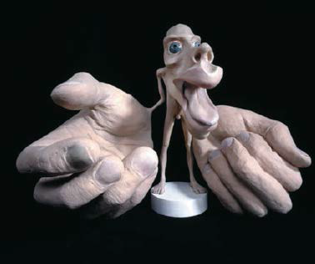

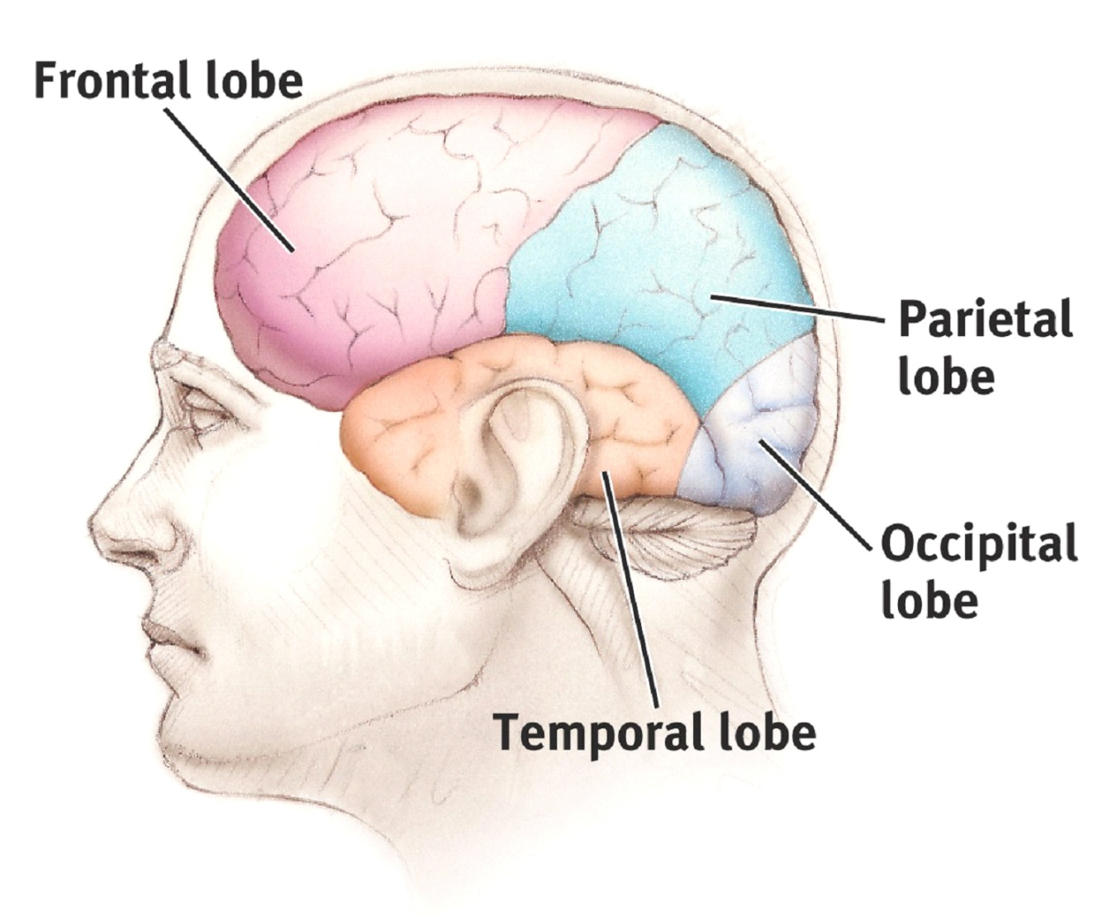
Brain side and brain size:
- Parallel processing - he ability of the brain to simultaneously process incoming stimuli of differing quality
- Corpus callosum – bundle of axons that allows communication from one side of the cortex to the other
- Hemispheres – two sides of the brain
- Brain lateralization:
  - Language centres in most right handed people are on the left side of the brain
  - But, in dome left hand people language centres are on the right or both sides

Helmuth Buxman:
- Had a stroke
- Changed behaviour and murdered his wife

Phineas Gage:
- Rod damaged his prefrontal cortex
- He survived and could talk and walk
- Became very impatient and impulsive
- Lost his job

Evolutionary psychology:
- How the process of evolution has shaped our body and brain due to the interaction of our genes and the environment to produce thoughts and behaviours
- Phylogeny – the development of unique species over time
- Convergent evolution – the development of similar physical similar characteristics in species that don’t share a common ancestor due to similar environmental conditions
- Homologous traits – same structure, but not necessarily the same function
- Analogous traits – same function, different origin
- Charles Darwin:
  - Evolution by natural selection – the differential likelihood between members of a species in their ability to survive and reproduce
  - Fitness – ability to grow old enough to reproduce good offspring
  - Wrote the book “On the Origin of Species”

Evolution of the brain:
- The Australopithecus skull is about 1/3 of the size of a present day human skull
- It has a smaller frontal area which makes it likely that the frontal cortex was smaller back then

Evolution of behaviour:
- Mate choice:
  - Female peacocks prefer males with elaborate tails with many eyes
  - Males prefer younger women (more likely to produce viable offspring)
  - Females prefer males who assist them with raising their young
- Parental investment:
  - In order for offspring to survive and reproduce parents must spend an enormous amount of time caring for their young

Environmental factors that affect intelligence:
- Exposure to toxins (e.g. tobacco, alcohol, infections, pollutants, lead, etc.)
- Malnutrition

Epigenetics:
- The study of heritable changes in gene expression (active versus inactive genes)
- Doesn’t involve changes to the underlying DNA sequence
- A change in phenotype without a change in genotype

Etiology (the cause) of ADHD:
- Smoking
- Alcohol
- Dopamine differences
- Maternal stress
- Low birth weight
- Lead

Failure to thrive syndrome:
- Children who aren’t given affection won’t grow normally
- Some even die despite good health
- Don’t reach developmental milestones at the usual age

Reactive attachment disorder (RAD):
- Inability to form normal relationships
- Impaired social development
- Aggressive
- Sociopathic behaviours
- Caused by disruption in attachment from 6 months to 3 years of age

