Chapter 1 – Managerial Accounting and the Business Environment

..
Managerial Accounting
- Provides information to managers.
- Determine and develop internal accounting information as tools to help managers make business decisions while monitoring costs and improving efficiencies.
- They focus on the future/ what they find is relevant.
- Internal reports aren’t mandatory nor restricted.
- Reports are prepared as needed, usually to investigate problems.
  - Some reports compare actual results to plans focusing on how managers or divisions have performed.
  - Other reports provide timely updates on key indicators; orders received, capacity utilization, customer satisfaction and sales.

Financial Accounting
- Provides information to shareholders, creditors, and lenders (outside the company).
- Prepare specific quarterly and annual financial statements.
- Follows the Generally Accepted Accounting Principles (GAAP) and government regulations.
- Information must be delivered in a timely manner and must be precise.

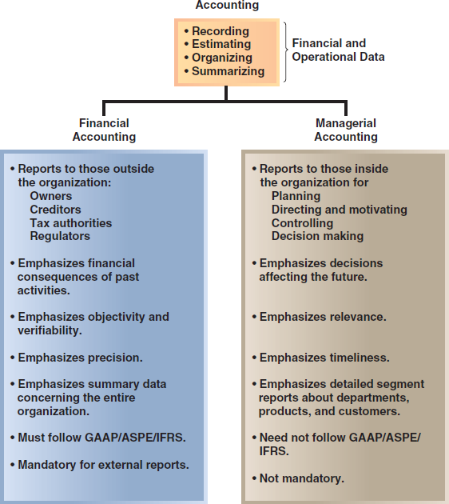
Comparing Financial and Managerial Accounting

1. Users

2. Time focus
3. Verifiability vs. Relevance
4. Precision vs. Timeliness
5. Subject
6. Rules
7. Requirement

Planning
- Manager establishes goals and specifies how to achieve them (Identify alternatives).
- List of objectives in order to reach the goal (Select alternative that does the best job of reaching the organization’s objectives).
- Accompanied by a budget (develop budgets to guide the progress toward the selected alternative).
- Budget – Detailed plan for the future that is expressed in formal quantitative terms. Prepared annually under the direction of the controller.
- Controller – Manager in charge of the accounting department.
- Plans may include a budget-controller.

Directing and Motivating
- Managers monitor day operations that keep the company running smoothly.
- Focus on getting employees to get their work done.
- Used in daily sales reports.
- Employee work assignments, routine problem solving, conflict resolution, and effective communication.

Controlling
- Gathering, evaluating and responding to feedback to ensure process meets expectations.
- Involves answering the following questions:
  - Did we succeed?
  - Is our method working?
  - Did we stay within our budget?
- Feedback is the in the form of performance reports are an essential part of the control function.
- Performance Reports – Detailed reports prepared on a periodic basis that compare budgeted data to actual data, in order to learn from them and improve performance, and to help evaluate and reward employees.
- Management reports show whether a company is in control based on predicted and actual sales.
- A company is in control when they meet their budgets.
- Management by Exception – Managers don’t need to see a report because they’re aware when everything is under control, they only look at the report in order to fix what is out of control.

Decision Making
- Most basic managerial skill is the ability to make intelligent, data driven decisions.
- Making calculated decisions based on how the planning, directing and controlling went.
- Revolve around 3 questions:
  - What should we sell?
  - Whom are we serving to?
  - How should we execute?
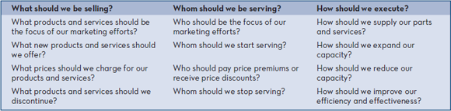

Planning and Control Cycle
- The smooth flow of management activities.
- All activities involve around decision making.
- Managerial accounting serves the information needs of managers in all phases of the planning and control cycle.
- Management accountants:
  - Prepare detailed reports that managers need to make decisions.
  - Prepare budgets to help direct resources toward the organization’s goals.
  - Compares actual costs and revenues with the budgeted figures.
  - Prepares reports to inform management about any significant variances from budget.
- Management information needs to vary from different businesses.
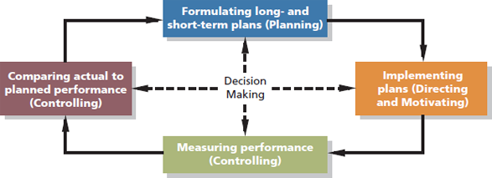

Strategy
- Companies must have a viable strategy for succeeding in the marketplace.
- Strategy – Game plan that enables a company to attract and retain customers by distinguishing itself from competitors.
- Focal point of a company’s strategy is targeting their customers.
- A company can only succeed if it creates customer value proposition.
- Customer Value Propositions – Reason for why a customer chooses them over their competitors, one usually outweighs the other.
- Components of customer value propositions:
  - Customer Intimacy – Understanding the customer and responding to their need better than competitors.
  - Operational Excellence – Deliver products and services fast, more efficient and at a lower price than competitors.
  - Product Leadership – Offering a better quality product than competitors.
- Managerial accounting provides information to management to facilitate implementing and monitoring strategies.
- Focal point of a company’s strategy should be its target customers.

Organizational Structure
- Decentralization – Delegation of decision making that provides managers at various levels with the authority to make decisions relating to their field.
- When a company is highly centralized they make decisions only at the top and the bottom managers have no authority.
- Organizational Chart – Diagram of a firms organizational structure that depicts formal lines or reporting, communication, and responsibility between managers.
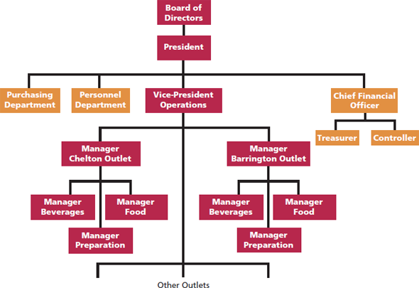

Line and Staff Relationships
- The organizational chart also depicts line and staff positions in an organization.
- Line Position – A job position that is directly related to the achievement of the organization’s basic objectives.
  - Ex. Production supervisors in a manufacturing plant.
- Staff Position – A job position that is indirectly related to the achievement of the organization’s basic objectives. They provide assistance to line positions but don’t have direct authority over them.
  - Ex. Cost accountants in the manufacturing plant.

Controller
- Member of the top management team.
- In charge of the Accounting Department and reports to the chief financial officer (CFO).
- Both are staff positions.
- Provides timely and relevant data to support planning and control activities.
- Prepares financial statements for external users.

Business Process Management and Value Chain
- Business Process – Series of steps that are followed in order to carry out some task in a business.
- Consists of major business functions that add value to a company’s products.
Research and development -
Product Design |
Manufacturing | Manufacture/produce a product
Marketing | OR
Distribution | Deliver/perform a service
Customer Service -
- All these departments need to interact with each other in order to make a product.
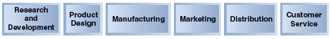

Lean Production
- Organizes resources (people and machines) around the flow of business process.
- Only produces what is needed, when a customer submits an order, companies respond by producing the product.
- Just In Time (JIT) – System in lean production where production is not initiated until a customer has ordered a product.
- Number of units produced tends to equal the number of units sold, therefore minimal inventory.
- Fewer defects, less waste effort and quicker customer response times.

Enterprise Systems
- Single software system that integrates data across an organization, enabling all employees to have simultaneous access to a common set of data.
- Software system is designed to overcome problems in data duplication, inconsistencies, and errors by integrating data across an organization into a single software system.
- A common database where information is shared between all the different departments.
- Data is only recorded once in the database.
- They facilitate communication between the different branches within a company.
- Unique data elements contained within a databased can be linked together.

Risk Management
- Process used by a company to proactively identify and manage foreseeable risks.
- In advance determine what the risks are and properly manage them.
- Once a company identifies its risks, most common risk management tactic is to reduce them by implementing specific controls.
- Hacking is an example of a risk faced every day.

Ethics, Corporate Governance and Corporate Social Responsibility
- Accountants must maintain a level of competence appropriate to their designation.
- Confidentiality is essential because of the importance of the information they analyze.
- Integrity is maintained by avoiding conflicts of interest with their employers or clients by communicating the limits of professional competence, and by not accepting favours that would compromise their judgement.
- Objectivity must be present in communications so that recipients can receive both favourable and unfavourable information.
- Ethical standards in business are essential for a smooth functioning advanced market economy.
- Without ethical standards the economy and all who depend on it for jobs/goods will suffer.
- Abandoning ethical standards leads to lower quality of life with less desirable goods and services at higher prices.

Corporate Governance
- A system by which a company is directed and controlled.
- It enhances shareholders’ confidence that a company is being run in their best interests rather than in the interests of top managers. 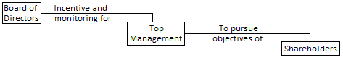
- Effective corporate governance system should also protect the interest of the company’s other stakeholders and the communities in which the company operates.
- Composed of employees, customers, creditors and suppliers.

Corporate Social Responsibility
- Concept where organizations consider the needs of all stakeholders when making decisions.
- Extends beyond legal compliance to include voluntary actions that satisfy stakeholder expectations.
- Composed of customers, employees, suppliers, communities, shareholders and environmental and human rights advocates.
- Extends beyond legal compliance to include voluntary actions that satisfy stakeholder expectations.
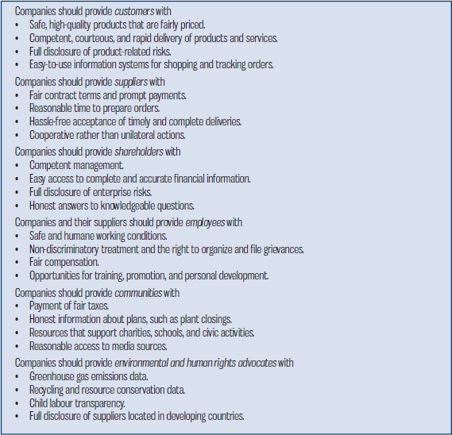

Professional Misconduct and Code of Professional Ethics Regulation
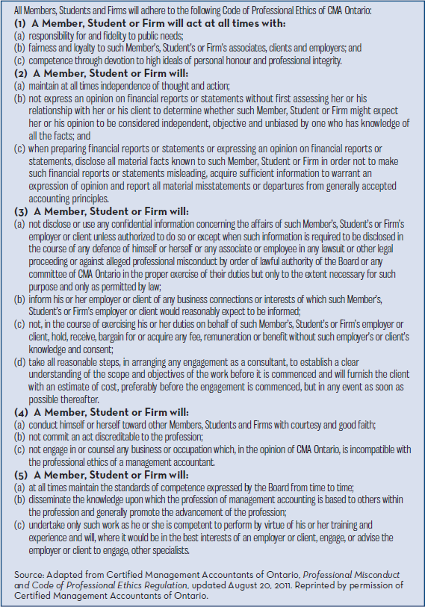

Chapter 2 – Cost Terms, Concepts, and Classifications

Direct Materials
- Materials that go into the final product called raw materials.
- Finished product of one company can be the raw material for another.
- Direct Materials – Raw materials that become an integral part of a finished product and can be conveniently traced to it (chairs in a train).
- Cost of materials that are part of a product.
- Able to trace the costs of the materials to the cost of the final product.
- Indirect Materials – Small items of material that may become an integral part of a finished product but whose costs of tracing exceed the benefits (glue on a shoe).

Direct Labour
- Consists of labour costs that can be easily traced to individual units of a product.
- Salary to those who make the product.
- Indirect Labour – Labour costs of janitors or supervisors that can’t be traced directly to particular products, they’re treated as part of manufacturing overhead.

Manufacturing Overhead
- All costs associated with manufacturing expect direct materials and labour.
- Includes indirect materials, indirect labour, taxes and insurance.
- They can’t be traced directly to specific units products.
- Conversion Cost – Direct labour plus manufacturing overhead cost.
- Prime Cost – Direct materials cost plus direct labour cost.
- Anything to do with factory is overhead (indirect labour, royalty, factory, production).

Manufacturing Cost
- When a product called inventorial is related to manufacturing and is not expensed.
- Overtime Premiums – Extra hourly wage rate paid to workers who must work more than their normal time requirements.
  - Overtime premiums for all factory workers are usually considered part of manufacturing overhead.
  - Product specific overtime premiums are part of direct labour.

Non-Manufacturing Cost
- Marketing or Selling Costs – All costs necessary to secure customer orders and get the finished product to the customer.
- Administrative Costs – All executive, organizational and clerical costs associated with the general management of an organization rather than with manufacturing, marketing or selling.
- Matched and expensed on an income statement in the same period.

Product Cost
- Product Costs – All costs involved in the purchase or making of a product.
- Consist of direct materials, direct labour, and manufacturing overhead.
- Also called inventorial costs.
- Uses inventory in the balance sheet and cost of goods sold is used in the income statement.
- Ex. Manufacturing equipment depreciation, direct materials costs and electrical costs to light the product facility.

Period Cost
- Period Costs – All costs that aren’t included in the product costs.
- They are expensed right then, right now on the income statement.
- They’re selling (marketing) and administrative expenses.
- Uses expenses in the income statement.
- Ex. Property taxes on corporate headquarters and sales commissions. 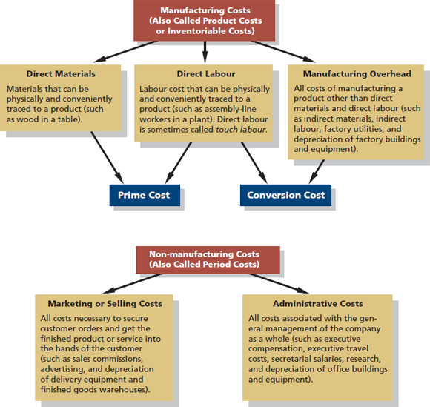

Merchandising vs. Manufacturing Activities
- Merchandisers buyer and sell finished goods.
- Manufactures buy raw materials and sell finished goods.

The Balance Sheet
- Have assets, liabilities but the goods purchased from suppliers is cut in 3 parts:
  - Raw (Direct) Materials Inventory – Materials used to make a product that has not yet been placed into production.
  - Work in Process Inventory – Inventory consisting of units of product that are only partially complete and will require further work before they’re ready for sale.
  - Finished Goods Inventory – Inventory consisting of units of product that have been completed but have not yet been sold to customers.
- Merchandiser current assets: cash, receivables, prepaid expenses, and merchandising inventory.
- Manufacturer current assets: cash, receivables, prepaid expenses, inventories (raw materials, work in process, finished goods).
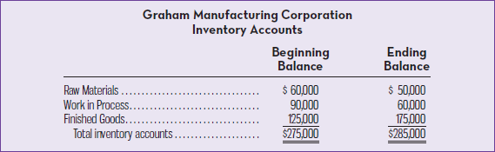

Schedule of Cost of Goods Manufactured
- Schedule showing the direct materials, direct labour, and manufacturing overhead costs incurred for a period and assigned to work in process and completed goods.
- Direct materials is the cost of materials used during the period.
- Purchases of raw material are added to the beginning balance to determine the cost of materials available for use.
- Ending raw materials is deducted from this amount to arrive at the cost of raw materials used in production.
- Total Manufacturing Costs – Sum of materials, direct labour, and manufacturing overhead.
- Calculates the cost of raw material, direct labour and manufacturing overhead used in production.
- Calculates the manufacturing costs associated with goods that were finished during the period.
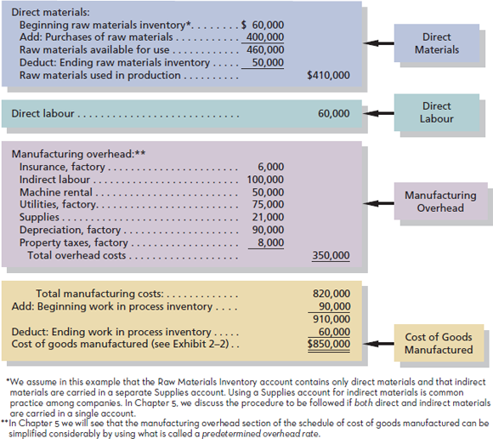

Income Statement
- Cost of Goods Manufactured – Costs that include the direct materials, direct labour, and manufacturing overhead used for the products finished during the period.
- Total Manufacturing Incurred – Total of direct materials, labour and manufacturing overhead.
- COGM = DM(BMI +PUR – EMI) + DL + OH + BWIP – EWIP
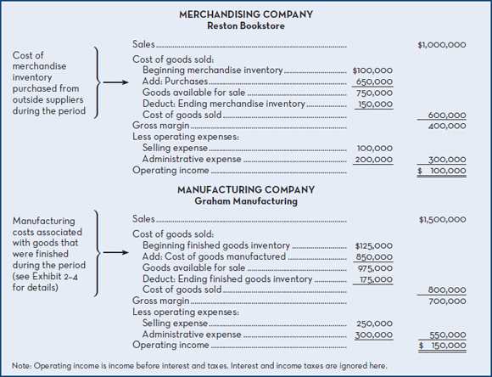

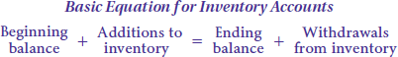

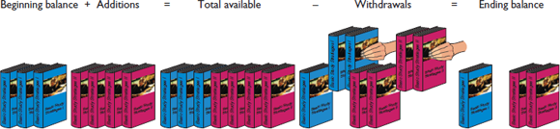

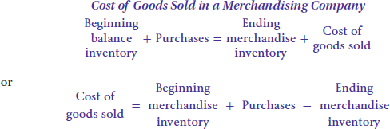
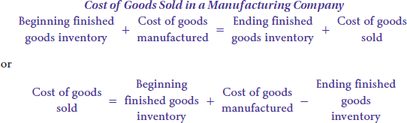

Product Costs Flow
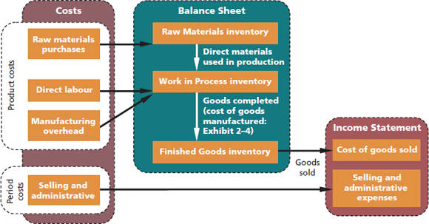

Inventorial Costs
- Products are often called inventorial costs.
- These costs go directly into inventory accounts as they’re incurred rather than going into expense accounts.
- They can end up as an asset on the balance sheet if they’re partially completed or unsold at the end of the period.

Cost Flows
- As goods are being worked on, costs for direct materials, direct labour, and manufacturing overhead are debited to work in process inventory.
- Once the goods are complete, work in process inventory is credited, with the corresponding debit to finished goods inventory.
- Both of these accounts are inventory accounts, so their related balances at the end of a reporting period are included on the balance sheet.
- When the goods are sold, finished goods inventory is credited for the cost of the items, with the corresponding debit to cost of goods sold, an income statement account.
- It is not until the goods are sold that the direct material, direct labour, and manufacturing overhead costs originally debited to work in process inventory get expensed on the income statement through cost of goods sold.
- Selling and administrative expenses are expensed immediately to the income statement in the period incurred.
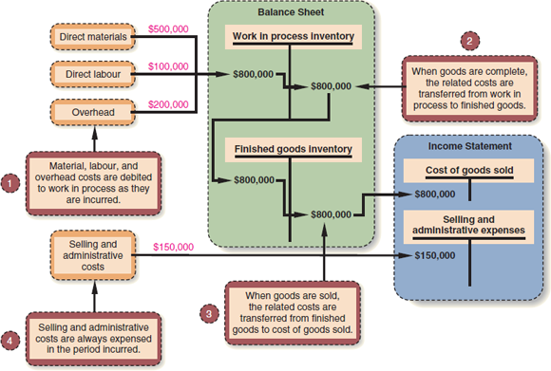
Costs associated with the goods that are completed during the period are transferred to finished goods inventory.

All manufacturing costs incurred during the period are added to the beginning balance of work in process.

Conversion costs are costs incurred to convert the direct material into a finished product.
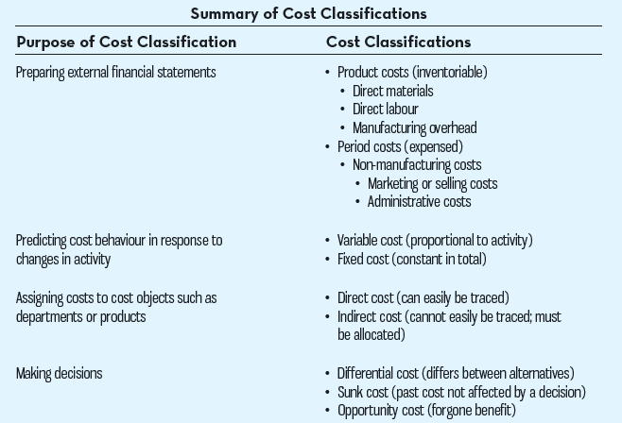

Predicting Cost Behaviour
- Cost Behaviour – A way in which a cost reacts or responds to changes in the level of activity.
- As activity level rises and falls, cost may rise, fall or remain constant.
- A manager should be able to anticipate which of these will happen and by how much it will change.
- In order to make distinctions costs are categorized as variable or fixed.
- Mixed Costs – Costs that contain variable and fixed costs (wages paid to sales staff). Salary is fixed but sale commissions vary.

Variable Cost
- Variable Cost – A cost that varies in direct proportion to changes in the level of activity.
- Can be expressed in units, kilometers, beds, lines, or hours.
- Good example is direct materials.
- Constant if expressed on a per unit basis.
- Ex. Total texting bill depends on the amount of texts sent.
- Cost Drivers – Measure of what causes the incurrence of a variable cost (units produced, labour hours, machine hours and miles driven).

Fixed Cost
- Fixed Cost – Cost that remains constant regardless or changes in the level of activity.
- If the activity level rises or falls, the fixed cost remains constant unless it’s influenced by some outside force (price changes).
- Rent is a good fixed cost.
- Cost is fixed within some relevant range.
- Relevant Range – Range of activity within the assumptions about variable and fixed costs are valid.
- Ex. Costs per text sent is at a constant rate of 5 cents per message.
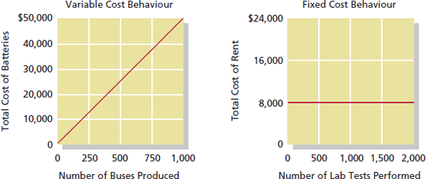
Cost Objects – Anything for which cost data are desired including products, customers, jobs and organizational subunits. They are classified as either direct or indirect.

Direct Cost
- Cost that can be easily and conveniently traced to the particular cost object under consideration.
- Ex. Direct materials and direct labour.

Indirect Cost
- Cost that can’t be easily traced to the particular cost object under consideration.
- To be directly traced to a cost object such as a particular product, cost must be caused by the cost object.
- Common Cost – Cost that is incurred to support a number of cost objects but can’t be traced to any of them individually. It’s a type of indirect cost.
- Ex. Manufacturing overhead

Cost Classification for Decision Making
- Every decision involves a choice between at least 2 alternatives.
- Only those cost and benefits that differ between alternatives are relevant in a decision.
- Other costs and benefits can be ignored.

Differential Cost and Revenue
- Costs and revenues that differ among alternatives.
- Differential Cost – A difference in cost between any 2 alternatives.
  - Differential costs can be either fixed or variable.
- Differential Revenue – A difference in revenue between any 2 alternatives.
- Incremental Cost – Also known as a differential cost, an increase or decrease between any 2 alternatives.
- Ex. Job pays $1,500/month. Job offer pays $2,000/month. Commuting cost to city is $300/month.
  - Differential cost = $300
  - Differential revenue = $500
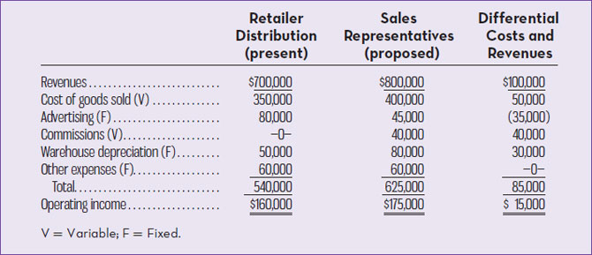

Opportunity Cost
- Potential benefit that is given up when one alternative is selected over another.
- Not usually entered in accounting records but they must be considered in every decision a manager makes.
- Ex. If you don’t attend school you could earn $15,000/year, opportunity cost of attending is $15,000.

Sunk Cost
- Cost that has been already incurred and can’t be changed by any decision made now or in the future.
- Never differ under any alternative courses of actions being considered, aren’t differential costs.
- They are always ignored.
- Ex. Bought a car for $10,000 but no matter what you do (drive, sell, trade or park) you can’t change the $10,000 cost.
- Ex. Discontinuing product A or B, its past tense.

Example of Schedule of COGM and Income Statement
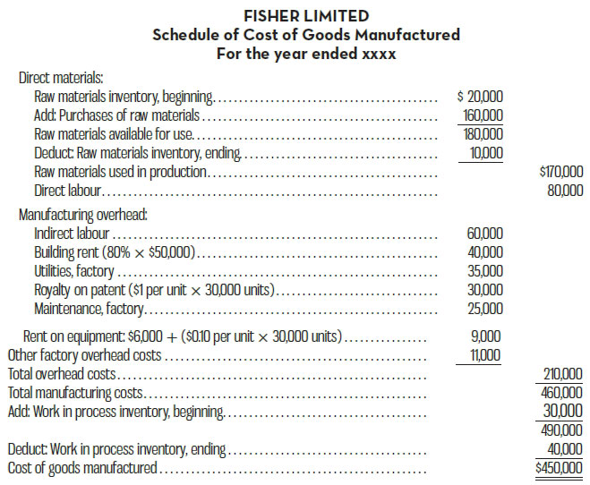
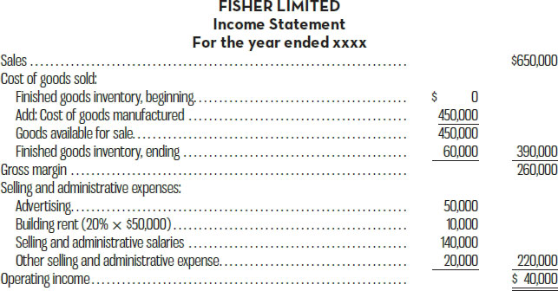

Chapter 3 – Cost Behaviour
- Cost Structure – Relative proportion of fixed, variable, and mixed costs found in an organization.
  - Has significant effect on a company’s decisions.

Variable Costs
- Total dollar amount varies in direct proportion to changes in the activity level.
- Remains constant if expressed on a per unit basis.
  - Ex. Unit cost of refreshments per person is constant at $10.
  - Total cost of refreshments changes since it depends on how many customers buy them.
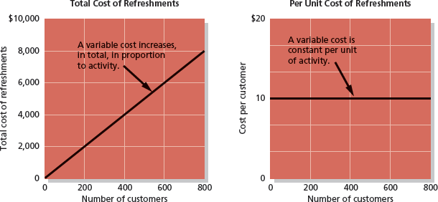
- Public utility with large investments in equipment will have fewer variable costs.
- Service companies will have higher proportion of variable costs.
- Merchandising companies will have a high proportion of variable costs, like cost of sales.
- Manufacturing companies will have many variable costs.
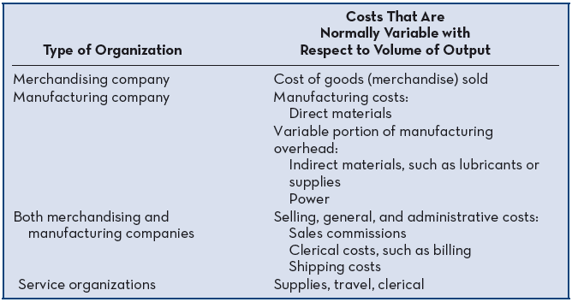

Activity Base
- In order for cost to be variable, it must be with respect to its activity base.
- Activity Base – Measure of whatever causes a variable cost to be incurred.
  - Ex. Total cost of direct materials increases as number of bikes produced increases. Activity base in this case is the number of bikes.

True Variable vs. Step-Variable Costs
- True Variable Cost – Ex. Direct materials since the amount used during a period varies in direct proportion to the level of production activity. Any amount purchased and not used can be carried to the next period as inventory.
- Step-Variable Cost – Costs that is obtainable only in large amounts and that increases/decreases only in response to fairly wide changes in the activity level (ex. Cost of a maintenance worker).
  - Maintenance time not used can’t be stored as inventory and carried forward to the next period. If time isn’t used effectively, it’s gone forever.
  - Maintenance crew can work at a fairly leisurely pace if there is limited work to do but intensify its efforts if things get busy.
  - Small changes in the level of production may have no effect on the number of maintenance workers employed by the company.
  - Strategy is to use the services to the fullest for each step.
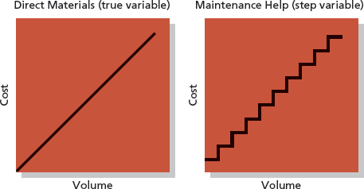

Linearity Assumption and Relevant Range
- Relevant Range – A curvilinear cost that is approximated with a straight line within the band of activity.
- Curvilinear Cost – Costs that show a curved relationship between cost and activity rather than a straight-line relationship.
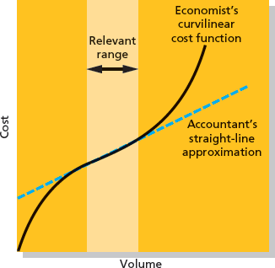

Fixed Costs
- Costs remain constant within the relevant range of activity.
- The average fixed cost per unit becomes progressively smaller as the level of activity increases.
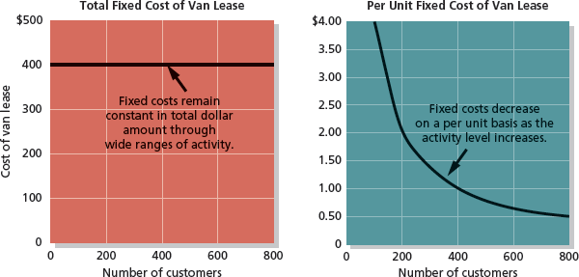

Types of Fixed Costs
- Referred to as capacity costs since they result from outlays required to provide the basic capacity for sustained operations.
- Preferred over variable costs since tasks are taken over by machines.
- Committed Fixed Costs – Fixed costs that are difficult to adjust in the short term and that relate to the investment in that organizational structure of a firm. Their planning extends for several years.
- Discretionary Fixed Costs – Fixed costs arising from annual decisions by management to spend in certain areas like research. Often called managed fixed costs, and their planning is short term (a year). They can be reduced in the short run with minimal damage to long-run objectives.
- Knowledge Workers – As machines take over mundane tasks previously performed by humans, they are demanded for their minds rather than their muscles.
  - Are salaried, highly-trained and difficult to replace.
  - Cost to compensate these employees are fixed.

Fixed Costs and their Relevant Range
- Average fixed costs per unit decrease as the activity level increases.
- Relevant range for the fixed cost is the range of activity where the graph is flat.
- Results in increased committed fixed costs as larger facilities are built and new management positions are created.
- Step-variable costs can often be adjusted quickly as conditions change, but once fixed costs have been set, they can’t be changed easily.
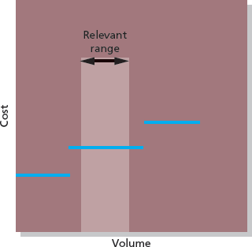

Mixed Costs
- Contains both variable and fixed, known as a semi-variable cost.
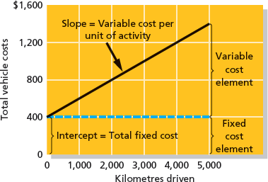
- Equation: Y = a + bx
  - Where:
Y = total mixed costs
A = alpha, total fixed costs
B = Beta, variable costs per unit of activity
X = Level of activity
Bx = total variable costs

How to Analyze Mixed Costs

Account Analysis Method
- Each account is classified as either variable or fixed based on the analyst’s prior knowledge of how the cost in the account behaves.
- Every manager must know and understand their own costs that they’re responsible to control.
- Must know what is variable and fixed.
- Makes 2 lists on what they think each cost is.
- Total the amount for fixed and variable/units for output.
- Ability for manager to classify whether it’s variable or fixed.
Engineering Method
- Cost estimates are based on an evaluation of production methods, and material, labour and overhead requirements.
- Detailed analysis of cost behaviour based on industrial engineer’s evaluation of the inputs that are required to carry out a particular activity and of the prices of those inputs.
- No past experience is available on activity and cost.

Cost Behaviour with a Scattergram Plot
- Y, known as the dependent variable, since amount of cost incurred during a period depends on level of activity.
  - Dependent Variable – Variable that responds to some causal factor, amount of cost incurred during a period depends on the level of activity for the period.
- X, the activity, known as the independent variable, since is causes variation in the cost.
  - Independent Variable – Acts as a casual factor, causes variation in the cost
- Linear Cost Behaviour – Cost behaviour where the relationship between cost and activity can be approximated by a straight line.

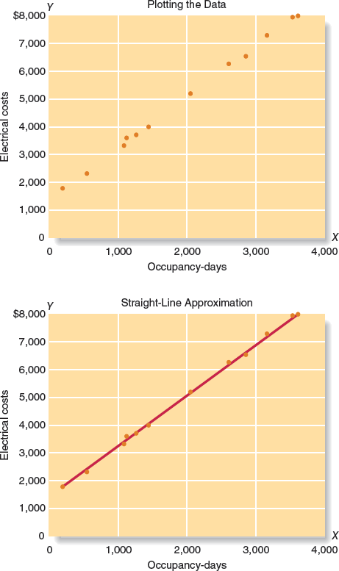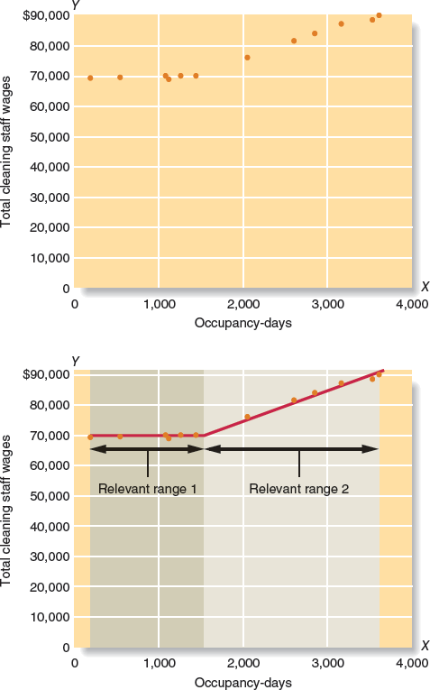

High-Low Method
- Fixed and variable cost elements of a mixed cost can be estimated using the high–low method.
- High-Low Method – Method of separating a mixed cost into its fixed and variable elements by analyzing the change in cost between high and low levels of activity.
- * When looking at the High-Low always go by the activity and not the costs.
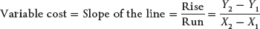
- To analyze mixed costs begin by identifying the period with the lowest level of activity and the period with the highest level of activity.
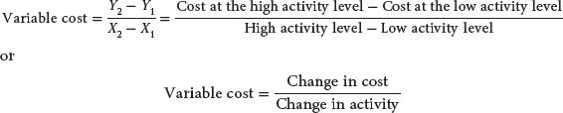
- Variable cost is estimated by dividing the difference in cost between the high and low levels of activity by the change in activity between those two points.

Y = $1,421.50 + $1.85X, where y = total cost, x = total days.
- Disadvantages:
  - Uses only two data points.
  - Periods with the highest and lowest activity tend to be unusual since they represent the two extremes.
  - A cost formula may misrepresent the true cost relationship during normal periods.
- For these reasons, other methods of cost analysis that utilize a greater number of points, such as least-squares regression, are generally more accurate than the high–low method. If managers choose to use the high–low method, they should do so with full awareness of its limitations.

Contribution Format
- Contribution Approach – Income statement where costs are separated into variable and fixed. Used for external reporting.
- Contribution Margin – Amount remaining from sales revenues after all variable expenses have been deducted. Used by management.
  - Contributes towards the covering of fixed expenses then towards the profit.
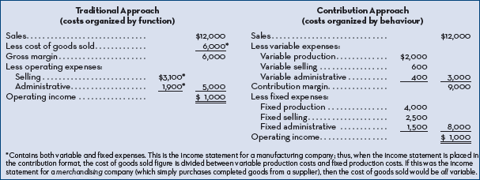

Least-Squares Regression Method
- Used to analyze mixed costs if a scatter graph plot reveals a linear relationship between X and Y variables.
- Uses all of the data points to estimate the fixed and variable cost components of a mixed cost.
- Goal is to fit a straight line to the data that minimizes the sum of the squared errors.
- Cost analysis objective is the same; y = a + bx
- Provides a statistic called R² which is the measure of the goodness of fit of the regression line to the data points.
- Economic Plausibility – Making sense that a change in the activity level of the independent variable would cause a change in the dependent variable.
- Multiple Regression – An analytical method used when the dependent variable (e.g. cost) is caused by more than one activity.

Chapter 4 – Cost Volume Profit Relationships

Contribution Margin
- Contribution Margin – Amount remaining from sales after variable expenses have been deducted.
- Used to cover fixed expenses and remaining goes to profit.
- If contribution margin is not sufficient then there’s a loss for the period.
- Break-Even Point – Level of sales where the profit is zero, when the total sales equals total expense, or where the contribution margin equals total fixed expenses.
- Sales – Variable – Fixed = 0

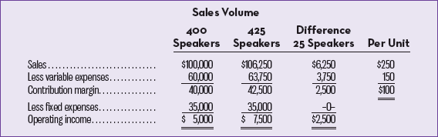

- Contribution income statement is helpful to managers in judging impact on profits of changes in selling price, cost or volume.
- Emphasis is on cost behaviour.
- 1 additional bike => $200 CM
- Must have $80,000 CM total to break even => 400 units.

Cost-Volume Profit Graph
- Cost-Volume Profit (CVP) Graph – Relationships among revenues, costs, and level of activity presented in graphic form.
- Used to help understand the interrelationship among cost, volume, profit in an organization by focusing on interactions between:
  - Prices of products.
  - Volume or level of activity.
  - Per unit variable costs.
  - Total fixed costs.
  - Mix of products sold.
- Unit volume is represented on the horizontal x-axis, and dollars on the vertical y-axis.
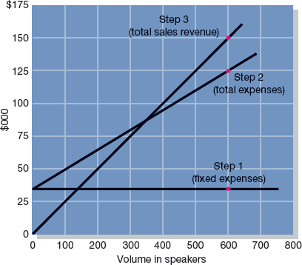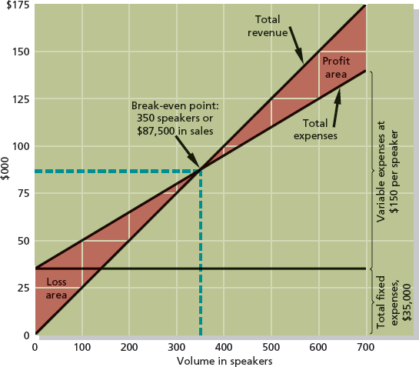
- Where Q is the quantity of items sold.

Contribution Margin Ratio
- Contribution Margin Ratio – Contribution margin as a percentage of total sales.
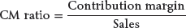 OR $\frac{Per Unit/Total Contribution Margin}{Per Unit/Total Sales}$
- Ratio shows how the contribution margin is affected by a change in sales.
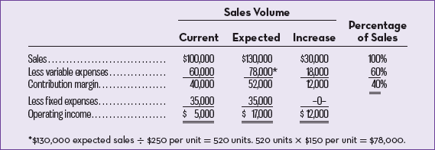

Variable Expense Ratio
- Variable Expense Ratio – The ratio of variable expenses to sales.
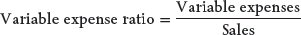
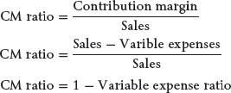
Key Formulas for Contribution Format Income Statements
Operating income = Unit CM × Q – Fixed expenses
CM = Sales – Variable expenses
CM per unit = Per unit sales – Per unit variable expenses
CM ratio = Total CM ÷ Total sales or CM ratio = per unit CM ÷ Per unit sales
Variable expense ratio = Variable expenses ÷ Sales
In these formulas, CM = contribution margin and Q = quantity of goods sold in units.

Changes in Fixed Cost and Sales Volume
  - 400 speakers/month at $250/speaker.
  - Monthly sales = $100,000
  - Increase in $10,000 in monthly advertising => $30,000 increase in sales.
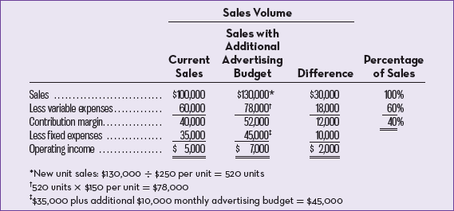
  - Solve by:
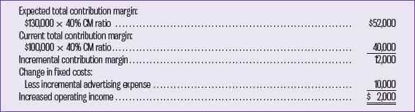 OR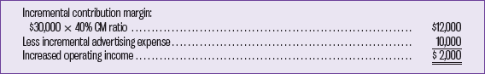
- Incremental Analysis – Analytical approach that focuses only on items of revenue cost, and volume that will change as a result of a decision.

Changes in Variable Cost and Sales Volume
  - Higher quality => increase by $10/speaker.
  - Increase sales to 480 speakers/month.
  - Increase in variable cost by $10 decreases unit CM by $10.
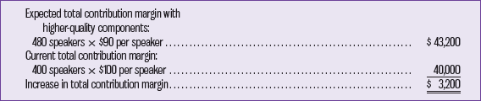

Changes in Fixed Costs, Selling Price, and Sales Volume
  - Reduce selling price by $20/speaker and increase advertising by $15,000/month.
  - Unit sales increase by 50% to 600 speakers/month.
  - Decrease of $20/speaker in selling price => CM to decrease $20.
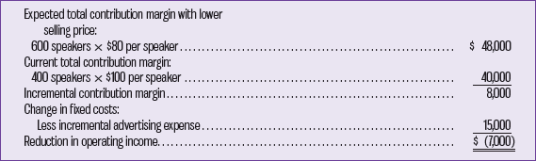
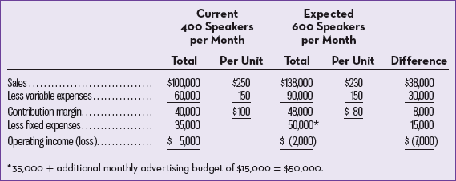

Changes in Variable Costs, Fixed Costs, and Sales Volume
  - Pay salespeople commission of $15/speaker sold rather than salaries of $6,000/month.
  - Increase sales by 15% to 460 speakers/month.
  - Fixed costs will decrease by $6,000.
  - Variable costs per unit will increase by $15.
  - CM will decrease by $15.
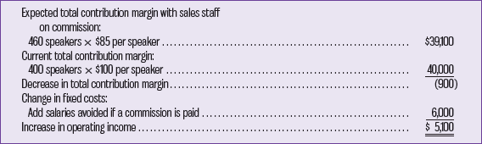
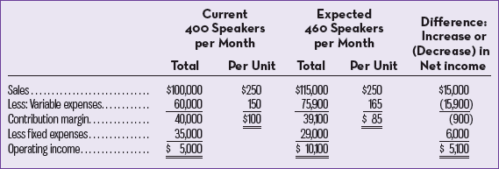

Change in Regular Selling Price
  - Bulk sales to of 150 speakers to increase monthly profits by $3,000.
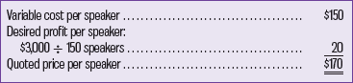
Make change if | Increase in contribution margin > Increase in fixed costs or Decrease in contribution margin < Decrease in fixed costs
Do not make change if | Increase in contribution margin < Increase in fixed costs or Decrease in contribution margin > Decrease in fixed costs

Break-Even Analysis

The Equation Method
- Equation Method – Method of computing break-even sales using the contribution format income statement.
In unit sales:
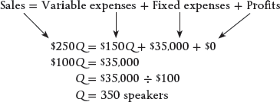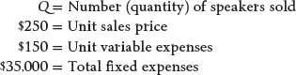
In sale dollars:
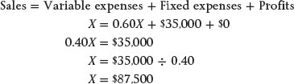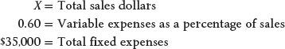

The Formula Method
- Formula Method – Method of computing the break-even point where the fixed expenses are divided by the contribution margin per unit.

After-Tax Analysis
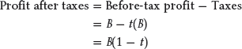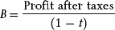
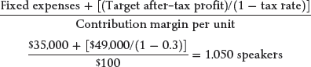
Target Operating Profit (Formula Method)*
- Units:
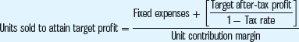
- Sales Dollars:
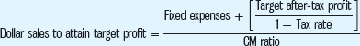
*In cases where taxes are ignored, replace “Target after-tax profit/(1 − Tax rate)” with “Target profit.”

Margin of Safety
- Margin of Safety – Excess of budgeted (or actual) sales over the break-even volume of sales.
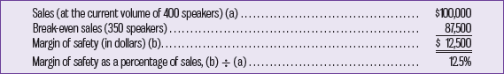

Cost Structure and Profit Stability
- Cost Structure – Relative proportion of fixed and variable costs in an organization. Managers have some ability in determining cost structure.
- High Fixed Cost Structure: Advantage – Income will be higher in good years compared to companies with lower proportion of fixed costs. Disadvantage – Income will be lower in bad years compared to companies with lower proportion of fixed costs.
- Low Fixed Cost Structures: Greater stability in income across good and bad years.
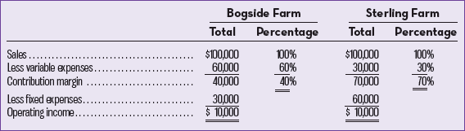
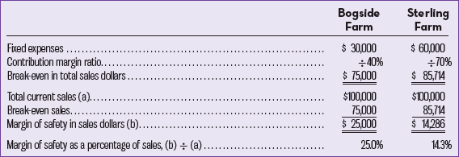

Operating Leverage
- Operating Leverage – Measure of how sensitive operating income is to a given percentage change in sales.
- Operating leverage acts as a multiplier. If operating leverage is high, a small percentage increase in sales can produce a much larger percentage increase in operating income.
- Degree of Operating Leverage – Measure, at given level of sales, of how a percentage change in sales volume will affect profits.
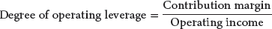
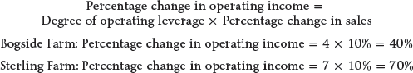
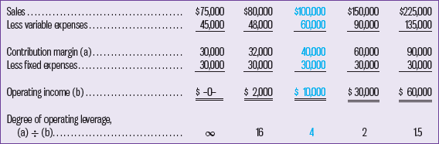

Indifference Analysis
- CVP analysis is useful for aiding decisions about comparative profitability of alternative products or methods of production.
- Analysis focuses on cost behaviour in relation to change in activity level.
- Objective is to find the level of unit sales at which we are indifferent between the two options.
- Based decision on expected sales levels.
- At what level of unit sales would a company be indifferent between two alternative:
  - Determine the unit CM * Q + total fixed costs of each alternative.
  - Setup equation with each alternative on opposite sides.
  - Solve for Q, the indifference point.
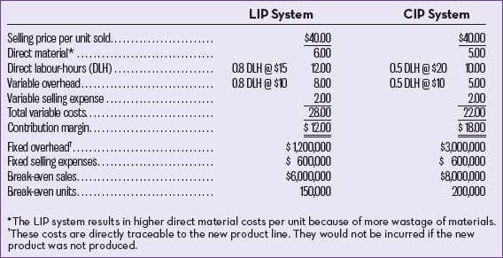

Sales Mix
- The relative proportion in which a company’s products are sold. Computed by expressing the sales of each product as a percentages of total sales.
- Changes in the sales mix can cause considerable variation in a company's profits.
- Shift in the sales mix from high-margin items to low-margin items can cause total profits to decrease even though total sales may increase.
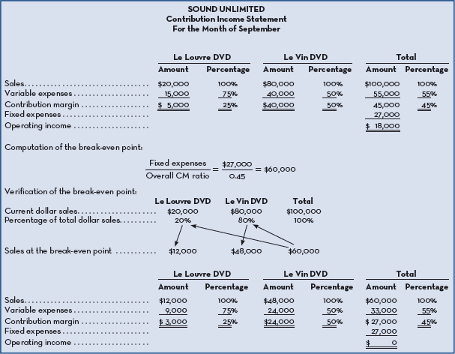
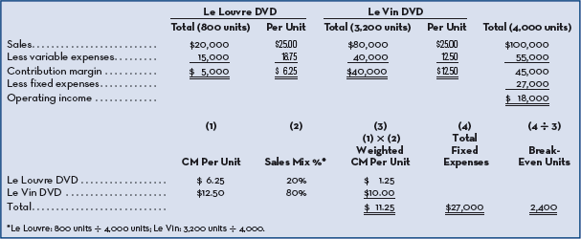
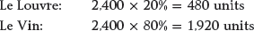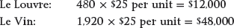
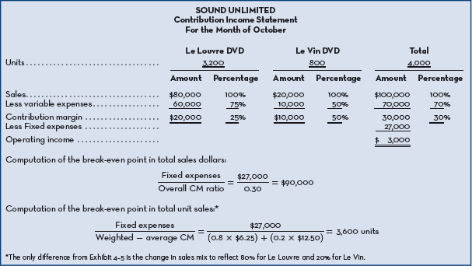

CVP Assumptions
- Selling price is constant throughout entire relevant range.
- Costs are linear and can be divided into variable and fixed elements.
- Multiproduct companies have constant sales mix.
- Manufacturing companies inventories don’t change (units produced = units sold).

Chapter 5 – Systems Design: Job-Order Costing
- Absorption Costing – Also known as full costing, is a method that includes all manufacturing costs – direct materials, direct labour, and both variable and fixed overhead – as part of the cost of a finished unit of product.
- All manufacturing costs, fixed and variable, are assigned to units of product – units are said to fully absorb manufacturing costs.

Process Costing
- Process Costing (Full Costing) – A costing system used in those manufacturing situations where a single, homogeneous product (oil) flows in a continuous stream out of the production process.
- Accumulate costs in a particular operation for an entire period and then divide the total cost by the number of units produced in that period.
- One unit is indistinguishable from other units, therefore is assigned the same average cost.

Job-Order Costing
- Job-Order Costing – A costing system used in situations where many different products, jobs, or services are produced each period.
- costs are traced and allocated to jobs, and then the costs of the job are divided by the number of units in the job to arrive at an average cost per unit.
- used extensively in service industries and not-for-profit organizations.

Measuring Direct Materials Cost
- Used extensively in service industries.
- There’s a lack of raw material in the cost of their services.
- Bills of Materials – A record that lists the type and quantity of each major item of the materials required to make a product.
  - Requires 4 G7 connectors, and 2 M46 housings.
  - Determined from blueprints.
- Material Requisition Form – A source document that specifies the type and quantity of materials that are to be drawn from the storeroom and identifies the job to which the costs of materials are to be charged.

Job Cost Sheet
- Job Cost Sheet – Form prepares for each job that records the materials, labour and overhead costs charged to the job.
  - Key part of a firms accounting records.
  - Subsidiary ledger to the Work in Process account, detailed records they provide for the jobs in process add up to the balance in work in process.

Measuring Direct Labour Cost
- Labour charges that are easily traced to a job.
- Time Ticket – Detailed source document that is used to record an employee’s hour-by-hour activities during a day.
- Cost is treated as part of manufacturing overhead and doesn’t get posted on a job cost sheet.

Predetermined Overhead Rates
- Assigning manufacturing overhead to units of product can be a difficult task because:
  - They’re indirect costs, very difficult to trace costs directly to a particular job.
  - Consists of many different items, like salary or gas used.
  - Output may fluctuate due to seasonal factors, however, costs remain constant due to fixed costs.
  - Timing of payment varies, like taxes on land is annually but others are done quarterly or monthly
- Only way to assign cost to products is to use an allocation process, done by selecting an allocation base that is common to all of the company’s products.
- Allocation Base – Measure of activity, such as direct labour – hours or cost – that is used to assign costs to cost objects, sometimes even unit of product.
- Predetermined Overhead Rate – Rate used to charge overhead costs to jobs; rate is established in advance for each period using estimates of total manufacturing overhead cost and of the total allocation base for the period.
- Based on an estimate rather than actual results since it’s computed before the period begins and is used to apply overhead cost to jobs throughout the period.
- Overhead Application – Process of charging manufacturing overhead cost to the job cost sheets and to the Work in Process account.
- If direct labour hours:
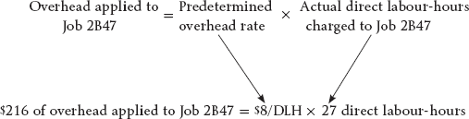
- When overhead is entered it’s not the actual amount of overhead caused by the job.
- Normal Cost System – Costing system in which overhead costs are applied to job by multiplying a predetermined overhead rate by the actual amount of the allocation based incurred by the job.

Need for a Predetermined Rate
- Instead of using estimates, a company could wait until the end of the accounting period to compute the actual overhead rate based on total manufacturing costs and actual total units in the allocation period.
- There are several reasons for using predetermined over actual:
  - Might want to know the valuation of completed jobs before the end of the period.
  - If actual overhead rates are computed frequently, seasonal factors in overhead costs or in the allocation base can produce fluctuations in the overhead rates.
  - The use simplifies record-keeping.

Allocation Base for Overhead Cost
- Cost Driver – Factor that causes overhead costs, such as machine hours, beds occupied or computer time.
- If base is used to compute overhead rates that doesn’t drive overhead costs, result will be inaccurate overhead rats and distorted product costs.
- Companies use direct-labour hours or labour costs as the allocation base for manufacturing overhead.
- Companies were direct labour and overhead costs have been moving in opposite directions, it’s difficult to argue that direct labour drives overhead costs.
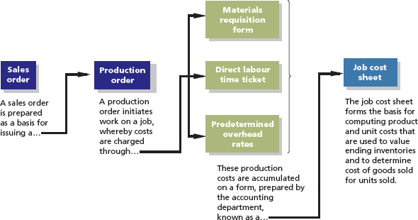

Job-Order Costing – Flow of Costs
- Issue of Direct and Indirect Materials
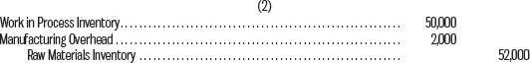
- Issue of Direct Materials Only
- Summary

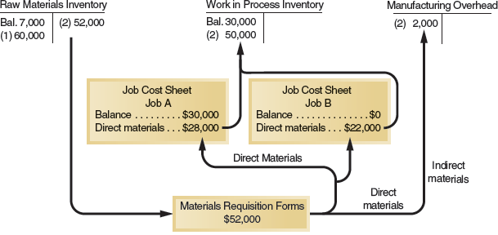

Labour Costs
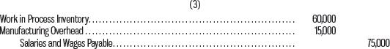
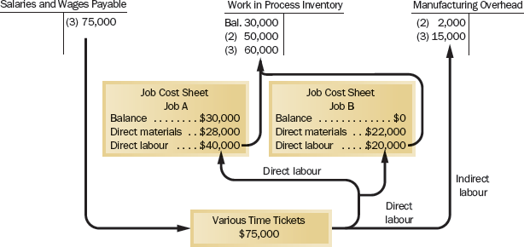

Manufacturing Overhead Costs
- All manufacturing overhead costs are recorded directly into the Manufacturing Overhead account as they’re incurred day-by-day throughout a period.
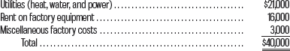
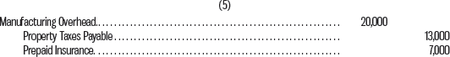

Application of Manufacturing Overhead

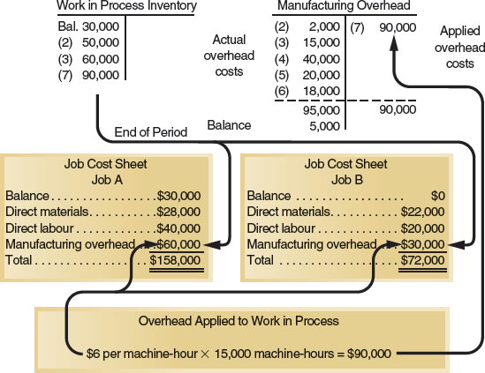

Concept of Clearing Account
- Manufacturing Overhead account operates as a clearing account.
- Overhead costs are debited to the accounts as they’re incurred day-by-day.
- When a job is completed, overhead cost is released from the manufacturing overhead account and is applied to the work in process accounting by means of predetermined overhead rate.
- Work in process is debited and manufacturing overhead is credited.
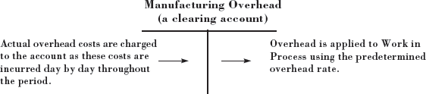
- Predetermined overhead rate is based on estimates of what overhead costs are expected to be, therefore overhead cost applied during the year will turn out to be more or less than the incurred.

Non-Manufacturing Costs
- Shouldn’t go into the manufacturing overhead account.
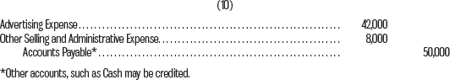
- Distinction between manufacturing overhead costs and non-manufacturing costs such as selling and administrative expenses is difficult because of the type of cost.

Cost of Goods Manufactured
- When a job is completed the finished output is transferred from the production departments to the finished goods warehouse.
- The job is charged with the direct materials, direct labour cost, and manufacturing overhead will have been applied using the predetermined rate.
- Transfer of those costs must be made within the costing system that parallels the physical transfer of the goods to the finished goods warehouse.
- The costs of completed jobs are transferred out of the Work in Process account and into the Finished Goods account.
- Sum of all amounts transferred between these 2 accounts represents the cost of goods manufactured for the period.

Cost of Goods Sold
- As units in finished goods are shipped to customers, their cost is transferred from the Finished Goods account into the Cost of Goods Sold account.
- If only a portion of units are sold, unit cost must be used to determine how much product cost should be removed from Finished Goods and charged to Cost of Goods Sold.
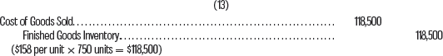

Summary of Cost Flows
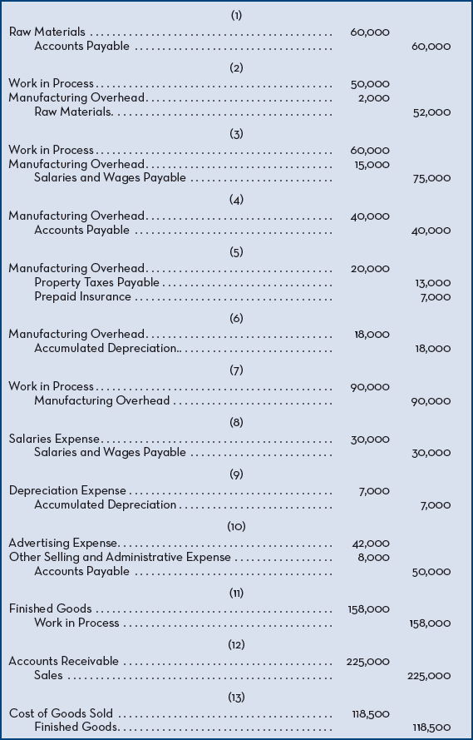
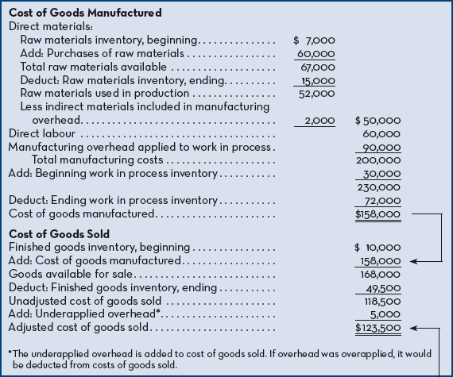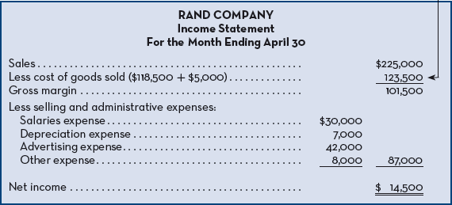
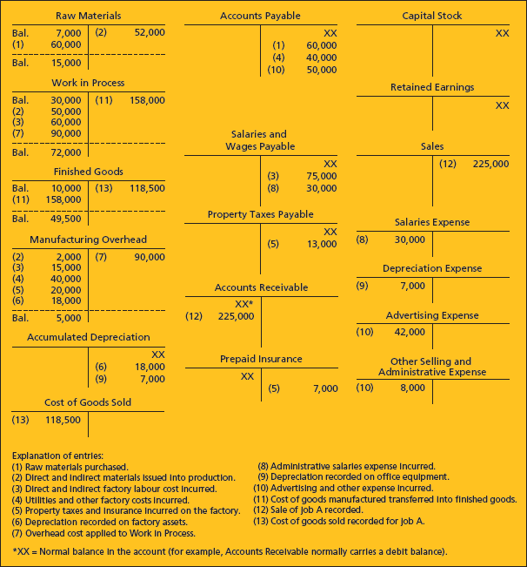

Complications of Overhead Application
- There will be a difference between the amount of overhead cost applied to Work in Process and the amount of overhead cost actually incurred during a period.
- The difference between the overhead cost applied to Work in Process and actual overhead cost is either underapplied or overapplied.
- Underapplied Overhead – Debit balance in the Manufacturing Overhead account that arises when the amount of overhead cost actually incurred is greater than the amount of overhead cost applied to Work in Process during a period.
- Overapplied Overhead – Credit balance in the Manufacturing Overhead account that arises when the amount of overhead cost applied to Work in Process is greater than the amount of overhead cost actually incurred during a period.
  - If overhead was underapplied, the remaining balance is closed out to Cost of Goods Sold.
  - If overhead was overapplied, the remaining balance is allocated among Work in Process, Finished Goods, and Cost of Goods Sold in proportion to the overhead applied during the current period in the ending balances of these accounts.
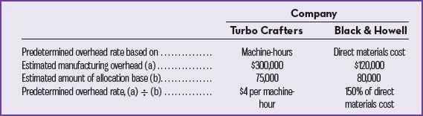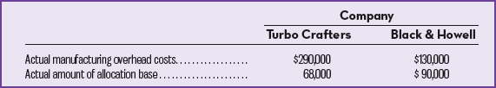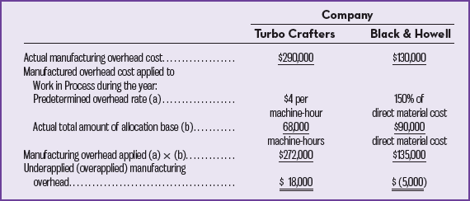

Close Out Underapplied Overhead to Cost of Goods Sold
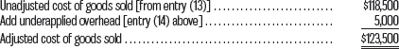

Allocate Overapplied Overhead among Accounts
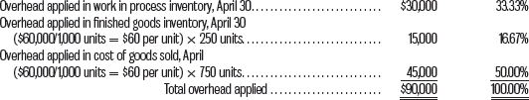
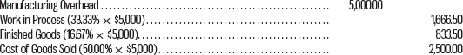
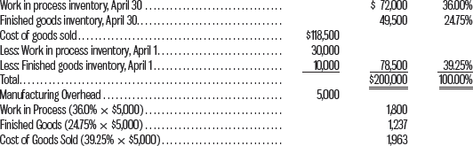
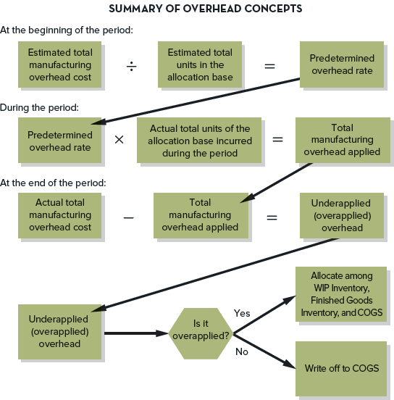

General Model of Product Cost Flows
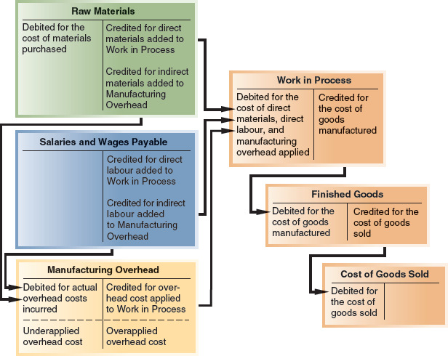

Chapter 8 – Variable Costing: A Tool for Management

Absorption Costing
- Treats all manufacturing costs as product costs, regardless if variable or fixed.
- Cost of a unit consists of direct materials, direct labour, and both variable and fixed manufacturing overhead.
- Allocates a portion of fixed manufacturing overhead cost to each unit of product, along with the variable manufacturing costs.
- Referred to as Full Costing since it includes all manufacturing costs as product costs.

Variable Costing
- Variable Costing – Costing method that includes only variable manufacturing costs in the cost of a unit of product (direct materials, direct labour, and variable manufacturing overhead).
- Fixed manufacturing overhead is treated like a period cost (like selling and admin expenses) and is expensed in its entirety against revenue each period.
- Cost of a unit product in inventory/cost of goods sold doesn’t contain any fixed overhead cost.
- Also known as Direct Costing or Marginal Costing.

Selling and Administrative Expenses
- Rarely treated as product costs regardless of the costing method.
- Under absorption or variable costing, they’re always treated as period costs (expenses) and deducted from revenues as incurred.
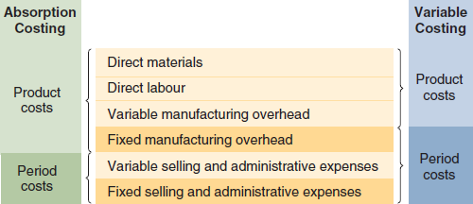

Unit Cost Computations
- Units Produced: 6,000 Fixed Manufacturing: 30,000 Fixed Selling and Admin Expenses: 10,000
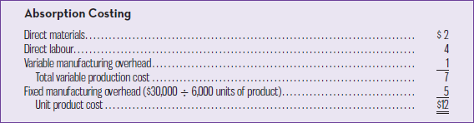
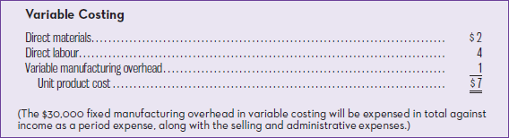

Income Comparison of Absorption and Variable Costing
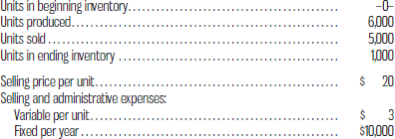
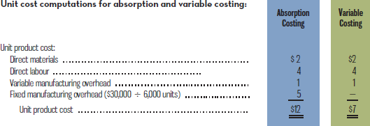
- Under absorption costing, if there’s an ending inventory, the fixed manufacturing costs associated with the inventory will be carried forward as a balance sheet account, inventory.
  - Fixed Manufacturing Overhead Cost Deferred in Inventory – Portion of the fixed manufacturing overhead cost of a period that goes into inventory under the absorption costing method as a result of production exceeding sales.
    - 6,000 units were produced only 5,000 sold, leaving 1,000 in ending inventory. Each unit produced is assigned $5 in fixed overhead a total of $5,000 for the 1,000 units.
    - From 30,000 in fixed manufacturing costs incurred in the period, $25,000 (5,000 units sold * $5) have been included on the income statement in cost of goods sold with a deferral of $5,000 of fixed manufacturing overhead costs.
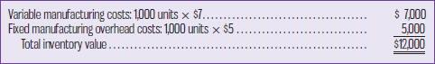
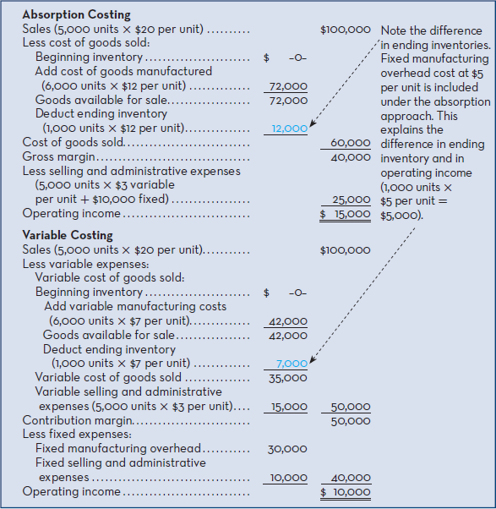
- Under variable costing method, entire $30,000 in fixed manufacturing overhead costs were treated as an expense of the current period.
- Ending inventory under variable costing is $5,000 less than under absorption.
  - Only variable costs are assigned to units of product.
  - $5,000 difference in ending inventory explains difference in operating income. In absorption costing the operating income is $5,000 more.
- Absorption costing makes no distinction between fixed and variable costs and therefore doesn’t work for CVP computations.
- Variable costing approach to costing units of product blends very well with the contribution approach income statement, and data can be used in CVP computations.
- Difference between the two centers around timing.
  - In variable costing, fixed manufacturing costs should be expensed immediately.
  - In absorption costing, fixed manufacturing costs should be charged against revenues bit by bit as units are sold. Any units not sold results in fixed costs being inventoried and carried as assets to the next period.

Extended Comparison of Income Data
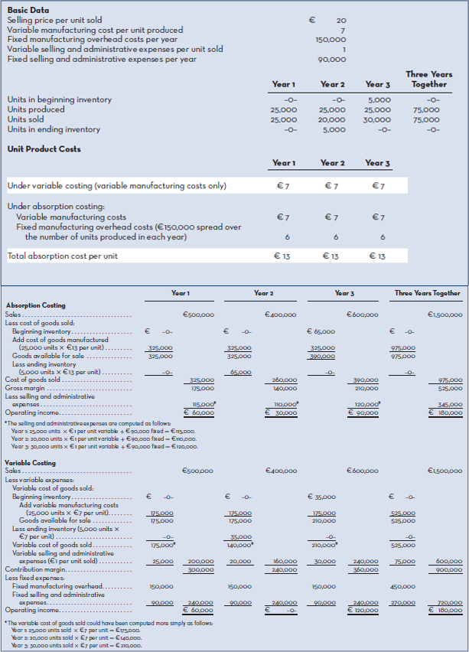
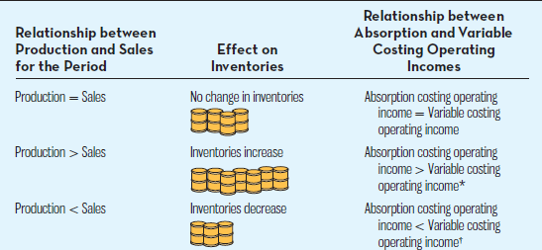
* Operating income is higher under absorption costing, since fixed manufacturing overhead cost is deferred in inventory as inventories increase.
* Operating income is lower under absorption costing, since fixed manufacturing overhead cost is released from inventory as inventories decrease.
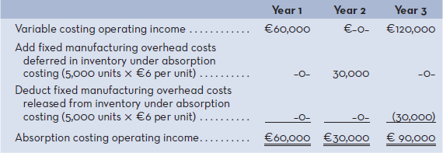
- Fixed Manufacturing Overhead Cost Released from Inventory – Portion of fixed manufacturing overhead cost of a prior period that becomes an expense of the current period under absorption costing as a result of sales exceeding production.
- Over extended period of time, cumulative operating income under both variable and absorption costing will be the same, this is because sales can’t exceed production and vice-versa.
- In variable costing, operating income isn’t affected by changes in production (same every year), a change in production has no effect on operating income.
- In absorption costing operating income is affected by changed in production.
  - Even though same number of units are sold, the income goes up or down due to the shifting or fixed manufacturing overhead costs between periods.

Effect of Changes in Production on Operating Income

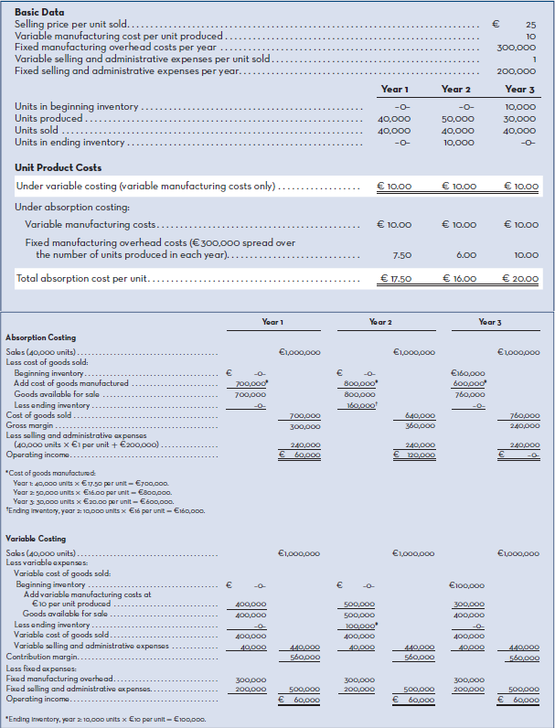

Choosing a Costing Method
- In variable costing:
  - Sales remain constant so both contribution margin and operating income also remain constant.
  - Revenue drives operating income.
- In absorption costing:
  - Some argue that absorption costing shifts fixed manufacturing overhead costs between periods which can be confusing and lead to misinterpretations and faulty decisions.
    - This is because a manager is unable to determine why sales are lower or higher in some months than other.
  - Both revenue and production drive operating income.
  - If inventories increase, fixed manufacturing overhead costs are deferred in inventories and operating income increases.
  - If inventories decrease, fixed manufacturing overhead costs are released from inventories and operating income decreases.
  - Fluctuations in operating income can be due to changes in inventories rather than to changes in sales

Cost-Volume Profit Analysis and Absorption Costing
- Absorption costing is widely used for both internal and external reports.
- Focuses on full costing of units of product.
- Weakness is its inability to dovetail well with CVP analysis.
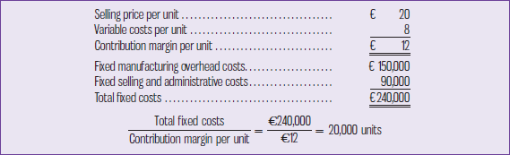
- One way to check the difference between absorption and variable costing is through the break-even point.
- Absorption required the analysis of two drivers, sales and product, by determining levels for each driver a zero operating income can be determined.

Advantages of Variable Costing and the Contribution Approach
- Absorption costing is used for external reports but variable costing and the contribution format income statements are used in internal reports.
- Some advantages are:
  - Data required for CVP analysis can be taken directly from a contribution format income statement. The data isn’t available on a conventional absorption costing statement.
  - Profit for a period isn’t affected by changed in inventories. Other things remain equal (E.g. selling prices, costs, sales mix), profits move in the same direction as sales.
  - Managers often assume that unit product costs are variable costs. This is a problem under absorption costing because unit product costs are a combination of both fixed and variable costs. Under variable costing, unit product costs do not contain fixed costs.
  - Impact of fixed costs on profits is emphasized under the variable costing and contribution approach. The total amount of fixed costs appears explicitly on the income statement, highlighting that the whole amount of fixed costs must be covered for the company to be truly profitable. Under absorption costing, the fixed costs are mingled with the variable costs and are buried in cost of goods sold and in ending inventories.
  - Variable costing data make it easier to estimate the profitability of products, customers, and other segments of the business. With absorption costing, profitability is obscured by arbitrary allocations of fixed costs. We will discuss these issues in later chapters.
  - Variable costing ties in with cost control methods such as standard costs and flexible budgets, which we will cover in later chapters.
  - Variable costing operating income is closer to net cash flow than absorption costing operating income. This is particularly important for companies with potential cash flow problems
- All manufacturing costs must be assigned to products to properly match the costs of producing units of product with the revenues from the units when they’re sold.
- All fixed manufacturing costs aren’t really the costs of any particular unit of product, they’re incurred even if nothing is made that period and are charged that period.
- Downside is that it can be used by an unethical manager to deliberately mislead others, if salary is based on operating income they can make profits to look higher by building up inventory levels.
- Restriction is to increase operating income by building ending inventories.

Cost-Volume Profit Analysis and Absorption Costing
- Absorption costing is used for both internal and external reports.
- It focuses on full costing units of product, but is unable to deal with CVP analysis.
- Requires the analysis of two drivers; sales and production.

Chapter 9 – Budgeting
- Budgets are used by management and by external parties (lenders).
- Tangible benefits can result from budgets and using them as a benchmark for evaluating performance.
- Important tool used by management to communicate financial objectives for the future, allocate resources, and coordinate activities across the different functional areas within the organization.
- Periodically compare actual performance of revenues, expenses, and profits to the plan.
- Budget – Detailed plan for the future expressed in quantitative terms.
- Budgeting – Act of preparing a budget.
- Budgetary Control – Use of budgets to control a firm’s activities.
- Master Budget – Summary of a company’s plans in which specific targets are set for sales, production, distribution, administrative, and financing activities; generally culminates in a cash budget, a budgeted income statement, and a budgeted balance sheet.
- Serves as a planning and control tool in organizations.
  - Planning – Developing objective and preparing various budgets to achieve them.
  - Control – Involves gathering feedback to assess the extent to which the objectives developed at the planning stage are attained.

Advantages of Budgeting
- Communicate management’s plans throughout the organization, leading to a better understanding by all employees of the organization’s objectives.
- Force managers to think about the plan for the future, not just day-to-day emergencies.
- Provides means of allocating resources to those parts or the organization where they can be used most effectively and are most needed.
- Can uncover potential bottlenecks before they occur, by indemnifying the demands that will be placed on key activities and processes. Changes are made to any activity or process that doesn’t currently have the capability or capacity to meet the budgeted level of activity on a timely basis.
  - Bottlenecks – Machines, activities, or processes that limit total output because they’re operating at capacity.
- Coordinate that activities of the entire organization by integrating the plans of various areas, and ensure that everyone in the organization is pulling in the same direction.
- Define objectives that can serve as benchmarks for evaluating actual performance. Comparison of actual results to budgets allow management to determine whether the organization’s goals are being met and to take corrective action.

Responsibility Accounting
- Responsibility Accounting – System of accountability in which managers are held responsible for those items of revenue and cost over which they can exert significant influence. Managers are held responsible for differences between budgeted and actual results.
- Central to any effective profit planning and control system.
- Someone must be held responsible for each cost or else no one will be responsible, and the cost may grow out of control.

Choosing a Budget Period
- Operating Budgets – Cover a 1 year period corresponding to the company’s fiscal year.
  - Companies divide budget year into 4 quarters; 1st quarter are subdivided into months, monthly budget figures are established. Last 3 quarters are carried in the budget at quarterly totals only.
  - Advantage of requiring a periodic review of budget data throughout the year.
- Continuous or Perpetual Budget – 12-month budget that rolls forward one month/quarter as the current month/quarter is completed.

The Participative Budget
- Most successful budget programs allow managers to participate in preparing their own budget estimates.
- Participative Budget – Method of preparing budgets in which managers prepare their own budget estimates, which are then reviewed by the manager’s supervisor, and any issues are resolved by mutual agreement, leading to a completed budget.
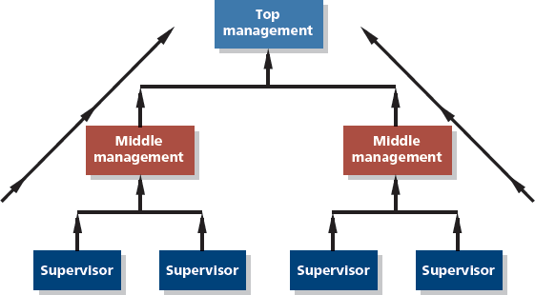
- Initial flow of budget data is from lower levels to higher levels of responsibility.
- Each person with responsibility for revenue or cost will prepare their own budget estimates and submit them to a higher level of management.
- Number of advantages:
  - Everyone in the organization is recognized as members of the team whose views and judgements are valued by top management.
  - Estimates prepared by front-line managers are often more accurate and reliable than estimates prepared by top managers, who have less knowledge of market factors and day-to-day operations.
  - Motivation is higher when individuals participate in setting their own goals than when the goals are imposed from above. They create commitment to attaining the goal.
  - Manager that can’t meet a budget that was imposed can state the budget was unrealistic and impossible to meet. This excuse ISN’T available.
- Budget estimate prepared by lower-management can’t be accepted without review by higher levels of management.
- Budgetary Slack – Difference between the revenues are expenses a manager believes can be achieved and the amounts included in the budget. Slack exist when revenue budgets are intentionally set below expected levels and expense budgets are set above expected levels.
  - Slack can result in the misallocation of resources, inefficiencies, waste, and less effort by managers.
- Top management is generally unfamiliar with detailed day-to-day operations, therefore all levels of organization should work together to produce budgets.
- Each level of responsibility in an organization should contribute in a cooperative effort to develop an integrated and realistic budget.
- Budget Committee – A group of key management personnel responsible for overall policy matters related to the budget program, coordinating the preparation of the budget, handling disputes related to the budget, and approving the final budget.
- Process of assigning budgets is more efficient since it doesn’t involve negotiations or discussions between managers.

Behavioural Factors in Budgeting
- If a budget program is to be successful, it must have complete acceptance from key management.
- If budget targets are too difficult, employees will recognize that they’re unattainable and will lose motivation and morale.
- If budget targets are too easy, inefficiencies or less effort will result.
- Budget targets in general should be highly challenging and should require management to stretch to meet them.
- Stretch Budget – A budget that is highly difficult to achieve. Requires considerable changes to the way task activities are performed.
- Difficulty level of budget targets are more important when managers’ bonuses are based on meeting or exceeding the budget.

Zero-Base Budgeting
- Manager uses last year’s budget and actual results as a basis for the current year, making adjustments to revenues and costs based on anticipated changes in the operating environment.
- Zero-Base Budget – Method of budgeting in which managers are required to justify all costs as if the activities involved were being proposed for the first time.
  - Effective way of identifying operational – inefficiencies and reducing costs dramatically.
  - Key problem is that they require considerable time and effort to prepare, issue is for companies to decide on the frequency of the review.

Master Budgets
- Consists of a number of separate but interdependent budgets.
- Preparing for a manufacturing company is more complex than for other types of organizations.
- Cash Budget – Detailed plan showing how cash resources will be acquired and used over a specified time period.

Sales Budget
- Sales Budget – Detailed schedule showing the expected sales for coming periods; these sales are typically expressed in both dollars and units.
- Help determine how many units must be produced by manufacturing companies, therefore production budget is prepared after.
  - Used to determine the budgets for manufacturing cost including direct materials and labour, and manufacturing overhead budget.

Preparing Master Budgets
- A sales budget, including schedule of expected cash collections.
  - Constructed by multiplying the budgeted sales in units by the selling price.
  - Schedule of expected cash collections: Cash collections consist of collections on sales made to customers in prior periods plus collections on sales made in the current budget period. At Patterson Framing, experience has shown that 60% of sales is collected in the quarter in which the sale is made and the remaining 40% is collected in the following quarter. So, for example, 60% of the first-quarter sales of $600,000 is collected during the first quarter and 40% is collected during the second quarter.
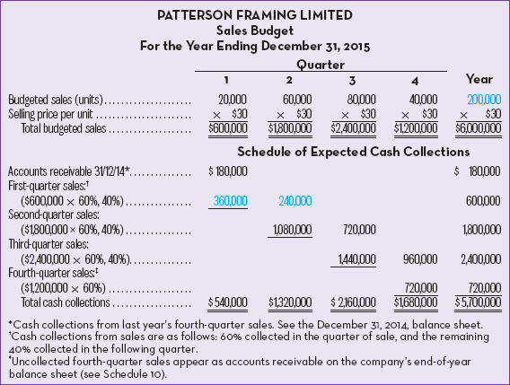
- A product budget.
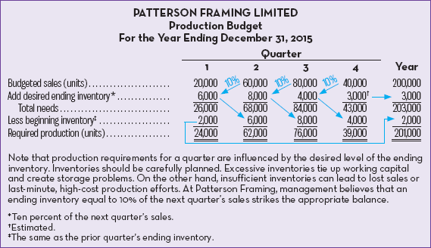
  - Production Budget – Detailed plan showing the number of units that must be produced during a period to meet both sales and inventory needs.
  - If it were a merchandising firm, it would prepare a merchanise purchases budget.

- Direct material purchases budget, including schedule of expected cash disbursements for raw materials.
  - Direct Material Purchases Budget – Detailed plan showing the amount or raw materials that must be purchased during a period to meet both production and inventory needs.
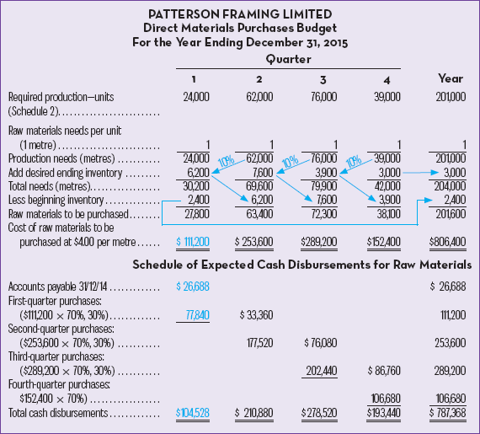
- Total production needs: 24,000 frames × 1 metre per frame = 24,000 metres.
- Desired ending inventory: 10% × 62,000 metres (the following quarter’s needs) = 6,200 metres.
- Total needs: 24,000 metres (production) + 6,200 (inventory) = 30,200 metres.
- Total purchases: 30,200 metres (total needed) – 2,400 (opening inventory) = 27,800 metres.
- Total purchase cost: 27,800 metres × $4.00 per metre = $111,200.

- A direct labour budget.
  - Direct Labour Budget – Detailed plan showing labour requirements over a specified period.
- Firms that neglect to budget face the risk of labour shortages or having to hire/lay off employees at awkward times.
- Erratic labour policies can lead to insecurity and inefficiency in employees.
- Workers * Hours * Labour Cost = Total
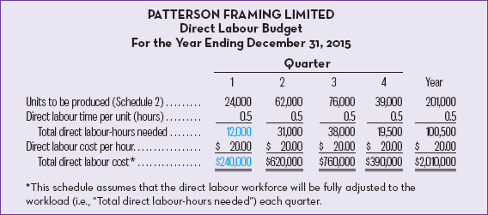
- A manufacturing overhead budget.
  - Manufacturing Overhead Budget – Detailed plan showing the indirect production costs that will be incurred over a specified time period.
    - Separated into variable and fixed costs.
    - Variable cost depends on direct labour hours.
    - Direct Labour Hours * Amount per Direct Labour Hour = Total
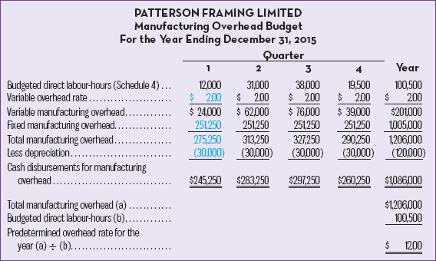
- An ending finished goods inventory budget.
  - Ending Finished Goods Inventory Budget – Budget showing the dollar amount of cost expected to appear on the balance sheet for unsold units at the end of a period.
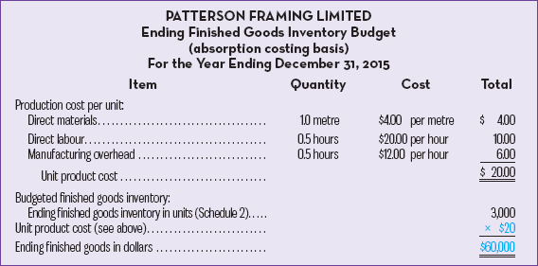
- A selling and administrative expense budget.
  - Selling and Administrative Expense Budget – Detailed schedule of planned expenses that will be incurred in areas other than manufacturing during a budget period.
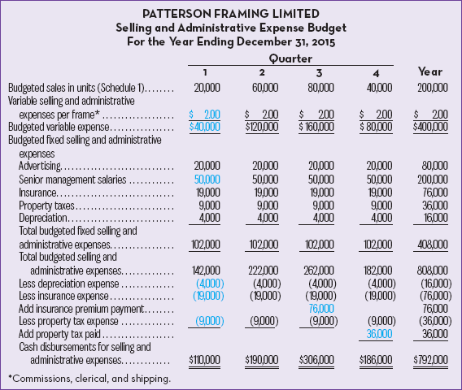
- A cash budget.
  - Cash Budget – Detailed plan showing how cash resources will be acquired and used over a specified time period.
  - Excess Cash (Deficiency) + Borrowing – Interest Borrowing = Target Cash Balance
  - Composed for 4 major reasons:
    - Receipts section.
    - Disbursements section.
    - Cash excess or deficiency section.
    - Financing section (borrowings, loan repayments, and interest expense).
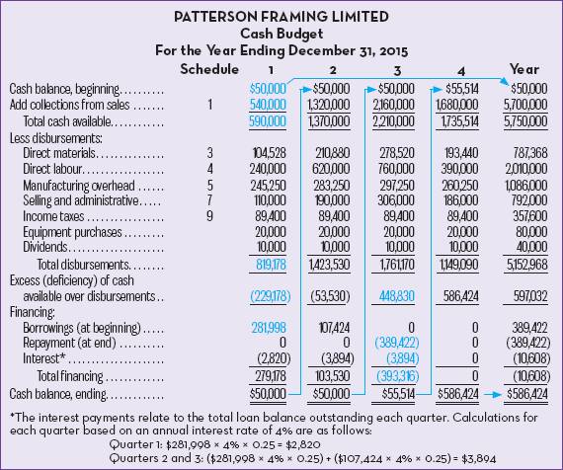
- A budgeted income statement.
  - Budgeted Income Statement – Shows a company’s planned profit for the upcoming budget period, benchmark where actual performance is measured.
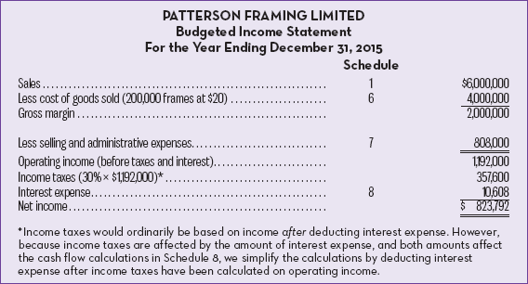
- A budgeted balance sheet.
  - Budgeted Balance Sheet – Developed using actual balance sheet at the end of the period, adjusting data contained in other budgets. External parties require them for assessment of a company’s financial position for decision making.
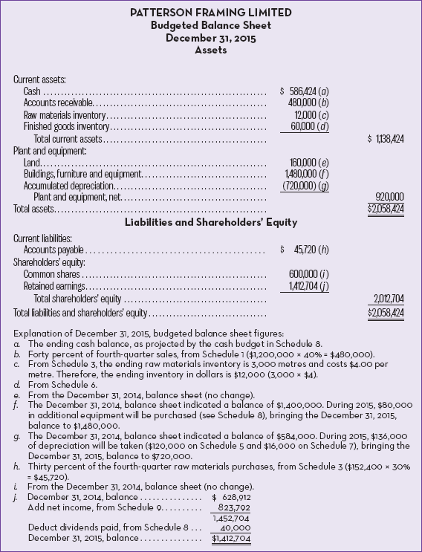

Flexible Budget
- Statistic Budget – Budget designed for only the planned level of activity.
- Flexible Budget – Budget that provides estimates of what revenues and costs should be for any level of activity within a specified range.
- If adjustments for the level of activity aren’t made, it’s difficult to interpret differences between actual and budgeted revenues and costs.

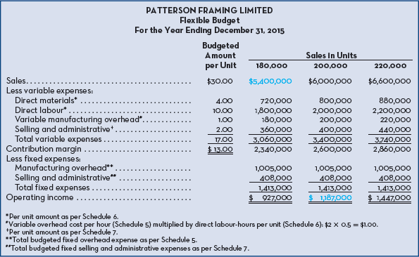

Using Flexible Budget in Performance Evaluation
- To demonstrate control benefits of flexible budgeting is to evaluate performance.
  - Presents actual revenues and expenses for the year.
  - Contains flexible budget based on actual sales of units.
  - Shows the flexible budget variance.
- Flexible Budget Variance – Difference between actual and flexible budget amounts for revenues and expenses.
- Labeled “U” and “F” for unfavourable and favourable variances.
- Favourable if:
  - Actual revenues are more than the budgeted/planned revenues.
  - Actual expenses are less than the budget/plan.
  - Actual manufacturing costs are less than the amount budgeted for the period.
- Tell the story as to why the unfavourable sales of variance occurred.
- Favourable budget for expenses are analyzed to identify the cause of the lower expenses.
- Static Budget Variance – Difference between actual and static budget amounts for revenues and expenses.
- Sales Volume Variance – Difference between flexible and static budget amounts for revenues and expenses caused by actual activity levels differing from static budget amounts.

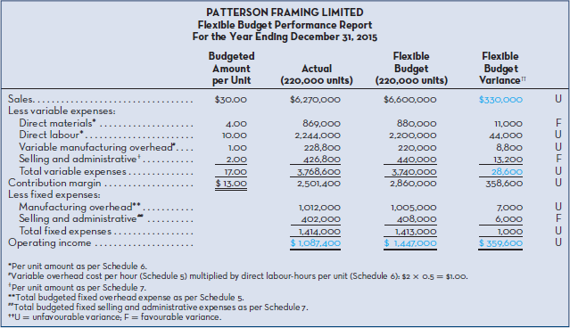
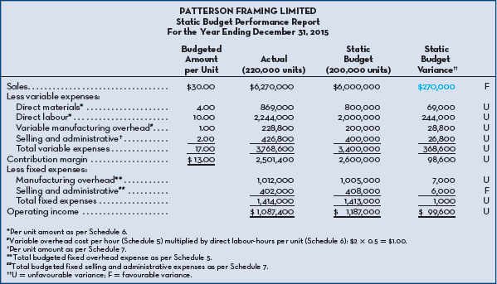
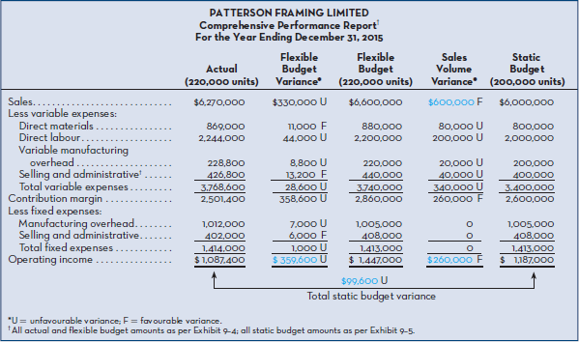

Chapter 11 – Reporting for Control

Decentralization in Organizations
- Decentralized Organization – An organization in which decision making is spread throughout the organization rather than being confined to a few top executives.
- In a strongly decentralized organization there are only very few constraints on the freedom of even the lowest-level managers and employees to make decisions.

Segment Reporting Decentralization in Organizations
- Segment Reporting – Report based on an activity of the organization about cost, revenue, or profit data.
- Provides a summary of a company’s overall operations but isn’t detailed enough to allow managers to detect problems within the organization.
- An operating segment for financial accounting purposes is a component of an enterprise:
  - Engages in business activities from which it may earn revenues and incur expenses.
  - Operating results are regularly reviewed by the enterprise's chief operating officer to make decisions about resources to be allocated to the segment and assess its performance.
  - Discrete financial information is available.

Assigning Costs to Segments
- Segment Statements for internal use are typically prepared in the contribution format.
- Rules are the same but when handling fixed costs they’re divided into 2 parts.
  - Traceable – Traced to a segment and charged to the various segments.
  - Common – If not traceable, it’s kept as a common cost and separate from the segments.
- Two guideline are followed in assigning costs under the contribution approach:
  - According to the cost behaviour patterns (ex. Variable and fixed).
  - According to whether the costs are directly traceable to the segments involved.

Sales and Contribution Margin
- Necessary to keep records of sales by individual segments, in total for the organization.
- After deducting related variable expenses, a contribution margin figure can be computed for each segment.
- If sales volume goes up or down, the effect on operating income is computed by multiplying the unit CM by the change in units sold or by multiplying the change in sales dollars by the CM ratio.
- The CM is basically a short-run planning tool, and is valuable in decisions relating to temporary uses of capacity, to special orders, or to short-run product-line promotion.

Different Levels of Segmented Statements
- Statements are prepared for different levels of activity and in different formats.
- Can be prepared for activities at many levels in a company.

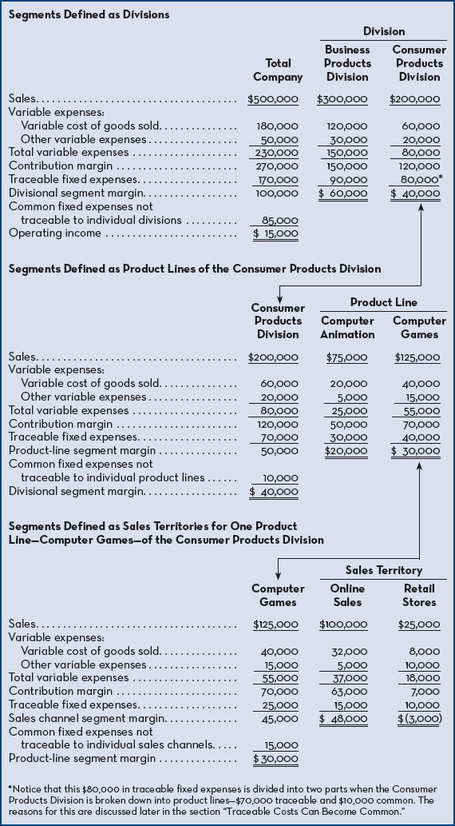

Traceable and Common Fixed Costs
- Traceable Fixed Costs – Fixed costs the can be identified with a particular segment and that arise because of the existence of the segment.
  - If segment doesn’t exist, fixed cost wouldn’t be incurred and if it’s eliminated the fixed cost disappears.
  - Only traceable fixed costs are assigned and charged to a particular segment.
  - Ex. Salary of the Frito-Lay product manager to PepsiCo. is traceable to the Frito-Lay business segment of PepsiCo.
- Common Fixed Cost – Fixed cost that supports the operations of more than one segment but isn’t traceable in whole or in part to any one segment.
  - Even if segment was eliminated, there’s no change in a true common fixed cost.
  - Ex. Salary of the CEO of GM is a common fixed to the various divisions of GM.

Traceable Fixed Costs
- Traceable fixed costs are charged to the segments, but common fixed costs are not.
- Treat traceable costs as costs that would disappear overtime if the segment itself disappeared.
- In preparing segmented income statements, managers like to separate the traceable fixed costs into two classes – discretionary and committed.
  - Discretionary Fixed Costs – Costs under the immediate control of the manager.

Activity-Based Costing
- Costs that are easy to identify as traceable.
- Example: cost of advertising on a product is clearly traceable while a warehouse that contains storage for many products is harder to define.
- Activity-based costing argues that the lease is traceable and should be assigned to the products according to how much space the products use.
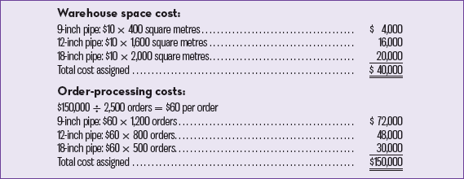
- Problem: Three products—9-inch pipe, 12-inch pipe, and 18-inch pipe. Space is leased in a large warehouse on a yearly basis as needed. The lease cost of this space is $10 per square metre per year. The 9-inch pipe occupies 400 square metres of space, the 12-inch pipe occupies 1,600 square metres, and the 18-inch pipe occupies 2,000 square metres. The company also has an order-processing department that incurred $150,000 in order-processing costs last year. Management believes that order-processing costs are driven by the number of orders placed by customers in a year. Last year, 2,500 orders were placed, of which 1,200 were for 9-inch pipe, 800 were for 12-inch pipe, and 500 were for 18-inch pipe. Given these data, the following costs would be assigned to each product using the ABC approach:
- It’s clear that the $20,000 in warehousing costs for 18-inch pipe would be eliminated if 18-inch pipe were no longer being produced. The company would simply rent less warehouse space the following year. However, suppose the company owns the warehouse. Then it is not so clear that the $20,000 of the cost of the warehouse would really disappear if 18-inch pipe were discontinued as a product. That part of the company warehouse might simply be empty while the costs of the warehouse continue to be incurred.

Traceable Costs becoming Common Costs
- Traceable fixed costs in one segment may be common costs in another segment.
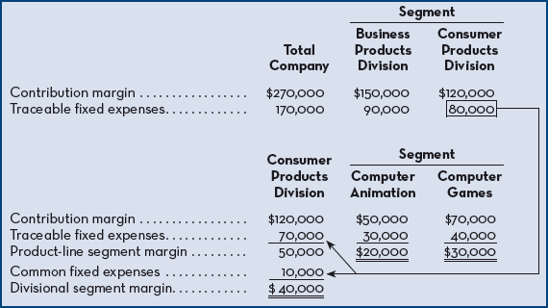
- There’re limits to how costs can be separated without arbitrary allocation, the more defined the more they have in common. Consumer Products Division has $80,000 in traceable fixed expenses. Only $70,000 of this amount remains traceable, however, when we narrow our definition to that of the product lines. Notice that the other $10,000 then becomes a common cost of these product lines of the Consumer Products Division. The $10,000 is the monthly salary of the manager of the Consumer Products Division. This salary is a traceable cost of the division as a whole but is a common cost of the division's product lines. The manager's salary is a necessary cost of having the two product lines, but even if one of the product lines were discontinued entirely, the manager's salary would probably not be cut. Therefore, none of the manager's salary can really be traced to the individual products. The $70,000 traceable fixed cost of the product lines consists of the cost of product-specific advertising. A total of $30,000 was spent on advertising animation software and $40,000 was spent on advertising computer games. These costs can clearly be traced to the individual product lines.

Segment Margin
- Segment Margin – A margin obtained by deducting a segments traceable fixed costs from the segments contribution margin.
- Best when determining the long-run profitability of a segment since it includes only those costs that are caused by that segment.
- Long-run is applied because fixed costs can be altered if the segment was eliminated, if a segment can’t cover its own costs it should be dropped.

Hindrances to Costs
- Costs must be properly assignment to segments.
- The following mistakes occur:

Omission of Costs
- Costs assigned to a segment should include all costs attributed to that segment from the company’s entire value chain.
- Only manufacturing costs are included in product costs under absorption costing.
- To avoid having to maintain 2 costing systems, many use absorption costing for internal and external reports.
- They omit from their profitability analysis in terms of:
  - Upstream Costs – Consist of research and development and product design.
  - Downstream Costs – Consist of marketing, distribution and customer service.
    - Both are under the selling and admin expenses.
- If those costs are omitted in the profitability analysis, the product is under-costed and management may develop and maintain products that result in losses in the long run.

Inappropriate Methods for Assignment Traceable Costs among Segments
- Companies don’t correctly handle traceable fixed costs on segmented income statements.
- They may not trace the expenses to segments even when it’s feasible to do so.
- They may use inappropriate allocation bases to allocate traceable fixed expenses to segments.

Failure to Trace Costs Directly
- Costs that can be traced directly to a specific company segment should be charged directly to that segment.
- Failure to trace the costs directly result in them being placed in a company overhead pool.

Inappropriate Allocation Base
- Some companies allocate costs to segments using arbitrary bases such as sales dollars or cost of goods sold.
- Costs are allocated to the various segments according to the percentage of company sales generated by each segment, if segment generates 20% of the company’s sales, it’s allocated 20% of the company’s selling and admin expenses as it’s “fair share”.
- Cost should be allocated to segments for internal decision-making purposes only when the allocation base actually drives the cost being allocated.

Dividing Common Costs among Segments
- Assigning non-traceable costs to segments.
- If a product was to be eliminated entirely, there would be no significant effect on any of the costs of the corporate headquarters.
- variable costing for segment reports and allocate fixed manufacturing overhead as a period expense based on the criterion of traceability; that is, fixed costs will disappear over time if the segment itself disappears

Responsibility Centres
- Responsibility Centre – Any business segment whose manager has control over cost or profit or the use of investment funds.
- There are three types of centres:

Cost Centre
- Cost Centre – A business segment whose manager has control over cost but no control over revenue or the use of investment funds.
- Ex. Accounting, finance, selling and administrative, legal and personnel departments.
- Managers are expected to minimize cost while providing the level of services or the amount of product demanded by the other parts of the organization.
- Flexible budget variances and standard cost variances are often used to evaluate the performance.

Profit Centre
- Profit Centre – A business segment whose manager has control over cost and revenue but no control over investment funds.
- Ex. Managers in charge of 1 of 6 resorts is responsible for profits of the resort but doesn’t have control of the major investments in the resort.
- Evaluated by comparing actual profit to targeted or budgeted profit.

Investment Centre
- Investment Centre – A business segment whose manager has control over cost and revenue and also has control over the use of investment funds.
- Initiate investments which is then approved by the board of directors.
- Evaluated using return on investment or residual income.
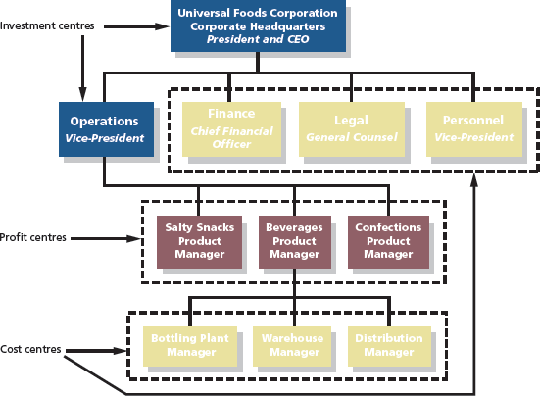

Return on Investment
- Operating income divided by average operating assets, also equals margin multiplied by turnover.
- The higher the ROI the greater the profit generated per dollar invested in the operating assets.


- Margin – Always in percentages
- Turnover – Amount of sales generated in an investment centre for each dollar invested in operating assets.
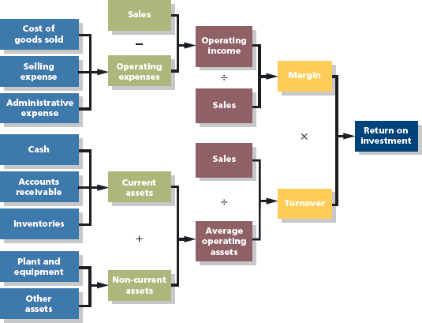

Example 1: Increased Sales without Increase in Operating Assets.
Manager can increase sales by 10% without any increase in operating assets. The increase in sales will require additional operating expenses. However, operating expenses include some fixed expenses, which would probably not be affected by a 10% increase in sales. Therefore, the increase in operating expenses would probably be less than 10%; let's assume the increase is 7.8%. Under these assumptions, the new operating income would be $12,980, an increase of 29.8%, determined as follows:
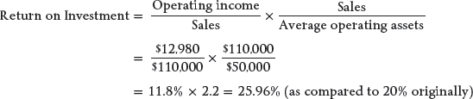
When sales are increased without an increase in operating assets, both the margin and turnover are likely to be affected. In the example above, because sales increased by 10% and operating expenses increased by only 7.8%, the margin increased to 11.8% (up from 10%). This improvement in the margin, combined with the increase in turnover to 2.2 (up from 2), led to the gain in ROI. Clearly, if the percentage increase in sales exceeds the percentage increase in operating expenses, ROI will always improve, if no additional operating assets are required to generate the new sales. However, it is worth pointing out that given the increase in turnover, the old ROI of 20% could have been maintained as long as the new margin did not fall below 9.09% (20% ÷ 2.2). If the new margin exceeds 9.09%, as it does in the example, ROI will increase. Using this type of analysis can help managers assess the extent to which operating expenses can increase before ROI begins to decrease.

Operating Income and Assets
- Operating Income – Income before interest and income taxes have been deducted.
- Operating income is used in the numerator because no debt is included in the denominator.
- Operating Assets – Cash, accounting receivable, inventory, plant and equipment, and all other assets held for productive use in an organization.

- Arguments for using net book value to measure operating assets in return on investment computations:
  - Is consistent with how plant and equipment are reported on the balance sheet (i.e., cost less accumulated depreciation to date).
  - Is consistent with the computation of operating income, which includes depreciation as an operating expense.
- Arguments for using gross cost to measure operating assets in return on investment computations:
  - Eliminates both the age of equipment and the method of depreciation as factors in ROI computations. (Under the net book value method, ROI tends to increase over time as net book value declines due to depreciation.)
  - Doesn’t discourage replacement of old, worn-out equipment. (Under the net book value method, replacing fully depreciated equipment with new equipment can have a dramatic

Residual Income
- Residual Income – Operating income that an investment centre earns above the required return on its operating assets.
- Economic Value Added (EVA) – Concept similar to residual income, popularized and trademarked by Stern, Stewart & Co.
  - Funds used for research and development are treated as investments.
Residual Income = Operating income – (average operating assets * minimum required rate of return)
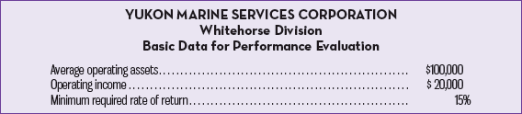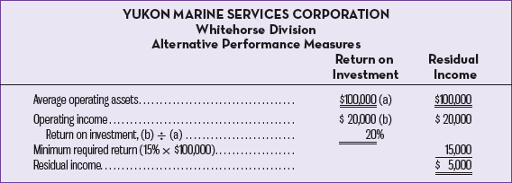

Motivation and Residual Income

Manager is considering purchasing a computerized diagnostic machine to aid in servicing marine diesel engines. The machine would cost $25,000 and is expected to generate additional operating income of $4,500 a year. This would be a good investment since it promises a rate of return of 18% ($4,500 ÷ $25,000), which is in excess of the company's minimum required rate of return of 15%. If the manager of the Whitehorse Division is evaluated based on residual income, she would be in favour of the investment in the diagnostic machine evaluated below:

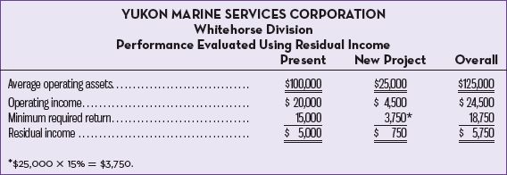
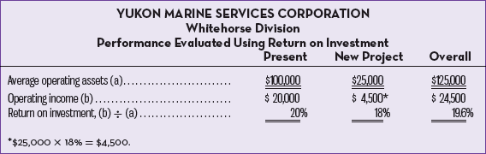
The new project reduces the division's ROI from 20% to 19.6%. This happens because the 18% rate of return on the new diagnostic machine, while above the company's 15% minimum rate of return, is below the division's current ROI of 20%. Therefore, the new diagnostic machine would reduce the division's ROI, even though it would be a good investment from the standpoint of the company as a whole. If the manager of the division is evaluated based on ROI, she will be reluctant to even propose such an investment. Generally, a manager who is evaluated based on ROI will want to reject any project whose rate of return is below the division's current ROI even if the rate of return on the project is above the minimum required rate of return for the entire company. In contrast, any project whose rate of return is above the minimum required rate of return for the company will result in an increase in residual income and thus add value for the shareholders. Since it is in the best interests of the company as a whole to accept any project whose rate of return is above the minimum required rate of return, managers who are evaluated based on residual income will tend to make better decisions concerning investment projects than managers who are evaluated based on ROI.

Division Comparison and Residual Income
Observe that Division X has slightly more residual income than Division Y, but that Division X has $1,000,000 in operating assets as compared to only $250,000 in operating assets for Division Y. Thus, Division X's greater residual income is probably more a result of its size than the quality of its management. In fact, it appears that the smaller division is better managed, since it has been able to generate nearly as much residual income with only one-fourth as much in operating assets with which to work. This problem can be reduced to some degree by focusing on the percentage change in residual income from year to year rather than on the absolute amount of the residual income.
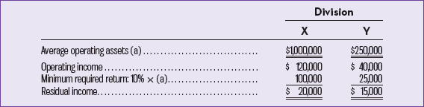

Criticisms of Residual Income
- Lead managers to make decisions more consistent with shareholders’ objectives.
- Closely related to shareholder returns.
  - Based on historical accounting data, accounting values used for capital assets can suffer from being out of sate when costs are rising resulting in inflated amounts for residual income.
  - Doesn’t indicate what earning should be for a particular business unit. Comparison is needed which involves using external benchmarks based on key competitors.
  - Calculating requires adjustments to financial information recorded using GAAP and can increase the costs of preparing the information.
  - Financial metric that doesn’t incorporate important leading non-financial indicators of success, such as employee motivation and customer satisfaction.

Balanced Scorecard
- Balanced Scorecard – An integrated set of performance measures that is derived from and supports the organization’s strategy.
- 3 successful generic strategic approaches to outperforming competitors:
  - Cost Leadership – Maintaining low cost through efficiency relative to competitors, a company can make superior profits at current prices. Company can become a price leader. Serves are a barrier against potential new entrants. Technological change by rivals can threaten success.
  - Differentiation – Products perceived as unique, customers will pay more giving the company higher profit margins. Higher profits reduces the effect of supplier or buyer power. Brand loyalty may fail is the cost difference between the firm and the cost leader becomes too wide.
  - Focus or Niche – Serving a narrow target market more effectively than rivals, company may achieve superior profitability. Risk of being overtaken by larger companies is a constant threat.
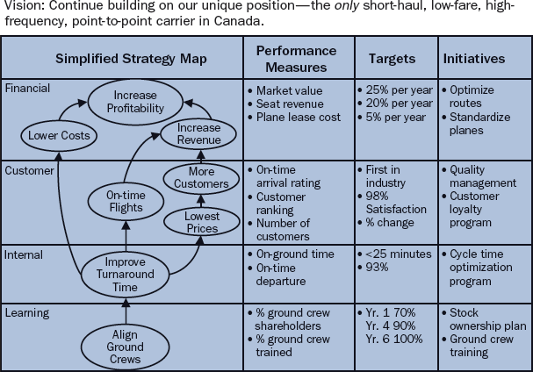

Chapter 11 – Appendix A

Transfer Pricing
- Transfer Price – The price charged when one segment provides goods to another segment of an organization.
- 3 approaches are used by when transferring prices:
  - Allow managers involved in the transfer to negotiate their own transfer prices.
  - Set transfer prices at cost, using variable or full absorption cost.
  - Set transfer prices at the market price.

Negotiated Transfer Prices
- Negotiated Transfer Price – A transfer price agreed on between buying and selling divisions.
- Autonomy of the divisions and is consistent with the spirit of decentralization.
- Managers of the divisions are likely to have much better information about the potential costs and benefits of the transfer than others in the company.
- Can predict two things:
  - The selling division will agree to the transfer only if the profits of the selling division increase as a result of the transfer.
  - The purchasing division will agree to the transfer only if the profits of the purchasing division also increase as a result of the transfer.
- If price is below selling division’s cost, a loss will occur on the transaction, if it’s too high it’ll be impossible for the purchasing division to make any profit on the transferred item.
- Range of Acceptable Transfer Prices – The range of transfer prices within the profit of both the selling and purchasing division would increase as a result of a transfer.
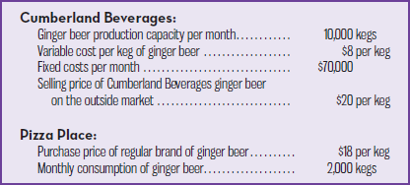
Selling Division’s Lowest Acceptable Transfer Price:
Purchasing Division’s Highest Acceptable Transfer Price:
Selling Division with Idle Capacity: 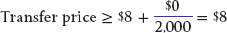,
= >
Selling Division with No Idle Capacity: , therefore no transfer is made (selling wants $20 and purchasing wants no more than $18)
Selling Division with Some Idle Capacity: , =>
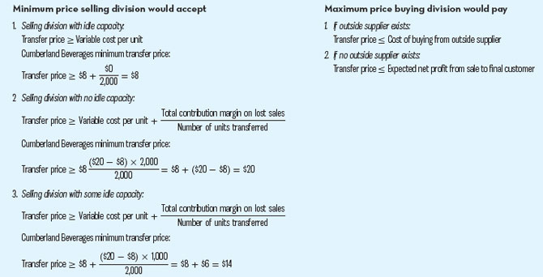

Transfers at Market Price
- Market Price – Price being charged for an item on the open market.
- Intermediate Market – Market in which a transferred product is sold in its present form outside customers.
- If the selling division has no idle capacity, the market price in the intermediate market is the perfect choice for the transfer price.
- Whether the item is transferred internally or sold on the outside intermediate market, the production costs are exactly the same.
- The market price is used as the transfer price, the selling division manager will not lose anything by making the transfer, and the purchasing division manager will get the correct signal about how much it really costs the company for the transfer to take place.

Quality Costs
- Quality of Conformance – Degree to which a product meets or exceeds its design specifications and is free of defects or other problems that mar its appearance or degrade its performance.
- Quality Cost – Costs that are incurred to prevent defective products from reaching customers or that are incurred as a result of defective units.
  - Broken down into 4 categories:
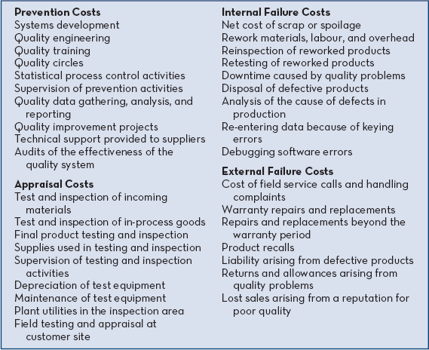
- They don’t relate to just manufacturing; they relate to all activities in a company.
- Quality costs can be very high unless management gives it special attention.

Prevention Costs
- Prevention Costs – Cost incurred to keep defects from occurring, any activity that reduces the number of defects in products.
- Quality Circles – Small groups of employees who meet on a regular basis to discuss ways on improving quality. Widely used in manufacturing companies, utilities, health care organizations, banks, etc.
- Statistical Process Control – Charting technique used to monitor the quality of work being done at a workstation for the purpose of immediately correcting any problems.

Appraisal Costs
- Appraisal (Inspection) Costs – Costs incurred to identify defective products before the products are shipped to customers.
- Maintaining inspectors is becoming a costly and ineffective approach to quality control.

Internal Failure Costs
- Internal Failure Costs – Costs incurred as a result of identifying defective products before they are shipped to customers.
- Costs of identification of defects in the appraisal process.
- The more effective a company’s appraisal activities, the greater the chance of catching defect internally and greater level of internal failure costs.

External Failure Costs
- External Failure Costs – Costs incurred when a product that’s defective is delivered to a customer.
- Can significantly reduce profits.
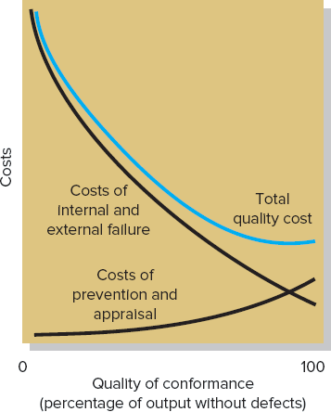

Quality Cost Reports
- Quality Cost Report – Report that details prevention costs, appraisal costs, and the costs of internal and external failures.

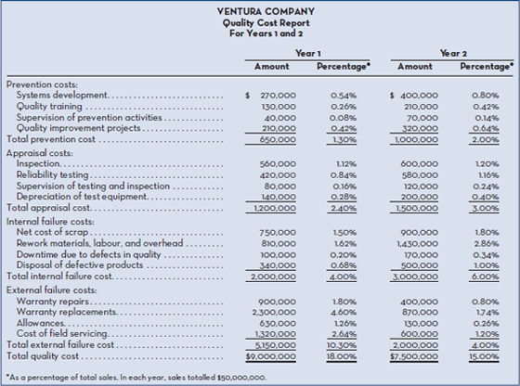
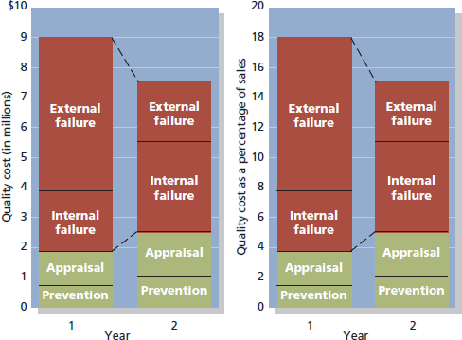

Internal Aspects of Quality
- ISO 9000 Standards – Quality control requirements issued by the International Organization for Standards.
- Supplier must demonstrate to a certifying agency that:
  - A quality control system is in use, and defines an expected level of quality.
  - The system is fully operations and backed up with detailed documentation of quality control procedures.
  - Intended level of quality is being achieved on a constant basis.

Direct Method
- Simplest of the three cost allocation methods.
- Ignores the services provided by a service department to other service departments (e.g., reciprocal services) and allocates all service department costs directly to operating departments.
- Even if a service department provides a large amount of service to another service department, no allocations are made between the two departments.
- All costs are allocated directly to the operating departments, bypassing the other service departments.
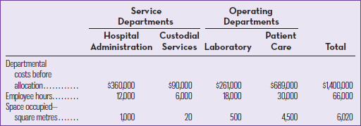
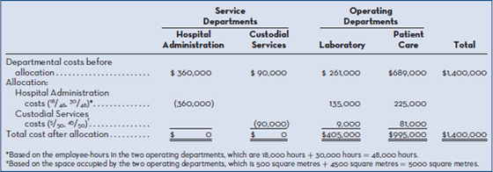

Step-Down Method
- Provides for allocation of a service department's costs to other service departments, as well as to operating departments.
- The sequence typically begins with the department that provides the greatest amount of service to other service departments.
- After its costs have been allocated, the process continues, step by step, ending with the department that provides the least amount of services to other service departments.
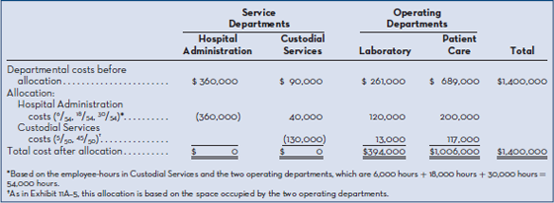

Reciprocal Method
- Reciprocal Method – Method of allocating service department costs that gives full recognition to interdepartmental services.
- Allocates service department costs in both directions.

Chapter 12 – Short-Term and Long-Term Decisions
- Relevant Cost – A cost that differs among the alternatives in a particular decision and will be incurred in the future.

Cost Concepts for Decision Making
- Avoidable Cost – Any cost that can be eliminated by choosing one alternative over another in a decision-making situation (Ex. Paying for movie or eating out instead of making food).
- 2 categories of cost that are irrelevant:
  - Sunk costs (e.g. previously owned computer to download movies).
  - Future costs that don’t differ between the alternatives (e.g. car payments when making decision between going to a movie vs. downloading one).
- Example of identifying Relevant Costs and Benefits:
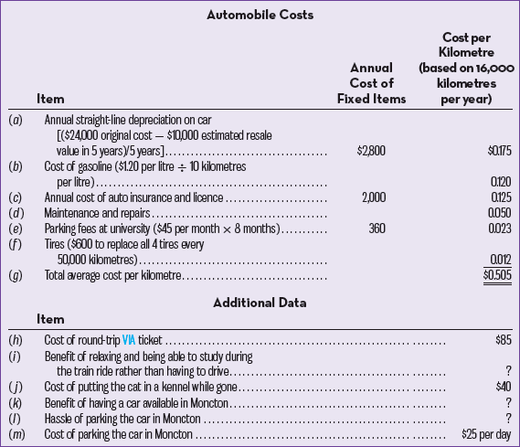
- a): Original cost of the car is a sunk cost, was already incurred and can never differ between alternatives. Irrelevant and can be ignored.
- b): The cost of gasoline consumed by driving is a relevant cost since she can choose to take a train instead and cost wouldn’t be incurred.
- c): Annual cost of auto insurance isn’t relevant. Whether she takes the train or drives her annual auto insurance will remain the same.
- d): Cost of maintenance and repairs is relevant. While maintenance and repair costs have a large random component, over the long run they are typically proportional to the amount the car is driven.
- e): Monthly fee that she pays to park at her university isn’t relevant. Regardless of which alternative she selects, she still needs to pay for parking at school.
- f): Cost of replacing all four tires is relevant. The more she uses her car, the sooner she will have to replace the tires.
- g): Some elements of the total average cost are relevant, but some are not relevant. Since it contains some irrelevant costs, it would be incorrect to estimate the cost of driving.
- h): The $85 cost of a round-trip ticket on VIA is clearly relevant in this decision. If she drives, she won’t have to buy the ticket.
- i): Although it is difficult to put a dollar value on relaxing and being able to study while on the train, this item is relevant to the decision. It is relevant because it is a benefit that is available only if she takes the train.
- j): The cost of putting he cat in the kennel while she is gone is clearly irrelevant to this decision. Whether she takes the train or drives to Moncton she will still need to put her cat in a kennel.
- k) and l): Relevant to the decision even if it is difficult to measure their dollar impacts.
- m): The cost of parking is relevant to the decision since it will be incurred only if she takes her car.
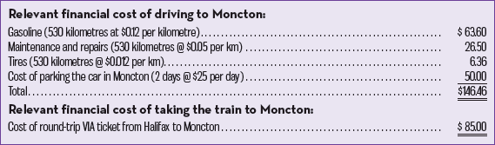

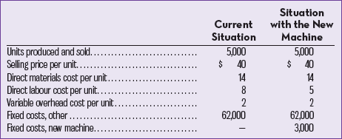
Total and Differential Approaches
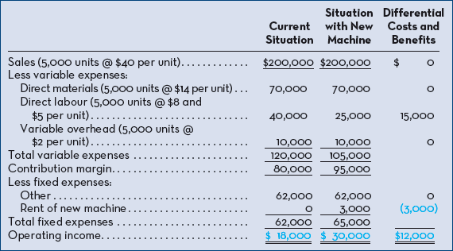
- Selling price/unit and number of units sold doesn’t differ between alternatives since total sales revenues and operating income are the same.
- Direct materials cost/unit, the variable cost/unit and number of units produced and sold don’t differ. They are the same and can be ignored.
- Other fixed expenses don’t differ, can be ignored.
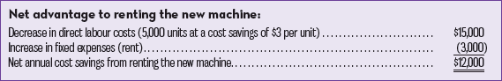

Adding and Dropping Product Lines and Segments
- If by dropping a product line the company is able to avoid more in fixed costs than it loses in contribution margin, then it will be better off if the line is eliminated, meaning the overall operating income should improve.
- On the other hand, if the company is not able to avoid as much in fixed costs as it loses in contribution margin, then the digital camera line should be retained.
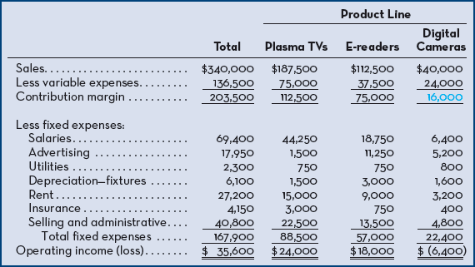
1. Salaries expense represents salaries paid to employees working directly in each product-line area. All of the employees working in digital camera–related activities will be laid off if the line is dropped.
2. Advertising expense represents direct advertising of each product line and is avoidable if the line is dropped.
3. Utilities expense represents utilities costs for the entire company. The amount charged to each product line is an allocation based on space occupied and is not avoidable if the product line is dropped.
4. Depreciation expense represents depreciation on fixtures used for display of the various product lines. Although the fixtures are nearly new, they are custom built and will have little resale value if the digital camera line is dropped.
5. Rent expense represents rent on the entire building housing the company; it is allocated to the product lines on the basis of sales dollars. The monthly rent of $27,200 is fixed under a long-term lease agreement.
6. Insurance expense represents insurance carried on inventories within each of the three product-line areas.
7. Selling and administrative expense represents the costs of accounting, purchasing, and general management, which are allocated to the product lines on the basis of sales dollars. Total administrative costs will not change if the digital camera line is dropped.
- They can then identify costs that can’t be avoided is the product line is dropped:
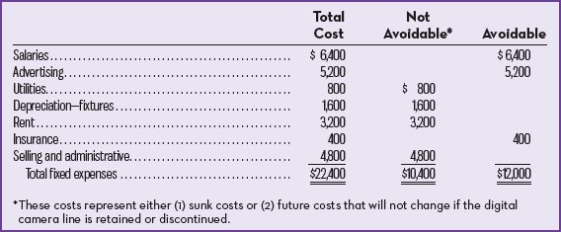
- Can compare the contribution margin:
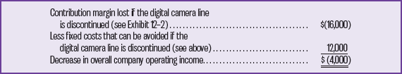
- The fixed costs that can be avoided by dropping the product line are less than the contribution margin that will be lost.
- The product line should not be discontinued unless a more profitable use can be found for the floor and counter space that it is occupying.

Comparative Format
Keep or Drop a Product/Segment
Relevant Costs and Benefits
- Contribution margin (CM) lost if dropped.
- Fixed costs avoided if dropped.
- CM lost/gained on other products/segments.
Irrelevant Costs
- Allocated common costs.
- Sunk costs.
Decision Rule:
Keep If:
CM lost (all products) > Fixed costs avoided + CM gained (other products).
Drop If:
CM lost (all products) < Fixed costs avoided + CM gained (other products).
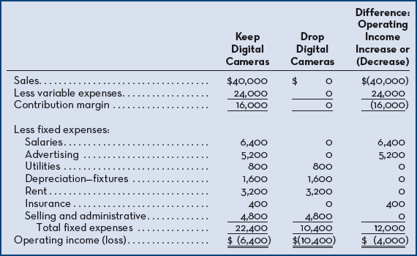

Allocation Fixed Costs:
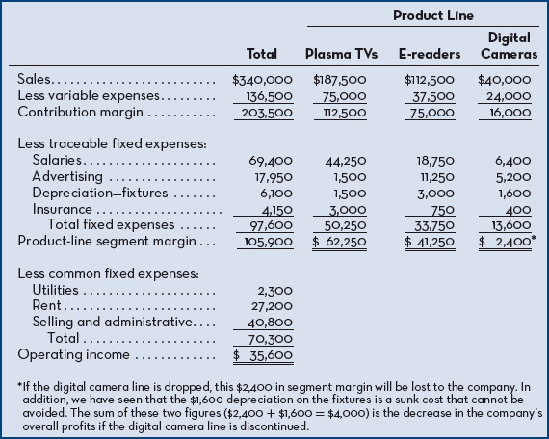

Make or Buy Decision
- Steps involved in getting a finished product to customers:
  - Raw materials are obtained (ex. mining, drilling, growing crops or raising animals).
  - Raw materials are processed to remove impurities leaving only desired usable materials.
  - Useable materials undergo preliminary conversion to be useable in final products.
  - Actual manufacturing of the finished product.
  - Finished product is distributed to the consumer.
- Vertical Integration – Involvement by a single company in more than one of the steps of the value chain, from production of basic raw materials to the manufacture and distribution of a finished product.
  - An integrated firm is less dependent on its suppliers and may be able to ensure a smoother flow of materials for production.
  - By pooling demand from a number of firms, a supplier may be able to realize economies of scale in research and development and in marketing, which results in higher quality and lower unit costs.
- Make or Buy Decision – Decision whether an item should be produced internally or purchased from an outside supplier.
- Example: Outside supplier has offered to sell OSN Cycles 8,000 shifters per year at a price of only $19 each. Should the company stop producing the shifters internally and start purchasing them from the outside supplier?
  - First: Determine the differential costs by eliminating the non-avoidable costs (sunk costs and the future costs that will continue regardless of the outcome).
  - Second: If these costs are less than the outside purchase price, then the company should continue to manufacture, if the costs are more than the outside purchase price they should buy it.
    - Materials, labour, variable overhead are differential costs that can be avoided.
    - Since it costs $5 less per unit to continue to make the product, they should reject the offer.
Make or Buy
Relevant Costs
- Incremental costs of making the product (variable and fixed)
- Opportunity cost of utilizing space to make the product
- Outside purchase price
Irrelevant Costs
- Allocated common costs
- Sunk costs
Total relevant costs of making = Incremental costs + Opportunity costs
Decision Rule:
Make If:
Total relevant costs of making < Outside purchase price.
Buy If:
Total relevant costs of making > Outside purchase price.

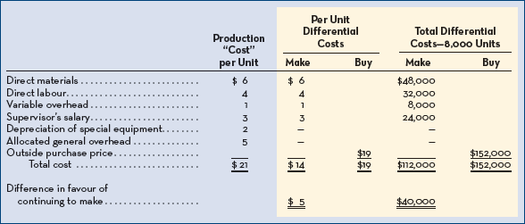
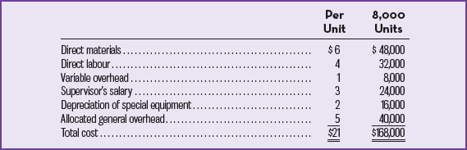
Opportunity Cost
- Space has an opportunity cost that must be considered, if the space is idle then that has an opportunity cost of 0; they aren’t recorded in the accounts.
- In this case, the segment margin is $60,000 per year, which means they should purchase from outside.
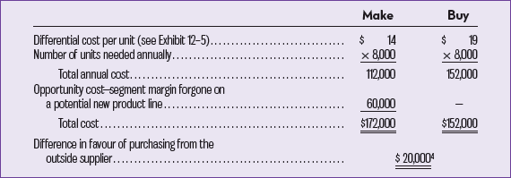

Special Orders
- Special Order – One time order that is not considered part of the company’s normal ongoing business.
- Must achieve positive operating income in order to make.
- Example: received a request from the police department of a large Canadian city to produce 100 specially modified mountain bikes at a price of $560 each. The bikes would be used to patrol some of the more densely populated residential sections of the city. OSN Cycles can easily modify its City Cruiser model to fit the specifications of the police department. The normal selling price of the City Cruiser bike is $700, and its unit product cost is $564.
  - The variable portion of the above manufacturing overhead is $12 per unit. The order would have no effect on the company's total fixed manufacturing overhead costs.
  - The modifications to the bikes consist of welded brackets to hold radios, nightsticks, and other gear. These modifications would require $34 in incremental variable costs per unit. In addition, the company would have to pay a graphic design studio $1,200 to design and cut stencils that would be used for spray painting the police department's logo and other identifying marks on the bikes.
  - Even though the price on the special order ($560) is below the normal unit product cost ($564) and the order would require incurring additional costs, it would result in an increase in operating income. In general, a special order is profitable as long as the incremental revenue from the special order exceeds the incremental costs of the order.
Accept or Reject a Special Order
Relevant Costs and Benefits -
- Incremental costs of filling the order (variable and fixed).
- Opportunity cost of filling the order.
- Incremental revenues from the order
Irrelevant Costs
- Allocated common costs
- Sunk costs
- Total relevant costs = Incremental costs + Opportunity costs
Decision Rule:
Accept If:
Incremental revenues > total relevant costs.
Reject If:
Incremental revenues < total relevant costs.
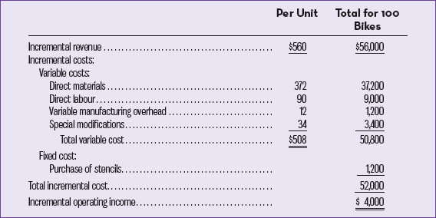

- Only incremental costs and benefits are relevant.
- Acquires additional costs but results in an increase in operating income.
- Must make sure that there is idle capacity and that the special order doesn’t affect the company’s ability to meet normal demands.
- Example: Company is already operating at 100% of capacity and normally sells all the bikes it can produce for $700 each? What is the opportunity cost of accepting the order? Should the company accept the $560 price? If not, what is the minimum price it should accept? To answer these questions, the analysis can be conducted as follows:
  - Since the total relevant costs of $746 exceed the offer price of $560, OSN Cycles should decline the offer. Indeed, to be no worse off from a financial perspective, the minimum price that should be charged on the special order is $746 per bike. At this price, management should be indifferent between filling the special order and continuing to sell all it can produce to regular customers.
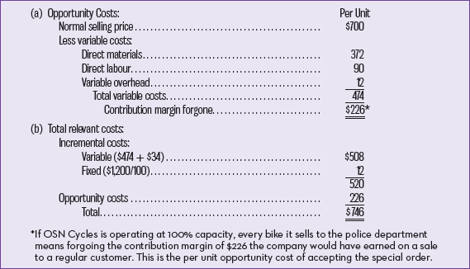

Joint Product Costs and the Sell or Process Further Decision
- Joint Products – Two or more items that are produced from a common input.
- Joint Products Costs – Costs that are incurred up to the split-off point in producing joint products.
- Split-off-Point – Point in the manufacturing process where some or all of the joint products can be recognized as individual products.
- Sell or Process Further Decision – Decision whether a joint product should be sold at the split-off point of processed further and sold at a later time in a different form.
  - Joint costs are irrelevant in these decisions since by the time the split-off point is reached joint product costs have already been incurred and are sunk costs.
  - Always profitable to continue processing a joint product after the split-off point as long as the incremental revenue from processing exceeds the incremental processing cost.
  - Joint product costs that have already been incurred up to the split-off point are sunk costs and are irrelevant in decisions going forward.
- Joint costs of buying and separating are irrelevant when considering profitability of the operating.
- Joint costs could be avoided if the entire operating were shut down.
- Company may be better off selling one or more of the products prior to more processing, to see what to do one must compare the incremental revenues to
the incremental costs from further processing.

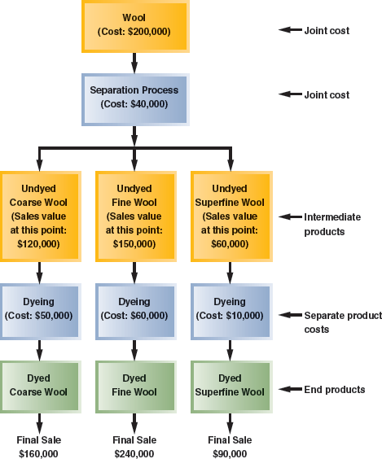
- It will always be profitable to continue processing a join product after the split-off point as long as the incremental revenue from such processing exceeds the incremental processing cost incurred after the split-off point.
Sell or Process Further
Relevant Costs and Benefits
- Incremental costs of further processing
- Incremental revenues from further processing
Irrelevant Costs
- Allocated joint product costs
Decision Rule:
Process Further If:
Incremental revenues > incremental costs of further processing
Sell at Split-off If:
Incremental revenues > incremental costs of further processing
- Joint product costs that have already been incurred up to the split-off point are sunk costs, which are irrelevant in decisions concerning on what to do from that split-off point.
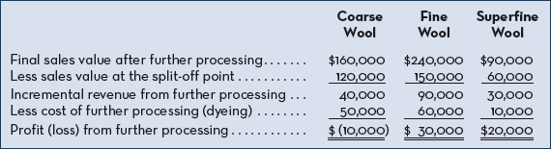
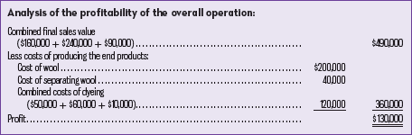
- Note that the joint costs of the wool ($200,000) and of the wool separation process ($40,000) play no role in the decision to sell or further process the intermediate products. These joint costs are relevant in a decision of whether to buy wool and to run the wool separation process, but they are not relevant in decisions about what to do with the intermediate products once they have been separated.

Using a Constrained Resource
- Constraint – Limitation under which a company must operate (such as limited machine time available) that restricts the company’s ability to satisfy demand for its products or services.
- Theory of Constraints – Management approach that emphasizes the importance of managing constraints.
Contribution Margin in Relation to a Constrained Resource
- A firm shouldn’t necessarily promote products that have the highest unit contribution margin.
- Total contribution margin will be maximized by promoting those products or accepting those orders that provide the highest unit contribution margin in relation to the constrained resource.
- Example: The mountain pannier appears to be much more profitable than the touring pannier. It has a $10 per unit contribution margin as compared to only $8 per unit for the touring model, and it has a 25% CM ratio as compared to only 16% for the touring model.
  - But the plant that makes the panniers is operating at capacity.
  - This doesn’t mean that every machine and every person in the plant is working at the maximum possible rate, since machines have different capacities, some machines will be operating at less than 100% of capacity.
  - However, if the plant as a whole cannot produce any more units, some machine or process must be operating at capacity. The machine or process that is limiting overall output is called the bottleneck—it is the constraint.
  - The mountain pannier requires four minutes of stitching time, and each unit of the touring pannier requires two minutes of stitching time. Since this stitching machine already has more work than it can handle, production will have to be cut back on one of the models.
  - Manager should look at the profitability index.
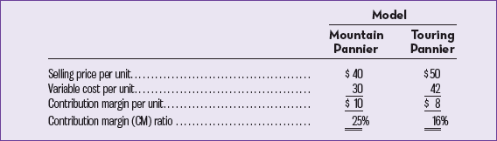
- Profitability Index – Contribution margin per unit / quantity of constrained resource required per unit.
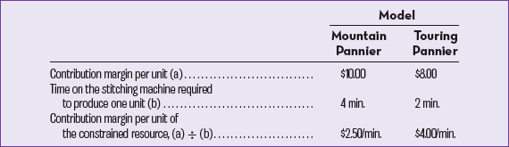
  - Each minute of processing time on the stitching machine that is devoted to the touring pannier results in an increase of $4 in contribution margin and profits.
  - The comparable figure for the mountain pannier is only $2.50 per minute. Therefore, the touring model should be emphasized.
  - Even though the mountain model has the larger per unit contribution margin and the larger CM ratio, the touring model provides the larger contribution margin in relation to the constrained resource.
  - Touring model is indeed the more profitable product when considering the constrained resource, suppose an hour of additional stitching time is available and that there are unfilled orders for both products. The additional hour on the stitching machine could be used to make either 15 mountain panniers (60 minutes ÷ 4 minutes) or 30 touring panniers (60 minutes ÷ 2 minutes), with the following consequences;
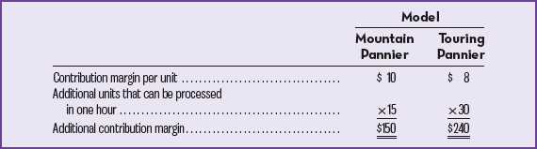

Managing Constraints
- Profits can be increased by effectively managing an organization’s constraints.
- If the constraint is a bottleneck in the production process, the manager should select the product mix that maximizes the total contribution margin.
- Management should focus efforts on increasing the efficiency of the bottleneck operation and on increasing its capacity.
- This will ultimately increase the output of finished goods and will often pay off.
- Relaxing (or Elevating) the Constraint – Increasing capacity of a bottleneck.
- Increasing the capacity of bottlenecks is done by:
  - Working overtime on them.
  - Subcontracting some of the processing that would be done as them.
  - Shifting workers from processes that aren’t bottleneck to a process that is.
  - Focusing business process improvement efforts such as total quality management and business process re-engineering on them.
  - Reducing defective units; each defective unit that is processed through a bottleneck results in the scraps being a good unit that could be sold.
- Bottleneck Example: The stitching machine operator could be asked to work overtime. This would result in more available stitching time and hence more finished goods that can be sold. The benefits from relaxing the constraint in such a manner are often enormous and can easily be quantified. The manager should first ask, “What would I do with additional capacity at the bottleneck if it was available?” In the bicycle pannier example, the additional capacity was worth $4 ($2.50) per minute or $240 ($150) per hour because adding an hour of capacity would generate an additional $240 ($150) of contribution margin if it were used solely to process more touring (mountain) panniers. Based on the profitability indices, additional capacity should first be allocated to production of touring panniers, followed by mountain panniers if any capacity remains. Since overtime pay for the operator is likely to be much less than $240 (or $150 for that matter!), running the stitching machine on overtime would be an excellent way to increase the company's profits while satisfying its customers at the same time.

