Phanerozoic – Paleozoic

Part A - Cambrian and Ordivician:
Acoelomate | A specific body plan of bilaterally  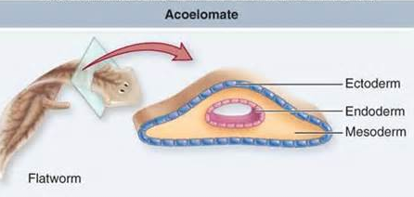  symmetrical animals or invertebrates that lack a coelem, which is a body cavity between the gut and body wall. Seen in flatworms, this means the mesoderm will fill up the space occurring between the ectoderm and endoderm and there will be no hollow body cavity. Phylogenies based on morphology suggest the acoelomate is ancestral but molecular trees disagree
Adaptive radiation | A cluster or group of closely related species that each adapt and become specialized to a specific habitat or food source. These related groups evolve in a relatively short time and split apart to have different characteristics allowing them to better target food sources or survive in an environment. Ex.Galapagos finches, which evolved from a common ancestor but now have unique appearances based on if they eat insects, seeds or fruits.
Amoebocyte (Archaeocyte) | Amoebocytes are migratory or mobile cells which circulate in body cavities of coelomates, by extending their cytoplasm or pseudopodia (false feet). This is amoeboid movement. They also have the ability to make any cell in the body and are important for digestion,reproduction and fighting disease. Archeocytes are a type of amoebocyte, found in sponges, that help regenerate the sponges and are undifferentiated,capable of developing into other types of cells (often their eggs). Ex. meosphyl
Aquiferous system | Type of system fund in sponges, consisting of canals and chambers through which water can flow. Water will then be pumped through this system by the choanocytes.
Archenteron (Enteron) | The primitive gut, which is the first tube or cavity running through the developing embryo and opens up into the outside environment. It is formed during gastrulation (early phase of embryonic development,) and surrounded by new endoderm. It will eventually develop into the digestive system. The enteron is the digestive tract or the complete gut, the recent version of the archenteron that is present not only for the embryo but during adulthood.
Arthropod (Arthropoda) | Arthropods are invertebrate animals with exoskeletons (made of chitin), segmented bodies and paired (jointed) appendages. They make up the phylum Arthropoda and include insects, arachnids and crustaceans. Evolved from the annelids in the Precambrian era.
Assymetric body plan | A body plan within an axis of symmetry running through and splitting up the body, to create identical parts. Common among sponges
Bilateral symmetry | In organisms, only one way that the axis of symmetry can pass through the longitudinal axis to create two identical halves. Allows for approximate mirror images when divided along the midline. It is a trait of organisms that are able to move freely through their environment.
Bivalve (Clams) | Any mollusk such as oysters, clams or mussels, which are a part of the class Bivalvia. These invertebrates have two shells hinged together (thus two or bi valve) and connected by a ligament, a soft body and lamellate (platelike) gills.
Blastopore | Opening in the archenteron or primitive gut that is formed during gastrulation. It will develop either into the mouth or an anus. Blastophores are the opening by which the grastula cavity can communicate with the exterior. It is what distinguishes protostomes and deuterostomes in embryonic development, because with protostomes, the first blastophore becomes the mouth and with deutorostomes, it becomes the anus.
Blastula | During the development of multicellular animals, this is a stage in which there is only one cell layer present (blastoderm) surrounding a fluid-filled cavity known as the blastocoels. Basically, at this stage, it ressembles a hollow ball of cells, and is the result of cleavage division early on in the embryo.  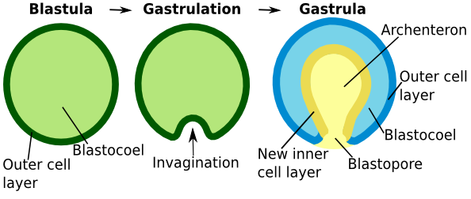
Bryozoa | Also known as moss animals or Ectoprocta, this is a phylum for aquatic invertebrate animals. They form branching colonies on surfaces like rocks and seeweed, are sessile and coral-like in appearance.
Burgess Shale fossils | Fossils from the Burgess Shale were first discovered in British Columbia by chance, when the railroad was built. After a rockslide, Charles Walcott, who collected thorusands of specimens, found what he thought were simply well preserved arthropods. In fact, they were never before seen organisms, from the Cambrian period. It was significant because it challenged the idea that slow change had occurred, since biodiversity exploded early and that predators and preys were simple in the beginning, since they were found to have huge complexity. All major types of animals and some of their unknown ancestors can be found in the Burgess Shale fossils
Cambrian burrowers | Organisms that burrowed under the microbial mats and past it, into the substrate during the beginning of the Cambrian period (Cambrian substrate revolution). The sea floor at the time was made of the microbial mat, followed by a hard layer of anoxic (oxygen free) substrate, where only bacteria lived since it was poisonous to other organisms. A burrower initially made its way into the substrate, loosening and oxygenating it, until others were able to enter, consume the bacteria and colonize. It gave them food, an anchor and these burrowers could avoid predator. These burrowers were first to show evidence of bilateral body plan.
Cambrian explosion | A relatively short evolutionary event which created tremendous biodiversity, introduced most of our modern major phyla at the beginning of the Cambrian period. This explosion of life lasted roughly 40 million years and saw the expansion from simple single celled organisms to more complex life such as marine based multicellular organisms and the species seen today. Some believed it was caused by the burrowers and increased oxygen.
Cambrian period | A period of the Paleozoic Era, which occurred from 550 to 488 Ma. In the beginning, algae and marine invertebrates dominated. It saw the Cambrian explosion, which saw the evolution of the chordates and many other groups. It is also characterized by the desert land areas, warm seas and rapid increase in biodiversity, with the appearance of almost all modern animal phyla. This [peiord marked the beginning of the continents and towards the end, was characterized by a mass extinction event.
Cambrian shelled arms race | A possible explanation for the cambrina explosion, it is the struggle between the prey that must stay alive and the predator, which has to compete for a meal. Predation became more intense as shell-crushing emerged. The evolution of eyes and other traits triggered the developed of hard shells for prey to survive and protect themselves. For prey to stay competitive, the durophagy trait emerged, which is the ability to consume hard shelled organisms, seen with fish and hyenas and other mammals (known as bone-crushers).
Cambrian swimmers | Organisms that dominated the mid-ocean level areas during the Cambrian era.
Cephalization | Development or evolution of a head, a distinct anterior region of the body. It contains specialized sensory structures where sensory organs and nervous system tissue are concentrated.
Cephalopod (Squids and Octapods) | Any mollusc of the class Cephalopoda, having tentacles attached to thehead, including the cuttlefish, squid, and octopus. These marine mollusks are also characterized by well-developed heads, a pair of eyes, and a ring of sucker-bearing tentacles.
Chitin | A complex carbohydrate or polysaccharide containing nitrogen. Chitin is a characteristic of the cell wall of fungi and the outer cuticle or exoskeleton of arthropods and crustaceans. It is excreted by the epidermal cells of arthropods
Choanocyte (Choanoflagellate) | Collar-shaped cells that are responsible for generating a water current in sponges, by beating their flagella. This movement brings O2 in the sponge and removes CO2. As well flagellum beating is able to trap food particles against the microvilli that form this collar. They have round cell bodies attached to the inside wall of the sponge and a single, whip-like flagellum.
Choanoderm | This is the layer of choanocyte cells that line parts of the aquiferous system in a sponge
Circular muscle | Muscle layer encircling the body between the epidermis and  longitudinal muscle layer. If the circular muscle contracts, the longitudinal muscle must lengthen, because they are antagonistic. The cells that line the gut have circular muscle fibres
Cnidaria | Phylum containing invertebrate animals such as jellyfish, sea anemones and coral. It is characterized by coelenterate, specialized stinging structures in the tentacles surrounding the mouth. Cnidarians also have radial symmetry, 2 cellular layers and saclike internal digestive cavities with a single opening.
Cnidocil | A modified flagellum on cnidocyte cells that cause the nematocyst inside to fire. It is a hair like sensory process. The stimulus involves some sort of chemical cue; touching the cnidocil doesn't fire the nematocyst.
Cnidocyte | Also known as the stinging cell, specialized explosive cells that can only be found in the Cnidaria. They contain a giant secretory organelle (cnida) that defines the phylum. When these cells turn inside out, a nematocyst (cell in tentacles that contain a venomous coiled thread to be projected in self-defense) is discharged. The nematocyst may act as a stinger or a sticky thread to entangle and capture prey.
Coelomate (Eucoelomate) | A specific body plan of bilaterally symmetrical animals or invertebrates  that have a coelem, which is a body cavity between the gut and body wall. It is the main body cavity in most multicellular animals and surrounds/contains the digestive tract and other organs. It is lined with mesodermal epithelium. Molecular trees suggest the acoelomate is ancestral but phylogeny disagrees disagree
Collagen | Tough fibrous glycoprotein found in the connective tissue of vertebrates and the cuticles of some invertebrates. The protein is flexible but doesn't stretch or compress. It gives connective tissue strength and provides cushioning.
Colonial choanoflagellate | Similar to choanocytes, it is hypothesis claiming that first animals evolved from flagellated protists living in colonies. Many modern choanoflagellates live in colonies, which supports it. It states that these colonial cells become more and more interdependent; some specialize to perform tasks, and differentiate, until they can’t survive on their own. This means they couldn’t be a colony anymore, but turn into a multicellular organism resembling a blastula and eventually, a gastrula.
Complete gut | An alimentary tract both anal openings through which undigested waste is voided and oral openings through which food enters (mouth and anus). It is an adaptation allowed for linear processing of ingested food with specialized areas in the gut for grinding, mixing, and digesting food under different conditions.
Corals | Hard, variously coloured skeleton secreted by certain marine polyps(hollow, columnar, sessile form of Cnidarians). Mostly colonial coelenterate (invertebrate animals of phylum Coelenterata with single internal cavity) with calcareous (chalky) structure. These collectively make up the coral reef.
Crustacean | Mostly aquatic arthropods from the class Crustacea and the phylum Arthropoda such as lobsters and shrimp, having the body covered in a hard shell. Contains an exoskeleton with chitin, are invertebrates with segmented bodies. They have a head, thorax and abdomen.
Cuticle | The nonliving, noncellular outer layer of plants and some animals, secreted by the underlying epidermis. Cuticles are common in a variety of animals including nematodes, annelids, and arthropods. It helps to prevent the plants from drying out by slowing water loss. The presence of a cuticle makes the presence of cilia impossible.
Deposit (Substrate) feeders | An aquatic animal that lives on or in the sediment of the sea floor and consumes particles of organic matter from the solid substrate on which it lives. It feeds on specks of organic matter that have drifted down through the water and settled at the bottom. It swallows this mud rich in organic material in order to obtain nutrients. Ex. Crabs, bass, shellfish
Deuterostome | Phyla, including the Chordata and Echinodermata, in which the anus develops from the first opening (blastophore) in the early embryo and the mouth develops later. There is radial indeterminate cellular cleavage in these embryo
Diploblastic | Organisms formed from only the two primitive cell layers--endoderm and ectoderm but no mesoderm. There is some type of a matrix between the two cell layers, often referred to as mesoglea or mesenchyme, but it isn’t a true tissue layer. This is seen with sponges and coelenterates  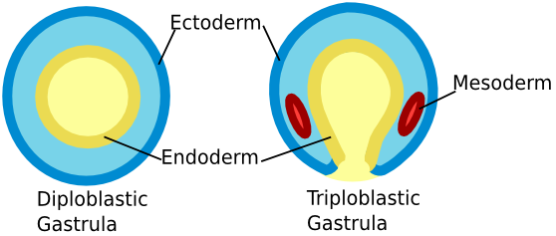
Doushantuo fossils | Extremely well preserved microfossils from the Doushantuo formation in Guizhou Province,China. They date from about 565 to 590 million years ago, before the Cambrian explosion, yet cellular structures can be visible under magnification, including soft tissues of embryos. The fossils include algaes, seaweeds, sponges, cnidarians and possible corals. Through these fossils, bilateral symmetry was observed, which a characteristic of modern organisms. It provides evidence for a theory that says that the diversification of organisms occurred even before the Cambrian explosion. Some of the animal embryos helped give a record for the early stages of cellular division. It is extremely similar to modern stages of early development but differ in later stages, demonstrating they are very primitive.
Ecdysis | Also known as molting, it is the periodic shedding of the outer cuticle (in insects and arthropods) , exoskeleton or old skin. Ex. The casting off of old skin by snakes.
Ecdysozoa | Group of protostomes which includes Athropoda and nematodes. These organisms build a chitinous or collagenous cuticle, an outer layer of organic material, to function as a lightweight flexible exoskeleton. This taxon was identified using molecular techniques and breaks the link between Anrthropoda and Annelids that was determined with traditional classification. Ecdysozoa get their name from the fact many in this category undergo ecdysis, regular shedding of their cuticle.
Ectoderm | Outermost cell layer that forms the epithelium and nervous system of animals. It is one of the three primary germ layers of an embryo. The epidermis and tissues like nails, hair and skin glands are derived from it.
Ediacaran fossils | Fossil impressions of soft-bodied organisms in sandstone, from the Proterozoic Eon at the end of the Precambrian. They have been preserved and can be found worldwide, although they were named after Ediacara Hills, the first place they were discovered. They are significant because they came before the Cambrian explosion and show the first metazoans (organisms made of more than 1 type of cell) that required O2 to grow. These soft-bodied organisms were similar to jelly-fish, sea anemones and seaweed, as well as other unknown organisms and were determined to be precursors to organisms with skeletons. These fossils told us that there had been surprisingly complex levels of evolution during the Precambrian period.
Ediacaran period | Period that marks the end of the Proterozoic Eon and the beginning of the Phanerozoic Eon (620 to 542 million years ago). It is characterized by the discovery of soft-bodied organisms that are the earliest known remains of multicellular life, and the appearance of a new chemically distinct carbonate layered that indicates climate change.
End Ordovician extinction | The second greatest mass extinction, which took place at the end of the Ordivician period (roughly 488 to 443 million years ago) and eliminated 85 percent of all the Ordivician species. It is preceded by the Cambrian period The extinction seems two have happened in two stages. The first was related to rapid cooling(possibly due to plaque movement) and the second is believed to have happened as a result of sea levels falling because of glaciations. This drop would have drained seas and reduce available habitats ,significant considering almost all organisms at the time were aquatic
Endoderm | The innermost layer of cells that forms the digestive tract, respiratory organs other associated organs. It is one of the three primary germ layers in the very early embryo. From it are derived epithelium of the pharynx, the bladder, urethra and more.
Endoskeleton | Supporting internal body structures of the skeleton surrounded by the body tissues, such as bones. As a result, there is living tissue on all sides of endoskeletal structures. Endoskeletons are found, for example, in echinoderms and chordates.
Enterocoel | Body cavity or coelem formed from a pocket-like outgrowth on the wall of the archenteron, often found in echinoderms and chordates.
Epidermis | Complex layer of tissue that covers an organism’s entire body. It’s often a continuous layer(in plants) or sometimes multiple layers of tightly packed cells (invertebrate animals). It is formed by the ectoderm and is a protective outer covering for many plants and animals, on top of dermis.
Epitheliomusculature | Also, known as myoepithelium, tissue comprised of myoepithelial cells arranged obliquely or longitudinally in sweat glands, mammary glands, lacrimal glands, and salivary glands. It is characterized as having both muscle and epithelial cell features. Seen with hydra and cnidarians
Exoskeleton | Supporting structures of the skeleton not surrounded by the body. Endoskeletal elements are secreted by an underlying epidermis and one side of the skeletal structures is exposed outside the body. Found, for example, in arthropods. It is a hard external covering of an organisms body that can block the passage of water and provide support and protection, like a beetle and its outer shell.
Filter feeding | Also known as suspension feeder, aquatic animals that ingest small food particles suspended in water. They feed on these particles of organic material strained or filtered out of water by circulating them through their system using currents. For example, most stationary feeders like clams, oysters, corals and sponges.
Gap (Septate) junctions | Cell junction that opens direct channels, allowing ions and small molecules to pass directly from one cell to another. Therefore, they are specialized intercellular connection between a multitude of animal cell-types. They directly connect the cytoplasm of two cells, which allows various molecules, ions and electrical impulses to directly pass through a regulated gate between cells.
Gastrodermis | Endodermal or inner layer of cells that line the gastrovascular cavity (coelenteron) of cnidarians. It is the endodermis of the cnidarians gut.
Gastropod (Snails) | Organisms in the class Gastropoda of mollusks (inclusing snails and slugs), characterized by a ventral muscular foot that the rest of the body sits on, tentacles on a distinct head, a univalve shell or none at all, and eyes.
Gastrozooid | Polyps in colonial coelentrates specialized for feeding; also referred to as hydranths. They are zooids (animals arising from others by divisions, making up colonial organisms) provided with a mouth and digestive organs to carry out digestive functions. At the gastrozooid base, there are zooid adapted for capturing prey and these transfer prey up to the gastrozooid to be digested.
Gastrula | A sac-like animal embryo at the stage following the blastula,where the embryo consists of two cell layers, an outer ectoderm and an inner endoderm, surrounding the primitive gut (archenteron) opening to the outside through the blastopore. Results from cell of blastula that migrates and divides once cleavage is complete.
Gastrulation | Second major process during early embryological development this stage results in the blastula is converted into a gastrula. Cells migrate toward the inside of the embryo from the region where the blastopore will form to create the second germ layer (endoderm). The embryo changes from having only one cell layer to having two cell layers, with three distinct primary tissue layers.
Gonozooid | Also known as gonangia, a polyp in colonial hydrozoans or coelenterates specialized for producing medusa, the reproductive stage in the life cycle. It is basically a sexual zooid which bears the gonads
Herbivores | An animal that obtains energy and nutrients primarily by eating plants or autotrophs. They are on the second level of food chain. Ex. Sheep, cows, deers.
Hermaphrodite (Hermaphrodism) | Organism having both male and female sexual organs and other sexual traits. Most flowering plants or angiosperms are hermaphrodite.
Homeotic genes | Class of genes that regulate development of anatomical structures during embryonic development. Encode proteins called transcription factors that direct cells to form various body parts of the body or repeated homologous structures like vertebrae or slower organs. Ex. genes were first identified in Drosophila fruit flies, through the occurrence of mutations that alter the development of entire body segments. Drosophila flies have two major clusters of homeotic genes: the antennapedia complex, which controls development of the head and anterior thoracic segments, and the bithorax complex, which governs the development of posterior segments.
Homeotic mutants | A mutation that causes tissues to alter their normal differentiation pattern, producing integrated structures but in unusual locations. Ex. a homeotic mutation in the fruit fly, Drosophila, causes legs to develop where antennae normally form.
Hox genes | Type of homeotic gene that control an embryo’s body plan along the cranial-caudal (head-tail) axis. It determines the orientation of a structure and also the identity of each body segment in early embryonic development.
Hydrostatic skeleton | Also known as hydroskeletons, formed by a fluid-filled closed cavity(coelem), which is surrounded by a body wall that contains muscles oriented in different directions. Muscular contractions help it to maintain its rigid shape or to change shapes, allowing for movement. There is no rigid support such as bone involved. It is found in soft-bodied invertebrates such as Cnidaria. It’s an exoskeleton that works because the muscles contract to change the shape of the coelom, which then produces movement due to the pressure of the fluid inside the fluid-filled cavity. Without pressure, these skeletons collapse.
Incomplete gut
  A digestive system that has only a mouth and no anal opening. Therefore, there is only 1 blastophore. Both ingested food and the undigested food must pass
  through the same opening to the alimentary tract.
Ingestive heterotrophy | An animal or protest that gets its nutrients by ingesting complex organic material before digesting it, as humans do. These organisms can’t manufacture their own food so obtain food and energy from organic substances in plants and animals.
Insecta | One of arthropoda classes, insects are invertebrates characterized as having one pair of antenna, a chitinous exoskeleton, a three part body (head, thorax, abdomen), three pairs of jointed legs, compound eyes
Larva | Distinct juvenile form many animals undergo before metamorphosis into adults. Animals with indirect development such as insects, amphibians, or cnidarians typically have a larval phase of their life cycle where they are newly hatched and clearly different in appearance to mature organisms. For insects, it will be the immature, wingless, often worm-like feeding stage of an insect.
Larval amplification | A form of asexual reproduction where, during the life cycle, a single larval organism can produce large numbers of the next developmental stage. A good example is the fluke life cycle. A single sporocyst develops into hundreds of redia.
Longitudinal muscle | Simply referring to the way smooth muscle fibers are organized, running lengthwise. longitudinal muscle fibres run lengthwise along the body, and are encircled by the circular fibers. Longitudinal muscle is mainly concerned with peristalsis and is also what contracts to allows for pressure in hydrostatic skeletons since it cradles the coelem.
Lophophore | It is a circular or U-shaped fold of one or two rings of hollow ciliated tentacles that surround the oral opening or mouth in a number of animal phyla. It is still uncertain but some consider the lophophore to be a unique character of the phylum Lophophorata. Lolophores are used to gather food. Seen especially with brachiopod or bryozoan
Lophotrochozoa | A new taxon that was discovered and supported by recet molecular evidence, it includes all the animals with a lophophore or a trochophore larval stage. Lophotrochozoans and ecdysozoans, animals with a cuticle, no epidermal cilias, and who shed their outer cuticle, were normally combined as the protostomes in traditional evolutionary classification of animals.
Mantle | A thin sheetlike membranous extension of the visceral mass of molluscs and brachiopods that forms two flaps of skin. The mantle secretes the shell on the dorsal side and the space between the two flaps of skin is referred to as the mantle cavity. Therefore, it forms the outer or dorsal wall in mollusks and encloses its visceral mass, which includes all of its internal organs. It is muscular and has been modified by many species for feeding and propulsion.  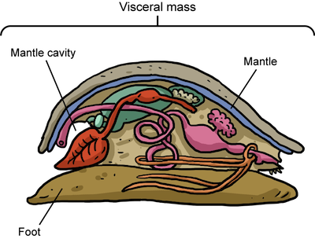
Mantle cavity | The protective chamber produced by the mantle in many molluscs. It is created when the mantle secretes a shell beyond the bodywall, meaning is a gap between the mantle and the animal’s body. It contains the respiratory organs.
Medusa | The free-swimming, mobile stage of the cnidarian life cycle. This stage, when present, is reproductive and mature gonads form on either male or female medusae. At this point, Cnidarian is umbrella or disk shaped and gelatinous, unlike the polyp form, which is the other sessile body form of the Cnidarians. For movement, medusa will have a bell that pulsates, allowing them to almost bob (Ex. like jellyfish).
Mesoderm | The third cell layer that develops in the gastrula between the ectoderm and endoderm in triploblastic animals (with 3 primary germ layers in animal embryo). Mesoderm develops into muscle, connective tissues, and bones, as well as blood and other components of the vascular system.
Mesoglea | A layer of gel-like connective tissue separating the gastrodermis and epidermis in radially symmetrical animals .This jellylike layer is therefore found between the ectodermal and endodermal cell layers of diploblastic organisms. It acts as a type of cement holding the two layers together but, unlike mesenchyme (embryonic connective tissue coming from mesoderm), it has few or no cells.
Mesohyl | Gelatinous, protein-rich matrix that is the middle layer of cells lining the body wall or cavity of a sponge. It divides the choanocytes from the epithelial cells and, contrary to what used to be believed, isn’t homologous with mesoderm.
Metamere (Metamerization) | 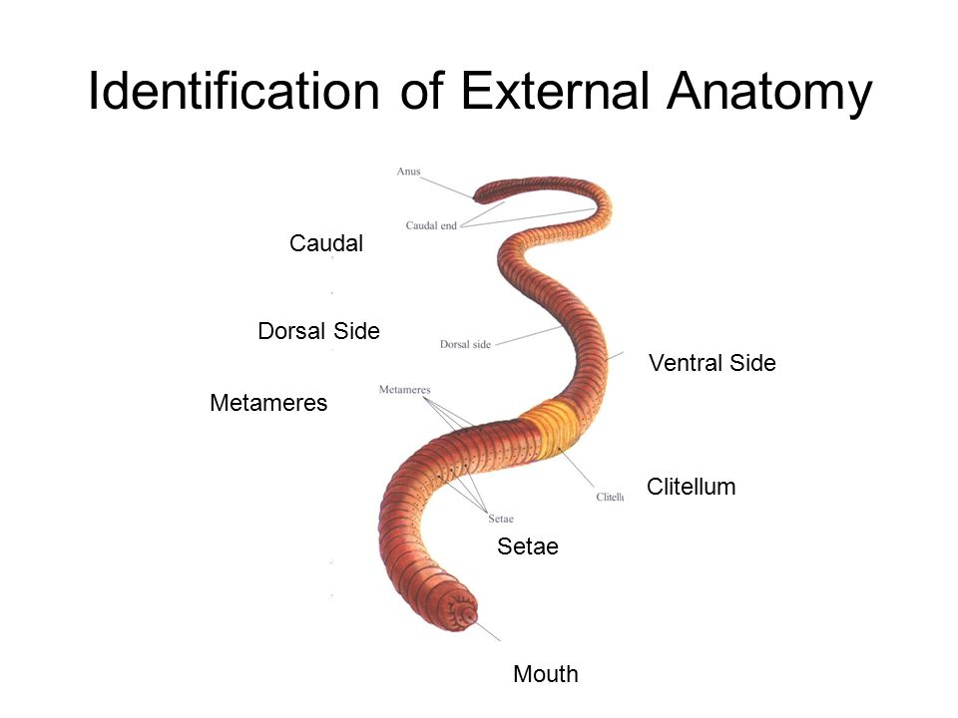  A metamere or somite, it is a single repeated unit in segmented animals that have undergone metamerisation. Each metamere contains identical structures to the metameres adjacent to it. A metamere is a homologous or primitively similar segment that makes up the bodies of certain animals, by dividing it longitudinally. Ex. Earthworms, lobsters, crayfish
Miniaturization | Much smaller in size than normal animals of the species, but with normal proportions. Animals born prematurely are miniatures but show evidence of prematurity in their haircoat, unerupted teeth and immature hooves. Can also be to make in extremely small size in order  to keep volume or weight to a minimum
Mollusc | Any of a large phylum of invertebrate animal like snails and lams, that have a soft unsegmented body normally in a calcareous shell. They first appeared in the Cambrian period. Molluscs all have a toothed tongue (made of chitin) called the radula, a mantle, a muscular foot (or tentacles) and a coelem.
Mucous glands | Glands found in several parts of the body, which cells secrete mucus, a slippery secretion that is rich in glycoproteins and water . These glands help with water balance and help protect from bacteria and are often found clustered in the mucous membranes lining body cavities
Mutable connective tissue | Connective tissue with the ability to reversibly vary the rigidity of their tissue ( ex. hard to soft with sea cucumber). Under the influence of the nervous system, it can quickly change its mechanical properties. This allows for a good defense mechanism and is used for protection. It can also be used in feeding, like in the case of a sea star over a mussel. This type of tissue is characteristic of the phylum echinodermata (starfish, sea urchins, sea cucumbers).
Nematoda (Round worm) | Phylum of invertebrates including unsegmented worms with bilateral symmetry, elongated and tapered appearance at ends, and that are triploblastic.They usually have thick and flexible collagenous cuticles, and only longitudinal body wall muscles (no circular). They also have complete digestive tracts, with no blood or respiratory systems. Many are parasitic and disease causing.
Onychophora (Velvet worm) | Class of small, elongated, and velvety textured wormlike terrestrial invertebrates that live in damp dark habitats in warm regions. They resemble slugs with legs and are sometimes described as the missing link between arthropods and annelids
Oral papilla | Small, round or cone-shaped protuberances (Papilla in Latin=nipple like) or projection on the top of the tongue that contain taste buds. These small bumps are what give tongue it’s rough texture and thousands of tastebuds cover the surfaces of the papillae. In fish, papilla in their mouth can be small lumps of dermal tissue.
Oral-aboral axis | 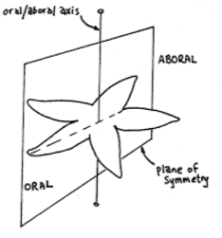  Also known as the anteriorposterior axis, the main axis in radial symmetry, going from the mouth (oral) to the opposite or posterior end of animal, sometimes the anus (aboral).
Ordovician period | Second of six periods in the Paleozoic Era, spanning from 485.4 to 443.8 Mya. Algae were very common and the first armoured fish evolved during this time. It saw changes in plate tectonics and climate. Rapid seafloor spreading caused high sea levels (that continued to fluctuate throughout) , which lead to a lot of flooding and deposited sediment blankets all over North America. Levels of CO2 were very high, which created high temperatures until glaciations at the end of the period, when end of Ordovician extinction took place as a result. The period was also characterized by a lot of diversification, as Ordovician radiation saw the appearance of almost every phylum of modern marine invertebrates, as well as the rise of fish.
Paleozoic era | It is the longest of the Phanerozoic eras, and is subdivided into six geologic periods (from oldest to youngest): the Cambrian, Ordovician, Silurian, Devonian, Carboniferous, and Permian. It occurred between 570 and 230 million years ago and is characterized by a large diversity of marine invertebrate animals. The era also saw the appearance of primitive fish, insects and trptiles. The end of the Paleozoic era is marked by the largest recorded mass extinction in the Earth's history (Permian-Triassic), which wiped out nearly 90%  known marine life forms. It is suspected asteroid impact may have been involved.
Pentaramous symmetry | 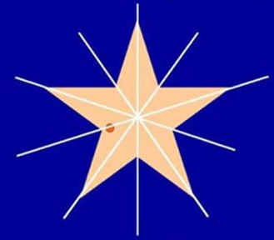  Type of radial symmetry where the body can be divided roughly into five parts (pentamerous meaning divided in 5 , that can all be arranged around the axis of the moth at 72 degrees apart.  Unique to echinoderm like starfish, sea urchins and cucumbers.
Pharynx | The throat. In some invertebrates,such as annelids and arthropods, a protrusible (extendable) tube used to bring food into the mouth for passage to the gastrovascular cavity. In mammals, the common membrane lined pathway for air entering the larynx and food entering the esophagus. In most animals it is muscular and forces food into the digestive tract that lies behind it. It is conical in shape and serves a function for both the digestive and respiratory tract.
Phytoplankton | Microscopic, free-flowing aquatic plants and protists. These small, single-celled organisms are autotrophic or self-feeding components of the plankton community and an important part of aquatic ecosystems. They make their own food from sunlight through photosynthesis and include many different types, such as cyanobacteria and diatoms. As well, all phytoplankton are considered algae. They are one of the most common primary producers, meaning they form the base of most aquatic food chains, since they are the main food source of zooplankton to fish, even whales.
Pinacoderm (Pinacocyte) | Pinacoderm is the outer layer of pinacocyte cells in a sponge, which are: flattened cells that cover the surface of a sponge, are capable of synthesizing collagen and can be expanded or contracted at their margins to allow the whole animal to alter its size slightly. As well, at the base, the pinacocytes secrete a substance which anchors the sponge to its substrate. pinacoderm is not a tissue, only a layer of cells that can be found on the external surface of a cell, as well as lining its canals.
Platyhelminthes | A phylum of invertebratre, unsegmented worms having bilateral symmetry and a soft, thin, usually flattened body, comprising the flatworms. They are acoelomate, triploblastic, have incomplete guts and they have organ systems, including an excretory, digestive, reproductive, and primitive nervous system, but no respiratory system. They accomplish movement using cilia.
Platyzoa | The infrakingdom(category inserted below subkingdom) of animals or protostomes that have three tissue layers but lack a coelom. Molecular evidence supports the taxon that includes Platyhelminthes, Gastrotricha, Gnathostomulida, Rotifera, and the recently discovered Cycliophora.
Polyp | The sessile, asexual stage in the cnidarian life cycle (the other being medusa). In some species they are independent, elongated and hollow organisms; in others, they form colonies where some polyps are involved in food gathering (gastrozooids) and other polyps (gonozooids) produce the reproductive stage. It is cylindrical in shape, has a mouth surrounded by tentacles at one end and is attached to a surface on the other end. Ex. In the life cycle of jellyfish and sea anemones.
Porifera | Prorifera(meaning pore bearer), is a phylum of primitive invertebrate animals including sponges, which have no true tissue or organ formation. Instead, their body is permeated with canals and holes through which a current of water flows and passes in its course through one or more cavities lined with choanocytes that allows them to filter-feed.
Primary consumers | A herbivore, a member of the second trophic level, which feeds on autotrophs.The plants they will consume have undergone the process of photosynthesis and therefore contain energy that will be directly passed on to the organism. A carnivore, that will eat this herbivore, would become a secondary consumer since the energy has been passed on or consumed through a secondary source.
Primary producers | An autotroph, usually a photosynthetic organism, a member of the first trophic level. This will be the plant or organism that is undergoing photosynthesis or chemiosmosis to gain energy and produce that complex organic matter to be passed on directly to herbivores or primary consumers.
Protostome | 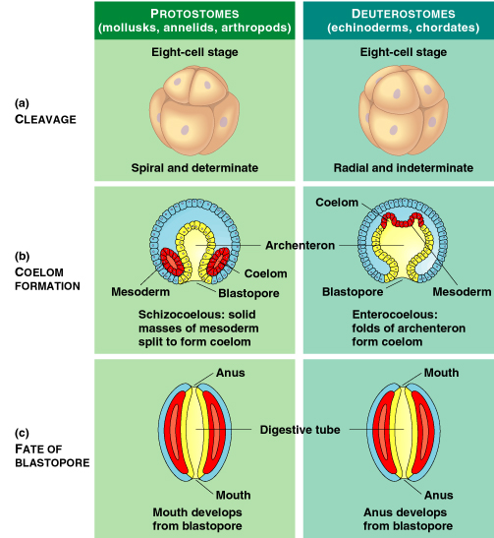  A division of the Bilateria in which the blastopore forms the mouth during development of the embryo and the anus appears later. Therefore, it is the opposite of the development with deuterostomes. As well, protostomes are determinate or differentiated and include molluscs and annelids.
Pseudocoelomate | Invertebrate animals with a body plan of bilateral symmetry, that have a body cavity that is not completely lined by mesoderm. Therefore, the cavity between the gut and the outer wall is not a true coelem (ie.pseudo). In the past these organisms were referred to as the phylum Aschelminthes but this is no longer considered acceptable because there is no apparent common ancestor to the group. Examples include the ringworm or nematodes.
Radial cleavage | During development as the cells of the zygote divide, the products of the cell division remain stacked directly on top of each other. It is cleavage pattern in deuterostomes in which newly formed cells lie directly above and below other cells of the embryo.
Radial symmetry | 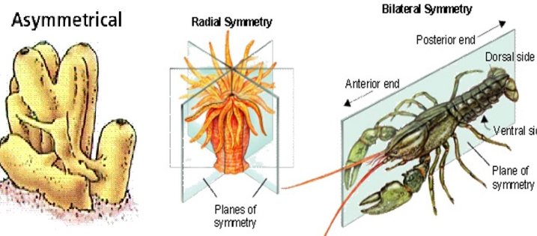  When an organism's body parts are arranged around the oral-aboral axis so that any plane passing through this axis results in two identical halves. It is a body plan in which structures are arranged regularly around a central axis, like spokes radiating out from the centre of a wheel. It is a characteristic of sessile- and bottom-dwelling animals such as echinoderms, cnidarians and sea sponges and anemones.
Radula | This unique feeding structure is an ancestral characteristic of all animals in the phylum Mollusca. It looks like a tongue covered with teeth and works like a file to rasp food off the substrate. It is drawn backward and forward over the floor of the mouth in the process of breaking up food. It can also drill through the shells of prey
Reefs | A structure made from the hard skeletons of coral animals or polyps; found largely in tropical and subtropical marine environments. They are built by colonies of tiny animals found in marine waters that contain few nutrients and mounds of deposits from algae, molluscs and protozoans. Most reefs grow best in warm, shallow, clear, sunny and agitated waters and the shallow reefs form some of the most diverse ecosystems on the planet.
Schizocoel | A true body cavity that forms by schizocoelus (splitting of the mesoderm). Often contained by protostomes, it is simply a pattern of animal embryonic development when a solid mass of mesoderm cells divide into a coelom.
Segmentation | In general, the production of body parts and some organ systems in repeating units. Segmentation is the division of the body into a series of identical segments, metameres, that are repeated down the longitudinal axis of the animal. Each metamere contains identical structures to the metameres adjacent. Ex. The process by which the identical segments or metameres on earthworms or lobsters can be seen.
Seminal receptacle | Also known as spermatheca, part of the female (or hermaphrodite) reproductive system where sperm (spermatozoa) received from the male during mating is stored and later used to fertilize the eggs (ova). Most common in invertebrates and some female vertebrates,it is a sac or a cavity for storage before fertilization begins.
Seminal vesicle | In invertebrates, part of the male reproductive tract where sperm is stored prior to mating. It is the small, tubular, saclike accessory gland in the male reproductive system of amniote vertebrates that produces the nutrient fluid part of the ejaculate or semen, secretes seminal fluid that mizes with sperm to form semen. This vesicle also promotes the movement of sperm.
Setae (Setal hairs) | Bristles, or hairlike structures, that extend or protrude outward from the body wall. Usually made or reinforced of chitin, they are common in annelids and arthropods (mostly invertebrates).
Slushball earth | This hypothesis counters the snowball earth hypothesis and proposes that Earth wasn;t completely frozen during periods of extreme glaciation in Precambrian times.Instead, it claims that, in addition to massive ice sheets covering the continents, parts of the planet (especially ocean areas near the Equator) could have been draped only by a thin, watery layer of ice amid areas of open sea. If this is true, photosynthetic organisms in areas with little or no ice could continue to capture sunlight efficiently and survive long periods of extreme cold.
Snowball earth | Hypothesis proposed by geologist J.L. Kirschvink, which suggests that Earth’s oceans and land were completely covered by ice during at least two extreme cooling events between 2.4 billion and 580 million years ago. This would mean the coolest global climate imaginable, with glacial ice from pole to pole. Evidence supporting this includes old preserved rocks that are known to be associated with the presence of ice, found near the Equator. It is believed that the Earth thawed because of out gassing of massive amounts of carbon dioxide by volcanoes enhancing the planets greenhouse gases or as a result of hot springs and deep-sea vents. However, both of these ideas have been heavily contested, which brought about the Slushball Earth hypothesis.
Spiral cleavage (Spiralia) | 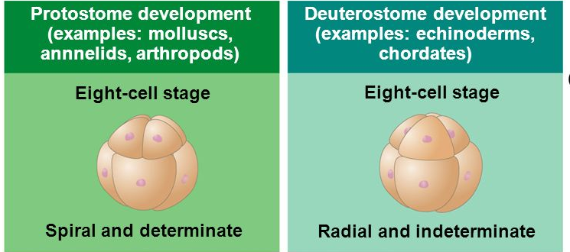  Pattern of cell division in the developing embryo where the products of the cell divisions shift by rotating either clockwise or counterclockwise so that the resulting daughter cells lie in the furrow of the underlying pair of cell. The opposite of radial cleavage.
Sponges | Aquatic animals of phylum Porifera, multicellular, with bodies full of pores and channels allowing water to circulate through them. They are made of jelly-like mesophyl between two thin layers of cell. They have a calcareous internal skeleton, occur in sessile colonies, are filter-feeders and lack tissue organization.
Spongocoel | The central internal cavity of asconoid(simplest of sponges with single layer choanocytes) and syconoid(intermediate complexity and size). Water enters spongocoel through hundreds of tiny pores (Ostia) and exits through the larger mouthlikeopening (osculum). There is no spongocoel in leuconoid sponges, as they are more complex, multicellialr and have bodies full of pores and channels.
Tagma (Tagmatization) | The distinct body regions, tagmata, resulting when different segments of a metameric animal become involved in specific functions. These segments are modified to carry out that function and their appearance changes, as they are grouped into coherently functional morphological unit. A well known example would be the head, thorax and abdomen of insects.
Totipotent cells | Cells that can develop into or generate a new organism or body part. They are undifferentiated, have the potential develop into any cell or tissue. These can be helpful for repair and regeneration. Ex. zygote which came from the unification of the egg and sperm cell and has undergone several sexual cellular divisions.
Trilobite | Fossil group of extinct marine arthropods that form the class Trilobita, found in Paleozoic rocks. These organisms have bodies divided by two furrows on the dorsal surface, into three lobes.
Triploblastic | Organisms formed from the three embryonic cell layers: endoderm, ectoderm, and mesoderm. Includes most multicellular animals, except coelenterates
Trochophore | This free-swimming ciliated larval stage is found in a number of animal phyla including the Mollusca and Annelida. The larvae has a unique circle of preoral(aound or before mouth) cilia around the middle of the body. Trochophores are often considered an ancestral characteristic of protostomes.
Trochozoa | A group of Invertebrata including all those (the annelids and mollusks) whose early larval stage is normally a trochophore.
Tube feet
  Hollow and fluid-filled tubes that are part of the water vascular
  system in Echinoderms. Muscles associated with the tube feet
  allow them to be hydraulically controlled and function in
  locomotion, attachment, food gathering, and gas exchange.
Water vascular system | A characteristic of echinoderms. It is a modification of the coelom, and this closed, water-filled system forms canals and branches throughout the body. In one part, the tube feet, it acts as hydrostatic skeleton permitting locomotion.
Yolk sac | In an amniote egg and in most vertebrates, a membrane or sac that is attached to the gut of an embryo that encloses the yolk, which is serving as its energy source. It is seen in bony fish, reptiles, and primitive mammals and birds. With placental mammals, it is a hollow cavity that functions as a part of the embryos circulatory system before placenta develops. It is been associated with the development of the primitive gut.
Zooplankton | Small, usually microscopic, invertebrate animals that float in aquatic habitats. These are hetrotrophic plankton, omprised mainly of freely floating protozoa, small crustaceans and fish eggs (therefore small animals and the immature stages of larger animals). It is the basic element of marine food chain. Ex. Krill, which is consumed often by whales

