CRIM Class 9 – September 8th

What is Criminology?
- Criminology is a rendezvous point for many disciplines, providing unique perspectives (each of which includes strengths and liabilities) on issues of crime, criminality, criminal justice, security, and public safety.
- The body of knowledge regarding crime as a social phenomenon.
- Includes the processes of making laws, breaking laws, and reacting to the breaking of laws.
- Its objective is the development of a body of general and verified principles and of other types of knowledge regarding this process of law, crime, and treatment.
- Mainly focused on stating institutions.
- It originally grew up as a state knowledge.
- Criminology became a lot more critical and philosophic, that lead to understand the criminal thought of it easier.

Why are we here?
- Objective One: Conceptualization/Categorization
- Do focus on stating institutions.
- What makes the people tick.
- Individualistic versus macro accounts
- Consensual versus conflict perspectives
- Situate what you read and therefore what you think somewhere in this grid – what kind of theory is this? What kind of theorist am I?

Typology of theories/approaches to criminology:
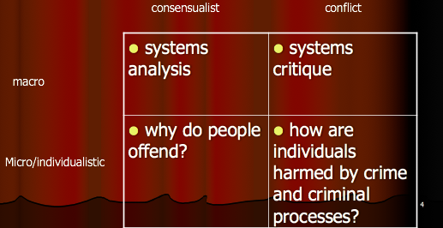

- The system analysis consists of what makes it better.
- Why do people offend? It consists of what makes people tick for them to commit a crime.
- The systems critique is usually known as an unfair system, where people will eventually critique.

Objective two: Denaturalization
- All aspects of society are social inventions: many of them are recent inventions.
- Inventions should be maintained when they are useful; they should be changed when they prove to no longer be useful

Policing
- What is policing? It is an inforce of criminal law, either by woman or man in uniform.
- Policing is everything that has to do with governing.
- There is a peculiar way in how to maintain a collective order.
- Punishments in the 1500’s were a lot more critical and much more public (ex: hanging people). Now people are put in jail and are watched and let to correct their own behavior.
- Interventions and punishments are socially negotiated and can be changed whenever it wants.

Objective three: getting smart and getting real
- We need to understand how power and knowledge shape the world around us in order to bring change.
- There is therefore no need to draw a sharp divide between “academic” and “applied” criminology: they are mutually dependent.
- The standards of good social science and evidence must apply in both domains!
- Analysing institutions around us can cause bigger issues than what makes police and courts do better jobs.... What kinds of power are active in and around policing organisations?
- If power dynamics are understood... Choose to navigate public relations differently.
- Power is built into institutions practices and relationships ... Already there… everywhere.
- No way to evade power, nor escaping power dynamics.
- Disciple, pastoral power, bail power

