MBG 2040 week 1

Gene: fundamental unit of heredity. Helps determine a characteristic
Genes: plural form of gene called alleles
Alleles: One of two or more alternative forms of a gene
Genotype: set of alleles possessed by an organism that produces the phenotype
Heterozygote: An individual possessing two different alleles at the locus
Homozygote: an individual organism possessing two of the same alleles at a locus
DNA: carries genetic information
Chromosomes: location of genes
Genetic information is transferred from DNA RNA Protein

Monohybrid crosses with homozygote parents produce all heterozygous offspring in the first (F₁ ) generation. The fertilization of the F₁ heterozygotes produce offspring in a 3:1 ratio in the second (F₂) generation.

Dihybrid crosses have a 9:3:3:1 in a F₂ ratio

[Insert pedigree symbol image]

Pedigree assumption
If the trait is rare and autosomal recessive, then individuals who marry into the pedigree are homozygous dominant unless there’s evidence to suggest otherwise

Recessive mutation often involve loss of gene function
Null/amorphic allele: a non-functional protein produced or no protein produced
Hypermorphic allele: poorly functioning protein or reduced amount of normally functioning protein produced

Autosomal dominant traits
- bb normal
- Bb affected heterozygote
- BB affected homozygote
- E.g. Huntington disease, polydactyl, neurofibromatosis
Dominant mutations often involved gain/ change of gene function
Dominant hypermorphic allele: negative phenotypic consequence due to the over-production of a normal protein OR negative phenotypic consequence due to the production of a protein with increased activity levels
Neomorphic alleles: negative phenotypic consequences due to the presence of an altered protein that has a new function. Negative phenotypic consequences when the altered protein interferes with the wildtype protein (Dominant-negative allele)

For autosomal dominant traits that are rare and dominant, affected individuals are most likely heterozygous (Bb) because if the trait is rare then mating between Bb individuals would not be frequent. In general, crosses will be between Bb and bb

Complete dominance and complete recessiveness are extremes of a range. BB = Bb is different from bb
Incomplete dominance: BB, Bb, bb are differ phenotypically. Bb is intermediate between homozygous phenotypes e.g. flower color (red, pink, white). Red snapdragons (WW) crossed with White snapdragons (ww) produces pink snapdragons (Ww)
Codominance: BB, Bb, and bb all differ phenotypically but Bb exhibits phenotypes of both homozygotes e.g. blood type

Multiple alleles often exist for a gene at a particular locus due to mutations on the wild type gene. Frequency of a particular allele varies from population to population

Multiple alleles contributing to fur coloration in cats
Five alleles:
Dominance series/allelic series in Cat fur coats
C > c^{b} = c^{s} > c > cª
>indicates dominance
=indicates incomplete dominance or codominance
c^{b}=c^{s}: mink
C- full color
c^{b}- Burmese
c^{s}- Siamese
c- white, blue eyes
cª- albino, pink eyes

Blood type: Codominance
- 3 alleles: I^{A}, I^{B}, i
- Gene I encodes transferase enzyme
- I^{A} encodes A transferase which adds acetylgalactosamine to the surface of red blood cells
- I^{B} encodes A transferase which adds galactose to the surface of RBC
- i encodes for a non-functional transferase which doesn’t add anything to the surface of RBC
- I^{A}I^{B} blood individuals have both acetylgalactosamine and galactose on the surface of RBC. These alleles are co-dominant.
- Type I^{A}I^{B} individuals are universal receivers. They can receive blood the other 3 blood groups
- Type O individuals are universal donors.

Types of alleles
Wildtype allele: the functional enzyme or other protein produced
Loss of function allele: an enzyme or other protein no longer produced, produced at lower levels or non-functional

Wildtype allele is dominant over the loss of function allele.
- Happlosufficiency is when diploid organisms have a single functional copy of the gene. Half as much protein is synthesized but this is enough to exhibit the wildtype phenotype

Dominant alleles aren’t always ‘normal’ and recessive alleles aren’t always mutations
- Dominant alleles can be a gain of function mutation, where the mutant allele produces a protein that has increased (detrimental) function e.g. Huntington’s disease
- Dominant allele can be a loss of function alleles. In the heterozygote, half as much protein is synthesized and it’s not enough for a normal phenotype. This is known as haploinsufficiency e.g. Tailless cats (Manx)

Recessive Lethal Alleles
- Two copies of a gene is called is a recessive lethal trait
- Causes death only in homozygotes
- E.g. Tay Sachs

Dominant lethal genes are expressed in both heterozygote and homozygote

Dominant and Recessive mutations
- Wildtype alleles produce a functional protein. a⁺
- Recessive (amorphic) loss of function allele does not produce a functional protein. Causes a severe mutant phenotype. a
- Recessive (hypomorphic) loss-of-function allele produces partially functioning protein. Causes a mild mutant phenotype. a^{h}
- Dominant negative allele produces a protein that interferes with the wild type protein. a^{D}
a^{D} > a⁺ > a, a^{h}

Penetrance and Expressivity
Phenotypes are further complicated when considering that the same genotype doesn’t always produce same phenotype. Incomplete penetrance and variable expressivity can occur together

Penetrance: proportion of individuals with particular genotype that produce expected genotype; variance in population
- Incomplete penetrance is when the identical known genotypes yield less than 100% expected phenotypes. Example of incomplete penetrance is Polydactyly (extra fingers and toes). If half the genotypes for polydactyl have extra digits then we can say it shows 50% penetrance
Expressivity: The degree to which a phenotype is expressed (mild to severe); variation in the individual
- Variable expressivity: The degree of expression is varying among the expected phenotypes e.g. eye size in fruit flies. Some fruit get normal eyes, some get intermediate ones and some don’t have any

Human disorders that show variable expressivity
Split hand-foot syndrome is a rare autosomal dominant trait: deficiency or absence of one or more central digits of hand or foot
Piebaldism is a rare autosomal trait with absence of cells of skin and hair
Huntington disease is a rare autosomal dominant disorder that shows variable expressivity in the time onset of disease. This is a neuro-degenerative disease that causes loss of muscle coordination, cognitive decline and dementia

Incomplete penetrance and variable expressivity are due to effects of other genes and to environmental factors that alter or supress effect of particular gene

Environmental factors that influence phenotypic expression

Factors include age, sex, temperature and chemicals
Norm of reaction: range of phenotypes expressed by single genotype under different environmental conditions

Temperature sensitive alleles: Dark pigment only develops at low temperatures. Enzymes for pigment production is inactivated at higher temperatures. Siamese allele, c^{s}, is a temperature sensitive allele of Tyrosinase gene. Protein is inactive at higher temperature near cat’s core, causing a light brown shade. At the extremities of cat, temperature is a lot cooler and enzyme is active and produces normal amounts of pigment that makes the dark points of Siamese

Sometimes, environmental factors alone produce phenotype that’s the same as the phenotype produced by a genotype

Phenocopy: a change in phenotype arising from environmental factors that mimic effects of mutation in gene e.g. thaliodomide chemical can produce phenocopy of rare dominant trait called phocomolia where limb development is disrupted.

We can control our environment and this can influence appearance of mutant phenotype or disease. Phenylketonuria (PKU) can be regulated by intake of phenylalanine.
- People that inherit genes that lead to possibility of heart disease can affect occurrence (penetrance) and seriousness (expressivity) by regulating diet and exercise.

Mendel’s law of independent assortment
Inheritance pattern of one trait will not affect the inheritance pattern of another trait

Complete dominance at two gene pairs that contribute to single trait can lead to 4 distinct phenotypes. Phenotypes will occur in 9:3:3:1 ratio. Use tree chart method to solve problems. Cat coloration is an example of complete dominance

Complementation: occurs when two strains of organism with different homozygous recessive mutations that produce the same phenotype, produce offspring with wild-type phenotype after mating. i.e. two deaf parents having child with normal hearing. Look at example of flower color or deafness in lecture slides
[A/A b/b] x [a/a B/B] [A/a B/b]

Deafness is a heterogeneous trait because a mutation in any one of 50 genes can cause it.

Genetic Epistasis
Epistatsis: masking of expression of one gene by another. No new phenotypes are produced. Epistatic gene masks hypostatic gene

Recessive epistasis causes F2 phenotypic ratio of 9:3:4
- Homozygous recessives at one pair mask expression of other gene
- [A/- b/b] and [a/a b/b] have the same phenotype

Dominant epistasis causes F2 phenotypic ratio of 12:3:1
- dominant allele at one gene masks expression from other gene
- [A/- B/-] and [A/- b/b] have same phenotype

F2 ratio | Description
Monohybrid
3:1 | Complete dominance
1:2:1 | Incomplete dominance or co-dominance
2:1 | Recessive lethal allele
Dihybrid
9:3:3:1 | Complete dominance
9:3:4 | Recessive epistasis
9:7 | Complementation
12:3:1 | Dominant epistasis

Pleiotropy
Single gene is responsible for number of distinct and seemingly unrelated phenotypic effects.
Sickle cell disease: respiratory issues, sickled cells, chronic infections, joint pain, enlarged spleen, etc.
Cystic Fibrosis: muscle clogs lungs and leads to infections. Mucus obstructs pancreatic ducts and creates digestion problems.

Inbreeding
Is not good for genetic diversity. Inbred plants will often be shorter and less vigorous than hybrid ones. When two inbred lines are crossed, hybrids are heterozygous for many genes. These hybrids display heterosis, the hybrid vigor.

Hardy Weinberg Principle
Predicts genotypes through allele frequencies in a population.
P² + 2pq + q² = 1
P= dominant allele e.g. A.
Pq= heterozygous alleles e.g. Aa
q= recessive allele e.g. aa

HWP works in absence of evolutionary influences including non-random mating, unequal survival, population subdivision, migration.

Look at Tay-Sachs example at the end of Chapter 4 lecture slides.

Chapter 6
Monoploidy: only one set of chrmosomes. Monoploids have 1 N
Polyploidy: more than two sets of chromosomes e.g. 3N or 4N
Polyploidy makes up 30-35% of flowering plants
In animal kingdom, polyploidy is rare

Autopolyploids have chromosome sets that are all identical and from the same species. Autopolyploids have more vegetation growth but less seed production

In citrus and watermelons and other plants, polyploids are seedless but diploid ones have seeds. These plants can reproduce asexually.

Most polyploids are sterile because of problems with pairing and separating of homologous chromosomes in meiosis.
- Looking at 3N = 33 bananas, the pairing of bananas in metaphase I and subsequent separation in anaphase I could lead to 11 bivalents + 11 univalents or 11 trivalents (with one of the gametes not getting anything)
- Gametes that have extra chromosomes or lack chromosomes are not viable.
- With each passing set of chromosomes, gamete combinations increase so the likelihood of all 11 sets of triplets matching are unlikely. Because of this most polyploids are sterile

Allopolyploids: polyploids that are the result of crosses between two or more related species. These polyploids are sterile but can use chromosome doubling to restore fertility. Look at slide 28 of chapter 6 lecture.
- The hybrid offspring between the closely related parents is sterile due to the irregular meiosis.
- Chromosome doubles to recreate parental chromosomes and meiosis can take place.
- E.g. Plant AA + Plant BB Plant AB
- Plant AB cannot go through meiosis without chromosome doubling which makes it plant AABB.
- Plant AABB is fertile and can undergo meiosis to produce AB plants.

Polyploidy in animals is rare. Interspecies cross result in sterile animal. Chromosome doubling is not well tolerated in animal cells. Mule is example of interspecies cross and it’s sterile

Aneuploidy: diploid genome which lacks or has extra chromosome. Happens through meiotic non-disjunction. Can happen in meiosis I or II.

In humans,
- Autosomal monosomies are not viable
- 3 autosomal trisomies are seen as live births. Trisomy 21 (down syndrome), trisomy 13 (Patau syndrome), trisomy 18 (Edwards syndrome).
- Down syndrome is the ONLY trisomy to live into adulthood probably because chromosome 21 is the smallest chromosome.

Sex chromosomes have more flexibility when it comes to non-disjunction.
- Xo- Turner Syndrome
- XXY- Klinefelter Syndrome
- XXX- Triple X Syndrome
- XYY- Double Y males

Frequency of trisomies increase with maternal age. 96% of down syndrome cases are the result of meiotic non-disjunction.
- Of these, 80% non-disjunction occurs in oogenesis and 20% occur in spermatogenesis.
- In female fetus, meiosis begins an arrests in prophase I until ovulation (16 to >40 years)
- The theory is that in bivalents with crossover near the ends of chromosomes are fragile and increasingly unstable over time. If bivalent dissociates, nondisjunction of homologues occur. Spindle attachment of chromosomes are affected. When homologous chromosomes fall apart from spindle, the segregation is not controlled.

Down syndrome (Tri 21)
- Epicanthic fold
- Small jaw and protruding tongue
- Broad hands and transverse palmar crease
- Often poor muscle tone and weak reflexes
- Facile profile: broad, flat faces with low set ears
- Mental ability from individual to individual

Patau syndrome (Tri 13)
- Average life span of 6 months
- Triangular nose with cleft lip and palate
- Malformation of brain and heart
- Polytactyl is common

Edward syndrome (Tri 18)
- Average life span of 3 months
- “Elf” appearance
- clenched hands and bottom feet
- severe heart and neurological problems are typical

Turner syndrome XO
- Short stature, wide-chested
- Normal IQ
- Webbing of neck
- Ovaries fail to develop
- Can receive growth hormone and estrogen therapy to increase height and breast development

Klinefelter syndrome XXY
- Phenotypic features develop after puberty
- Breast development and female body fat distribution can be seen in XXY males
- Testosterone therapy with breast tissue removal in a more male phenotype

Triple XXX
- Phenotypically normal
- Slightly taller than average
- Some fertility problems

XYY Males: phenotypically normal, usually taller than average

Chemicals that cause nondisjunction include Colchicine, Bisphenol A

Deletion or duplications of chromosome segments
Deletion or deficiency is a missing chromosome segment. Duplication is an extra chromosome.

Hypoploidy: less genetic material such as deletion of chromosome segment or loss of entire chromosome

Hyperploidy: more genetic material such as duplication of a chromosome segment or again of entire chromosome

Rearrangement of chromosome structure
Pericentric inversion: includes centromere in inversion
Paracentric inversion: excludes centromere in inversion
Thsese two inversion changes the way chromosomes pair with each other because the genes on the chromosomes will still try to line up despite the inversion

Translocations occur when segment from one chromosome is detached and reattached to a different (nonhomologous) chromosome
In reciprocal translocation, pieces of two nonhomologous chromosomes are enchanged without any net loss of genetic material

Compound chromosomes: formed by fusion of homologous chromosomes, sister chromatids, or homologous chromosome segments.

Robertsonian translocations are formed by fusion of two nonhomologous chromosomes at their centromeres. Causes <5% of cases of Down syndrome by robertsonian translocation of chromosome 21 onto long arm of chromosome 14

Chapter 7
Note: Genes on the same chromosome travel through meiosis together but alleles of chromosomally linked genes can be recombined by crossing over.

A 24:1:1:7 F2 ratio can be produced by two genes that linked and recombine during meiosis. The gametes are no longer released in equal proportions.
- The frequency of recombinants is calculated by dividing number of recombinants by total offspring.
- The frequency can tell us how far apart the two genes are on the chromosome e.g. a frequency of 0.08 tells us that the two genes are 8 map units or centi-morgans apart.
- Most abundant gametes will be parental gametes. Recombinants will be a lot less
- The further that chromosomes are apart, the more recombination is possible.
- The maximum recombination is 50%, the genes have to be really far apart for this to happen
For a cross between AaBb and aabb where the two genes are NOT linked, the F1 produces 4 gamete sets in EQUAL proportions e.g. AaBb would produce (AB, Ab, aB, ab) in equal frequencies.

For a cross between AaBb and aabb where the genes ARE linked, the F1 produces 2 gamete sets in equal proportions e.g. AaBb would only produce AB or ab gametes and aabb would only produce ab gametes.

Crossing over occurs between homologous chromosomes in prophase I of meiosis.
- A TETRAD or BIVALENT is formed when homologous chromosomes pair up
- Chiasma (interlocking of chromosomes) is the site of recombination

A dihybrid cross with AaBb x AaBb has 3 scenarios
- Genes A and B are not linked and independently assorting. 4 classes of offspring with equal frequencies (9:3:3:1)
- Genes A and B are tightly linked- 2 classes of offspring with equal frequencies (3:1)
- Genes A and B are linked and crossing over happens (Variations in 3:1 ratio)

Recombination frequency and genetic map distance does not have a fully linear relationship. The percent recombination levels out at 50 even if the map distance is greater than 50.

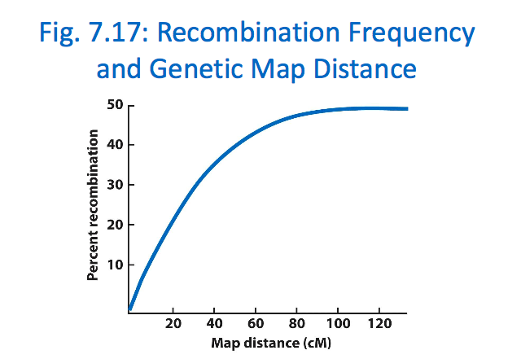

Look at the in class problem solution from Courselink on Slide 34 of chapter 7

On cis configuration, two dominant alleles are on the same side of the chromosome. Recessive alleles are on the other side

On trans configuration, the dominant alleles are on opposite sides. One each side, there is one dominant allele and one recessive allele.

In the F2 offspring of linked genes, we can tell if the genes are in cis or trans configuration by looking at the parental gametes (most abundant offspring).

For example if unspotted is spotted to spotted and short hair is dominant to long and the progeny is distributed as follows:
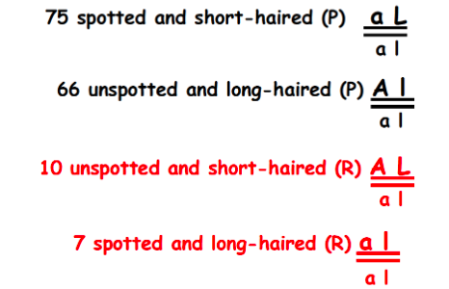

the above example shows Trans configuration because the dominant alleles are not side by side: unspotted and long are together (instead of unspotted and short), spotted and short are together (instead of spotted and long).

Tracking linked genes: Pedigrees
Pedigree analysis can sometimes be used to track genes.

ABO and Nail-Patella syndrome are linked. Nail patella is caused by rare dominant allele N on chromosome 9. We can calculate the distance between the two ABO gene and the NPS1 mutation (that causes Nail patella) based on amount of recombinant offspring in a cross between a nail patella parent and normal parent. The NPS1 mutation is initially located on the B blood group but after recombination the B blood group ends up being a wild type phenotype and Blood type O ends up gaining Nail Patella.

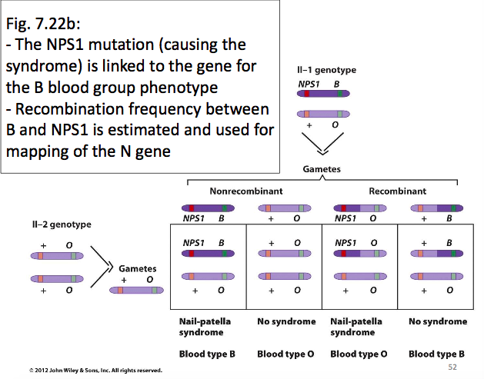
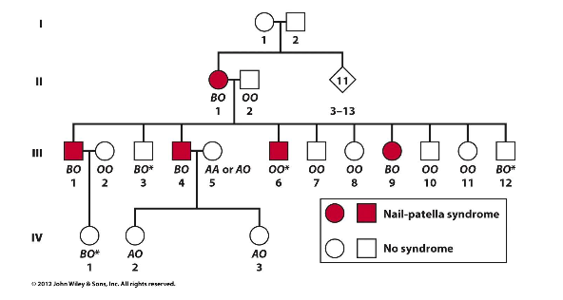

The progeny produced from II-1 and II-2 with asterisks indicate the recombinant alleles. Out of the 13 offspring produced in total, 4 were recombinant.

Chapter 8

Bacteria is useful of research because they have rapid reproduction and their simple structure and physiology allows us to identify presence of active allele.

Bacterial Viruses such as T4 are known as Bacteriophages. They ‘reproduce’ by infecting bacterial cells.

The basic structure of viruses include a capsule that holds genetic material on top of a mobile sheath.

The Lytic cycle e.g. T4 bacteriophage on E.coli cell
- T4 attaches to e-coli cell and injects DNA.
- T4 mRNA in synthesized within host cell
- Host cell DNA broken down by viral nucleases
- Viruses assembled within host cell
- Host cell bursts and viruses leave

Bacteriophage λ (Lambda) can undergo both lytic and lysogenic cycle. Viruses that undergo lysogenic cycle have to also undergo lytic cycle by default to take over the host cell

Lysogenic cycle e.g. with λ e.coli cell
- Lambda phage attaches to e.coli cell and inserts DNA
- Can choose to undergo lytic or lysogenic at this stage
- Lysogenic cycle involves the recombination of viral DNA with host cell DNA. Will increase size of DNA
- The Recombinant DNA is a viral prophage and can undergo regular cell division

Bacterial genetics
- Have circular bacterial chromosomes
- Additional genetic material exists in plasmids (circular DNA) that can replicate independently of bacterial chromosome
- Episomes are large circular DNA that can integrate into bacterial chromosomes for replication or remain separate.
- Bacteria does not have meiosis and chiasmata
- Bacterial recombination is possible through 3 parasexual processes: transformation, conjugation and transduction
- In bacteria, there’s a donor and receiver; no an equal exchange.

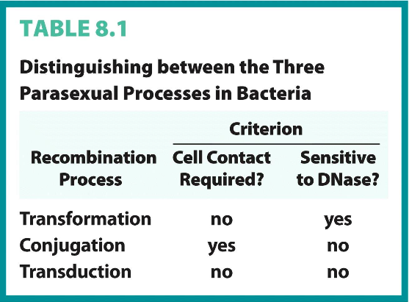
The U-tube experiment which eliminated transformation (through DNase) and conjugation (through physical barrier too small for viruses to pass through) showed us that Transduction did not require cell-cell contact for recombination to occur

Transformation
- Bacteria is not a ‘sponge’ for DNA. Only ‘Competent’ DNA from environment is observed
- DNA is imported through receptor
- Bacteria has ability to turn off DNA import
- Transferred DNA can be incorporated into bacterial chromosome
- Only 0.2-0.5% bacterial chromosome is transformed
- Transformation can be used to measure distance between bacterial genes. If two genes are very close, they’ll be present on same piece of transforming DNA.
- Transformation can be measured as a change in phenotype e.g. a⁻ a⁺

Conjugation
- ‘sexual reproduction’ mediated by Fertility (F) factor (episome). Episode exists as an extra chromosome DNA OR it can insert into bacterial chromosome and replicate as part of it.
- If a cell does not have an F factor then it is a F⁻ cell and is the receiver. Recipient GAINS F factor becomes F⁺
- F⁺ cells have F factor. Can be donors.
- HFR cells have F factor integrated into chromosome. HFR cells function the same as F⁺ cell but it now also transfers bacterial DNA(copy) to receiver cell. It can give a copy of wildtype alleles to receive cell.
- Conjugation occurs through conjugation channel/bridge.
- F pili of F⁺ donor cell grabs recipient cell and brings it closer. Genes on F factor synthesize conjugation bridge.
- F factor is replicated is transferred to recipient cell through conjugation bridge.
- Conjugation in bacteria substitutes for genetic crosses in diploid organisms.
- Often full chromosomes are not conjugated to next bacteria because bridge is fragile.

Plasmids and episomes
- Plasmid does not have genes and are not necessary for survival of host cell and provide additional genetic elements. Bacteria that acquire anti-biotic resistance get it through plasmids
- Episomes are also not essential to host survival but can replicate by itself or through integrating in bacterial chromosome

Transduction
- Virus acts as vector that carries some bacterial DNA to new host cell

There are two types of transduction
- Generalized transduction: loose of piece of DNa packages in with phage DNA
- Specialized transduction: DNA of host cell and phage DNA recombined

Chapter 9
Avery, MacLeod and McCarty showed that DNA is the hereditary transformaing factor when DNA transformed non-virilent strains into virulent strain

It was also proved that RNA was also genetic material in viruses

DNA structure
- 5 nitrogenous bases: Adenine, Thymine, Guanine, Cytosine. Uracil instead of thymine in RNA
- Pentose (deoxyribose or ribose)
- Phosphodiester bond

Deoxyribose in DNA does not have hydroxyl group at 2’ carbon

Adenine and Guanine are Purines.
Uracil, Cytosine and Thymine are Pyrimidines.

Nucleotides are joined by phosphodiester bonds at the 3’ of one sugar and 5’ of another sugar in DNA and RNA

DNA strands are anti-parallel. One strand goes from 5’ to 3’ and the other one from 3’ to 5’

A=T and G= C in DNA. A=U and G=C in RNA
A + G = T + C
Purines = pyrimidines

DNA has a helical structure and the bases are held by H bonds

DNA can have alternate forms in different environments such as labs

DNA when stretched out takes a lot of space, that’s why it’s supercoiled.
There is a nick on one of the strands that’s cut and twisted to supercoil and then sealed back up

E.coli has a single genome: monoploid
Typical prokaryotic cell 2 micrometers x 1 micrometers
- Circular unfolded chromosome: 350 micrometeres
- 40-50 loops: 30 micrometers. Each loop coils
- Supercoiled and folded: 2 micrometers (can now fit inside cell)

DNA in prokaryotes and viral chromosomes are supercoiled
Bacterial chromosomes contain circular DNA segregated into 50 domains

Eukaryotic chromosomes are a lot more complex.
Slide 28, chapter 9: metaphase chromosome. 30 nanometer fiber

Human DNA
- Haploid DNA: 3.3 billion nucleotides. (1000x greater than bacteria)
- Length of diploid genomes is roughly 2 meters.
- Human nucleus is 5-10 micrometers

In terms of genome size, Eukaryotes are the largest and viruses are the smallest

Each Eukaryotic chromosome
- Nucleotides are negatively charged so DNA is a very negative molecule. That’s why Histones are positively charged.
- There’s also a divergent froup of non-histone proteins

Chromatin: DNA + Histone + Protein

3 levels of packaging
- Nucleosomes: 146 nucleotide pairs of DNA wrapped 1 ¾ times around Octamer (8) of histones known as a nucleosome. The nucleosomes are linked by more DNA known as linker DNA that vary from 8-114 nucleotide pairs. The width now is 11 nanometers.
- Octamer has 4 different histones in copies of 2. 2H2a + 2H2b + 2H3 + 2H4. There are two molecules and each carry 4 histones
- There’s a 5th histone known as Histone H1 that keeps the nucleosome together
- Solenoid (one of several conformations 2nd stage can take): second level of packaging after some coiling. Width is approximately 30 nanometer fibre although it can vary because of the linker DNA length. Solenoid takes place when linkers are typically the same size. Expanded form happens when linker DNA alternates from short to long. Zigzag is also possible
- Inner phase chromosome. Proteins make up a chromosome scaffold where the 30 nm DNA fiber can fold up. The width now is 300 nanometers. The metaphase chromosome is at the final stage of packaging

2nm 11nm 30 nm 300 nm

