Chapter 8 Learning and Decision Making

Learning: A relatively permanent change in an employee’s knowledge or skill that results from experience

Decision making: The process of generating and choosing from a set of alternatives to solve a problem

Expertise: The knowledge and skills that distinguish experts from novices

Types of knowledge that employees gain as they learn and build expertise:

- Explicit knowledge: Knowledge that is easily communicated and a large part of what companies teach during training sessions.
- If you can write the knowledge down for someone that is explicit knowledge
- Tacit knowledge: Knowledge employees can only learn through experience

Methods that employees use by which employees learn in organizations

Reinforcement

Skinner thought we learnt by observing the link between our voluntary behaviours and the consequences that follow it, otherwise known as operating conditioning.

Operating conditioning: People will exhibit specific behaviors if they are rewarded for doing so
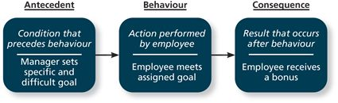

4 Contingencies of reinforcement

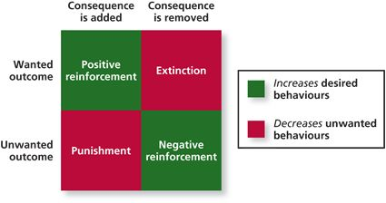
Both designed to increase desired behaviors

Positive reinforcement: The most common type of reinforcement. A positive outcome follows a desired behavior
- For it to be successful the employee needs to see a direct link between his or her behavior and the desired outcome

Negative Reinforcement: A unwanted outcome is removed following a desired behavior.
- Ex. You do something so you will not get yelled at

Both are deigned to decrease undesired behaviors

Punishment: An unwanted outcome follows an unwanted behavior
- Organization gives an employee something they don’t like because of something they did that the organization does not like

Extinction: The removal of positive outcomes following an unwanted behavior
- You are hardworking but your boss sees you act childish they will forget about how hard working you are

Schedule of Reinforcement

Interval based schedules:

Fixed-interval schedule: When workers are rewarded after a certain amount of time, and length between reinforcement periods stay the same. Ex Pay check

Variable-interval schedule: A schedule designed to reinforce behaviors at more random points in time. Ex. A supervisor who walks around at random times during the day

Actual behaviors:

Fixed-ratio schedule: Reinforces behaviors after a certain number of them have been exhibited. Ex. Some employees get paid by the number of items they produce

Variable-ratio schedule: rewards people after varying number of exhibited behaviors Ex. Sales people, they get paid extra for the sales that they make

Observation

Social learning theory: People in organizations have the ability to learn through the observation of others, one of the primary ways for employees to gain knowledge within a workplace

Behavioral modelling: When employees observe the actions of others, learn from hat they observe and then repeat the observed behavior

4 Steps within behavioral model:

- Attentional Processes: Learner must focus on an appropriate model and accurately perceive the critical behavior the model exhibits

- Retention Processes: Learner needs to remember what the model’s behavior was and how they did it

- Production Processes: Learner must undertake production processes or actually be able to reproduce what the model did

- Reinforcement: Learner can observe the consequences of the model having exhibited the behavior, whether its positive reinforcement or punishment.

Goal orientation

Learning orientation: Building competence is deemed more important than demonstrating competence
- learning-oriented people enjoy working on new kinds of tasks, even if they fail during their early experiences
- View failure as positive terms

Some people think demonstrating competence is more important than building competence
Demonstration of performance oriented competence can be shown in two thought processes
- Tend to work on things that they are already good at, preventing them from failing

- Performance-prove orientation: Focus on demonstrating their competence so that others think favorably of them

- Performance-avoid orientation: Focus on demonstrating their competence so that others will not think poorly of them

Method employees use to make decisions

Programmed Decision: that are somewhat automatic because the decision maker’s knowledge allows him or her to recognize the situation and the course of action being taken
- Intuition: An emotional judgment based on quick, unconscious gut feelings, gut feeling
- Crisis Situation: is a change, whether sudden or evolving that results in an urgent problem that must be addressed immediately, anything that can cause sudden or serious damage to employees
Non-programmed decisions: Decisions made by employees when a problem is new, complex, or not recognized

- Rational decision making model: A step by step approach to making decisions that is designed to maximize outcomes by examining all available alternatives. This model assumes that there is a clear and definite problem to solve and that people have the ability to identify what that problem is

- Identify the criteria that are important in making the decision, taking into account all involved parties

- Generate a list of all available alternatives that might be potential solutions to the problem

- Evaluation of those alternative against the criteria laid out in step one
- Does it matter how much the alternatives costs?

- Select the alternatives that result in the best outcome
- What alternatives gives us the most value

- Implement the alternatives

Decisions making problems

Limited Information

Bounded rationality: The notion that people do not have the ability or resources to process all available information and alternatives when making a decision

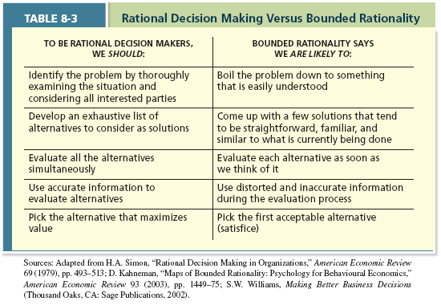

Satisficing: Decision makers select the first acceptable alternative considered
- Decision makers will come up with alternatives that are straight forward and not different from hat there already doing

Faulty Perceptions

Perception: is the process of selecting, organizing, storing, and retrieving information about the environment

Selective perception: The tendency for people to see their environment only as it affects them and as it is consistent with their expectations. Affects the ability to
- Identify problems
- Generate and evaluate alternatives
- Judge outcomes

Projection Bias: People project their own thoughts, attitudes, and motives onto other people. It limits our ability to develop appropriate criteria for a decision and evaluate decisions carefully

Social Identity Theory: A theory that people identify themselves according to the various groups to which they belong and judge others according to the groups they associate with

Stereotype: Assumptions made about others based on their social group membership

Heuristics: simple efficient, rules of thumb that allow us to make decisions more easily
- Usually lead to correct decisions
Availability Bias: one of the most frequent heuristics, tendency for people to base their judgments on information that is easier to recall

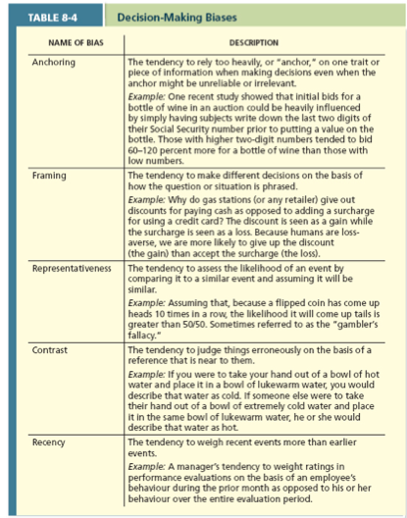

Faulty Attributions

How we explain the actions and events that occur around us. Research on attributions suggest that when people witness a behavior or outcome they make a judgment about whether it was internally or externally caused. Ex is someone shows up late, may think internally that they are lazy or may think it was cause externally by traffic

Fundamental attribution error: The tendency for people to judge others behaviors due to internal factors such as ability, motivation, or attitudes

Self-serving bias: When one attribute one’s own failures to external factors and success to internal facets

Model of attribution processes

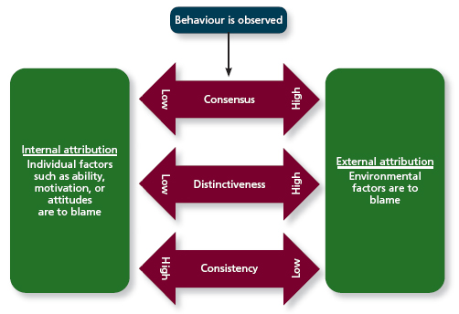

Consensus: Used by decision makers to attribute cause; whether other individuals behave the same way under similar circumstances
- Did others arrive late on the same day?

Distinctiveness: Used by decision makers to attribute cause; whether the person being judged acts in similar fashion under different circumstances
- Are they responsible when it comes to appointments outside of work?

Consistency: Used by decision makers to attribute cause; whether this individual has behaved this way before under similar circumstances
- Have they arrived late to work before?

Escalation of Commitment

What happens when a decision begins to go wrong

Escalation of commitment: A common decision making error in which the decision maker continues to follows a failing course of action
- They may want to avoid admitting they made a mistake

