Chapter 12: Leadership Styles and Behaviours

Leadership: The use of power and influence to direct the activities of followers toward goal achievement
- This can affect follower’s interpretation of events, the organization of their own achievement

Leader-member exchange theory: describe how leader-member relationships develop over time on a dyadic basis
- New leader-member relationships are typically marked by a role taking phase
- The leader tries to get a feel for the talent and motivation levels of the employee
Role taking: the phase in a leader-follow relationship when a leader provides an employee with job expectations and the follow tries to meet those expectations
Role making: The phase in a leader-follower relationship when a follower voices his or her own expectations for the relationship resulting in a free-following exchange of opportunities and resources for activities and effort

role taking and role making result in two general types of leader-member dyads
- High quality exchange dyad: frequent one on one exchanges of information between the leader and the member, these dyads form the “in-group” characterized by higher level of communication and respect
- Low exchange quality dyad: more limited exchange of information, influence, support and attention creating the “outgroup” and have lower levels of communication.

Leader effectiveness: the degree to which the leader’s actions result in the achievement of the unit’s goals, the continued commitment of the unit’s employees and the development of the mutual trust, respect, and obligation in leader-member dyads.

4 defining styles of leader decision-making

Autocratic style: the leader makes the decisions alone without asking for the opinions or suggestions of the employees in the work unit
- The employee may provide information that the leaders need but are not asked to generate any potential solutions
- Usually not told about the decision that needs to be made
Consultative style: the leader presents the problem to the individual employees or a group asking for their opinions and suggestions before making the decision him or herself
- The employees do have a say but the ultimate decisions belong to the leader
Facilitative style: leader presents the problem to a group of employees and seeks consensus on a solution making sure that his or her own opinion receives no more weight than anyone else’s
- Is earning ideas about the decision but does not give up authority
Delegative style: the leader gives an individual or group of employees the responsibility for making the decision within some set of specified boundary conditions.
- The leader plays no role in the decision unless asked

Time driven model of leadership: suggests that seven factors combine to make some decisions-making styles more effective in a given situation and other styles less effective
The seven factors are:
Decision significance: is the decision significant to the success of the project or the organization
Importance of commitment: is the important that employees buy in to the decision
Leader expertise: does the leader have significant knowledge or expertise regarding the problem
Likelihood of commitment: how likely is it that employees will trust the leader’s decision and commit to it
Shared objectives: do employees share and support some objectives or do they have an agenda of they own
Employee expertise: do the employees have significant knowledge or expertise regarding the problem
Teamwork skills: do the employees have the ability to work together to solve the problem or will they struggle with conflicts

Day-To-Day Leadership Behaviours
Both the following concepts leaders can be high on both or low on both or have some of each type. They both overall do encourage employees

Initiating Structure: reflects the extent to which the leader defines and structures the roles of employees in purist of goal attainment. They play a higher role for directing group activities, scheduling, ask employees to follow formal procedures, and criticize poor work
- Initiation: originating, facilitating and sometimes resisting new ideas and practices
- Organization: Defining and structuring work, clarifying leader versus member roles
- Production: Setting goals and providing incentives for the effort and productivity of a employee
This concept encourages employees to be more motivated

Consideration: reflects the extent to which leaders create job relationships characterized by mutual trust, respect for employee ideas, and consideration of employee feelings. These leaders create a strong way of communicating, and treat employees as equals
- Membership: mixing with employees
- Integration: encouraging a pleasant atmosphere
- Communication: providing information to employees seeking information from them
This concept really helps employee satisfaction

Life cycle theory of leadership: this model argues that the optimal combination of initiating structure and consideration depends on the readiness of the employees in the work unit

Readiness is defined as the degree in which an employee has the ability and willingness to accomplish their specific tasks
Readiness can be expressed in terms of four important snapshots

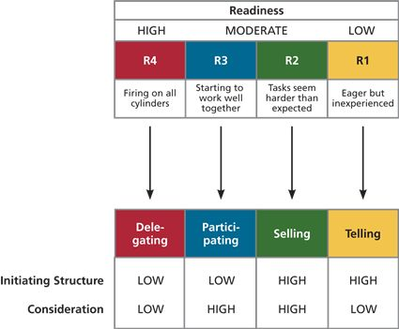

R1 refers to a group of employees who are working together for the first time and are eager to begin but they lack the experience and confidence need to perform their roles. Optimal combination is high initiating structure and low consideration, the leader will give specific instructions and closely monitor the performance

R2 Members are working together and find that their work is more difficult then they anticipated, eagerness can easily turn to dissatisfaction. The optimal combination is high in both structures so the leader can give his or her support to protect the confidence levels of the employees

R3 Employees have learned to work together, though they still need collaboration and support from their leader, low initiation structure and high consideration

R4 Delegating: the leader gives responsibility for key behaviours over to the employees, Low in initiating and consideration

Transformational leadership: inspiring followers to commit to a shared vision that provides meaning to their work while also serving as a role model who helps follows develop their own potential and view problems from new perspectives
- What motivated employees beyond expectations?
- These leaders heighten followers awareness of the importance of the outcomes
- What gets transformed is the way the employees view their work
5 distinct approaches to motivating employees

Laissez faire leadership: optimal approach, hands off approach, the leader avoids leadership duties altogether

Transactional leadership: occurs when the leader rewards or disciplines the follower depending on the adequacy of the follower’s performance. 3 parts
- Passive management by exception – leader waits around for mistakes and errors then takes the corrective action necessary
- Active management by exception – the leader monitors and arranges mistakes and errors actively and corrects them when requires
- Contingent reward – represent a more active and effective brand of transactional leadership, leader attains follower’s agreement and that needs to be done using rewards in exchange for good performance
Represents the dominant approach to motivating employees

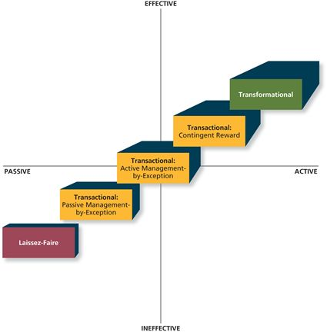
Transformational leadership: the most active and effective approach, most common leadership approach

Idealized influence: involves behaving in ways that earn the admiration, trust and respect of followers, causing followers to want to identify with the leader
- Having attributes like extraversion, opens to experience, and agreeableness can make a person have charisma, which is a good behaviour to have if you want idealized influence

Inspirational motivation: involves behaving in ways that foster an enthusiasm for and commitment to a shared vision of the future
- The leader is able to have such a great emphasizes on the goal of the future all of the negative factors are not noticed and can be overcome

Intellectual stimulation: involves behaving in ways that challenge followers to be innovative and creative b questioning assumptions and reframing old situations in new ways
- Leader gets employees to look the the problems from many different angles

Individualized consideration: involves behaving in ways that help followers achieve their potential trough coaching, development, and mentoring
- Treating employees as unique individuals with specific needs

Leadership importance

Units led by a transformational leader tend to be more financially successful and bring higher quality products and service to the market fast

Transformational leadership is more strongly related to dyad focuses measures of leader effectiveness; they tend to foster leader-member exchange relationships that are of higher quality

Transformational leadership good job performance

Transformational Leadership great organizational commitment

Substitutes for leadership model: suggests that certain characteristics of the situation can constrain the influence of the leader, making it more difficult for the leader to influence employee performance. Come in two characteristics
- Substitutes: reduce the importance of the leader while simultaneously providing a direct benefit to employee performance
- Neutralizers: only reduce the importance of the leader they themselves have no beneficial impact on performance

The change process
Basic process that involves three steps
Unfreezing: the organization realizes that the status quo is unacceptable, Ex increase in customer complaints, once the need for change has been recognized the second step comes into play
Change initiative: this may be bringing in a new leader, introducing a new reward system, implementing a new training program,
Refreeze: meaning that the newly developed attitudes and behaviours nee to harden up, becoming as new norms, values, and shared understandings

Person organization fit negative job performance

Person organization fit organizational commitment

Person-organization fit: The degree to which a person values and personality match the culture of the organization

