Student ID: 8688440
Student Name: Himansu Sehgal
Date: Tuesday, September 27th, 2016

Problem 2.5
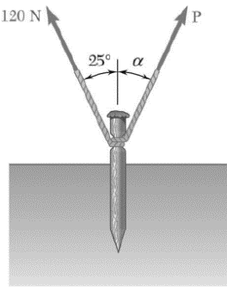
A stake is being pulled out of the ground by means of two ropes as shown. Knowing that α= 30º, determine by trigonometry;
- The magnitude of the force P so that the resultant force exerted on the stake is vertical.
- The corresponding magnitude of the resultant.

Since the forces acting on this object are in the same direction, they can be added using the “tip to tail” method, then the sine law can be used to determine the magnitude of the resultant and the vector P.
A = 120 N
$$\frac{A}{Sin(∝)}=\frac{P}{Sin(25)}=\frac{R}{Sin(r)}$$
$$P=A\frac{Sin 25}{Sin ∝}$$
$$P=(120)\frac{Sin 25}{Sin 30}$$
$$P=101.43 N$$
$$R=A\frac{Sin r}{Sin ∝}$$
$$R=(120)\frac{Sin 125}{Sin 30}$$
$$R=196.60 N$$

α = 30 º
r = 180 º - 25 º – α
r = 125 º
25º
r
α
A
R
P

Therefore the magnitude of force P is 101.43 N and the magnitude of the resultant is 196.60 N.
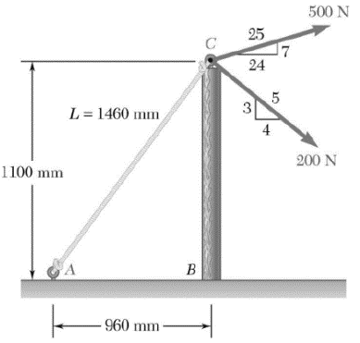
Problem 2.36
Knowing that the tension in rope AC is 365 N, determine the resultant of the three forces at Point C of the post BC.
To solve this problem, the force components must first be solved.
Cable Force AC =
$$F_{x}= -\left(365N\right)\frac{960}{1460}=-240N$$
$$F_{y}= -\left(365N\right)\frac{1100}{1460}=-275N$$

$$500 N Force:F_{x}=\left(500 N\right)\frac{24}{25}=480 N$$
$$F_{y}=\left(500 N\right)\frac{7}{25}=140 N$$
$$200 N Force:F_{x}=\left(200 N\right)\frac{4}{5}=160 N$$
$$F_{y}=-\left(200 N\right)\frac{3}{5}=-120 N$$
Therefore concluding that the x-component of the resultant force is the sum of all the forces in the x-direction.
$$R_{x}= ΣF_{x}$$
$$ΣF_{x}= -240N+480N+160N$$
$$ΣF_{x}= 400N$$
$$R_{y}= ΣF_{y}$$
$$ΣF_{y}=-275 N+140N-120N= -225N$$
$$ΣF_{y}= -225N$$
This leads to using the Pythagorean Theorem, stating that the square of the x and y components will result in the magnitude of the result vector.
$$R=\sqrt{R_{x}^{2}}+R_{y}^{2}$$
$$R=\sqrt{[(400 N)^{2}}+\left(-255 N)^{2}\right]$$
$$R=473.40 N$$
The angle that the resultant makes with the horizontal can be represented by the tan ratio.
$$tanα=\frac{Opposite}{Adjacent}$$
$$tanα=\frac{225}{400}$$
$$α=tan^{-^{1}}\left(\frac{225}{400}\right)$$
$$α=32.5°$$
The resultant has a magnitude of 474 N at an angle of 32.4° below the horizontal.

Problem 2.48
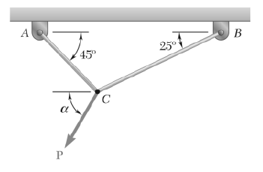
Two cables are tied together at C and are loaded as shown. Knowing that P = 500 N and α = 60°, determine the tension in
(a) In cable AC
(b) In cable BC

To analyse the equation, a free body diagram must be drawn.
Now use the sine law to solve for each tension.
60°
45°
25°
P = 500N
T_{AC}
T_{BC}

$$\frac{T_{AC}}{Sin 35°}=\frac{T_{BC}}{Sin 75°}=\frac{500 N}{Sin 70°}$$
$$T_{AC}=\frac{500 N\left(Sin 35°\right)}{Sin 70°}$$
$$T_{AC}=305 N$$

$$\frac{T_{BC}}{Sin 75°}=\frac{500 N}{Sin 70°}$$
$$T_{BC}=\frac{500 N\left(Sin 75°\right)}{Sin 70°}$$
$$T_{BC}=514 N$$
Therefore the tension in wire AC is 305 N, whereas the Tension in wire BC is 514 N.

Problem 2.61
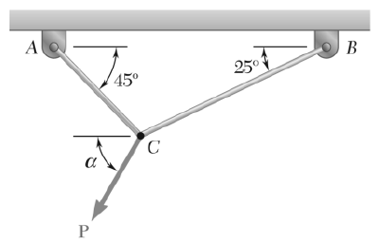
For the cables of Problem 2.48, it is known that the maximum allowable tension is 600 N in cable AC and 750 N in cable BC. Determine
(a) The maximum force P that can be applied at C
(b) The corresponding value of α.
T_{AC} = 600 N
P
25°
45°
α
T_{BC} = 750N
C

After constructing the free body diagram, use the properties of the cosine law and isolate for P.
$$P^{2}={\left(600\right)}^{2}+{\left(750\right)}^{2}-2\left(600\right)\left(750\right)\cos\left(70°\right)$$
$$P=784.02 N$$
Now use the sine law to isolate for the corresponding value of α.
Note: (The sine law can be used both ways, the sine can be on the top or bottom, as long as it is kept consistent.)
$$\frac{Sinβ}{600 N}=\frac{Sin(70°)}{784.02 N}$$
$$β=Sin^{-1}\left[\frac{\left(600 N\right)\left[Sin\left(70°\right)\right]}{784.02 N}\right]$$
$$β=46.0°$$
Proportionally since the beta angle is 46 degrees, then the 25 degrees would have to be added to that value to achieve the alpha value, resulting to be 71 degrees.

