All Social Psychology Notes FINAL EXAM
Week 8
Stereotypes, Prejudice, and Discrimination
- Stereotypes (cognitive): the generalized perceptions, beliefs, and expectations a person has about members of some group
  - Schemas about entire groups of people
  - Effects of stereotypes on behaviour can be automatic and unconscious
- Prejudice (affective): a negative attitude toward an individual based solely on the person’s membership in some group, including an irrational hostility toward a particular group – on one word…prejudgment
- Discrimination (behavioural): differential treatment of individuals who belong to different groups
Stereotypes
- Stereotypes are a type of schema – generalized beliefs about members of a group (based on race, gender, religion, etc)
  - May or may not be accurate, may be positive or negative
  - Most researchers believe it is even possible to have a schema that you don’t personally believe (eg. Other people think that Group X has qualities, but I don’t)
- Highest communicability or gossip value of traits study (Schaller, Conway, and Tanchuk, 2002)
- Stereotypes are formed through social categorization – the classification of persons into groups on the basis of common attributes
  - Helps us form impressions quickly and use past experiences to guide new interactions
- Devine (1989): suggests that our parents and media may have started an early process that has now become automatic
- Serious drawback: by categorizing people, we often:
  - Overestimate the differences between groups
  - Underestimates the differences within groups
  - This may bias our perceptions
- We have a strong tendency to divide people into in-groups and out-groups
  - Such group identifications can promote an in-group bias…often it becomes an “us vs. them” attitude
- Consequences:
  - Exaggerate differences between in-groups and other out-groups
  - Creates an out-group homogeneity effect – a phenomenon of overestimating the extent to which members within other groups are similar to each other (eg. They all look the same to me)
Three Levels of Stereotypes
- Public: what we say to others about a group
- Private: what we consciously think about a group, but don’t say to others
- Implicit: unconscious mental associations guiding our judgments and actions without our conscious awareness
Stereotypes and Prejudice in Action
- Who has the razor? (Allport and Postman, 1947)
  - Subjects were shown a picture depicting two men, one black and one white, confronting each other on a subway car
  - The white man has a straight razor in his hand
  - After viewing the picture, the first subject describes it to a second subject, who in turn describes it to another, and so on
  - After a few retellings, the straight razor ends up (is inferred to be) in the hand of the black man

Interesting Replication
- Boon and Davies (1987): subjects see a cartoon story of 2 men interacting on the subway, and at the end of the interaction, one man pulls a knife
  - Different subjects see one of three different versions:
    - 1) Both men are white – Man A has the knife (wearing a suit)
    - 2) Both men are white – Man B has the knife (wearing work clothes)
    - 3) One is black, one is white – White man has the knife
- Retrieval phase: both recall and recognition tests
  - Recall test: no stimuli, just “describe the man who pulled the knife”
  - Recognition test: see two versions of the critical picture (correct knife-holder, or knife in the OTHER man’s hand): instructions are “pick the one you saw before”
    - There is a correct and an incorrect version for the participants who saw the original story with two white men, AND also for those participants who saw the original story with one white man and one black man
Some Consequences of Stereotypes and Prejudice
- Self-perpetuating stereotypes
  - Subtyping: accommodating groups of individuals who deviate from one’s stereotype by thinking of them as a special category of people with different properties – the role of attribution in maintaining or changing a stereotype
  - Subgrouping: accommodating groups of individuals who deviate from one’s stereotype by forming a new stereotype about this subset of the group
- Can stereotypes actually create self-fulfilling prophecies? (Wood et al., 1974)
  - White male University students interviewed white and black male high school students seeking employment
  - White interviewers of black applicants (relative to white interviewers of white applicants)
    - Sat further away
    - Conducted shorter interviews
    - Made more speech errors
  - Appeared to cause black applicants to become uncomfortable
- Follow-up experiment: white males were applicants; treated like black applicants were treated in the first experiment; they performed similarly (to black applicants in exp. 1 during the interview
- Stereotype threat: a self-confirming apprehension that one will be evaluated based on a negative stereotype (Steele, 1997)
Stereotype Activation
Stereotype-Relevant Situation Stereotype ThreatArousalRestricted Capacity Under-Performance
Self-Categorization
Prejudice and Discrimination
- Our feelings and actions towards members of social groups
- Where does prejudice come from and why does it persist?
  - Threats to self-esteem
  - Realistic Conflict Theory: prejudice stems from direct competition between various social groups over scarce and valued resources
  - Social categorization
  - Scapegoating: prejudice is the result of members of a dominant group becoming frustrated and taking their frustration out on members of a weaker group
- Modern prejudice: thinking that minorities are seeking and receiving more benefits than they deserve and a denial that discrimination affects their outcomes
- Traditional racism vs. modern racism – microaggressions (article 16)
- Discrimination without awareness (implicit prejudice)
- Sexual Harassment as Gender Discrimination (Fitzgerald, 1993)
  - As many as 50% of women surveyed reported having been sexually harassed during their academic or working lives
  - Research shows that men are more likely to harass than are women
- But does whether men harass or not depend on the man, and on the situation?
- In one study, male students were asked to train a young woman on a complex word-processing task (Pryor, LaVite, and Stoller, 1993)
  - Results did not depend on the IV but rather depended on the participants chronic disposition to harass
  - So the situational factor here was relatively unimportant
Some Costs of Prejudice and Discrimination
- Schulman et al. (1999)
  - Physicians were only 60% as likely to suggest a top-rated diagnostic test for black heart patients as for whites even when blacks presented same symptoms, and gave identical information about themselves
- Ayres and Siegelman (1995)
  - This study found that white men were offered better deals on cars:
    - $109 less than white women
    - $318 less than black women
    - $935 less than black men
Reducing Prejudice and Discrimination
- Contact hypothesis
  - Stereotypes, prejudice, and discrimination toward a group will diminish as contact with the group increases
  - Getting to know and hopefully to understand a group
  - Get two groups to work towards a common goal – cooperation helps; competition hurts
- Group contact is considered effective when…
  - Out-group members have traits and abilities challenging negative stereotypes
  - Contact is supported by local authorities and norms
  - Groups are of equal status, at least in contact setting
  - Contact is at individual level
  - Contact is rewarding
  - Groups work toward common goals
Week 9
Social Influence
- What is Social Influence?
  - A change in behaviour in response to the intentional or unintentional influence of others
  - It may or may not be accompanied by a change in attitude
- The three main types of social influence:
  - 1) Conformity: a change in response to social norms (no pressure is required)
  - 2) Compliance: a change in response to a direct request
  - 3) Obedience: a change in response to a command/order
Conformity
- Social norms: rules indicating how people are expected to behave in a specific situation – they can be:
  - Descriptive: how do people typically behave?
  - Injunctive: how should people behave?
- Why norms?
  - To regulate social interaction (ie. Make behaviour consistent and predictable)
  - To prevent social chaos
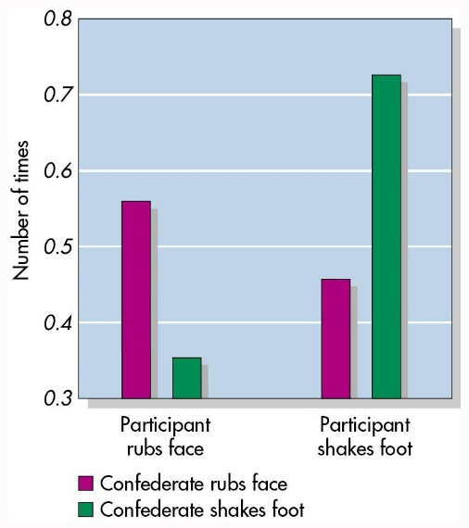
  - To provide automatic guides for behaviour
- The Chameleon Effect (Chartrand and Bargh, 1999)
  - Sometimes we conform automatically and unintentionally
  - Participant and confederate worked on a task together
    - IV – confederate rubbed eye, shook foot, or did nothing
    - DV – how did participant behave?
- The effect of ambiguity
  - In ambiguous situations, people tend to rely on information provided by others
  - Sherif (1937) asked students to judge the apparent movement of a stationary light on a wall
- Autokinetic effect: a stationary spot of light in a dark room appears to move
- Sherif, 1937…put yourself in the role of the participant…
  - Day 1: participant stares at a pinpoint of light about 15 feet away
    - The light seems to be moving but you can’t be sure
    - After a few seconds it disappears
    - Sherif: how far did it move? Participant: I’m not really sure, but maybe about 8 inches
  - Day 2: the participant is now joined by three confederates
    - This time all four stare at the pinpoint of light about 15 feet away
    - Again you think it moved about 8 inches
    - Sheriff: how far did it move? 1) 2 inches 2) an inch or two 3) oh, no it can’t be more than one inch Participant: oh, I guess about 6 inches
    - Everyone else looks at you like you’re crazy
  - Day 3: the same situation as day 2 except this time you reply “about 4 inches”
  - Day 4: the same situation as day 2 except this time you reply “it’s probably like 2 inches”
- What happened? Diverse individual judgments quickly converged on group norm
  - Each developed own norm
  - Norm persisted after individuals left the group
  - Norm persisted when original members were replaced by new members
- Asch original study on conformity (1951)
  - Which of the lines on the left most closely matches line A on the right?
  - In this early version, Asch had 16 “naïve” participants with 1 confederate who gave incorrect answers
    - Results: participants laughed at/ridiculed the confederate
- After his initial study, Asch conducted a series of experiments; most done with 1 participant and 5-8 confederates (1955)
  - Real participants would give their judgement after several confederates had already given theirs
  - Research question: would participants conform to obviously incorrect answers?
  - When alone, 95% of the participants got all the answers correct…but when confronted by the unanimous incorrect majority, participants conformed 37% of the time, in fact, 75% went against their own eyes at least once if the group gave a wrong answer
- Why did participants conform? Some participants said they didn’t want to look silly or be rejected by the rest of the group
  - This is referred to as normative social influence: they wanted to “fit in” with the others
- Some participants said it was because they thought the others must have had better eyesight or be better informed in some way
  - This is referred to as informational social influence: they were basically utilizing others as a source of information
When are we more likely or less likely to conform?
- The following were influential insofar as conformity was concerned
  - Group size: as the number of people increases so does conformity
  - Incompetent and insecure individuals: when one is made to feel incompetent or insecure conformity is likely
  - Group’s status and attractiveness: kind of goes without saying…if it’s a group you want to be a part of, you will likely conform to its opinions
  - Presence of an ally: the presence of a true partner, who agreed with the participant, reduced conformity by 80% - when we have an ally, we can diffuse the pressure because we are not the only one breaking the norm
    - Substantially more difficult to stand alone for one’s convictions than when one is part of even a tiny minority
    - Any dissent can reduce the normative pressures to conform
  - Independence: some people care more about standing up for their rights than being disliked
Difference between Asch and Sherif studies
- Sherif: because of ambiguity, participants turned to each other for guidance
  - Participant didn’t know it wasn’t the correct answer – reasonable to consider other’s views
  - Participants later adopted social norms (conformity leads to internalization)
- Asch: participants often found themselves in an awkward position – it was obvious that the group was wrong
  - Participants knew there was a correct answer (conformity does not lead to internalization)
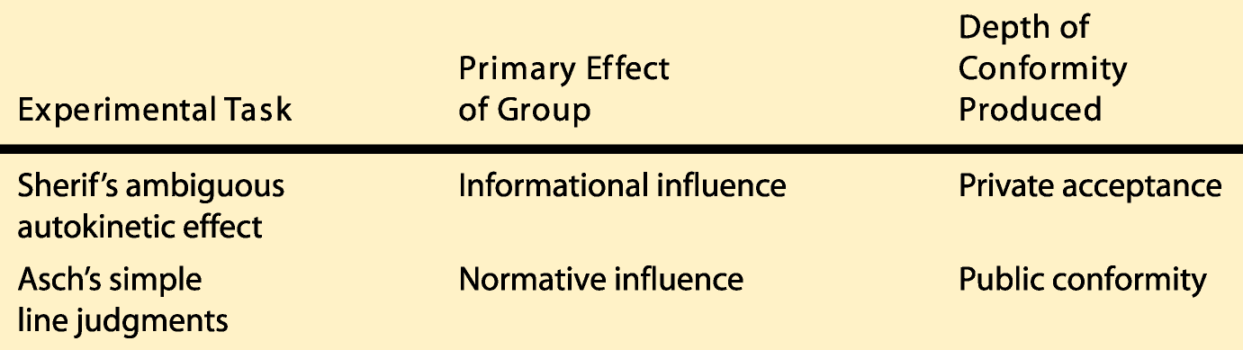
Types of Conformity
- Private conformity: changes in both overt behaviour and beliefs
- Public conformity: superficial change in overt behaviour only

Active and Public Commitments
- Students in one experiment were asked to judge lines in an Asch-type experiment (Deutsh and Gerard, 1956)
  - Before hearing group members make erroneous judgments:
    - Some privately wrote down their judgments (active commitment only)
    - Others wrote their judgments and gave them to the experimenter (active plus public commitment)
    - Control group
Minority Influence and Conformity
- Dissent from a minority can reduce conformity from the majority
- How do minorities influence others? Through their own behavioural style:
  - Make their proposition clear at the outset
  - Stick to their original proposition – consistency in its position is key
  - Withstand the majority influence
  - Don’t appear to be driven by self-interest
Compliance
- The language of request
  - Talking fast and catching people off guard can improve compliance rates
  - People can be disarmed by the simple phrasing of the request – how you ask for something can be more important than what you ask for
- Mindless conformity (Langer et al. 1978)
  - People often engage in mindless conformity by obeying internalized social norms without deliberating about their actions
  - The advantage to mindless conformity is that is facilitated our getting through the day – in most cases, it leads to appropriate behaviour
  - However, there is a cost to acting on automatic pilot – sometimes, we end up following the wrong social norm and behave inappropriately
- Cialdini (1995) proposed that common influence tactics utilize 6 basic principles:
  - 1) Social validation (consensus): one should be more willing to comply with a request for behaviour if it is consistent with what similar others are thinking (especially when uncertain) – based on the social comparison theory
    - Reingen (1982) – list technique he asked participants to donate money to a worthy cause…participants who were first shown a list of others who had donated agreed to give more money
    - “Salting” the tip jar
  - 2) Consistency:
    - The Foot-in-the-Door technique: the tendency for people who first agreed to a small request to comply later with a larger request
    - Freedman and Fraser (1966) – called housewives and asked them if they would answer a few questions about soap (all agreed)…later, made a second request of those housewives and an additional group would they allow a 5-6 man team to come out and inventory their household products, with the freedom to go through all closets and drawers?
      - Agreement: 22% (2nd request only) and 53% (1st and 2nd requests)
    - The low-ball technique: people who agree to an initial request will often still comply when the requester “modifies” the conditions – people who receive only the costly request are less likely to comply
      - Cialdini et al. (1978) – the 7 am experiment
        - Mentioned up front – 24% agreed
        - Mentioned later – 56% agreed initially
        - After mentioned, none changed the their mind – 95% actually showed up
      - After making an active choice for something, people take “mental possession” of it and it becomes part of their self-concept
      - It is often easier to continue with the commitment than to change the self-concept
  - 3) Authority: we are more likely to comply with someone who is (or resembles) a legitimate authority
    - Bickman (1974): experimenter dressed in street clothes vs. security guard uniform – “you’ve” seen the guy over there by the meter? He’s overparked but doesn’t have any change. Give him a dime.”
      - Walked out of sight – compliance: 42% (street clothes) vs. 92% (uniform)
    - Hofling et. Al (1966): experimenter called hospital nurses and identified himself as a doctor at the hospital – asked nurse to give a dangerous dose of an unauthorized drug to a specific patient
      - 95% of nurses got medication and stated toward patient’s room to administer it
  - 4) Reciprocity: norm of reciprocity – obligates individuals to return the form of behaviour they have received from another – more willing to comply with a request from someone who has previously provided a favour or concession
    - Berry and Kanouse (1987): sent a survey to doctors with either a $20 cheque or the promise of a $20 cheque, if the survey was returned
      - Survey returned – 78% (cheque first) vs. 66% (cheque later)
      - Cheques cashed – 95% (respondents) vs. 26% (non-respondents)
    - Cialdini et. Al (1975): the door-in-the-face technique (after someone turns down a large request, the requester follows up with a smaller request – a concession)
      - Asked college students if they would serve as unpaid juvenile delinquency counsellors for 2 hours a week, for 2 years
      - No one agreed
      - 2nd request would they be willing to take a group of juvenile delinquents on a 2 hour trip to the zoo? Agreement – 15% (2nd request only) and 48% (1st and 2nd requests)
  - 5) Friendship/liking: we are more willing to comply with friends or other likeable individuals
    - How do salespeople get others to like them? Physical attractiveness, similarity, compliments (ingratiation)
    - Attractive fund raisers for American Heart Association obtained 42% compliance compared to 23% for unattractive fund raisers (Reingen and Kernan, 1993)
    - Emswiller et al. (1971): experimenter in “hippie” vs. “straight” clothes asked students for a dime – compliance 66% (matching clothes) vs. 33% (mismatched clothes)
  - 6) Scarcity: heuristic – if it is scarce, it must be valuable, and reactance – we react against loss of freedom by wanting item
    - Worchel, Lee and Adewole (1975)
      - Showed participants a jar of cookies
      - There was either 2 or 10 cookies in the jar
      - When 2 cookies, rated as more desirable, attractive and expensive
      - Study 2 – jar with 2 cookies (always scarce) vs. jar with 10 cookies, which was replaced with jar or 2 cookies (newly scarce)
      - Cookies more in demand recently were now rated as more desirable, attractive, and expensive
Persuasion: How Attitudes are Changed
- Persuasion: effort to change others’ beliefs, attitudes, and behaviours through the use of various types of messages
- There are several factors involved in attitude change
  - The source of the message (the communicator)
  - The message
  - The target audience
  - How the message is communicated (the channel)

- The Elaboration-Likelihood Model: a cognitive theory of persuasion (Petty and Cacioppo, 1986)
Attitude change depends on strength of arguments in message
Central Route
Careful processing of info in message
Message important; processing capacity high
Attitude change depends on presence of persuasion cues – heuristic processing
Peripheral Route Heuristic processing of info in message

Message unimportant; processing capacity low
Persuasive Message

Obedience
- Most authority figures have been given their authority by society – we are just told to follow what they tell you to do
- Every person at some time in their life has followed a superior without questioning why they are doing what they are doing
- Milgram’s questionnaire (1963)
  - Everyone answering Milgram’s questionnaire said they would refuse to punish the learner
  - They also believed that other people would disobey
  - Most people reject unnecessary pain and therefore would not follow brutal orders
  - The responses of college students, psychiatrists, and middle-class adults all predicted that only 1% or 2% of the general population would obey such orders fully, administering the highest shock available
Milgram Obedience Experiments
- Psychiatrists guessed that 1 in 1000 would go clear to 450 volts (only “true psychopaths”)
- But, in the original study, 26/40 went all the way
Factors Affecting Obedience in Original Study
- Prestige and status of authority figure – supported by prestigious institution
- Person giving orders was close at hand – Milgram was right there
- Victims were depersonalized – out of sight
- Presence of others who disobey – here, no role models who disobeyed
In Replications…
- Legitimacy of authority: when a “clerk” gave the orders, compliance was 20%
- Proximity of authority figure: when Milgram gave commands by telephone, compliance dropped to 21%
- Emotional distance: when learner was in the same room, full compliance dropped to 40% - when teacher applied learner’s hand to shock plate, compliance fell to 30%
- Group influence: when two confederates “refused” to keep going, only 10% of real subjects fully complied with the orders
Explanations for Obedience
- Cognitive dissonance: behaviour (shocking learner) conflicted with belief (learner is a decent person)
  - So solution is to alter belief – “he’s such an idiot he deserves to get shocked”
- The experimental procedure itself: participants were led to feel relieved of personal responsibility for the victim’s welfare
  - Gradual escalation of shocks was used
Week 10
Group Behaviour and Leadership
What is a Group?
- According to social psychologists, a group can be defined as a collection of people who are perceived to be bonded together in a coherent unit to some degree
- Characteristics of “true groups” (Lickel, 2000)
  - Members interact with one another often
  - The group is important to its members
  - Members share common goals and outcomes
  - Members are similar to one another in important ways
The Presence of Others
- Social facilitation: if performance can be individually evaluated, the presence of others will be arousing – this will improve performance on simple tasks but interfere with performance on complex tasks
- Triplett (1897): was one of the first scientists to ask the question “what happens when individuals join together with other individuals?”
  - Triplett, who was a bicycling enthusiast, noticed that cyclists performed better in races than when they were timed riding the course alone
- Mere presence of others and social facilitation: same result when he asked children to wind fishing reels as quickly as possible
  - Triplett (1897) thought that the mere presence of others would improve performance
  - Participants: 40 children ages 8-17
  - Procedures: a trial consisted in turning the reel at the highest rate of speed until a small flag sewed to the silk band had made four circuits of the four-meter course – the time of the trial was taken by means of a stop-watch
  - Results: all children performed faster when in competition compared to when alone
- For a long time, the social facilitation phenomenon was viewed as a universal principle…
  - Some may have even called it a “proven fact”
  - Zajonc (1965) went back and analyzed the research; he found that there were some exceptions; when the task was novel or complex, the presence of an audience impaired performance on the task
  - Triplett was only partially right…the type of task was an important determinant to success as well
Why does Social Facilitation Occur?
- Distraction conflict theory (Sanders, 1981): attentional conflict between focusing on task and inspecting the distracting stimulus creates arousal – can hurt performance sometimes and help sometimes
  - Presence of others can create a distraction leading to poorer performance
  - But sometimes will stimulate greater effort to overcome the attentional conflict
  - “Tunnel vision” can help on some tasks
Group Behaviour
- Social loafing: a group-produced reduction in individual output in easy tasks in which contributions are pooled
- Latane et al. (1979) sat participants in a group of 6 people…
  - Blindfolded participants and had them put on headphones
  - Played clapping or shouting over headphones
  - IV thought they were making noise alone or with 5 others
  - Results: 1/3 less noise when they thought others were also making noise
Why does Loafing Happen?
- Diffusion of responsibility: in a group we feel able to share responsibility and this may lead to a reduction of effort
- Free-rider effect: if we feel like our contribution is not essential…still benefit from the group and give little in return (low input, high output)
- Sucker effect: willing to do your share but not more than that (especially if others are free-riding) – since everyone is benefitting and getting credit, you don’t want to be the sucker who does all the work (and no recognition), therefore do the minimum requirement
We Loaf Less When…
- Personal efforts are identifiable
- A task is challenging, appealing, involving
- The task is meaningful and important
- We think our contribution is essential
- We are working with friends vs. strangers
- The group expects to be punished for poor performance
- The group is small
- The group is cohesive
Deindividuation Theory
- A social psychological account of the individual in the crowd
- A psychological state of decreased self-evaluation, causing anti-normative and disinhibited behaviour
- Anonymity has been shown to amplify the effect – eg. Wearing a mask
- Why does deindividuation lead to impulsive acts?
Group Behaviour
- Group polarization: the exaggeration, through group discussion, on initial tendencies in the thinking of group members; often manifests itself as a shift towards the opinion of the majority
- Imagine you were considering the pros and cons of going to grad school, and you talked it over with two groups
  - Your family: who was initially slightly opposed to the idea
  - Your fellow students: who were initially slightly favourable
- After discussion within each group
  - The group that initially favoured grad school would be even more strongly in favour
  - The group that initially disfavoured grad school would be even more opposed
Why do Groups Polarize after Discussion?
- Persuasive arguments: with even a slight bias in one direction, you’ll hear more favourable arguments on that side
- Social comparison: when members realize the group is leaning in one direction, they may seek acceptance by moving further in that direction
Groupthink
- Tendency of the members of highly cohesive groups to assume that their decisions cannot be wrong, that all members must support the group’s decisions, and that information contrary to these decisions must be ignored
- Leads to group decision-making process that is not optimal, sometimes disastrous, because the group’s primary goal is consensus instead of accuracy
- They seem to have a greater desire to get along and agree with one another than to generate and critically evaluate alternative viewpoints and positions
- The deterioration of group judgment produced by striving for consensus
- Revised groupthink framework (article 34) – two moderators (time pressure and leadership style)
Symptoms of Groupthink
- The group overestimating their might and right…
  - Illusions of invulnerability – over-optimism, blind to warnings
  - Unquestioned belief in the group’s morality
- Members become close-minded
  - Rationalization discounts challenges by justifying their decisions
  - Holding a stereotyped view of the opponent (weak, dumb)
- Pressures towards uniformity
  - Conformity pressure – those who raise doubts are rebuffed (ridiculed)
  - Self-censorship – disagreements are uncomfortable
  - Illusions of unanimity – everyone keeps quiet, seems like everyone is unanimous
  - Mind guards – some members keep information (that would lead to question) from the group
How can we Prevent Groupthink?
- Be impartial; don’t endorse any position
- Encourage critical evaluation; devil’s advocate
- Subdivide the group
- Encourage and welcome criticisms from outsiders
- Before implementing, call a second-chance meeting
Leadership in Groups
- What makes a great leader?
  - The great person theory: certain key personality traits makes a person a great leader, regardless of the situation the leader faces
  - Intelligence, extraversion, charisma, socially skilled, adaptive, flexible, confident, desire for power, etc
  - Role of integrative complexity (Suedfeld, 1998)
- Leadership styles: transactional vs. transformational leaders
- The role of the situation: Contingency theory of leadership (Fiedler, 1978)
  - Task-oriented leader: getting the job done
  - Relationship-oriented leader: feelings and relationships among people
- Gender and leadership: the dilemma facing women in leadership positions – behaving in a communal vs. agentic fashion
Week 11
Aggression and Prosocial Behaviour
What is Aggression?
- Although there are several different definitions of aggression, social psychologists tend to define it as follows:
  - A physical or verbal behaviour that is intended to cause either physical or psychological pain to someone
- There are three main ideas in that definition
  - 1) The presence of a behaviour, hence omission/negligence does not constitute aggression
  - 2) The causing of harm or pain to someone intentionally, hence assertiveness, accidents and play don’t constitute aggression, since they lack the intent to hurt another
  - 3) The nature of the harm caused to the person can be either physical or psychological. It has to be noted that many social psychologists consider threat to reputation or social relations, a third type of harm caused to a person. They refer to it as relational aggression, since it is intended to destroy one’s relations with others. It is considered to be the type of aggression manifested most often by women
Different Types of Aggression
- We distinguish between several different types of aggression depending on the situation, relational aggression being only one of them. However, we will focus on the main different types, which are:
  - Direct aggression: when we have face to face contact with the person
  - Indirect aggression: when we are trying to hurt another without contact, as such it often involves an agent (eg. Hiring a hit man, spreading rumours)
  - Hostile aggression (or emotional aggression): an act of aggression stemming from feelings of anger and aimed at inflicting pain
  - Instrumental aggression: aggression is used as a means to some goal other than causing pain. There is still the intention to hurt the other person, but the hurting takes place as a means to some other aim such as money, success, or defence
Situational Approaches to Aggression
- Focus on how factors “outside” the person – the environment or situations – can play a part in aggressive behaviour
- The frustration-aggression hypothesis (Dollar et al. 1939): how frustrating experiences cause aggressive behaviour
  - Environment triggers aggression – the occurrence of aggression always presupposes the existence of frustration and, contrariwise, the existence of frustration always leads to some form of aggression
  - Goal response being blocked
- The revised frustration-aggression hypothesis (Berkowitz, 1962, 1989): it is not just frustration that can result in aggression
  - People’s perceptions of being deprived of what they want
  - Any aversive event can result in frustration
  - Thus, any unpleasant experience could be a contributing factor to subsequent aggression (eg. Being insulted, unfairly criticized, pushed, waiting in a long queue, being uncomfortably hot, etc)
- Excitation transfer and aggression model (Zillmann, 1974, 1983): both the person and situation need to be considered when attempting to understand aggression
  - Emphasize how people cognitively appraise their physiological and psychological states of heightened arousal or excitation
  - Misattribution of arousal – idea that we might incorrectly make sense of heightened state of arousal, perceiving it as being caused by something other than what actually had caused it

The Excitation Transfer Model of Aggression
- Arousing stimuli lingering state of arousal subsequent provoking event misattribution of arousal opportunity to act aggressively aggressive act
Situational Approaches to Aggression
- General aggression model (Anderson and Bushman, 2002): incorporates many different approaches to aggression with the idea that aggression involves both the person and the situation
  - Several potential causes of aggression, such as person factors, situation factors and internal states
  - Focuses on the idea of cycle/episodes of aggression – instances of aggression may not end with the aggressive act, but instead, the aggressive act and response to it may feed into the cognitions and affective response of the person who aggresses (and others) and can result in other aggressive or non-aggressive behaviour
  - Theory accounts for the notion of desensitization to violence, as it takes into consideration how a person can be changed by previous episodes of potential or actual aggression; over time and with repetitive exposition to violence, the person becomes less responsive to stimuli (eg. Violent images)
What is Prosocial Behaviour?
- “Voluntary actions that are intended to help or benefit another individual or group of individuals” (Eisenburg and Mussen, 1989)
  - Includes: helping others, obeying rules, conforming to social norms, cooperating with others
Why do we Help Others?
- Social-exchange theory: helping someone is essentially a cost-benefit analysis
  - Aim of human behaviour is to minimize costs and maximize rewards
  - Rewards: materialistic goods, social rewards, or self-reward (internal and external)
  - Costs: time, money, discomfort, inconvenience
  - If rewards outweigh costs, we help
- Kin selection theory: evolutionary perspective
  - People favour those who are genetically similar because they want their genes to be “passed on”
  - More likely to help those who are relatives
  - Increases odds of gene transmission
- Reciprocal altruism: the incentive for an individual to help in the present is based on the expectation of being the potential recipient of helping behaviours in the future
  - Essentially a selfish motive for helping others based on reciprocity
- Negative-state relief model: people help others to reduce personal distress
  - People experience an empathetic reaction when we see someone else in distress; it makes them feel uncomfortable
  - When personal distress cannot be relieved by other actions (eg. Avoiding the person in need of help), we help to reduce our own discomfort
- Empathy-altruism hypothesis: when we see someone in distress, it produces an empathetic response
  - This sympathy for another person creates an internal need to reduce that person’s distress – different than negative-state relief model because the internal need to reduce another person’s distress does not stem from personal discomfort, but from general concern for the other person
  - This results in altruistic behaviour – we are motivated to increase another’s welfare without conscious regard for one’s self-interests
When Will We Help?
- If you have an altruistic model
- If you are not in a rush (Darley and Batson, 1973)
- If the victim is similar to ourselves
- Small towns and rural areas
- Few bystanders
- Feeling guilty
- In a good/bad mood
- Men: public
- Women: private settings
When will we NOT Help?
- The Bystander Effect: the more bystanders that are present, the less likely any one of them will act to help (Darley and Latane, 1969)
- What causes the bystander effect?
  - 1) Diffusion of responsibility: because there are other observers, individuals do not feel as much pressure to take action; the responsibility to take action is thought to be shared among all those present
  - 2) Socially acceptable behaviour (social comparison): when other observers fail to react, individuals often take this as a signal that a response is not needed or not appropriate
Week 12
Interpersonal Attraction and Close Relationships
Need to Affiliate
- It is a basic human motive to seek and maintain interpersonal relationships
- Our affiliation with others serves various functions:
  - Positive stimulation
  - Social support
  - Attention
  - Social comparison
- In general, those with a network of close social ties tend to be happier, healthier, and more satisfied with life than those who are more isolated
- Sometimes our affiliation needs are not met, because of…
  - Ostracism: when an individual is ignored by others or excluded from a social group
  - Shyness
- This will lead to a feeling that we don’t belong (ostracism) or a feeling of deprivation about social relations (shyness)
- May lead to loneliness – unpleasant emotional and cognitive state based on desiring close relationships, but being unable to attain them
  - Dispositional/existential loneliness
  - Situational loneliness
- Social exclusion leads to increased sensitivity to interpersonal information, in less effective cognitive functioning, and to low self-esteem over time (Baumeister, Twenge, and Nuss, 2002)
Interpersonal Attraction
- There are two basic necessary factors in the attraction process:
  - Proximity and exposure – propinquity effect
- Festinger’s study: chartered friendships in apartment complex determined by physical and functional proximity
- Why does proximity lead to liking?
  - Repeated exposure leads to feelings of familiarity
  - Evolution: familiar things, including others, more likely to be “safe”
- Physical attractiveness and stereotypes: “what is beautiful is good” stereotype
  - The belief that physically attractive people also have other socially desirable characteristics
  - Beautiful people are liked more by adults, children and infants
  - Clifford and Hatfield (1973): gave teachers identical information about a boy and a girl, but varied attractiveness – DV (rated intelligence and success)
  - Roszell et al. (1990): 1-5 scale of attractiveness – for each point, people tended to earn an extra $2000
  - Is the stereotype accurate? Why does the stereotype persist?
Close Relationships
- Often involves three basic components
  - 1) Feelings of attachment, affection, and love
  - 2) The fulfillment of psychological needs
  - 3) Interdependence between partners, where a change in behaviour of one results in a change in behaviour of partner
- According to Aron et al. (1991): the movement from casual to close relationships had to involve the development of interdependence
  - Close relationships are only possible with the inclusion of the other in one’s self-concept
  - Closeness – degree to which cognitive representations of the self-overlaps with the partner
- The first close relationships develop in the family – these set the stage for the relationships that we will form throughout our lives
- Attachment styles (Shaver and Brennan, 1992): our earliest developmental experiences allow us to form two “working models”
  - Working model of the self: reflects our basic feelings of self-worth or self-esteem
  - Working model of others: reflects our basic beliefs involving interpersonal trust
  - The two working models define different attachment styles that influence most of our close relationships
    - Secure attachment style
    - Fearful-avoidant attachment style
    - Preoccupied attachment style
    - Dismissing attachment style
Preoccupied attachment style  I am more affectionate than my partner  I fall in love easily  Sometimes, I tell people too much about myself  My most important goal is to be truly appreciated by another person | Secure attachment style  I find it easy to meet new people  I enjoy looking at myself in the mirror  I am very happy with my life right now  Dancing is great!
Fearful-avoidant attachment style  Whenever I hear the doorbell ring, I am usually a little worried about who it might be  I feel that most people don’t like me  I don’t have much to be proud of  It’s really much safer just to think about a relationship instead of actually initiating one | Dismissing attachment style  I had rather depend on myself than on other people  I don’t like to reveal things about myself to others  My friends seldom live up to my expectations  I can get along quite well without a close emotional relationship in my life

Close Relationships
- What is love?
  - Stemberg’s Triangular Theory of Love (1986): this researcher believes that the numerous ways to define love (eg. Caring, loyalty, attraction, etc) could be reduced to three essential components
    - Passion: the sexual motives and excitement
    - Intimacy: closeness felt by two people
    - Commitment: decision that you are committed to maintain the relationship
  - Different combinations of these three components help define eight different types of love
  - The components of Sternberg’s model tend to change in level over time, which accounts for the changing nature of love in most long-term relationships
    - Passion peaks early in relationship, then tends to diminish gradually
    - Intimacy steadily increases as the relationship progresses
    - Commitment makes a somewhat sudden apparition then remain stable and high over time
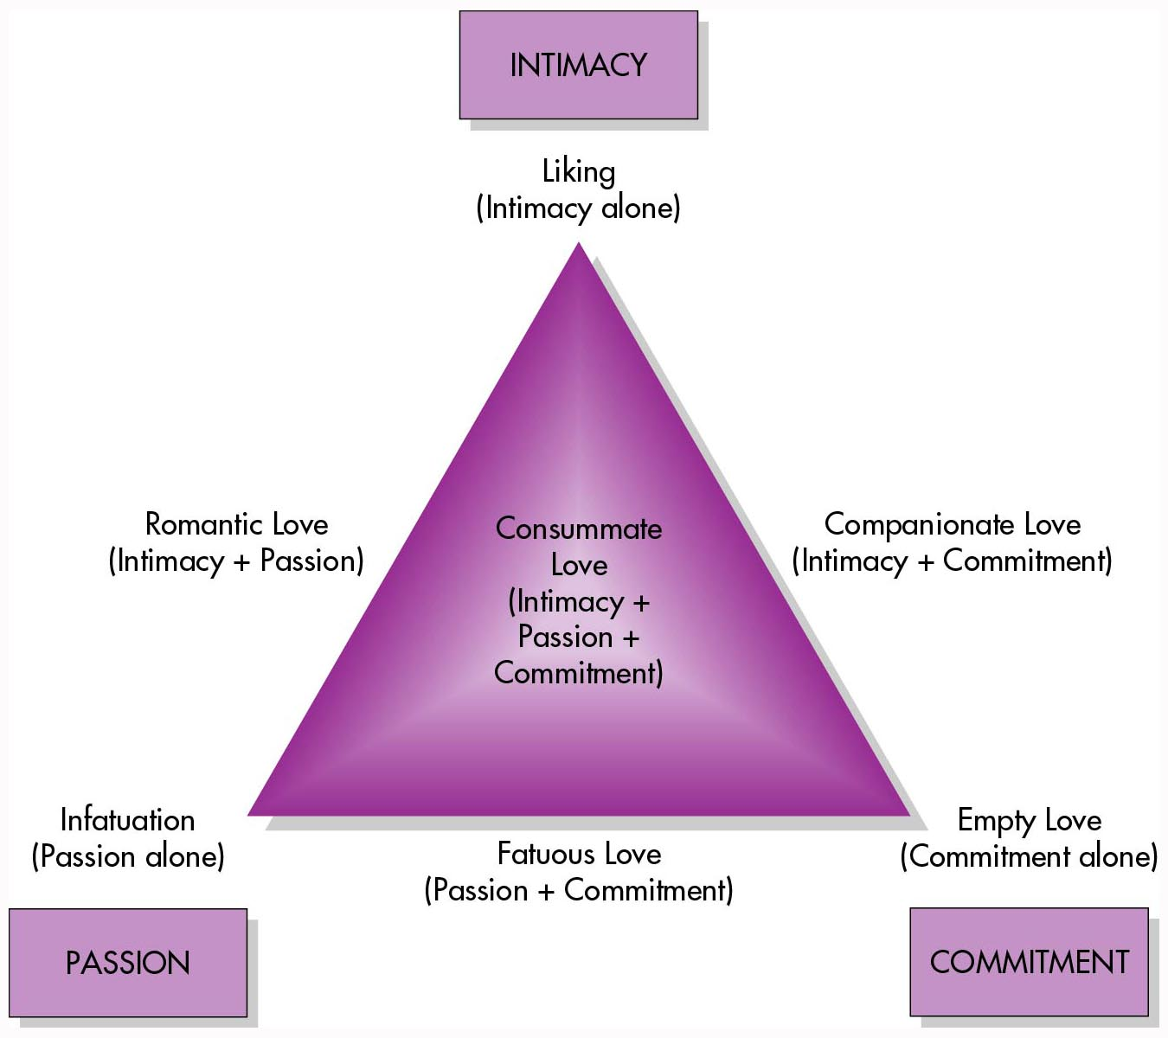
EXAM – take out articles 24 and 28

