Biology 202
Lecture 1: Scientific Thinking

Science is an intellectual activity, encompassing observation, description, experimentation, and explanation of natural phenomena.

Biology is the study of living things

SCIENTIFIC LITERACY

A general, fact based understanding of the basics of biology & other devices.
- How to think scientifically
- How to use the knowledge we gain to make wise decisions
- Increasingly important in our lives
- Literacy in matters of biology is especially essential

BIOLOGICAL LITERACY

The ability to:
- Use the process of scientific inquiry to think creatively about real world issues (that have biological component)
- Communicate those thoughts to others
- Integrate them into your decision making

SCIENTIFIC METHOD
The process of examination and discovery based on experience and observations that are rational, testable and repeatable.
Rarely proceeds in a straight line. Conclusions often lead to new observations and refined hypothesis.
Basic steps:
- Step 1: make OBSERVATION
- Step 2: formulate a HYPOTHESIS
  - Must accomplish:
  - 1. Establish mutually exclusive alternative explanations for a phenomenon (hair that is shaved grows back coarser or darker. Hair that is shaved does not grow back coarser or darker)
  - 2. Must generate testable predictions.
- Step 3: devise a TESTABLE PREDICTION
- Step 4: conduct a critical EXPERIMENT
  - Experimental Group
  - Placebo: a pill that appears identical to the test drug but contains no active ingredients
- Step 5: draw CONCLUSIONS and make REVISIONS
THE NULL HYPOTHESIS

A negative statement that proposes that there is no relationship between two factors (opposite of the hypothesis)
Must generate testable prediction

ELEMENTS COMMON TO MOST EXPERIMENTS

- TREATMENT: experimental condition applied to individuals
- EXPERIMENTAL GROUP: a group of individuals who are exposed to a particular treatment
- CONTROL GROUP: a group of individuals who are treated identically to the experimental group with the one exception, they are not exposed to the treatment (placebo)
- VARIABLES: characteristics of your experimental system that are subject to change (timing, dosage, method of delivery, etc.)

EXPERIMENT DESIGN

- HYPOTHESIS
- PREDICTION

THE PLACEBO EFFECT

- Improvement of disease symptoms caused by placebo
- The placebo effect highlights the need for comparison of treatment effects with an appropriate control group
- Effect of the test drug must be significantly larger than the placebo effect

EXPERIMENTAL DESIGN

- OPEN-LABEL: the experimental subjects know that they are receiving the treatment. Conclusions are less reliable
- BLIND: the experimental subjects do not know which treatment (if any) they are receiving
- DOUBLE-BLIND: neither the experimental subjects nor the experimenter knows which treatment the subject is receiving
- RANDOMIZED: the subjects are randomly assigned into experimental and control groups

REPEAT EXPERIMENTS: AN EXPERIMENT MUST BE REPRODUCIBLE AND REPEATABLE

HYPOTHESES AND THEORIES

- A hypothesis is a proposed explanation for phenomenon: a good hypothesis leads to testable predictions
- A theory is a hypothesis for natural phenomena that is exceptionally well-supported by the data

IMPORTANT THEORIES IN BIOLOGY

CELL THEORY- all organisms are composed of cells and all cells come from pre-existing cells

THEORY OF EVOLUTION- species change over time and are all related to each other through common ancestry

BIASED

Biases can influence our behaviour, including our collection and interpretation of data
With careful controls, it is possible to minimize such biases.

VISUAL DISPLAYS OF DATA USED IN BIOLOGY

Bar graph: used to represent data, with a height that is proportional to the value of being represented

Line graph: may be used to connect data points or to illustrate trends across many data points

Pie chart: “slices” are used to represent data, which each slice is proportion of the whole

VARIABLES

Independent variables: a measurable entity that is present at the start of the experiment

Dependent variables: is the measured result of an experiment

STATISTICAL ANALYSIS

Because of variation that exists in the world, statistics can help evaluate whether differences between a treatment and control group can be attributed to the treatment rather than random chance.
- PSEUDOSCIENCE individuals make scientific-sounding claims that are not supported by trustworthy, methodical scientific studies

- ANECDOTAL OBSERVATIONS- based on only one or a few observations, people conclude that there is or is no link between two things.

LIMITS TO WHAT SCIENCE CAN DO

The scientific method is empirical based on experiments and observations:
- Rational
- Testable
- Repeatable

The scientific method does not provide:
- Value judgments
- Subjective information
- Moral statements Solution to ethical problems

Science is a process: Publication

Results of an experiment are published in peer-reviewed journals. Experts review these scientific journals before publication to ensure accuracy.

Considerations for good studies

- Type of study
• Anecdotal or Experimental
- What they are testing
• Hypothesis
- Control
- Blinded
- Sample size
- Randomized
- Peer Review

Lecture 2: Chemistry

Element is a substance that cannot be broken down chemically into any other substances: gold, carbon, and copper.
If you keep cutting down into smaller pieces, each piece will behave exactly the same as other pieces.

Cells are the basic unit of life
- Cell is the smallest unit of life
- Structures of cell are created by different molecules
- Molecules are made by combining atoms
- Atom is the basic unit of matter

Organization of life

7- Organism
6- Organ system
5- Organ
LIVING 4- Tissue
3- Cell

NONLIVING 2- Molecule
- Atom

ATOMS – BASIC UNIT OF MATTER

IT CANNOT BE BROKEN DOWN BY CHEMICAL METHODS
ALL ATOMS HAVE SAME GENERAL STRUCTURE
ELECTRONS DETERMINE WHETHER OR NOT AN ATOM WILL BOND WITH OTHER ATOMS
ATOMS ARE MADE UP WITH 3 SUBATOMIC PARTICLES: NEUTRONS, PROTONS & ELECTRONS

Nucleus (at the center of the atom) is made up of two types of particles: protons & neutrons

Electrons NEGATIVE charge (weights almost nothing, mass can be ignored)
Protons PROSITIVE electrical charge

Neutrons NO electrical charge

PROTONS & NEUTRONS HAVE APPROXIMATELY THE SAME MASS

Mass is the amount of matter in a particle

Atomic Mass (mass of an atom) is made up of the combined mass of all its protons and neutrons
PARTICLES THAT HAVE THE SAME MASS REPEL EACH OTHER
THOSE WITH OPPOSITE CHARGES ARE ATTRACTED TO EACH OTHER
ALL ELECTRONS HAVE THE SAME CHARGE, ELECTRONS REPEL EACH OTHER
(ELECTRON) - + (PROTON) = ATTRACTION, THIS HOLDS ELECTRONS CLOSE ENOUGH TO NUCLEUS TO KEEP THEM FROM FLYING AWAY WHILE THE ENERGY OF THEIR FAST MOVEMENT KEEPS THEM FROM COLLAPSING INTO THE NUCLEUS
WHEN THE NUMBER # OF ELECTRONS AND PROTONS ARE = EQUAL, THE CHARGES IN THE ATOM ARE BALANCED.
The number of protons in an atom’s nucleus determines what element it is

Atomic Number the number of protons
Usually, PROTONS = ELECTRONS
- At the center is the nucleus containing protons & neutrons
- The nucleus is surrounded by electrons
- Atomic mass is often double the element’s atomic number
(when the number of neutrons = protons) because they have
similar mass

Isotopes are atoms with the same number of protons but different number of neutrons
The charge does not change since neutrons don’t have
charge but the mass changes due to loss or addition of
another particle in the nucleus.
Radioactive atomic nuclei break down spontaneously after they are created (not so stable by losing or gaining neutrons, protons or electrons)
In the process of decomposition, they release at a constant rate,
A tiny, high-speed particle carrying lots of energy.
- Useful determining the age of fossil
- Generating vast amounts of energy
Periodic table elements arranged in a scheme, in the order of their atomic number
“BIG 4” oxygen, carbon, hydrogen and nitrogen (in our bodies)
Ions are charged atoms
An atom that loses one or more electrons becomes positively charged
An atom that acquires becomes negatively charged
An atom with extra electrons becomes negatively charged
An atom lacking one or more electrons becomes positively charged
Atoms can bond together to form molecules or compounds.
Molecules Groups of atoms held together by bonds
Bond Energy the amount of energy it takes to break a bond between two atoms
Chemical bonds:
- Types of chemical bonds depend on the number of electrons in their outermost shells.
- Atoms are most likely to bond with other atoms when their outermost electron shell is not full.
Covalent bonds (strong) two atoms share an electron and form a stable bond
The sharing of two electrons between two atoms forms a single covalent bond
Non Polar Covalent Bond- atoms are attracted by equal forces
Polar Covalent Bonds- unequal pull between atoms creates small charges
Water molecules are made with polar covalent bonds
Double bond: the sharing two pairs of electrons between two atoms
Ionic bonds (weaker) atoms that bond together without sharing electrons. It occurs when the two oppositely charged ions attract each other.
The atom gaining electrons becomes negatively charged
The atom losing electrons becomes positively charged.
Iconic compound ions of two or more elements linked by ionic bonds.
The ions attracted to each other are of equal and opposite charge,
The compound is neutral, that is no charge.
Hydrogen bonds (weakest) ion and covalent bonds link two or more atoms together within an ionic compound or a molecule.
Are also important in holding molecules together. It is formed between a
hydrogen atom in one molecule and another atom in another molecule
(or even in another part of the same molecule)
This bond is based on the attraction between positive and negative charges
POLAR- molecules with slightly charged atoms become like a magnet. Distinct positive and negative sides. They are attracted to other polar molecules, lined up so the positive region is near the negative regions of another. THESE ATTRACTIONS ARE CALLED HYDROGEN BONDS.
A MOLECULE’S SHAPE GIVES IT UNIQUE CHARACTERISTICS:
- Shape determines function
  - Physical properties such as:
1. Taste
2. Smell
- The properties of a molecule such as how the molecule tastes or smells, or its likelihood of bonding with other molecules depends upon
  - the shape in which the atoms are linked together
  - the electrons in their outermost shells.
HYDROGEN BONDS MAKE WATER COHESIVE
Molecules stick together
Water molecules are polar and form easily hydrogen bonds, giving water great cohesive

PROPERTIES OF WATER:

- Cohesion: Water molecules stick together due to hydrogen bonds
- Large Heat Capacity: Since water molecules don’t increase their movement, temperature doesn’t increase.
- Low density as a solid: water becomes less dense when frozen due to hydrogen bonding. Temperature drops and molecules slow down, each V molecule bonds with four partners. So hydrogen bonds arrange water molecules into crystalline lattice, keeping them slightly apart and, therefore, less dense.
  - Liquid water: water molecules move about freely, allowing them to be closer to one another.
- Good solvent: the positively charged sodium ions are attracted to the negatively charged side of the water molecule and the negatively charged chloride ions are attracted to the positively charged side. Substances are, like water, polar and consequently dissolve easily in water.
  - Nonpolar molecules (such as oils) don’t have positively charged regions nor negatively charged regions, therefore, the polar water molecules are not attracted to them.
Hydrophobic and Hydrophilic
- Water is a good solvent for molecules with charges.
  - Ions (such as salt)
  - Polar molecules (such as sugar)
  - These molecules are said to be hydrophilic (hydro=water, philic= like), as they interact with water molecules.
- Water repels non-polar molecules such as oil.
  - Non-polar molecules are hydrophobic (hydro=water, phobic=dislike)
Ionization of water

Water can break up spontaneously into ions: OHand H+.
- Pure water contains an equal amount of OH- and H+ ions.
- The amount of H+ in a solution is a measure of its acidity and is called pH.
- The greater the number of H+, the more acidic the solution is
- Buuffers absorb excess H+ ions to keep a solution from becoming acidic and they can release H+ ions to counteract in the increase of OH-. RESIST CHANGES IN PH
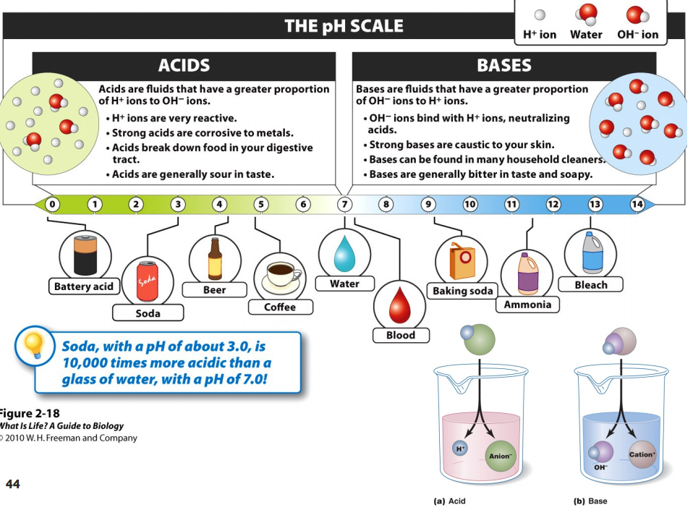
Carbon has 4 bonds
Carbohydrates & Biological Molecules
- Living organisms are mainly made of organic molecules (molecules containing carbon)
- Carbon atom can form stable bonds with four other atoms creating infinite possibilities to create new molecules.

Macromolecule a large molecule made up from smaller building blocks or subunits. They are made from smaller units, monomers (building blocks) they make polymer.
- There are four essential to the building & function of a living organism:
  - CARBOHYDRATES (sugar, starch, glycogen)
  - LIPIDS (fats)
  - PROTEIN (enzymes)
  - NUCLEIC ACID (DNA & RNA)

Carbohydrates molecules that contain carbon, hydrogen & oxygen: the primarily fuel for organisms.
- Cell structure
- Store energy & are easily broken down by organism
- Starch is a polymer, the monomer is glucose
- Glucose molecules are covalently joined to create starch
- Chemical bonds are broken down to create energy, Cellular respiration
- Excess glucose is converted into glycogen or fat
- They are categorized (carbohydrates) by their size & composition

FORMATION- BONDS BETWEEN SIMPLE SUGARS FORMED
Monosaccharides (simple carbohydrates or simple sugars)
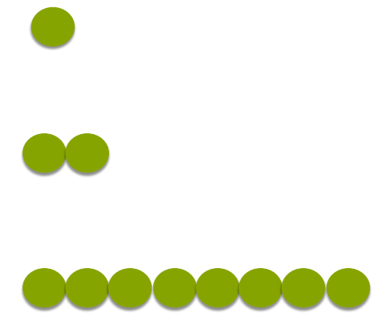
- Glucose
Monomer
- Galactose
- Fructose
Disaccharides (formed by the union of TWO simple sugars)
- Sucrose
- Lactose
Polymer
- Mannose
Polysaccharides (formed by the union of many simple sugars)
- Starch
- Cellulose
- Chitin
- Glycogen

THE CARBOHYDRATE OF MOST IMPORTANCE TO LIVING ORGANISMS IS GLUCOSE
- Fuel for cellular activity
- Stored temporarily as glycogen (muscles & liver): The stored glucose molecules are linked together to form a large web of molecules called glycogen.
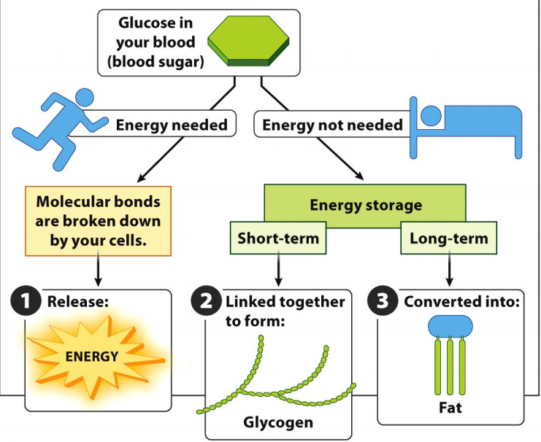
- Converted to fat

NOT ALL CARBOHYDRATES ARE DIGESTIBLE

Chitin forms the outer skeleton of most insects and crustaceans.
Cellulose forms a variety of plant structures that are visible all around us.
FIBER

- “Roughage” passes through the digestive system.
- Colon cancer prevention/reduction
  - Soluble fibers attract water and form a gel, which slows down digestion.
  - Insoluble fibers have a laxative effect and add bulk to the diet.
Lipids

A second group of macromolecules important to all living organisms with several functions: energy storage.
- Insoluble in water
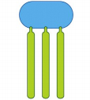
- Greasy to the touch
glycerol
- Three types of lipids
  - Fats: long term energy storage & insulation
    - GLYCEROL “head” region
Triglycerides
Fatty acids
    - FATTY ACIDS: “tails”
    - Triglycerides: 3 fatty acids linked to the glycerol
  - Sterols: regulate growth & development
  - Phospholipids: form cellular membranes
Hydrophobic- fear of water
Hydrophilic- water-loving
Saturated & Unsaturated

- Depends on the number of bonds in the hydrocarbon chain in a fatty acid
- Health considerations

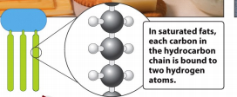
Saturated fat: each carbon in the hydrocarbon chain is bound to two hydrogen atoms

- Can be packed together tightly
- As result, are solid at room temperature

Unsaturated fat: at least one carbon in the hydrocarbon chain is bound to just one hydrogen causing the fatty acid to have a crooked shape.
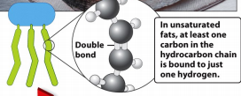
- Can’t be packed together tightly
- As result, are liquid at room temperature

- NOT ALL LIPIDS ARE FATS NOR NECESSARILLY FUNCTION IN ENERGY STORAGE
Sterols

regulates growth & development

  - Cholesterol: important component of cell membranes in animals
    - Can attach to vessel walls and cause them to thicken, may cause serious health problems
  - Steroid Hormones: regulate sexual development, maturation & sex cell production
    - Estrogen influences memory and mood
    - Testosterone stimulates muscle growth
- Phospholipids are the major component of the cell membrane
Phospholipids & Waxes
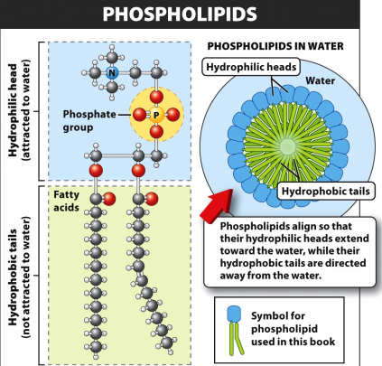
  - surrounds the contents of a cell and controls the flow of chemicals into & out of the cell
  - has 2 fatty acids instead of 3
  - Hydrophilic head & Hydrophobic tail
  - Align so heads extend towards water
while their tails are directed away
from the water

- Waxes resemble fats but have one long-chain fatty acid linked to the glycerol
  - Strongly hydrophobic.
Protein

- Building blocks of all life
- Are versatile macromolecules
- Are essential dietary component
  - Growth repair and replacement

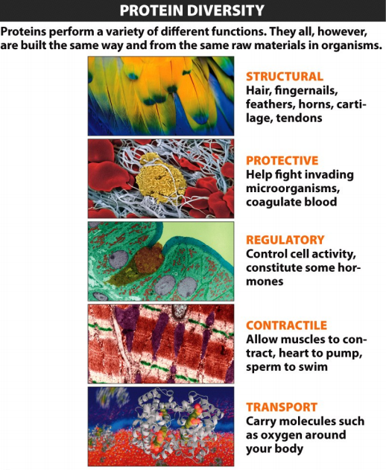

Enzymes proteins initiate & assist every chemical reaction that occurs
  - 20 amino acids give rise to proteins, the chief building blocks of physical structures that make up all organisms
  - Proteins perform myriad functions.
  - Contain nitrogen

Carboxyl group it is one bond that attaches the carbon to a group of atoms
  - to one by a single bond and to the other by a double bond
  - second bond attaches the central carbon to a single hydrogen atom
  - the third attaches the central carbon to an amino group
Amino group is a nitrogen atom bonded to hydrogen atoms (two or three)
  - these components are the foundation that identifies a molecule as an amino acid
  - as multiple amino acids are joined they form the “backbone” of the protein
Amino acid structure is made up of a central carbon atom attached to a hydrogen atom, an amino group, a carboxyl group and a side chain.
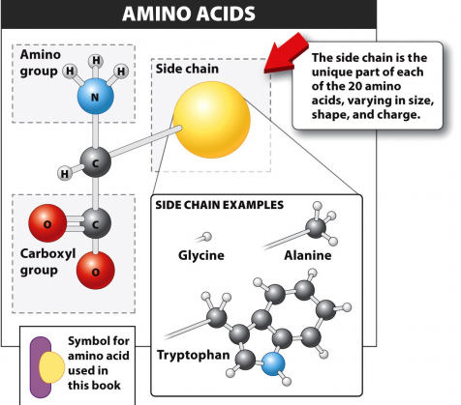
- Complete proteins have all essential amino acids while incomplete proteins do not
Peptide bond

Proteins are formed by linking individual amino acids together with a peptide bond
The amino group of one amino acid is bonded to the carboxyl group of another
- two amino acids form dipeptide
- several amino acids form polypeptide
STRUCTURES OF PROTEIN:

Primary structure is the sequence of amino acids in the polypeptide chain
Secondary structure is the distribution of corkscrews and zigzags within a protein
Tertiary structure the protein folds into a unique and complex three-dimensional shape
Quaternary structure two or more polypeptide chains are held together by hydrogen bonds and other non-peptide bonds between amino acids the different chains
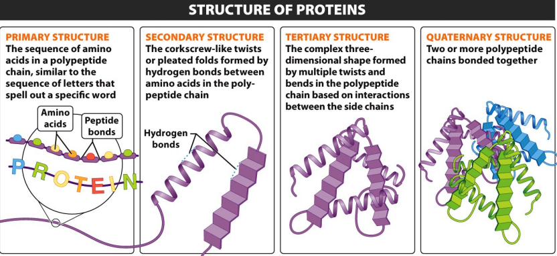
Denaturation of proteins is when a protein's shape is deformed by factors such as temperature and pH etc. The protein usually loses its ability to function.
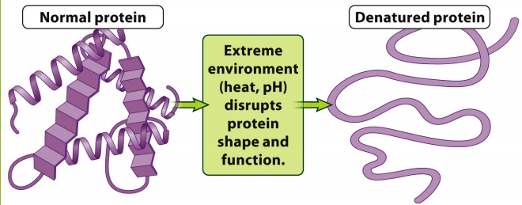

Protein shape is critical in enzymes:
- molecules that help initiate and accelerate the chemical reactions in our bodies
- enzymes emerge unchanged (original form)
- when the reaction is complete and can be used again and again
Active site small area that provides a place for the participants in a chemical reaction, the reactants or substrate molecules, to nestle briefly.
- The chemical reactions that occur can either release or consume energy
Activation energy a certain minimum energy is needed to initiate the reaction
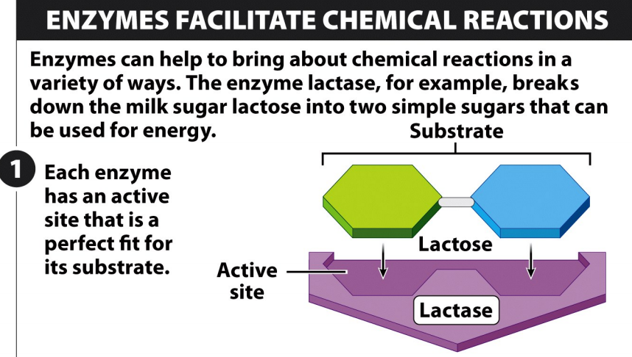

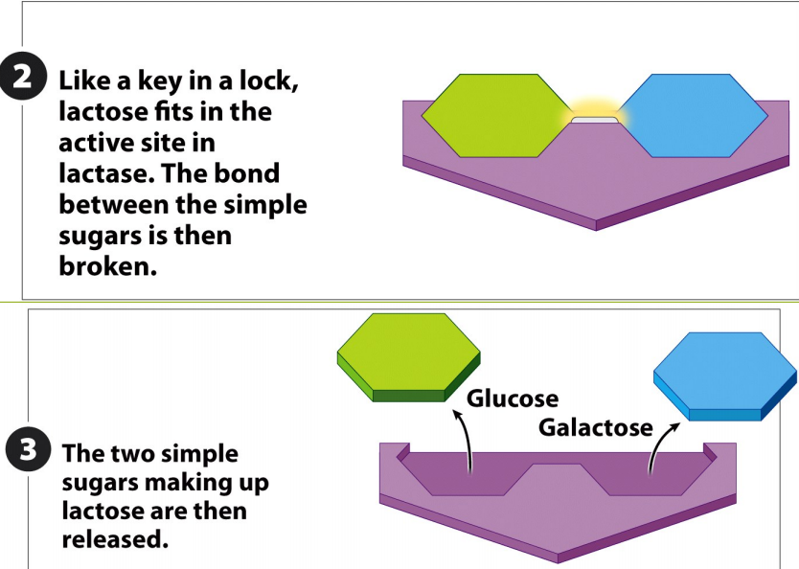

LOCK & KEY enzymes are very specific about which molecules and reactions they will catalyze

“MIS-SPELLED” PROTEINS
- Incorrect amino acid sequences
- Active site disruptions
- Enzyme no longer functions

ENZYME ACTIVITY
- Enzyme and substance concentration
  - Reaction rates increase with increased amounts of enzyme but only up to the point at which all of enzyme molecules are bound to substrate. At that point, additional enzyme no longer increases the reaction rate
- Temperature
  - Reaction rates generally increase at higher temperatures, but only up to the optimum temperature for an enzyme. A temperature above the optimum, reaction rates decrease as enzymes can lose their shape or even denature
- pH
  - Reaction rates generally increase as pH nears the optimum level for an enzyme. Above or below the pH enzyme function can be disrupted and reaction rates decrease
- Presence of inhibitors or activators
  - Reaction rates increase in the presence of activators and decrease in the presence of inhibitors
  - Inhibitors reduce enzyme activity and come in 2 types:
    - Competitive inhibitors: bound to the active site, blocking substrate molecules from the site and this from taking part in the reaction
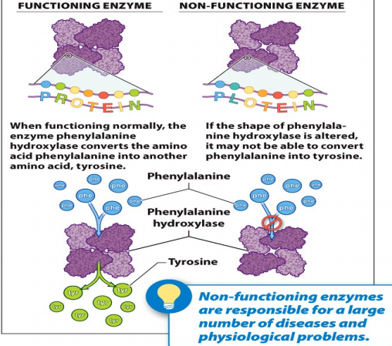
    - Noncompetitive inhibitors: do not compete for the active site but bind to another part of the enzyme, altering its shape in a way that changes the structure of the active site, reducing its ability to bind or substrate

Nucleic Acid
Macromolecule that stores information. RNA & DNA are the nucleic acids present
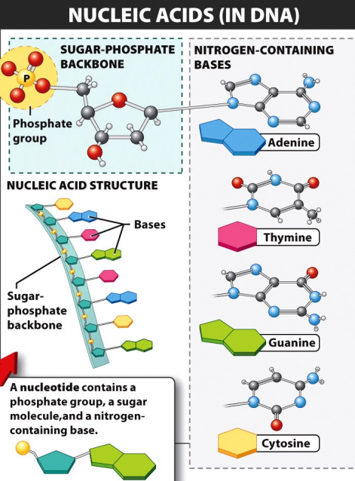
Nucleotides make up the nucleic acid
- Have 3 components:
  - A molecule of sugar
  - A phosphate group
  - A nitrogen-containing molecule
Nucleotides are linked in a series to form a
Ribbon-like strand that is the backbone of the
Nucleic acid molecule: a sugar molecule is
Attached to each sugar and protruding from the
Backbone, is one of the nitrogen-containing
Molecules called DNA or RNA, bases.
DNA

Holds the genetic information to build an organism
- DNA has two strands, each a sugar-phosphate-sugar-phosphate (sequence) backbone with a base sticking out from each sugar molecule
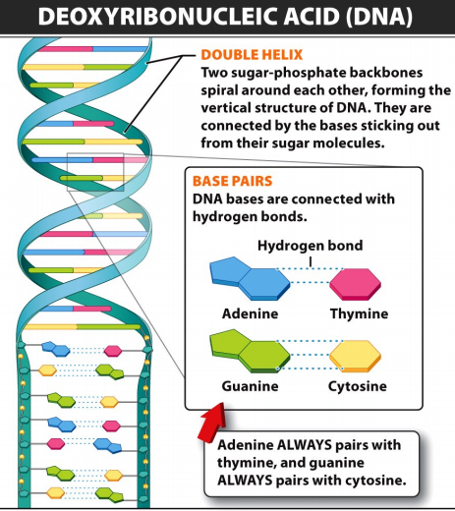
- Double helix two spiraling strands together
Combination of bases:
A – T
C – G

RNA
It is a universal translator, reading DNA and directing protein production
It takes instructions for production of a protein from DNA, moves them to another part of the cell, and directs the building of a protein
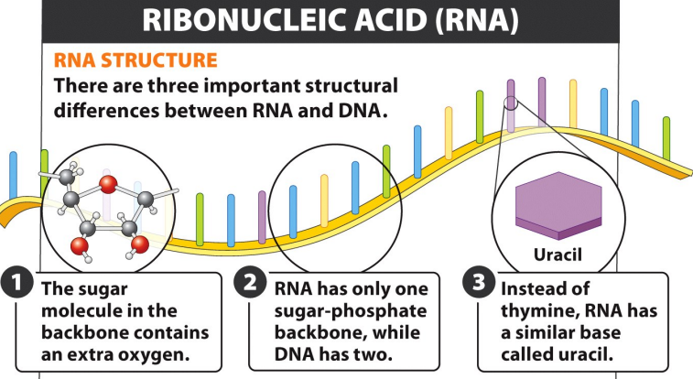
- RNA does not have a T base

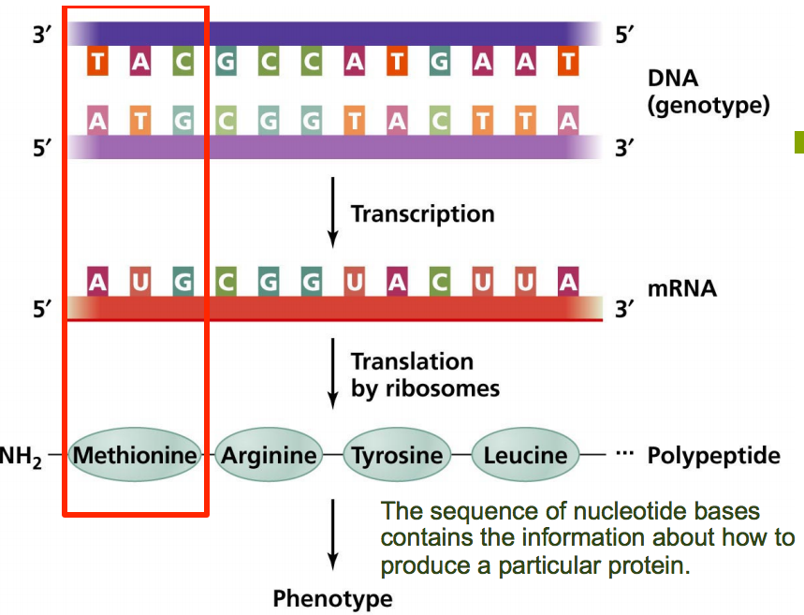

DIFFERENCE BETWEEN DNA & RNA
- Sugar molecule of the sugar-phosphate backbone is different
- Uracil (U) replaces thymine (T)
- RNA is single stranded whereas, DNA is double stranded

Lecture 3: Cells

