F-Yaccarini’s School of Hockey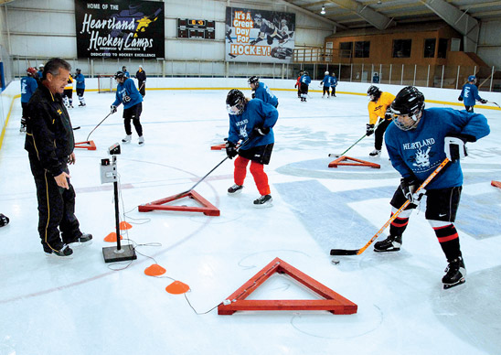
Inte 290 Word Assignment
Francois Yaccarini
40031797

October 13th 2017
Concordia University

Table of Contents:

Project Description 3

Schedule 4

Location and Budget 5

Our value 6

Works cited 7

F-Yaccarini’s school of hockey is a brand new hockey school that will be opening in late July 2017. It will be located in Ville Mont-Royal at the REC center. Players from all across the city looking for an elite training program will be spending two weeks at our camp. We will accept kids from all age and will be separating them in appropriate groups. The interest for hockey in Montreal keeps growing every year. The competition is harsh in this business as there are already many hockey schools in Montreal. Our advantage is that most schools are located on the North or South shore; we offer an easy transport for people living on the island. Our camp will offer 14 days of intense training, with elite coaches across the province at a cost of 650$.

There are two practices a day. The first one being from 9 to 11am. Then from noon to 2pm the kids will eat and play some games. And finally from 3 to 5pm they will go back on the ice for the last practice. At 5:30pm the day should be done and parents can pick them up at the arena.

Location

Our hockey camp will be located at the Recreation center in the heart of the Town of Mont-Royal. The arena and parking are already built. There are parks all around for outside activities. The only thing left is to rent the facilities for the two weeks in august.

Budget

Reason | Expenses $
Renting the facilities for two weeks | 15,000
Paying employees (for the two weeks) | 10,000
Ordering of equipment | 2,000
Advertising | 1,500
Inviting NHL players | 5,000
TOTAL: | 33,500

Long term goal

This circle of success is what we aim for. We want to develop elite players that reach high levels such as NCAA and the NHL. These players will then come back to our camp and young players will want to come to our camp seeing what good it did for these professionals. Hopefully these players will become pro, and so on and so on. Of course we can’t expect all our players to make it in the big leagues but if we can have one player each year that eventually goes on to play at a high level: that would be great for us.

- Recreation Center, Retrieved October 11th 2016, from http://www.ville.mont-royal.qc.ca/en/services-residents/recreational-facilities/recreation-centre
- Salles et installations sportives de Mont-Royal, Retrieved October 11th 2016 from http://www.ville.mont-royal.qc.ca/sites/default/files/documents/politique_reservation_salles.pdf
- Summer Camp for all, Retrieved October 11th 2016, from http://www.budgettravel.com/print/4487/
- Meet the experts, Retrieved October 11th 2016, from http://www.proambitions.com/experts.html
- Facility, Retrieved October 11th 2016 , from http://www.prostarhockeyschool.com/facility.html

See reservation policies at : http://www.ville.mont-royal.qc.ca/sites/default/files/documents/politique_reservation_salles.pdf

