IMC Mid – Term James M
Chapter 1 Core Learning Objectives

- Appreciate role of IMC planning in business today
- Identify components of the IMC mix
- Identify the conditions that have led to the emergence of IMC
- Explain how consumer behavior concepts influence IMC
- Essential criteria for business marketing requirements
- Explain how the unique characteristics of organizational buying behavior influence marketing communications

1. Role of IMC planning in business today

• Integrated marketing communications is the coordination of all marketing communications in a unified program that maximizes the impact on the intended target audience.

• Todays environments are changing rapidly with the influence of technology

• Must deliver the same core message over a large variety of media in order to successfully engage target market

2. Identify components of the IMC Mix
• IMC has seven core elements
- Advertising
- Digital Communications
- Sales Promotions
- Personal Selling
- Experiential Marketing
- Direct Response
- Public Relations

Advertising:
The placement of persuasive messages that seek to inform and persuade the target market about their products, services, organization, or ideas.

What are the two main types of advertising?
Product Advertising
• Helps build an image for the product by presenting the features, attributes, and benefits of the product in a persuasive manner.

Promotional Advertising
• Used to communicate a specific offering to encourage an immediate response from the target market

Digital Communications
• Commercial messages placed on the internet, a cell phone, or other personal devices
• This is the fastest growing form of advertising

Sales Promotions
• Involves a special incentive to initiate an immediate reaction from a consumer or a distributer
• Consumer Promotion – Pull Strategy
• Distributer Strategy – Push Strategy

Personal Selling

• Delivery of a personal message from seller to buyer, with the objective of making a sale

ex. A car salesman leads you too “the perfect car for you”

Experiential Selling

• Creates an emotional connection with the consumer in a way that creates personal memories

Event Marketing

• Integrating a variety of communications elements into a single event

Sponsorship

• Financially supporting an event in return for ad privileges

Direct Marketing
• The delivery of a message to one specific target
ex. Direct mail, telemarketing, mobile communications

Public Relations
• Designed to gain public understanding and acceptance, creating a general positive attitude towards products

3. Identify the conditions that have led to the emergence of IMC

• Consumers media habits moving towards digital media

• The explosion of social media popularity and its reach

• Mobile communications becoming the next big thing

• Role of database marketing and direct forms of communication. Individualization is expanding.

• The demand for efficiency and accountability is increasing

4. Explain how consumer behavior concepts influence IMC
Define consumer behavior?
• The acts that individuals perform in obtaining and using a product, including the decision making process that occurs before purchase

Why is it important to understand behavioral concepts in marketing?
• This knowledge is directly applied in the development of marketing communications strategies

What areas do companies need to be knowledgeable in regarding consumer behavior?
• Needs and motives
• Personality and Self – Concept
• Attitudes and Perceptions
• Reference Groups
• Families

Needs vs Motives
Need
• An absence of something useful
Motive
• Condition that prompts action to satisfy this need

The Hierarchy of Needs
What two assumptions is Maslow’s hierarchy based on?
- When lower level needs are met, a person moves to high level needs
- Satisfied needs don’t motivate, behavior is influenced by yet satisfied needs

Hierarchy from top to bottom
- Self actualization (Fulfillment, realizing potential)
- Esteem Needs (Recognition, status)
- Social Needs (Belonging, love from family/friends)
- Safety Needs (Security, Protection, Comfort)
- Physiological Needs (Hunger, thirst, sex, shelter)

Personality & Self Concept
• A persons distinguishing psychological characteristics that lead to relatively consistent responses

Self Concept Theory (four components)
- Real Self: An objective evaluation of ones self
- Self-Image: How you see yourself
- Looking Glass-Self: How you think others see you
- Ideal Self: How you would like to be, what you aspire to

Attitudes and Concepts
Attitudes
• Peoples feelings towards an object or idea

What influences peoples attitudes?
• Advertising, friends, trendsetters, and opinion leaders

How must companies position themselves in regards to consumer attitudes?
• Must present their product in accordance with the attitude held by their target market

Perceptions
• How individuals receive and interpret messages

What are the three levels of selectivity?
- Selective Exposure:
Eyes & mind notice only info that interests us

- Selective Perception:
We screen out messages that conflict w/ our attitudes

- Selective Retention:
We remember only what we want to remember

Reference Groups
• A group of people with a common interest, that influence one another’s attitudes and behaviors

Why are reference groups so effective, and to what demographic?
• Young people are strongly influenced by reference groups, as they have a strong desire to satisfy social needs

Family Influence
• Family members all have influence on one another

• Changing roles/responsibilities in households have necessitated “double targeting”

What is double targeting?
• Creating marketing strategies that reach both genders effectively

5. Essential criteria for business market requirements?
The four main Criteria include…
- Quality: Consistent quality on every order

- Service: Reputable suppliers with prompt service

- Supply Continuity: Provision of goods over the long term

- Price: Lowest price is not always accepted

The buying center
• An informal purchasing process where individuals in an organization are involved in the purchase

The five roles in the buying center include…
- Users
- Influencers
- Buyers
- Deciders
- Gatekeepers

Users
• Those in the organization who use the product
• Ex: For a computer, any end user in the organization

Influencers
• Those who define the product specifications
• Ex: An engineer

Buyers
• Those with the authority to buy
• Ex: A purchasing manager

Deciders
• Those with power to finalize the purchase
• Ex: Potentially the CEO

Gatekeepers
• Those who control the flow of information to the buying center members
• Ex: Could also be fulfilled by the purchasing manager

Chapter 2: Strategic Planning Principles Core Learning Objectives

- Identify essential external trends and conditions that influence organizational planning
- Describe the steps in the strategic planning process
- Identify the distinctions and relationships among the various types of plans
- Characterize the essential elements of a corporate plan
- Outline the structure and content of a marketing plan
- Outline the structure and content of a marketing communications plan
- Show how integrated marketing planning provides solutions to marketing problems

1. Identify essential external trends and conditions that influence organizational planning

Three levels of business planning include?
- Corporate planning
- Marketing planning
- Marketing communications planning

Strategic Planning
• The process of determining objectives, and identifying strategies, and tactics to help achieve these goals

There are three common variables in strategic planning
- Objectives
- Strategies
- Tactics

Objectives
• Statement of what is to be accomplished in terms of sales, profit ect

Strategies
• Statements that outline how objectives will be achieved, such as tactics or allocation of resources

Tactics
• Action oriented details, including details about cost and timing

List the seven external influences on strategic planning
- External environments
- Economic Conditions
- Competitor Activity
- Demographic Trends
- Social Change
- Technology
- Laws and Regulations

Economic Conditions
• State of economy changes in accordance with fluctuations in GDP, inflation rates, employment levels, income distribution

Four Stages in the economic cycle include…
Recession -> Depression ->Recovery -> Prosperity

Competitor Influence
• Most Canadian markets are either oligopoly or monopolistically competitive
• Consumers have freedom to choose between competitors
• Forms of competition are direct and indirect

Indirect vs Direct Competition
•Direct: Competition from alternative products that satisfy same needs
• Indirect: Competition from a substitute product, offers same benefits
Social & Demographic Influences
Key Canadian trends include…
- An aging population
- Trending towards urbanization
- Increase in ethnic diversity
- Change in lifestyle for Canadians
- Changing household formations

Technology Influence
• The incredible pace that tech is changing having a strong effect on marketing communications
• Consumer generated content is actually being encouraged and used by companies

Legal & Regulatory Influence
What are the three main elements of the Competition Act?
- Maintain and encourage competition
- Ensure small businesses have equal opportunity
- Provide consumers with product choice and competitive prices

Canadian Code of Advertising Standards
• Regulations regarding product claims, price claims, gender portrayal ect

Privacy Laws include…
- Privacy Act
•Places limits on use of personal information
- PIPEDA (Personal Information Protection and Electronic Documents Act)

Strategic Planning Process
• The Corporate plan, Marketing plan, and marketing communication plan

The Corporate Plan
• A plan formed by senior executives, mostly financial objectives. Sets the stage for other marketing communications plans in the company

• The corporate plan includes a mission statement, corporate objectives, and corporate strategies

What is a mission statement?
• A statement of an organizations purpose and philosophy, oriented around customers, marketing, competition, and long term results

Corporate strategy Factors include….
- Marketing strengths
- Degree of competition
- Financial Resources
- R&D capabilities
- Management commitment levels

The Marketing Plan
• Developed for each of the company’s products, it also sets out the objective for all brands

Marketing Communications Plan
• Develop a synergistic communications plan that will improve the well being of a product or service

Market Planning
The analysis, planning, implementing and controlling of marketing initiatives to satisfy target market needs and achieve organizational objectives

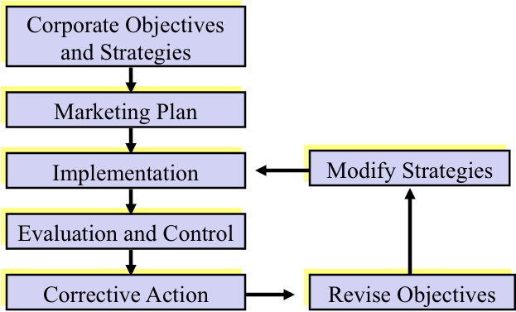

Market Background
The direction taken by a marketing plan is influenced by both internal and external conditions. These conditions can be analyzed by SWOT

• Strengths and Weaknesses are internal and controllable
• Opportunities and Threats are external and uncontrollable

Structure and content of marketing plan model

The market background has six core elements
- External influences
  - Economic trends
  - Social trends
  - Tech trends
  - Regulatory trends

- Market analysis
  - Market Size/Growth
  - Market Segment Analysis
  - Seasonal Analysis

- Competitor Analysis
  - Market Share trends
  - Market Strategy Assessment

- Target Market Analysis
  - Consumer Data
  - Consumer Behavior

- Product Analysis
  - Sales Volume Trends
  - Market Share Trends
  - Distribution
  - Marketing Communications
  - New Product Activity
- SWOT Analysis
  - Strengths
  - Weaknesses
  - Opportunities
  - Threats

The marketing plan has seven core elements
- Positioning Strategy
  - Positioning Strategy Statement

- Target Market Profile
  - Demographic
  - Psychographic
  - Geographic

- Marketing Objectives
  - Sales Volume
  - Market Share
  - Profit
  - Other

- Marketing Strategies
  - Product
  - Price
  - Distribution

- Marketing Tactics
  - Product
  - Price
  - Communications
  - Distribution
  - New Products
  - Marketing Research
  - Service
  - Partnerships & Alliances

- Budget Summary
  - Budget Allocation
  - Brand Financial Statement

- Timeline or Calendar
  - Activity Schedule

Marketing Communications Plan
• The marketing communications plan, developed simultaneously with the marketing plan, covers aspects like the advertising plan, direct response plan, interactive plan, sales promotions, ect

Examples of marketing communications objectives include… (not limited too)
• Building awareness and interest in the product
• Change customer perception about products
• Attracting new target markets
• Engaging consumers

The Marketing Communications Plan is different for every company!!

---Marketing Plan is more quantitative goals, Communications is Qualitative---

Examples of implementing a marketing communications plan
- Advertising Plan
- Direct Response Plan
- Interactive Communications Plan
- Sales Promotions Plan
- PR Plan
- Experiential Marketing Plan
- Personal Selling Plan

Notes on Chapter 2

Chapter 3: Branding Strategy
Key Learning Objectives
- Describe the concept of branding and the role it plays in marketing communications & other business-building programs
- Identify the various components of a brand
- Describe the benefits of branding for organizations & consumers
- Characterize various stages of brand loyalty
- Describe the role and importance of brand positioning and its relationship to marketing communications plans
- Explain various brand positioning strategies commonly used in marketing communications
- Describe the role and influence of packaging and product design in the brand-building process

1.Describe the concept of branding and the role it plays in marketing communications & other business-building programs

Brand
• An identifying mark, symbol, word that separates one product form another

Trademark
• The part of a brand that’s granted legal protection allowing only the owner to use it

What are crucial characteristics of a brand?
• Personality
• Offering of something unique
• Quality Assurance
• Expression of a set of values

Brand Loyalty is measured three ways
Brand Recognition
Consumer is aware of name, benefit ect

Brand Preference
Brand is top of mind, and consumer will buy if available

Brand Insistence
Consumer buys one brand only, wont buy unless said brand

Examples of Consumer Benefits of Branding (3)
- Suggests a certain level of quality
- Psychological Rewards
- Distinguishes competitive offerings

Marketing Benefits of Branding (3)
- Unique Selling Point
- Creation/development of image
- Repeat purchases and loyalty

Building a Brand
There are four essential steps involved in building a brand…
- Identify brand values and positioning strategy
- Plan and implement brand marketing performance
- Measure and interpret brand performance
- Grow brand equity

Brand Positioning
• How does the brand position itself compared to other competitors, what ideologies does the brand have? What are its core values?

Importance of Positioning
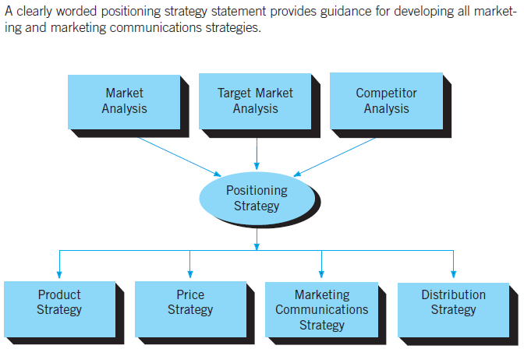
Examples of varies brand positioning strategies include… (7) (DLHIPCL)
- Product Differentiation
- Brand Leadership
- Head On (comparative)
- Innovation
- Price
- Channel
- Lifestyle

To build brand loyalty and equity....
• Determine brand elements to focus on, such as packaging, names, symbols, and characters
• Devise effective marketing communications to communicate the brands values and positioning strategy

Why is good packaging important in building a brand?
• The “look” of a brand must be instilled in the customers mind, everyone knows Coca Cola’s Red Letterhead, Apples Logo, McDonalds Arches
• Helps maintain identity across various product lines
•Familiarity creates trust

Chapter 4: Advertising Planning
Key Learning Objectives
- Identify the basic elements of the communications process
- Explain the various stages of creative planning
- Explain the role of a creative brief and describe the content of such a document
- Distinguish between creative objectives, creative strategies, and creative execution
- Describe the role of creative objective statements.
- Appreciate the variety of appeal techniques for developing creative strategies
- Identify the various execution techniques for best presenting creative strategies

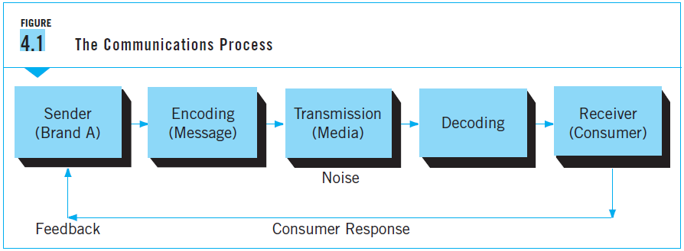

Encoding
• Developing a message into something that reaches consumers, such as an advertisement, a mailing piece, or a newspaper article

Transmission
• Sending out this encoded message through media (TV, Radio, ect)

Decoding
• Consumer viewing the advertisement

A message must break through the clutter that stands between the brand and the consumer, this clutter is referred to as “Noise”

Three factors determine if a message will “Breakthrough the noise”
- The quality of planning while developing the message
- The execution of the plan, need good timing
- The impact of competitive messages
The brand has no control over the third factor

Theory’s of Communication

Dagmar (Defining Advertising Goals for Measured Advertising Response)
• Dagmar is an advertising goal to be accomplished among a defined audience in a measurable period of time. It also should have benchmarks set for goals.

The ACCA Model
This model is a combination of four core attributes that have been found to have a high correlation with an advertisements likelihood to succeed.

Awareness -> Comprehension -> Conviction ->Action

Awareness
• Customer learns something for the first time; advertisers try to plant the brand name in the customers mind

Comprehension
• The consumer is expressing interest, it satisfies a need. They will consider it for a potential purchase

Conviction
• Consumer feels strongly about the brand and its benefits, it is now a preferred brand. The motivation to take action and buy the product increases

Action
• The desired action occurs! Grreeeeaaattttt success

The FCB Grid
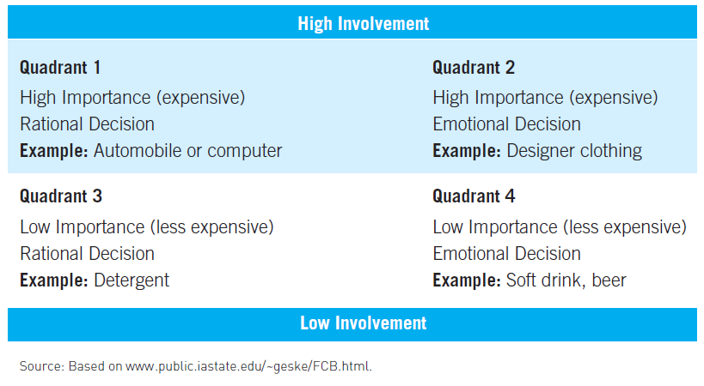

Quadrant 1
• These products are expensive and require extensive decision-making
• Message strategy should be informative, and brands should choose an advertising forum appropriately (newspaper, magazines, ect) (More details)

Quadrant 2
• Still high involvement, but higher emphasis on emotional basis, people don’t buy jeans on basis of which is “better” but of what they prefer
• Message must generate emotion and create self-image

Quadrant 3
• Low involvement but still require decision-making
• Message should give a compelling reason to pick one brand over another

Quadrant 4
• Low involvement products purchased on emotional decisions
• Quick, emotional decision. People like feel good brands.

The Creative Brief
• Business document that contains information about the advertising task

The seven components of the creative brief
- Market Information
- Problem and Overall Objective
- Advertising
- Positioning Strategy
- Creative Objectives
- Creative Strategy
- Creative Execution

Every marketing campaign must have a central focus, be it to create brand awareness, to alter consumer perceptions, to launch a new product, or attract a new target market

Creative Objectives
• Statement that clearly indicate the information to be communicated to the target audience

Key Benefit Statement: The primary benefit, the promise

Support Claims Statement: The substantiation, the proof
Ad’s need to have a central theme or “big idea”

Examples of appeal techniques
• Positive, Negative, Humorous, Sexual, Emotional, Lifestyle, Factual

Chapter 12: Evaluating Marketing Communications Programs
- Define the role and scope of marketing research in contemporary marketing organizations
- Describe the methodologies for collecting primary research data
- Distinguish between qualitative data and quantitative data
- Determine the influence of primary data and information on the development of marketing communications plans
- Assess a variety of marketing research procedures and methodologies that measure and evaluate behavioural responses to communications messages
- Identify the unique methods that measure the effectiveness of individual components of marketing communications

