Chapter 14
Financial Options

Option Basics

A financial option is a contract that gives its owner the right (but not the obligation) to buy or sell an asset at a fixed price in the future. Two distinct types of option contracts exist:
- Call option – gives the owner the right to buy the asset, and
- Put option – gives the owner the right to sell the asset.
Because an option is a contract, the other person of the contract is known as the option writer. The most commonly encountered option is the stock option.

Understanding Option Contracts

When the owner of an options contract enforces the agreement to buy or sell an option they are exercising the option. The price at which the holder buys or sells an option is known as the strike/exercise price.
There are two kinds of options: (1) American options, are the most common and allow the owner to exercise the option at any time up to the final date known as the expiration date, and (2) European options, which allows the owner to exercise the option only on the expiration date. The names have nothing to do with geography, they are both used in NA and Europe.

The option buyer (or option holder) has the right to buy or exercise the option, this is known as having a long position. The option seller (or option writer) is holding the short position and has the obligation to fulfill the contract if it is exercised.

Interpreting Stock Option Quotations

Options are traded on exchanges, the largest being the Chicago Board Options Exchange (CBOE). All options traded expire on the Saturday following the third Friday of the month.

If the payoff from exercising an option immediately is positive, then the option is said to be in-the-money, call options with strike prices below the current stock price are out-of-the-money. Options where the stock and exercise price are significantly different to create a profit, are deep in/out-of-the-money.

Options on other Financial Securities

While options on stocks are the most common, the most well known option on other assets is the option on stock indices. The Montreal Stock Exchange offers the S&P TSX 60 index option. A stock index put option can be used to offset losses in a portfolio in the case of a market downturn; using an option to reduce risk in such a way is called hedging. Options allows investors to speculate on the direction the market is likely to move. For instance, an investor may think that the market will increase and can purchase a call index option (the right to buy) at a much smaller price than the cost of buying a share in the index.

Options Payoffs at Expiration

According to the law of one price, the value of any security are the future cash flows an investor receives from owning the asset. To determine what an option is worth we must first determine its payoff at the time of expiration. When determining the payoff we ignore the cost of buying the option (in the case of the option holder) or we ignore the profit of having sold an option (in the case of the option seller).

Long Position in an Option Contract

Call Option
Assume you own an option with an exercise price of $20. If at the expiration date the stock price is $30 then the option holder can make a $10 profit by exercising the option and immediately selling the option. The $10 payoff is what the option is worth.

If at the expiration date the stock price is less than the exercise price, then the option holder will not exercise the option and make no profit. Therefore, the option is worth nothing. If, at the time of expiration, K = exercise price, S = stock price, and C = value of the call option, then,

C = max(S – K, 0)

Max represents the maximum of the two values in the parenthesis.

Put Option
The holder of a put option (the right to sell the stock) will only exercise the option if the stock price is lower than the exercise price. That way, the owner of the option can sell it for more than the market price.

P = max(K – S, 0)

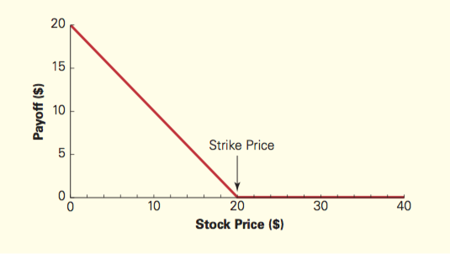
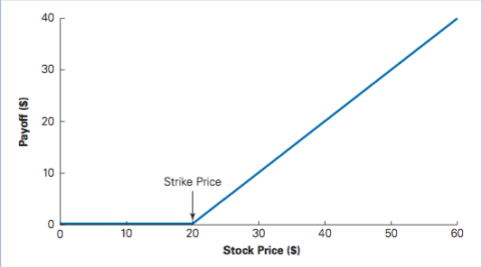
Long Call Option (the right to buy) Long Put Option (the right to sell)
Short Position in an Option Contract

Call Option
An investor in the short position has an obligation. The investor in the short position is taking the opposite side of the long position. The short position’s cash flow will always be the negative cash flow of the long position.

Assume you have a short position in a call option with an exercise price of $20. If the stock price is greater than the exercise price then the holder will exercise the option. For example, if the stock price is $25 then you have the obligation to sell the stock for $20 and you must purchase a stock at the market price of $25. This concludes with a $5 loss. If the stock price is less than the call price then the option holder will not exercise.

C = -max(S – K, 0)

Put Option
An option holder in the put long position will exercise the option if the share price is lower than the exercise price. Thus, if the stock sells for $30 then the investor in the short position will not have to buy the option. If however, the stock price is $15 then the investor in the short position will have to buy the stock at a loss of $5.

P = -max(K – S, 0)

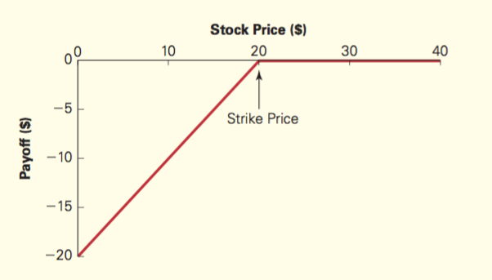
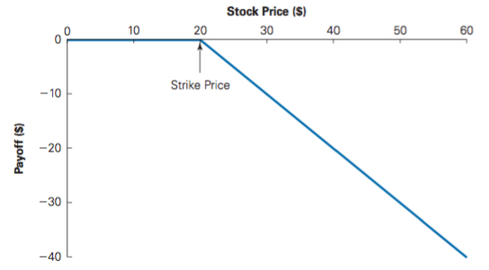
Short Call Option (the obligation to sell) Short Put Option (the obligation to buy)

Profits for Holding an Option to Expiration

The payoffs of an option in the long position will never be negative, the lowest it will be is 0. However, the profit or net payoff can very well be negative given that there is a cost associated with purchasing an option. For instance, if an option costs $2.05 and at the expiration date the price of the stock is less than the exercise price, meaning that the option will not be exercised, then the option holder will have a loss of $2.05.
In other words, given a share price of S, the net payoff will be: max(S – 50, 0) – 2.05. If the exercise price of the option is $50, then the option holder will only make a profit if the share price is greater than $52.05.

Returns for Holding an Option to Expiration

In all cases, the maximum loss of an option is 100% by it expiring worthless. The return curves change as a function of the strike price. The returns for out-of-the-money call options are more extreme than for in-the-money option calls. Thus, an out-of-the-money call option is more likely to have a 100% return and if the stock goes up significantly it will also have a much higher return than in-the-money call options.
All call options have more extreme returns than the stock itself, consequently, the risk of a call option is amplified relative to the risk of the stock, and this is even greater for deep out-of-the-money options. If a stock has a positive beta, then the call option has an even higher beta and higher expected returns.
For put options, the returns are higher with lower stock prices. If the stock has a positive beta, then the put option has a negative beta. This is amplified with deep out-of-the-money options. As a result, put options are usually not held as investments, but as insurance to hedge against other risks in portfolio.

Call Option Put Option
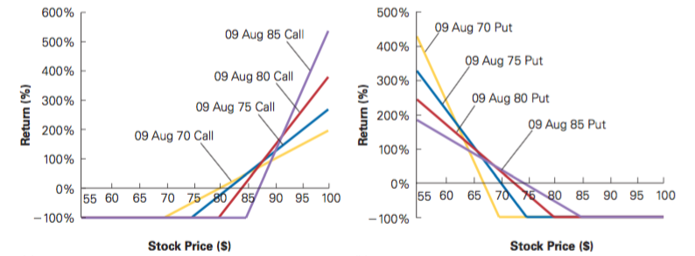

Combinations of Options

Some investors combine option positions by holding a portfolio of options. Some common ones are described below.

Straddle
Long a call and put option with the same strike price. What would happen at expiration? Purchasing both options will always make money, unless the options expire at the money. The farther away the options are from the money, the higher the payoff. The profit will be the payoff less the option premium.

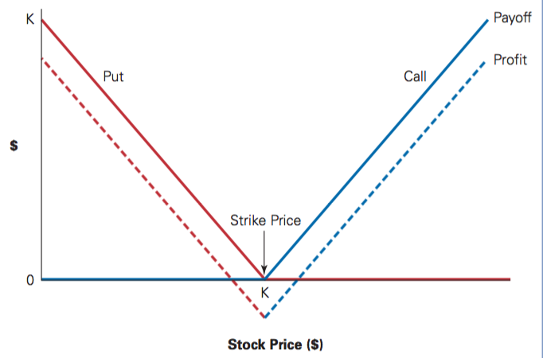
Butterfly Spread
In the straddle combination, more money is made the further the stock price is from the option price. With the butterfly combination a greater payoff is provided the closer the strike price is to the exercise price.
Requires two short call positions between two long call positions.
For example:
- 2 x Short Call Position with a strike price of $30
- 1 x Long Call Position with a strike price of $20
- 1 x Long Call Position with a strike price of $40
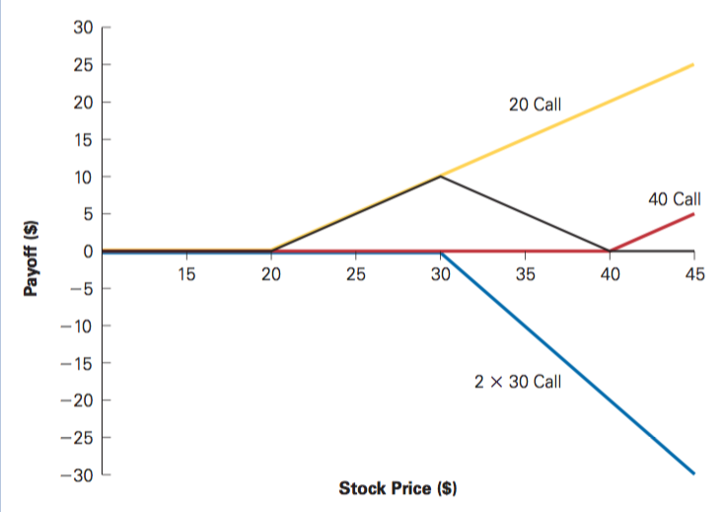

- The black line represents the payoff of the entire combination.
- When the stock price is below $20, no money is made.
- When the stock price is above $40, the money gained from the long call positions is equivalent to the money lost from the two short call positions.
- When the stock price is between $20 and $40 there is a positive payoff with the maximum being reached when the stock is $30.
- Because the payoff is always positive, the initial cost must be positive. Otherwise arbitrage opportunities exist. Thus, the option premiums of the two long call options must be greater than the sum of the money made from the two short call option premiums.

Portfolio Insurance
Suppose you purchase a stock and don’t want to make a loss. You can simply less the stock and avoid any losses. But this gives up the opportunity of making any money if the stock price increases. You have the option to buy a put option, which gives you the right to sell the stock at a certain price, protecting you from losses. If the stock price increases, you can therefore make some profit. This is known as a protective put.

Example:
You own a stock for $45. To insure yourself you purchase a put option. This guarantees that you can sell the stock for at least $45.

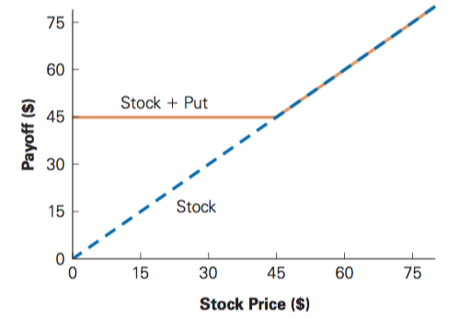

This strategy can be used on an entire portfolio to protect against losses. This is known as portfolio insurance.

Another way to protect your portfolio is by buying a risk-free zero coupon bond and a long call option. Say a stock costs $45. If the share price is below $45 we do not exercise our call option and we receive the payoff from the bond. If the share price is above $45 the option is exercised and the payoff from the bond is used to pay for the strike price of the stock. This scenario provides the same payoff as the Stock and Put Option as demonstrated above.

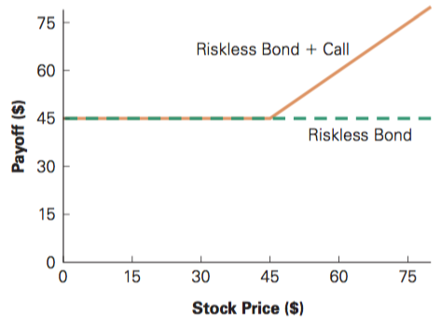

Put-Call Parity

Above we considered two different ways in which we can protect portfolios: (1) a stock and put option, and (2) a bond and call option. Because of these yield the same payoff, the price must be the same. This leads to the following relationship.

S + P = PV(K) + C

S is the stock price. P is the put option price. C is the call option price. The cost of buying a coupon with a face value of the strike price is its present value. Rearranging this equation gives the price of the call and put options:

No Dividends:
C = P + S – PV(K)
P = C – S + PV(K)

When dividends are paid, the two different ways to protect the portfolio do not have the same payout, as option 1 will have a dividend payout and option 2 with bond doesn’t pay dividends. The two strategies will only cost the same if we add the present value of future dividends to the bond and call combination.

S + P = PV(K) + C + PV(Div)

Rearranging this equation leads to the general put-call parity formula for pricing calls and puts.

With Dividends:
C = P + S – PV(K) – PV(Div)
P = C – S + PV(K) + PV(Div)

Factors Affecting Option Prices

Strike Price and Stock Price
Because put options give the right to sell, puts with lower strike prices are less valuable. The value of call options, the right to buy, is higher when the current stock price is higher than the strike price, as there is a greater chance that the option will be in the money.

Arbitrage Bounds and Option Prices
An option can’t have a negative payoff. American options enjoy all the same benefits as European options. American options therefore can’t be worth less than European options.
For a put option, the highest payoff occurs when the stock is worthless (ex: bankruptcy). In that case the payoff is equal to the strike price. Therefore, a put option can never be worth more than its strike price.
Call options are worth more the lower the strike price because there is a greater chance that the stock price will be higher than the strike price, yielding a positive payoff. If the strike price is 0 then there is always money to be made by exercising the option (unless the stock becomes worthless). Thus, a call option is never worth more than the stock price.
The intrinsic value of an option is its value if it is exercised immediately. The intrinsic value will be the value by which it is in the money. Or, if it is out of the money its intrinsic value is 0. If an American option can be purchased for less than its intrinsic value an arbitrage opportunity exists. Therefore, an American option can’t be worth less than its intrinsic value.
The time value of an option is the difference between the option’s current price and its intrinsic value. Since American options can’t be worth less than its intrinsic value, the time value can’t be negative.

Option Prices and the Expiration Date
American options are more valuable the longer the time until expiration (more opportunities to make a profit). Thus, an American option with a alter expiration date can’t be worth less than an American option with an earlier expiration date.
The same argument does not work with European options. A European option can’t be used at a time earlier than the expiry date. A European option that has a longer expiration period may be worth more or less than a European option with a shorter expiration date. European options that expire earlier may be worth more than those expiring later because there is a smaller chance of default.

Option Prices and Volatility
Another important fact underlying the price of an option is the volatility of the stock. Consider two stocks, one with low volatility and another with high volatility. Assume the stock price is $50 for both. The low volatility stock price will certainly be $50 tomorrow. The high volatility stock price has equal chances of decreasing to $40 or $60. If the options expire tomorrow then the low volatility option will expire worthless. But there is a good chance that the volatile option will be positive by increasing to $60. Therefore, the value of an option generally increases with the volatility of the underlying stock.

Exercising Options Early

American options are not always worth more than European options, even though they can be exercised at an earlier date.

Non-Dividend Paying Stocks/Options

Call Option
Recall the Put-Call parity and its pricing for the call option: C = P + S – PV(K)
The present value of the face value of the coupon can be rewritten as PV(K) = K – dis(K). That is, the present value of K is K less the discount amount from the face value. Substituting this into the price of the call option from the put-call parity yields the following:
C = P + S – PV(K)
C = P + S – [K – dis(K)]
C = P + S – K + dis(K)
C = S – K + dis(K) + P
(Intrinsic Value) (Time Value)

The intrinsic value is the money gained from exercising an option immediately (share price – strike price). The discount value plus the put price is the time value.
The put price is always positive and as long as interest rates remain positive then the time value is always positive for call options. Because American options are worth at least as much as European options, American options must also have a positive time value. Therefore, the price of a European or American call option always exceeds its intrinsic value.
This conclusion means that it is always better to sell an option that to exercise it early. If you exercise the option then you only get its intrinsic value. If you sell it you get the price (C) of the call options, i.e. the intrinsic value and the time value. Because it’s never optimal to exercise an American option before its expiration date, the right to exercise the call early is worthless. The following becomes true for non-dividend paying options:
- It is never optimal to exercise an American call option early.
- The right to exercise the American call option early is worthless.
- An American call will have the same price as an European call option.
- Since American calls with later expiration dates are worth more than American calls with an earlier expiration date, the same applies to European calls being worth more with later expiration dates than European call options with earlier expiration dates.

Put Options
Using the Put-Call parity, the rearranged formula with PV(K) = K – dis(K) for the put price is as follows:
P = C – S + PV(K)
P = C – S + [K – dis(K)]
P = C – S + K – dis(K)
P = K – S – dis(K)
(Intrinsic Value) (Time Value)

The time value in the put price is negative. This is the discount of the bond. If the option is deep in the money then the time value can be negative. A European option will then sell for less than its intrinsic value. American put options cannot sell for less than their intrinsic value because otherwise arbitrage opportunities exist (for example, of the intrinsic value, that is, strike price – the share price is higher than the cost of the put option it could be sold immediately for profit). Since this can’t happen and American options can’t fall below their intrinsic value, unlike the European put there is value in being able to exercise an American put option early.
- It can be optimal to exercise an American put option before the expiration date.
- The right to exercise an American put option has value attached to it.
- American put options can therefore be worth more than an identical European put.

Dividend Paying Stocks/Options

Call Option
First, let’s consider the put-call parity including dividends for call pricing:

C = S – K + dis(K) + P – PV(Div)
(Intrinsic Value) (Time Value)

If the option is deep in the money the dividend payment can be high, making the time value negative. Because an American option can’t be worth less than it’s intrinsic value, the price of an American option can be greater than an identical European option. Therefore, there is value to being able to exercise the American option early.

Put Option
The put-call parity with dividends leads to the following put price equation:

P = K – S + c – dis(K) + P(Div)

Again, because the time value can be negative, there is value in exercising the option early.

Summary:

 | Option
 | Without Dividend | With Dividend
Call | Right to exercise early is not valuable. | Right to exercise early is valuable.
Put | Right to exercise early is valuable. | Right to exercise early is valuable.

Options and Corporate Finance

Equity (Shares) as a Call Option

Shares in a company or equity can be thought of as call options. Imagine a word where companies get liquidated after a certain length. Once the liquidation time comes the company’s assets or values can either be larger or smaller than its debt. If the debts are larger than its value it must declare bankruptcy and the shareholders don’t get anything. If the value is greater than the debt then the holders get the value (assets) – debt, or the equity.

Debt as an Option Portfolio

Debt can be viewed representing options as the debtholder owning the firm and having sold a call option. The strike price being the debt owed. If the firm exceeds the debt payment the call is exercised and the debtholders debt/strike price and give up the firm. If the firm declares bankruptcy the debtholders will receive the assets.

