Chapter 13
Investor Beahviour and Capital Market Efficiency/
Behavioural Finance

According to the CAPM, the market portfolio is efficient. Therefore, it is impossible to consistently do better than the market without taking on additional risk. In this chapter we will assess to what extent the market portfolio is efficient (or not). We will look at the role of competition in driving the results of CAPM, highlighting that for some investors to beat the market, others must be willing to hold a portfolio that underperforms the market. We will also look at individual investors who make a number of mistakes and reduce their returns.

Other investment “styles” like holding small stocks, value stocks, and stocks with recent high returns perform better than as predicted by the CAPM, indicating that the market portfolio might not be efficient. Based on the evidence we will consider how to calculate the cost of capital by deriving an alternative model of risk – the multifactor asset pricing model.

Competition and Capital Markets

To understand competition in the market, it is useful to understand how the CAPM equilibrium in Chapter 11 might arise based on the behaviour of individual investors. Specifically, this section will describe how investors who only care about the rate of return and volatility affects the CAPM equilibrium.

Identifying a Stock’s Alpha

Alpha = the distance of a security above or below the security market line (as %)

Suppose that news comes out that will change the expected return of two stocks. If market prices remain unchanged and the expected return of stock A increases by 2% and the expected return of stock B decreases by 2% then the expected return of the market remains unchanged.

However, this will have an effect on the efficient frontier. With this information, the market portfolio will no longer be efficient – there will be other portfolio combinations with a higher expected return and lower volatility. Investors will improve their position by comparing the expected return of each security in the portfolio with the required return of the CAPM.

r_{s} = r_{f} + ß_{s}(E[R_{Mkt}] – r_{f})
Stocks that have a changed return are no longer on the market security line. The difference between the new (required) return and the expected return (as modelled by the SML) is a stock’s alpha.

a = E[R_{S}] - r_{s}

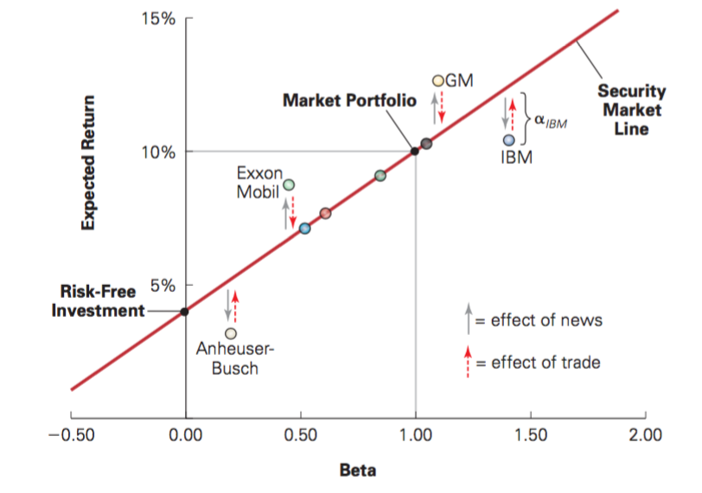
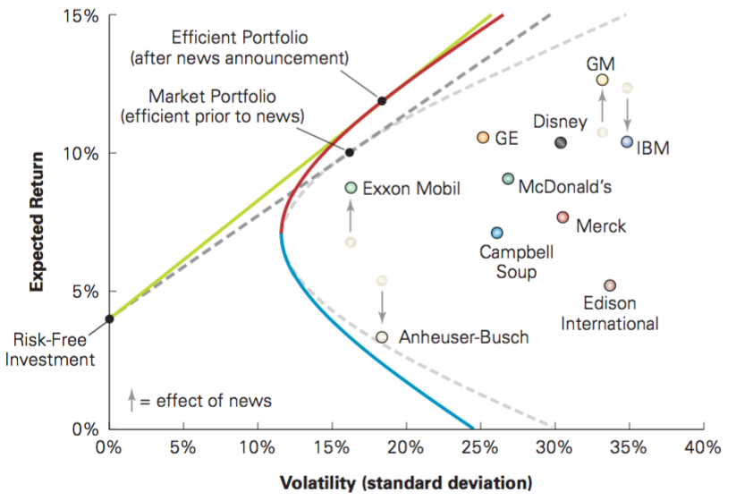
Profiting from Non-Zero Alpha Stock

Investors will want to buy stocks in companies above the security market line (GM, Exxon) and sell stocks below the security market line (IBM, Anheuser-Busch). Over time, in competitive market, more people will buy GM and the price will of the stock will increase, which will lower its expected return. More people will sell IBM and the price decrease, causing its expected return to increase. This continues until the stocks reach an equilibrium and are on the SML once again.

This analysis provides two insights:
- The market is not always efficient.
- There may exist trading strategies that take advantage of non-zero alpha stocks.

Information and Rational Expectations

How could an investor profit from a non-zero alpha position? Consider that GM has a positive alpha prior to the price change. Investors will anticipate that the price will change and place buy orders for GM. GM’s positive alpha:

Required Return: r_{G} = r_{f} + ß_{s}(E[R_{Mkt}] – r_{f}) = 0.04 + 1.1(0.1 – 0.04) = 0.1
New Expected Return: E[R_{GM}] = 0.125

Alpha: a = E[R_{S}] - r_{s} = 0.125 – 0.1 = 0.025

Everyone who hears the news that GM’s price is going up will want to sell at GM’s old price. This can create a large order imbalance. The only way to remove this imbalance is by changing GM’s price. Sometimes, it is possible that the price of a stock changes, without any trading. This occurs when competition between investors is so intense that prices move before anyone can trade at the old price – the no-trade theorem.

Informed versus Uninformed Investors

In order to profit from buying a positive alpha stock there must be someone willing to sell it. The CAPM assumes homogenous expectations, which means that all investors hold the same information. This would mean that everyone would be aware if a stock has a positive alpha and nobody would be willing to sell the stock.

In reality however, investors have different information and spend varying amounts of effort researching different companies. Even differences in the quality of an investor’s information may not be enough to generate a trade. A smart, uninformed investor will hold the market portfolio. Holding the market portfolio with risk-free investments does not depend on the quality of an investor’s information or trading skill.

Suppose you are an investor without any information, aware that others know a great deal of information and are using that information to create the efficient portfolio. How can you guarantee that your portfolio will have the same return as the average investor? You are guaranteed the same return as the average investor simply by holding the market portfolio, because the aggregate of all investors’ portfolios must equal the market portfolio (demand must equal supply). If all uniformed investors hold the market portfolio then informed investors can’t take advantage of their additional information and profit form uninformed investors.

Rational Expectations

As demonstrated above, all investors, even those with no information, can generate a market return. The market portfolio has an alpha of 0; no investor should choose a portfolio with a negative alpha. If no investor has a negative alpha, then no investor can profit from owning shared with a positive alpha. CAPM then does not rely on the assumption of homogenous expectations, rather that investors have rational expectations. This means that all investors correctly interpret and use their own information, and information that can be inferred from the market prices and trades of others.

In order for some investors to profit from positive alpha stocks some investors must hold negative alpha stocks, even though they could have held zero alpha stocks. This draw the following conclusions:

The market portfolio can be inefficient (thus it is possible to beat the market) only if a significant number of investors:
- Do not have rational expectations so that they misinterpret information and believe that they are earning a positive alpha, or are not holding a negative alpha stock, or
- Care about aspects of their portfolios other than their expected return and volatility, and so are willing to hold inefficient portfolios of securities.

How do investors actually behave? Do they heed the advice of holding the market portfolio?

The Behaviour of Individual Investors

Many small, individual investors tend to fail to diversify and trade too much. These departures form holding the market portfolio create an opportunity for more sophisticated investors to profit at an individual investor’s expense. Let’s consider whether it is possible to exploit this opportunity by looking for predictable, systematic patterns in the types of errors that individuals can make.

Underdiversification and Portfolio Biases

As explained, investors can reduce the risk/volatility in their portfolio while holding the same expected return through appropriate diversification. Evidence from the U.S. Survey of Consumer Finances shows that households that own stocks, held, on average, four stocks. And 90% of investors held less than 10 stocks. Furthermore, these stocks tend to be held in the same industry and/or the same geographical region. Retirement savings (from 401K plans) are largely invested in the company that a person works for.

These trends can be explained by the familiarity bias, which means that people are more likely to invest in companies which they are more familiar with. Another reason is that investors have relative wealth concern, meaning that they care significantly about their portfolio’s performance relative to the people they know. This leads them to invest largely into the same stocks, making their portfolios undiversified.

Excessive Trading and Overconfidence

The market portfolio is a value-weighted portfolio (the amount invested in each security is proportional to its market capitalization). It is also passive in that an investor does not need to respond to daily price changes. Therefore, if all investors held the market portfolio, there would be little trading.

In reality however, trading volume is much higher. At its peak in 2008, the annual turnover on the NYSE was 140%. This means that on average, each stock was traded 1.4 times per annum. Individual investors trading is even higher, with turnover being 50% higher than the overall rates. What causes this behaviour? Uninformed individuals tend to overestimate the precision of their knowledge; this presumptuousness is known as the overconfidence theory. Frequent trading will result in worse performance due to the costs of trading. Furthermore, in areas such as finance, men tend to be more overconfident than women. This is even more pronounced for single men and women.

Individual Behaviour and Market Prices

So far, the evidence shows that individual investors underdiversify and trade too often; thereby violating a key aspect of CAPM (i.e. rational expectations). Does that make the other conclusions of CAPM invalid? Not necessarily.

If individuals depart from the market portfolio randomly, in idiosyncratic ways, then the combined portfolios will cancel out the departures. Individuals will hold the market portfolio in aggregate. In order for investors to have an impact on the market there must be patterns in their behaviour that lead them to depart from the CAPM in systematic ways. What might motivate investors to depart from the market portfolio?

Systematic Biases

Hanging on to Losers and the Disposition Effect

Investors tend to hold on to losers and sell stocks that have gone higher in price, this is known as the disposition effect. This arises because (1) investors are willing to take on more risk in the face of losses, and (2) a reluctance to admit a “mistake”. From a tax perspective it is optimal to hold on to “winners” as long as possible because delaying the tax payments will decrease the present value. In addition, investors should sell “losing” investments, especially near the end of the year, to accelerate tax write-offs.

Investor Attention, Mood, and Experience

Most investors are not full time investors and thus have fewer time to spend analyzing their investments. They may be influenced by attention gabbing news stories, companies in advertisement, or stocks that have experiences exceptionally high trading volume or returns.

Mood affected by the weather or by major sports events also has an impact on stock returns. Lastly, individuals tend to value their experience more highly than historical evidence.

Herd Behaviour

Another reason why investors make similar trading errors is that they are trying to follow one another’s behaviour. This is known as herd behaviour. There are three reasons why individuals might engage in herd behaviour: (1) investors believe that others have superior information and so they attempt to take advantage of their information by copying their trades – this is known as the cascade effect where traders ignore their own information in hopes of profiting from other’s, (2) people have relative wealth concerns, investors choose to invest in the same securities as to not underperform relative to their peers, and (3) Professional Fund Managers face reputational risk if they stray too far from the actions of their peers.

Implications of Behavioural Biases

Making mistakes is natural. What is surprising however, is that investors continue to make mistakes, even when the economic downside is apparent and when the solution is so easy – holding the market portfolio.

The Efficiency of the Market Portfolio

Can proficient investors take advantage of opportunities when other investors buy negative alpha stocks? Two conditions must be met in order to profit:
- Mistakes must be sufficiently pervasive and persistent to affect stock prices.
- There must be limited competition to exploit these negative alpha situations, otherwise, opportunities will be eliminated before traders can take advantage of them.

Trading on News or Recommendations

One place to look for trading opportunities is in reaction to news events or analysts’ recommendations. If not enough investors are paying attention, perhaps one can profit.

Takeover Offers
When it is announced that a firm is taking over another, its stock price tends to jump up, usually at a premium to the current stock price. While it jumps, it rarely increases as high as the offer. There remains uncertainty as to whether the offer price will remain, fall, increase or not go through at all. The stock’s cumulative abnormal return measures the stock’s return relative to that predicted by its beta. This return shows that after jump, the stock price remains high enough that the future returns do not generate higher returns that the market. Profiting in this case would only be an option if we could predict a future takeover.

Stock Recommendations
When stock recommendations are made one must look at whether there is news regarding that organization. If there is news, then the price of the stock rises and remains that way the next day. If there is no news, then the price rises but tends to fall again subsequently. Smart investors short these stock recommendations. However, not enough shorts are done because the stocks tend to be about small, illiquid companies, which makes it hard to find and borrow these stocks.

The Performance of Fund Managers

Sophisticated investors could create profit opportunities from news (by predicting takeovers and shorting small stocks), but do such, full-time investors, like professional fund managers take advantage of these opportunities? Are they able to find these opportunities?

Fund Manager Value-Added
By scaling a fund’s gross alpha (return relative to market index, before fees) by the fund’s assets under management (AUM), indicates that the average mutual fund manager is able to find trading opportunities worth around $2 million per year. Most managers however, appear to behave like individual investors by trading so much that their costs exceed the profits.

Returns to Investors
If an investor seeks out the mutual funds that provide positive returns will the investor benefit by investing in that mutual fund? The answer is no. On average, mutual funds have a negative alpha and don’t provide a superior return relative to the market portfolio. At the end of each year Forbes publishes a list of the top performing mutual fund managers – the Honour Roll funds. In 1994 a study compared the results of investing in these top performing mutual funds and index funds over a 19 year period. The Honour Roll funds returned 11.2%, whereas the market index returned 13.1%. In conclusion, while profits of mutual fund managers implies that it is possible to find profitable opportunities, being able to do so, especially consistently, requires rare talent. The profits from this talent mostly go to the manager through a higher compensation, as opposed to the investor through returns.

Institutional Funds
Similar results have been found amongst managers hired to manage retirement plans, pension funds, and endowment (non-profit) assets. Hired managers usually outperformed the past benchmark. Once hired however, the profits past the average return are usually paid to the managers as a fee.

The Winners and Losers

This section demonstrated that while it is possible to beat the market returns, it is nearly impossible. This takes into account that the average investor earns an alpha of zero before trading costs. Beating the market thus must consist of superior analytical skills or lower trading costs. The key point is that extra trading can result in losses and will result in trading costs; the best bet is to hold the market portfolio. Indexing wins, only because it can’t lose.

Variance
More than 2 stocks in P | 2 stocks in P
 | Var(R_{P}) = x₁²*Var(R₁) + x₂²*Var(R₂) + 2x₁x₂Cov(R₁,R₂)
Equally Weighted | Any Other:
Var(R_{P}) = [(1/n)*(Avg. Var)] + (1 - 1/n)*(Avg. Cov.) | Var(R_{P}) = x₁²*Var(R₁) + x₂²*Var(R₂) + x₃²*Var(R₃) + 2x₁x₂Cov(R₁,R₂) + 2x₂x₃Cov(R₂,R₃) + 2x₁x₃Cov(R₁,R₃)

