Chapter 11
Optimal Portfolio Choice & Capital Asset Pricing Model (CAPM)

This will focus on how to create an efficient portfolio; particularly how to find the portfolio with the highest return given a certain level of volatility (risk) through the statistical techniques of mean-variance portfolio optimization. These techniques are routinely used by professional investors, money managers, and financial institutions.

The capital asset pricing model (CAPM) is the most important model of the relationship between risk and return. Under the assumptions of the CAPM, the most efficient portfolio is a market portfolio consisting of all stock and securities.

The previous chapter explained how to calculate the expected return, and the risk (volatility) of a single stock. To find the most efficient portfolio we must find the expected return and volatility of a portfolio of stocks.

The Expected Return of a Portfolio

A portfolio is composed of portfolio weights, i.e., the fraction of the total investment in the portfolio each stock/investment (denoted as x_{i}). Each investment has a return (denoted as R_{i}). Thus, the sum of the returns multiplied by each investment’s weight is equivalent to the return of the portfolio:
$x_{i}= \frac{Value of i}{Value of Portfolio}$ $R_{P}=\sum{x_{i}*R_{i}}$

The expected return of a portfolio is simply the weighted average of the expected returns of the investments within the portfolio (using the portfolio weights):

$$E\left[R_{P}\right]= \sum{x_{i}*E[R_{i}]}$$

Example: You invest $10,000 in A and $30,000 in B and expect a 10% return in A, and 16% return on B.
$$E\left[R_{P}\right]=\left[\left(\frac{10,000}{40,000}\right)*0.10\right]+\left[\left(\frac{30,000}{40,000}\right)*0.16\right]=0.145$$

The Volatility of a Two-Stock Portfolio

Combining stocks in a portfolio eliminates some rick through diversification. The remaining risk will depend on the degree to which the remaining stocks are exposed to common risk. The following will outline the statistical methods used to quantify that common risk and volatility of a portfolio.

Combining Risks

Risk changes when stock are combined in a portfolio. When stocks are combined risks are reduced compared to the risk of an individual stock through two ways: (1) Diversification – because prices of stock don’t move identically some of the risk is averaged out in the portfolio, and (2) more risk is eliminated if stocks face less common risk because they are less likely to move identically in price.

For instance, a portfolio consisting of two airline companies is less risky than individual stocks of either company, but the companies still share a lot of common risk. A portfolio consisting of one airliner and one oil company is even less risky because they share less common risk.

Determining Covariance & Correlation

To find the risk of a portfolio, we need to know more than just the risk and return of the individual stocks. We also need to know the risk that the individual stocks have in common, that is, their returns move together. There are two statistical measures that allows us to measure the co-movement of returns (covariance, and correlation).

Covariance is the expected product of the deviation of two returns from their means.

Covariance between Returns R_{i} and R_{j}:
$$Cov\left(R_{i,}R_{j}\right)= E\left(R_{i}-E\left[R_{i}\right]\right)*E\left(R_{j}-E\left[R_{j}\right]\right)$$

Estimate of the Covariance from Historical Data:
$$Cov\left(R_{i,}R_{j}\right)= \frac{1}{T-1} *\sum{(R_{i,t}-{\overline{R}}_{i})(R_{t,i}-{\overline{R}}_{j})}$$

If the two stocks move together they will both be above or below the mean at the same time and return a positive covariance. If the stocks don’t move together, they will be above and below the mean at the same time, meaning a negative covariance.

The sign is easy to interpret. The magnitude of the covariance is more complex as a larger coefficient indicates (1) more volatility, because the deviations from the mean are larger, and (2) the stocks move closer in relation to one another.

Correlation makes it easier to quantify the strength of the relationship between two stocks by calculating the correlation between the two stocks’ returns.

$$Corr\left(R_{i}, R_{j}\right)= \frac{Cov(R_{i},R_{j})}{SD\left(R_{i}\right)*SD(R_{j})}$$

The sign of the correlations is interpreted the same as covariance. The closer the correlation is to 1, the more the two stocks move together as a result of common risk. A correlation of 0 indicates that the returns are uncorrelated. A correlation closer to -1 indicates that the stocks always move oppositely.

Stocks tend to move together if they are affected similarly by economic events. Therefore, stocks in the same industry tend to have more highly correlated returns.

Computing Portfolio Variance and Volatility

The variance of a two-stock portfolio, with the return R_{P} = x₁R₁ + x₂R₂, is as follows:

$$Var\left(R_{P}\right)= x_{1}^{2}Var\left(R_{1}\right)+x_{2}^{2}Var\left(R_{2}\right)+2x_{1}x_{2}Cov(R_{1},R_{2})$$

Like always, the volatility is the standard deviation: SD(R_{P}) = √Var(R_{P})

Example:

The following portfolio consists of ½ A shares and ½ B shares. The SD is given below. The variance of each stock is the SD², namely 0.134² = 0.018. The covariance is calculated to be -0.0128. Lastly, since the portfolio is comprised of equally values A and B shares, the weight is 0.5 for both.

$$Var\left(R_{P}\right)= {\left(0.5\right)}^{2}\left(0.018\right)+{\left(0.5\right)}^{2}\left(0.018\right)+2\left(0.5\right)\left(0.5\right)\left(-0.01284\right)=0.0026$$

The volatility of this portfolio is thus SD = √0.0026 = 0.051, or 5.1%.

The Volatility of a Large Portfolio (More than two stocks)

Additional diversification and thus, lowered volatility, can be reached by adding more stocks to a portfolio. The next section will determine the amount of diversification that is possible by holding large amounts of shares.

Large Portfolio Variance

The risk of a portfolio depends on how each stock’s return moves in relation to it. The variance of a portfolio is equal to the sum of the covariances of the returns of all pairs of stocks in the portfolio, multiplied by each of the stocks’ weights’.
$$Var\left(R_{P}\right)= \sum_{i}{\sum_{j}{x_{i}x_{j}Cov(}}R_{i},R_{j})$$

This formula can be extended to include an unlimited number of stocks. Consider a portfolio with three stocks: x₁, x₂, and x₃. The stocks can be combined in 6 different ways, which leads to the various covariances:

x₁ x₁ and x₂ and x₂ and x₁ => 2(x₁ + x₂)

x₂ x₂ and x₃ and x₃ and x₂ => 2(x₂ + x₃)

x₃ x₁ and x₃ and x₃ and x₁ => 2(x₁ + x₃)

The variance of the portfolio would therefore be as follows (note that the individual variations of the stocks are simply the standard deviations squared):

$$Var\left(R_{P}\right)=$$
$$x_{1}^{2}Var\left(R_{1}\right)+x_{2}^{2}Var\left(R_{2}\right)+x_{3}^{2}Var\left(R_{3}\right)+$$
$$2x_{1}x_{2}Cov\left(R_{1,}R_{2}\right)+2x_{2}x_{3}Cov\left(R_{2,}R_{3}\right)+ 2x_{1}x_{3}Cov(R_{1,}R_{3})$$

Diversification with an Equally Weighted Portfolio

The Variance of an equally weighted portfolio of n stocks is calculated as,

$$Var\left(R_{P}\right)=\frac{1}{n}*\left(Avg. Var of Indiv. Stocks\right) + \left(1-\frac{1}{n}\right)*(Avg. COV between stocks)$$

The historical volatility of the return of a typical large firm is 40%, and the typical correlation between the returns of large firms is about 28%. Given these statistics,

$$SD\left(R_{P}\right)=\sqrt{\frac{1}{n}*({0.4}^{2}) + \left(1-\frac{1}{n}\right)*(0.28*0.4*0.4)}$$

By substituting a different number of stocks in the portfolio (changing n), the following pattern emerges:
Diversification decreases volatility substantially in the beginning. After around 30 stocks have been added to the portfolio almost all of the benefit of diversification has been achieved. Even for a large portfolio not all risk can be eliminated. Volatility declines to 21.7%.

Diversification with General Portfolios

The previous volatility of a portfolio relied on equally weighted portfolio. For a portfolio with arbitrary weights however, the following formula is used:

$$SD\left(R_{P}\right)= \sum_{i}{x_{i} * {SD(R}_{i}) * Corr(R_{i},R_{P}) }$$

Risk Vs Return: Choosing and Efficient Portfolio

By knowing how to calculate the expected return and the volatility of a portfolio an investor can create an efficient portfolio.

Efficient Portfolios with Two Stocks

This is the simplest case. Given two stocks and their expected return and volatility we can create a table of expected returns and volatility given certain weight combinations of these stocks. For instance,

 |  |  | Correlation with
Stock | E[R] | Volatility (SD) | Intel | Coca-Cola
Intel | 26% | 50% | 1 | 0
Coca-Cola | 6% | 25% | 0 | 1

Now we can create different combinations of Intel and Coca-Cola and determine their respective expected return and volatilities. Consider a portfolio consisting of 40% Intel and 60% Coca-Cola. In order to calculate the expected return of the portfolio we use the expected return formula:
$$E\left[R_{P}\right]= \sum{x_{i}*E[R_{i}]}$$

$$E\left[R_{P}\right]=\left(0.4\right)\left(0.26\right)+\left(0.6\right)\left(0.06\right)= 0.14$$

The expected return of a portfolio weighted as described above is 14%. To calculate the volatility of this portfolio (at the given weights) we will use the volatility formula for a portfolio with two stocks (that are not equally weighted):

$$Var\left(R_{P}\right)= x_{1}^{2}Var\left(R_{1}\right)+x_{2}^{2}Var\left(R_{2}\right)+2x_{1}x_{2}Cov(R_{1},R_{2})$$

Recall that: $Corr\left(R_{i}, R_{j}\right)= \frac{Cov(R_{i},R_{j})}{SD\left(R_{i}\right)*SD(R_{j})}$, thus $Cov\left(R_{i}, R_{j}\right)=Corr\left(R_{i},R_{j}\right)*SD\left(R_{i}\right)*SD(R_{j})$

$$Var\left(R_{P}\right)= {(0.4)}^{2}{(0.5)}^{2}+{(0.6)}^{2}{(0.25)}^{2}+2\left(0.4\right)\left(0.6\right)\left(0\right)\left(0.5\right)\left(0.25\right)= 0.0625$$

The volatility/standard deviation is thus the root of 0.0625, which is 25%. This means that a portfolio with 40% Intel and 60% Coca-Cola will result in an expected return of 14% with a volatility of 25%. Repeating these calculations with various weights yields the following expected returns and volatilities:

Weights |  | Expected Return (%) | Volatility (%)
Intel | Coca-Cola | E[R_{P}] | SD[R_{P}]
1 | 0 | 26 | 50
0.8 | 0.2 | 22 | 40.3
0.6 | 0.4 | 18 | 31.6
0.4 | 0.6 | 14 | 25
0.2 | 0.8 | 10 | 22.3
0 | 1 | 6 | 25

Notice how two different portfolios have the volatility, yet one of them has a higher expected return. Naturally, it makes more sense to choose the portfolio with the higher expected return. A portfolio is inefficient when another portfolio with a better return and volatility can be created.

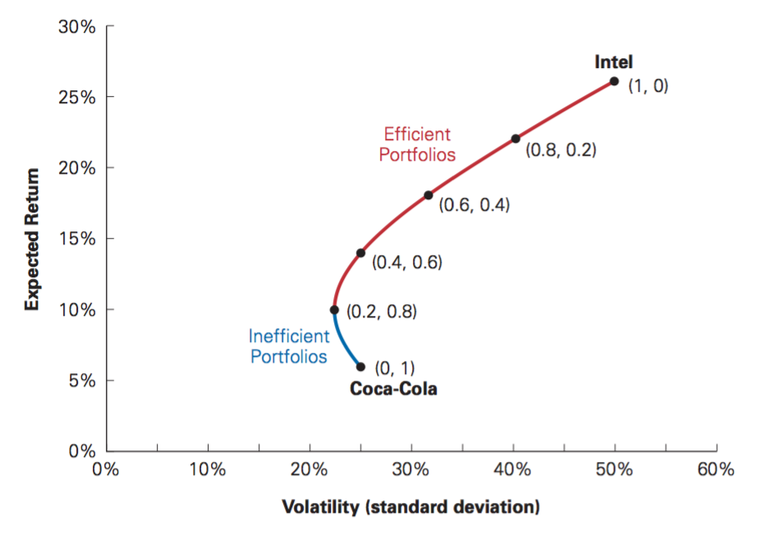
The Effect of Correlation

Correlation amongst stocks in a portfolio will not change the expected return, but it will change the volatility of the portfolio. This is demonstrated by the fact that correlation is not part of the expected return calculation, but it is part of the volatility calculation.

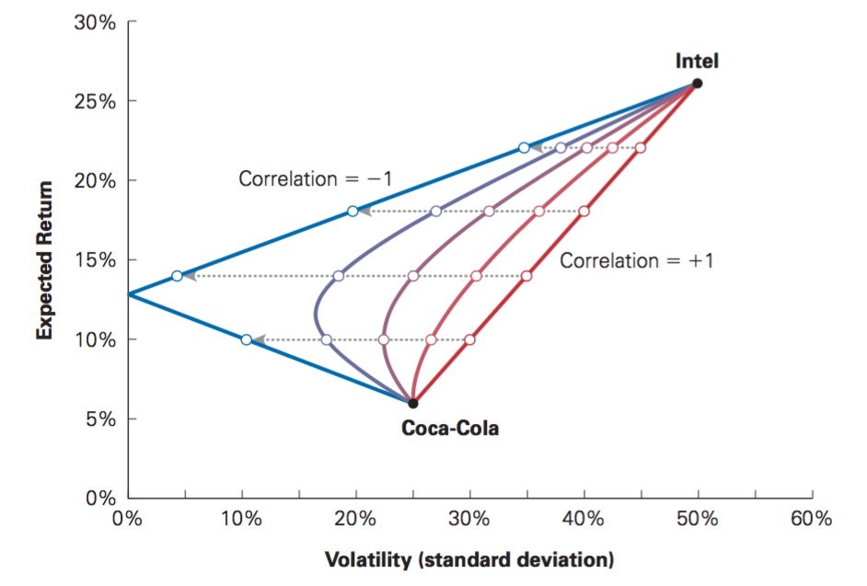
The lower the correlation, the less volatile the portfolio will be. Consider Intel and Coca-Cola. If they were perfectly negatively correlated (-1), then the stock will always move opposite. Thus, if one stock decreases in price, the other will increase in price and negate the loss/gain. Likewise, a perfectly correlated set of stocks (+1) will have the greatest volatility. The following shows how portfolios of the same weight but different correlations between stocks will change volatility:
Volatility at 40% Intel and 60% Coca-Cola reduced as correlation amongst the stocks declines.

Short Sales

So far we have only mentioned portfolios in which we invest a positive amount in stocks; this is called the long position. It is also possible to invest a negative amount by selling a stock that was borrowed and buying the stock back later at a lower price and returning the stock (having made a profit by selling higher and buying back at a lower price). This is done through short sale and is called the short position.

Returning to the Coca-Cola and Intel example, say you short $10,000 worth of Coca-Cola stocks and invest $20,000 plus the $10,000 from the short sale (in total $30,000) into Intel:

Weight of Intel = 30,000 / 20,000 = 1.5
Weight of Coca-Cola = -10,000 / 20,000 = -0.5
Note that the total weight adds up to 1.

$$E\left[R_{P}\right]=\left(1.5\right)\left(0.26\right)+\left(-0.5\right)\left(0.06\right)= 0.36$$

$$SD\left(R_{P}\right)= \sqrt{{(1.5)}^{2}{(0.5)}^{2}+{(-0.5)}^{2}{(0.25)}^{2}+2\left(1.5\right)\left(-0.5\right)\left(0\right)\left(0.5\right)\left(0.25\right)} = 0.76$$

Note that the expected return is higher than the long-position, yet the volatility is higher. The same possibility of inefficient portfolios exists:

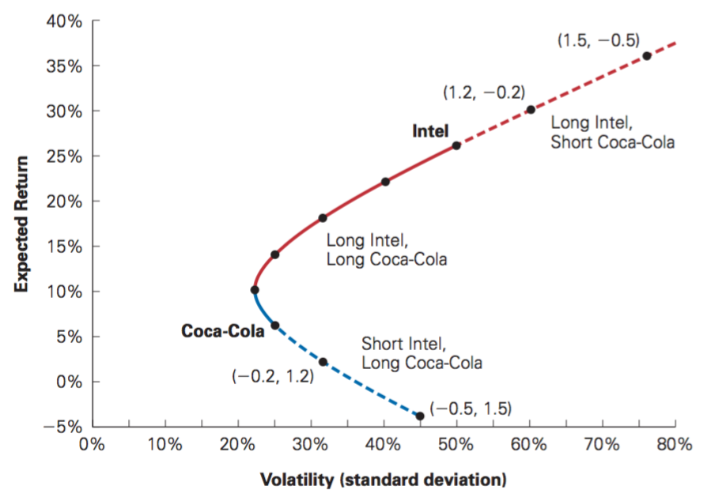
Efficient Portfolios with Many Stocks

Adding additional stocks to portfolios will diversify the portfolio and decrease volatility. By combining more stocks an entire region of risk and return possibilities is opened up that is not available prior. The efficient frontier improves.

Risk-Free Saving and Borrowing

So far we have considered the returns and risks of individual stocks and how those possibilities change by combining stocks into a portfolio. When we include all risky investments is a portfolio we diversify the risk by creating an efficient frontier and achieving maximum diversification.

There is another way to reduce risk other than diversification and that is keeping money in a risk-free investment like a treasury bill. Conversely, an investor might choose to borrow money and invest it. Choosing the amount to invest in risky and riskless securities allows us to determine the optimal portfolio.

Investing in Risk-Free Securities

Consider an arbitrary risky portfolio and determine the expected return and volatility of it. Assume you put a fraction of your total money (x) into a portfolio and the remainder in a risk-free investment, namely Treasury Bills, with a yield of r_{f} (1 – x). The expected return is:

$$E\left[R_{xP}\right]=\left(1-x\right)r_{f}+ xE[R_{P}]$$

This equation simply describes that the expected return is the fraction invested in the risk-free security times the risk-free return rate, plus the fraction invested in the portfolio times the expected return of the portfolio. This equation rearranged yields the following:

$$E\left[R_{xP}\right]= r_{f}+ x(E\left[R_{P}\right]- r_{f})$$

Thus, our expected return is equal to the risk-free rate, plus a fraction of the portfolio’s risk premium, i.e. (E[R_{P}] – r_{f}).

Considering the volatility of this portfolio, because the risk-free rate is fixed and does not movie with (or against) the portfolio its volatility and covariance with the portfolio are zero:

$$SD\left(R_{xP}\right)= \sqrt{{(1-x)}^{2}Var\left(r_{f}\right)+x^{2}Var\left(R_{P}\right)+2(1-x)(x)Cov(r_{f},R_{P})}$$

$$SD\left(R_{xP}\right)= \sqrt{x^{2}Var(R_{P})}$$

$SD\left(R_{xP}\right)= xSD(R_{P})$

That is, the volatility is a fraction of the portfolio’s volatility (or standard deviation). This is because the risk-free investment makes the portfolio less risky.

Borrowing and Buying Stocks on Margin

As we increase our investment in the portfolio from 0% to 100% and decreasing our investment in the risk-free securities we are moving along the line as demonstrated in the following diagram:

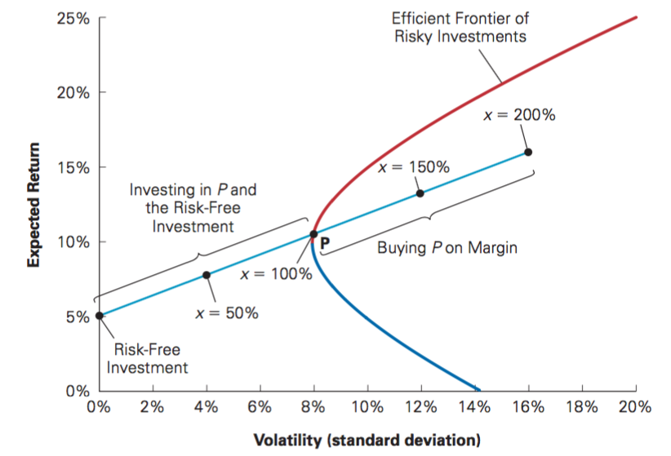

Once we go past 100% investment in the portfolio we are buying on margin by short-selling the risk-free investment. In order to short sell the risk-free investment we borrow money at the risk-free rate and use it to invest in the portfolio. Using borrowed money to invest in stocks is called buying stocks on margin. A portfolio that consists of risk-free investments in the short position is known as a leveraged portfolio. Note that leveraging investments is risky, even riskier than the risk of the portfolio itself. In exchange, the expected return is higher.

Note:
So far we have identified three ways how to create a Portfolio:
- Portfolio consisting solely of stocks (possible to have stocks in the short position)
- Portfolio consisting of risk-free investments and stocks
- A leveraged portfolio of risk-free investments in the short position, i.e. buying stocks on margin.

Identifying the Tangent Portfolio

Examining the diagram above we see that the efficient frontier is steeper than the risk-free investment line. Therefore, it is better not to invest in the risk-free investment as the expected return increases faster for the same amount of risk in a risk-free investment.

To earn the highest possible expected return for any level of volatility we must find the portfolio that generates the steepest possible line when combined with the risk-free investment. The line that passes through the portfolio is known as the Sharpe Line:

$$Sharpe Ratio=\frac{Portfolio Excess Return}{Portfolio Volatility}=\frac{E\left[R_{P}\right]-r_{f}}{SD(R_{P})}$$

The Sharpe Ratio is therefore a measures of reward-to-volatility for a portfolio. Thus, the optimal portfolio will be the one combined with the risk-free investment that just touches the efficient frontier, where the line is tangent to the efficient frontier. This line will have the highest Sharpe ratio. The portfolio that generates this tangent line is known as the tangent portfolio. This portfolio provides the biggest reward per unit of volatility of any portfolio combination available.

The tangent portfolio has one striking consequence:

The tangent portfolio is an efficient portfolio. Once risk free investments are included in the market, the efficient portfolios will always include the risk free investment, otherwise they are not efficient.

The tangent portfolio, which provides the biggest reward per unit of volatility, combined with the risk free investment is the optimal portfolio. This optimal portfolio of risky stocks no longer depends on how aggressive or conservative an investor is. Every investor should invest in the optimal tangent portfolio regardless of risk averseness. In other words, the proportions of investments is determined by the tangent portfolio. The only decision an investor should make is in regards to how much to invest in the tangent portfolio and how much to invest in the risk free investment.

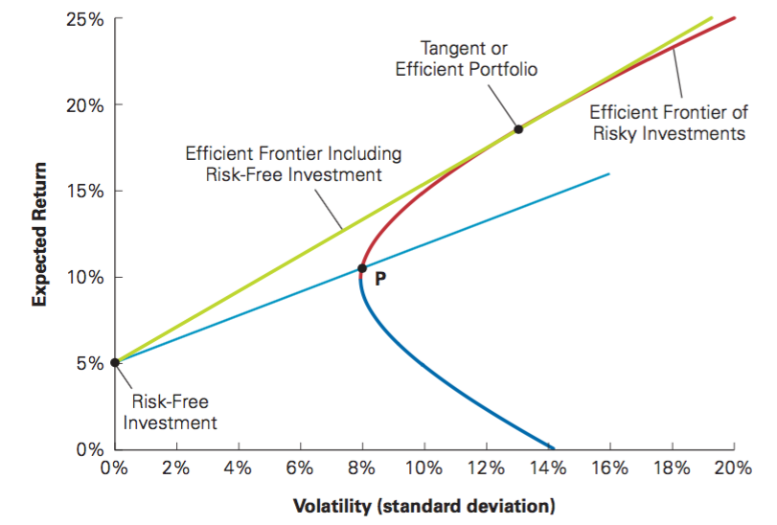

In conclusion, the efficient portfolio is the tangent portfolio, the portfolio with the highest Sharpe ratio in the economy. The line passing through portfolio P is not efficient because the Sharpe ratio is lower than the tangent portfolio.

The Efficient Portfolio and Required Returns

This section will explore the implication of the efficient portfolio on the firm’s cost of capital. We derive a condition to determine whether we can improve a portfolio by adding more of a given security, and use that to calculate an investor’s required rate of return for holding a certain investment.

Portfolio Improvement: Beta and the Required Return

Consider the portfolio, P, and let’s determine if we can raise its Sharpe Ratio by selling risk-free investments (or borrowing money) and placing the proceeds in an investment, i. There will be two consequences:

- Expected Return – We are giving up the risk-free investment’s return and are replacing it with the new investment’s return; therefore, the our expected return will increase by i’s excess return: E[R_{i}] – r_{f}.
- Volatility – We must add the risk that i has in common with the rest of the portfolio (the remainder of i's risk will be diversified); the incremental risk is measured by i's volatility multiplied by its correlation with the portfolio: SD(R_{i}) * Corr(R_{i}, R_{P}).

The question then becomes: Is the gain in return worth the extra risk?

Another way of increasing the expected return and risk is through more investment into the portfolio. In this case, the Sharpe ratio tells us how much more expected return we will receive for taking on more risk. So which is better? An investment in i or an investment into the portfolio? An investment in i offers a larger return than what we would get from an investment in the portfolio IF,
Return per unit of
volatility from portfolio
Incremental volatility
from investment i
Additional return
from investment i
$$E\left[R_{i}\right]- r_{f} > SD\left[R_{i}\right]* Corr\left(R_{i}, R_{P}\right) × \frac{E\left[R_{P}\right]-r_{f}}{SD(R_{P})}$$

The beta of investment measures the sensitivity of the investment, i, to the fluctuations of the portfolio, P. That is, for each 1% change in the portfolio’s excess return, the investment’s excess return is expected to change by ß_{i}^{P}% because of the risk that i has in common with P.

Beta of Investment i with Portfolio P:

$$β_{i}^{P}=\frac{ SD\left[R_{i}\right]* Corr\left(R_{i}, R_{P}\right)}{SD(R_{P})}= \frac{Cov\left(R_{i}, R_{P}\right)}{Var(R_{P})}$$

Given this definition, the previous equation can be restated as (the required rate of return):

$$E\left[R_{i}\right] > r_{f}+ β_{i}^{P} × E\left[R_{P}\right]-r_{f}$$
That is, increasing the amount invested in i will increase the Sharpe ratio of portfolio P if its expected return E[R_{i}] exceeds the required return given portfolio P.

The required rate of return is the expected return that is necessary to compensate for the risk investment i will contribute to the portfolio. The required rate for investment i is equal to the risk free rate, plus a risk premium that is equivalent to the risk premium of the current portfolio (P) multiplied (or scaled) by i's sensitivity to the portfolio (ß). If i's expected return is greater than the required return, then adding more of investment i will improve the portfolio.

The Required Rate of Return:

$$r_{i}= r_{f}+ ß_{i}^{P}*(E\left[R_{P}\right]-r_{f})$$

Expected Returns and the Efficient Portfolio

As mentioned, if the expected return of i > required return i, then the portfolio can be improved. But how much of i should be added to the portfolio? As more of i is added to the portfolio, it’s ß, or correlation with the portfolio will increase until the expected return = required return.

A portfolio is efficient if and only if the expected return of every available security is equal to is required return.

$$E\left[R_{i}\right]= r_{i}≡ r_{f}+ ß_{i}^{eff}*(E\left[R_{eff}\right]- r_{f}]$$

where the eff = the efficient portfolio (triple equal is “identical to”).

According to this equation, we can compute the expected return of any security based on its beta wit the efficient portfolio.

The Capital Asset Pricing Model

In order to implement the efficient portfolio approach we face a critical problem: to identify the efficient portfolio we must know the expected returns, volatilities, and correlation among investments for every security (not just stocks, also real estate, that is why we use index funds, which are not always most representative of the market). In addition, these quantities are sometimes difficult to forecast. So how do we go about putting theory into practice?

The answer lies in the capital asset pricing model, which allows us to identify the efficient portfolio of risky assets without the knowledge of the individual assets’ expected returns. Instead the model uses the optimal choices investors make to identify the efficient portfolio as the market portfolio – the portfolio of all stocks and securities in the market. To obtain this portfolio we make three assumptions of our investors:

- All investors can buy and sell securities at competitive market prices (without being taxed or incurring transaction costs) and can lend money at the risk-free rate.
- All investors hold only the efficient portfolios of traded securities; i.e., portfolios that provide the greatest return for a given level of volatility.
- Investors have homogenous expectations regarding volatilities, correlations, and expected returns.
  - Not all investors have the same estimate for volatility, correlation, and expected returns. But these numbers are also not chosen arbitrarily. They are based on public information like historical patterns. Therefore, most expectations will be similar, this is known as homogenous expectations.

Supply, Demand, and the Efficiency of the Market Portfolio

If expectations are homogenous then all investors will identify the same portfolio as having the highest Sharpe ratio – the tangent/efficient portfolio. Therefore, all investors will have the same (efficient) portfolio and vary only the amount invested in the risk-free security.

If every investor is holding the tangent portfolio, then the combined securities of all investors is the tangent portfolio. In addition, because every stock is owned by someone, all portfolios combined make the market portfolio. Therefore, the efficient tangent portfolio is the market portfolio.

This concludes that the market portfolio is efficient, which is simply the statement that demand must equal supply. All investors demand the efficient/tangent portfolio and the supply of stocks is the market portfolio – therefore, the two must coincide. If a particular security is not part of the market portfolio then the demand for it will decline, and so will its price, which will then drive its demand up again until the security becomes part of the market portfolio once again.

Optimal Investing

When the CAPM assumptions hold, the market portfolio is efficient so the tangent portfolio is actually the market portfolio. The tangent line graphs the highest possible expected return for any level of volatility. When the tangent line goes through the market portfolio, it is called the capital market line (CML). All investors should hold a portfolio on the capital market line by having a combination of the market portfolio and the risk free security.
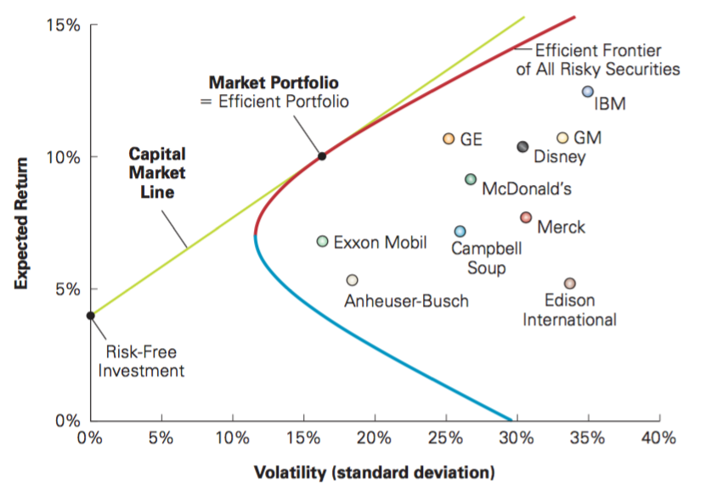

Determining the Risk Premium

Market Risk and Beta

As explained previously, the expected return of an investment is given by its beta with the efficient portfolio. If the market portfolio is efficient, then the CAPM Equation for the expected return is:
$$E\left[R_{i}\right]= r_{i}≡ r_{f}+ ß_{i}*(E\left[R_{Mkt}\right]- r_{f}]$$

In this respect, ß_{I} is the beta of the security in relation to the market portfolio, defined as:

$$ß_{i}=\frac{ SD\left[R_{i}\right]* Corr\left(R_{i}, Mkt\right)}{SD(R_{Mkt})}= \frac{Cov\left(R_{i}, R_{Mkt}\right)}{Var(R_{Mkt})}$$

The beta here measures the volatility of i due to market risk relative to the whole market; it captures the security’s sensitivity to market risk. That is, for every x% change in the market, the investment, i, will move ß%.

To determine the appropriate risk premium for any investment we must rescale the market risk premium (the return above the risk free rate) by the investment’s market risk, or beta.

The Security Market Line

The expected return of an investment (with respect to the market portfolio) is a linear equation. It implies that there is a linear relationship between a stock’s beta and its expected return. The line that is graphed is known as the security market line (SML) and all securities should lie on this line according to the relationship of their expected return and beta.
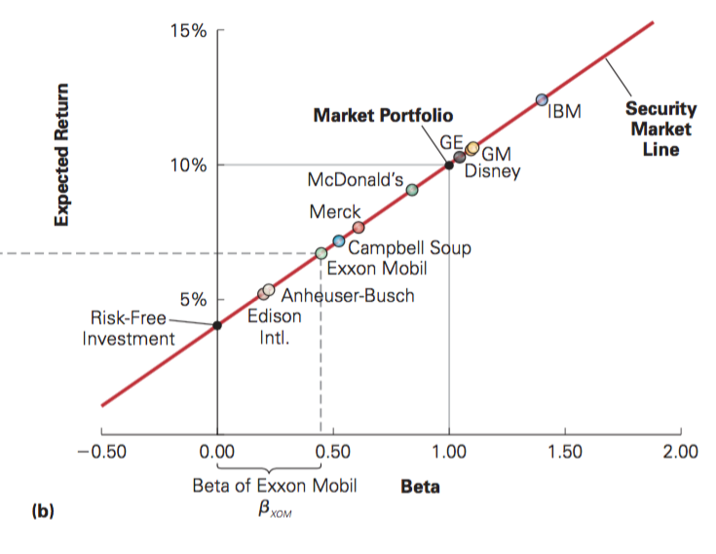
Here, the relationship between risk and return is clear.

Contrast the security market line with the capital market line:

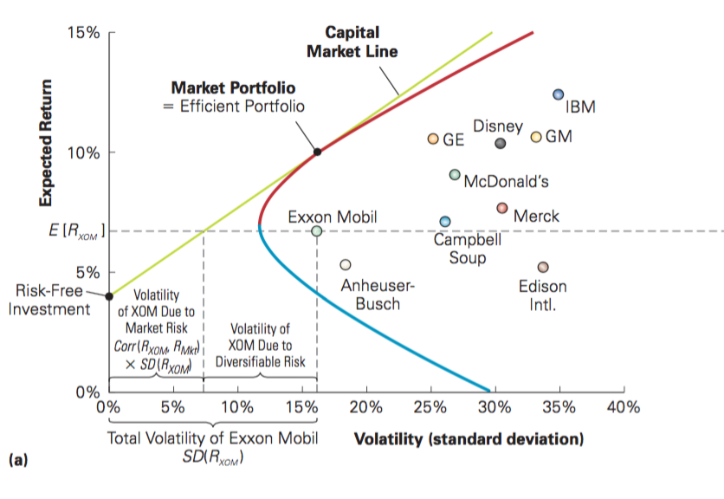
There seems to be no pattern between individual stock’s expected return and volatility. Given the capital market line all we can say is that volatility to the left of the capital market line is due to market risk, and volatility to the left of the capital market line is due to diversifiable risk.

The expected return is proportionate to beta relative to the market portfolio.

Beta of a Portfolio

The security market line applies to all tradeable investment opportunities. That is, it does not only apply to individual stocks, but also portfolios. The beta of a portfolio is the weighted average beta of the securities in the portfolio:

$$ß_{P}= \sum_{i}{x_{i}ß_{i}}$$

Summary of CAPM

Given the assumptions of competitive markets, investors choosing efficient portfolios, and homogenous expectation, CAPM leads to two major conclusions:

- The market portfolio is the efficient Portfolio.
- The risk premium for any investment is proportional to its beta with the market; the relationship between risk and required return is given by the security market line (see equation and diagram above).

The CAPM is based on strong assumptions. In reality however, these assumptions do not fully describe investors’ behaviour, some conclusions are not completely accurate (for instance, not every investor holds the market portfolio). The next chapter will focus on individual investor behaviour, where we also consider extensions to the CAPM because it is still the most common model for risk and return.

William Sharpe, Developer of the Capital Asset Pricing Model:

The process of upward and downward pressure on prices of individual stock continues until prices reach an equilibrium and everyone wants to hold what is available. At that point what can be said about the relationship between risk and return? The answer is that expected return is proportionate to beta relative to the market portfolio.
The CAPM is a theory of equilibrium. Why would anyone invest in a security that is doing badly? You need to be compensated for doing badly in bad times, or else who would hold it? The redeeming virtue is that in normal times you expect to do better. The key insight with the capital asset pricing model is that higher expected returns go with greater risk of doing badly in worse times. Beta is the measure of that. Securities with high betas tend to do worse in bad times than securities with low betas. While the CAPM has become more complex with several more additions like taxes, liquidity, dividend yield, etc. the fundamental idea remains that there is no reason to expect reward just for bearing risk. If there is reward for risk, then it has to be special. There has got to be some economics behind it.

