ANALYSIS OF THE SOCIAL NETWORKS’ BENEFITS FOR
THE NEW NORDIC CANADA COMPANY

Presented to John Peterson
CEO of the New Nordic Canada Company

New Nordic Canada Company

Prepared by Tala Hakla
27049307
COMM 212 – Section X
Manager at New Nordic Canada

March 27th, 2015
MEMORANDUM

TO: John Peterson, CEO of New Nordic Canada
FROM: Tala Hakla, Manager at New Nordic Canada
SUBJECT: Appraisal of Social Networks’ Benefits For New Nordic Canada
DATE: March 27, 2015
Here is the report on the benefits that the company would gain from social networks, which you requested on ???. In this case, this research takes aim at three top social media platforms whose Facebook, Twitter and Pinterest. The following study engages in different stages of marketing;
The benefits of social media; its cost; revenue variances; its influence on society (attraction); its way of increasing online sales; improve internal and external environment.

Although the company has been doing great and growing continuously within the market, the research contains valuable information on how to improve the company’s performance economically. Therefore, in the short future, it is highly recommended to adapt at least one of the top three social media networking.

I highly appreciate and congratulate the company for having me leading out this report. It have brightened and evolved our knowledge in the marketing strategy.

It is my hope that this report will provide you and the company the required information to evaluate the competence of embracing social media networking. The New Nordic Canada Company have great potential in increasing its benefits and advantages within the upcoming years. If you have any questions or require more information concerning this study, please do not hesitate to contact me through this number (514) 987 – 6543 or by e-mail at <tala--hakla@newnordiccanada.ca>. I look forward to clear all your concerns towards this report with you.

Enc.

TABLE OF CONTENT

EXECUTIVE SUMMARY……………………………………………………………………….4
INTRODUCTION………………………………………………………………………………...5
Purpose of the Study…………………………………………………………………........5
Scope of the Study………………………………………………………………………...6
Sources and Methods……………………………………………………………………...6
BENEFITS FROM THE USE OF PINTEREST………………………………………………….7
Reducing Costs in Advertising……………………………………………………………7
Attracting More Customers………………………………………………………………..7
Expanding the Market Research……………………………………………………….….9
Increasing Online Sales……………………………………………………………………9
Improving Internal Communications…………………………………………………….10
CONCLUSIONS AND RECOMMENDATIONS………………………………………………11
Implement Pinterest within the Company………………………………………………..11
Apply a Social Network Policy…………………………………………………………..12
Analyse the Marketing Trends in Pinterest………………………………………………12
Put Forth a Marketing Strategy for Pinterest…………………………………………….13
REFERENCES…………………………………………………………………………………..14

EXECUTIVE SUMMARY

In order to improve the financial state of the company, this research explores the benefits of introducing social networking channels. We use this report to explain the advantages of using these channels. Therefore, this study exposes the various methods of promoting online sales to the company using the facilities offered by these mediums. The use of Facebook, twitter or Pinterest as social media site, to post direct links, or creating a store page, or even creating a pinboard is now the best way to sponsor our products and share them with everyone.
The outcome of this research illustrate that the use of these social media in marketing would apprehend better control of the market. Thus resulting in increase of income at a reduce cost.
Resulting to this assessment, some recommendation concerning changes to me introduced to the company:
- Introduce social media within the company, doing supplementary research on how to apply social media in the company.
- Establishing
As a result of this assessment, the following recommendations involve changes to be made in the company:
- Establish Pinterest within the company by doing additional researches on how to use Pinterest and informing all the employees of its benefits.
- Setting a social network policy by implementing rules and regulations regarding behaviour standards, discipline in terms of online communication, and distinction between personal use of social media and work related social media.
- Analyze the marketing trends in Pinterest by doing further research on the company’s competitors and customers online.
- Implement a marketing strategy for Pinterest by exploring the strengths, weaknesses, threats and opportunities of the company.

INTRODUCTION

The New Nordic Canada Company was established to serve customers around the world with the best dietary supplements and natural medicines. Nowadays, consumers around the world use our products on a daily basis craving increased vitality (Nordic Web). We are currently sold in 25 countries and hoping for expansion. In order to achieve our objective, we must adapt social media to market our product. Social networking is one of the best online marketing services that provide consumers to share information with others. This evolved system of broadcasting news, photos, videos, audio, text, and information is the on going trend of marketing. As an outcome, it provides a great amount of information that can be searched, shared, sponsored and reviewed. Three of the world’s largest social networks are Facebook, Twitter, and Pinterest.
Facebook is one of the most visited online networks. It is currently ranked as the most popular social networking site. Facebook allows users to connect with family and friends with the option of sharing pictures, status updates, and other items of interest. Facebook users can also ‘Like’ and ‘Comment’. Its simplicity led for more than 160 million users in the United States alone (1). Twitter is also considered as popular tool that allows its users to send out ‘tweets’ messages up to 140 characters to ‘followers’ people who subscribe to you (2). Tweets can also contain a direct link to a photograph or video or any online content such as blog post, PDF document, website page, etc. Pinterest is another recognized social network. It is now one of the ‘fastest growing social networks online’ (Goodrich, 2013). It allows users to ‘pin’ videos and images found online to a simulated pinboards and share them with others. It gets quite handy as one can create as many pinboards as desired and relate them to hobbies, events or others interests.

Purpose of the Study
The purpose of the study is to clarify the use of social network channel for the New Nordic Canada Company in order to define the benefits and the gains to be explored. In this report, we mainly express the function of Facebook, Twitter and Pinterest, as the three top social network platforms it can use to promote an awareness campaign about its initiatives/products. Recommendations on providing the use of Facebook, Twitter and Pinterest to the company’s marketing campaign will be made based on the results of this study.
Scope of the Study
This review was intensive and extensive. It focused particularly on the following concerns:
- Opportunities and advantages obtained from the use of Facebook, Twitter and Pinterest.
- Accommodation of Facebook, Twitter and Pinterest to the company’s advertising campaign.
Sources and Methods
Our assessment included
- Numerous secondary articles about Facebook, Twitter and Pinterest, and their benefits.
- Secondary articles from Business Insider, Forbes, Y Marketing Manners, Internet Basic Experts, Fast Company, The Globe and Mail, Small Business, etc.
- Several articles focuses on explaining what Facebook, Twitter and Pinterest implies.
- Other articles concentrate on the benefits of Facebook, Twitter and Pinterest for dietary supplements and natural medicines retail business.
- Other sources pay more attention on the advantages and opportunities of Facebook, Twitter and Pinterest on behalf of business in general

BENEFITS FROM THE USE OF FACEBOOK, TWITTER AND PINTEREST

The findings of this study will be presented in three categories: (1) diminishing costs in advertising, (2) attracting more consumers; and (3) increasing online sales.

Diminishing Costs in Advertising

The efficiency of electronic communication shrinks the cost of exposing online advertisement versus offline ads. In the domain of the social media and especially for online advertisement, as it is inexpensive and highly engaged within the society; using online advertisement offers greater returns than any different media. Digital marketing advisors stated that ‘globally, Facebook ads cost 21 cents per click in the fourth quarter of 2013 when purchased on a cost-per-click basis. The average cost-per-click for Facebook ads (when purchased on a per-click basis) increased 24% in 2013, worldwide.’ (http://www.convinceandconvert.com/social-media-research/15-new-facebook-advertising-statistics/). On the behalf of Twitter, the costs discussed according to revealed email from its sales department are as follows: $2.50 and $4 per follower and $0.75 to $2.50 for each favorite, retweet, click, or reply (http://www.smartinsights.com/social-media-marketing/twitter-marketing/twitter-advertising-campaign-costs/). On the side of Pinterest, Daniel Maloney, CEO of a consultancy tracking social media named PinLeague confirmed in The Globe and Mail article that Pinterest’s advertising costs is inferior than other social networking sites. Currently, the cost of obtaining a Pinterest follower ‘is a penny to 50 cents, depending on which type of business. This is low compared to 50 cents to 2.50 on Facebook’ (Pinsker and Lipka, 2013). This reveals that other than advertising through television, radio or journals; which are more expensive methods of marketing; the company should take in consideration the use of Facebook, Twitter and Pinterest as another method of advertising. This is definitely a profitable way for the company to lower the expenses of marketing.

Attracting More Consumers
To ad on the fact that these social medias are cost-efficient on the side of advertising, they also provide new methods to attract more consumers. We can see in the figure 1 below the social media traffic trends according to Mashable article.
Figure 1 – Social Media Traffic Trends in the year 2012 and 2013.
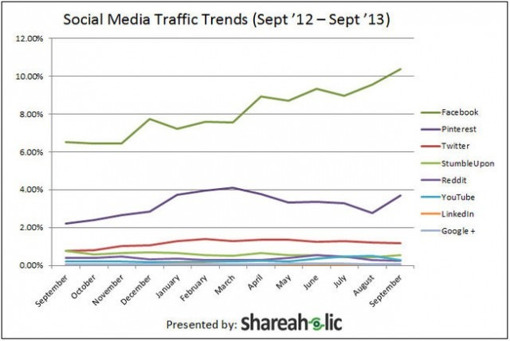
‘Facebook accounted for more than 10% of overall traffic to publishers in September, by far the most of any social network, according to data released Tuesday from Shareaholic, a social plugin service that collects data from 200,000 publishers reaching 250 million monthly unique visitors collectively’ (Mashable, 2013). Pinterest, the second ranked popular social network reached three times more traffic to publishers than Twitter, ranked third. In fact, Pinterest ‘drove 3.68% of traffic in September’ (Mashable, 2013). The visits of Pinterest’s share went up by 66% each year compared to other social network. In figures 2, 3 and 4, we can see other facts explaining why Facebook, Twitter and Pinterest can attract more customers.
(http://mashable.com/2013/10/15/pinterest-referral-traffic/#)
Figure 2 – Facebook facts
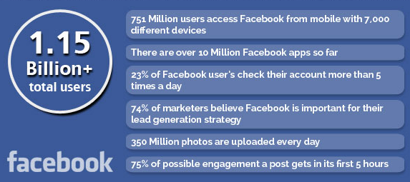

Figure 3 – Twitter Facts
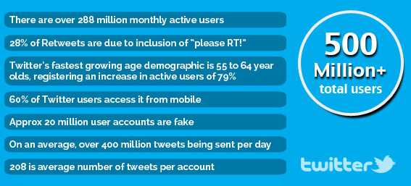

Figure 4 – Pinterest Facts
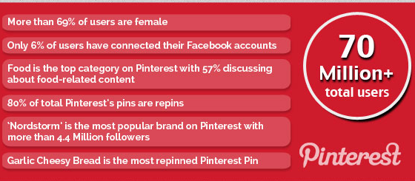

see http://expandedramblings.com/index.php/by-the-numbers-17-amazing-facebook-stats/#.UvPgnEJdXe4
http://expandedramblings.com/index.php/facebook-advertising-statistics/

Increasing Online Sales

More than one billion people are active Facebook users. It is certainly the reason why professionals discovered it could be used as a powerful marketing tool. Since the Timeline came into effect back in March, Facebook Pages have been a better fit for brands. The cover photo presents the opportunity to deliver fresh content more frequently. To coincide with that, Facebook Insights provides real-time data (within five to ten minutes) and the opportunity to either Promote your Post or make it a Sponsored Story. http://corp.wishpond.com/blog/2012/10/10/top-20-articles-on-how-to-increase-sales-using-facebook/
Wordstream found out a few interesting things about Twitter in their study:
- Twitter has a much better Click through rate (CTR) in comparison to Facebook. On Twitter you can expect a CTR of around 3.6%. That may seem small, until you see the dismal 0.4% of Facebook.
- Advertisements can be highly targeted to specific user groups. This can lower your overall cost as you’re not paying to show your ad to people who aren’t related to your products or target market.
Twitter is the champ when it comes to engagement with your brand. If you’re looking to build a following of people that can be sent to your website, there’s no question that Twitter is the platform you want.
To look at some claims from Twitter, you can expect their Ads to:
- Provide an increase of 22% in brand conversions
- Increase positive mentions of your brand by 30%
- Get you 32% more retweets – vastly increasing your brand reach
http://blog.devumi.com/2015/02/using-twitter-ads-increase-sales-good-bad/

As the 3rd most popular social networking website in the world, Pinterest can be a great tool for ecommerce stores to use to increase site traffics and boost sales.
While it's still relatively new to the social networking scene, Pinterest is already having a huge impact on the ecommerce industry. After analyzing data stores equal to traffic coming from Twitter. Of the traffic from Pinterest, shoppers are 10% more likely to make a purchase compared to those who arrive from other social sites. Of those purchases, the average order is $80 – double the average order of customers coming from Facebook.
http://www.shopify.ca/infographics/pinterest
In summary, the company should take this opportunity to increase its reputation and sales with Facebook, Twitter and Pinterest.

CONCLUSION AND RECOMMENDATIONS

On the concern of the company, this study conducts an analysis supporting the benefits obtained by using social media platforms. In this research, it is focused on Facebook, Twitter and Pinterest, which advertise with lower costs. These services provide other advantages to the company such as attracting new customers online and increase the market research. Successively, a growth in online sales is brought forth and internal communication between employees is involved. Many evidences brought up from the articles has shown that Facebook, Twitter and Pinterest can incite employees to interconnect with each other more, and express their interests and personalities to the public. Basically, these opportunities should not be underestimated by the company. Supported by the findings and conclusions of this study, the following recommendations are offered in the form of an action plan to adopt the use of Facebook, Twitter and Pinterest to promote an awareness campaign to the company’s marketing.
Applying Facebook, Twitter and Pinterest within the company
- Inform all workers of the advantages and opportunities that these three platforms could offer to the company. That process will speed up the implementation of these methods.
- Knowing and understanding the use of these platforms would be extremely important to all staff members within the company. This process might be challenging time wise, but it is very useful and rewarding for everyone to acknowledge the association of these media and the way they function.
- A supplementary research on the updates and new tools these web based media has initiated lately would be inspirational and would aid the staffs to apprehend them on higher level of performance.
- Final step is to create an account related to our business on one or all of these platforms, and create the first (ad, tweet, pinboard) for the company. This procedure would be the beginning of social networking marketing through online sites.
Apply a Social Network Policy
- The distinction between the private and business use of social media in workplace. As well as establishing regulations concerning the discipline and behavior standards for online communication. This is to protect the company against accountability for the activity of its workers.
- Ensure the awareness of the new social network policies. Prevent problems for arising especially when employees ignore the new regulations and procedures. Therefore, it is important to for them to apply the new policy.

Put Forth a Marketing Strategy for Pinterest
- Specify the improvements and modification to be made to the organization by studying the strengths and weaknesses of the company.
- Acknowledge the position of the company according to Facebook, twitter and Pinterest. Pointing out threats and occasions where the company is profitable.
- Gathering information on customers, taking in consideration staffs’ opinions and new ideas to evolve the company’s pages on the web.
- Finally, determining the strategy to be used on one of the three platforms for the company. This analysis drives the company to determine what to modify or exploit in the future.

REFERENCES

Sites
http://www.forbes.com/sites/jaysondemers/2014/08/11/the-top-10-benefits-of-social-media-marketing/
http://ymarketingmatters.com/google-plus-for-your-business/
http://www.newnordicusa.com/about-new-nordic/
http://mashable.com/2013/10/15/pinterest-referral-traffic/#
http://www.businessinsider.com/the-worlds-largest-social-networks-2013-12
http://ymarketingmatters.com/why-social-media-is-so-important-for-your-business-in-2014/

Facebook
Learning to leverage Facebook's popularity can prove beneficial to your small business. After registering for a free Facebook account, you can create your own business page complete with a detailed description, location, operating hours and contact information. While users must adhere to a standard profile template to maintain the site's uniformity and appearance, Facebook permits personalization through the profile's large cover image and profile image, enabling you to establish your business branding. Facebook pages are open to the public and can appear in search results of the major search engines. After you've built your business page, invite friends and existing customers to "Like" your business. Everyone who clicks your page's "Like" button receives automatic updates each time you post to your company page. Your page is a great place to share news about your business, including upcoming events, special sales or new product releases. All the page's status updates appear on the news feeds of everyone who liked your business, serving as free advertising to your core customer base. Customers may also share your posts, add comments or contact the page administrator directly through Facebook, enhancing interactivity. 1) http://smallbusiness.chron.com/description-facebook-63730.html
Twitter
If a picture is worth a thousand words, adding an image to a tweet greatly expands what you can share to beyond the 140-character limit for tweets.
People follow (subscribe) to your Twitter account, and you follow other people. This allows you to read, reply to and easily share their tweets with your followers (retweet). While Twitter may have started as a micro-blogging service, it is grown into much more than simply a tool to type in quick status updates. Twitter is microblogging. Twitter, and 'tweeting', is about broadcasting daily short burst messages to the world, with the hope that your messages are useful and interesting to someone. Conversely, Twitter is about discovering interesting people online, and following their burst messages for as long as they are interesting. Twitter is very simple to use as broadcaster or receiver. You join with a free account and Twitter name. Then you send broadcasts daily, or even hourly. Go to the 'What's Happening' box, type 140 characters or less, and click 'Tweet'. To receive Twitter feeds, you simply find someone interesting (celebrities included), and 'follow' them to subscribe to their tweet microblogs. Once a person becomes uninteresting to you, you simply 'unfollow' them.
You then choose to read your daily Twitter feeds through any of various Twitter readers.
2) http://netforbeginners.about.com/od/internet101/f/What-Exactly-Is-Twitter.htm
Pinterest
Other users can follow individuals on their pinboard, and even repin the content that they like. Pinterest also provides a bookmarking tool called ‘‘Bookmarklet’’ that allows people to pin any image or video you find when browsing the Internet. In summary, Pinterest offers five options for actions to perform when visiting another person’s pinboard: to follow that person, follow a pinboard, like a specific pin, comment on a pin, or ‘‘repin’’ the pin.

