- Every scientist is an observer. They are experiencing it but that experience comes with a cost.
- SDT (not unlike what we use to make stats decisions) involves accuracy, it is important for any measure that you will take.
- An Assay that you do to find things out. It is good for a questionnaire that you give to people. Good for a diagnostic. These all involve accuracy and sensitivity and specificity.
- SDT is about a stimulus and the yes/no response you give.
- There is usually noise (uncertainty) and bias (the criteria)
- There is a non-parametric version of SDT
- If your normal distribution is off, you use a’ instead of d’ for a non-parametric version.
Sensitivity and Bias in SDT
Identifies at least the sensitivity issue when used in a detection (yes/no) task. It can become about specificity if you are looking at discrimination (is it benign/no).
- Sensitivity – ability to detect past the threshold with noise
- Specificity – can you discriminate between two things.
Borderline Personality Disorder: Differentiating between one over the other can be different. There are things that borderline people will do that overlaps with narcissism.
We are talking about normal distributions. Now we are talking about things that you can actually calculate in certain ways. Z scores are how you calculate d’. Z(hits) – Z (False alarm)
For the response bias, there is different measures. Depends on what kind of decision maker you are dealing with. C and B are with strict decision makers. C is a bit better. B is non-parametric, can be used where there isn’t normal distribution.
To show accuracy of performance, you can use percentages. The advantage here is that you get more information. The areas can be calculated. If the normal distribution are overlapping, you can see these errors. If you don’t have errors, you can’t calculate the d’ (without z).
Multiple choice/True False examples are great for this. TF is great for SDT. You need to detect the truth.
What kind of error can you make? If you say a false question is true, that is an error. Any error can be quantified.
You can identify if people are liberal or conservative with their answers.
You can use SDT with multiple choice, because it becomes about discrimination. The more options you give involves adding more noise.
Important Notes on D’
The participants or subjects or instances are doing better than thought. There is a way to deal with this and correct this. The 2 known solutions are:
- Transform the proportions of 0 to 1/2N.
- Add 0.5 to ALL DATA CELLS. You flip all of the cell in the matrix to this (usually simpler).
After this, you make SDT weaker. You make assumptions about errors, and you give it a standard minimum error.
Range of d’ and approximate % correct
When the two curves are starting to separate, you are very close to d’=4. When experiments were done in Neuroscience with rats, no and no go detection tasks happened. They either knew it was there or said that it wasn’t. Discrimination is stimulus 1 vs stimulus 2.
What is there is more than 2 stimuli? What if it is a multiple choice exam?
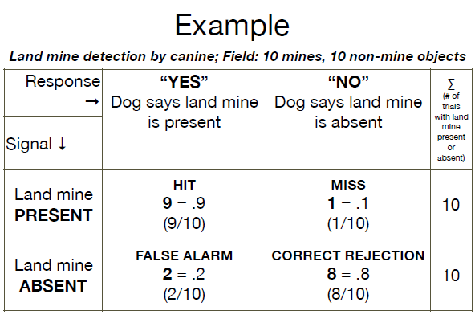
SDT is hard to use in the field unless you run an experiment or have some sort of measure for the field.
D’, C, b
Won’t need to do this on the exam, you just need to understand how simple it is to extract the two measures. C is at 0 if neutral, Conservative if positive and liberal if neutral.
The last paragraph on this slide will come up late. In diagnostic theory they use the likelihood ratio.
D’
One easy way to account for this is that if you have anything else but the detection, you need to divide the d’ by the square root of the number of choices you have.
Raises some questions about the value of SDT when you get a lot of different options in terms of the number of responses that you can give.
Slides 43/44 are not super important right now. They are just examples for what ifs.
In summary:
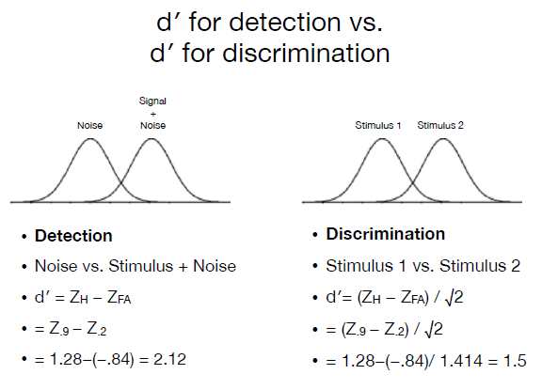
Noise vs stimulus: When you look at a tumor, you are looking at the tumor and the noise. The noise is always with the signal; it is always there.
Assessing the performance of a system
Terms and Formulas
- True Positives = Hits
Sensitivity and Specificity
- In medical diagnostics
  - Sensitivity: About the hits, more precisely, the hit rate. This is d’, it is telling you when you are right about saying yes.
  - Specificity: about the correct rejections, more precisely, the correct rejection rate.
- Problem: Those measures do not take in consideration the ERRORS made:
  - False alarms (Type I) and Misses (Type II)
You can have a bit of specificity. You may not know exactly what it is looking for, but you know what it is not.
Errors
- Type I error: False Alarms
  - High Type I error = low specificity
  - Low type I error = high specificity
- Type II error: Misses
  - High type II error = low sensitivity
  - Low type II error = high sensitivity
The average of the specificity and sensitivity is your accuracy.
In diagnostic, the problem is you look at an X ray and give an estimate. You may not know for months if you are right or not.
Biometrics, Neuromeric
Accuracy is both sensitivity and specificity. Accuracy really is validity. This is usually a reference to constant error. There is always error in what you measure. There is precision as well, which goes towards reliability. One way to assess this is to do replication. If you get a different number every time you test them, you won’t have accuracy.
Precision is how the measurements are.
The closer you are grouping means you are precise but you may not be accurate. If it is consistently on the right of the bullseye, it can tell you two things:
- External factors (wind)
- Adjustment
If you do see a lot of precision without accuracy, it may not be due to you. These factors should be considered. There error is not always for the subject, you can be the problem or external factors. You must be able to detect the ability you are looking for.
Pipetting takes a long time. Biggest issues can be underestimating the error that you are creating. If you add a little bit extra in the pipette, it really isn’t just a little problem.
Slide 52: Important
These are terms to describe. The False Omission rate and discovery are more details about what is actually going on. There are many different types of errors that you can analyse. Here we have an example that is basically about land mine detection.
Rats are used for the mine fields because they weigh less. You just have to hope the dog was right not signalling anything there.
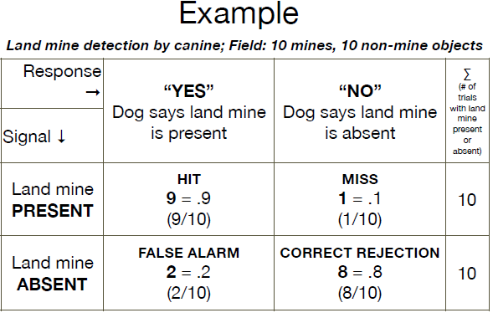
You cannot afford misses in these situations.
SDT in a behavioural point of view is that you can change the criteria. You want here a dog that is fine with giving false alarms. Time is worth a lot less than blowing up. You can train someone to be more liberal or conservative when it comes to answers. In other words, you are generous with your rewards.
Understand the terms in bold. With logic, you will be able to extract some of the other stuff.
The following matrix is reversed, it is just because of the arrangement of the columns and rows.
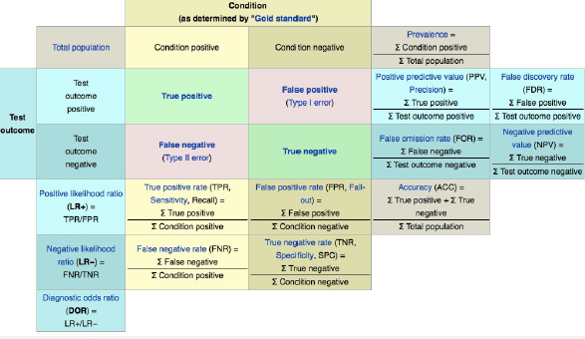
Diagnostic Validity
The flu could be diagnosed as HIV by someone who doesn’t know the baseline symptoms.
Even the HIV test isn’t terribly reliable. If you have a positive, they will always retest you a second time. Really what they want to avoid is that person being so stressed over a false diagnosis. It is strange that they don’t retest in the other direction.

