Plagiarism detection: Most of the cases (especially in this course) are detected without the software.
Pheromones: can change mood, perception of one’s self. The perfume industry knows this.
You determine people’s accuracy in things like this. This is extremely basic background of SDT.
The basic elements of SDT
- Situations and subjects are taken in consideration
- Four elements
- Signal: the stimulus, the object, the target.
- Response: the action taken or decision made
- Noise: the “uncertainty” factor, the interference (intrinsic or extrinsic). It is a reference to all of the meaningless things that may mask what is actually going on. This is about how you make decisions, and if a neuron fires in a situation of uncertainty.
- Response Bias: very proper to it. The bias from the decision maker, the responder. Every person has a bias.
You will pretty much always have an error. What error are you making and does it matter?
Example: Does it matter if they have false alarms? Does it matter if they miss? Prefer to have a dog that may have more false alarms.
Example: For land mines, does it matter if it is a false alarm or a miss? Yes. You will die if it is a miss.
The cost can change the context. In the American health system, things cost a little bit more.
FA: Type 1 errors. “There is a strong effect of this drug” but there is none
Miss: Type 2 errors. “this drug has no effects” but there is some.
Liberal: More likely to do false alarms than misses.
Multiple choice use these principles to make a good exam.
Detection/Discrimination
- The parameters:
  - The accuracy in detection/discrimination is measured by d’ (d prime)
  - The observer’s bias is called the criterion and is measured by c or b (beta)
  - Both can be represented with ROC (receiver operating characteristics) curves or plots: Those curves should the relationship between hits (correct) and FA’s.
Looks at how accurate you are. The accuracy is defined by d’. D is for difference or discrimination or detectability (all work). D’ is likely to tell you about the sensitivity of the stimulus. A low threshold stimulus will still be picked up by the system.
Specificity goes to discrimination
Sensitivity is about detectability
Sensitivity/Detection: The ability to see the tumor.
Specificity/Discrimination: Ability to tell if it is benign
Everything you do in neuroscience and psychology can be influenced by your decisions and your accuracy.
If you are colour blind and counting due to stains, you have noise.
There are different types of measures for bias. C and b are two mathematically different ways of getting to a bias.
Chemistry and the behavioural sciences use the same tools; they just use slightly different emphasis of the sub tools.
If there are two types of errors, there is also two types of getting it right.
This is a lot more than telling someone about percentage correct, which is often what you see in psychology and neuroscience. People often show accuracy and their percent correct. The mark on the exam may be 75% BUT in that 75% of the time correct, you don’t know how many times it was because of a hit or a correct rejection. It is there, but we don’t know the partition between the two. We also don’t know the nature of the 2 that were wrong, were they hits or misses?
We can’t say if we are liberal or conservative decision makers. In a hospital, a bunch of false alarms can be costly, but a bunch of misses can kill.
ROC Curves
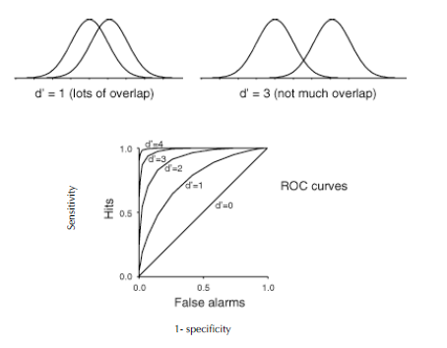
This is a theory about the 4 components (signal, response, noise.) The one on the left is the noise. That represents how noisy it is.
The one on the right is the stimulus or the signal. They would be distributed on a normal distribution. Overlap means there is uncertainty. The d’ is basically the distance between those two curves based on the average. The average is the peak of the mountain. There is less overlap on the right, it is easier to do a detection or a discrimination in this case.
D’=0 would fully overlap. This is usually chance. The system just went by chance, and really had no idea what was going on.
D’4= just about not overlapping anymore
SDT is really useful when you have uncertainty. You need to have an overlap to have uncertainty.
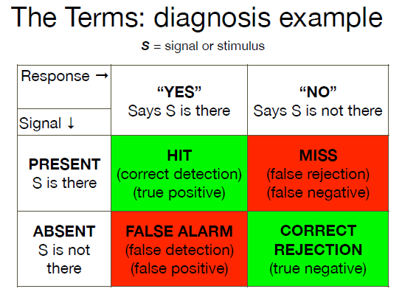
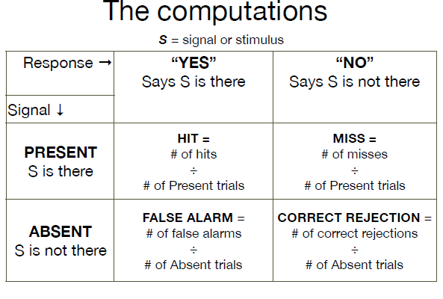
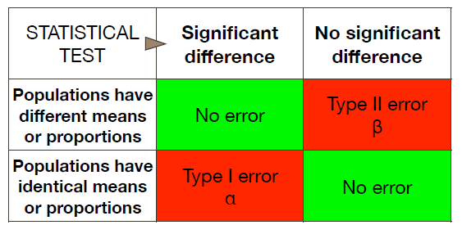
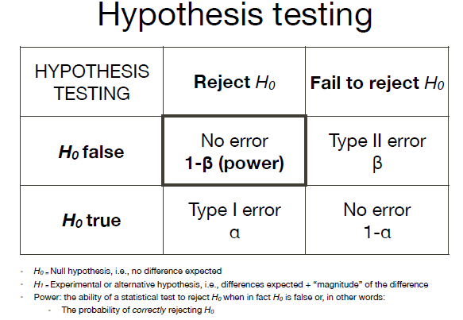
If you want to use the stats we know, you want nomothetic research because you want power. Imagine you decide to do a study where you want to test a placebo with 2 and treatment with 2. You divided the subjects into two smaller groups, losing even more power.
Errors: Summary
- In other words:
  - Type I errors are akin to false alarms
  - Type II errors are akin to misses
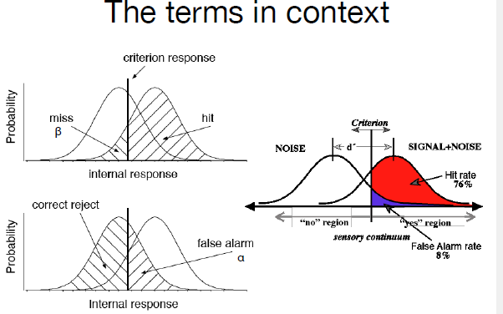
The criterion within can move as well as the curves.
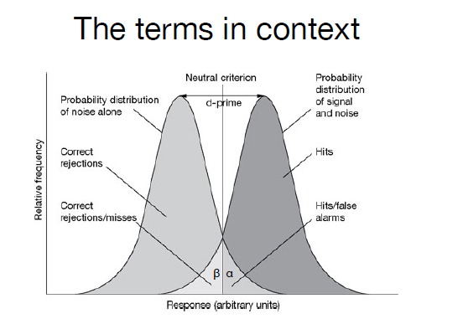
This is right in the middle, neither conservative or liberal. For specific things, like sonar readers, you want right in the middle. For a mine sniffer dog, you want way more false alarms.
Triangle, equal proportions of everything.
Left: Liberal
Right: Conservative
Before you go to the field, you need to know how likely misses are. You want a dog that does false alarms if they are going to do any error at all.

