Experiment 8
Fischer esterification

CHM2123A

Jenna MacNeil 8120972
Kaitlyn Rourke 8175164

TA: Sven Bourgeois
November 28th 2016

Introduction
Esters are a distinct class of organic compounds that are often known for their pleasant fragrances, making them extremely useful in both the perfume industry as well as the food and beverage industry. Chemically, esters are in the form of COOR, containing a carbonyl adjacent to an acetal group. Typically, they are synthesized from carboxylic acids and alcohols.
Simple esters can be made directly, by combining both the carboxylic acid (electrophile) and the alcohol (nucleophile), along with an acid catalyst. More complex esters, however, require that the carboxylic group be protonated first before the alcohol is added, thus yielding a key tetrahedral intermediate. Several proton transfer steps lead to the protonation of the OH group, and the carbonyl reforming, thus releasing water as a leaving group and forming the final ester product. This method of ester synthesis is called Fischer esterification.
It is important to note that Fischer esterification is a reversible reaction, thus there is a continuous equilibrium between products and reactants and the maximum possible yield will be determined based on the reaction at equilibrium between all reactants and products of the chemical equation. The rate constant can be determined by comparing the ratio of products to reactants as a fraction, thus: K=[ester][H₂O]/[acid][alcohol]. Based on this equation, the yield can thus be manipulated by changing the relative concentrations of each reactant. A useful tool to calculate the yield at equilibrium is to use an ICE table to determine the relative concentrations of each species at equilibrium.
Theoretical K values can be determined using a version of the Gibbs free energy equation: ΔG° = Δ_{rxn}H° – TΔ_{rxn}S° Using entropy enthalpy values, ΔG° values can be determined and subbed into the equation ΔG° = - RTlnK. In order to solve for K. Literature values for the standard heat of formation as well as values for the standard molar entropies will be used to solve the first equation.
The goal of this experiment is to synthesize methyl benzoate from methanol and benzoic acid. Firstly, the carboxylic acid group will be protonated, followed by the attack at the carbonyl center by the alcohol acting as a nucleophile, followed by a proton transfer and the elimination of water as a leaving group thus reforming the carbonyl, and finally the deprotonation of the carbonyl under the presence of concentrated sulfuric acid as a catalyst. The equilibrium constant, K, will also be determined and thus the yield calculated relative to the theoretical value of K.
This reaction will involve refluxing the reactants in order to allow a reaction to occur, followed by an extraction in order to separate the ester product (organic) from the unreacted benzoic acid (deprotonated with base to move to aqueous phase) in order to determine the relative amounts of each at equilibrium. Distillation will be used to separate the solvent in the organic phase (low boiling point) from the ester. Generally, no side reactions take place in esterification, thus no additional products are expected to form.

Table of reagents
Reagent | Molar mass (g/mol) | Amount (g or mL) | Density (g/mL) | Mmol | Equivalent
Benzoic acid | 122.12 | 5.0 g | - | 40.94 | 1
Methanol | 32.04 | 15 mL | 0.792 | 370.79 | 9.05
Sulfuric acid | 98.079 | 1 mL | 1.84 | 18.76 | 0.458 (catalyst)
Water | 18.02 | 50 mL | 1.00 | 277.8 | solvent
Dichloromethane | 84.93 | 25 mL | 1.33 | 391.5 | solvent
5% NaHCO₃ | 84.007 | 25 mL | 2.20 | - | Solvent
NaCl solution | 58.44 | 20 mL | 2.16 | - | solvent
HCl | 36.461 | dropwise | 1.02 | n/a | n/a
Na₂SO₄ | 142.04 | - | - | - | Drying agent

Experimental Procedure
Refer to CHM2123 lab manual, p90. No modifications to the procedure were made.

Observations and results
Table 1. Qualitative observations of Fischer esterification
Key step | Observation
Benzoic acid, methanol in flask | Benzoic acid is white flaky powder. Once methanol is added, it completely dissolves into a transparent colourless solution
Reflux for 60 minutes | Result is clear, colourless solution
Wash with 25 mL x2 of H₂O | Aqueous and organic phase are turbid, white solutions
Extract with NaHCO₃ and NaCl solution | After each extraction, organic layer becomes more clear At the end of extraction, it is slightly white turbid.. Aqueous phase is very turbid, white.
Add Na₂SO₄ to organic phase and filter | Turbidity clears up and granules observed at bottom of flask. Once the crystals are filtered, the solution is clear, slightly yellow
Perform distillation with organic phase to isolate methyl benzoate | Isolated ester is transparent, yellow liquid with a distinct, pleasant aroma.
Add HCl to aqueous phase | After adding significant HCl, a small about of white precipitate begins forming at bottom. The precipitate has the appearance of snow.
Suction filtration of aqueous phase and wash | A pure white flaky powder obtained.

Table 2. Results of Fischer esterification
Mass of benzoic acid product (g) | 0.5
Mass of methyl benzoate product (g) | 3.66
Theoretical K | 0.967
Observed K (based on benzoic acid equilibrium) | 0.99
Observed K (based on methyl benzoate equilibrium) | 0.096
Yield (%) | 57

Calculations
Theoretical K value
C₇H₆O_{2 (g)} + CH₃OH _{(l)} C₆H₅CO₂CH_{3 (l)} + H₂O _{(l)}
Substance | S⁰ (J/mol K) | Δ_{f}H⁰ (kJ/mol K)
Methyl benzoate (l) | 298.97 | -324.8
Water (l) | 69.9 | -285.8
Benzoic acid (l) | 167.6 | -385.2
Methanol (l) | 127.2 | -238.6

T = 298.15 K
R = 8.314 J/mol K
Δ_{rxn}S⁰ = ∑S⁰_{products} - ∑S⁰_{reactants} = (S⁰_{methyl benzoate} + S⁰_{liquid water}) – (S⁰_{benzoic acid} + S⁰_{methanol})
=(268.97 + 69.9) – (167.6 +127.2) J/mol K
= 44.07 J/molK

Δ_{rxn}H⁰ = ∑Δ_{f}H⁰_{products} - ∑Δ_{f}H⁰_{reactants} = [(Δ_{f}H⁰_{methyl benzoate} + Δ_{f}H⁰_{liquid water}) – (Δ_{f}H⁰_{benzoic acid} + Δ_{f}H⁰_{methanol})]
=(-324.8 + -285.8) – (-385.2 + -238.6) kJ/mol K
=13.2 kJ/mol K

Solve for G:
ΔG₀ = Δ_{rxn}H⁰ - TΔ_{rxn}S⁰
=13.2x10³ J/mol K– (298.15K)(44.07 J/mol K)
=60.5295

Solve for K:
ΔG₀ = -RTlnK
lnK= ΔG₀/-RT
lnK= 60.5295/ (-8.314 J/molK) (298.15K)
lnK= -0.0244
K=0.976

Experimental value of K
Moles of observed species at equilibrium:
N_{benzoic acid} = 0.5g x( mol/ 122.12g) = 4.1mmol =0.0041mol
N_{methyl benzoate} =3.66g x (mol/136.15g)= 26.9mmol =0.0239mol
K based on equilibrium of benzoic acid
Initial benzoic acid –x = benzoic acid at equilibrium
X= initial benzoic acid- benzoic acid at equilibrium = 0.041mol-0.0041mol
X= 0.0369
 | Benzoic acid | methanol |  | Methyl benzoate | water
Initial | 0.041 | 0.371 |  | 0 | 0
Change | -x | -x |  | +x | +x
Equilibrium | 0.041-x= 0.0041 | 0.371-x= 0.3341 |  | x= 0.0369 | x= 0.0369

K = [methyl benzoate][H₂O]
[benzoic acid][methanol]
= (0.0369)²/(0.0041)(0.3341)
= 0.99

K based on equilibrium of methyl benzoate (ester product)
x= moles methyl benzoate= 0.0239
 | Benzoic acid | methanol |  | Methyl benzoate | water
Initial | 0.041 | 0.371 |  | 0 | 0
Change | -x | -x |  | +x | +x
Equilibrium | 0.041-x= 0.0171 | 0.371-x=0.3471 |  | x= 0.0239 | x=0.0239

K = [methyl benzoate][H₂O]
[benzoic acid][methanol]
K= (0.0239)²/ (0.0171)(0.3471)
K= 0.096

Yield
Actual yield= 0.0239mol methyl benzoate
Theoretical yield:
K= (x²)/(0.041-x)(0.371-x)
0.976=(x²)/(0.041-x)(0.371-x)
0=0.024x² + 0.402x -0.01464
Use quadratic formula, taking only the positive x value:
X=0.0417mol
%yield = actual/ theoretical x100%
=0.0239mol/0.0417mol x100%
=57%

Flowchart
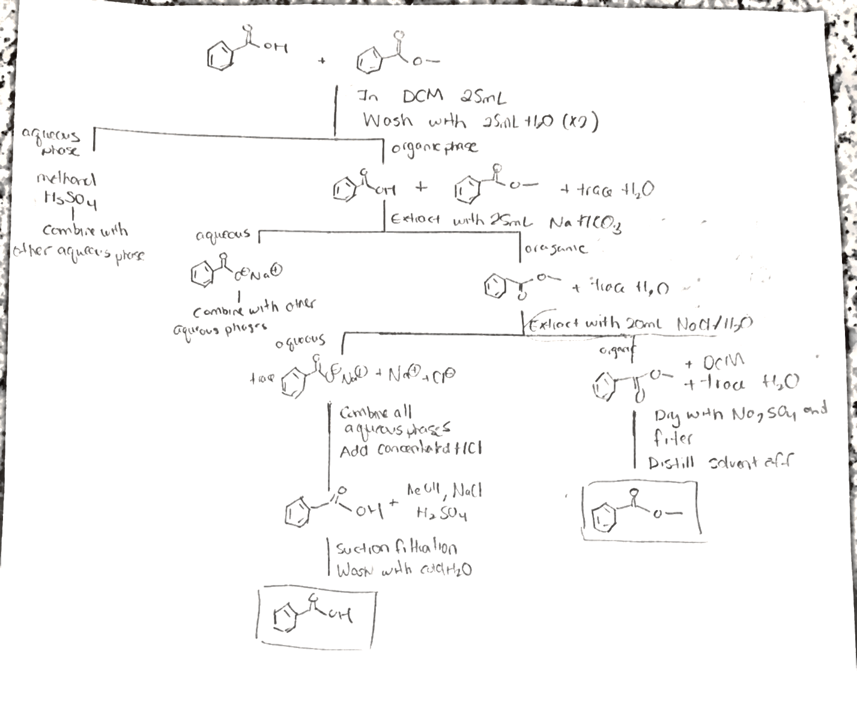

Discussion
The goal of this experiment was to obtain methyl benzoate, at determine its equilibrium constant, K, and corresponding yield. Benzoic acid, methanol and sulfuric acid were combined at reflux (with the heat from the reflux system providing sufficient thermal energy to overcome the reaction’s activation energy barrier). Sulfuric acid acted as the catalyst, protonating the oxygen on the carbonyl on the benzoic acid in order to make the carbonyl center carbon more electrophilic. The benzoic acid thus acted as the electrophile, while the methanol acted as a nucleophile via a lone pair of electrons on the oxygen atom that attack the carbonyl center of benzoic acid, forming the tetrahedral intermediate. A proton transfer from the added ROH group to the original OH group of the acid creates water as a leaving group, thus the carbonyl reforms as water leaves. The final step is a deprotonation of the oxygen on the carbonyl, thus reforming the original acid catalyst, and obtaining an ester as the final product, with water as a byproduct.
In the case of this experiment, a large excess of methanol (the nucleophile) was used in order to force the equilibrium to favour the products. When the equilibrium constant remains the same, increasing the concentration of one reactant relative to the other will increase the overall yield based on the conversion of the limiting (other) reagent, in this case the carboxylic acid. As with all equilibriums, le Chatelier’s principle applies in that increasing the concentration of one of the reactants will force the equilibrium towards the products side.
Once the reaction reaches equilibrium, the reaction mixture will contain unreacted methanol, sulfuric acid (regenerated as the catalyst), unreacted benzoic acid and the produced ester. In order to determine the equilibrium constant, it must be determined how much reacted and how much did not react. Thus, the next step is to isolate remaining reactant benzoic acid and product methyl benzoate, and determine their masses. Extractive separate is the first step in isolating the compounds.
The solution is cooled to room temperature, or else solvent DCM will begin to boil when added. Once it is cooled, the solution is added to an extraction funnel already containing water. Thereafter, DCM is added as the organic phase, and the aqueous (water) phase is drawn off. The purpose of this step is to wash all the aqueous-soluble impurities away, leaving only the desired products in the organic phase. The impurities include H₂SO₄ and methanol, both of which are polar molecules and aqueous. The organic phase contains benzoic acid and methyl benzoate. In order to separate these two molecules in the organic phase, NaHCO₃⁻ in water is added to the organic phase. It is a weak base that deprotonates benzoic acid, forming sodium benzoate. This ionic compound is now soluble in the aqueous phase and insoluble in DCM. HCO₃⁻ forms water and CO₂ during the reaction, hence some fizzing could be heard from the flask as it was vented. The aqueous phase is drawn off (containing sodium benzoate). To finally draw out any ions that may still remain in organic, the organic phase is washed with a saturated NaCl solution. Sodium chloride increases the polarity of the aqueous phase, increasing other ion’s solubility in it and decreasing nonpolar molecule’s solubility. This furthermore removes unwanted water from the organic phase. After all the extractions, the aqueous phase contains sodium benzoate and the organic phase contains methyl benzoate. To remove residue water in organic phase, Na₂SO_{4,} a drying agent, is added. It forms hydrated crystals around trace water, which are then gravity filtered from the phase.
To isolate benzoic acid, HCl (a strong acid) is added to the aqueous phase, lowering the pH. In acidic conditions, benzoic acid will be found in its protonated form. It is insoluble in water unlike its ion, hence it will begin to precipitate out. Some other impurities may precipitate out, such as NaCl from the brine solution. Subsequently, benzoic acid is isolated with suction filtration, which allows the solvent and other soluble ions to pass through. To ensure no NaCl is also separated, the filter cake is washed with cold water, forcing salt to reionize and pass through in the solvent.
To isolate methyl benzoate from the organic solvent is a bit trickier, because it is a liquid at room temperature. The physical properties between methyl benzoate and DCM must be taken advantage of. The ester forms strong intermolecular dipole-dipole forces due to the polar C-O bonds, hence has an ordered structure. DCM has weaker dipoles because the C-Cl bonds have a smaller electronegativity difference than C-O. Hence, DCM requires less energy for the intermolecular forces to break and vaporize, at a temperature of 37 ºC. The b. p. of methyl benzoate is much higher, at 200 ºC. Hence, a distillation set up is used to isolate the ester, heating it to the b. p. of DCM. DCM only evaporates off, liquefies in the cold condenser and enters the receiving flask. After 10 minutes, all the DCM is lifted off leaving only pure methyl benzoate in the distillation flask. The mass is obtained from this.
Two equilibrium constants were calculated for this experiment: one based on the moles of benzoic acid obtained at equilibrium, and another based on the moles of the ester product obtained at equilibrium. The value for theoretical K was obtained by calculating is using standard (T=298.15K) heat of formation and molar entropy values in order to obtain Gibbs free energy value, ΔG°. Having obtained this value, theoretical K could be computed and was determined to be 0.967, meaning that theoretically the reactants are slightly favoured, but it is about a 1:1 ratio of products to reactants. Based on benzoic acid at equilibrium, the experimental K value was determined to be 0.99, extremely close to the theoretical value. This implies that more products were made than expected, thus a larger K value. A reason for this could be that too much HCl was added and thus NaCl precipitated out as well and would thus be added to the total mass of solid product obtained, thus giving a falsely increased mass for benzoic acid obtained. The experimental K value based on the equilibrium of methyl benzoate is 0.096, much lower than both the theoretical K value and the K value obtained by the equilibrium of benzoic acid. This means that the reaction did not proceed to completion and less product was formed than expected (which was verified by the computation of our yield to be 57%). The differences between both experimental K values is likely due to NaCL precipitating out as mentioned above, giving a false positive for the mass of the benzoic acid product. The difference between the experimental K value for methyl benzoate and the theoretical K value could be due to many sources of error. Notably, temperature must be taken into account. The theoretical K value was determined based on standard heat and entropy of formation at 25ºC (standard temperature). Since the reaction occurred at reflux, the temperature was higher than that of the theoretical value, thus leading to the difference in results. To account for this error, the temperature of the reaction flask at reflux could be measured to accurately determine K based on the specific temperature. The yield obtained was 57% for the ester product. As we obtained a lower K value in terms of the ester product, the yield correlates with this result as it means that less product was obtained than expected. To increase the yield, increasing the concentration of the alcohol could lead to more product being obtained.

Questions
- A)
 | Benzoic acid | methanol |  | Methyl benzoate | water
Initial | 1 | 1 |  | 0 | 0
Change | -x | -x |  | +x | +x
Equilibrium | 1-x | 1-x |  | x | x

K=0.976
K = [methyl benzoate][H₂O]
[benzoic acid][methanol]
0.976 = x²/ (1-x)²
0.99 = x/ (1-x)
0.99-0.99x= x
X=0.497 mol , 0.497mol water
b) Using more methanol, the theoretical yield would increase.
0.976 = x² / (1-x) (20-x)
0= 8.236 x10⁵ – (8.6478 x10⁵) + 4.118 x10⁴X²
Using quadratic formula,
X= 0.951mol
Therefore, the theoretical yield would increase by 0.454mol for a total of 0.951 moles.

- b) is a Sn2 reaction 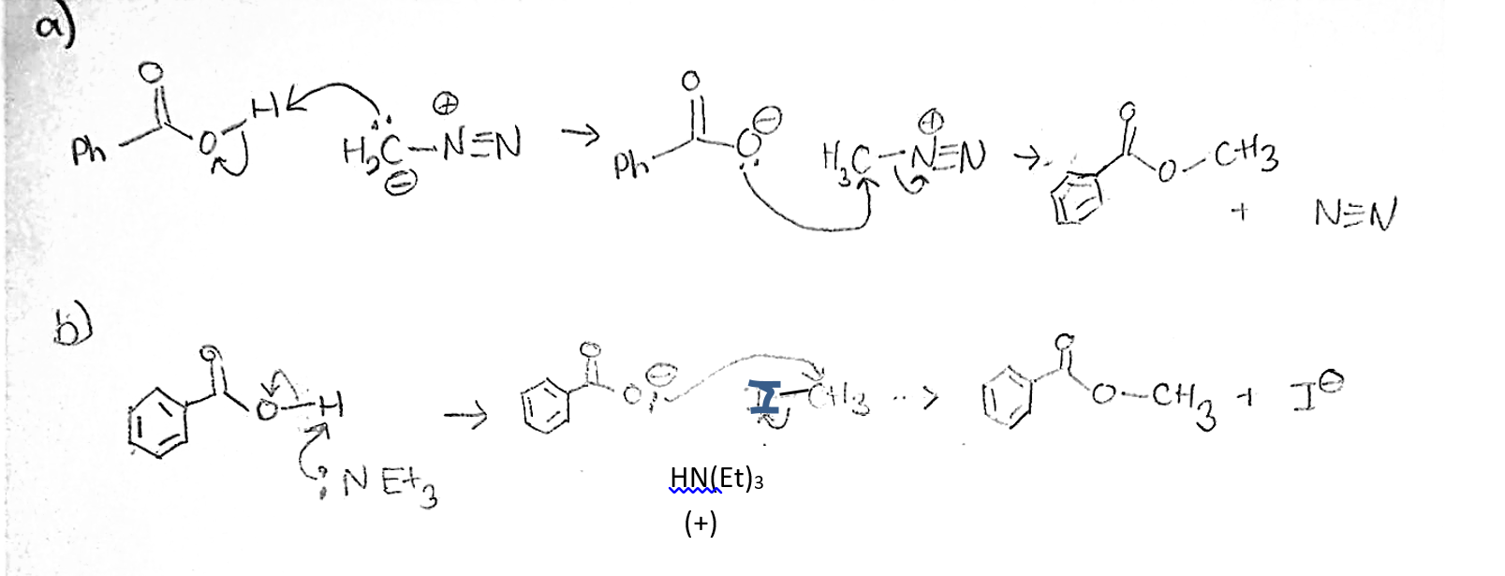
- This reaction would not occur since tBuOH is a weak nucleophile (although a strong base). Due to its bulky nature as a tertiary alcohol, steric hindrance would prevent the lone pair of electrons on the oxygen from being able to attack the carbonyl center, thus lack of accessibility due to steric hindrance causes tBuOH to be a bad nucleophile. Instead, the oxygen on the carbonyl would simple be protonated by the acid, but no further reaction would occur.
- 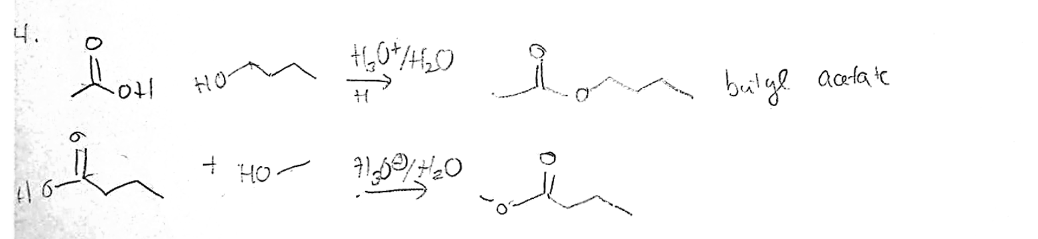
Please note: all reactions in 4) are at equilibrium (the arrows are omitted)

