Assignment 3
ADM 2303
Completed by: Ryan Robinson
Student: 8216165
November 27, 2016

1 a)
Objective function:
min Z= 100 (Rij) + 130 (Oij) + 10 (B1 + B2 + B3 + B4) + 150 (x1 + x2 + x3 + x4)
Variables:
Let Xi be the amount of sinks purchased from competitor in month i
Let Rij be the amount of sinks produced in regular time in month i and transported to month j
Let Oi be the amount of sinks produced in overtime in month i and transported to month j
Let Bi be the amount of inventory at the beginning of month i
Where (i= 1,2,3,4) (j=1,2,3,4)
Constraints:
Regular Time Production Constraint
(production month 1) R11, R12 , R13, R14 <= 100
(production month 2) R22 , R23 , R24 <=100
(production month 3) R33 , R34 <= 100
(production month 4) R44 <= 100
Overtime Production Constraint
(Production month 1) O11, O12, O13, O14 <= 50
(production month 2) O22, O23, O24 <= 50
(production month 3) O33, O34 <= 50
(Production month 4) O44 <= 50
Purchase Constraint
(purchases from the competitor) x1+X2+X3+X4 >= 450
Demand Constraint
(month 1) B1 + X1 + R11 + O11 =120
(month 2) B2+ x2 + R12 + O12 + R22 + O22= 160
(month 3) B3 + X3 + R13 + O13 + R23 + O23 + R33 + O33= 240
(month 4) B4 + X4 + R14 + O14 + R24 + O24 + R34 + O34 + R44 +O44 =100
Non negativity
Bi , Rij, Oij, Xi >= 0
Where (i=1,2,3,4)

b)
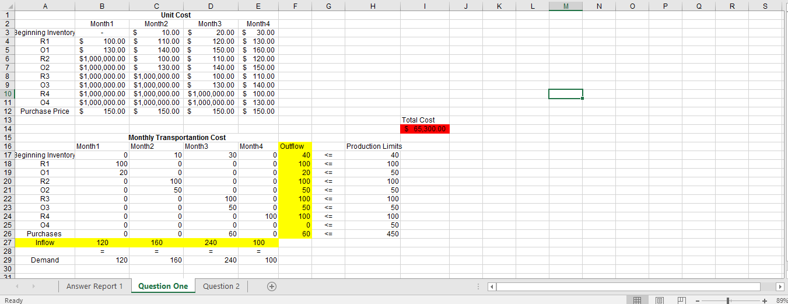
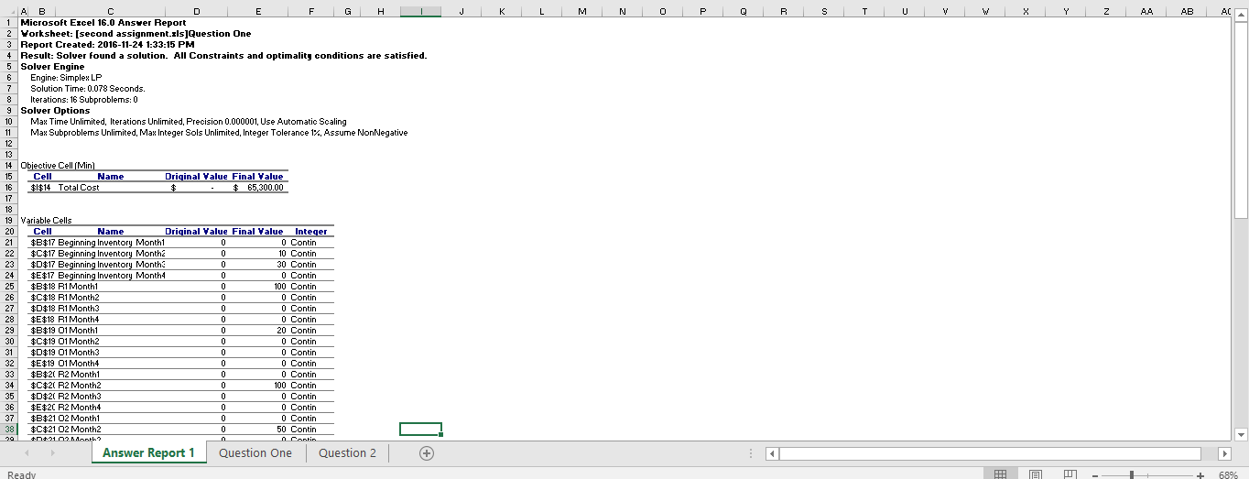
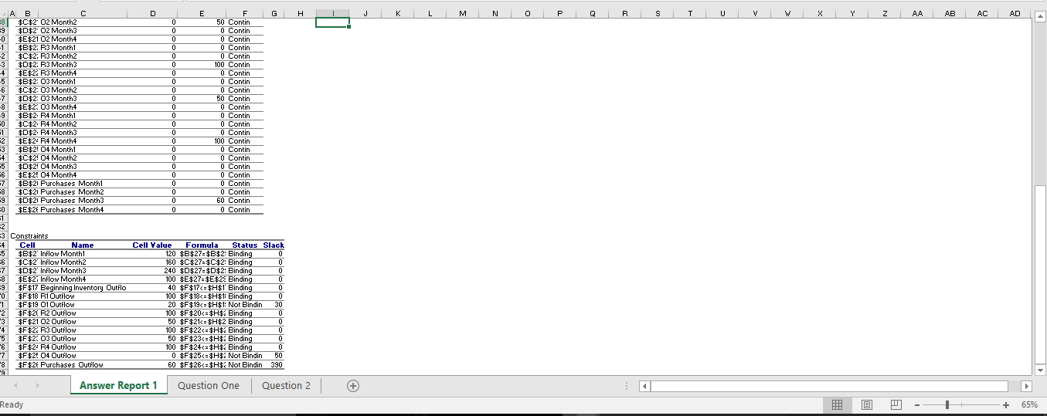

Managerial Statement:
Therefore, to meet monthly demand for stainless steel sinks at the minimum production cost of $65,300. J. Mehta Company should produce sinks in the most economical way possible. J. Mehta Company should produce 100 sinks using regular production and 20 sinks using overtime production in month one. For month two they should produce 10 sinks from its beginning inventory in month two, 100 sinks produced using regular production and produce 50 sinks using overtime production. For month three they should use 30 sinks from the beginning inventory of month 3, than produce 100 sinks using regular production time, 50 sinks using overtime production, and make 60 sinks purchases from the competitor. For month four, they should produce 100 sinks using regular time production. If this production plan is used, J. Mehta Company will have a minimized cost of $65,300 and meet their demand needs.
2a)
Objective function:
Max Z = 13XA1 + 13XA2 + 13XA3 + 10XB1 + 10XB2 + 10XB3 + 12XC1 + 12XC2 +12XC3 – 150Y1 – 120Y2 – 100Y3
Variables:
Let Xij reperesent the number of product i with machine j.
Where (i=A,B,C) and(j=1,2,3)
Let Yj represent the utilization of machine j
Where (j=1,2,3)
Constraints:
Capacity of Machine 1: 4XA1 + 3XB1 + 5XC1 <= 1000 (hours)
Capacity of Machine 2: 3XA2 +2XB2 + 4XC2 <= 800 (hours)
Capacity of Machine 3: 2XA3 + 4XB3 + 2XC3 <= 700 (hours)
Production of Product A: XA1 + XA2 + XA3 >= 40 (pounds)
Production of Product B: XB1 + XB2 + XB3 >= 40 (pounds)
Production of Product C: XC1 + XC2 + XC3 >= 40 (pounds)
Binary Constraint :
Yj = 1 if used
= O if not used
Integer Constraint: Xij = Interger

Xij >= 0 (non- negativity)

Yj = 0 or = 1
b)
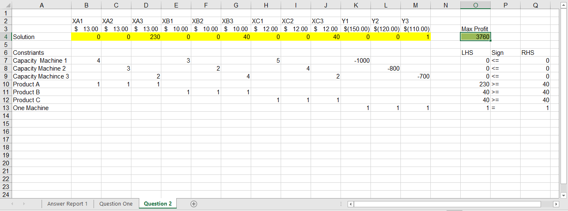
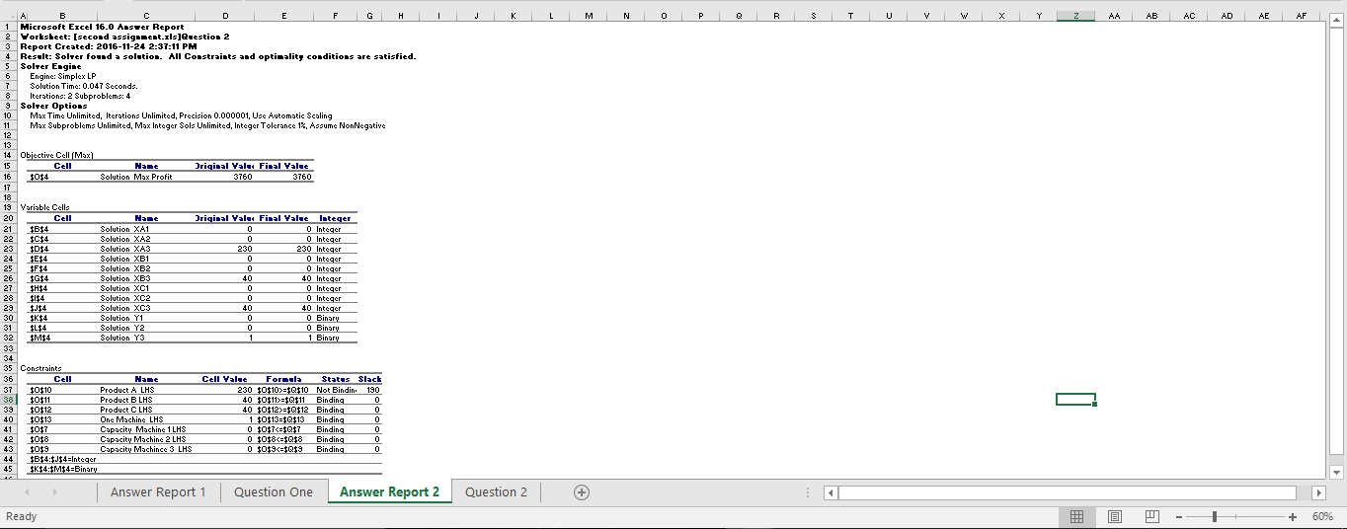
Managerial Statement:
Therefore, to maximize the profit of the new department the department should produce 230 units of product A with machine 3, 40 units of product B with machine 3, and 40 units of product C with machine 3. If the department utilizes its production resources in this way than profit will be maximized to $3760.00.
3 a)
Objective function: Min total deviation = P₁d₁⁺ + P₂d₂⁻ + P₃ (d₃⁺ d₃⁻ )
Variable:
Let X1=SF= San Francisco, X2=OK=Oakland, X3=PA= Pablo Alta, X4=SJ= San Jose, X4=SM= San Mateo,
X5= CO= Concord, X6= SC= Santa Cruz, X7=MN=Monterey
d1- = Expenses Underachieved, d1+= Expenses Overachieved, d2-= 5 cities visited Underachieved, d2+= 5 cities visit overachieved, d3-= SM visited underachievement, d3+= SM visited overachievement

Constraints:
(goal 1) 5000X1+ 4500X2 + 3600X2 + 4100X3 + 3500X4 + 2500X5 + 3200X6 + 4000X7 + d₁⁺ – d₁⁺ = 1500
(goal 2) X1 + X2 + X3 + X4 + X5+ d₂⁺ – d₂⁺ = 5
(goal 3) X4 + d₃⁺ – d₃⁺ =1
Integer Constraint
X=1 if visited x= 0 if not visited
Non-negativity
d_{i}⁺ , d_{i}⁺ >= 0
where (i= 1,2,3)
Xi >= 0
Where (i=1,2,3,4,5,6,7)
b)
Goal 1
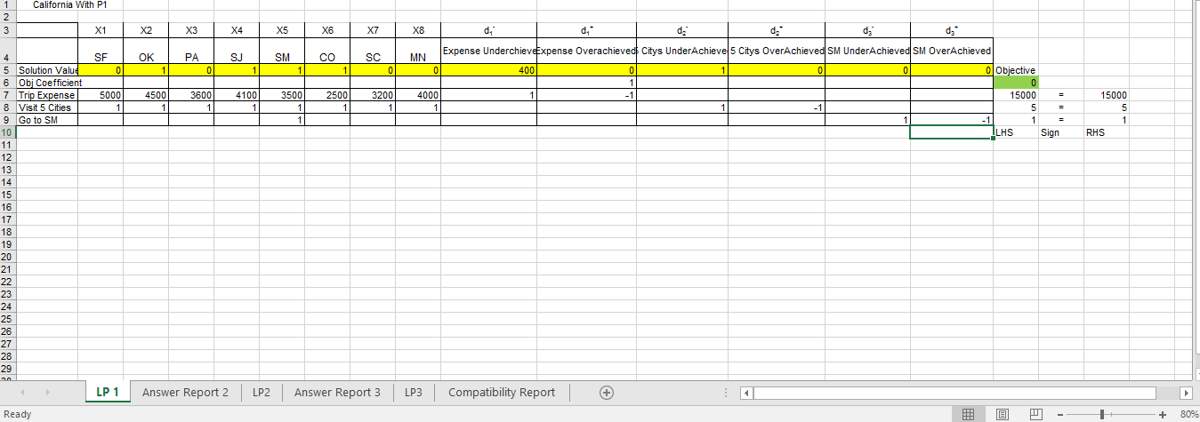
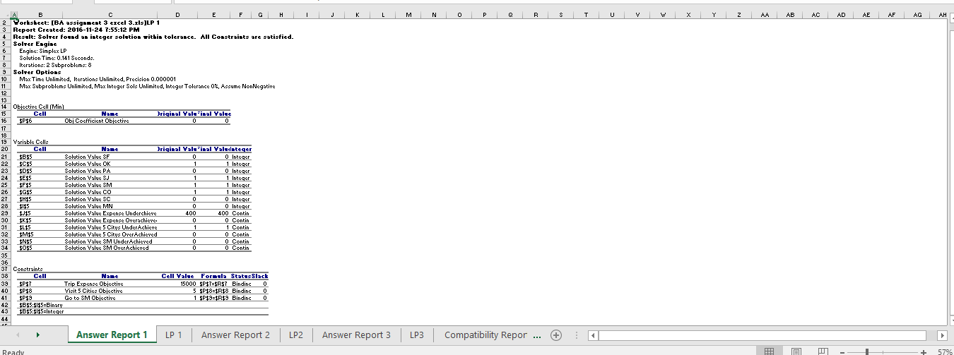

Managerial statement:
Therefore, to achieve the first goal of minimizing the deviation of overachieved expenses. California Tours should run a trip to visit SF, OK, SJ, SC. This will ensure that the first goal is satisfied.

Goal 2
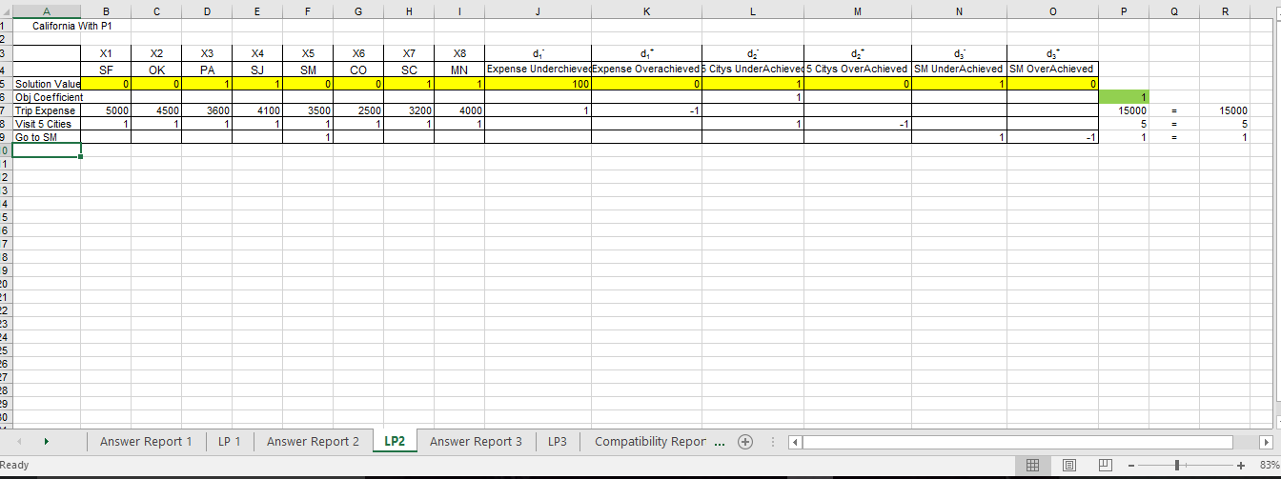
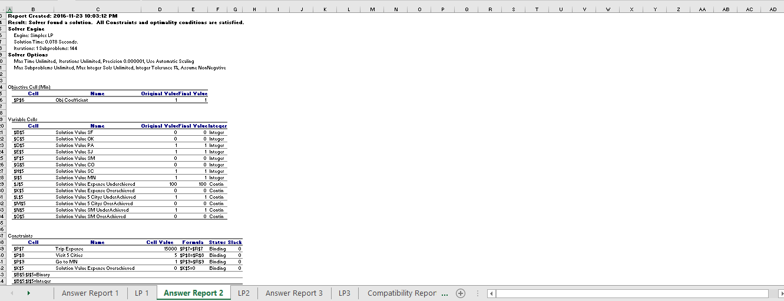
Managerial statement:
Therefore, to achieve the second goal of minimizing the deviation of underachieved visits of 5 cities. California Tours should run a trip to visit PA, SJ, SC, MN. However, this will not satisfy the second goal, but the deviation will be minimized.
Goal 3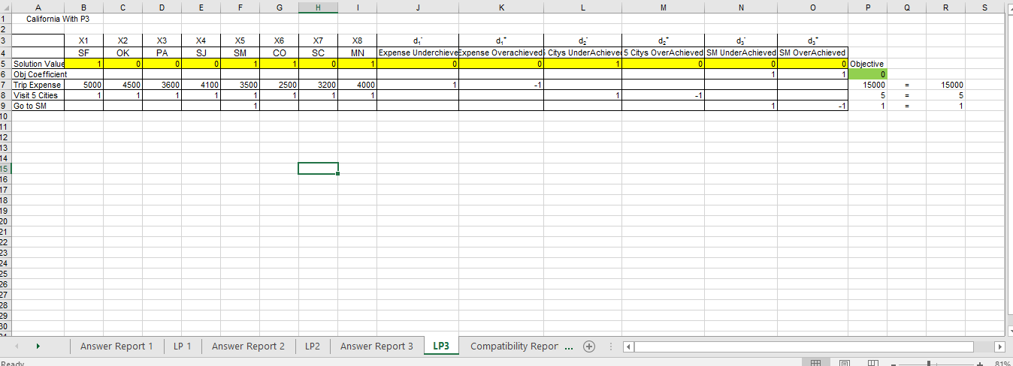
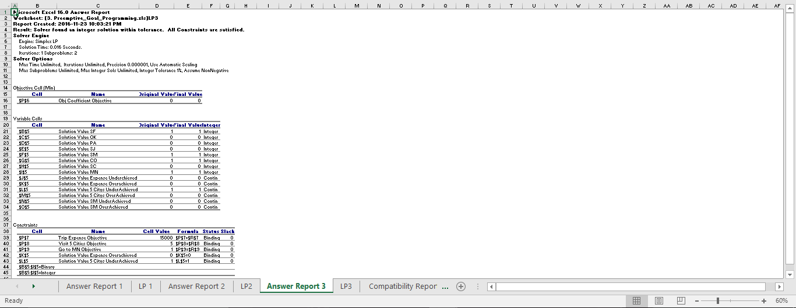
Managerial statement:
Therefore, to achieve the third goal of minimizing the deviation of underachieved and overachieved of visiting San Mateo. California Tours should run a trip to visit SF, SM, CO, MN. This will satisfy the third goal and ensure that the California Tours will visit SM.



