Module 2: The scientific method and matter

Scientific method
1. Performing Experiments
2. Making Observations
3. Proposing a Hypothesis
4. Confirming the Hypothesis
5. Proposing a scientific law

Experiment
Set of steps (procedures) that are performed under controlled conditions to propose or test a hypothesis.

Observation
Qualitative: Observation does not use numbers
Quantitative: observation is a measurement. It has two components: A measured quantity (numerical value) with an appropriate unit

Hypothesis
Tentative explanation to account for the observations of an experiment. Valid provided that one’s assumptions to explain the observations of experiment can be tested.

Confirm hypothesis
Needs to be confirmed via repeated and controlled experiments
There must be no inconsistencies between hypothesis and experimental observations
In event of inconsistencies, step 1 through 4 must be repeated.

After repeating all these steps, we can propose a scientific law.

Scientific notation
Express very large or very small numbers and increase efficiency in scientific calculations.
N x 10^{±n} for example: 598.46 n would be 2, hence 5.9846 x 10².

Significant figures (chiffres significatifs)
- used to indicate the precision (closeness of measurements) of a measurement or that of a calculated result using such measurements
- not apply to counted items such as exact numbers and defined conversions factors (1inch=2.54cm) -> these have infinite number of significant figures.

Rule #1: all nonzero digits are significant figures
Rule #2: counting begins from left with the first nonzero number
Rule #3: Zeros between nonzero digits are counted as significant figures
Rule #4: Terminal zeros (zeros to the right of a number)

Significant figures in chemical calculations

Depends on the operation performed
Rule #1: In addition and subtraction, final answer contains same number of decimal places as are in the measurement with least number of decimal places
Example 1: 25.0 g + 22.41 g + 1.234 g = 48.6 g (25.0 have 1 decimal: final answer 1 decimal)
Example 2: 4.85 mL – 0.02 mL = 4.38 mL (both have 2 decimals: final answer 2 decimals)

Rule #2: In multiplication and division, final answer contains same number of significant figures as are in the least number of significant figures
Example 1: 9.20 x 2.450 = 22.5 (9.20 -> 3 figures: answer 3 figures)
Example 2: 2.35 / 1.456 = 1.61 (2.35 -> 3 figures: answer 3 figures)

Rule #3: Exact numbers, unit conversion and constants have no effect on the number of significant figures.

Rounding off chemical calculations
Rule #1: multi-step calculations, all numbers carried to final result, which is then rounded off to give correct number of significant figures.
Rule #2: 8.379 g becomes 8.38 cuz 9>5
Rule #3: 6.371 g becomes 6.37 cuz 1<5
Rule #4: 16.75 becomes 16.8 cuz 7 odd number : 16.65 becomes 16.6 cuz 6 even number

SI
International units included metric system, length, volume, mass, density, temperature and time.
Length = meter (m)
Volume = cubic meter (m³) -> the most common is L or mL (1L = 10⁻³ m³) (1mL = 10⁻⁶ m³)
Mass = kilograms (kg) -> mass is a constant.
Density = kilograms per cubic meter (kg/m³) -> generally g/mL or g/L (mass/volume)

Giga -> 10⁹
Mega -> 10⁶
Kilo -> 10³
Centi -> 10⁻²
Mili -> 10⁻³
Micro -> 10⁻⁶
Nano -> 10⁻⁹

Solving numerical problems
Rule #1:
1.0 cm x 2.1 cm = 2.1 cm²
10.4 g / 2.0 g = 5.2

Rule #2:
1.0 g = 10³ mg
1.0 L = 10⁶ µL

Rule #3: (1.0 g / 10³ mg) and (10³ mg / 1.0 g)

Rule #4: mg x (g/mg) = g
Example 1:
1$ = 31 Rupees
251.10 Rupees x (1$ / 31 Rupees) = 8.10$

Example 2:
1 lb = 453.6 g
1 g = 1 x 10³ mg

$$10.31 lb × \frac{453.6 g}{1.00 lb} × \frac{1 × {10}^{3} mg}{1.00 g}=4.677 × {10}^{6} mg$$

Test 9/10

Matter
- occupy space (volume and mass)
- are perceivable by our senses
- physical state (liquid, solid, gas)
- chemical composition (element, compound, mixture)

Elements
- composed by one type of atom
- classified as metal, non-metal, metalloid (semi-metal)
- ex: copper (cuivre)

Compound
- combination of elements in definite proportion. Atoms chemically combined to form compound. Properties different from those of the individual elements that is comprised of. Chemical change can break down a compound into its individual elements.
- Ex: sugar

Mixture (mélange homogène et hétérogène)
- non-pure substance made of two or more elements or compounds that can be separated by physical, as opposed to chemical, procedures.

Atoms
Electrons -> negative charge (e⁻) surround nucleus
Protons -> positive charge (p⁺) in nucleus same number of electrons
Neutrons -> no charge in nucleus

Atomic & Mass numbers
Atomic number (Z) = number of protons
Mass number (A) = number of protons + neutrons
Number of neutrons = A – Z
X = atomic symbol

Molecules and Ions

Molecules
- Molecules are a combination of atoms in a definite proportion e.g., molecule of water
(H₂O; hydrogen:oxygen = 2:1).

Ions
- Ions are charged species formed by loss or gain of electron(s) from an atom.

Cation
- Cation generation: M (g) M⁺(g) + e- (loss of e⁻) [M = metal; g = gaseous state]
[where M⁺, a positively charged ion is the cation]
Anion
- Anion generation: X (g) + e⁻ X⁻ (g) (gain of e⁻) [X = nonmetal]
[where X⁻, a negatively charged ion is the anion]
Example: NaC(table salt) a compound, consists of Na⁺(cation) & C⁻ (anion) ions.

Module 3: The periodic table and naming compounds

Dmitri Mendeleev proposed the table 1869
Vertical (groups/families) horizontal (periods)
In order of increasing atomic number

A designation are referred to as the main-group elements
B designation as the transition elements.
Elements in the same group (or family) have similar chemical properties. Elements in a period have different chemical properties.

• Alkali metals (Group 1A)
• Alkaline earth metals (Group
2A)
• Halogens (Group 7A)
• Noble (rare, inert) gases (Group
8A)

Physical States

In general, the metals are solids (at 25oC) with the exception of mercury (Hg)
which is a liquid (at 25 oC).

Metals lose electron(s) to form cations and the nonmetals gain electron(s) to form anions.
Esstential Elements

The elements H, Na, Mg, K, Ca, C, N, O, P, S, Cl are the most abundant in living systems and are essential for life.

The elements Li, V, Cr, Mo, Fe, Co, Mn, Ni, Cu, Zn, Cd, B, Si, Sn, Pb, As, Se, F, I are found in trace amounts in the living systems.

The inner transition elements (lanthanides and actinides) are located between groups 3B and 4B.

Naming compounds

Chemical compounds are classified as:
- Organic: Compounds that contain at least one carbon atom.
- Inorganic: Compounds that contain atoms other than carbon. Exceptions are inorganic compounds such as carbon monoxide (CO), carbon dioxide (CO₂), etc.
For the purpose of nomenclature (systematic naming), inorganic compounds are classified as those:
- containing a metal and a nonmetal (ionic compounds)
- containing two nonmetals (covalent compounds)

More about Ionic Compounds
Ionic compounds are composed of ions. They are formed by the electrostatic attraction between a positive ion (cation from the metal) and a negative ion (anion from the nonmetal). Electrons are transferred from the atoms of one element to the atoms of another element.
In general, metals lose electrons and nonmetals gain electrons. Ionic compounds are charge neutral (zero net charge). Charges on ions involved in an ionic compound must be known in order to name the compound formed between them or to derive the formula for the compound.

Rules for naming compound
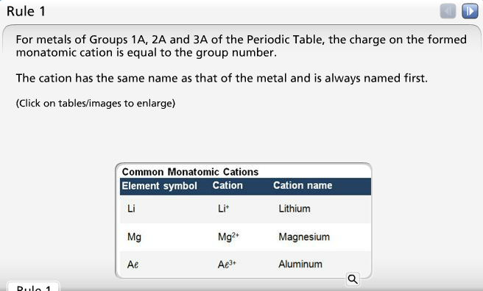

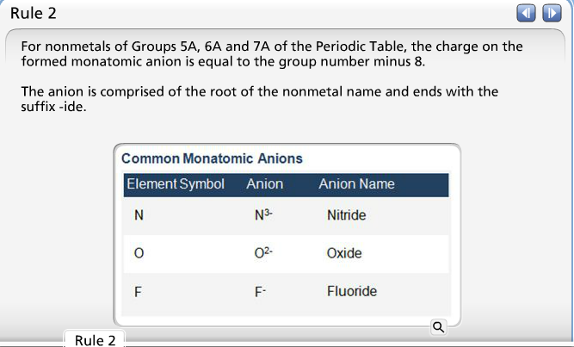

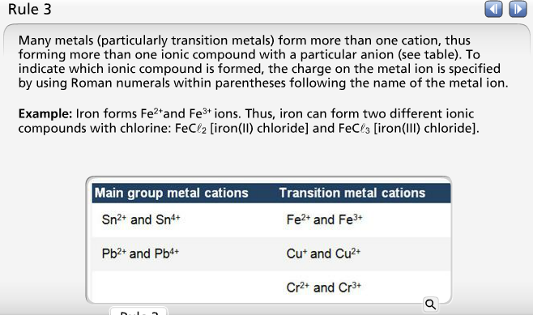

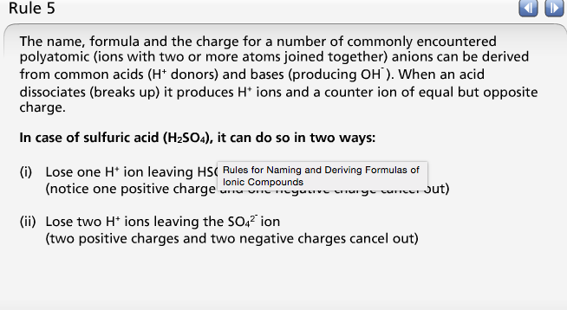
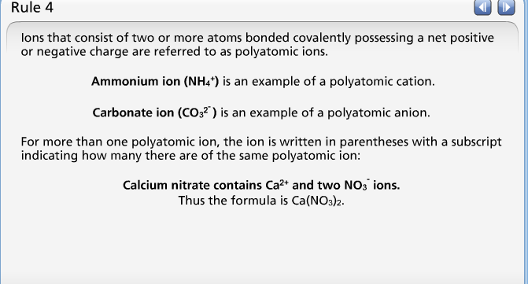

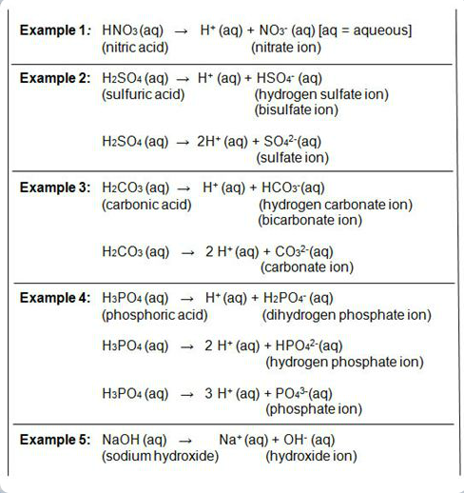

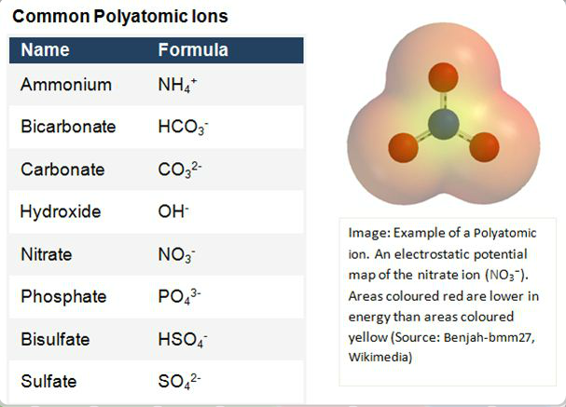

Covalent Compounds

Rules for Naming Covalent Compounds
- Rule #1: Name the first element in the formula first.
- Rule #2: Name the second element as an anion.
- Rule #3: Use prefixes to indicate the number of atoms of each element.
- Rule #4: Do not use the prefix mono- for the first element.

Exceptions
- Water (H₂O) [not dihydrogen monoxide]
- Ammonia (NH₃) [not nitrogen trihydride]
- Hydrogen sulfide (H₂S) [not dihydrogen monosulfide]
- Hydrogen peroxide (H₂O₂) [not dihydrogen dioxide]
- Methane (CH₄) [not carbon tetrahydride]
- Ozone (O₃) [not trioxygen]

a) Carbon tetrachloride
b) O₂F₂

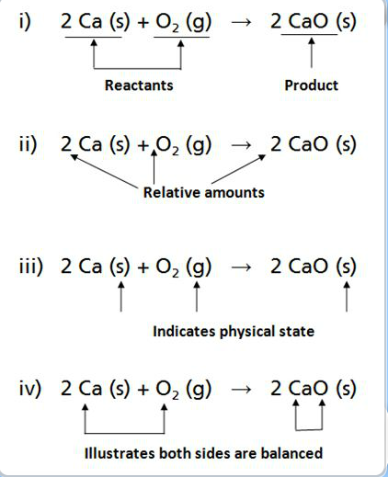
Chemical Reactions
= equation using chemical formulas

(i) reactants and products
(ii) relative amounts of reactants and products
(iii) physical state (l=liquid, g=gas, s=solid, aq=aqueous)
(iv) Law of Conservation of Mass and Matter

Writing
(i) non fractions
(ii) small numbers

coefficient in front (4,3,2) vs. subscripts (1,2,2,3)


