Module 4: Hazards in the Work Environment

Occupational Hazards

Type of hazards
Safety hazards | Health hazards
Based on the nature of the work, safety hazards are due to material handling, machines, energy, work practices, and confined spaces.  - Material handling hazards: These can lead to muscle strains due to lifting and carrying materials. The use of devices such as forklifts, cranes, etc. exposes the worker to accidental contact with the moving equipment.  - Machine hazards: Rotating shafts, moving belts, presses, etc. can cause very serious injuries.  - Energy hazards: All energy sources such as electricity, steam, hydraulic pressure, etc. can lead to serious injury.  - Work practice hazards: Failure to follow safe operating procedures may lead to serious injuries.  - Confined space hazards: In such spaces (for example, silos, storage tanks, pipelines etc.) hazards arise due to difficulty of entry and exit, build-up of hazardous materials and oxygen deficiency. | The extent of occupational health hazards varies with the type of activity. However, such hazards may have the potential to cause severe discomfort, illness, and lack of efficiency among workers. Based on the nature of the causative agent (or factor), occupational health hazards can be classified as physical, chemical, biological and ergonomic.  - Physical hazards are due to the presence of physical agents such as pressure and temperature extremes, excessive noise and vibration, and exposure to radiation.  - Chemical hazards are due to the presence of chemical agents such as dust, fume, gas, mist, smoke and vapor.  - Biological hazards are due to the presence of biological agents such as bacteria, moulds and viruses.  - Ergonomic hazards are due to ergonomic stresses such as fatigue and repetitious work.

Physical and Chemical

It is very important to note that the mere presence of a causative agent does not necessarily constitute a hazard. A causative agent is classified as hazardous in certain circumstances such as high concentration or intensity and a prolonged exposure.

Physical agents: radiation, vibration, heat, noise
Chemical agents: vapor, gas, fume, dust

Hazard assessment

Processes, operations and related activities
- Generally various emissions are evaluated because the emission of any physical, chemical or biological agents has the potential to be a health hazard.
Equipment
- Equipment is generally assessed in terms of mechanical and electrical safety and the potential to create excessive noise and vibration.
Properties of substances used and produced
- These include an evaluation of raw materials and finished products in terms of their physical, chemical and toxic properties and effects.
Control measures
- All engineering controls in place for proper materials handling, storage, etc. are evaluated. Also considered are the ventilation system and the availability of personal protective equipment.

Physical agents

Commonly encountered physical conditions with a potential to cause adverse health effects include:
- pressure and temperature extremes
- excessive noise and vibration
- radiation

The action of physical agents consists of transfer of residual energy through the surrounding air or the equipment the worker is in contact with. Except for radiation, our senses can detect all other physical agents.

Pressure extremes

Hyperbaric: pressure higher than normal, example: diving underwater
Hypobaric: pressure lower than normal example: a mountain

Temperature extremes
Hot or cold depends on various factors
Air  movement | Hot or cold objects  in the vicinity | Relative  humidity

Heat | Cold
Some of the adverse effects in very hot work environments (depending upon the individual worker and the heat intensity) include:  - Heat exhaustion  - Fainting  - Heat stroke  Heat-related problems may arise for:  - Outdoor workers (working in construction)  - Industrial workers (working near furnaces) | In very cold work environments (depending upon the individual worker and intensity of cold), the adverse effects include:  - Frostbite  - Hypothermia  Workers at risk include:  - Outdoor workers (divers)  - Meat packers and handlers (working in refrigerated warehouses)

Excessive Noise
Noise is a form of irregular vibration. It may be conducted through gases (or vapors), liquids, or solids. Above a certain level, the noise becomes of concern because it may hinder communication between workers, thus leading to annoyance. This in turn may lead to poor job performance and compromise the safety of the worker. In addition, excessive exposure to high noise levels may cause loss of hearing.

Excessive Vibration
It is important to note that exposure to vibration is more than just a nuisance. Whereas exposure to vibration may cause discomfort, intense vibration has been known to cause serious health problems such as back pain, carpal tunnel syndrome (a condition affecting the hand and wrist) and damage to bones and joints.

There are two types of occupational vibration: whole-body and hand-arm vibration. Whereas whole-body vibration is transmitted through the supporting surface (feet, back, etc.), hand-arm vibration is transmitted to the hands and arms. Examples include: Mining equipment (whole-body vibration) and Hand-held power tools (hand-arm vibration).

Radiation
The hazard associated with a particular type of radiation depends on its energy and ability to penetrate the body tissue. Thus, even brief exposure to high energy and highly penetrating x-rays can cause severe damage to the tissue. Infrared, ultraviolet and microwaves on the other hand do not penetrate appreciably below the skin and the damage is mainly restricted to burns to the skin and eyes. Severe damage to eyes may result from excessive exposure to ultraviolet radiation.

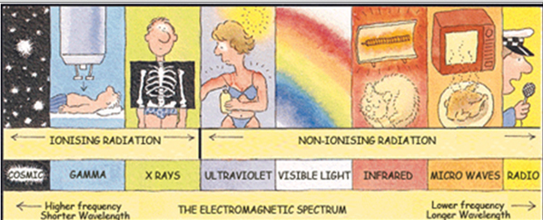

Types of Radiation
Radiation is the energy that travels through space from many different natural and human-made sources. Some different types of radiation include: visible light, ultraviolet rays, microwaves, x-rays and radio waves. Thus, it is easy to see that we are exposed to radiation every day.
Depending on its energy, radiation is of two main kinds:

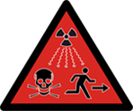 | Ionizing radiation: The energy associated with it is high and thus strong enough to damage cells and DNA. Some examples and sources of ionizing radiation include:  - x-rays (from x-ray machines)  - alpha, beta and gamma rays (from radioactive materials),  - high-energy ultraviolet (from germicidal lamps).
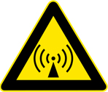 | Non-ionizing radiation: It is not as strong as ionizing radiation. However, prolonged exposure to some types of non-ionizing radiation can still cause harm. Some examples and sources of non-ionizing radiation include:  - visible light, microwaves (from telecommunications and microwave ovens)  - infrared (from infrared heat lamps)  - radio waves (from broadcasting)  - low-energy ultraviolet (tanning lamps)

Some applications of radiation include:
- Industrial: Quality control, non-destructive testing using radiography
- Household: Television, smoke detectors
- Medical: Imaging, treatment
- Science: Material analysis, sterilization

Chemical hazards in workplace

Chemical hazards may arise in operations involving:
- Compressed gases
- Flammable and combustible materials
- Oxidizing materials
- Poisonous & infectious materials
- Corrosive materials
- Dangerously reactive materials

Chemicals agents may be present in the air as:
- Fine particles
- Gases and vapors
- Both as particles and vapors at the same time
- Adsorbed or absorbed gases and/or vapors on particles

Compressed gases : chlorine gas compressed and stored in cylinders under high pressure, worker not only subjected to the chemical hazard but also the hazards associated with pressure extreme

Flammable and combustible materials: burn in the presence of sources ignition : gasoline, solvents

Oxidizing materials: contribute to fire hazards, destroy the biomolecules in living systems : potassium permanganate, hydrogen peroxide

Poisonous materials: dangerous to life: potassium cyanide, mercury salts

Corrosive materials: deterioration of materials including living tissues on contact: sulfuric acid, potassium hydroxide

Dangerously reactive materials: rapid or violent reactions under certain conditions: alkali metals react with water producing highly flammable hydrogen gas

The problem with fine particles: less than five microns most hazardous retention in the lungs: dust, fume, smoke (for solids) and mist (for liquids)
Ex: spray painting (mist), welding (fume), incomplete combustion of oil and grease(smoke), ore grinding (dust)

The problem with gases and vapors: result of various operations and distribute rapidly through the workplace, small size can enter the bloodstream through the lungs
Ex: solvent degreasing (vapors of solvent used), spray painting (vapors of solvent used), welding (gaseous combustion products)

Biological agents

Biological agents are living organisms, or substances produced by such organisms, that can cause illness or disease in humans. The adverse health effects due to biological agents may range from allergic reactions to serious medical conditions and even death. Food poisoning, rabies, tuberculosis and hepatitis are some of the infections caused by biological agents.

These include: bacteria, fungi, viruses and other micro-organisms and their associated toxins

Workplace Exposure
Many micro-organisms pose a potential danger in a variety of workplaces due to their ability to:
- Reproduce rapidly
- Survive with minimum resources
Workplace exposure to work-related biological agents such as bacteria, moulds, and viruses is limited to certain occupations such as health care workers (i.e., hospital workers and veterinarians), meat handlers (i.e., ranchers, farmers, and meat packers), and those who work in sanitation or sewage operations.

Ergonomic stresses

Ergonomics can be defined as the science or study of work. It is a way of designing a work environment to fit people.
Over the recent years it has been fully realized that the traditional method of assigning people to jobs without accommodating their needs, limitations, sizes, strengths and weaknesses may lead to certain adverse job safety and health issues such as mental stress, loss of efficiency and accidents.

It has been established that ergonomics, properly applied, can help:
- reduce workplace injuries and illnesses; particularly back injuries and cumulative trauma disorder (CTD) affecting, joints, muscles, nerves and tendons that can cause pain and swelling
- improve productivity and quality of work
- increase job satisfaction
- satisfy government regulations

Toxicology

Toxicology: Science that involves study of proprieties and interactions of physical, chemical or biological agents.

Toxicity: degree of danger of a material to injure living organism by other than chemical means.

Toxic hazards (toxicity): posed by chemical are influenced by a number of factors such as:
  - physical properties
  - chemical properties
  - intensity of exposures (exposure dose)
  - mode of handling
  - routes to entry
  - susceptibility of the worker

Respiratory, digestive & cutaneous
Interaction of physical, chemical and biological agents produce adverse responses with our bodies. Minor irritation to dreaded diseases like cancer.

Most common entry of chemical agents into body:
  - respiratory tract (by inhalation)
  - digestive tract (by ingestion)
  - Cutaneous – skin and eyes (by absorption)

In occupational settings, inhalation most important route followed by absorption through skin and eyes.

Dose and Exposure

Dose
Dose is defined as the amount of toxicant(s) actually delivered to the target organ. The units used to express dose are mg/kg (mass of toxicant/body mass).

Exposure
Exposure on the other hand is the total amount of the toxicant(s) present in the workplace. However, exposure does provide an indication of the dose. Higher the exposure, greater the probability of larger amounts being delivered to the target organ and hence higher the dose.
The units used to express exposure are:
- mg/m³ and μg/m³ (mass of toxicant/volume of air) for particles
- ppm (parts per million), ppb (parts per billion) and percent (%) for gases and vapors.

Threshold Limit Values
In order to provide guidelines for controlling occupational health hazards, Threshold Limit Values (TLVs) for various physical and chemical agents have been developed by the American Conference of Governmental Industrial Hygienists (ACGIH). According to ACGIH, one of the ways to specify these values is as Threshold Limit Value-Time-Weighted Average (TLV-TWA). It is the time-weighted average concentration of a substance for a normal 8-hour workday and a 40-hour workweek to which nearly all workers may be repeatedly exposed, day after day, without adverse effects.

Therefore, the lower the TLV value, the more potentially dangerous (or high risk) the substance is.

Example: Which of the following statements is true based upon the information that the TLVs for two chemicals X and Y are 15 ppm and 5 ppm respectively?
(a) Y poses less risk than X
(b) Y poses more risk than X
(c) X and Y pose the similar risk
(d) X poses more risk than Y

The effects of toxicants

Classification for the effects of over exposure to toxicants (or
the commonly used term contaminants) can be based upon :
  - Duration of the effect
  - Organs affected and physiological action

Duration of the effect
Classified as acute or chronic

Acute: observed effect of toxin considered acute if appears soon after exposure. Brief exposure to a high concentration of the contaminant. Effect easy to observe and relate

Chronic: observed much later after exposure. Result from low and repeated exposure after a long period of time, more difficult to study and very important to consider when dealing wit hazardous wastes and pollution.

Physiological effects

Toxicant may affect normal functioning of an organ or a set of organs in a system.
Hepatotoxins (carbon tetrachloride) affect liver
Immunotoxins (vinyl chloride) affect immune system.

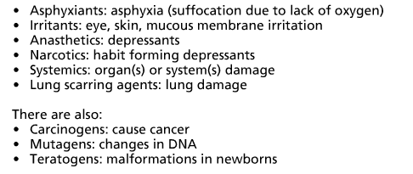
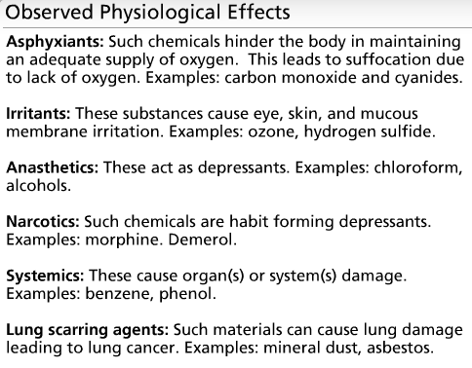
Chemicals:

Carcinogenic effect
Chemicals that cause cancer examples: ethylene dibromide, vinyl chloride
Identified ability to cause cancer in exposed workers, other human populations, or in test animals. Occupational cancers long latency period, cancer may develop 10-20 years after exposure to carcinogenic.

Mutagenic effect
Substances cause changes in DNA examples: benzene, ethylene oxide
From people to test animals, which may result in disease or abnormalities in future generations. In WHMIS, mutagens are classified as VERY TOXIC if shown to affect cells of the reproduction system (sperm and egg cells), but classified as TOXIC if studies show genetic changes in only cells (e.g. skin or lung cells).

Teratogenic effect
Cause malformations in newborns. Examples: organic mercury compounds, anaesthetic gases such as nitrous oxide.
Can cause birth defects, abnormalities, developmental delays, or death in animal offspring in the absence of significant harmful effect on the mother.

W.H.M.I.S Workplace Hazardous Materials Information System

Workplace hazards

The system consists of three key elements:
- cautionary labeling of containers of hazardous materials
- provision of Material Safety Data Sheet (MSDS), which provides more detailed information on the hazardous nature of the material
- provision of worker education program

Hazard Symbols
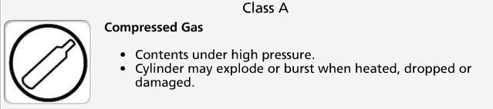





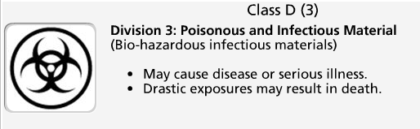
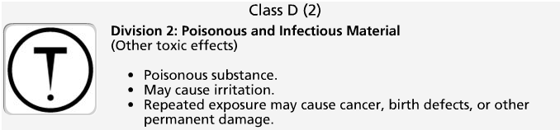


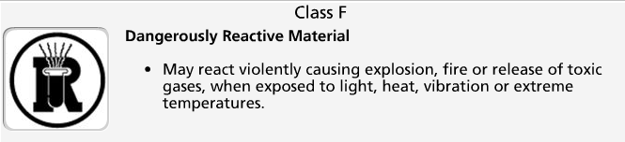
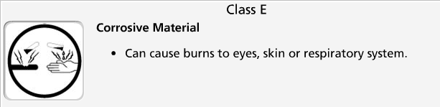

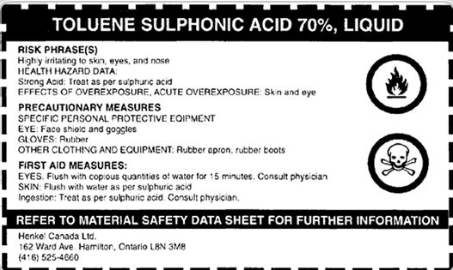

Safety Data Sheet

The Material Safety Data Sheet (MSDS) provides basic information on a chemical product.
It contains information regarding its:
- Properties
- Potential hazards
- Safe use
- Emergency procedures

It is important to note that these are not a complete source of information.
In some cases it might be necessary to consult other relevant sources for further information and details on a given substance.

Implementation

Worker Education
Workers handling hazardous products must be instructed in:
- The information on labels and MSDSs as it applies to their work
- Safe use, handling, storage and disposal of hazardous materials
- Emergency procedures to be used in case of a spill or overexposure

Successful Implementation Requirements
Successful implementation of WHMIS in the workplace requires cooperation of all parties involved. WHMIS sets the responsibilities of the parties involved:

- Suppliers: provide hazard information through labels and MSDS on all controlled products/containers of controlled products.
- Employers (Supervisors): ensure WHMIS labels, identifiers and MSDSs for all containers of controlled products. Employers also ensure availability and accessibility of MSDS information to employees and provide effective worker training to ensure understanding among employees of the labels, MSDSs, and precautionary measures for hazardous materials in their workplace.
- Employees: handle controlled products safely and inform supervisors of damaged/missing labels and missing MSDS information.
- Regulators: develop and administer WHMIS legislation.

GHS

The Globally Harmonized System (GHS) for Hazard Classification and Labelling
Systems similar to WHMIS (for hazard communication) exist in other countries.
In 1992, the United Nations Conference on Environment and Development (UNCED) agreed to develop a Globally Harmonized System (GHS) for hazard classification and labelling. It is anticipated that such a system will facilitate safe use of chemicals and reduce trade barriers.

Some of the anticipated changes are:
- Inclusion of consumer, transport and workplace sectors rather than workplace only.
- Inclusion of all chemicals except pharmaceutical and cosmetic products intended for consumer use.
- Hazard classification format in the MSDSs.
- Hazard communication format in the labels.

