ADM 1100- Final Notes

Management, Leadership and the Internal Organization

What is management?
- The process of achieving organizational goals through people and other resources
Top management- chief executive officer, chief financial officer, premier, mayor
- Develop long-range strategic plans for the organization
- Inspire executives and employees to achieve their vision for the company’s future
Middle management- regional manager, division head, director, dean
- Focus on specific operations, products or customer groups within an organization
- Responsible for developing detailed plans and procedures to implement the firm’s strategic plans
Supervisory (first-line) management- supervisor, department chairperson, program manager
- Implement the plans developed by middle managers
- Responsible for non-manager employees
- Motivate workers to accomplish daily, weekly, and monthly goals

What does management require?
- Skills
  - Technical skills- ability to understand and use the techniques, knowledge tools, and equipment of a specific department or area of study
  - Human skills- interpersonal skills that enable a manager to work effectively with and through people
  - Conceptual skills-ability to see the organization as unified whole and to understand how each part of the overall organization interacts with other parts
- The top level managers need conceptual skills the middle level managers need human skills and the lower level managers need technical skills
- Functional capabilities
  - Planning: looking forward to future events and conditions and deciding on the courses of action for achieving organizational goals
  - Organizing: blending human and material resources through a formal structure of tasks and authority
  - Directing: guiding and motivating employees to accomplish organizational goals
  - Controlling: The function of assessing an organization’s performance against its goals:
    - 1. Setting performance standards
    - 2. Monitor actual performance
    - 3. Compare actual performance with the standards
    - 4. Making corrections is needed
- The results of a successful functional process lead to achieving the organization’s states purpose

Remuneration Rankings
- Money paid for work or service
- Average salary for a CEO is just under $20 million
- Reputation is not correlated with pay or CEO rank
- Pay is not statistically correlated with rank

Managers as Decision Makers
- Decision making is the process of seeing a problem or opportunity, assessing possible solutions, selecting and carrying out the best suited plan and assessing the results
- A programmed decision involves simple, common and frequently occurring problems that already have solutions
- A nonprogrammed decision involves a complex and unique problem or opportunity with important results for the organization

Decision Making Process

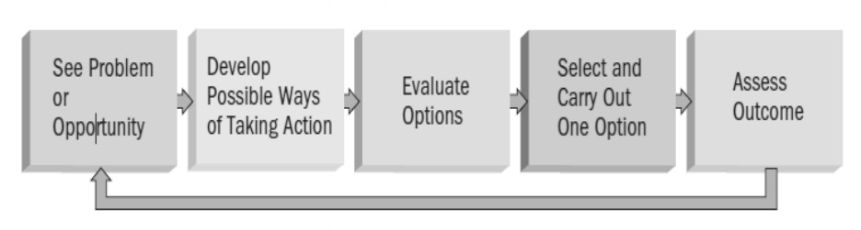

Setting a Vision and Ethical Standards for the Firm

- Vision: the ability to perceive marketplace needs and what an organization must do to satisfy them
  - Must be focused yet adaptable to changes in the business environment
- Long term success is also tied to the ethical standards that the top management team sets
  - High ethical standard can also encourage, motivate, and inspire employees to achieve goals

There are different types and levels of plans
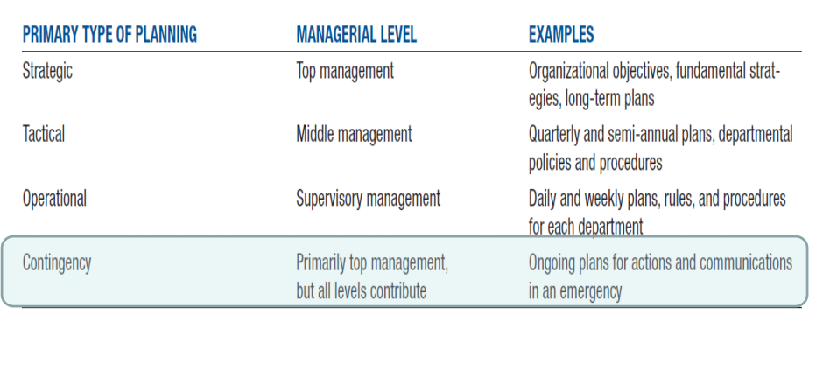
- Firms that spend more effort on effective planning get better results

Planning Process
- Organizations should have a comprehensive planning framework
  - each step should fir into the overall plan
  - broad/long-range mission statement; objectives and goals
  - narrow/short-range: functional plans for specific employees/areas
- Plans outline the steps the company will take to meet goals and objectives

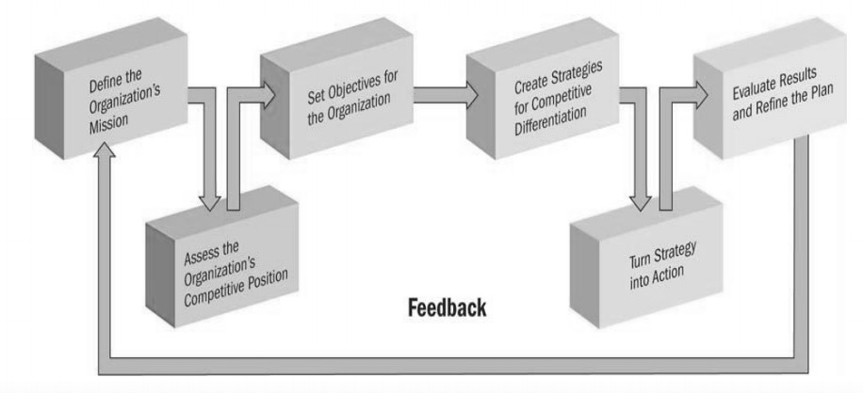
Strategic Planning Process

Elements of SWOT Analysis
- SWOT stands for strengths, weaknesses, opportunities, and threats
  - By assessing all four factors one by one, a firm can then develop the best strategies for gaining a competitive advantage

Developing Organizations
- Organization: a structured group of people working together to achieve common goals
  - Human interaction
  - Goal-directed activities
  - Structure

The Process of Organizing
- Decide on the specific work activities needed to carry out plans and achieve objectives
- Group all work activities into a pattern or structure that makes sense
- Assign activities to specific employees and give them the resources they need
- Coordinate the activities of different groups and individuals
- Evaluate the results of the organizing process (loops back to 1)

Departmentalization (Org Structures)
The process of dividing work activities into units within the organization
- Product departmentalization: organized based on the goods and services a company offers
- Geographical departmentalization: organized by geographical regions within a country or, for a multinational firm, by region throughout the world
- Customer departmentalization: organized by the different types of customers the organization serves
- Functional departmentalization: organized by business functions such as finance, marketing, human resources, and production
- Process departmentalization: organized by work processes necessary to complete production of goods or services

Delegating Work Assignments
- Delegation: the managerial process of assignment work to employees
  - Providing employees with the responsibility and necessary authority for completing tasks
  - Employees have accountability, or responsibility, for their actions and decisions
- Span of management is the number of employees a supervisor manages
- Centralization means that decision-making is retained at the top of the management hierarchy
- Decentralization means that decision making is shifted to the lower levels; many firms believe it enhances their flexibility and responsiveness to customer needs
Types of Organizational Structures
Line organizations
- Oldest and simplest form; direct flow of authority from CEO to employees
- Chain of command indicates who directs which activities and who reports to whom
Line and staff organizations
- Combines line departments and staff departments
- Line departments participate directly in decisions that affect the core operations of the organization
- Staff departments lend specialized technical support

Committee Organizations
- Authority and responsibility are in the hands of a group of individuals
- Often part of a line- and- staff structure
- Often develop new products
- Tend to act slowly and conservatively
- Often make decisions by compromising conflicting interests rather than choosing best alternative

Matrix Organizations
- Project management structure that links employees from different parts of the organization to work together on specific projects
- Employees report to both a line manager and a project manager
Advantages:
- Flexibility in adapting to changes
- Focus on major problems or products
- Outlet for employees’ creativity and initiative
Disadvantages:
- Integrating skills of many specialists into a coordinated team
- Team members’ permanent functional managers must adjust the employees’ regular workloads

Leadership Styles
Autocratic leadership:
- Leader-centered: make decisions on own without consulting employees
- Democratic (participative) leadership: involves employees in decisions, delegate assignment, and ask them for suggestions
- Free-rein leadership: involves minimal supervision; leave most decisions to employees
Transformational Leadership
- Engaging individuals
- Personal qualities and core values
- Engaging the organization
- Moving forward together
Types of Controls
- Leadership and supervision
- Goals/objectives-bonuses/penalties
- Accounting/performance
- Performance feedback
- Employee & customer surveys
- Rules, regulations, & guidelines

Corporate Culture
- An organization’s collection of principles, beliefs, and values
- Managers use symbols, rituals, ceremonies and stories to influence and reinforce corporate culture

Influences on Organizational Culture

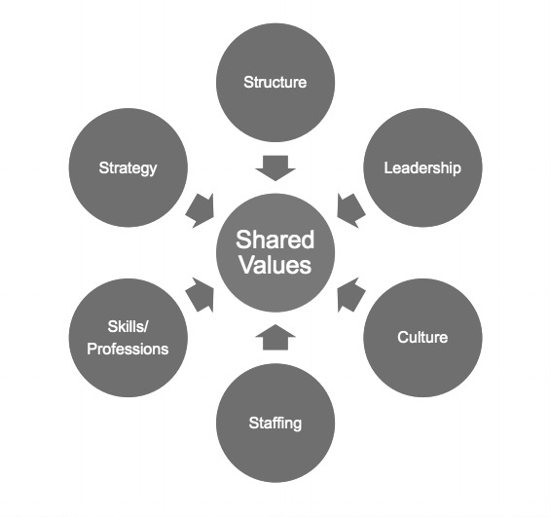

Human Resource Management

- The function of attracting, developing and retaining employees who can perform the activities needed to meet organizational objectives
- Three main objectives
- Providing qualified, well-trained employees for the organization
- Maximizing employee effectiveness in the organization
- Satisfying individual employee needs through monetary compensation, benefits, opportunities to advance and job satisfaction

Ultimate Goals of HR Management
- Locate- make sure you have the people who are best suited to the company and job
- Develop- train and provide employees with the necessary knowledge and assets to do the job effectively and efficiently
- Retain- continually motivate employees to improve the company in any way possible

HR Management Responsibilities
- Employee recruitment and selection
- Planning for staffing needs
- Employee training and performance evaluation
- Employee separation
- Employee compensation and benefits

Recruitment and Selection
- Recruiting techniques continue to evolve as technology advances
- Internet recruiting is quick, efficient and inexpensive
- Must follow legal requirements
- Failure to follow these exposes company to risk of litigation, bad publicity and poor employee morale
- Recruiting and hiring is a costly process for employers
- Some employers require employment tests (e.g., mechanical, computer, language skills)

Tasks of Performance Appraisal
- Define expectations -> measure and evaluate -> provide feedback-> record performance

Orientation, Training and Evaluation
- Newly-hired employees often complete an orientation program
  - Inform employees about company policies
  - Employee manuals
  - Describe benefits/programs
  - Training
- Training programs
  - On-the-job training
  - Classroom and computer-based training
  - Management development

Performance Appraisals
- Evaluation of and feedback on an employee’s job performance
- Effective performance reviews:
  - Take place several times a year
  - Are linked to organizational goals
  - Are based on objective measures
  - Take place in the form of a two way conversation
- Some firms conduct peer reviews

Compensation
- The amount the employees are paid in money and benefits
- Wage: pay based on an hourly rate or the amount of work accomplished
- Salary: pay calculated on a periodic basis, such as weekly or monthly
- Most firms base compensation decisions on five factors:
  - What competing companies are paying
  - Government regulation
  - The cost of living
  - Company profits
  - Employee’s productivity

Four Forms of Incentive Compensation
Profit Sharing- Bonus based on company profits
Gain Sharing- Bonus based on productivity gains, cost savings, or quality improvements
Lump-Sum Bonus- One time case payment or option to buy shares of company stock based on performance
Pay for Knowledge- Salary increase based on learning new job tasks

Employee Benefits
- Additional compensation such as vacation time, retirement savings plans, profit-sharing, health insurance, gym memberships, child and elder care, and tuition reimbursement paid entirely or in part by the company
  - Could reach 30% of total employee compensation
- Some benefits required by law
  - Canadian pension plan
  - Unemployment insurance
  - Workers’ compensation programs

Flexible Benefits
- With flexible benefit plans, employees are provided a range of options to choose from
  - Medical, dental, vision, life and disability insurance
- Many companies also offer flexible time off policies instead of establishing a set number of holidays, vacation days and sick days
  - Employees have freedom to use paid time off (PTO) as they like
  - Is an expensive benefit for employers

Flexible Work
- Allows employees to adjust their working hours and places of work to accommodate their personal needs
- Flextime allows employees to set their own work hours within constraints specified by the firm
- A compressed workweek allows employees to work the regular number of weekly hours in fewer than the typical five days
- A job sharing program allows two or more employees to divide the tasks of one job
- A home-based work program allows employees, or telecommuters, to perform their jobs from home instead of at the workplace
  - More than 70% of the Generation Y professionals are concerned with balancing career and their personal lives

Employee Separation
- Voluntary turnover: Employees may leave firms to start their own businesses, take jobs with other firms, or retire
  - Some firms ask employees who leave voluntarily to participate in exit interviews to find out why they decided to leave
  - Successful companies are clearly focused on retaining their best workers
- Involuntary turnover: Employers may terminate employees because of poor job performance, unethical behavior, or the need for downsizing
  - Employers must carefully document reasons when terminating employees
  - Human resource managers must be educated in employment laws so the termination is handled properly

Downsizing/Outsourcing
Downsizing
- The process of reducing the number of employees within a firm by eliminating jobs
  - Negative effects: anxiety, health problems, and lost productivity among remaining workers
  - Expensive severance packages paid to laid-off workers
  - A domino effect on the local economy
Outsourcing
- Using outside vendors to produce goods or fulfill services and functions that were previously handled in house or in county
- To save expenses and remain flexible, companies will try to outsource functions that are not part of their core business
- Outsourcing might work on paper, the reality might be different

Motivating Employees
- Motivation starts with good employee morale (the mental attitude of employees toward their employer and jobs)
- High employee morale occurs in organizations where workers feel values, heard, and empowered to contribute what they do best
- Poor morale shows up through absenteeism, voluntary turnover, and lack of motivation
- Need produces motivation which leads to goal-directed behavior resulting in need satisfaction

Maslow’s Hierarchy of Needs Theory
- People’s needs depend on what they already posses
- A satisfied need is not a motivator; only needs that remain unsatisfied can influence behavior
- People’s needs are arranged in a hierarchy of importance; once they satisfy one need, at least partially, another emerges and demands satisfaction
- People have five levels of needs that they seek to satisfy:
  - Physiological needs (shelter/salary)
  - Safety needs (financial stability/seniority)
  - Social (Belongingness) needs (friendships/social activities)
  - Esteem needs (status/incentives)
  - Self-actualization needs (creative success/ challenging job)
- Need motivated behavior

Herzberg’s Two Factor Model
- Hygiene factors- result in satisfaction
  - Salary
  - Job security
  - Working conditions
  - Status
  - Interpersonal relations
  - Technical supervision
  - Company policies
- Motivator factors- can produce high levels of motivation if present
  - Job responsibilities
  - Achievement
  - Recognition
  - Growth opportunities

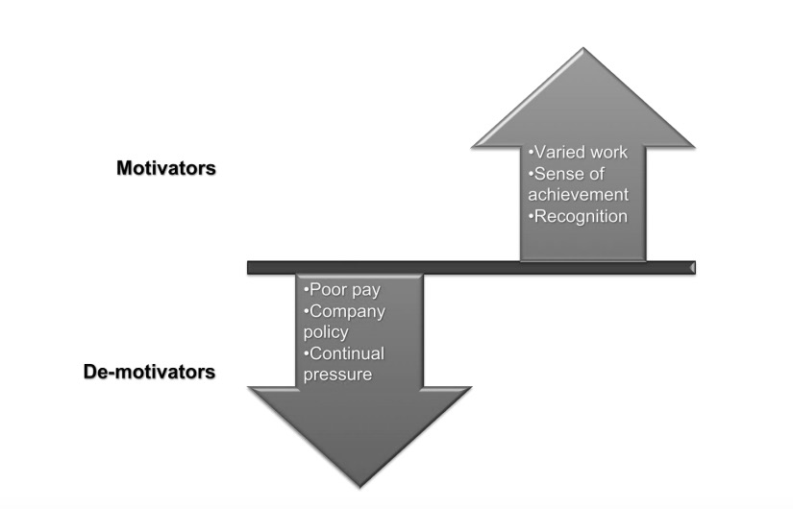
Expectancy Theory
- The process people use to evaluate the likelihood that their effort will lead to the results they want
- Effort performance reward

Equity Theory
- An individual’s perception of fair and equitable treatment
  - Compared to fiends, others in profession, others in company working about as hard, etc

Are My Inputs Giving Me Expected Outputs
- What you put in your job should be equal to what you get from your job
- People become demotivated, reduce input and/or seek change/improvement whenever they feel their inputs are not being fairly rewarded

Goal- Setting Theory
- A goal is a target, objective, or result that someone tries to accomplish
- Goal-setting theory: the idea that people will be motivated to the extent which they accept specific, challenging goals and receive feedback that shows their progress toward goal achievement
- A challenging goal leads to the greatest motivation and performance (vs. too easy or too hard)
- Goals should be specific, measureable assignable, realistic and time based (SMART)

Management by Objectives (MBO)
- A structured approach that helps managers to focus on reachable goals and to achieve the best results based on the organization’s resources
- MBO helps motivate individuals by aligning their objectives with the goals of the organization, increasing overall organization performance
- MBO principles:
  - A series of related organizational goals and objectives
  - Specific objectives for each person
  - Participative objectives for each person
  - Participative decision-making
  - A set time period to accomplish goals
  - Performance evaluation and feedback

Key Elements of MBO
- Goal specificity
- Participative decision making
- Explicit performance period
- Performance feedback

Job Design and Motivation
Job enlargement: expands employees’ responsibilities by increasing the number and variety of tasks assigned to the worker
Job enrichment: expands an employee’s job duties to empower an employee to make decisions and learn new skills leading toward career growth
Job rotation: involves systematically moving employees from one job to another, increasing their range of activities

Managers’ Attitudes and Motivation

- Theory X
- Assumes that employees dislike work and try to avoid it whenever possible, so management must coerce them to do their jobs
  - Money and job security are motivators (Maslow’s lower order of needs)
- Theory Y
- Assumes that the typical person actually likes work and will seek and accept greater responsibility
  - Self-control and self-direction are motivators (Maslow’s higher order of needs)
- Theory Z
- Views worker involvement (i.e., involvement in culture and group) as key to increased productivity for the company and improved quality of work life for employees

Introduction to Marketing

What is Marketing?
- An organizational function and set of processes for creating, communicating, and delivering value to customers and for managing customer relationships in ways that benefit the organization and its stakeholders
Marketing Strategy Process
- Research market segment and choose target market understand targeted customer behavior develop marketing strategy

Market Strategy: Marketing Mix
- A blending of the four elements of marketing strategy to fit satisfy chosen customer segments
Product
- Functionality
- Brand
- Packaging
- Services
Price
- List price
- Discounts
- Bundling
- Credit terms
Promotion
- Advertising
- Sales force
- Publicity
- Sales promotion
Place
- Channel
- Inventory
- Logistics
- Distribution
Customer Utility
- Customers must perceive value in products
- Utility: the power of a good or service to satisfy a want or need
  - Create time utility by making a good or service available when customers want to purchase it
  - Create place utility by making a product available in a location convenient for customers
  - Create ownership utility through an organized transfer of goods and services from the seller to the buyer
Developing a Marketing Strategy
- Study an analyze potential target markets and choose among them
- Create a marketing mix to satisfy the chosen market (product, distribution, promotion and pricing)
Target Marketing Process:
Linking Customer Needs to Marketing Action
- Segmentation
- Identify and describe market segments
- Targeting
- Evaluate segments and decide which to go after
- Positioning
- Design a product or service to meet a segment’s needs and develop a marketing mix that will create a competitive advantage in the minds of the selected target market

Types of Markets
- Consumer (B2C) product: A good or service that is purchased by end users
- Business (B2B) product: A good or service purchased to be used, either directly or indirectly, in the production of other goods for resale

Selecting a Target Market
- Target Market: A group of people that a organization markets its goods, services, or ideas toward, using a strategy deigned to satisfy this group’s specific needs and preferences

Marketing Research
- The process of collecting and evaluating information to support marketing decision-making
- Types of market research include: surveys, focus groups, interviews, libraries, government agencies, trade associations
- Internal data is generated within the organization; includes financial records, inventory levels, sales, profitability
- External date comes from outside sources; includes trade associations, advertising agencies, national marketing research firms
- Secondary data is previously published data
  - Low-cost and easy to obtain
  - Government publications provide data sources
- Primary data is collected through observation, surveys, and other forms of observational study
- Focus groups gather 8 to 12 people in a room or over the Internet to discuss a specific topic
  - Can lead to new ideas, address consumer needs, and point out flaws in existing products
- Business intelligence: a field of research that uses activities and technologies for gathering, storing and analyzing data to make better competitive decisions
- Data mining: the use of computer searches of customer data to detect patterns and relationships
Market Segmentation
- The process of dicing a total market into several relatively similar groups
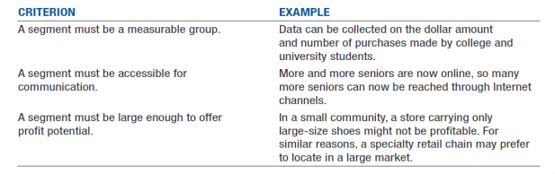
- Key criteria for picking dimensions for segmentation other than usefulness

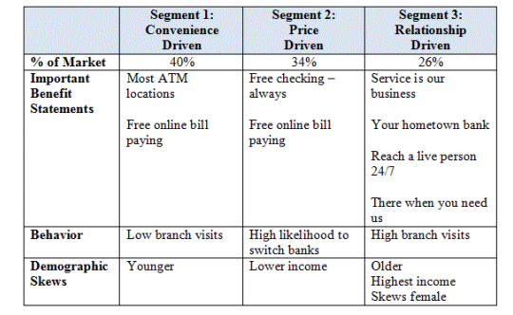

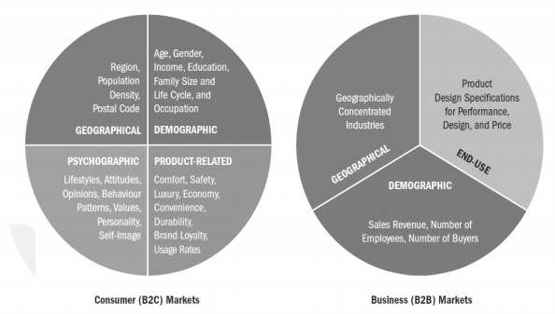
How segmentation works

Segmenting Consumer Markets
- Geographic segmentation: dividing an overall market into similar groups on the bases of their locations
  - Targets geographically concentrated industries
- Demographic segmentation: diving markets on the bases of various demographic or socioeconomic characteristics such as gender, age, income, occupation, household size, stage in family life cycle, education or ethnic group
  - Designs a good or service intended for a specific organizational market (e.g., healthcare institutions)
- Psychographic segmentation: dividing consumer markets into groups with similar attitudes, values and lifestyles
  - AIO (Attitude, interests and opinion) statements are people’s verbal descriptions of various attitudes, interests and opinions
- Product related segmentation: dividing consumer markets into groups that are based on benefits sought by buyers, usage rates and loyalty levels
- End-use segmentation: a marketing strategy that focuses on the precise way B2B purchaser will use a product

Consumer Behavior
- End consumers’ activities that are directly involved in obtaining, consuming and disposing of products, and the decision processes before and after these activities
  - Personal factors: needs and motives, perceptions, attitudes, learned experiences, self concept
  - Interpersonal factors: cultural, social, and family influences
  - External factors: economic events
- Business buying behavior often includes a variety of influences from multiple decision makers within the organization

Steps in the Consumer Behavior Process
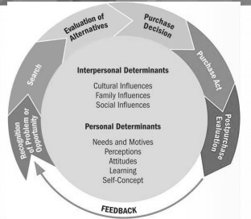

Product Strategy
- Product: a bundle of physical, service and symbolic characteristics designed to satisfy consumer wants
Types of Products
Consumer Products (B2C)
- Shopping Product (couch, microwave, fridge, t.v.)
Market Strategy Factor | Product Characteristics
Purchase frequency | Relatively infrequent
Store image | Very important
Price | Relatively high
Promotion | By manufacturer and retailers
Distribution Channel | Relatively few wholesalers and retailers
Number of outlets | Few

- Convenience product (e.g., toothpaste, milk, soda, toilet paper)
Market Strategy Factor | Product Characteristics
Purchase frequency | Frequent
Store image | Unimportant
Price | Low
Promotion | By manufacturer
Distribution Channel | Many wholesalers & retailers
Number of outlets | Many

- Specialty product (benz, hermes scarf, rolex watch)
Market Strategy Factor | Product Characteristics
Purchase frequency | Infrequent
Store image | Important
Price | High
Promotion | By manufacturer and retailers
Distribution Channel | Many wholesalers and retailers
Number of outlets | Very small number, often 1/area

Industrial Products (B2B)
- Capital product
- Expense product
- Inventory product

Classifying Business Goods

Capital Goods | Expense Good | Inventory Good
- Installations are major capital items such as new factories, heavy equipment and machinery, and custom made equipment  - Accessory equipment includes less expensive and shorter-lived capital items than installations, and involves fewer decision makers | - Supplies are expense items used in a firm’s daily operations that do not become part of the final product | - Component parts and materials become part of the final product  - Raw materials are farm and natural products used in producing other final products

Product Lines Product Mix
- Product line: a group of related products that share by physical similarities or are targeted toward a similar market (e.g., different types of advil)
- Product mix: the assortment of product lines and individual goods and services that a firm offers to consumers and business users

Product Life Cycle
- The four basic stages in the development of a successful product
Introduction
- The firm promotes demand for its new offering, informs the market about it, gives free samples to entice consumers to make a trial purchase and explains its features uses and benefits
Growth
- Sales climb quickly as new customers join early users who are repurchasing the item
- The company begins to earn profits on the new product
Maturity
- Industry sales eventually reach a saturation level at which further expansion is difficult
Decline
- Sales fall and profits decline

Product Identification
Brand: A name, term, sign, symbol, design or some combination that identifies the products of one firm and shows how they differ from competitors’ offerings
Brand name: The part of the brand that is made up of words or letters that form a name
Trademark: a brand that has been given legal protection

Brand Categories
- A manufacturer’s (or national) brand is offered and promoted by a manufacturer
  - Tide, cheerios, windex, fossil, nike
- A private or store brand is not linked to the manufacturer but instead carriers a wholesaler’s or retailer’s label
  - Loblaw’s, president’s choice foods, sears
- A family branding strategy uses a single brand name for several related products
  - KitchenAid, Johnson & Johnson
- An individual branding strategy gives each product within a line a different name
  - Procter $ Gamble products, Tide

Brand Loyalty
- In brand recognition, the consumer is aware of the brand but does not have a preference for it over the other brands
- In brand preference, the consumer chooses one firm’s brand over a competitor’s
- In brand insistence, the consumer will seek out a preferred brand and accept no substitute for it (the ultimate degree of brand loyalty)

Brand Equity
- The added value that a respected and successful name gives to a product

Packages and Labels
- Packaging affects the durability, image and convenience of an item and is responsible for one of the biggest costs in many consumer products
- Packing is important in product identification and play is an important role in a firm’s overall product strategy

Distribution Strategy (Place)
- Distribution channel: The path that products and their legal ownership follow from producer to consumers or business users
- Physical distribution: The actual movement of products from producer to consumers or business users

Direct distribution
- Direct contact between producer and customer
- Most common in B2B markets
- Often found in the marketing of relatively expensive, complex products that may require demonstrations
- Internet is helping companies distribute directly to consumer market

Distribution channels using marketing intermediaries
- Producers distribute products through wholesalers and retailers
- Inexpensive products sold to thousands of consumers in widely scattered locations
- Lower costs of goods to consumers by creating market utility

Wholesaling
- Wholesaler: a distribution channel member that sells primarily to retailers, other wholesalers, or business users
- Manufacturer-owned wholesaling intermediaries
  - Owned by the manufacturer of the goods or products to control distribution or customer service
  - Sales branch stocks products and fills orders from inventories
  - Sales office takes orders but does not stock the product

Retailing
- Retailers: distribution channel members that sells goods and services to individuals for their own use not for resale
- Final like of the distribution channel; deal directly with customers
- Two types: store and nonstore

Non-store Retailing
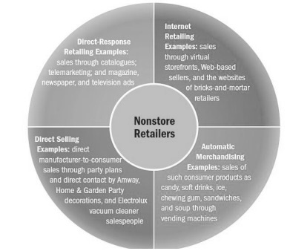

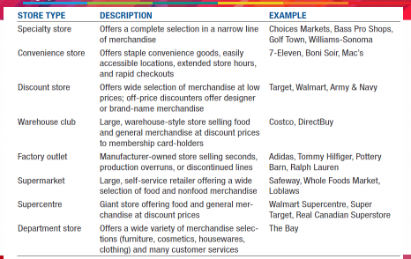
Types of Retail Stores

How Retailers Compete
- Identifying a target market
- Selecting a product strategy
- Selecting a customer service strategy
- Selecting a pricing strategy
- Choosing a location
- Building a promotional strategy
- Creating a store atmosphere

Distribution Channel Decisions and Logistics
Selecting distribution channels
- Complex, expensive, custom-made, or perishable products move through shorter distribution channels involving few or no intermediaries
- Standardized products or items with low unit values usually pass through relatively long distribution channels
- Start-up companies often use direct channels because they cant persuade intermediaries to carry their products, or because they want to extend their sales reach

Selecting Distribution Intensity
- Intensive distribution: involves a firm’s products in nearly every available outlet, and requires the cooperation of many intermediaries
- In selective distribution, the manufacturer selects a limited number of retailers to distribute its product lines
- Exclusive distribution limits market coverage in a specific geographical region that will enhance a product’s image

Logistics and Physical Distribution
- Supply chain: the complete sequence of suppliers that help to create a good or service and deliver it to business users and final consumers
- Logistics: the process of coordinating the flow of foods, services, and information among members of the supply chain
- In physical distribution, activities are aimed at efficiently moving finished goods from the production line to the consumer or business buyer
  - Marketer customers

Customer Service
- Customer service standards measure the quality of service a firm provides for tis customers
- Warranties are a firm’s promises to repair a defective product, refund money paid, or replace a product if it proves unsatisfactory
- Internet retailers have worked to humanize their customer interactions and deal with complaints more effectively

Promotion and Pricing Strategies

Marketing Mix- Promotion and Practice
- Products and distribution area about providing an appropriate product to the right place
- Promotion and pricing are about attracting and sustaining customers
Promotion:
- The function of informing, persuading and influencing a purchase decision

Objectives of Promotional Strategies
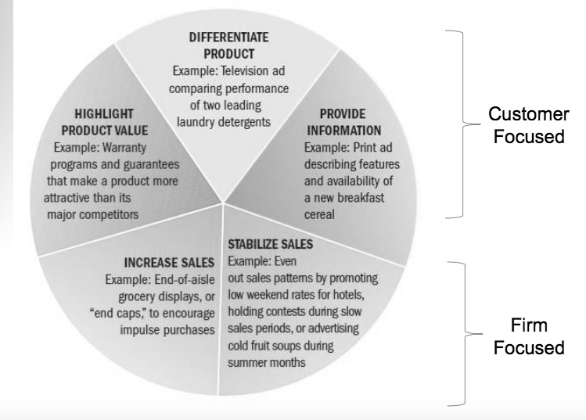

The Promotional Mix
- The combination of personal and non-personal selling that marketers use to meet the needs of a firm’s target customers and to effectively and efficiently communicate its message to them
Personal Selling
- The most basic form of promotion: a direct person-to-person promotional presentation to a potential buyer
- Firms focus on personal selling under four conditions:
  - Few geographically concentrated customers
  - Product is technically complex, involves trade-ins, or requires special handling
  - Product carries a relatively high price
  - Product moves through direct distribution channels
Non-personal selling
- Forms of selling such as advertising, sales promotion, direct marketing, and public relations

Push vs Pull Market Strategies
Pushing Strategy
- Promotion of a product to wholesalers and retailers in a company’s distribution channels
  - Companies promote the product to members of the marketing channel, not the end users
Pulling Strategy
- Promotion of a product by generating consumer demand for it, mainly through advertising and sales promotion appeals
  - Potential buyers will request the retailers or local distributors carry the product, thereby pulling it through the distribution channel
- Most marketing promotional strategies require combinations of push and pull strategies

Cooperative advertising
- Allowances that marketers provide to share with channel partners the cost of local advertising of their firm’s product or product line

Comparing the Elements of the Promotional Mix

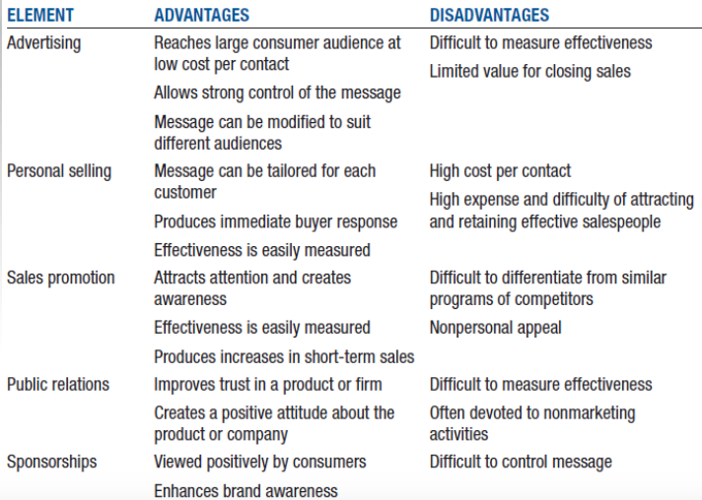

Types of Advertising
Product advertising
- Messages designed to sell a particular good or service
Institutional advertising
- Messages that promote concepts, ideas, or philosophies
- It can also promote goodwill toward industries, companies, organizations, or government entities
  - Government advertising economic plan
Cause advertising
- A form of institutional advertising that promotes a specific viewpoint on a public issue as a way to influence public opinion and the political process (e.g., cancer research)

Types of Advertising & the Product Life Cycle
Informative advertising
- Is used to build initial demand for a product in its introductory phase
Persuasive advertising
- Attempts to improve the competitive status of a product, institution, or concept, usually in its growth and maturity stages
Comparative advertising
- Compares products directly with their competitors, either by name or by inference
Reminder-oriented advertising
- Maintains awareness of the importance and usefulness of a product in its late maturity or decline stages

Forms of Advertising Media
Television
- Easiest way to reach a large number of consumers
- Leading, but most expensive advertising medium
Newspapers
- Dominate local advertising
- Relatively short life span
Radio
- Commuters in cars are a captive audience
- Internet radio offers new opportunities
Magazines
- Consumer publications and trade journals
- Can customize message for different areas of the country
Direct mail
- Average North American receives 550 pieces annually
- High per person cost, but can be carefully targeted and highly effective
Outdoor Advertising
- Billions spent annually in North America
- Requires brief messages
Outline and interactive advertising
- Widgets or gadgets are small television screen images carrying marketing messages; contain embedded links to home sites
- Viral advertising creates a message that is novel or entertaining enough for consumers to forward it to others
Sponsorship
- Providing funds for a sporting or cultural event in exchange for a direct association with the event
  - Exposure to target audience
  - Association with image of the event

Sales Promotion
- Forms of promotion such as coupons, product samples, and rebates that support advertising and personal selling
Consumer-Oriented Promotions
- Premiums, coupons, rebates, samples
- Games, contests, sweepstakes
- Specialty advertising
  - Promotional items that prominently display a firm’s name, logo, or business slogan
Trade- Oriented Promotions
- Sales promotion geared to marketing intermediaries, not to final consumers
- Encourage retailers
  - To stock new products
  - To continue carrying existing ones
  - To promote both new and existing products effectively to consumers
- Point-of-purchase (POP) advertising
- Trade shows

Product Placement Promotion
- A form of promotion where marketers pay placement fees to have their products featured in various media, from newspapers and magazines to television and movies
Guerilla marketing:
- Innovative, low cost marketing efforts designs to get consumers’ attention in unusual ways
Sales Tasks
Order processing
- A form of selling sued mostly at the wholesale and retail levels; involves identifying customer needs, pointing out products that meet those needs and completing orders
Creative selling
- A persuasive type of promotional presentation
  - Promotes a good or service whose benefits are not readily apparent or whose purchase decision requires a close analysis of alternatives
Telemarketing
- Personal selling by telephone, which provides a firm’s marketers with a high return on their expenditures, an immediate response and an opportunity for personalized two-way conversation
Missionary selling:
- An indirect form of selling in which the representative promotes goodwill for a company or provides technical or operational assistance to the customer
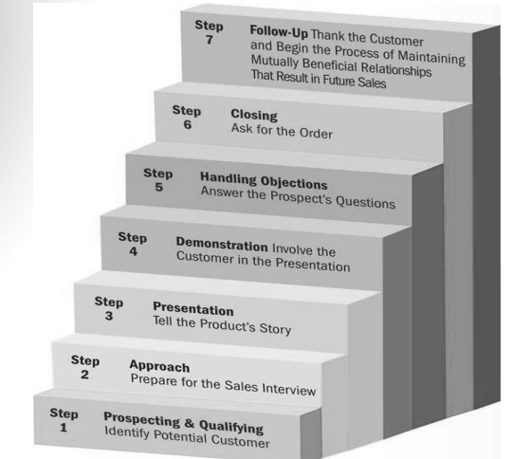
The Sales Process

Pricing objectives in the marketing mix
- Profitability
- Prestige
  - Establishing a relatively high price to develop and maintain an image of quality and exclusiveness
  - Recognition of the role of price in communicating an overall image for the firm and its products
  - Products that are limited in distribution or so popular that they become scarce generate their own prestige
- Meeting competition
- Volume
Price-quality relationships
- Consumers’ perceptions of quality closely tied to price
- High price = prestige and higher quality
- Low price = less prestige and lower quality
Odd pricing
- A pricing method that uses uneven amounts to make prices appear to be less than they really are ($1.99)
Alternative Pricing Strategies
Skimming pricing
- A strategy that sets an intentionally high price relative to the prices of competing products
Penetration pricing
- A strategy that sets a low price as a major marketing tactic
Everyday low pricing
- A strategy of maintaining continuous low prices instead of using short term price cutting tactics such as cents off, coupons, rebates and special sales (discount pricing)
Competitive pricing
- A strategy that tries to reduce the emphasis on price completion by matching other firm’s prices and by focusing on their own marketing effort on the product, distribution and promotional elements of the marketing mix
Cost-based pricing
- Calculating total costs per unit and then adding markups to cover overhead costs and generate profits
Types of Costs
Fixed Costs
- Expenses that do not change as a function of the activity of a business, within the relevant period (e.g., annual fixed costs)
Variable Costs
- Vary depending on a company’s production volume (e.g., cost per unit of product produced)
Contribution (Margin)
- Is the selling price per unit minus the variable cost per unit
- It is the contribution per unit to paying of the fixed costs
Contribution (margin) = Price – Variable Cost (all in per unit)
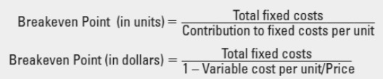
Breakeven analysis: The pricing related technique used to calculate the minimum sales volume a product must generate at a certain price level to cover all costs

When revenue = total cost

Markup
- How much channel intermediaries increase the price of the product from the cost they bought it at
Retail Markup
- The percentage the price is increased from the cost of the product to the retailer to its selling price
Wholesale Markup
- The percentage the price is increased from the cost of the product to the wholesaler to its selling price

Understanding and Analyzing Financial Statements
Users of Accounting Information
Accounting
- The process of measuring, interpreting and communicating financial information to support internal and external business decision making
Business Activities Involving Accounting
- Financing activities provide necessary funds to start a business and expand it after it begins operating
- Investing activities provide valuable assets required to run a business
- Operating activities focus on selling goods and services, but they also consider expenses as important elements of sound financial management
The Foundation of the Accounting System
- Generally accepted accounting principles (GAAP): Principles that outline the conventions, rules, and procedures for deciding on the acceptable accounting practices at a particular time
- Accounting Standards Board (AcSB): The organization that interprets and modifies GAAP in Canada for private and not-for-profit businesses
- Canadian public companies are required to use International Financial Reporting Standards (IFRS). These standards allow for financial statements to be more easily compared from country to country
- Senior executives must personally certify that the financial information reported by the company is correct.
- Corruption of Foreign Public Officials Act: A federal law that prohibits Canadian citizens and companies from bribing foreign officials to win or continue business (in US Sarbanes-Oxley Act)

The Accounting Cycle
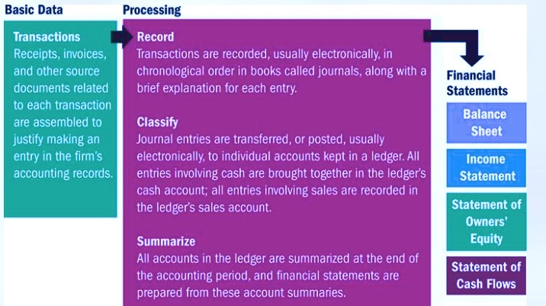
- The set of activities involved in converting information and individual transactions into financial statements

Financial Statements
- Balance sheet statement (end of year) income statement (year) statement of change in ownership equity (year) Cash flow statement(year)

Balance Sheet
- Statement of a firm’s financial position at a specific point in time
  - What the firm owns vs. what is owes at a specific point in time
Balance Sheet Components
- Liability: a claim against a firm’s assets (what the firm owes others apart from owners)
- Asset: anything with future value (or benefit) owned or controlled by a firm (i.e., what the firm owns)
- Owner’s equity: the funds that owners invest in the business plus accumulated profits
Assets
- Current assets- cash of tangible liquid assets that can be easily converted into cash and are expected to be used with in the next year (cash, supplies, inventory, etc.)
- Fixed assets- tangible assets that are expected to last one year or more (plant, equipment, land, etc.)
- Intangible assets- intangible assets that are expected to last one year or more (e.g., patents, copyrights, trademarks, etc.)

Types of Liabilities
Current Liabilities
- Liabilities expected to be paid off within one year (e.g., wages bank line of credit, bills that have money still owning, etc.)
Long-term Liabilities
- Liabilities expected to not be paid off within the next year (e.g., bank loans, mortgages, etc.)

Balance Sheet: Two Key Notions

Accounting equation:
Assets = Liabilities + Owners’ equity

- Balanced Accounts and Double entry bookkeeping
  - The process used to record accounting transitions; each individual transaction is always balanced by another transaction

The Income Statement
- A financial record of a company’s revenues, expenses, and profits over a specific period of time
- Reports profit or loss
- Focus on revenues and costs associated with revenues
Statement of Changes in Equity
- A record of the change in equity from the end of one fiscal period to the end of the next fiscal period
- Begins with the amount of equity shown on the balance sheet
- Net income is added, and cash dividends paid to owners are subtracted

Statement of Cash Flows
- A record of the sources and uses of cash during a period of time
- Accrual accounting: an accounting method that records revenue and expenses when they occur, not when cash actually changes hands

Financial Analysis
Categories of Basic Financial Analysis
- Ratio Analysis- assess and interpret the relationships among the financial results of a firm
- Trend- look at a firm’s financial trends over a period of time to see whether they are improving or declining
- Comparative Analysis- compare financial metrics and ratios to firm’s the same industry or situation

Financial Ratio Analysis
- Examines the relationships between critical components of information found on the financial statements
- Produces a standardized metric
- Ratio analysis is a tool for measuring a firm’s liquidity, profitability and reliance on debt financing, and how effectively management uses the firm’s resources

Liquidity Ratios
- Measure a firm’s ability to meet its short-term obligations
- Current ratio compares current assets to current liabilities
- How much the firm owns in cash-like assets vs. how much it owes over the next year
Current Ratio
- Identified how much current activities are available to payoff current liabilities
- A ratio under 1 suggests that the firm would not be able to pay its short-term obligations
Current Ratio =$\frac{current assets}{current liabilities}$
- Acid-test (or quick) ratio measures the ability of a firm to meet short-term financial commitments
- Generally should be higher than 1.1
Acid- test ratio = $\frac{current assets-inventory}{current liabilities}$

Efficiency Ratios
- Measure how effectively management used the firm’s resources
- Inventory turnover ratio- indicates the number of times merchandise moves through a business
Inventory turnover = $\frac{cost of goods sold}{average inventory }$
- Total asset turnover ratio: indicates how much in sales each dollar invested in assets generates
Total asset turnover = $\frac{sales}{average total assets}$
- Receivables turnover ratio: indicated the number of times receivables turnover in a year
Receivables turnover= $\frac{sales}{accounts receivable}$

Profitability ratios
- Measure the organization’s overall financial performance by evaluating its ability to generate performance by evaluating its ability to generate revenues in excess of operating costs and other expenses
- Examines the profitability of the firm

Net Profit Margin
- Identifies the profit produced by one dollar in sales revenues
Net Profit Margin = $\frac{net income}{sales}$

Return on Equity
- Identifies the profit produced by every dollar invested by owners in the firm
Return on Equity =$\frac{net income}{average equity}$

Gross Profit Margin
- Identifies the gross profit produced by every dollar of sales
Gross profit margin = $\frac{gross profit}{sales}$
- Gross profit tends to vary in proportion to production and sales
- Therefore, it is a critical number for calculating breakeven analysis

Leverage Ratios
- Measure how much a firm relies on debt financing
Debt Ratio
- Examines the ratio of assets that back up the debt
- If it is greater than 50% this indicated that a firm is relying more on borrowed money than owners’ equity
Debt ratio = $\frac{total liabilities}{total assets}$
Long-Term Debt to Equity
- Examine firm’s ability to cover long-term debt

Long-term debt to equity = $\frac{long-term debt}{owners^{'}equity}$
- Capital intensive industries: ratio about 2
- Personal computer companies: ratio under 0.5

Relationship Between Profits & Financial Statements
- Income statement (profits) statement of change in equity balance sheet (owners equity)

Activity Ratios
- Examines how efficient the firm is at operating
Inventory Turnover
- How many times inventory is sold or turned over in a year
- Faster inventory turnover is efficient because it lowers the possibility of inventory deterioration or out of style. It also lowers inventorying costs
Inventory turnover = $\frac{cost of goods sold}{inventory}$
Total Asset Turnover
- Indicated how efficient a firm is at deploying its resources
- Fewer assets required to make a sale the more efficient operation
Total Asset Turnover= $\frac{sales}{average total assets}$

Trend Financial Analysis
- How are the metrics trending with time
Comparative Financial Analysis
- Compare financial metrics, values, and ratios to other firms (usually in the same industry)

