Chapter 1: Information Systems and You

A system is a group of components that interact to achieve some purpose (function)
An information system (IS) is a group of components that interact to produce (and consume) information.

** Five fundamental components of computer-based information systems are:
  - Computer hardware
  - Software
  - Data: No value by it self, when information is brought together = value
  - Procedures
  - People

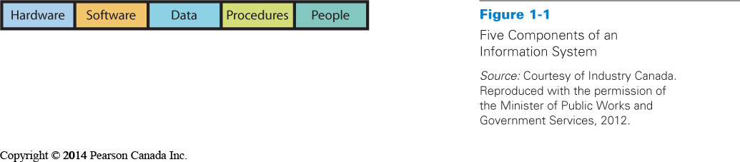
Management Information Systems (MIS)
- MIS, comprise the development and use of information systems that help organizations achieve their goals and objectives
- Key elements:
  - Development and use
  - Information systems
  - Goals and objectives

Take an active role in order to ensure that system will meet your needs
Understand how they are constructed
Consider the user’s needs during development
Learn how to employ the system
Take into account other important functions
    - Security
    - Backup
    - Recovery

MIS aids businesses in achieving objectives
  - Organizations themselves don’t do anything
  - People within an organization or business who: sell, buy, design, produce, finance, market, account, and manage
  - We need organization
    - Division of labor
    - Collaboration and coordination

- MIS empowers users to reach goals
  - Exist to assist business people
  - Need to be developed for right reason

Social Media: Changing the Relationship between Customers and Business
- Social media connect people, and when people get connected they talk, share, and let friends know what they think about the world
- When instant messaging (IM), web logs (blogs), wikis, video logs, podcasts, and social networking (SN) sites first became popular, many business organizations responded by simply passing them by

Information system (IS) is a system of hardware, software, data, procedures, and people that produces information

Information technology (IT) represents raw technology components of IS
  - Hardware
  - Software
  - Data components
IT refers to:
  - Methods
  - Inventions
  - Standards
  - Products

IT alone will not help an organization achieve goals
IT must be embedded into an IS to help accomplish objectives
- Technology must be combined with people and procedure components
- IS will make IT useful

Real difference between IS and IT
- IS includes people in the equation
- Including people in the system impacts how you design, implement and use systems
- Successful business people take advantage of crucial differences IT and IS to improve their systems.

Importance of IS to our economy
- The Information and Communications Technology (ICT) sector includes companies involved in:
  - software and computer services
  - cable and other program distributors
  - telecommunications services
  - ICT manufacturing
  - ICT wholesaling

** Gaining a Competitive Advantages
- Think about IT and IS when you consider the problems and opportunities that confront your department or organization
- To remain productive, there is need for innovation
- You need not be a developer of technology
- Think creatively about problems, challenges, and opportunities in your business/organization. New interesting ways to do things better than our competitors.
- Apply new technology and a knowledge of IS to your business needs

