Wednesday, January 13th

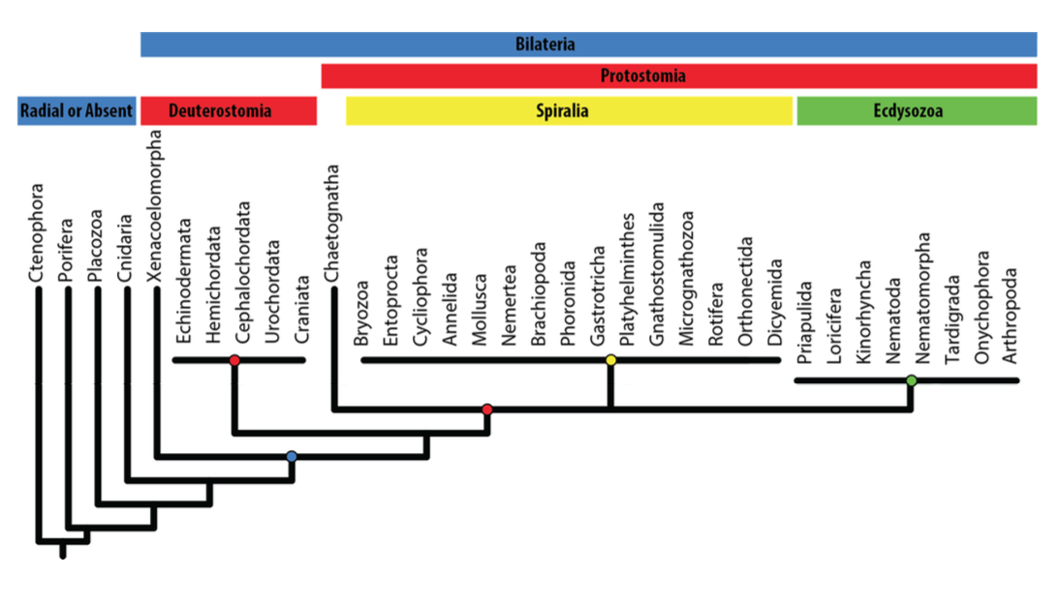

Deuterostomes= us

**Know highlighted categories

Evolution by Natural Selection 5 conditions:
- Variation within populations
- Variation is heritable
- Overproduction of offspring
- Differential survival and reproduction determined by the environment
- Result is a change in gene frequencies that correlates with a change in morphology, behavior, physiology, etc.

Example) Peppered moth
- Manchester, fueled by coal, grew 10x between 1770 and 1850 causing an enormous landscape transformation– dark Satanic mills – number of trees decreased and colour of trees changed (coated in soot)
- Moth came in two different varieties
- Typica – more common because better camouflage
- Carbonaria – darker
- During 100 years carbonaria became more common because could hide better in soot covered trees
- Since coal factories are decreasing, typica is becoming more common again
Tested against evolution by natural selection:
- Variation within populations: typica and carbonaria
- Variation is heritable: gene variant is responsible for the melanism
- Overproduction of offspring: 350 eggs/female
- Differential survival and reproduction: strong differential bird predation against typica in 19th and early 20th centuries
- Results in change in gene frequencies (morphology, behavior, physiology)

Coelenterata:
- Speculation that an intermediate form/ character exists providing a phylogenetic link between the Cnidaria and the Ctenophora
- Recently proven to be convergent evolution (broke up basal group)
Linnaean categories (taxonomy) | Phylogenetic systematics (cladistics)
- Groupings based on similarities and differences | - Groupings based on order of dichotomous branching’s
- Nested hierarchies | - Only monophyletic groups recognized
- Typically morphology- based | - Includes molecular data
- Linnaean levels emphasized (domain, kingdom, phylum, class, order, family, genus, species) | - Linnaean levels are de-emphasized

Cladistic Analysis:
- Degree of relatedness based on number of shared derived characters
- Shared ancestral characters are not considered
- Multiply trees – Principle of Parsimony – the tree that makes the fewest number of assumptions about homoplasy or character reversal is accepted
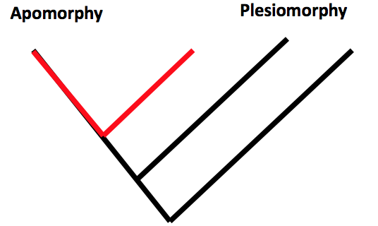
Apomorphy: a derived character
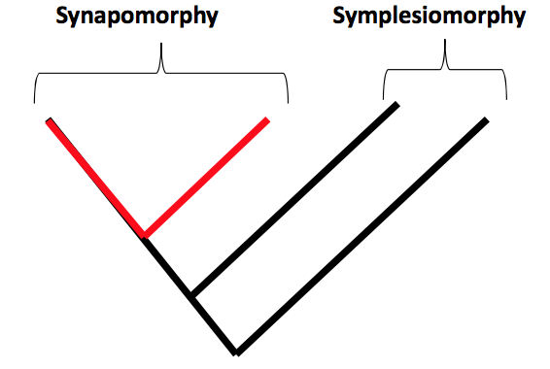
Plesiomorphy: a shared character

Synapomorphy: a shared derived character

Symplesiomorphy: a shared ancestral character
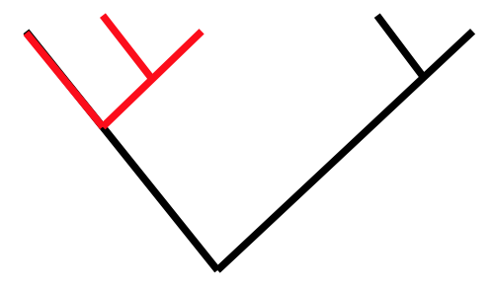
Monophyletic taxon: included all the descendants of a single immediate ancestor

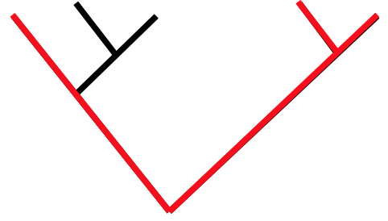
Paraphyletic taxon: group that includes some, but not all of the descendants of a stem species
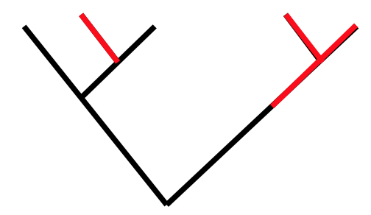
Polyphyletic taxon: group the includes descendants of more than one ancestor
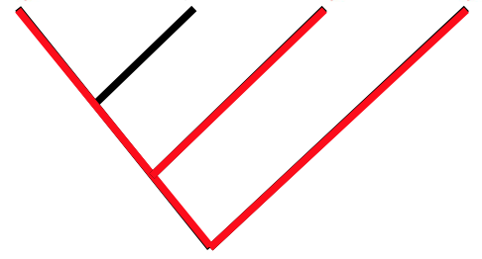
Homology: similarity via common genetic inheritance (shared ancestry)
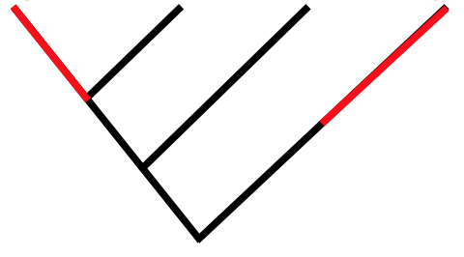
Homoplasy: similarity via common genetic inheritance (convergent evolution)

Taxon: may occur at any part of the Linnaean hierarchy but should be monophyletic

Polytomy: we know they are a group but we don’t know the order

Autapomorphy: character traits that differentiate one from another, shared derived trait by that lineage, defining trait

Outgroup: a close relative of members of the ingroup (various taxa being studied) that provides basis for comparison with other, assumed to represent ancestral Friday, January 15th

Molecular Data
- First aligned so the bases being compared are homologous
  - Can see is the ancestral condition was lost through an apparent deletion of base
  - If all the same they are not phylogenetically informative
- Degenerate code: redundancy of codons specifying an amino acid (=tolerance of point mutations)
- Saturation: so many base pair substitution that phylogenetic signal is lost
- Long branch attraction: rapidly evolving sequences lead to long branches (long branches tend to cluster together but not due to evolutionary relatedness)

Cladistic Analysis
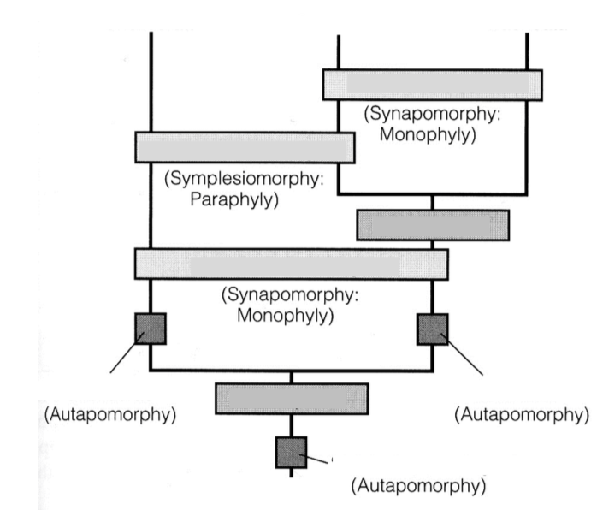
Myriapoda
- Group within Tracheata (in Arthropoda)
- We now think that Myriapoda is not monophyletic with tracheata (insects and arachnids)
- This would mean Tracheata is not monophyletic itself

Invertebrates and life of Earth
- Earth is ~4.6 billion years old
- 1st prokaryotes ~3 billion years ago
- 1st eukaryotes ~1.5 billion years ago
- 1st metazoans ~0.7 billion years ago

Prokaryotes – simple single cells
- No true nucleus
- Septum (during fission), mesosome, cell membrane, cell wall, DNA, ribosomes
- Protists

Eukaryotes – membrane bound organelles
- Have mitochondria (power house of the cell)
- Two principle autapomorphy have allowed for explosion of designs
- Nucleus
- Cytoskeleton – provides structure for 3d shape, can resist environmental pressures
Where did eukaryotes come from?
- Prokaryotic ancestor
- Serial endosymbiosis

- Size increase allowed for more ribosomes, rough endoplasmic reticulum, etc.
- Can interact with environment in more violent ways
- Phagocytosis – repeated engulfing of food and incorporation of genes into the host nucleus – start of internal membranes

Evidence for endosymbiotic theory:
- Mitochondria and chloroplasts have their own DNA and divide
- Different genetic code in mitochondria
- Double membranes
- rRNA similarities (bacteria, mitos, chloros)
- Facultative and secondary endosymbioses
- Recent endosymbiotic events in protists

Recent evidence for the endosymbiotic theory
- Mesodinium chamaeleon (food vacuole temporarily acts as photosynthetic unit)
- Cells fed autotrophs maintained them for a long period of time, not really digested

Choanoflagellata – single-celled eukaryotic ancestor
- Stiff microvili around mouth – suspension feeders
- Heterotrophic
- Single flagellum with collar
- Solitary or colonial
- Sister taxon of Metazoa

When did animals first appear? ~600 million years ago
- Cryogenian: protists and stromatolites (algal mats)
- Ediacaran fauna (sponges, jellyfish, fern shaped sessile creatures) was replaced by numerous complex eukaryotes during Cambrian explosion

Protista: single celled eukaryotes
- Primary producers and consumers
- Characterized mainly by asexual reproduction and separated by methods of movement (convergent evolution – movement are not homologous)
- Groups are very divergent (we don’t know which ones are ancestral)
- Euglena
- Peranema

Protozoa: cytoskeleton is critical!
- “First animals” - animalcules: living creatures in rain water (1677)

- Motile
- Heterotrophic
- 1.4-2.7 billion years ago
- Subcellular specialization
Euglenozoa
- Photosynthetic forms
- Some switch to heterotrophic mode
- Flagella
Euglenoidea
- Autotrophs, heterotrophs
- Chloroplasts and pyrenoids
- Pellicle reinforces cell membrane
- Clonal reproduction
- Trailing and leading flagellum, rod organ used in food capture
Kinetoplastida (type of euglenoidea)
- Heterotrophs
- Undulating membrane
- Kinetoplast – large mass of DNA in single mitochondrion
- Gut parasites of insects and blood parasites of vertebrates
  - Leishmania (black fever) – vector are no-see-ums
  - Trypanosoma – Chaga’s disease (blood sucking bugs) – African sleeping sickness (tsetse fly)
- Huge number of pellicle genes thus change the surface coat to ‘hide’ from immune system
Chlorophyta
- Green algae
- Flagellated
- Solitary and colonial
- Clonal/ sexual reproduction
Fornicata:
Retortamonada – Giardia – contaminated water – duplicated nuclei and 2ndarily lost mitochondria – many different lineages specializing on whom they parasitize within species
Axostylata – sexually transmitted disease living in urinary tract
Condition

Monday, January 18th

Alveolata: monophyletic
Dinoflagellata
Ciliophora
Apicomplexa

Autapomorphy: alveoli – system of abutting membranous sacs that support cell membrane

Dinoflagellata
- 2 flagella (movement)
  - Sulcus: longitudinal groove in which one flagellum lies
  - Cingulum: a transverse groove with a flagellum
- Theca: rigid cellulose (sculpted skeleton), occurs in alveoli
- Auto and heterotrophs
- Primary producers
- Red tides
  - Some dinoflagellates produce neurotoxins
  - Killing of fish can be due to toxins (damage gills) and a decrease in oxygen caused by dense blooms
  - Toxins can work their way up the food chain and cause gastrointestinal and neurological illnesses in humans
- Bioluminescence (Noctiluca)
  - Can see patterns of water of motion around animal moving
- Zooxanthellae: critical for coral reefs

Ciliophora
- Heterotrophs
- Multiple cilia
- Alveolar vesicles
- Mitochondria with tubular cristae
- 2 types of nuclei (used in reproduction)
- Carbs stored as glycogen
- Cilia – somatic and oral ciliature
  - Kinetid (cilium and basal body (9 triplets and a central doublet)) kinety (row of kinetids) and kinetodesma (bundling of basal body fibrils)
    - Create metachronal waves (power and recovery stroke)
  - Cirri: fused short cilia in a row, allows “walking”
Paramecium and Gause
- Gause used colonies of Paramecium to demonstrate competitive exclusion via intraspecific competition
Defense and prey capture
- Extrusomes: membrane bound structures
- Trichocytes: long nail-like spikes
- Toxicysts: discharge a long thread with a toxic bulb at base
- Mucocysts: release mucus filaments
- Haptocysts: harpoon-like structures used by suctorians
Osmoregulation
- Contractile vacuoles pumps excess water out (sw), water flows into cell (fw)
Reproduction
- Micronucleus – comparable to gonad
- Macronucleus – working copies, contain millions of copies of genes
- Asexual fission – transverse-fission plane cuts across rows of kinetids
- Sexual conjugation – involves meiosis and exchange of haploid micronuclei (macronuclei degenerate prior to conjugation)

Apicomlexa
- Parasites: malaria and coccidiosis
- Autapomorphy: apical complex
- Gliding locomotion (no cilia)
Malaria (plasmodium)
- Anopheles mosquito vectored
- 250 million infected humans (~1% die)
  - Evolution: sickle cell anemia, thalassemia and ovalocytosis
Toxoplasma
- 1/3 of human population
  - Almost never kills host- pregnant and immune compromised
  - Changes personality, reduces motor skills, dead-end host
- Cats and their prey
  - Spores form – boost of immune system
  - Kills off excess unprotected cells in host
  - Cause cysts in the brain which change behavior of rat, cause rats to be attracted to cats (allows parasite to be passed to cat – necessary next stage of life)

Amoeboza (ameboid protozoa): polyphyletic group
Amebas
Forminifera
Actinopoda

Amebas
- Transition of cytoplasm from stiff, clear ectoplasm and fluid internal endoplasm
- Psuedopodia (lobopodia and filopdia)
- Tests are protein or siliceous (casing)

Foraminifera
- Reticulopodia (long finger-like projections)
- Extracellular test (hard casing)
- Diverse fossil fauna in marine deposits (calcareous test)

Actinopoda
- Radialaria and heliozoic
  - Radiolaria: mostly planktonic (marine sediments), organic and siliceous tests, algal symbionts
  - Heliozoa: mostly benthic, siliceous spicules, algal symbionts
- Axopodia: needle like pseudopodia (prey capture, flotation, locomotion, attachment)
- Organic tests (sometimes addition of inorganic tests)

Wednesday, January 20th

Protozoans:
Excavates
- Euglenoids, kinetoplastids, retortamonads
  - Euglena, Trypanosoma, Gardia
- Apomorphies: broadly similar flagellar apparatus, suspension feeding groove, cytoskeletal apomorphies
Alveolates
- Dinoflagellates, ciliates, apicomplexan parisites
  - Noctiluca, Toxoplasma, Paramecium
- Apomorphies: alveoli, kinetid, kinety, kinetodesma, trichocysts etc, metachronal waves, apical complex
Amoeboza
- Polyphyletic taxa
  - Amoeba
- Apomorphies: cytoplasm gel and solution, lobopodia, filopodia
Rhizharia
- Foraminifera, radiolaria, heliozoan
- Apomorphies: reticulopodia, extra-cellular test, axopodia
  - Reticulopodia: characterizes foraminifera, long extensions of cytoplasm
________________________________________________________________________

Myxozoans – are cnidarians (not parasitic protists)
- Polar capsule mistaken for apical complex, actually more similar to a nematocyst

Metazoa (animals)
Cells and Tissues
- Motile, heterotrophic
- Multicellular
- Develop from embryos
- Somatic cell differentiation
- Tissues – specialized cells bound together in sheets of epithelium, bound together with collagen (stronger protein found only in animals)
  - Autapomorphy of animals = collagen

Advantages of multicellularity:
- Many differences due to size and the ratio of SA:V
- The surface is the interface between the organism/ cell and its environment
- Division of labour
- Efficiency (environmental damage & loss)
- Increase in size
- Ecological advantages (predators)
- Metabolic advantages (complex tasks, biomechanics)
- Information processing
Surface area to volume:
- # of reactions increase as volume increases
- Materials for these reactions have to enter cell across the membrane (diffusion), limits # of reactions that can occur
- SA of cell controls how much can enter cell
- Larger cell= smaller SA:V (limits size of organism)
Limitations: physical limitations have enormous effects on directing evolution
- Getting oxygen to internal cells/ void cell waste
- Balance between SA and respiration/ heat loss/ water loss / strength
- Strength of your muscles is determined by SA, while mass is dependent on volume
- Increase SA internal (invaginations, microvilli, cilia, trachaea) or external

Metazoans Origins:
Syncytial theory: Metazoa as derived from a multinucleate but unicellular like ciliate protozoan, large multinucleate cells eventually portioned into compartments
Colonial Theory: metazoan as derived from a colony of flagellated Protozoa, cell division without separation
- Choanoflagellata as sister taxon of metazoan (colonial choanoflagellates)
- Occurred multiple different independent times (animals, fungi, brown and red algae, green plants)
- Conflict between locomotion and growth
  - Centrioles needed for mitosis are already in use as flagellar basal bodies
  - Division occurs after the flagella regresses
- Enlarge existing cells
- Regress flagella, divide, reassemble flagella
- Some cells divide while others do not
- Division of localized cells set aside for growth
- Limits body size
- Comprises locomotion
- Permits both larger size and locomotion (best compromise)

Porifera: sponges
Apomorphies
- Sessile adult
- Pinacocytes (pavement-like cell that covers the body)
- Mesohyl (connective tissue layer between the pinacoderm and choanoderm)
- Internal aquiferous system
- Archeocytes
- Sclerocytes
- Siliceous spicules
- Stereoblastula larva

Porifera cell types:
Lophocytes: interior to cell, secrete collagen
Pinacocyte: squamous lining cells
Choanocyte: collared cells, very similar to choanoflagelles (made us think they were the basal group), responsible for moving flagella for water flow (feeding)
Porocyte: form the ostia (openings, linking interior of sponge to exterior environment)
Acheoctye: totipotent (can become any cell)
Sclerocyte: secrete spicules (help organism stand up in 3D/ skeleton)
*Spicules (shape) were a key trait for division of species

Sponge Phylogeny:
Porifera
Symplasma (Hexactinellida)
Cellularia
Demospongiae
Calcarea
Hexactinellida (glass sponges)
Apomorphies:
- Siliceous spicules (will dissolve in HCL)
- 6-rayed
- Syncytium
- Secondary silicification

Cellularia:
Apomorphies:
- Cellular tissues
- Poroctyes (different links)
- Extracellular calcification
- Demospongiae and calcarea

Friday, January 22nd

Porifera: sponges
- Suspension feeding
- Incurrent canals
- Intracellular digestion

Demospongiae
Apomorphies:
- Siliceous tetraxons
- Spongocytes and spongin (type of collagen)

Calcarea:
Apomorphies:
- Calcium carbonate (calcite) spicules (wont dissolve in HCl)
- Large choanocytes
- Coeloblastula larva (hollow)

Aquiferous system of sponges: Important because adult sponges are sessile (allows feeding)
- Dermal pores or ostia
- Choanoctye chambers
- Excurrent canals (flows of water through sponge)
- Osculum

Water pumping: area and flow
- Sponge can pump its body volume in water in ~5s (efficient)
- Continuous flow
- Velocity=1/area
- Slow flow = feeding
- Fast flow = entry and exit
- Allowed by choanocytes (villi creating flow) and direction of current (from environment) pushing water through the sponge

Porifera characteristics:
- Suspension feeding
- Incurrent canals
- Phagocytosis
- Intracellular digestion
Three different shapes of Porifera:
- Asconoid: (small and simple) barrel shaped, bag or bladder, very narrow and small to avoid large stagnant zone, ~1mm
- Synconoid: barrel shaped but choanocyte chambers to increase SA, ~1cm
- Leuconoid: nested choanocytes within excurrent canals to increase SA, all large sponges (demospongiae) are leuconoids

Asexual reproduction:
- Gemmules (dormant structures)
- Archaeocytes accumulate nutrients by phagocytizing other cells
- Cluster together
- Bag created within mesohyl of the cell at the end of the season (aquatic species), that open in the spring releasing gamates

Sexual reproduction:
- Most sponges are hermaphrodites
- Germ cells embedded in mesohyl – make eggs (from archeocytes) and sperm (from choanocytes)
- Sperm release out excurrent canals
- Phagocytosed by choanocytes (not digested)
- Delived to egg for fertilization
- Viviparity in most sponges (release of lecithrotrophic larvae)
Development:
- Coeloblastula (hollow) larva
  - Coeloblastula - > stereoblastula -> olynthus
- Lecithotrophic (mobile) larva

Boring sponges: carnivorous
Cliona celata – bore/ etch holes in shells of prey (archeocytes) through bioerosion, cryptic species

Predatory sponges: carnivorous (monophyletic group)
- Do not have choanocytes – exist at deep deaths (low current)
- Hooked spicules (velcro-like tips) catch prey, sponge then slowly digest prey

Placozoa (1883)
- Phylum of very few
- 4-5 cell types and several thousand cells
- Flattened body
- Ciliated upper and lower cells
- Fibre-syncytium (contractile) – amoeba-like motion via cilia movement
- Not polarized and can rip itself in two
- Epithelial cells without basal lamina (odd for a metazoans)
- Shiny/ lipid spheres (dark spots along the rim and in the center) distributed amongst dorsal layer function in anti-predator defense

Feeding: Trichoplax
- Glides over patch of algae and cilia stop moving
- Lipophils (cell type) simultaneously secretes granules which rapidly lyses algae
- Secretion is accurately targeted (only lipophils near algae release granules)
- Algal content is ingested, then resumes gliding

Monday, January 25th

Eumetazoa (traditional taxon)
- All animal groups except sponges and placozoa
- Ctenophora, Cnidaria, Bilateria
- Characteristics: body symmetry is radial or bilateral, epithelial tissue, gut, muscles, nerves
Epithelia – key innovation leading to diversification
- Covers surfaces and lines internal cavities and spaces allowing physiological compartmentalization allowing diversification
- Polarised (basal facing other cells, apical facing environment)
- Continuous layer
- Basal lamina
- Intracellular junctions (evolved into muscle and nerve)

Cnidaria ~550 mya
Apomorphies:
- Stinging cells (cnidocytes)
- Polyp adult and planula larva
- Nerve nets (permit coordinated firing and motions)
- Longitudinal and circular muscles
- Endodermal gonads (permit sexual reproduction)
- Circular mitochondrial DNA

Polyps and Medusae: alternating sessile (polypoid) and motile (medusoid) generations
Gamates lectotrphic (feed off yolk) or planktotrophic (feed of plankton) -> Larva -> polyp-> Budding medusoids move through the water
* Comes from blastula larva, which will form a gastrula with a blastopore

Cnidocytes: the stinging cells
- Secretion of cnidoblast involved in both defense and prey capture
Nematocysts
- One of the fastest biomechanical events, injection of toxins
- May be convergent evolution with protozoans
- Inside the nematocyst
  - Tuble (coiled, extends during injection)
  - Ciliary cone with microvilli, lining dart as it is fired
  - Operculum, flap of nematocyst
  - Rapid change is facilitated by change in Ca+ levels (made possibly by nerve net)

Groups of cnidarians (slightly different nematocysts/ morphological adaptations)
- Spirocyst– sticky threads along shaft
- Ptychocyst

Cnidaria cell types
Cell types: cnidoctyes, muscles, nerve, glandular, interstitial, ciliated, sensory, germ
- Antagonistic muscles (longitudinal and circular muscle filaments)

When in sessile form: colonial form (can be polypoid or medusoid)
- Stolonate: runner
- Coenosarcal: stolonate mat, continuous
- Fruiticose: generated by two different kinds of budding of polyp from other polyps (sequence)

Skeleton (within hydroids)
- Derived from chitin or calcium carbonate
- Spicule endoskeleton (sea plumes)
- Mainly due to hydrostatic skeleton (fluid filled cavity surrounded by logitundinal and circular musles)
- Foreign material, provides nutrition (zooanthellae and zoochlorellae)

Musculature

Polyps: have antagonistic sheets of smooth muscles
- Epidermal is longitudinal (causes shoring of body)
- Gastrodermal is circular (causes elongation of body)
Medusae: have a ring of muscles – coronal muscle
- Antagonized by the elastic mesoglea
- Liquid is expelled out (jet propelled via coronal muscle)

Nervous system
- Movement is made possible because of nerve net (sensory, motor, interneurons)
  - One net under the gastrodermis, one under the epidermis (connected)
  - Neural net isn’t differentiated/ segmented (no brain)
- Simple nerve nets and ganglia
- Nerve rings are concentrations of neurons that innervate the coronal muscle

Class Anthozoa: ~6,000 spp.
- Corals (scleratinia), sea anemones (actinaria), sea plumes (gorgonacea), sea fans (holaxonia), sea whip (pennatulacea)
*Know anthozoa and sea fans/ etc. but don’t need to know holaxonia/ etc.
- Polyps only
Apomorphies
- Polyps with pharynx with siphonoglyph (ciliated groves)
- 3 cnidocytes
- Incomplete septa (division of coelentron into vertical partitions)
- Septal filaments

Wednesday, January 27th

Anthozoa - polyps only
Apomorphies:
- Polyps with pharynx with siphonnoglyphs
- 3 cnidocytes
- Septa (division of coelentron into vertical partitions)
- Septal filaments (outfolds of gastrodermis and mesoglea that increase SA for feeding) – important for classification (#)
Scleractinia – calcium carbonate hard shells in colonies form corallum (good fossils)

Meduszoa
Apomorphies:
- In medusa stage have linear mitochondrial DNA
Reproduction: medusozoan cycle
- -medusa-planula-polyp (budding)-medusa

Scyphozoa
Apomorphies:
- Medusa with:
  - Rhopalia (sense organs) with mesogleal, gastrodermal, and epidermal components
    - Statocyst, mechanoreceptor, and photoreceptor
  - Gastric filaments bearing nematocysts and digestive cells
- Reproduce through strobilation
  - – egg – planula – scyphistome (sessile) – strobili – budding produces young medusa – adult medusa

Cubozoa
Apomorphies:
- Small polyps lacking septa
- Cubic medusa (radically symmetrical)
- Tentacles are on pedalia (thickenings) at 4 corners of bell
- 4 rhopalia with ocelli
- Velarium – powerful waterjet (function similar to velum but develop from different tissues)
- Highly venomous (sea wasp)

Hydrozoa
- Many are not named because poorly preserved/ sampled, too difficult to collect and identify

Apomorphies:
- Medusa with velum (ring of tissue that directs flow of water out of the bell)
- No endodermal cnidocytes
- Nerve rings with gap junctions
- Have colonies in both medusoid and polypoid zooids (extremely colonial) – only hydrozoans
***Myxozoans are hydrozoans (highly specialized) – not parasitic protozoans like originally thought

Ctenophora
- Can be bioluminescent or iridescent (light is reflected from beating ctene rows
Apomorphies:
- Biradial symmetry
- Aboral organ
  - Diffused nerve net centralized at the apical organ
  - Functions as rudimentary brain controlling the comb rows
  - Gravity sensing
- Ciliary rosettes
  - May assist in accommodation process by pumping water into/ from the mesoglea (floatation tissue) – maintaining osmotic conditions (body fluids are isosmotic to seawater)
  - Help transport nutrients to muscles in the mesoglea
- Photocytes – light receptors
- Ctene rows (8 rows of ctenes) for locomotion
- Collocytes
  - Cells on epidermis and tentilla that secrete a sticky substance for prey capture
  - Create a ‘spin-capture’ movement to increase amount of water column for feeding
Nervous system
- Neural nets, ciliated combs, colloblasts
- Lack neuron-building genes (controlling neuronal fate and patterning)
- Lacks components critical for synaptic function in other eumetazoans
- Do not use standard complement of neurotransmitters found in other animals
  - Do not have serotonin, acetylcholine, dopamine, noradrenaline, octopamine, histamine or glycine and intercellular messengers
- Convergent evolution – evolution took place in two separate lineages
  - One leading to ctenophores, the other leading to organisms with nervous systems
  - Gain of mesoderm occurred twice (bilaterans and ctenophores)
  - Ctenophore fossils found in late Ediacaran, and ctenophore-like fossils found in the ca. 505 Ma Burgess Shale (Cambrain)

Friday, January 29th

Five different proposed relationships of the five deep clades
- Don phylogeny supports that Ctenophora are basal group

Bilateria (us) – deuterostomia and protostomia
- Cephalization – has an anterior end where sensory information is concentrated and information processing occurs
  - Increases feeding, sessile vs. motile abilities
Apomorphies:
- Bilateral symmetry (mid-sagittal plane) and cephalization *synonymous
- Dorsal and ventral sides
- Coelum (body cavity)
- Filtration excretory organs

Symmetry:
Radial –
- Best for sessile suspension feeders (open ocean)
  - Can orient up/down responding to changes in depth, temperature, light (gradients)
- Radial symmetrical organism in a unidirectional current = bilaterally symmetrical colony
Bilateral –
- Anterior/ posterior
- Dorsal/ventral
- Allows movement forward and backward, specialization of structures (feeding, movement, protection)

Radial bilateral – significance of symmetry
- Can move perpendicular to environmental gradients (feeding, swimming, reproduction, differentiation)
Bilateral radial – directionality
- Food in all directions, no polarization necessary

Protostomia:
Apomorphies:
- Blastopore becomes the mouth
- Schizocoely – coelom is formed by splitting the mesodermal embryonic tissue / blastopore becomes the mouth
- Triploblastic – three cell layers (ectoderm, mesoderm, endoderm)

Developmental pathways:
 | Protostomes | Deuterostomes
Cleavage | - Eight-cell stage  - Spiral and determinate | - Eight-cell stage  - Radial and indeterminate
Coelom formation | - Schizocoelous (solid masses of mesoderm split to form coelom) | - Enterocoelous (folds of archenteron from coelom)
Fate of blastopore | - Mouth | - Anus

Within the protozoans:
- Spiralia = ‘Lophotrochozoa’ Depending on the placement of lophophorate taxa within Spiralia, Lophotrochozoa (clade comprised of mollusca, annelida, lophophorata) is either:
- Subclade of Spiralia
- Synonym of Spiralia
- Ecdysozoa

Spiralia= Lophotrochozoa
Apomorhpies:
- Larval protonephridia (face outward to environment) with beating flagella for ultrafiltration and reabsorption
  - May be homologous with ciliary rosettes (but not parsimonious hypothesis) so maybe convergent evolution
  - protonephridia cells = excretory cell
- Chaetae (still bristles for mobility and prey capture)
- Bata chitin

Platyhelminthes (flat worms) ** read chapter 9
- Aquatic, marine, and terrestrial
Apomorphies:
- Multi-ciliated epidermis and gastrodermis (planaria – moving around stomach-like organ)
- Two cilia per protonephridial terminal cell
  - Excretion accomplished by negative pressure
  - Flame cell – characterized by 2 cilia or more (flatworms = 2)
  - Solenocyte – terminal cell with 1 flagellum

Turbellaria – not monophyletic anymore (paraphyletic)
*Recent evidence hypothesizing Acoelomorph are deuterostomes (not protostome)
Characteristics:
- No cuticle
- Rhabdites (within body wall): epidermal glands with rhabdites (rod shaped secretions)
  - Involved in slime production, predator repellant, cocoon formation
- Duo glands: produces glue like structure allowing temporary adhesion
Comprised of two parts:
- Viscid gland: adhesive function
- Releasing gland: de-adhesive function
- Musculature
  - Circular and longitudinal
  - Dorsal and ventral (create muscular waves for swimming)

Reproduction: hermaphrodites
- Hypodermic impregnation – fight to see who can inject sperm into other first (who takes role of male/ female)
  - Injection of sperm offers direct access to eggs
  - Females bear cost of wound healing and lose control over fertilization

Regeneration in Planaria
- Terminally differentiated cells can be reprogrammed (leading to stem cell research)
- Thomas H. Morgan discovered you can cut a flatworm 279 pieces and each one would grow into a new planarian

Monday, February 1st

Platyhleminthes
- Turbellaria
- Trematoda
- Cestoda
- Monogenea

Nervous system
- Nerve cords
- Nerve nets
- Statocysts (gravity receptors)
- Ciliary receptors at head (mechanoreceptor)
- Chemoreceptors
- Photoreceptors
  - Pigmented eye spot (cerebral eyespot)
  - Strongly negatively phototactic (move away from light)

Digestive system
- Mouth and sucking pharynx, no anus (waste products filtered out through skin)
- Lateral branches (increasing internal surface area of tract)
- Phagocytic, gland cells
- Gastro-vascular

Neodermata – monogenea, cestoda, trematoda
Apomorphies:
- Neodermis (tegument): adaptation to parasitic lifestyle
  - Protects from gut enzymes, absorption of nutrients from host
  - Increased surface area into microvilli (non-ciliated)
  - Syncytial – a multinucleated mass of cytoplasm that is not separated into individual cells (interlinked cells) – gives increased control over what enters and exits body and can share nutrients more efficiently
  - Epidermis is composed of a distal anucleate cell layer
  - Cytons (cell bodies containing nuclei) lie beneath a superficial layer of muscles
    - Connected to cytoplast via bridges (internucial process)

Phylogenetic hypothesis – “Cercomeromorpha”
- Makes a parsimonious phylogeny based on behavior (free-living, ecto, endo)

Trematoda (flatworms or flukes)
Apomorphies:
- Larval epidermis is a combination of ciliated cells and syncytial neodermis
- Two or more hosts are necessary (mulluscs are primary hosts)
- Huge health problems for humans (secondary host)

Apidogastrea (mostly fish and turtles)
Apomorphies:
- Large, complex ventral adult sucker
- Aspido = shield
Digenea (flukes)
Apomorphies:
- Miracidium larva with transverse bands of ciliated cells
- Intermediate (mollusc) and definitive (vertebrate) hosts
Morphology:
- Very dorso-ventrally flattened (adaptive to currents)
- Oral sucker (feeding)
- Ventral sucker (attachment)
- Bulbous pharynx (strong muscular feeding bulb under oral sucker)
- Circular and longitudinal muscle (movement)

Didenean life cycle
- Multiple asexual stages – allows rapid expansion of numbers

Chinese liver fluke (Clonorchis siensis)
- 1st intermediate host – snail
- 2nd intermediate host – arthropod or fish
- Definitive host = host in which parasite reaches sexual maturities and reproduces – vertebrate
egg (from feces, ingested by snail) miracidium (snail) sporocyst (snail) redia (snail) cerecaria (free swimming, encyst flesh of freshwater fish) metacercaria (in flesh are ingested by human) adult (in biliary duct)

Dicrocoelium dendriticum – trematoda – digenea
- Eggs can survive freezing to -80˚C (highest rate of infection towards eggs of the summer)
- Ants are a good host because it is a colony species (abundant)
- Snail infection prevalence increases with the age of the snail
egg(from feces, ingested by snail) miracidia sporocyst cerecaria (released from snail via respiratory pore in a slime ball) metacercaria (eaten by an ant) adult (in bile duct)

Tentany: a condition marked by intermittent muscular spasms (ex. ants climbing onto flowers and acting sluggish when cows are grazing)

Trichobilharzia
“Swimmers itch” – cercarial dermatitis
- Interrupt cycle (parasite mistakes human for bird – results in death of parasite)

Schistosoma
- 200 million people infected worldwide (2nd to Malaria as most devastating parasitic disease)
- Improved sanitation and access to safe drinking water (avoid freshwater swimming)
egg (in feces/ urine) miracidia sporocysts cercariae (penetrate skin) schistocomulae (cercariae loose tails during penetration) migrate to portal blood in liver and mature into adults paired adult worms migrate to bowel/ rectum and bladder

Monogenea
Apomorphies:
- Onchomiracidium larva with three widely separated bands of ciliated cells and a pair of pigment cup ocelli

Pseudodiplorchis americanus
- Toads estivate (burry underground) for 10-11 months/year (come out to breed during rains)
- Transmission of monogenean parasite to toads can occur a maximum of 7 hrs spread over 1-3 nights

Wednesday, February 3rd

Monogenea
- Ectoparasites (well developed dorsoventral muscles)
- Aquatic vertebrate host
- No intermediate host – one host (MONOgenea)
- No asexual stage – larval stage is transmitted
- Oral sucker (mucus and scraping from host)
- Haptor: posterior attachment organ (with hooks, sucker, anchor)

Pseudodiplorchis americanus
- Toads estivate (live in a mucus filled hole) for 10-11 months/year (come out to breed during rains)
- Transmission of parasite occurs in a maximum of 7 hrs spread over 1-3 nights
- During few hours parasites must release themselves out of the toad bladder (urinate into water), then invade the nostrils of another
- Synchronization of life-cycles

Cestoda (tape worms)
Apomorphies:
- Gut is absent
- Ciliated larval epidermis syncytial (increasing absorption efficiency)

Morphology:
- Scolex containing holdfast organs (suckers) – adaptations to burrow into prey or hold onto microvilli
- Neck
- Strobila with proglottid (segments of eggs – more mature the farther from the head)
- Neodermis – non-ciliated, syncytial endodermis
  - Epidermis is replaced during development
  - No inter-cellular space
  - Cytoplasmic extensions between outer and inner zone of neodermis
  - Microtriches
  - Exchange of substances through body wall is regulated
  - The entire body functions as an inverted intestine

Dipylidium caninum (canine tapeworm)

Gravid proglottids are passed in feces, proglottids contains egg packets
Egg packets are ingested by larval stage of flea
Encospheres hatch from eggs and penetrate intestinal wall of the larvae (cysticercoid larvae develop in the body cavity)
Infected larval stage develop into adult flea (harbors infective cysticercoid)
Vertebrate host is infected by ingesting flea (scolex attaches to intestine)
Oncosphere: ciliated “egg” containing many cells (has 3 pairs of small hooks)
- Found in aquatic cestopods
- Transmitted by copepods – enters fish guy after ingestion of copepod

Rotifera
- Schizocoely development

Apomorphies
- Ciliary corona on head “wheel organ”
- Unpaired retrocerebral gland (secretes mucus to lubricate wheel)
- Female has vitellarium (syncytial structure producing eggs)

Morphology
- Transverse rings
- Circular and longitudinal muscles
- Hemocoel (space)
- Body wall is a syncytial epidermis
  - Some have a cuticle (hardened test, some with spines)
- Lorica (keratin-like protein endodermal skeleton

Reproduction
- Gonochoric – opposite of hermaphrodidc
- Parthenogenetic – eggs develop without fertilization (asexual reproduction)
OR
- Hypodermic impregnation – injection of sperm into coelom
- In freshwater environment (stress of drying up) – have heterogony as an adaptation (alternation of sexual and asexual generations)
  - Don’t have sex because it is costly OR may be a genomic incompatibility that prevents meiosis

Locomotion and feeding
- Contracting the circular muscle elongates body and stretches out the relaxed longitudinal musculature
- Pseodocoel acts as a hydrostatic skeleton – permits mutual antagonization of the circular and longitudinal musculature through generation of temporary increase in hydrostatic pressure
  - Allows it to either be suspension feeder, raptor, or omnivore
- Can use muscles for swimming, crawling, inchworming, ‘telescoping’

Lophophorata (Bryozoa, Brachiopoda, Photonida)
- Have lophophore – crown of hollow, ciliated tentacles encircling the mouth
  - Employ lophophore cilia to capture planktonic organisms
  - Hollow space (in tentacle) is extension of Coelomic space
  - Increase in SA permitting more efficient gas exchange
- Sessile or sedentary suspension feeders
- No distinct head

Waterflow:
- Lateral cilia pull water down into lophophore (create current)
- Frontal cilia transport food toward mouth
- Water then expelled between adjacent tentacles

Bryozoa (moss animals) – fossilize very well (have test)
- Colonial
- Freshwater and marine

Body (Lophophorate)
- Mesosome/ mesocoel: coelom containing lophophore
- Metasome/ metacoel: most of the body
- Zooecium (base): “animal house”, body can retract into it
- Coelomopores
- Interzooidal pores (connecting in colonies)
- Funiculus: nutrient transportation and sexual reproduction (intra-zooid)
- Multiciliated cells
- Retractor muscle: extending and retracting

Apomorphies:
- Introvert – formed by anterior part of body within which the lophophore and tentacles can be withdrawn
- Funicular system (nutrient transport in colonies)
- Multiciliated cells
- Colonial
- Coelomopores: ciliated groove in the mesothelium along which eggs move to be released from the mouth

Bryozoan musculature:
- Funiculus – tendon connecting the stomach to the bottom of the body wall
Lophophore eversion: contraction of parietal muscles increases coelomic pressure and everts lophophore

Bryozoan colonies:
- Physiologically and physically integrated zooids (integrated coelom)
- Modular (mode of life)
- Form that colony takes depends on pattern of sexual budding
Different forms of bryozoan colonies:
Stolonate: hydroid shaped
Foliaceous: leaf like
Fruticose
Encrusting (most common)

Zooids – polymorphism:
- In some groups (eurystomes)
- Autozooids (feeding)
- Heterozooids (non-feeding)
  - Avicularia – jaw like mechanism used in defense
  - Vibracula – large cilia-like structure used to keep colony clean (sometimes locomotion)

Colony integration –Membranipora: suspension feeding experiment was done with red dyed yeast
- Could watch food being shared through pores, but not all need food, some are non-feeding zooids

Friday, February 5th

Bryozoa
Bryozoan Larvae:
- Corona: ciliary band for swimming and locomotion
- Cyphonautes larvae: long-live larva (large opportunities for recolonization)
- Planktotrophic (functioning gut and actively feed before settling) or lecithotrophic (nutrition not required before settling – live off of yolk)
- Brooding
- Metamorphosis occurs when larval rudiment develops into zooid

Statoblast formation: (similar to gemmules)
- Colonies arise by asexual budding from a settled zooid
  - Settles zooid= ancestrula
- Formed by metamorphosis of a sexually produced larvae or from a resting bud (statoblast)
- Colony can travel long distances

“Lophophorata”
- Bryozoa, brachiopoda, phoronida all have lophophore (not a monophyletic grouping)
- Evolved at least twice (convergent evolution)

Lophophore: crown of hollow, ciliated tentacles encircling the mouth (no distinct head)
- Hollow space in tentacle is part of coelomic space
- Used in feeding (capture planktonic organisms) and gas exchange
- Mostly sessile or sedentary suspension feeders

Brachiopoda “arm-footed”
- Sometimes called lamp-shells (resemble roman lamps)
- Marine benthic suspension feeders
- In decline from Paleozoic/ Mesozoic
- May date to Ordovician (compete with bivalve molluscs)
- 5+ cm in size
- Very rich and old fossil record ~350 species now
- Superficial resemblance to bivalves

Differentiate molluscs vs. brachiopod – how shell is formed and oriented to body

Bivalve molluscs:
- Valves are lateral – left and right (symmetrical)
- Plane of symmetry runs along hinge line
Brachiopod:
- Valves are dorsal and ventral
- Plane of symmetry runs perpendicular to hinge

Apomorphies:
- Bivalve shell and mantle (allow erection and large SA for feeding)
- Brachia – calcareous lophophore support
- Heart is dorsal
- Digestive ceca
- Adduct muscles (contraction pulls valves and closes shell – protection) and abductor muscles (contraction opens the valves – feeding)
- Pedicle – muscular extension of the body wall that anchors shell to substrate

Morphology:
- Valves are dorsal and ventral
- Inarticulata and articulata – presence or absence of hinged teeth and sockets
  - Most modern brachiopods are Articulata
  - Hinge that holds valves together is more developed in articulata
- Large lophophore
- Shell secreted by outer mantle edge
- Pedicle is an attachment stalk (symmetry)
- Chaetae - series of small bristles extending from the grooves at the valve and mantle edges, tactile sensory device (independent from annelida chaetae)

Movements
- Burrowing – pedicle with scissor-like movements borrows into sand
- Orientation in water column – perpendicular to water flow so currents aid ciliary current of lophophore (increases efficiency of respiration and feeding)

Feeding
- Upstream particle collection system: suspension feeding via specific channels
  - Branchial groove: transports particles to mouth
  - Exhalent channel: removed rejected particles
- Brachia (lophophore extension) – extend SA (allows folds within)
- Increased SA = increased respiration and feeding efficiency

Reproduction – sexual gonochronic (separate sexes)
- Free spawner – fertilization occurs in water column
- Brooding and viviparity also occurs within mantle cavity
- Planktotrophic, inarticulate, long-lived larvae that undergo metamorphosis

Phoronida (small phyla) – molecular evidence groups them closely to brachiopoda
- Benthic, sessile, marine organisms
- Live in permanent chitinous tubes
- Lophophore is only external feature (rest is in anoxic/hypoxic environment in substrate)
- External bilateral symmetry
- Internally asymmetrical (left side dominance)

Lophophore
- As size increases, lophophore complexity (SA) increases – adaptation to anoxic/ hypoxic conditions
circular horseshoe simple spiral complex spiral

Apomorphies
- Corpuscular hemoglobin in hemal system
- Actinotroch larva (free-swimming and feed on plankton)
- Loss of chaetae

Corpuscular hemoglobin
- Pumping heart moves a blood-like substance through the body through vein-like structures in tissues
  - Adaptation to anoxic/hypoxic conditions – lophophore extends up into oxygenated water but water is not circulated to part of organism in tube
Nucleated RBCs (oxygen transport) – circulate in body fluids
- In five invertebrate phyla (evolved independently multiple times)
  - Most are extracellular/ extravascular occurring in coelomic fluid
  - Phoronid RBC”S circulate in a closed vascular system
Hemoglobin issues
- Extracellular hemoglobin is large, intracellular hemoglobin is small
  - Small molecules have greater SA and bind more O₂ (more efficient)
  - Small molecules increase osmotic pressure BUT cellular hemoglobin reduces osmotic pressure

Morphology
- Secret chitinous tubes (closed posterior, anterior has lophophore) into sediment – never leave tube
- Cylindrical body
- Swollen posterior ampulla
- Coelom creates hydrostatic skeleton
- Muscle fibers allow movement within tube (retraction)
- Lophophore can be autotomized (spontaneously cast off)

Feeding – use upstream collection system

Development –Actinotroch larvae
- Upon settling, the gut rapidly changes from linear to u-shaped allowing secretion of tube
- Benthic adult

Chaetognatha – arrow worms
- Numerous but not very diverse, found in all marine environments
- Predators
- Fossils date to Cambrian explosions
- Inordinate number of traits that have been lost (hard to differentiate within group)
Apomorphies
- Hollow grasping spines (at top) made of alpha-chitin
  - Capture prey and envenomate them
  - Encapsulated in a hood
- Ciliary fences along body to sense prey
- Double-walled lateral fins (movement)
- Stratified epidermis
  - Chitinous cuticle occurs at the head
  - Along rest of ‘torpedo’ 3-5 layers thick

Feeding: sit and wait predators (then use grasping spines)

Monday, February 8th

Placement of Xenacoelomorpha
- Xenacoelomorpha is the sister group to Protostomia and Deuterostomia
OR
- Xenacoelomorpha within Deuterostomia
- Recently found molecular data supporting union of Xenoturbella and Acoela (share epidermal ciliary rootlets)

“Turbellaria” – paraphyletic (doesn’t include all descendants of a common ancestor)
- Mouth, no anus, lateral branches, phagocytic, gland cells, gastro-vascular
Acoelomorphs are related to Xenoturbella
- Potentially new phyla of deuterostomes
- Potentially new phyla of Xenoturbella
- Phylogeny of Acoels depends on which genes you include Acoels

Papers published in Nature 2016:
- Xenacoelomorpha is the sister group to Nephrozoa (Protostomia and Deuterostomia)
- Species descriptions for four new species of Xenacoelomorpha found in deep sea

“The purple sock mystery”
History of Xenoturbella
- Discovered in 1916, described in 1949
- Ciliated
- Few centimeters in length
- Epidermis, gastrodermis, ventral mouth, no anus or distinct organs
- Originally found in Sweden, until now (California)
1997 suggest it is a highly derived mollusc
- Sequencing from gastrodermis said mollusc (mistake- was what it ate, not actually a mollusc)
- Sequencing from epidermis said something else
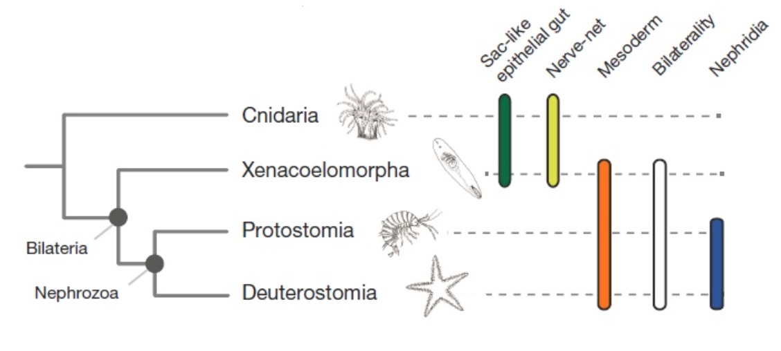
Final position – Key question: placement of Xenacoelomorpha with Bilateria
- Xenacoelomorpha is the sister group to Bilateria
- Xenacoelomorpha is within Deuterostomia

Another question – placement on Dendrogramma (depends where we put ctenophora – coelenterate hypothesis or ctenophora-first hypothesis)

Annelida
- 20th century three groups: Polychaeta, Oligochaeta, and Hirudinae
- Then split into two groups: Clitellata and Polychaetea
- Recent evidence suggests other taxa that where once considered to be separate phyla should be included (Sipuncula, Echiura and Siboglinidae)

Two major clades: evolution was driven by adaptations to two different modes of life
Errantia, “Polychaetea” – appendages, parapodia, nuchal organ
Sedentaria, “Clitellata” – clitellum, cocoons, no appendages
*Polychaetea – Pompeii worms – live in deep water thermal vents

Annelida Apomorphies:
- Metamerism (segmentation)
  - Septa divides fluid filled coelom, rings are added sequentially
    - Echiura’s segmentation may be secondarily lost (fused segments)
- Chaetae: cuticular structures produced by epidermal cells
  - Four bundles per segment
  - Made of β-chitin (separates it from other species)
  - Functions in traction
    - Also have parapodia (walking organs)

Chaetae and Setae:
Annelids | Arthropods
- β-chitin – adjacent parallel molecules with same polarity, tough and flexible, channels in pulp cavity | α-chitin: adjacent parallel molecules with opposite polarity, hard and stiff, hollow pulp cavity

Metamerism- type of segmentation
- Structural plan in which the body is differentiated along its longitudinal axis into a series of units of segments, each containing elements of the nervous, musculature, and digestive system – allows specialization and insurance
- Within phylum no perfect example of a series of metameres (some reduced, some lost, some span segments)
Body regions:

- Prostomium (oldest segment, head)
- Peristomium
- Metameres
- Growth zone: contains ectoderm and mesoderm teloblast cells that form each segment
- Pygidium

Metameres contain:
- Pair of mesodermal somites with coelomic spaces
- Pair of nephridia – excretory organs, replicated along each segment
- Pair of coelomoducts – Nephrostome ciliated excretory and reproductive channels
- Pair of ganglia on a ventral nerve cord
- Pair of appendages

Friday, February 12th

Sedentaria “Oligochaeta”
Musculature
- Similar to polychaetes
- Alternate action (anterior to posterior) of circular and then longitudinal muscles – peristaltic movement
  - a-c: contraction of circular muscles from anterior to posterior
  - d-f: contraction of longitudinal muscles
- Chaetal (extensions that help anchor organism in environment) protractor and retractor muscles

Nervous system
- Centralized ganglia (brain) more posterior in organism
- Single ventral nerve cord – giant axons (enabling quick retraction and coordination of movement)
- Photoreceptors: unicellular and distributed around the body (no eyes)
- Chemoreceptors (tubercles)

Digestive system
- Muscular pharynx
- Esophagus
  - Gizzard (beta-chitinous projections for grinding)
  - Crop (storage)
- Intestine
  - Typhlosole (u-shaped folding= increased SA)
  - Chlorogogen tissue – site of glycogen and fat synthesis

Circulation/ gas
- Hemoglobin in blood - tolerant of hypoxic environments
- Circumesophageal vessel – thickenings that function as a heart

Excretion
- Excreting via metanephridia in each segment
- Waste is drawn into ciliated nephrostome
- Passed though loops of nephridium (retention of positives)
- Expelled through the nephridiopore of next segment
- Don’t deal well with dehydration

Reproduction
- Simultaneous hermaphrodites
  - Errantia are gonochoric – Sedentaria are hermaphroditic
- Exchange of sperm via copulation
- Egg and sperm are injected into egg case which is secreted by clitellum

Clitellum –series of segments that are enclosed in a thick, glandular epidermis (girdle)
- Reproductive structure – secretes mucus for copulation, nutrients for eggs and cocoon
*Apomorphy for Sedentaria

Invasive earthworms in Ontario
- Earthworms consume leaf little of forests – causing tree seedling, ferns, wildflowers, and potentially water quality to decline
- Change the physical and chemical properties of the soil – affects native species
- Change soil structure, inhibiting the historical and natural functioning of forest systems

L. terrestris – invasive earthworm, discovered to be 2 species, but in fact it is only one

Tubifex “sewer worms”
- Live in lake bottoms and stagnant mud
- Hemoglobin-rich tips (extend out of soil) allow toleration of low O₂

Hirudinomorpha – leech-like families within the sedentarians
Apomorphies
- Posterior sucker – dorsal anal anterior to sucker
- Superficial annulations: un-segmented body with superficial marks (segmentation secondarily lost)
- No chaetae
- Unpaired mid-ventral gonopore
- Ectoparasites (lives on surface of host)
- Sensory papillae: small projecting discs in a ring around one annulation, specialized sense organs

Body walls and muscles
- 4 major muscle groups: circular, diagonal, dorsoventral, longitudinal
- Extreme reduction of coelom – continuous and has become the hemal system – powered by muscular contractions
- Dorsal and ventral coelomic channel

Locomotion (via layers of muscles): crawling and swimming

Nerves and Senses
- Brain in segment 5 – suprapharyngeal ganglion (joining of prostomial and peristomial ganglia)
- Ventral nerve cord
- Segmented ganglia
- Chromatophores (can change color)
- Pigment cup ocelli (phototaxic)
- Small number of large neurons
Excretion
- Coelomic cavity is circulatory system
- Pairs of metanephridia per segment – embedded in connective tissue (not septa)
Nephrostome: not used in excretion (like other groups) but contains phagocytes, involved in immune system

Reproduction
- Simultaneous hermaphrodites
- No asexual reproduction or regeneration
- Ventral surface of clitellar surface come together for internal fertilization
- Some leeches brood their young

T. Rex – species with very large teeth found in Amazon

Digestion
- Anterior sucker/jaws with protrusible or non-protrusible pharynx
- Large number of lateral ceca (increase SA – blood is hard to digest – allows large number of bacteria to live on ceca to help with blood digestion)
- Lack most digestive enzymes – rely on symbiotic bacteria

Medicinal use
- Post surgery (antibacterial action and increased blood flow)
- Hirudin (peptide) used a anti-coagulent
- Act as a prosthetic, temporary vein

Leech conservation: screening mammal biodiversity in Vietnam (compared DNA of blood meal and read distribution of mammals in that environment)

Echiura “spoonworm”
- Deposit or filter feeders
- Body in u-shaped burrows and crevices, prostomium projected out for feeding

Apomorphies
- Pair of anterior ventral chaetae
- 2 posterior rings of chaetae (β-chitin) used for digging
- Un-segmented body – secondarily lost segmentation (fused)
- Prostomim (front end “spoon”)
  - Spoon coelomic= more hemoglobin (adaptations to
- Prostomial and trunk coeloms cavities divided by septum (nearly separate)
- Intestinal siphon – “accessory gut”, moves water out of digestive system

Systems
- Nervous: prostomial ring and ventral nerve cord
- Digestive: long coiled gut + siphon (large SA = efficiency of nutrient absorption)
- Circulatory: simple hemal system (dorsal and ventral blood vessels)
Morphology
- Prostomium and trunk
- Hooked β-chitin chaetae
- 3 muscular layers: circular, longitudinal, cross-helical

Reproductive
- Gonochoric
- Male are miniature ciliated individuals that live in genital sac of the female
- External fertilization
- Trochophore larvae (processing bands of cilia)
  - Developmental system – any larva that land on a female become a male

Sipuncula “peanut worms”
- Marine
- Live in blind burrows and crevices
- Suspension or deposit feeders
- Some are boring

Apomorphies
- Introvert
  - Eversible via circular muscles
  - Retractable via retractor muscles
- Tentacles with a tentacular coelom
- Cuticle with scattered hooks
- J-shaped intestinal tract
- Intestinal ciliary groove (water shunt – move water via cilia action out of digestive system)
- Hemerythrin in cells – O₂ binding pigment – no hemoglobin

Trocophore larvae:
- Some species have multiple stages
  - 1st is short-lived lecithotrophic
  - 2nd is long-lived planktotrophic
- Advantages – could move far distances

Monday, February 22nd

Bilateria
Apomorphies:
- Bilateral symmetry (mid-sagittal plane)
- Dorsal and ventral sides
- Cephalization
- Coelom
- Filtration excretory organs

Protostomia
Apomorphies:
- Blastopore becomes the mouth
- Schizocoely – coelom is formed by splitting the mesodermal embryonic tissue
- Triploblastic organisms (3 cell layers) – ectoderm, mesoderm, endoderm

Spiralia = Lophotrochozoa
Apomorphies:
- Larval protonephridia (face outward to the environment)
- Chaetae
- Beta chitin

Nemertea “ribbon worms”
- Mostly marine ambush predators
- Polymorphic

Apomorphies:
- Proboscis
- Rhynchocoel (a fluid-filled coelomic cavity)
- No chaetae (secondarily lost)

Body wall:
- Ciliated, glandular epidermis
- Cephalic glands (on head) – secrete slime
- Muscle layers
  - Circular muscle is inside the longitudinal muscle – facilitates fine movement
  - Body is mostly muscle – good for burrowing

Proboscis:
- Lies in rhynchocoel
- Has a stylet at the tip – calcareous barb
  - Not directly venomous but have nearby glands that secrete neurotoxins and adhesives
- Retractor muscles – can be everted
Feeding and digestion:
- Carnivorous
- Stylet can be armed or unarmed
- One-way GI tract (allows specialization)
  - Mouth, foregut, stomach, intestine, anus

Internal transport:
- No gills
- Rhynchocoel – fluid filled coelomic cavity
- Coelomic circulation – ciliary beating and muscular contraction
- Vascular plugs (where rhynchocoel and vessels join)
- Lateral vessels

Reproduction and development:
- Asexual reproduction, fragmentation
- Gonochoric
- External fertilization
- Indirect and direct development
- Pilidium larva (invagination of the ectoderm) – defining character nemertea

Mollusca
- Most morphologically disparate living animal phylum
- Diversified into all habitats
- Deep fossil record
- Monophyly and identity of eight living classes is undisputed

Apomorphies:
- Dorsal mantle with secreted chitin cuticle
- Radula (rasping/ feeding organ)
- Foot and paired pedal retractor muscles
- Bipectinate gills
- Tetraneural nervous system
  - Pair of pedal nerve cords, pair of visceral nerve cords
- Dorsal mantel with secreted chitin cuticle and calcareous spicules
- Cephalization – ganglionic nervous system
  - 5 ganglia concentrations: cerebral, pleural, pedal, parietal, visceral

Generalized mollusc:
- Marine
- Benthic
- Head, visceral mass, foot (degree of cephalization)
- Radula
- Mantel and shell

Mantle:
- Mantle (pallium)
  - Elaborated portion of the body wall over the visceral mass
  - Mantle epithelium secretes the shell
Shell:
- 3 layers
- Periostracum (organic)
- Ostracum (calcitic, aragonitic)
- Hypostracum (nacreous)

Variation in mantle and shell:
- Variability on the mantle and shell depending on the lifestyle of the clade
- Cuttlebone: internal shell, chambered and gas filled for buoyancy control
  - In Sepidae, lost in octopus
- Cephalopoda: completely externalized shell, septa and separate gas filled chambers

Gills
- Housed in mantle cavity
- Bipectinate gills
- Ctenidia – composed of leaf-life filaments that extend from supporting axis
  - Ciliated – propel H₂O across surface, sort of food, bring O₂ in
  - Countercurrent blood movement – H₂O moves in opposite direction od blood = more efficient O₂ extraction (allowing it to live in more hypoxic environments)
  - Monopectinate (one sided), bipectinate (2 rows of filaments)

Sensory:
- Osphradium – sensory organ hanging in the inhalant water current
  - Monitor water entering mantle cavity
  - Detection of high sediment content triggers reduction of ciliary beating to protects gills
Foot:
- Adaptation of ventral body wall to a creeping lifestyle
- Muscular – retractor muscles (pulls shell towards foots)
- Ciliated creepsole
- Mucus glands – facilitate locomotion
- Pedal hemocoel with blood sinus

Wednesday, February 24th

Mollusca

Eight classes of molluscs:
- Historically due to degree of cephalization and eye evolution grouped gastropods and cephalopods together because believed that adaptation only arose once (monophyletic)
- NOW believe that degree of cephalization has arisen twice (cephalopods and gastropods not monophyletic)

Odontophore: tooth-bearing organ composed of radula, radula sac, muscles and cartilage
  - Can be projected out of mouth
Radula:
- Rasping, protusible tongue-like organ
- Membrane with chitinous teeth pointing backwards
- Sits on top of odontophore, can move overtop of
- Moved forwards and backwards Protactor and retractor muscles
- New teeth are constantly being created
  - Limpet teeth are strongest natural material known
- Adaptations:
  - Scraper and collector (ancestral)
  - Drilling (predatory)
  - Breaking up food (cephalopods)
  - Secondarily lost in bivalves

Feeding and digestion:
- Stomach is a pear-shaped sac in anterior of visceral mass
- Gastric shield: chitin-reinforced part of the stomach, protection from abrasion
- Sorting field: ciliated groves for separating digestible and indigestible particles
- Protostyle: a fecal rod, spins and winds in the mucus rope
- Intestine: formation of feces

Coelom and internal transport:
- Reduction of coelom
  - Coelom is important for movement via hydrostatic skeleton (support) – but can be reduced since there is now a shell acting as the skeleton
- Two coelomic spaces: pericardial cavity (heart) and gonocoels (gonads)

Hemal system:
- Tissues are surrounded by blood
- Heart is dorsal
- Respiratory pigment – hemocyanin – dissolved directly in blood – copper containing

Open system (mollusc) – blood is pumped into the hemocoel
- Less efficient, lower pressure, limited ability to alter velocity and distribution of blood with activity
- Blood moves through sinusoidal system
  - Differs from venous system – no endothelial lining
Closed (annelid) – small capillaries connecting arteries and veins (venous system)

Excretion:
- Heart-kidney complex – pair of metanephridium with nephrostomes into coelom
- Ultrafiltrate into pericardial cavity
  - Pericardial glands are evaginations of the pericardium into parts of hemal system
- Nephridia connected to pericardium
- Secretion and reabsorption
- Nephridiopore is exit to exhalent chamber

Nervous systems:
- Ganglionic nervous system
- Identifiable neurons
- Cephalic tentacles (chemosensory)
- Eyes
- Statocysts (gravitational responses) in the foot
- Osphradia: olfactory organ detects water quality – linked to gills (beating cilia rates) – protection from particles in water

Reproduction:
- Both gonochoric and hermaphroditic
  - External fertilization in the sea (ancestral)
  - Internal fertilization in some
- Gonads near pericardial cavity release gametes into coelom which exit via nephridiopore

Development:
- Spiral, holoblastic cleavage (general mollusc)
- Blastopore becomes the mouth
- Direct development and metamorphosis
- Trochophore larva
- Veliger larvae – has a foot and two lateral ciliated lobes together called the velum, planktonic

