ADM1300 Finals Notes
Content: chapters 1-11, 15, 16; Accounting, Finance, Marketing

CHAPTER 1 & 2
- Business: Profit seeking activities and enterprises that provide goods and services necessary to an economic system
- Profit: The difference between the revenues earned and the costs earned by a business
- Organization: Collection of people working together to achieve a common purpose. They provide useful goods and services that return value to society and satisfy customer needs
- Organizations as an open system
  - The environment supplies: People, money, materials, technology, information.
  - The organization creates: Turning inputs into outputs (transformation process
  - Environment consumers: Finished goods and services which is fed back into the input system
  - Productivity and Performance:
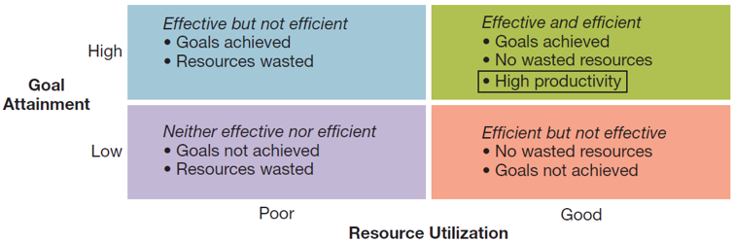

- Organizational Environment:
  - Socio- Cultural: Demographics
  - Economic: Health of Economy
  - Technological: Development & Availability
  - Natural Environment: Nature & Conditions of Environment
  - Legal-Political: Norms, Customs, Social Values

- Management: The art and science of getting things accomplished through others in organization.
  - First level Management: Mobilization = Team leaders in charge of small work groups of non-managerial workers.
  - Second (middle) level: Coordination= Middle managers in charge of relatively large departments/divisions
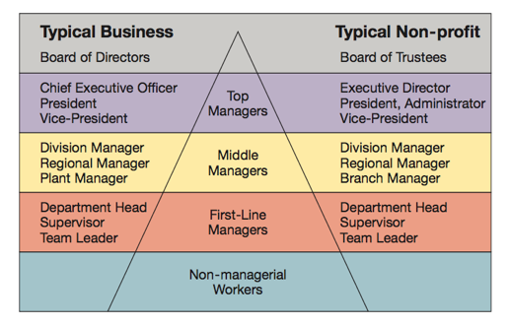
  - Third level: Strategic= Top leaders Responsible for the performance of the organization as a whole or for the entirety of one of its larger parts

    - Managers in the new workplace’s jobs are more geared towards serving the customer and supporting workers’ efforts.

- Four Functions of Management (PLOC): Management is the process of planning, organizing, leading, and controlling the use of resources to accomplish performance goals. All managers are responsible for the four functions.
  - Planning is the process of setting objectives and determining what should be done to accomplish them
  - Leading is the process of arousing enthusiasm and inspiring efforts to achieve goals
  - Organizing is the process of assigning tasks, allocating resources, and coordinating work activities
  - Controlling is the process of measuring performance and taking action to ensure desired result
    - possible exam question: which is most important? answer given by TA: control because you can't do anything if you don't have any control over yourself
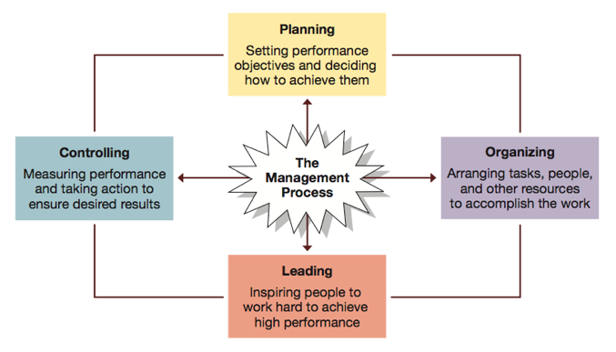

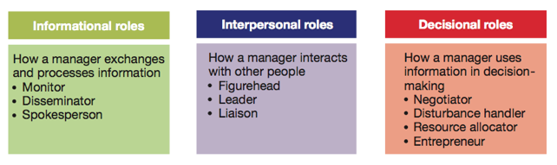
- Henry Mintzberg’s 10 Natural Managerial Roles

- John Kotter’s Managerial Agendas: Agenda setting and agenda implementation are behavior patterns of successful managers.
  - Agenda setting: What is wanted to be accomplished by the organization. Almost always informal and unwritten as well as concerned with people issues.
  - Networking: is the sum of one’s formal and informal network of key people inside and outside the organization. Relationships are usually relevant to manager agendas.
  - Agenda Implementation: These networks are used by managers to implement agendas and they employ influence tactics to do so. Usually involves informal interactions and concern with people issues.

- Robert Katz managerial skills:
  - Conceptual: Critical thinking and analyzation of information in order to solve complex problems
  - Technical: Applying special proficiency or expertise to perform particular tasks
  - Human: Good with relationships and working well in cooperation with others

- Daniel Pink: Competencies: High Concept & High Touch
  - Communication: Sharing ideas and
  - Team-work: Working effectively with others
  - Self-Management: Scrutinizing and modifying one’s own actions
  - Leadership: Influencing and supporting others
  - Critical thinking: Analyzing and gathering information
  - Professionalism: Impression management and career advancement

- Management Past-to-Present: Management is getting the right thing done through others. “Management Thought” developed over 100 years ago and has evolved quickly.
  - Classical Management, classical approaches:
    - Scientific Management: Frederick Taylor
    - Bureaucratic Organizations: Max Weber
    - Administrative Principles: Henri Fayol
  - Behavioral Management:
    - Maslow - Theory of Human Needs
    - Mayo - Hawthorne Studies
    - Mary Parker Follett - Organizations as Communities
    - McGregor - Theory X (lazy and don't like work) & Y (like work and are creative
    - Argyris - Personality & Organization (low supervision)

CHAPTER 3:

- Global Economy: Resource supplies, product market and competition are on a worldwide scale as opposed to local
- Globalization: Growing interdependence of these components in global economy
- Global Manager: Informed about international development, transnational in outlook. Competent in working with other cultures, also aware of regional developments abroad
- International Management: Management in organizations with business interests in more than one country.

- Global Dimensions of Management
exam question: pros & cons of going global? how can a company go global?

PROS | CONS
- more profits
- more customers
- more suppliers
- capital
- labour at lower costs

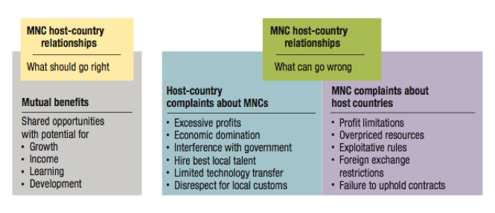
- How to go global:
Possible exam question- list and explain 5 ways
  - Market entry strategies:
    - Global sourcing: Process of purchasing materials globally for local use
    - Exporting: Selling locally made products in foreign countries
    - Importing: Selling foreign made products locally
    - Franchising: Fee paid for rights to use other firms name and production methods
    - Licensing Agreements: Firm pays for rights to make and sell other company’s products
  - Direct Investment Strategies:
    - Joint ventures: Operates in a foreign country through co-ownership by local and foreign partners
    - Global Strategic Alliances: A partnership in which foreign and domestic partners share information, resources, knowledge for mutual gains.
    - Foreign subsidiaries: Local operation completely owned by a foreign firm.
    - Greenfield Investment: Builds an entirely new operation in a foreign country.
    - Foreign direct investment is building, buying all, or buying part ownership of a business in another country.
    - Insourcing is job creation through foreign direct investment

- Global Business Environment:
  - Political Risk: Potential loss in value of investment in foreign country due to instability and changes in political scene
  - Local legal systems: Foreign law can be complex and is very unfamiliar so must familiarize to avoid problems

- World Trade Organization (WTO): Resolves trade and tariff disputes among countries.
  - Protectionism: Wanting to protect domestic businesses from foreign influence is something which can harm global trading relationships

CHAPTER 4:

- Ethical Issues:
  - Corruption
  - Sweatshops
  - Child Labour
  - Sustainable development: Working simply for “today” as opposed to the future

- Culture: A set of shared beliefs, values and patterns of behaviour common to a group of people.

- Artifacts of Culture:
  - Context:
    - Low-Context Cultures: Focus on written or verbal communication
    - High- Context Cultures: Focus on nonverbal +social cues + written/ verbal
  - Time and Space:
    - Monochronic Cultures: People tend to accomplish one thing at a time
    - Polychronic Cultures: Time is used to accomplish many different things
    - Proxemics: How people use space to communicate

- Geert Hofstede Values of national cultures:
  - Power distance
  - Uncertainty avoidance
  - Individualism-Collectivism
  - Masculinity-Femininity
  - Time Orientation (Short-term vs. Long-term)
    - Managerial practices and perspectives differ amongst different countries and cultures
      - Ex. Not all Japanese practices can be duplicated anywhere else or U.S practices which might be ethnocentric.

- Ethics: Moral obligation to identify what is right from wrong
  - Always includes:
    - Theory of obligation (conduct)
    - Theory of values (what makes something good and/or bad) and;
    - A theory of decisions/self-conscious thoughts of motivation

  - Three criterias:
    - Antiquity: The older the more apt it is to be correct
    - Numbers: How many hold it (the majority is always right – the bandwagon effect)
    - Prestige: How many important prestigious persons hold this viewpoint

- Four views of ethical behavior:
  - Individualism View: Does a decision or behavior promote one’s long term self-interests
  - Moral Rights View: Does a decision or behavior maintain the fundamental rights of all human beings?
  - Justice view: Does a decision or behavior show fairness and impartiality?
  - Utilitarian View: Does a behavior or decision do what is best for everybody.

- Ethical Development (KOHLBERG):
  - Preconventional: All acts are done in one’s best interest.
  - Conventional: Upholds moral and legal laws, does what is expected.
  - Principled: Lives by an internal set of moral codes values and ethics

- Maintaining High Ethical Standards:
  - Social Entrepreneurship: People who use their ideas and strategic thinking not for money but to help solve a pressing social issue using the money earned as a means to the solution. (Housing/job training for homeless, technology for poor families.)
  - Corporate social responsibility: Organizations working in a way which satisfies both their own interests and the interests of society as a whole.

CHAPTER 5:
- Entrepreneur: Person who seeks opportunity and takes necessary risks to successfully operate a business. (why? : being your own boss, financial success, job security,quality of life) Entrepreneurs take calculated risks to control their own destiny.
- Entrepreneurship: Strategic thinking and risk-taking that creates new opportunities for individuals and organizations.

- Types of Entrepreneurs:
  - Classic
  - Serial
  - Social Entrepreneurs

- Characteristics of an Entrepreneur:
  - Vision: an overall idea for how to make business ideas successful
  - High energy level: a willingness to work hard
  - Need to achieve: want to excel and achieve difficult goals
  - Self-confidence: fearlessness in the face of difficult odds
  - Tolerance for failure: not easily discouraged
  - Creativity: devise innovative ways to overcome difficult problems and situations; have new ideas for good and services
  - Tolerance for ambiguity: take business uncertainties in stride
  - Internal locus of control: belief in control of own fate

- Financing:
  - Seed capital: The initial funding needed to launch a new venture
  - Debt Financing: Credit cards, Family and friends, Bank loans, Finance companies
  - Equity Financing: Venture Capitalists, Angel Investors

- Forms of legal Ownership:
  - Sole proprietorship
  - Partnership
    - General partnership
    - Limited partnership
    - Limited liability partnership
  - Corporation
  - Limited liability corporation (LLC)

- Intrapreneurship
  - The process of promoting innovation within the structure of an existing organization
  - An idea to promote creativity
  - Ways to promote Intrapreneurship:
    - Skunkworks
    - Pacing programs

CHAPTER 6:
- Planning: Setting out objectives and determining how to best achieve them
- Steps of Planning: Determine objectives then see where you stand. Develop alternatives to situation then choose and implement
- Planning & Control
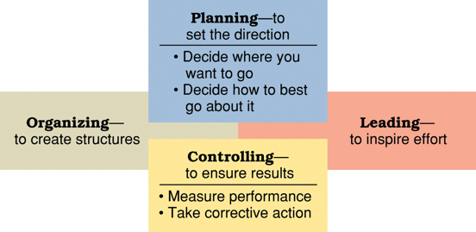

- Why Plan? Improves flexibility, action orientation, time management, coordination and control

- Types:
  - Short term: 1 year or less
  - Intermediate: 1-2 years
  - Long term: 3+ years
    - Higher management focuses more on longer time horizons.
  - Strategic plans: Set broad, comprehensive and longer term action directions for the entire organization.
  - Tactical Plans: Define what need to be done in specific functions to implement strategic plans
  - more: Financial, Marketing, HR, Production, Facilities, Operational, Policy, Rules or Procedures, Budgets.

- Planning tools and techniques:
  - Forecasting: attempting to predict the future
  - Contingency: Mapping out alternatives solutions to your plan if circumstances change. They anticipate changing conditions.
  - Scenario Planning: Long-term version of contingency planning. Making alternatives to future scenarios for best and worst case.
  - Benchmarking: Use of external and internal comparisons to evaluate performance and identify any areas for future improvement.
  - Use of Staff Planners: Coordinating and energizing the planning function. Help bring focus and expertise to accomplish important, often strategic, planning tasks.

- Implementation- Goal Setting:
  - SMART goals (Specific, Measurable, Attainable, Referred to Regularly, Timely)

- MBO - Management By Objectives
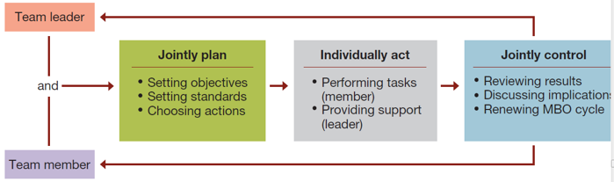
  - Formal agreement specifying worker’s goals for a specific time period. Plans through which objectives need to be accomplished.
  - Type of performance objectives: Improvement, personal development, maintenance
  - Effective performance objectives are challenging, time sensitive, measurable, specific.

CHAPTER 7:

CHAPTER 8:
- Organization: The process of organizing people and resources to work together to accomplish a goal.
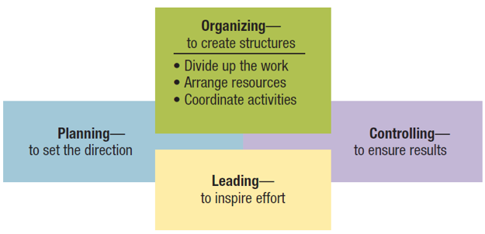
- Organizing

- Organizational Structure: system of tasks, operations, reporting, relationships and communications that link diverse individuals and groups together.
  - The formal structure describes the organization in its official state
  - The informal structure (aka a shadow organization) is made up of the unofficial, but often critical, working relationships between organization members

- Organizational Chart: Identifies the following aspects of organizational structure:
  - Division of work, supervisory relationships, communications channels, major subunits, levels of management.

- Traditional(Vertical) Organizational structures: Departmentalization, grouping teams together to enhance coordination. Resulted in 3 types of structures
  - Functional: Similar skills employees are grouped together. Members work in their functional area of expertise. Good for small operations producing few new products.
  - Divisional: Group together people who work on the same product or process, server similar customers and/or work in the same geographical region.
    - Ex: Product structures focus on same product; geographical products focus on same region. Customer structures focus on same customers and clientele.
  - Matrix: Combines divisional and functional to gain advantages and minimize disadvantages in: Manufacturing, service, non-profit and MNC. Involves multiple reporting lines so people may have more than one boss.

- Horizontal organizational structures:
  - Team structures: Permanent and temporary teams deployed to solve problems and complete special projects and accomplish day-to-day tasks. Often made up of cross-functional teams from various departments, convene for special tasks or project then get disbanded once goal is accomplished.
  - Network structures: A central core that is linked through networks with connections to external contractors and suppliers of essential services. Own only necessities and use strategic networking to outsource anything else needed.
  - Advantages of Network structures: Firms can operate with fewer full time employees and less complex structures, can cut a lot of overhead costs and work with increased operating security. Permits operating across great distances.
  - Disadvantages: Control and coordination problems may arise from network complexity. Potential loss of control over outsourced activities. Lack of loyalty among infrequently used contractors. Excessive outsourcing can be dangerous.
  - Boundary less: Blurring boundaries with subsystems and external boundaries with environment, made possible with combinations of teams and networks.
  - Virtual organizations: (type of boundaryless) use informational technology to mobilize a shifting mix of strategic alliances to accomplish tasks and projects

- Organizational Design:
  - Mechanistic designs are bureaucratic and vertical, performing best for routine and predictable tasks
  - Organic designs are adaptive and horizontal, performing best in conditions requiring change and flexibility
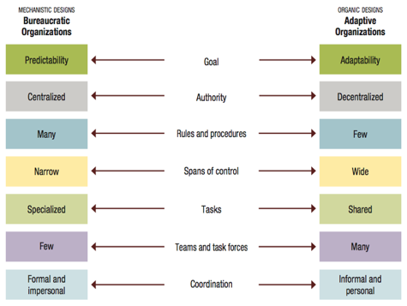

CHAPTER 9:

CHAPTER 10:

CHAPTER 11:
- LEADING:
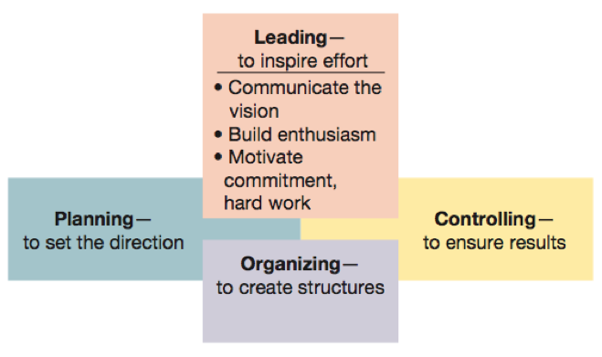

- Nature of Leadership
  - Leadership:
    - The process of inspiring others to work hard to accomplish important tasks
  - Contemporary leadership challenges:
    - Shorter time frames for accomplishing things
    - Expectations for success on the first attempt
    - Complex, ambiguous, and multidimensional problems
    - Taking a long-term view while meeting short-term demands

  - Power: Ability to get someone else to do something you want done or make things happen the way you want. Power should be used to influence and control others for the common good rather seeking to exercise control for personal satisfaction. Two sources of MANAGERIAL POWER:
    - Position power:
      - Based on a manager’s official status in the organization’s hierarchy of authority
      - Sources of position power:
        - Reward power
          - Capability to offer something of value
        - Coercive power
          - Capability to punish or withhold positive outcomes
        - Legitimate power
          - Organizational position or status confers the right to control those in subordinate positions
    - Personal Power:
      - Based on the unique personal qualities that a person brings to the leadership situation
      - Sources of personal power:
        - Expert power
          - Capacity to influence others because of one’s knowledge and skills
        - Referent power
          - Capacity to influence others because they admire you and want to identify positively with you

- Managers have huge influence on the quality of their subordinate’s work experience and they guide their subordinates work behavior. An employee with a manager who has good leadership skills will generally work harder, enjoy their job, want to perform well and know how to achieve higher level of performance.

- Strategic Leadership: Leadership which involves being able to anticipate, envision, create flexibility and work with others to create a viable future for the organization.

- Formal Leadership: Leaders with titles such as manager, executive, supervisor etc… are people who occupy formal leadership roles.

- Classic Leadership Styles
  - Autocratic style: Emphasizes control over others and keeping information between leaders tight
  - Human style: People over work
  - Laissez-faire style: Shows little concern for task, lets the group make decisions, and acts with a “do the best you can and don’t bother me” attitude
  - Democratic style: Committed to task and people, getting things done while sharing information, encouraging participation in decision making, and helping people develop skills and competencies

- Contingency Approaches
  - Henry-Blanchard Style: leaders determine their styles based on their follower’s readiness
  - House’s path: Effective leaders guide their workers to go through paths to achieve goals
    - Directive, supportive, participative and achievement oriented.

- THE COMMUNICATION PROCESS:

- Communication is the interpersonal process of sending and receiving symbols with messages attached to them

- Key Elements of the communication process: sender, message, communication channel, receiver, interpreted meaning, feedback

- Importance of communication to Management:
  - Management is getting things done through other people
  - Everything a manager does involves communication (managers spend 75% of their time on communicating)
  - For the manager, communication facilitates control, motivation, the expression of emotions and the transfer of information/meaning

- Interpersonal Communication

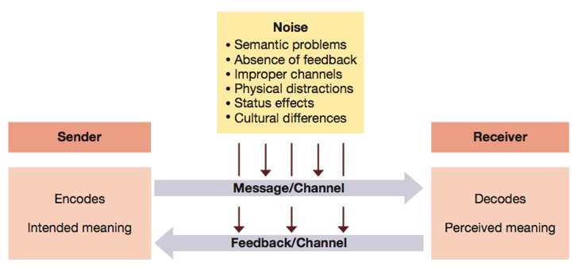
- Effective communication occurs when the sender and the receiver of a message both interpret it in the same way
- Efficient communication occurs when the message is sent at low costs for the sender
- Persuasive communication results in the recipient acting as intended by the sender, credibility earned by expertise and good relationship is essential to persuasive communication

- Communications Barriers:
  - Noise is anything that interferes with the effectiveness of communication, common examples are poor utilization of channels, poor written or oral expression, physical distractions, and status effects
  - Encoding Issue: VERBAL vs. NONVERBAL
  - Perceptions Based Issues: stereotypes, biases and pre-set beliefs affecting communication

- Communication within Organizations:
  - Downward: Goals, objectives, direction, decisions, and feedback
  - Upward: Information, suggestions, questions, problems
  - Lateral: Information exchange- informal and formal- that assist or affect coordination

- Informal Communication Channels
  - Tend to be more lateral, information flows extremely fast, carries both work related as well as non work related work

- Channel Richness/ Communication Media
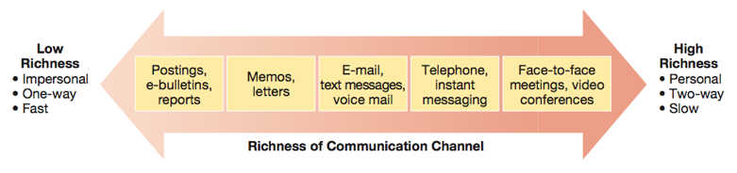

CHAPTER 15:

CHAPTER 16:
- Controlling: The Process of measuring performance and taking action to ensure desired results. It has a positive and necessary role in the management process in order to ensure that the right things happen, in the right method and the right time.
  - Effective control is essential to organizational learning.
  - After-action reviews identify lessons learned through completed tasks.
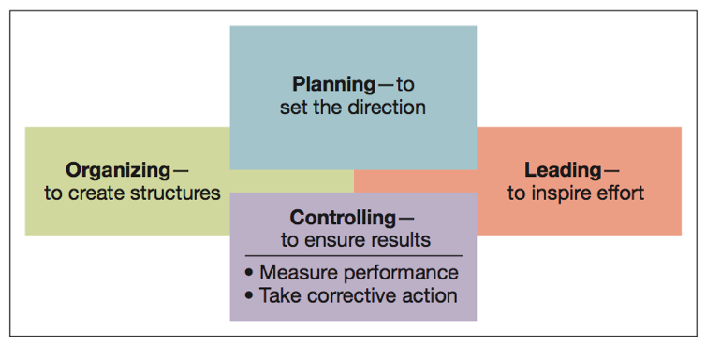

- Types of Controls:
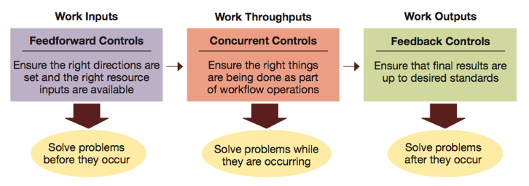

- Internal control & External Control:
  - Internal: Allows motivated individuals and groups to exercise self discipline in fulfilling job expectations
    - Self- Control: Occurs through self-discipline in fulfilling many responsibilities
  - External: Occurs through personal supervision and the use of formal administrative systems
    - Bureaucratic Control: Influences behaviour through authority, policies, procedures, budgets, and day to day supervision
    - Clan Control: Influences behaviour through norms and expectations set by the organizational culture
    - Market Control: Influences behaviour through market competition

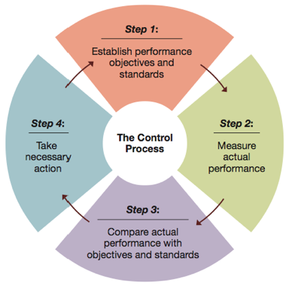
- 4 Step Control Process:

Step 1: Establish Objectives & Standards: Output standards (measure performance results in terms of quantity, quality, cost or time) & Input standards (measures effort in terms of amount of work expended in task performance
Step 2: Measuring performance: Try to accurately measure performance and performance efforts. Identify actual results and differentiate them from the original plan
Step 3: Comparing results: reflect between actual results and desired and actual performance
Step 4:

- Control Tools and Techniques
  - Employee Discipline System: - Addressed by the HR department
    - Discipline: the act of influencing behaviour through reprimand
    - Progressive Discipline: ties reprimand to the severity and frequency of misbehaviour
  - Project Management & Control: - Overall planning, supervision, and control of projects
    - Projects: unique one time events that occur within a defined time period
    - Gantt Charts: Graphic display of scheduled tasks required to complete a project
    - CPM/ PERT Techniques: Combination of the critical path method and program evaluation and review technique
  - FInancial Controls:
    - Economic Value Added: A Performance measure of economic value created by profits being higher than the cost of capital
      - Market Value Added: Performance measure of stock market value relative to the cost of capital
    - Basic Financial Ratios
      - Liquidity: The ability to generate cash to pay bills
      - Leverage: The ability to earn more in returns than the cost of debt
      - Asset Management: The ability to use resources efficiently and operate at minimum cost
      - Profitability: The ability to earn revenues greater than costs
- Balanced Scorecard:

Why u giving me heartattack by turning the whole thing pink?

ACCOUNTING, FINANCE & MARKETING:

- Diversity
  - Workforce Diversity: Differences among workers in gender, race, ethnicity, religion, sexual orientation and able-bodiedness.
  - Prejudice: Display of negative, irrational behaviours toward members of diverse groups.
  - Discrimination: Actively denies minority members full benefits of organizational membership
  - Glass Ceiling Effect: Invisible barrier limiting career advancement of women and minorities.
- Globalization: Worldwide interdependence of resource flows, product markets, and business competition that characterizes our new economy. It is the process in which advancements in technology along with deregulation of markets opens boarders to bring vastly expanded flows of people, money, goods, services and information.
- Technology: It is an indispensable part of our everyday lives and has become a key tool in business, many businesses have taken to simply becoming E-businesses. For other businesses it is a necessity, whether you are checking inventory, making sales transactions, ordering supplies, analyzing customer preferences. Jobs now involve increasing multi-media resumes and electronic portfolios
- Ethics: Code of moral principles that sets standards of what is right and good as opposed to wrong and bad in the conduct of a group or person.

