EXIT QUESTIONS

LAB 1 THE MICROSCOPE
- What is the magnification of the specimen under the microscope, with the present object lens in place?
Scanner: 4x10= 40
Low power: 10x10= 100
High power: 40x10= 400

- What is the name and function of the indicated microscope part?
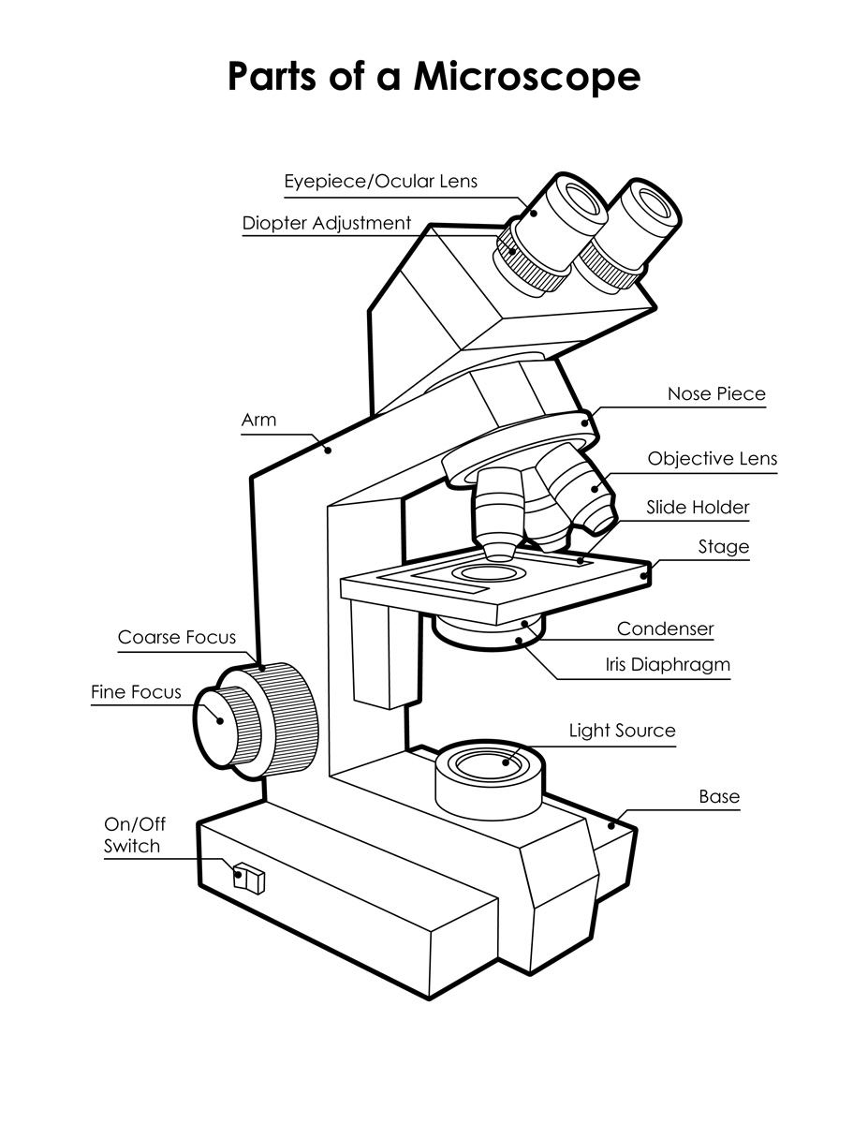
- The section of cloth in this slide is made up of interwoven fibers of cotton, each of which is a bundle of tiny fibrils. What is the thickness of a fiber?
2mm/6= 0.25mm
- Which objective lens on your microscope has the greatest depth of focus?
The scanner 4x
Which objective lens has the smallest working distance?
The high power lens 40x

- Which lenses of your microscope have “empty” magnification?
Ocular lens

LAB 2 DIFFUSION AND BROWNIAN MOVEMENT

- What is the difference between Brownian movement and diffusion?
Diffusion is when particles move from an area of high concentration to an area of lower concentration while Brownian movement is continuous random movement of particles in water.

- How would the rate of diffusion of a substance be influenced by temperature?
When the temperature is higher there is a higher average kinetic energy of particles which makes the rate of diffusion faster, when the temperature if colder diffusion will be slower.

- If the cytosol of a bacteria is hypotonic to its environment, what would you expect to happen?
The solution surrounding the cell is less concentrated than inside the cell. It would start collapsing as the water inside moves out of the cytosol.

- The right side of an aquarium has a solution of salt in water. The left side of the same aquarium has a solution of sugar in water. If the right side is hypertonic to the left side in relation to the salt, which way will the sugar diffuse?
To the right

- These red blood cells are in what kind of solution? (in terms of tonicity)
The cell is in a hypertonic solution
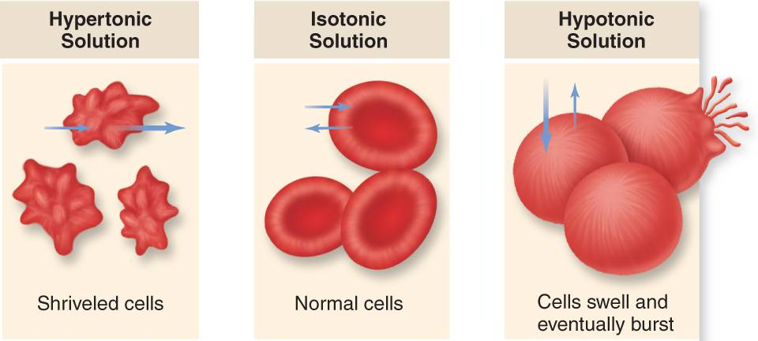

LAB 3 CELL DIVISION

- In what stage of mitosis is the cell indicated by the pointer? Anaphase (onion cell)
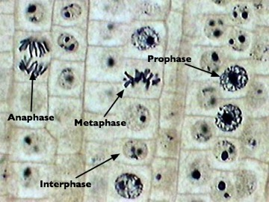

- What stage of mitosis precedes the stage of the cell in question 1? Metaphase (plant cell)

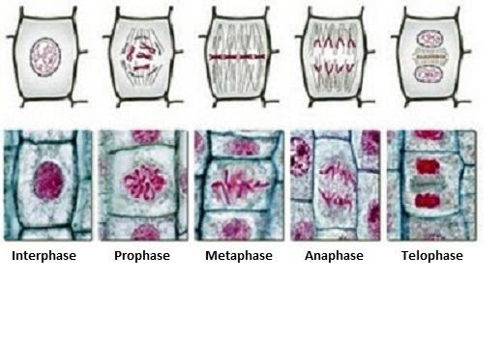
- How many chromatids are in each chromosome of the cell indicated by the pointer? 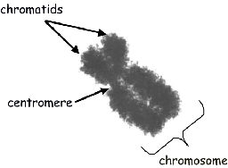 2 chromosomes

- In what stage of mitosis is this cell indicated by the pointer?
Metaphase
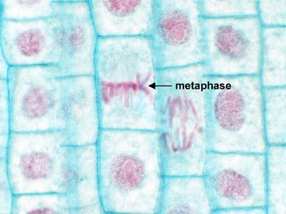

- Name the cell and name the process of the cell indicated by the pointer?
Spermatogonia cell and the process is spermatogenesis
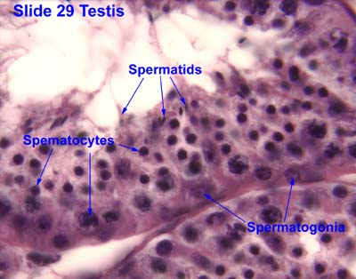

LAB 4 GENETICS

- In humans, the allele for "attached" earlobes is recessive to the allele for "free" earlobes, and the allele for "straight" hairline is recessive to the allele for "widow's peak" hairline. A man who is heterozygous at both loci has a large family with a woman who is homozygous at both loci and has a "straight" hairline and "free" earlobes. Approximately what proportion of their children would we expect to have which phenotypes?
Free: 1 / attached: 0 / widow: 0.5 / straight: 0.5

- Define heterozygote in genetic terms?
Having different alleles of a gene, genotype has one dominant allele and one recessive
allele

- If you suffer from a really rare genetic disease that is caused by a recessive allele as a single locus, and neither your parents or your brother have that disease, what is the probability that your brother is a carrier (heterozygous at this locus)?
2/3 probability

- If half the members of a population have the phenotype of the dominant allele and half have the phenotype of the recessive allele, which allele at this locus is probably more common in the population? Recessive is more common

- In ants, males develop from unfertilized eggs (and are therefore haploid) while females (including workers) develop from fertilized eggs (and are therefore diploid). Imagine that ant colour is determined at a single locus, with the allele for dark being dominant and the allele for light being recessive. If the only breeding ants in a colony are a dark male and a light female, what proportion of the male offspring would be dark, and what proportion of the female offspring would be dark?
All men: light all women: dark
LAB 5 DNA

- Why is SDS in the lysis solution?
SDS is a detergent that allows the lipids to diffuse in water

- After exposure to the electric current, the gel is immersed in a warm stain solution. Why do we keep this solution warm?
The stain will diffuse into the gel and turn the entire gel blue, but it will stick only to the DNA

- In this drawing of DNA bands in a gel after electrophoresis, which lane indicated by a letter includes the bands with the smallest DNA fragment? Why?
C because it’s the longest and smaller DNA fragments move faster.

- What are the four bases that are found in DNA?
Adenine, thymine, guanine, cytosine

- A sample of DNA is 100,000 bases long. It is cut between bases 25,000 and 25,001 and between bases 50,000 and 50,001. This DNA is then loaded into a gel and exposed to an electric current (electrophoresis). How many bands of DNA would result?
2 bands

LAB 6 BACTERIA AND EUKARYA

- List two characteristics of fungi?
They have a cell well made out of chitin and are multicellular

- State the complete Linnaean classification of the species rhizopus stolonifera (black bread mold) omitting: class, family, and order.
Domain: eukarya / Kingdom: fungi / Phylum: zygomycota

- Identify four multicellular organisms on display in today’s lab?
Brown algae / green or blue algae / mushrooms / red algae

- In which domain does the organism under the microscope belong to?
Eukaryotic

- Is the organism under the microscope a heterotroph or an autotroph?
Autotroph
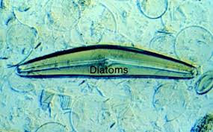

LAB 7 PLANTS

- Is this plant a monocot or a dicot? Explain.
Dicot, they have parallel branching veins
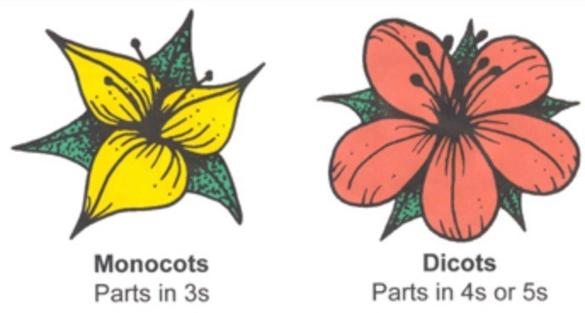

- How many petals would you expect in the flowers of the plant in question 1?
Between 4-5 flowers on a dicot flower

- Exactly what kind of tissue is indicated by the pointer?
The xylem
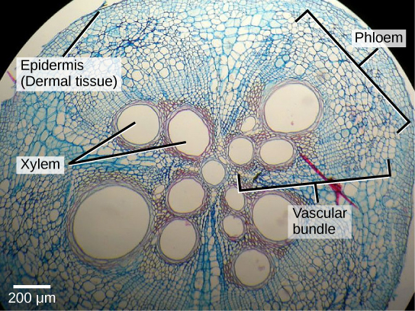

- What organ is seen in question 3?
A dicot root
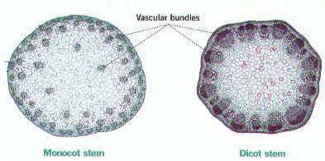

- Exactly what is the structure indicated by the pin?
ovary
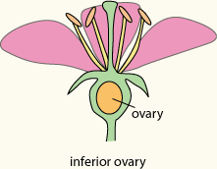

LAB 8 ANIMAL TISSUE AND ORGANS

- Exactly what kind of tissue is indicated by the pointer?
Simple cuboidal epithelial tissue
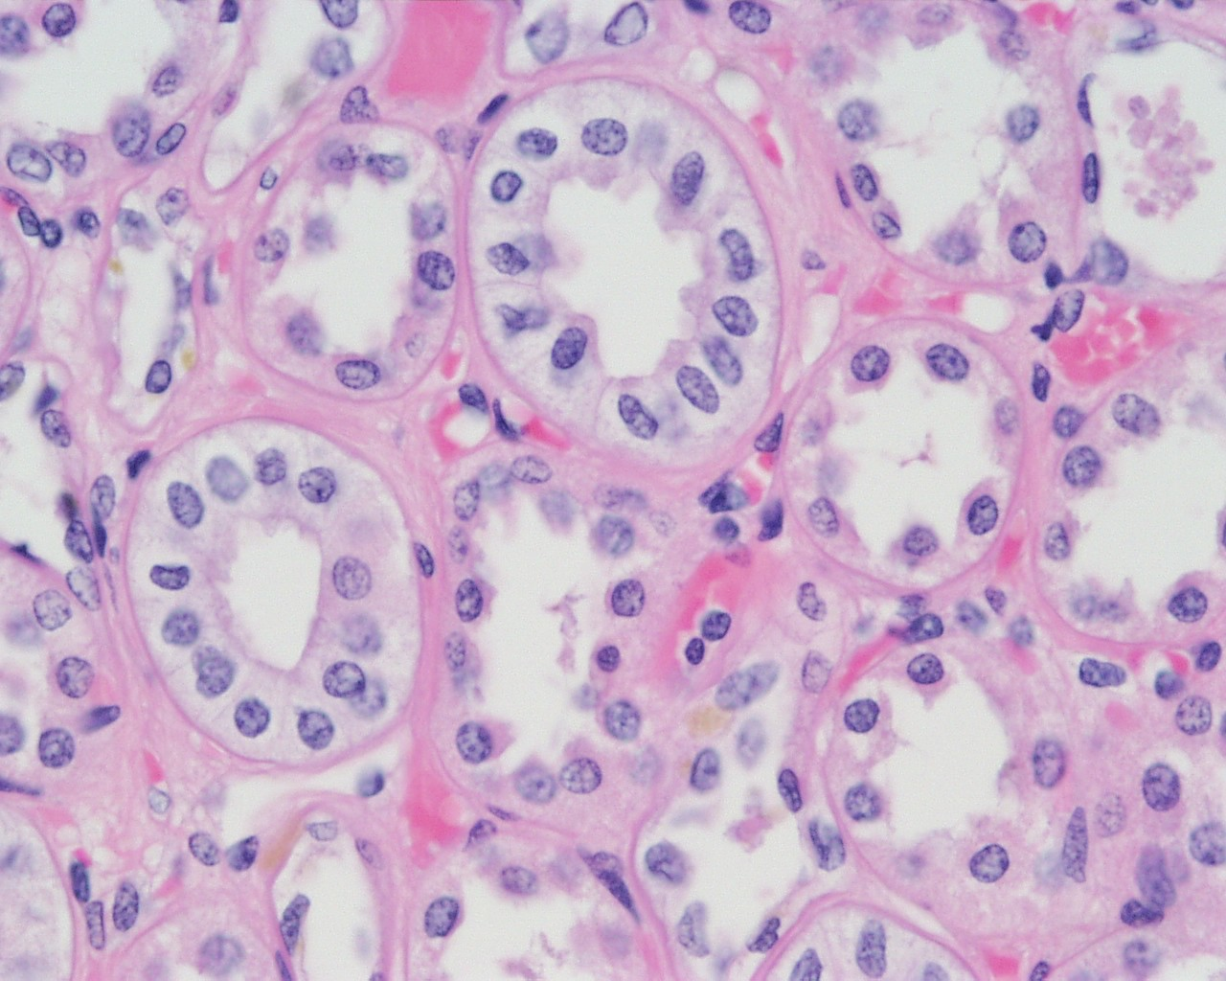

- What is the structure indicated by the pointer?
The central canal in bone tissue
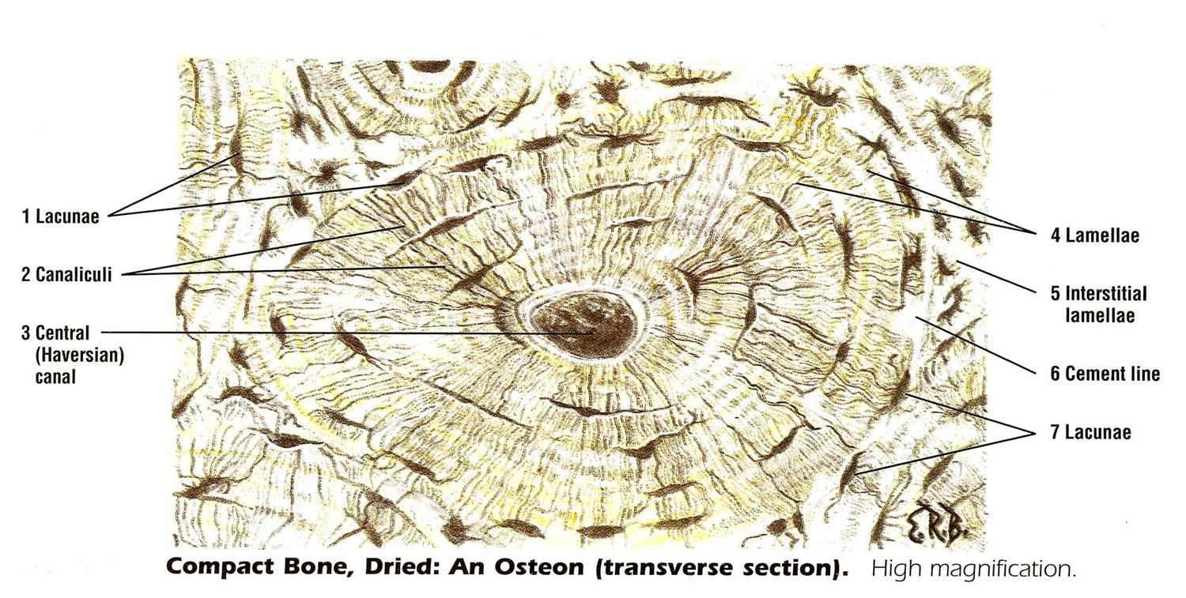

- Where would you find this tissue?
Adipose tissue
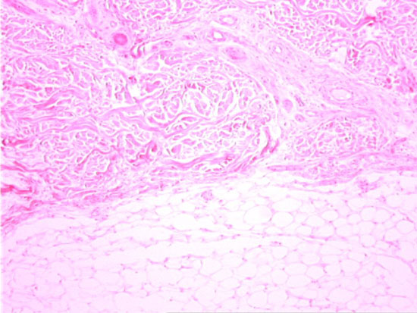

- When blood is returned to the piglet heart from the rest of the body via the vena cava, what part of the heart does it first enter?
Right atrium

- What is the organ indicated?
Trachea

LAB 9 KINGDOM ANIMALIA

- In which phylum does this animal belong?
Cnidarian
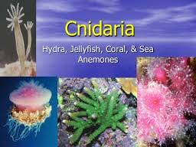

- Does the animal in question 1 have a nervous system, and if so what kind?
Yes it has a nerve net with simple sensory cells

- In which phylum does this animal belong?
Platyhelminthes
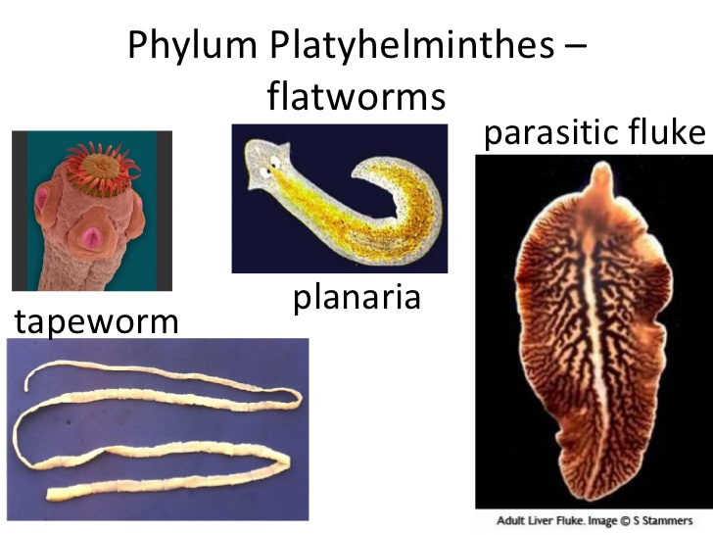

- In which phylum does this animal belong to?
Arthropoda
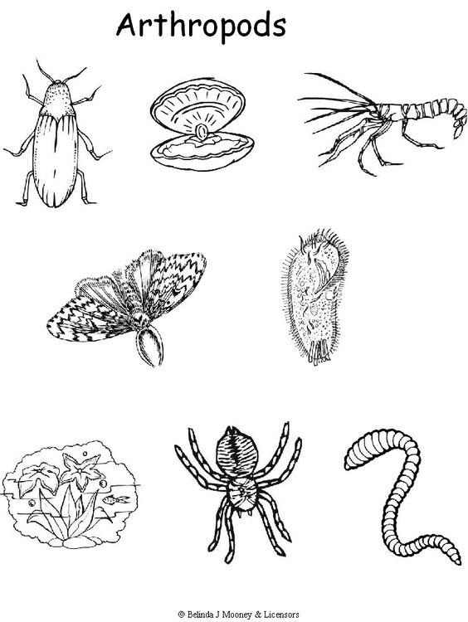

- In which phylum should you classify an animal with the following characteristics: Bilateral symmetry, incomplete digestive system, no coelom or appendages, no circulatory system, no respiratory system?
Platyhelminthes

LAB 10 PHYLUM CHORDATA

- In which group (class) does this animal belong?
Mammals

- In which class should you classify a chordate with the following characteristics: 2-chambered heart, 5 pairs of gills slits, a swim bladder and gills?
Ray finned fish

- In which group (class) does this animal belong?
Ray finned fish

- How many chambers are there in the heart of the animal in the previous question?
2-chambered heart

- In which group does this animal belong?
Mammal


