MODULE 2: THE SCIENTIFC METHOD AND MATTER
What is chemistry? the science concerned primarily with the structure and properties of matter and with the transformation of one form of matter into another. Now one of the most theoretically and methodologically sophisticated sciences, chemistry had its beginnings in medieval alchemy.
The scientific method (performing a study in organized steps)
Step 1performing experiments: an experiment is a set of steps (procedure) tjhat are performed under controlled conditions to propose or test a hypothesis.
Step 2 making observations: observations are a key factor in scientific studies as well as in everyday life and can be classified as
- Qualitative: observation does not use numbers (example: the flower is purple.)
- Quantitative: observation is a measurement (example: observed temperature for the liquid was found to be 33C)
Step 3 proposing a hypothesis: a hypothesis is a tentative explanation to account for the observations of an experiment. A hypothesis is valid provided that one’s assumptions to explain the observations of an experiment can be tested.
Step 4 confirming the hypothesis: the validity of the hypothesis needs to be confirmed via repeated and controlled experiments. In order to accept a hypothesis, there must be no inconsistencies between the hypothesis and the experimental observations. In the event of any inconsistencies, steps 1 through 4 must be repeated.
Step 5 proposing a scientific law: by repeatedly performing experiments and modifying the hypothesis to account for the observations from these experiments, one is able to propose a scientific law.
Expression of numerical value: certain rules apply to the expression of the numerical value and the system of units in scientific measurements.
Scientific notion: a very convenient way of expressing very large or very small numbers and at the same time provides a method of increasing efficiency in scientific calculations. It is a mathematical expression in which a number is expressed as: N x 10 * to express a number in scientific notation we use powers of 10 raised to a certain number. N can be any number. (example: 598.46= 5.9846 x 10 ) (.076/10= 7.6 x 10² )

Rules for determining significant figure (digits): every measurement and thus all of the calculations performed by using such measurements always have some uncertainty (a characteristic of any measurement) the concept of significant figures is: used to indicate the precision of measurements or that of a calculated result using such measurements. It does not apply to counted items such as exact numbers (5 cars) and defined conversion factors (I inch=2.54cm)
Rule #1 all nonzero digits are significant figures: measurement: 135.62g = 5 significant numbers
Rule #2 counting begins from the left with the first nonzero number: 0.056mL = 2 significant figures
Rule #3 zeros between nonzero digits are counted as significant figures: measurement 1.056g = 4 significant figures
Rule #4 terminal zeros (zeros to the right of a number): there are always significant if the value contains a decimal point. Terminal zeros in other cases may or may not be significant. For example, a measured value given as 200cm does not signify anything regarding the number of significant figures. Measurement 2.3700g = 5 significant figures
Rules for significant figures in chemical calculations
Rule #1 in addition and subtraction of measured quantities, the final answer contains the same number of decimal places as are in the measurement with least number of decimal places (least precise measurement) example: 25.0g + 22.41g + 1.234= 48.6g the measurement has the least number of decimal places, therefore the answer has one decimal place.
Rule #2 in multiplication and division of measured quantities, the final answer contains contains the same number of significant figures as are in the measuremtn with the least number of significant figures. Example: 9.20g (3 sign. Figures) x 2.450g (4 sign. Figures) = 22.5g
Rule #3 in the final answer of a calculation involving exact numbers, unit conversion factors and constants, the number of significant figures is dictated by the measured quantity involved. Exact numbers, unit conversion factors and constants have no effect on the number of significant figures. Example 1: if the mass of a steel ball is 2.35g (measured quantity), what will the total mass of 8 (exact number) identical steel balls? = the total mass of 8 identical steel balls is: 2.35g x 8= 18.8g
Example 2: using the formula c=axb, calculate the value of b when a-22.65cm (measured quantity) and c=1.2cm/s (constant) = substituting values a, b and c: 1.2cm/s= 22.65cm x b. the value of be = 1.2/22.65 = 0.05298s
Rules for rounding off chemical calculations
Rule #1 for multistep calculations, all numbers are carried to the final result, which is then rounded off to give the correct number of significant figures.
Rule #2 if the digit being rounded off is >5, you round the digit up by 1. Example: for 8.379g rounded to three significant figures, the digit 7 is rounded to 8 because 9>5 therefore the answer is 8.38g
Rule #3 if the digit being rounded off is <5, the preceding digit remains the same. Example: the measurement 6.371g rounded to three significant figures, the digit 7 remains the same because 1<5.
Rule#4 if the digit being rounded off is equal to 5, the preceding digit is rounded up if it is odd and remains the same even if it is even. Examples: the measurement 16.75mL rounded to three significant figures, the digit 7 is rounded up to 8 because 7 is an odd number, the measurement 16.65mL rounded to three significant figures, the digit 6 remains the same because it’s even.
What is system of units? Known as systeme international d’unites the system uses si base units. Some SI based and SI derived units include length, volume, masas, density, temperature, and time.
Length: the SI unit for length is the meter.
Volume: the SI derived unit for volume is the cubic meter (m3) the most common unit for volume is the liter (L) and the milliliter (mL)
1L= 1 dm³ = 10 ³ m³ 1mL= 1cm³ = 10 dm³
Mass: the SI unit for mass is the kilogram (kg). mass refers to the amount of matter an object contains, thus mass is a constant. Like volume, mass also depends on the size of an object.
Density: the SI unit for density is kilogram per cubic meter (kg/ m³). Generally, in chemistry, density is expressed in the units of g/mL or g/L. Density is a physical property of a substance. Density= mass/volume
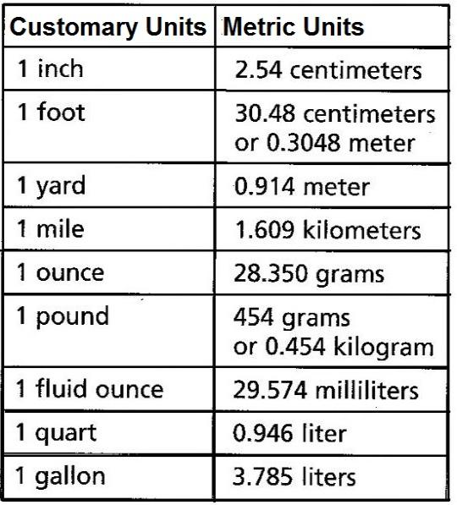
Solving numerical problems
Dimensional analysis is a method of solving numerical problems using both the numerical problems using both the numerical value and the unit. Dimensional analysis involves the use of conversion factors to change the units that a measured quantity is expressed in. in this method the identical units are multiplied or cancelled. Examples: 1.0cm x 2.1cm = 2.1cm
Step 1: write the equation relating the units. For example, to convert a mass from grams to milligrams, the equation must show the relationship between one gram and the number of milligrams in one gram.
Step 2: state the relationship as a fraction (also called conversion factor) the conversion factor can be expressed in two different ways.
Step 3: multiply the measured quantity by the conversion factor that cancels unwanted units and gives the final answer in the required unit. A conversion factor changes the units of the measured quantity, but the actual quantity does not change. To convert from milligrams to grams, the initial unit of quantity is in the denominator of the conversion factor and the unit of quantity we are converting to (g) is in the numerator of the conversion factor. By multiplying the measured quantity by this conversion factor, the units of the measured quantity change from milligrams to grams.
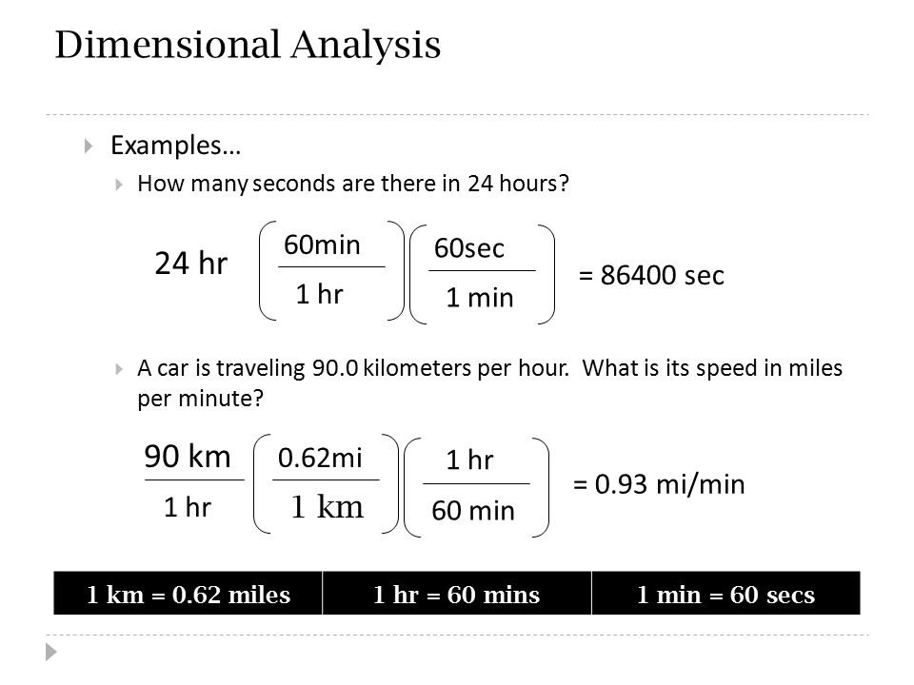
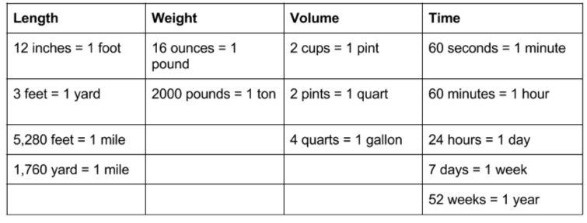
MATTER
What is matter? occupies space (hence possess volume and mass) and are perceivable by our senses. Can be classified as physical state: solid (wood), liquid (water), or gas (air) OR chemical composition: element (copper), compound (sugar), or mixture (antifreeze)
Key terms:
Mixture: A non-pure substance made of two or more elements or compounds that can be separated by physical, as opposed to chemical, procedures. For example, a mixture of sodium chloride salt (an ionic compound) and water (a covalent compound) can be separated by removing the water through evaporation, leaving behind solid sodium chloride.
Elements: are composed of one type of atom. Elements are classified as metal, nonmetal, or metalloid (semi-metal). (ex. Copper)
Compounds: a combination of elements in a definite proportion. The atoms of each or the individual elements are chemically combined to form the compound. The properties of the compound are different from those of the individual elements that it is comprised of. A chemical change can break down a compound into its individual elements. (ex. Sugar)
Mixture: a non-pure substance made of two or more elements or compounds that can be separated physically, as opposed to chemical procedures. (ex. antifreeze)
What are atoms? The smallest unit of any element. Composed of protons (+) and neutrons (no charge) in the nucleus and the electrons (-) surround it and are equal to the number of protons in a neutral atom.
Atomic number: is equal to the number of protons in the nucleus of its atoms. Each element has a different atomic number.
Mass number: equal to the number of protons and neutrons in the atom. To calculate the number of neutrons: subtract the atomic number form the mass number
Atomic symbol: every element has an atomic symbol. Both the atomic and mass numbers are included with the atomic symbol.
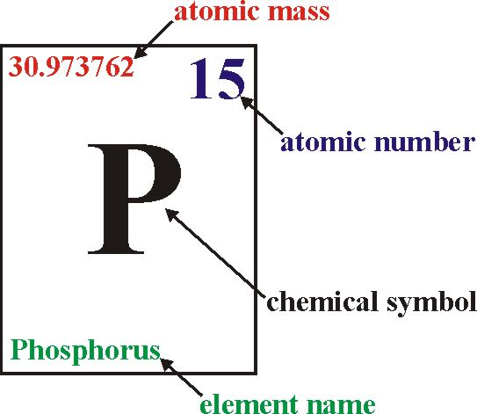
Molecules: a combination of atoms in a definite proportion. (example: molecule of water H20: hydrogen, oxygen=2:1)
Ions: charged species formed by loss or gains of electrons from an atom.
Cation: an atom/molecule that has lost one or more electrons and thus possesses a positive charge. Generated by the removal of electrons and typically metals.
Anion: atom/molecule that gained one or more electrons and thus possesses a negative charge. Generated by the capture of electrons and typically non-metal (Example: NaC(table salt) a compound, consists of Na⁺(cation) & C⁻ (anion) ions)
MODULE 3: THE PERIODIC TABLE AND NAMING COMPOUNDS
The periodic table was proposed by the Russian scientist Dmiri Mendelev in 1869. It is arranged in increasing number and consists of vertical columns with similar properties (groups/families) and horizontal rows with different properties (periods). Groups are designated with the numbers 1(I) to 8(VIII) and a letter A or B. Periods are designated with the numbers 1 to 7.
Elements with group letter A are referred to as the main-group elements.
Elements in the groups with the letter B are referred to as the transition elements.
The inner transition elements (lanthanides and actinides) are located between groups 3B and 4B
Traditional group names:
Group 1A elements: alkali metals
Group 2A elements: alkaline earth metals
Group 7A elements: halogens
Group 8A elements: noble (or rare or inert) gases
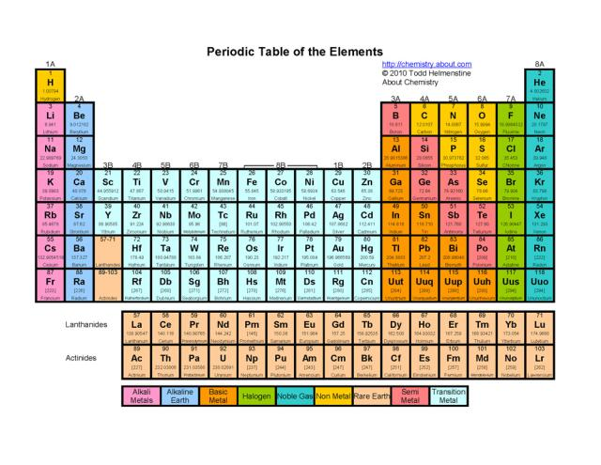
Naming compounds
Ionic compound: A compound consisting of a cation and an anion (generally a metal and a non-metal) where the bond is formed through the electrostatic interaction between the cation and the anion.
Chemical compounds are classified as:
Organic: compounds that contain at least one carbon atom.
Inorganic: compounds that contain atoms other than carbon. Exceptions are inorganic compounds such as carbon monoxide (CO), carbon dioxide (CO₂)
For the purpose of nomenclature (systematic naming), inorganic compounds are classified as those:
- containing a metal and a nonmetal (ionic compounds)
- containing two nonmetals (covalent compounds)

Ionic Compounds: composed of ions. They are formed by the electrostatic attraction between a positive ion (cation from the metal) and a negative ion (anion from the nonmetal). Electrons are transferred from the atoms of one element to the atoms of another element.
In general, metals lose electrons and nonmetals gain electrons. Ionic compounds are charge neutral (zero net charge). Charges on ions involved in an ionic compound must be known in order to name the compound formed between them or to derive the formula for the compound.
IONS
Rules for naming and deriving formulas of ionic compounds
Rule 1: for metal groups 1A, 2A and 3A of the periodic table, the charge on the formed monoatomic cation is equal to the group number. The cation has the same name as that of the metal and is always named first.
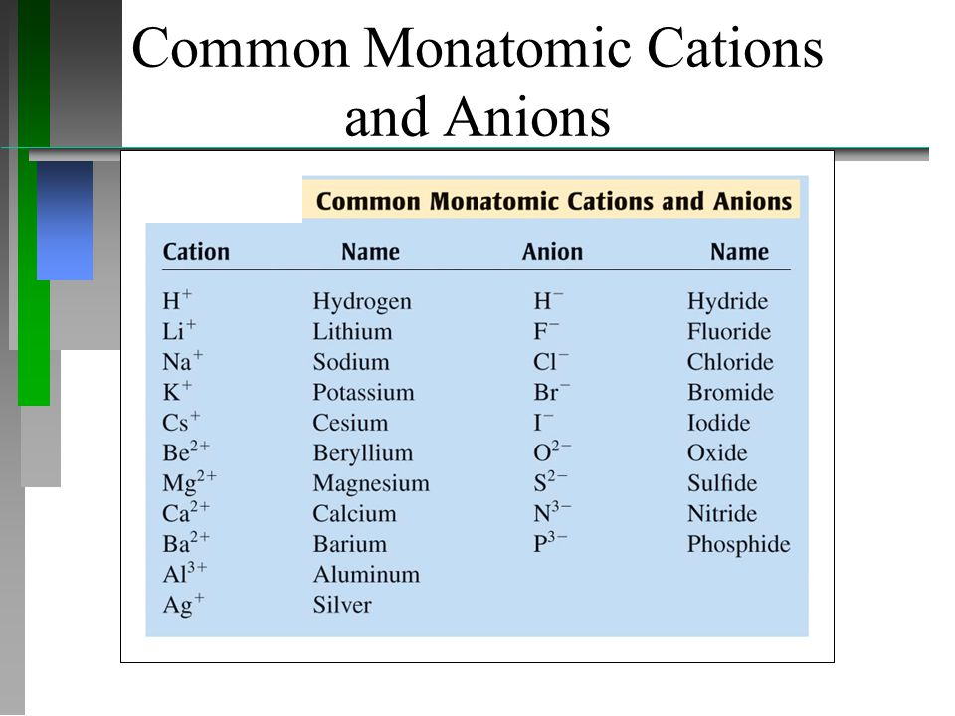
Rule 2: for nonmetals of groups 5A, 6A and 7A of the periodic table, the charge on the formed monatomic anion is equal to the group number minus 8. The anion is comprised of the root of the nonmetal name and ends with the suffix
Element symbol | Anion | Anion name
N | N³⁻ | Nitride
O | O²⁻ | Oxide
F | F⁻ | Fluoride
Rule 3: many metals (particularly transition metals) form more than one cation, thus forming more than one ionic compound with a particular anion. To indicate which ionic compound is formed, the charge on the metal ion is specified by using Roman numerals within parentheses following the name of the metal ion. Example: Iron forms F³⁺ and Fe³⁺ ions. Thus, iron can form two different ionic compounds with chlorine: FeCl [iron (II) chloride]
Main group metal cations | Transition metal cations
Sn²⁺ and Sn⁴⁺ | Fe²⁺ and Fe³⁺
Pb^{2+ and} Pb⁴⁺ | Cu⁺ and Cr³⁺
Rule 4: ions that consist of two or more atoms bonded covalently possessing a net positive or negative charge are referred to as polyatomic ions.
Ammonium ion NH₄+ is an example of a polyatomic cation.
Carbonate ion CO₃²⁻ is an example of a polyatomic anion.
For more than one polyatomic atom the ion is written in parenthesis with a subscript indicating how many there are of the same polyatomic ion:
Calcium nitrate contains Ca² and two NO₃⁻ ions. So this formula is Ca(NO₃) ₂₋
Rule 5: the name, formula and the charge for a number of commonly encountered polyatomic (ions with two or more atoms joined together) anions can be derived from common acids (H⁺ donors) and bases (producing OH⁻). When an acid dissociates (breaks up) it produces H⁺ ions and a counter ion of equal but opposite charge. In case of sulfuric acid (H₂SO₄) it can do so in two ways:
Lose one H⁺ ion leaving HSO₄ ion (notice one positive charge and one negative charge cancel one)
Lose two H⁺ ions leaving the SO₄²⁻ ion (two positive charges and two negative charges cancel out)

COVALENT COMPOUNDS
Covalent compound: the sharing of electrons between non-metals forms covalent compounds
Rules for Naming Covalent Compounds
- Rule 1: Name the first element in the formula first.
- Rule 2: Name the second element as an anion.
- Rule 3: Use prefixes to indicate the number of atoms of each element.
- Rule 4: Do not use the prefix mono- for the first element.
Note: Some compounds are still known by their old names (and not by using the system of nomenclature):
- Water (H₂O) [not dihydrogen monoxide]
- Ammonia (NH₃) [not nitrogen trihydride]
- Hydrogen sulfide (H₂S) [not dihydrogen monosulfide]
- Hydrogen peroxide (H₂O₂) [not dihydrogen dioxide]
- Methane (CH₄) [not carbon tetrahydride]
- Ozone (O₃) [not trioxygen]

Prefixes used in naming compounds
Prefix | Number indicated
Mono- | 1
Di- | 2
Tri- | 3
Tetra- | 4
Penta- | 5
Hexa- | 6

Chemical reactions: are expressed as an equation (chemical equation) using chemical formulas. For example, the reaction between calcium metal and oxygen gas is expressed as the balanced chemical equation: 2 Ca (s) + 0₂ (g) 2 CaO (s)
Step 1 identify the reactants and the product
2 Ca (s) + 0₂ (g) 2 CaO (s)
^reactants^ ^product
Step 2 show the relative amount of the reactant(s) and product(s)
2 Ca (s) + 0₂ (g) 2 CaO (s)
Step 3 indicate the physical state of the reactant(s) and product(s) [s=solid, l=liquid, g=gas, aq=aqueous]
2 Ca (s) + 0₂ (g) 2 CaO (s)
Step 4: the balanced equation above complies with the law of conservation of mass and matter (ex. Atoms and charges on both sides must be balanced)
2 Ca (s) + 0₂ (g) 2 CaO (s)
^---------^ ^--^
illustrates both sides are balanced

Writing chemical equations:
- Fractional coefficients are avoided
- Smallest whole number coefficients are written
It is very important to understand the difference between a coefficient and a subscript. Let us look at the following reaction:
4 Al (s) + 3 O₂ (g) 2 Al₂ O₃ (s)
coefficients: (numbers written in front of each formula) 4, 3 and 2
subscripts: (number written after the letter of the element, subscript 1 never shows) 1, 2, 2, 3
whereas the coefficients indicate the moles of reactants and products, subscripts show the number of each atom present (example: Al₂ O₃ contains 2 aluminum atoms and 3 oxygen atoms. These must not be changed in balancing an equation. The coefficient multiplies every atom in the formula. Thus: 2 Al₂ O₃ represents 4 aluminum atoms and 6 oxygen atoms.
An example:
Pb(NO₃)₂ (aq) + 2Kl (aq) Pbl₂ (s) + 2KNO₃ (aq)
Coefficients: 1,2,1,2
Subscripts: the subscript for Pb is 1. For N it appears to be 1 and for O, 3.
However, N and O have a brackets around them and so the subscript outside the bracket multiplies the subscript on both N and O by that amount. Hence, the real subscript for N would be 1x2=2 and for O, 2x3=6
1,1 [for K and l in Kl]
1,2 [for Pb and l in Pbl₂]
1,1,3 [for K, N, O respectively in KNO₃]
2 KNO₃ represents 2 potassium atoms, 2 nitrogen atoms and 6 oxygen atoms.

Representation of chemical reactions
A main point of a balanced equation is that there are the same numbers of atoms appearing in the reactants (left hand side – LHS) and the products (right hand side – RHS)
Let us balance the following equation:
K+H₂O KOH+H²
K: 1 K:1
O:2 H:3
K:1 O:1
With two on the LHS and three on the RHS, hydrogen is not balanced. Note that both K and H₂ are in elemental form (example: they are not combined with any other element)

Now since hydrogen appears in both H₂O and KOH, we will begin balancing using these two, more complex, series. So, multiplying each H₂O and KOH by 2 gives:
K+2 H₂O 2 KOH + H₂
K: 1 K: 2
H: 4 H: 4
O: 2 O: 2
Both H and O are now balanced, but K is not.
We can just multiply K on the LHS by a factor to balance the overall equation.
2 K + 2 H₂O + H₂
K: 2 K: 2
H: 4 H: 4
O: 2 O: 2
So the balanced equation is:
2 K + 2 H₂O 2 KOH + H₂

Using balanced equations for chemical calculations
Balanced chemical equations are used for chemical calculations. As atoms, molecules or ions are the basic units, the coefficients in such equations denote their number. For example, according to the chemical equation:
N₂ (g) + 3 H₂ (g) 2 NH₃ (g)
1 mole of nitrogen molecules consumes 3 moles of hydrogen molecules
to yield (to produce) 2 moles of ammonia molecules
if under a set of optimum conditions, solid calcium carbonate decomposes to produce solid calcium oxide and gaseous carbon dioxide, how many moles of carbon dioxide gas will be produced (under similar conditions) from 5.00 moles of solid calcium carbonate?
CaCO₃ (s) CaO (s) + CO₂ (g)
According to the balanced chemical equation, 1.00 mole of solid calcium carbonate 1.00 mole of carbon dioxide gas. Therefore, 5.00 moles of carbon dioxide gas will be produced from 5.00 moles of solid calcium carbonate.

Mole: can be considered a “packaging unit” for atoms, molecules, ions, etc. as a dozen (also packaging unit) always refers to the number 12, a mole always equals 6.022x 10²³ (Avogadros number)
Atomic masses: (mass of 1 mole of atoms or mass of 6.022 x 10²³ atoms) of elements are gieven in the periodic table. From these and the chemical formula, molecular masses (mass of 1 mole of molecules or mass of 6.022x10²³ molecules) and formula masses (term used for ionic compounds) can be calculated:
Molecular mass (or formula mass) = sum of atomic masses

For example, knowing the formula of calcium nitrate is [Ca(NO₃)₂] its formula mass can be calculated as:
Ca: 1 x 40.08 g/mol = 40.08 g/mol
N: 2 x 14.01 g/mol = 28.02 g/mol
O: 6 x 16.00 g/mol = 96.00 g/mol
= 164.10 g/mol
similarly, the molecular mass of SF₆ can be calculated as:
S: 1 x 32.06 g/mol = 32.06 g/mol
F: 6 x 19.00 g/mol = 114.00 g/mol
= 146.06 g/mol
Chemical calculations often involve conversion of mass to mole and vice versa. The following expression can be used in performing such conversions:
mole = mass in grams

molar mass (or formula mass)

Example: how many moles are there in 98.0g of sulfuric acid?
Mole=? Mass in grams= 98.0g
Formula mass (H₂SO₄) = 2 x 1.008 + 1 x 32.06 + 4 x 16.00 = 98.08 g/mol
Mole = 98.0g
= 0.999 mole (9.99 x 10⁻¹)
98.08 g/mol
Example: how many grams are there in 2.000 moles od carbon tetrachloride?
Mole=? Mass in gram= 2.000 moles
Molecular mass (CCl₄): 1 x 12.01 + 4 x 35.45 = 153.81 g/mol
Mass in grams: 2.000 mole x 153.81 g/mol = 307.6 (3.076 x 10²g)

MODULE 4 HAZARDS IN THE WORK PLACE

The Environment and Our Health
Our physical and mental well-being (the state of our health), is determined by a combination of hereditary factors and the quality of the environment we encounter. However, it is very important to realize that the term environment includes home, community, workplace and recreational environments. All of these individually or collectively can have a significant impact on our health

Types of hazards in the work place
Safety hazards:
Safety hazards are due to material handling, machines, energy, work practices, and confined spaces.
- Material handling hazards: These can lead to muscle strains due to lifting and carrying materials. The use of devices such as forklifts, cranes, etc. exposes the worker to accidental contact with the moving equipment.
- Machine hazards: Rotating shafts, moving belts, presses, etc. can cause very serious injuries.
- Energy hazards: All energy sources such as electricity, steam, hydraulic pressure, etc. can lead to serious injury.
- Work practice hazards: Failure to follow safe operating procedures may lead to serious injuries.
- Confined space hazards: In such spaces (for example, silos, storage tanks, pipelines etc.) hazards arise due to difficulty of entry and exit, build-up of hazardous materials and oxygen deficiency.
Health hazards:
The extent of occupational health hazards varies with the type of activity. However, such hazards may have the potential to cause severe discomfort, illness, and lack of efficiency among workers. Based on the nature of the causative agent (or factor), occupational health hazards can be classified as physical, chemical, biological and ergonomic.
- Physical hazards are due to the presence of physical agents such as pressure and temperature extremes, excessive noise and vibration, and exposure to radiation.
- Chemical hazards are due to the presence of chemical agents such as dust, fume, gas, mist, smoke and vapor.
- Biological hazards are due to the presence of biological agents such as bacteria, moulds and viruses.
- Ergonomic hazards are due to ergonomic stresses such as fatigue and repetitious work.

Occupational hazards: Physical and chemical
It is very important to note that the mere presence of a causative agent does not necessarily constitute a hazard. A causative agent is classified as hazardous in certain circumstances such as high concentration or intensity and a prolonged exposure.
Workers have the right to:
- Work in a safe and healthy environment
- Know the processes and substances they are working with
- Know potential hazards from these processes and substances

CCOHS: Canadian Centre for Occupational Health and Safety
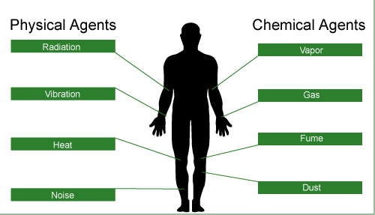

Hazard assessment
In order to recognize and assess the potential impact of occupational hazards, walk-through surveys are performed. Such surveys generally include a study of the following parameters in terms of their impact on the surrounding environment and thus the workers.
Processes, operations and related activities
- Generally various emissions are evaluated because the emission of any physical, chemical or biological agents has the potential to be a health hazard.
Equipment
- Equipment is generally assessed in terms of mechanical and electrical safety and the potential to create excessive noise and vibration.
Properties of substances used and produced
- These include an evaluation of raw materials and finished products in terms of their physical, chemical and toxic properties and effects.
Control measures
All engineering controls in place for proper materials handling, storage, etc. are evaluated. Also considered are the ventilation system and the availability of personal protective equipment.

Physical agents
Although we are constantly exposed to such agents, their intensity and duration of exposure may be more significant in the workplace. Such agents may cause immediate or cumulative adverse health effects.
Commonly encountered physical conditions with a potential to cause adverse health effects include:
- pressure and temperature extremes
- excessive noise and vibration
- radiation
The action of physical agents consists of transfer of residual energy through the surrounding air or the equipment the worker is in contact with. Except for radiation, our senses can detect all other physical agents.

Pressure and temperature
Pressure extremes: Our bodies are conditioned to work at normal atmospheric pressure. Any extreme can be detrimental to one's health. Two types of abnormal pressure-related conditions are hyperbaric and hypobaric.
2 types:
Hyperbaric: defined as a pressure higher than normal atmospheric pressure. Mining and underwater workers may be exposed to hyperbaric conditions.
Example: underwater welding
Hypobaric: defined as a pressure lower than atmospheric pressure. Hypobaric conditions are encountered by those working at high elevations such as ski instructors and airline pilots.
Example: climbing mount Everest

Temperature extremes: The biochemical processes in one’s body take place within a very narrow temperature range and hence the regulation of body temperature is an important function. Temperature extremes affect the working efficiency as well as the health of a worker.
Hot and cold depends on various factors: apart from the surrounding temperature hot and cold depends on some other factors such as: air movement, hot or cold objects in the vicinity and relative humidity.
Heat/cold stress: refers to excessive exposure to very hot or very cold work environments. Both such conditions may interfere with workers performance and may even be fatal.
Heat: Some of the adverse effects in very hot work environments (depending upon the individual worker and the heat intensity) include:
- Heat exhaustion
- Fainting
- Heat stroke
Heat-related problems may arise for:
- Outdoor workers (working in construction)
- Industrial workers (working near furnaces)

Cold: In very cold work environments (depending upon the individual worker and intensity of cold), the adverse effects include:
- Frostbite
- Hypothermia
Workers at risk include:
- Outdoor workers (divers)
- Meat packers and handlers (working in refrigerated warehouses)

Noise and vibration (occupational noise is one of the most common hazards in the work place)
Excessive Noise: Noise is a form of irregular vibration. It may be conducted through gases (or vapors), liquids, or solids. Above a certain level, the noise becomes of concern because it may hinder communication between workers, thus leading to annoyance. This in turn may lead to poor job performance and compromise the safety of the worker. In addition, excessive exposure to high noise levels may cause loss of hearing.
Excessive Vibration: It is important to note that exposure to vibration is more than just a nuisance. Whereas exposure to vibration may cause discomfort, intense vibration has been known to cause serious health problems such as back pain, carpal tunnel syndrome (a condition affecting the hand and wrist) and damage to bones and joints.
There are two types of occupational vibration: whole-body and hand-arm vibration. Whereas whole-body vibration is transmitted through the supporting surface (feet, back, etc.), hand-arm vibration is transmitted to the hands and arms. Examples include: Mining equipment (whole-body vibration) and Hand-held power tools (hand-arm vibration).
Radiation: the hazard associated with a particular type of radiation depends on its energy and ability to penetrate the body tissue. Thus, even brief exposure to high energy and highly penetrating x-rays can cause severe damage to the tissue. Infrared, ultraviolet and microwaves on the other hand do not penetrate appreciably below the skin and the damage is mainly restricted to burns to the skin and eyes. Severe damage to eyes may result from excessive exposure to ultraviolet radiation.

Types of radiation: Radiation is the energy that travels through space from many different natural and human-made sources. Some different types of radiation include: visible light, ultraviolet rays, microwaves, x-rays and radio waves. Thus, it is easy to see that we are exposed to radiation every day.
Ionizing radiation:
The energy associated with it is high and thus strong enough to damage cells and DNA. Some examples and sources of ionizing radiation include:
- x-rays (from x-ray machines)
- alpha, beta and gamma rays (from radioactive materials),
- high-energy ultraviolet (from germicidal lamps).
Non-ionizing radiation:
It is not as strong as ionizing radiation. However, prolonged exposure to some types of non-ionizing radiation can still cause harm. Some examples and sources of non-ionizing radiation include:
- visible light, microwaves (from telecommunications and microwave ovens)
- infrared (from infrared heat lamps)
- radio waves (from broadcasting)
- low-energy ultraviolet (tanning lamps)
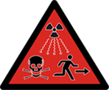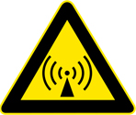The new supplementary ionizing radiation warning symbol launched on 15 February 2007 by the International Atomic Energy Agency (IAEA) and the International Organization for Standardization (ISO)

Radiation applications:
- Industrial: Quality control, non-destructive testing using radiography
- Household: Television, smoke detectors
- Medical: Imaging, treatment
- Science: Material analysis, sterilization

Chemical hazards in the workplace: a large variety of chemical agents are encountered in the workplaces due to the diversity of raw materials and processes used. Chemical hazards in such environments arise due to the chemical agents whose properties (physical or chemical) and toxicity may pose a potential health risk to the health and safety of the worker handling or coming in contact with it.
Where do chemical hazards come from?
They arise in operations involving:
- Compressed gases: hazardous chemicals are compressed and stored in cylinders under pressure. Exposes workers to chemical hazard and pressure extreme
- Flammable and combustible materials: materials that may burn readily in the presence of sources of ignition. (organic compounds like gas or solvents)
- Oxidizing materials: contributes strongly to fire hazards and may possess the ability to oxidize and destroy the biomolecules in living systems (potassium permanganate, hydrogen peroxide)
- Poisonous & infections materials: may be dangerous to life in very small amounts (potassium cyanide, mercury salts)
- Corrosive materials: chemicals cause deterioration of materials including living tissues on contact (sulfuric acid, potassium hydroxide)
- Dangerously reactive materials: chemicals may undergo rapid or violent reactions under certain conditions.

Chemical agents may be present in the air as:
- Fine particles: particles of size less than 5 microns (5x10⁻⁶m) are potentially the most hazardous because of their effective entry and retention in the lungs. (dust, fume and smoke (solids) mist (liquids)). Sources of fine particles are spray painting(mist), welding(fume), incomplete combustion of oil and grease(smoke) and ore grinding(dust).
- Gases and vapor: generated as a result of various operations and can mix and distribute rapidly throughout the workplace. Due to their small size, gases can easily enter the bloodstream through the lungs. Sources of toxic gases are solvent degreasing, spray painting and welding.
- Both as particles and vapors at the same time
- Adsorbed or absorbed gases and vapors on particles

Biological agents: Biological agents are living organisms, or substances produced by such organisms, that can cause illness or disease in humans. The adverse health effects due to biological agents may range from allergic reactions to serious medical conditions and even death. Food poisoning, rabies, tuberculosis and hepatitis are some of the infections caused by biological agents. These include: bacteria, fungi, viruses and other micro-organisms and their associated toxins
Workplace Exposure
Many micro-organisms pose a potential danger in a variety of workplaces due to their ability to:
- Reproduce rapidly
- Survive with minimum resources
Workplace exposure to work-related biological agents such as bacteria, molds, and viruses is limited to certain occupations such as health care workers (i.e., hospital workers and veterinarians), meat handlers (i.e., ranchers, farmers, and meat packers), and those who work in sanitation or sewage operations.

Ergonomic stresses: the science or study of work. It is a way of designing a work environment to fit people. Over the recent years it has been fully realized that the traditional method of assigning people to jobs without accommodating their needs, limitations, sizes, strengths and weaknesses may lead to certain adverse job safety and health issues such as mental stress, loss of efficiency and accidents.
It has been established that ergonomics, properly applied, can help:
- reduce workplace injuries and illnesses; particularly back injuries and cumulative trauma disorder (CTD) affecting, joints, muscles, nerves and tendons that can cause pain and swelling
- improve productivity and quality of work
- increase job satisfaction
- satisfy government regulations

Toxicology: the science that involves the study of the properties and interactions of physical, chemical or biological agents.
Toxicity: the degree of danger of a material to injure a living organism by other than mechanical means.

Toxic hazards: posed by a chemical are influenced by a number of factors such as:
- physical properties
- chemical properties
- intensity of exposure (exposure dose) [concentration x duration of exposure]
- mode of handling
- routes of entry
- susceptibility of the worker

Respiratory, digestive and cutaneous
the interaction of physical, chemical, or biological agents may produce adverse responses with our bodies. Such response range from minor irritation to dreaded diseases like cancer.
The most common natural routes of entry of chemical agents are:
- respiratory tract (by inhalation)
- digestive tract (by ingestion)
- cutaneous – skin and eyes (by absorption)

Dose: Dose is defined as the amount of toxicant(s) actually delivered to the target organ. The units used to express dose are mg/kg (mass of toxicant/body mass).
Exposure
Exposure on the other hand is the total amount of the toxicant(s) present in the workplace. However, exposure does provide an indication of the dose. Higher the exposure, greater the probability of larger amounts being delivered to the target organ and hence higher the dose.
The units used to express exposure are:
- mg/m³ and μg/m³ (mass of toxicant/volume of air) for particles
ppm (parts per million), ppb (parts per billion) and percent (%) for gases and vapors.

Threshold limit values
In order to provide guidelines for controlling occupational health hazards, Threshold Limit Values (TLVs) for various physical and chemical agents have been developed by the American Conference of Governmental Industrial Hygienists (ACGIH). According to ACGIH, one of the ways to specify these values is as Threshold Limit Value-Time-Weighted Average (TLV-TWA). It is the time-weighted average concentration of a substance for a normal 8-hour workday and a 40-hour workweek to which nearly all workers may be repeatedly exposed, day after day, without adverse effects.
Therefore, the lower the TLV value, the more potentially dangerous (or high risk) the substance is.

The effect of toxicants
Duration of the effect:
The duration of the effect can be classified as
Acute: brief exposure to a high concentration of the contaminant and easy to observe. Effect appears soon after exposure.
Chronic: results from low and repeated exposure over a long period of time. More difficult to observe/study. Effect appears much later on after exposure. Organs affected and physiological agents
Toxicant may change the normal functioning of one or a set of organs that operate a system. Example, hepatotoxin (carbon tetrachloride) affect the liver whereas immunotoxins (vinyl chloride) act upon the immune system.
Chemicals with physiological effects:
- asphyxiate: chemicals hinder body in maintaining an adequate supply of oxygen (suffocation due to lack of oxygen)
- irritants: substances cause eye, skin, mucous membrane irritation (ozone, hydrogen sulfide)
- anesthetic’s: depressants (chloroform, alcohol)
- narcotics: habit forming depressants
- systemic’s: cause organ or system damage (benzene, phenol)
- lung scarring agents: lung damage leading to lung cancer (mineral dust, asbestos)
- carcinogens: cancer causing chemicals with long latency period (can develop 10-20 years later)
- mutagens: change in DNA which results in disease or abnormalities in future generations.
- teratogens: malformation in newborns (mercury compounds)

W.H.M.I.S (WORKPLACE HAZARDOUS MATERIALS INFORMATION SYSTEM)
Work place hazards: Several studies estimated a high social cost due to exposure to hazardous materials in the workplace. Due to the seriousness of such health & safety problems, it was agreed to implement an information system with the goal of reduced incidence of illnesses and injuries caused by the hazardous materials in the workplace.
The Workplace Hazardous Materials Information System (WHMIS) is a Canada-wide system developed over several years through the collective efforts of Labour, Industry, and Federal, Provincial, and Territorial Governments. Published in January 1988, it became legislation in October 1988.
The system consists of three key elements:
- cautionary labeling of containers of hazardous materials
- provision of Material Safety Data Sheet (MSDS), which provides more detailed information on the hazardous nature of the material
- provision of worker education program

Class category
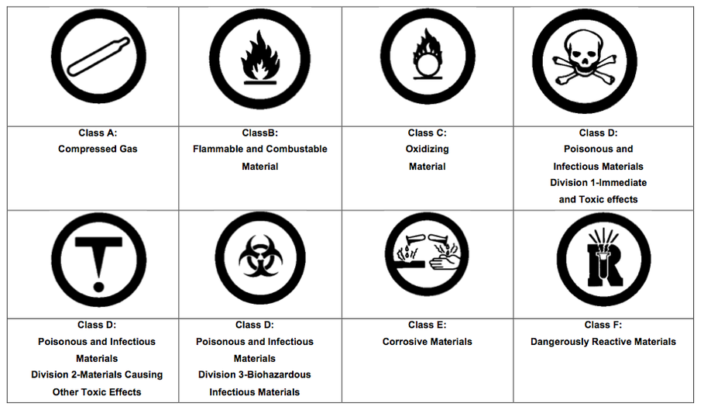

Container labels
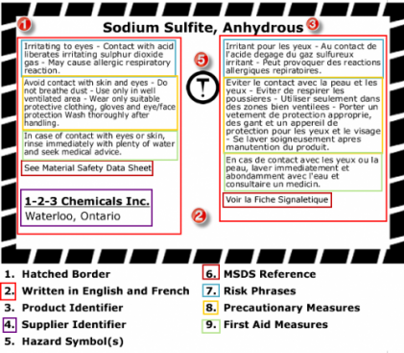
Safety data sheet
The Material Safety Data Sheet (MSDS) provides basic information on a chemical product.
It contains information regarding its:
- Properties
- Potential hazards
- Safe use
- Emergency procedures
It is important to note that these are not a complete source of information.
In some cases, it might be necessary to consult other relevant sources for further information and details on a given substance.

Worker Education
Workers handling hazardous products must be instructed in:
- The information on labels and MSDSs as it applies to their work
- Safe use, handling, storage and disposal of hazardous materials
- Emergency procedures to be used in case of a spill or overexposure

Successful Implementation Requirements
Successful implementation of WHMIS in the workplace requires cooperation of all parties involved. WHMIS sets the responsibilities of the parties involved:
- Suppliers: provide hazard information through labels and MSDS on all controlled products/containers of controlled products.
- Employers (Supervisors): ensure WHMIS labels, identifiers and MSDSs for all containers of controlled products. Employers also ensure availability and accessibility of MSDS information to employees and provide effective worker training to ensure understanding among employees of the labels, MSDSs, and precautionary measures for hazardous materials in their workplace.
- Employees: handle controlled products safely and inform supervisors of damaged/missing labels and missing MSDS information.
Regulators: develop and administer WHMIS legislation.

The Globally Harmonized System (GHS) for Hazard Classification and Labelling
Systems similar to WHMIS (for hazard communication) exist in other countries.
In 1992, the United Nations Conference on Environment and Development (UNCED) agreed to develop a Globally Harmonized System (GHS) for hazard classification and labelling. It is anticipated that such a system will facilitate safe use of chemicals and reduce trade barriers.

Some of the anticipated changes are:
- Inclusion of consumer, transport and workplace sectors rather than workplace only.
- Inclusion of all chemicals except pharmaceutical and cosmetic products intended for consumer use.
- Hazard classification format in the MSDSs.
- Hazard communication format in the labels.

MODULE 5 AIR AND WATER

Air (which all of us must breathe) composes the atmosphere and is a complex mixture of gases surrounding the Earth. The atmosphere is a layered structure divided into layers according to a variety of criteria such as gradually changing:
- Altitude  - Pressure  - Temperature | - Electrical nature  - Chemical composition and concentration
The Atmosphere
According to altitude, the atmosphere is divided into layers:
- Troposphere (8-15km)  - Stratosphere (50 km) | - Mesosphere (80 km)  - Ionosphere/Thermosphere (500-600km)

Composition of air: The air we breathe is a mixture of several gases, fine particles and vapors. Dry air consists of 21% oxygen and 78% nitrogen plus traces of other substances that are both natural and human-made.
Major components of air:
- Nitrogen (N₂)
- Oxygen (O₂)
- Water (H₂O)
- Carbon dioxide (CO₂)
Some minor components of air:
- Carbon monoxide (CO)
- Ozone (O₃)
- Oxides of Sulfur (SO_{x})
- Oxides of Nitrogen (NO_{x})
The air pollutants:
Whereas major components are essential for life, the minor components are pollutants, which under certain conditions may produce adverse environmental and health effects. These air pollutants are emitted directly into the atmosphere during combustion and production processes, changing the composition of atmosphere and causing poor air quality.
The burning of fossil fuels (i.e., petroleum, natural gas and coal) can be used:
- to generate energy (electricity, gas and steam)
- in transportation (combustion engines)
- in industrial processes that use a great deal of energy sources (i.e., pulp and paper mills, ore smelters, petroleum refineries, power generating stations and incinerators)
These elements are mainly responsible for the presence of minor components. That is, they are the major sources of human-created air pollution.

Carbon monoxide: adequate supply of oxygen leads to a combustion of fossil fuels forming the major by-products: carbon dioxide and water. Most carbon monoxide (CO) produced in this process is immediately oxidized to carbon dioxide. If there is insufficient supply of oxygen, there is incomplete combustion of fossil fuels and carbon monoxide gas is released. Natural sources of carbon monoxide are forest fires and volcanoes. When a person CO is binds to the oxygen carrying site on the hemoglobin of red blood cells causing a reduction of oxygen transport in the body. Health effects are cell and tissue death., impaired ability to use oxygen, decreased athletic performance and cardiac problems.
Ground-level ozone: O₃ is a naturally occurring gas that forms a protecting layer in the atmosphere, present predominantly in the stratosphere. Protects earth by absorbing harmful ultraviolet radiation from the sun. Ground level ozone is produced during photochemical reactions between volatile organic compounds (VOCs) released in automobile exhaust and oxides of nitrogen (NO) in the presence of sunlight. Health effects are damaged biological tissue and cells, reduced lung function and itchy, burning and watery eyes.
Oxides of sulfur: (SO_{x}) released mainly during processing (smelting) of mineral ores and the combustion of fossil fuels (burning of coal/petroleum). Natural sources are volcanoes. The health effects are problems breathing, and respiratory illness.
Oxides of nitrogen: (NO_{x}) caused by fuel combustion for transportation, home and industrial use. NO forms in the air from fuel being burnt at high temperatures. Natural sources are lightning and microbial activity of soil bacteria. The health effects are serious lung damage, and shortness of breath and chest pains.
Entry into the body
The air we breathe (inhalation) is handled by the lungs, which provide an extremely efficient method of getting oxygen (required for metabolic processes) into and carbon dioxide (waste product of metabolic processes) out of the body.
Unfortunately, the lungs also provide an excellent opportunity for minor components (pollutants) to diffuse into the blood stream via gas exchange in the alveoli.
As breathing is a continuous process, considerable amounts of a pollutant (even if present as a minor component) can be inhaled and efficiently transported into the body. Once in the body, they may manifest adverse health effects.

Risk Assessment
In order to assess the health risks due to air pollutants, we require exposure and effects assessment.
- Exposure assessment: estimates concentrations using chemical measurements.
- Effects assessment: relies on toxicity testing (estimates of exposure toxicity) and computer models to extrapolate data from human population, animal, and bacterial toxicity studies. Quantitative analysis of epidemiological, toxicological and exposure data that are based on the accurate scientific evidence estimates exposure toxicity and risk.
Risk characterization integrates the exposure and effects components to estimate the risk.

Exposure measurement
Exposure is measured by determining the pollutant concentration in air. Monitoring methods include:
- Air sampling followed by laboratory analysis of the pollutant(s) using established procedures.
Real time monitoring using direct reading pollutant-specific monitors.

Commonly used concentration units
For gases and vapors: | For particles:
- Parts per million (ppm)  - Parts per billion (ppb)  - Percent (%) | - Milligrams per cubic meter (mg/m³)  - Micrograms per cubic meter (µg/m³)
Keep in mind these useful conversion factors:
- 1% = 10⁴ ppm
- 1 ppm = 10³ ppb
Example: A gas is toxic at a concentration of 500. ppm and any level of exposure above this value is considered unsafe for a worker. A real time monitor for the gas indicated a concentration of 0.0615% in a workplace environment. Is it safe to work in such an environment?
(0.0615 parts gas/10² parts air) x 10⁶ parts air = 615. ppm
It is not safe to work in such an environment.
Note: x% simply means x parts per hundred parts.

Threshold limit values
Thus, for pollutants, Threshold Limit Values (TLVs) have been developed and issued by the American Conference of Governmental Industrial Hygienists (ACGIH) to assist in the control of workplace health hazards.
According to ACGIH, Threshold Limit Value-Time-Weighted Average (TLV-TWA), is defined as the time-weighted average concentration for a normal 8-hour workday and a 40-hour workweek, to which nearly all workers may be repeatedly exposed, day after day, without adverse effect.
Substance | TLV-TWA
CO | 25 ppm
NO₂ | 3 ppm
O₃ | 0.1 ppm
SO₂ | 2 ppm

Air quality:
Asbestos fibers: has been used in building construction material for insulating and fire proofing. Deteriorating, damaged or disturbed insulation, fireproofing become the source of asbestos fibers in the indoor air.
Biological contaminants: includes bacteria, dust mites, insects, mold, pet dander, rodents, and viruses.
Combustion by products: includes gases (carbon monoxide etc) and small particles created by incomplete burning of fuels (wood, gas, coal)
Formaldehyde: source in indoor air is pressed wood products such as hardwood plywood wall paneling, tobacco smoke, glues etc.
Pesticides: originates from products used to kill household pests, outdoor pesticides can be tracked indoors too.
Radon gas: slowly released from ground, water and some building materials that contains small amounts of uranium.
Respirable particles: depending on size, can be inhaled into lungs. Sources are fireplaces, wood stoves tobacco.
Volatile organic compounds: originate from a variety of indoor sources like air fresheners, aerosol sprays, disinfectants etc.

Control strategies
Over the past two decades, stricter environmental emission control regulations and pollutant(s) mitigation (reduction) technologies have led to considerable reduction in the concentration of many pollutants.
The North American Free Trade Agreement (NAFTA) obliges all the three signatories to enforce environmental laws. There is a move in all the three nations toward tougher and thorough reporting of releases of pollutants to the environment. In Canada, National Pollutant Release Inventory (NPRI) is a publicly-accessible database of pollutants released to the Canadian environment.
Among the global initiatives is the establishment of the International Register of Potentially Toxic Chemicals (IRPTC). It is a computer based database. One of the objectives of the register is to identify the potential hazards of using chemicals and to make people aware of them. The database provides access to information regarding production, distribution, release and disposal of hazardous chemicals. The database also includes information on environmental and health effects of such chemicals.

The water molecule
Water (H₂O) consists of two nonmetals hydrogen and oxygen. The water molecule is formed by the covalent
bonding of two hydrogen atoms to an oxygen atom. Water is a unique substance that is literally everywhere.
A vital substance to our well-being and very existence, water is intimately linked to our daily life.
Unique properties of water: The polar nature and the capability to form hydrogen bonds are responsible for many of the unique properties of water. Such properties play an important role in making water essential for life and in determining its chemical behavior in the environment.
Polarity of Water
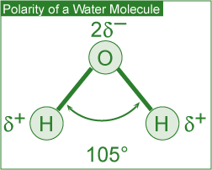
The polar nature of the water molecule is due to its:
- Polar covalent bonds: The electron pair forming the covalent bond (between the oxygen atom and each of the two hydrogen atoms) is more strongly attracted by the oxygen atom due to its higher electronegativity (the ability of an atom in a molecule to attract shared electrons over another atom in the molecule).
- This leads to a partial positive charge on each of the two hydrogen atoms (represented as ⁺ ) and a partial negative charge on the central oxygen atom (represented as ⁻ ) making the water molecule behave like a dipole.

Molecular shape: A water molecule has a bent (V-shape) shape (H-O-H bond angle of 104.5°). This, in combination with the polar covalent bonds, leads to a resultant dipole and hence the polarity of the water molecule.

Hydrogen bonding: The partial charges present lead to intermolecular attraction between water molecules. A single water molecule can thus attract four other water molecules. These intermolecular attractive forces are called hydrogen bonds. These are much weaker than the forces holding the atoms in the covalent O-H bond.

Solvent properties: Water is a powerful solvent due to its high polarity and hydrogen bonding ability. It is an excellent solvent for ionic (e.g., table salt), polar covalent (e.g., sugar) and non-polar (e.g., oxygen) compounds. In the case of ionic compounds, the ions are separated from the solid and caged (solvated) by polar water molecules, thus keeping them in solution.
Polar covalent compounds (i.e., ethanol and glucose) dissolve in water by the formation of hydrogen bonds. Water therefore plays an important role in the transportation of nutrients and waste products in biological processes. Aquatic life and plants survive due to dissolved oxygen and carbon dioxide.

Thermal properties: The presence of hydrogen bonds in water accounts for its exceptionally high boiling point, specific heat and heat of vaporization. A portion of the heat supplied is used up in breaking the hydrogen bonds.
Specific heat is defined as the amount of heat energy required to increase the temperature of 1 g of a substance by 1°C.
High specific heat of water regulates and stabilizes the temperatures of geographical regions and organisms within a narrow range. This in turn allows our planet to support life.
Heat of vaporization is defined as the quantity of heat required for the conversion of 1 g of a liquid entirely into its vapor at a constant temperature. High heat of vaporization of water helps in regulating the temperature of our body. It is also responsible for powering the winds and storms of our planet.
Density of solid and liquid water: Ice has a hexagonal open structure due to the presence of hydrogen bonds. When ice melts, the open spaces are filled with liquid water, causing the crystal structure to break down.
This leads to a reduction in volume for the same mass and hence an increase in density (density = mass/volume). The higher density (thus expansion and contraction of volume due to the freeze-thaw cycle) of liquid water than that of ice accounts for phenomena such as:
- Floating of ice on water
- Survival of aquatic life during winter
- Nutrient turnover in bodies of water
- Formation of pebbles, soil and sand
- Bursting of frozen water pipes

Surface properties: The high surface tension and capillarity of water is due to the presence of hydrogen bonds. Water is the liquid with the highest surface tension. Plant debris rests (rather than sinks) on the surface of water bodies due to its high surface tension. This provides aquatic life with much-needed shelter and nutrients.
Capillary action (also due to high surface tension) makes water in soil available to plants. On Earth, the capillary effect can be seen in fine tubes containing liquid: surface tension pulls the liquid column up until there is a sufficient mass of liquid for gravity to overcome the intermolecular forces. As the mass of the liquid column is proportional to the square of the tube's diameter, a narrow tube will draw a liquid column higher than a wide tube.

MODULE 6 HOUSEHOLD PRODUCTS

Soaps, detergents and our health
Soaps and detergents play a very important role in our lives. These chemicals help us in making our surroundings cleaner (i.e., by removing soil and grease), healthier (i.e., by reducing the germs), and pleasant.
In order to make it more effective in the process of cleaning, the water must be made to spread and thus wet surfaces effectively, i.e., its surface tension must be reduced.
This is achieved by using compounds called surfactants.

What are surfactants?
Composed of a hydrophilic (water-soluble) head and a hydrophobic (fat-soluble, water-hating) tail. The hydrophilic end is stable when solubilized in water and the hydrophobic end consists of a long chain hydrocarbon that is more stable when surrounded by other organic groups. Soaps and detergents are composed of surfactants and they are water soluble and surface-active agents.
Classes of Surfactants
There are different classes of surfactants categorized by the charge of the hydrophilic component of the surfactant molecule after dissociation in water:
- Anionic surfactants have a negative charge.
- Cationic surfactants have a positive charge.
- Non-ionic surfactants have no charge.
- Amphoteric surfactants have both positive and negative charges.
Composition and Limitations of Soap
Soaps (anionic surfactants) consist of the long hydrocarbon tails of fatty acids and the polar heads of sodium or potassium salts of fatty acids (found in fats and oils of animals and plants).
Traditionally, soap was made from animal fat and wood ash (composed of potassium hydroxide and potassium carbonate).
Advantages
- Soaps are manufactured from combinations of natural and renewable resources.
- Soaps are biodegradable and do not pollute bodies of water.
Disadvantages
- Formation of soap film (or scum) in water containing Ca²⁺ and Mg²⁺ ions (hard water) the calcium and magnesium ions react with soap molecules to produce calcium and magnesium salts of fatty acids. These salts are insoluble in water and impair the surfactant properties of soap because the amount of soap available for cleaning it is reduced. Soap scum is difficult to rinse away and can be visible, example on fabrics, bathtubs and sinks
- Poor adaptability to diversity of fibers, washing temperatures and water conditions.
- Tendency to clog sewage systems due to their gelling properties.
Composition and limitation of detergents
Detergents (containing a variety of engineered anionic or non-ionic surfactants) are made from petrochemicals.
Advantages
- Detergents are less affected by calcium and magnesium ions in water, thus acting as better cleaning agents and almost eliminating the film formation.
- Detergents perform well under diverse conditions such as adaptability to diversity of fibers, washing temperatures and water conditions.
Disadvantages
- Detergents are made from non-renewable petroleum-based oils.
- Majority of detergents are not biodegradable
The soap/detergent interaction
In the cleaning process, the polar end of the surfactant molecule interacts with water (a polar molecule) and the non-polar end is attracted to oil or grease (non-polar molecules)
Step 1: chemical interaction (with soap or detergent) traps the oily and greasy soil molecules. In aqueous solution, surfactants cluster near the surface.
Step 2: the hydrophobic tails are attracted to grease and the hydrophilic heads to the water, thereby forcing the grease away from the soiled surface.
Step 3: the grease is then surrounded by the individual surfactant molecules and removed from the soiled surface.
Finally, thermal interaction (with hot water) helps dissolve oil and grease molecules. Mechanical interaction (machine agitation or hand rubbing) releases oily and greasy soil from the fabric.

Depending on the function, household soaps and detergents can be classified as those used for: personal hygiene, laundry, dishwashing and household cleaning.
It is important to note that in view of the functional diversity, these products are usually formulated by mixing many ingredients. For example, laundry detergents are formulated from the following groups of chemicals:
- Surfactants to bind and suspend grease and dirt in the washing water
- Builders to remove Ca²⁺ and Mg²⁺ from hard water and soil
- Bleaching agents to remove stains and kill bacteria
- Enzymes to catalyze the degradation and elimination of some stains
- Miscellaneous chemicals such as foam stabilizers, fabric brighteners, fragrances, corrosion inhibitors etc. are added in small quantities.

Environmental impact: Developing Products that are Safe for all of Us
As cleaning products are an integral part of our lives, it is very important to be aware of their impact on our health as well as the impact on the environment once discharged.
Health risks are very real, particularly in the case of some specialty household cleaners. Drain openers, oven cleaners and toilet bowl cleaners may contain reactive and/or corrosive chemicals. It is imperative that adequate safety precautions are taken while using such products.
The manufacturers are obliged by law to evaluate the environmental safety of the ingredients. Most of these products are formulated to work with water and end up in wastewater treatment plants, thus impact on the environment is minimized.
The Safer Detergent Stewardship Initiative (SDSI) program of the U.S. Environmental Protection Agency (EPA) recognizes corporate environmental leaders using safer surfactants which break down quickly into non-polluting chemicals and thus protect aquatic life.
Recent trends
In keeping with consumer demand for more efficient and environmentally friendly products, the present trend is to develop home and fabric care products that:
- Contain surface protectors or modifiers that repel soil and stains more effectively.
- Deliver active ingredients in a controlled way.
- Are effective in cold water.
- Contain natural or naturally derived ingredient(s).
- Do not contain chemicals of concern with respect to toxicity.
- Generate less carbon dioxide during production (smaller environmental footprint).

Personal care products:
Nearly all of us use personal care products for one or more reasons: to make our hair clean and colorful, skin free of wrinkles or to delight the senses. This is an expanding and dynamic field primarily because such products must be developed to take care of the changing needs of society.
- Influencing factors
- Aging population
- Changing attitudes of men
- More woman in the workplace
- Concerns about exposure to radiation
The chemical ingredients in these products are thus changing at a remarkably fast pace. The availability of biotech products and processes to produce new ingredients is going to revolutionize the development of personal care products in the future.
In addition to rapidly changing chemical ingredients, more efficient delivery systems are being introduced. These include a variety of encapsulation systems to deliver the active ingredients in cosmetics.
Many shampoos, lipsticks, face creams and toothpastes contain these microcapsules. The active ingredient is delivered when the microcapsules rupture on the applied surface (e.g., skin) due to rubbing, presence of moisture, change in pH or the presence of naturally occurring bacteria.

Hair care products:
Shampoo: cleansing agents containing anionic surfactants to remove oil and dirt from hair and scalp. Surfactants produce foam, lifting the oil and dirt from the hair. Fragrance’s, thickeners, foam boosters and other agents may also be added.
Conditioners: usually contain cationic surfactants. These help in rinsing out any residual shampoo and at the same time provide softer and easy to manage hair.
Styling agents: the curling of hair is carried out in 3 steps:
- Treatment of hair with a reducing agent (an electron donor) that breaks certain covalent bonds.
- Setting hair in the desired shape
- Treating hair with an oxidizing agent (an electron acceptor) such as dilute solution of hydrogen peroxide to reform the previously broken covalent bonds in the new shape.
Colorants: hair coloring is a two-step process involving oxidation of natural hair pigments to colorless products using a bleaching agent and application of an organic, synthetic dye to obtain the desired color. In order to reduce the damage to hair and the smell of ammonia chemists replace it with ammonium carbonate.
Major developments in the field of hair coloring:
- A large variety of colors
- Improved delivery systems to enhance the adhesion of colors to hair
- More effective conditioners to neutralize the harsh effects of dye chemicals
How do moisturizers work?
Used to increase the water content in the skin. They perform a number of functions such as:
- Prevent and treat dry skin
- Protect the skin and make it appear smooth by encouraging an orderly shredding process
- Improve skin tones and texture
- Protect sensitive skin and mask imperfections
The active ingredients in moisturizers are:
- Humectants: absorb and hold it in the skin (example glycerin)
- Emollients: lubricate and smooth the skin (example mineral oil)
- Miscellaneous: antioxidants, fragrances, minerals, plant extracts, vitamins.
Skin care products containing plant derived chemicals are being developed at a fast rate

How do sunscreens work? Used to protect the skin against harmful effects of UV radiation. Sunscreens are formulated with additional chemical ingredients that absorb UV radiation.
Two types of active ingredients in sunscreen
Inorganic: approved for use are titanium dioxide and zinc oxide. These work primarily by reflecting and scattering UV light.
Organic: varieties approved for use, they work by absorbing UV light and dissipating it as heat.
The effectiveness of sunscreen is rated by its ability to block the UV-B rays that cause skin burns. This is called SPF (sunburn protection factor) in order to achieve high SPF formulation contains a mixture of organic and inorganic ingredients.

Protection factors:
- Activities (swimming leads to a loss of sunscreen from body)
- Amount applied and frequency pf re-application
- Solar intensity
- Type of skin
- Amount of sunscreen absorbed by the skin
Safety in the sun: In an attempt to inform the consumers, the level of UV-A protection in sunscreens, the US Food and Drug Administration (US FDA) is proposing a four-star rating system to be displayed near the SPF rating on the label. According to this system, one star will represent low UV-A protection and four stars the highest UV-A protection.

COSMECEUTICALS
Whereas pharmaceuticals are defined as products that may affect the structure or any function of the body, cosmetics are something superficial to cover a deficiency or defect.
Cosmeceuticals: used to describe cosmetics containing ingredients which may affect the structure or any function of the body like pharmaceutical ingredients. During the late 1980s, alpha hydroxy acids (AHAs) became important ingredients in many cosmetic formulations claiming to reduce signs of aging, sun-damaged skin and wrinkles. These work by breaking down and lifting off part of the top layer of dead skin cells in order to get rid of some surface damage and accelerate growth of living cells. The cosmetic industry believed the ingredients to be more than simple cosmetics and hence called them cosmeceuticals.
Some of these products are only available with a doctor's prescription and supervision. They include, among others, Botox (for a more youthful look), Vaniqa (to eliminate unwanted facial hair) and Propecia (for bald men).

Perfumes: Perfumes are alcoholic solutions of organic compounds with pleasant odors (fragrant compounds). Today, a large variety of natural and synthetic compounds are available to create fragrances for perfumes. In creating perfumes, the ingredients are blended based on their molecular size and volatility.
For this reason, the fragrances in perfumes are generally experienced in three different stages referred to as top, middle and base notes. The top notes are the most volatile components and hence experienced immediately after the opening of the package. The middle notes are experienced next followed by the base notes which last longest.
A recent trend has been to develop more intense and long-lasting alternatives to the known fragrant compounds. Such low-volume production means less impact on energy, health and the environment.

Deodorants
Body odors are reduced or masked by the use of deodorants. Such odors may originate from the conversion of certain compounds (present in the perspiration) to unpleasant odors by bacteria. Thus the effective chemical ingredients in such products are antibacterial agents and perfumes.
Cosmetics
Facial cosmetics such as lipstick and mascara generally contain oils, waxes, pigments and perfumes. Lipstick manufacturers blend various proportions of oils, waxes and emollients (to soothe the skin) to formulate the base for their unique brand. Fragrances, pigments, preservatives, antioxidants and a variety of other ingredients are then added.
In recent years there has been a concern regarding the presence of low levels of lead in certain cosmetics. A recent testing of a number of brands of lipstick by the US FDA (United States Food and Drug Administration) has shown the presence of low levels of lead. According to the US FDA, the levels observed do not pose a safety concern.

MODULE 7 DRUGS AND MEDICATIONS

Organic chemistry: the study of carbon containing compounds and their reactions. Organic molecules are present in living organisms and in many products used in our everyday lives such as foods, household cleaning products, personal care products etc. As the element carbon is present in the majority of drugs used today, some basic principles of organic chemistry (the study of carbon compounds) are discussed in this section.
The element carbon
The main characteristics of carbon that lead to the formation of such a large number of organic compounds (over 10 million known) with dramatically different physical and chemical properties include the ability to form:
- Covalent single, double and triple bonds with some other elements, including carbon.
- Covalent bonds with other carbon atoms to build chains and cyclic structures.
- Covalent bonds with elements such as hydrogen, nitrogen, oxygen and halogens.
Single bond
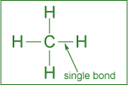 formed by the sharing of one pair of electrons
Double bond
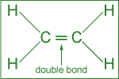 formed by the sharing of two pairs of electrons.
Triple bond
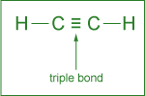 formed by the sharing or three pairs of electrons.

Arrangement of atoms
Among the cyclic structures, the arrangement of carbon atoms in 5- or 6-membered rings is quite common. The hexagonal (6-membered) ring with three single and three double bonds is called a benzene ring.
Various ways to represent benzene (C₆H₆)
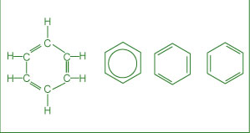

Organic compounds are divided into some important families based on their characteristic functional group. A functional group can be visualized as a small structural unit or arrangement of atoms in a molecule that is the chemically functioning part of the molecule. In the case of drugs, the functional groups are responsible for their action. In addition, the functional group may also determine important parameters such as the rate of uptake and reaction as wells as the time of residence of the drug in the body.
Functional groups:
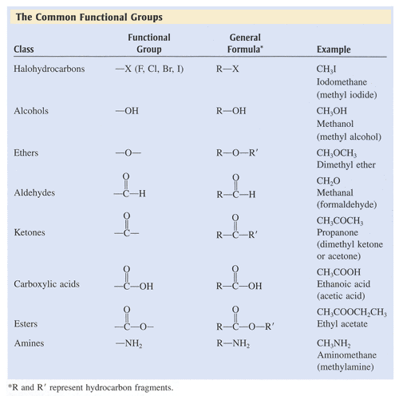

Treatment of infectious diseases
From the Sumerians (2200 BC) to the present, the discovery and usage of drugs has gone through a number of phases such as:
- Medicinal preparations and concoctions from plants, minerals and animal sources.
- Isolation and the use of plant ingredients as medications.
- Synthesis and testing of a variety of chemicals as potential cures for ailments.
- New areas of research into marine plants and organisms as potential drugs.
- Molecular modeling in designing drugs.
Extensive research with the available sophistication in the field of medicine has led us to engineer molecules that can be used to improve the quality of life by preventing, moderating or curing illnesses
Antibiotics: used to fight (prevention or treatment) bacteria that can cause infectious diseases such as meningitis, pneumonia, tuberculosis etc.
Several different categories of antibiotics include:
- Penicillin
- Cephalosporin
- Tetracycline
The discovery of a large number of chemically modified derivatives of these antibiotics led to the control of a large variety of bacterial infections. Antibiotics are isolated from bacterial sources, but can also be human-made. Antibiotics act directly on bacteria and destroy them or inhibit their growth. Antibiotics will not kill viruses.
How do antibacterial drugs work? The mechanism of antibacterial drugs is to alter or inhibit one of the following cellular structures/processes:
- Cell wall synthesis: prevents new bacterial cells from forming by preventing formation of the cell wall.
- Cell membrane permeability: kills bacteria cells by causing breakdown of the outer cell membrane
- Protein synthesis: prevents the bacteria from converting proteins to energy, causing starvation and ultimate cell death.
- Nucleic acid synthesis: keeps bacteria cells from growing by interrupting DNA synthesis
- Competitive inhibitor: mimics bacteria’s growth factors, thus preventing spreading of the bacteria.
Penicillin:
- Treat infections caused by bacteria
- Do not fight infections caused by viruses
- Mode of action: affect the development (damaging) of bacterial cell walls.
Cephalosporin
- Have similar structure to that of penicillin
- Treat a much broader range of infections compared to penicillin’s
- Mode of action: affect the development of bacterial cell walls
Tetracycline
- Chemical structure consisting of four rings
- Used to treat penicillin-resistant infections
- Mode of action: inhibit the synthesis of required bacterial proteins

Antibiotics vs superbugs
The emerging concern in the use of antibiotics is the resistance many of the so-called superbugs have shown towards the known antibiotics. The suggested ways to decrease antibiotic resistance include:
- More cautious use of antibiotics
- Monitoring outbreaks of antibiotic resistance
- Developing new antibiotics
Antiviral drugs
Antiviral drugs are used to treat (cure or control) viral infections such as flu, polio, herpes and AIDS (Acquired Immune Deficiency Syndrome). A different strategy has to be used to combat viruses, as these do not respond to antibiotics. Two commonly used strategies to fight viral infections include:
Prevention through vaccination
When a vaccine (consisting of inactivated virus) is injected, antibodies to fight off a virus are developed and stored in the body. The stored antibodies become available to fight future infection.

Use of antiviral drugs
Commonly used antiviral drugs (particularly for the treatment of the AIDS virus) fall into three classes:
- Nucleoside derivatives inhibit the synthesis of viral DNA, thus preventing the virus from spreading.
- Protease inhibitors, on the other hand, interfere with the viral protein formation, thus preventing their reproduction.
- A three-drug cocktail consisting of different nucleoside derivatives and protease inhibitors has shown considerable promise in the treatment of AIDS. This triple cocktail treatment is also known as Highly Active Antiretroviral Therapy (HAART). The success of the therapy is probably due to the cocktail's ability to disrupt the viral replication at different stages. It is important to note that the therapy is very expensive and patients must adhere to their dosing schedule.

Some major problems associated with multiple drug therapy are: Moderate effectiveness, lack of response in some cases, serious to severe side effects and drug resistance by the virus. Recent efforts in the fight against AIDS have been directed towards the development of: Viral entry inhibitors (i.e., the drugs that will prevent HIV from attaching and consequently entering into the cell) and Vaccines.

Anticancer drugs: chemotherapeutic agents
Cancer involves an uncontrolled division of some cells of the body due to mutation od DNA within the healthy cells. These cells invaded nearby tissue and spread throughout the body via the bloodstream or lymphatic system. The chemical treatment of cancer (chemotherapy) involves drugs targeting rapidly dividing cells to kill the cancerous cells. Some chemotherapeutic agents include:
Alkylating agents: due to their high reactivity, alkylating agents introduce defects in the DNA killing the rapidly growing cells by preventing cell growth and multiplication. Alkylating agent drugs also affect the growth of normal cells and cause mutations.
Antimetabolites: metabolite is a general term for the organic compounds that are synthesized, recycled or broken down in cells. Antimetabolites inhibit DNA synthesis, stopping cell replication. They compete for binding sites on enzymes and are incorporated into nucleic acids.
Topoisomerase inhibitors: damage DNA which cause cell death. Act against the topoisomerase enzymes to prevent cancer cell growth.
Hormone therapy: used against certain cancers that depends on hormones for their growth. This therapy is used primarily for the treatment of breast cancer and other sexual organs. As these tissues require hormones for their growth, chemotherapeutic agents act by inhibiting the hormone supply and stopping the tissue growth. Stops the production of certain hormones or changes their mode of function.

Antidepressants:
A deficiency of certain neurotransmitters (any chemical that carries impulses between nerve cells), particularly serotonin in the brain, seems to be partly responsible for causing clinical depression. Neurotransmitters are needed for normal brain function and mood control, in addition to other functions.

Anti-inflammatory drugs:
Inflammation is the first response of the immune system to infection or irritation characterized by pain, swelling, redness or heat. An inflammation results from the rapid transport of blood proteins and other substances to a damaged tissue site or an area under attack by a foreign organism. Certain steroids are used as potent anti-inflammatory drugs. These suppress the inflammatory responses of the body and reducing inflammation.
Over the counter drugs
A considerable number of drugs are sold over the counter (OTC) without prescription. According to the non-prescription drug manufacturer association, in the US alone there are more than 600 OTC drugs.
OTC drug criteria:
The criteria generally used by the regulatory agencies to designate a drug with OTC status or switch it status from R_{x}-to-OTC (from a prescription drug to one sold without a prescription) involves a benefit-risk comparison and making sure that patients alone can achieve the desired medical result without endangering their safety
Although OTC drugs allow patients to participate in their own health care, experts emphasize that the labels must be followed closely because OTC drugs are not without risk.
Aspirin (the best known OTC drug): introduced more than a century ago, it has long been used as an analgesic (relieving minor pain) antipyretic (lowering fever) and anti-inflammatory drug (reducing swelling). Recent studies have also shown its usefulness in treating heart attack and stroke.
Its effectiveness is due to its ability to reduce the production of prostaglandins (a hormone-like substance that promotes inflammation, fever and pain) and thromboxane’s (responsible for platelet aggregation in the formation of blood clots) in the body.
Some possible side effects are:
- Stomach irritation
- Ringing in the ears
- Allergy
- Reye syndrome in children (brain disorder)

Drug delivery system
Active pharmaceutical ingredient (API) in a medicine is delivered to the body in many forms, such as tablets, gel caps, liquids and so on. Some newer alternate methods for drug delivery have been developed with three major advantages:
- User convenience
- Improved drug performance
- Better patient compliance

Some of these methods include:
- Pulmonary delivery: The system is noninvasive and facilitates the rapid absorption of the drug on the large surface area of the lungs followed by rapid desorption into the bloodstream.
- Skin absorption: Skin patches are being used to deliver the medication via skin absorption.
- Nanocrystals: This method reduces the drug particle size to nanoscale (<400 nm) making it more soluble in body fluids.
Environmental Effects of Pharmaceuticals
Recent research has led scientists to be concerned about the environmental impact of old and/or expired medications that are discarded. The pharmaceuticals enter the environment mostly through raw or treated sewage.
Some of the effects observed include:
- Feminization of male fish due to estrogenic compounds: The signs of feminization in male fish have been concluded as a response to estrogen (in birth control pills) exposure.
- Slow development of fish and frogs due to certain antidepressants: Profound effects on spawning and other behaviors in shellfish can occur with antidepressants such as Selective Serotonin Reuptake Inhibitors (SSRIs).

Recent Trends in Pharmaceutical Development
In the field of pharmaceutical development, the present trends include:
- A shift from blockbuster drugs (drugs that work for a large number of patients) to personalized medicine: In personalized medicine, therapies are catered towards genetic profiles of patients and their diseased cells.
- Exploring marine organisms in an attempt to obtain new compounds with therapeutic potential: Several of these compounds are being investigated as potential anticancer agents, analgesics and anti-inflammatory drugs.

Medications and health
Drugs should not be considered risk-free chemical substances. It is strongly recommended by health professionals that patients should always bear in mind the fact that medications have side effects and may have serious interactions with other medications, dietary supplements, food and beverages consumed.
In order to reduce risks, it is strongly recommended that all individuals:
- Read drug labels carefully.
- Learn about the warnings of all drugs taken.
- Inform health care providers of all prescription and OTC drugs and dietary supplements taken.
- Keep a record of all medications taken.

MODULE 8 ENVIRONMENTAL CONCERNS
What are the environmental concerns?
Human activities producing particulate (i.e., soot and fly ash) and gaseous (CO, CO₂, SO_{x}, NO_{x}, Hydrocarbons, etc.) pollutants alter the atmosphere. Some of these activities include:
- Generation of industrial emissions
- Burning of fossil fuels (for power generation and transportation) and vegetation
- Agricultural practices

Acid rain: When atmospheric carbon dioxide dissolves in water it forms carbonic acid.
CO₂ (g) + H₂O (ℓ) H₂CO₃ (aq)
The acid formed dissociates partially generating small amounts of hydrogen ions.
H₂CO₃ (aq) H⁺ (aq) + HCO₃⁻ (aq)
The hydrogen ions formed are responsible for the weakly acidic nature of rain.

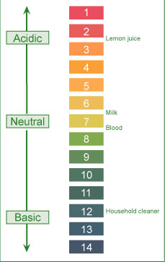
The acidity (a measure of hydrogen ion concentration) of a solution is conveniently described in terms of pH scale.
pH<7: solution is acidic (vinegar)
pH>7: solution is basic (detergent)
pH=7: solution is neutral (water)

↑ Acidity = ↓ pH
Based on the concentration of carbonic acid and small amounts of other natural acids, the estimated pH of rain (as well as fog, dew and snow) under normal atmospheric conditions should be around 5.3.
Field measurements in many areas, on the other hand, show much lower pH values (4.1- 4.5).
Higher acidity (lower pH) is due to the reactions of NO_{x} and SO_{x} present in the atmosphere.
Various reactions of these oxides lead to the formation of acids. The dissociation of formed acids generates hydrogen ions and hence higher acidity (or lower pH).
2 SO₂ (g) + O₂ (g) + 2 H₂O (ℓ) 2 H₂SO₄ (aq)
H₂SO₄ (aq) H⁺ (aq) + HSO₄⁻ (aq)
HSO₄⁻ (aq) H⁺ (aq) + SO₄²⁻ (aq)
4 NO₂ (g) + O₂ (g) + 2 H₂O (ℓ) 4 HNO₃ (aq)
HNO₃ (aq) H⁺ (aq) + NO₃⁻ (aq)

Environmental effects
Material damage: marble and limestone (CaCO₃) used in many historic and irreplaceable statues and buildings (Parthenon in Greece, the Taj Mahal in India) react with acid in the rain. The reaction leads the formation of calcium salts. The solubility of these salts in water is much greater than that of marble in water. The dissolution of formed calcium salts leads to roughened surfaces, removal of material and loss of carved details from the buildings and statues.
CaCO₃ (s) + 2H⁺ (aq) Ca²⁺ (aq) + CO₂ (g) + H₂O (l)
Forest damage: considerable damage to trees has been reported in various parts of North America and Europe. Acid rain has been implicated with slower growth, injury and destruction of forests and has been attributed to be a contributing factor to the declining health of trees by damaging their leaves, limiting the nutrients available to them or exposing them to toxic substances released from soil due to the change in pH. Acid rain is implicated in depleting the nutrients supply to the trees by attacking leaves who’s protective coating has already been destroyed due to attack by other atmospheric pollutants such as O₃ and NO_{x}
Corrosion of metals: the corrosion process is accelerated in the presence of acid. iron structures, bridges, railroads etc show a faster rate of corrosion (rusting) in acid rain predominant areas. Studies indicate that even painted or plated iron corrodes more rapidly in such areas. The reaction occurs in two steps with hydrogen ions (formed from the dissociation of acid) being involved in the first step of the reaction. Conversion of iron to its oxide (rust):
4 Fe (s) + 3 O₂ (g) 2 Fe₂)₃ (s)
Aquatic life: quite susceptible to changes in pH. Reduced pH has led to lakes with no fish or other living beings. Acid rain has been shown to reduce fish population, kill individual fish and in some cases eliminate fish species entirely from a body or water. The effects of acid rain are due to lowering of pH well below the required value of about 6.5 for healthy aquatic life and increasing aqueous concentration of metals (Al, Pb) due to their higher solubility at lowered pH. Both low pH and increased aluminum levels are toxic to fish. In addition, low pH and increased aluminum levels cause chronic stress leading to a smaller size and lower body weight. These factors make fish less able to compete for food and habitat.

Some control technologies
Reduction of SO_{x} emission: progress has been made by reducing the emissions of sulfur dioxide. The major strategies under consideration are:
- Using coal with low sulfur content
- Removing sulfur from the coal before using
- Using chemicals to neutralize acidic sulfur dioxide
In Japan, using the technologies like the use of scrubbers (neutralization of acidic sulfur dioxide) has led to considerable decrease in sulfur dioxide emissions.
Reduction of NO_{x} emission: catalytic converters are now in use in automobiles to reduce the emission of oxides of nitrogen.
Using cleaner energy sources in transportation: cleaner energy sources such as alcohol and hydrogen are being explored. Three are considerable numbers of investigations in process pertaining to the use of hydrogen fuel.
Developing/ using alternate energy: hydroelectric, nuclear and wind power are being used in many parts of the world. Development is slow due to high costs and environmental issues.

Global warming
How does this happen? Global warming refers to an increase in the Earth’s average temperature. This warming is the result of increased absorption by the atmosphere of infrared (IR), a major source of heat, radiated back from Earth's surface. This is due to an increase in concentration of gases that trap heat in the atmosphere. These gases are often called greenhouse gases.
The principal greenhouse gases that enter the atmosphere due to human activities include:
- Carbon dioxide (CO₂): enters atmosphere due to the burning of fossil fuels (oil, natural gas, and coal) waste materials, and as a result of other chemical reactions.
- Methane (CH₄): main sources are the production and transport of fossil fuels, livestock, agricultural practices and organic waste decay)
- Nitrous oxide (N₂)): emitted during agricultural and industrial activities as well as during the combustion of fossil fuels and waste materials.
- Fluorinated gases: compounds emitted from a variety of industrial processes and are sometimes called High Global Warming Potential (GWP) gasses.
Based on measured concentrations of various greenhouse gases, computer models have been developed to predict the extent of global warming. It is estimated that the temperature of the atmosphere may increase anywhere from 1.5 ºC to 3.5 ºC during the next fifty years.

Environmental effects include:
- Climatic changes: human activities such as burning of fossil fuels, deforestation, industrial processes and some agricultural practices release greenhouse gases. These gases rap energy in the atmosphere causing it to warm.
- Changes in sea level due to melting polar ice caps: the north pole is warming up faster than the rest of the world. The arctic sea ice is in a state of ongoing decline.
- Possibility of droughts and heatwaves due to warming: based on detailed analysis using computer climate models and data, its concluded that in the next few decades increasingly dry conditions may be encountered across much of the globe.
- Changes in ecosystem: many animals and plants survive within a narrow range of climatic conditions; some animal species are shifting towards higher elevations. Many even face extinction as ocean temperatures arise the coral reefs will continue to decline.
- Effects on human health: global warming may lead to increased temperature-related illnesses, air pollution due to higher temperatures and possible spread of some infectious diseases.

Control strategies
Reduction in CO₂ emissions: The governments all over the globe are working to reduce their country's carbon dioxide emissions by:
- Promoting that alternate non-fossil sources such as hydroelectric, solar, nuclear and wind are developed and used
- Capturing the carbon dioxide generated by burning fossil fuels
- Supporting new fuels and technologies (like electric cars) to reduce carbon dioxide emissions from transport
- Setting 'carbon budgets' to cap overall carbon dioxide emissions.
Encouraging energy conservation: This will lead to lesser energy consumption and hence lower production and reduced emissions.
Using carbon dioxide sinks: A carbon dioxide sink is any resource (natural or artificial) that captures and stores atmospheric carbon dioxide. Natural carbon dioxide sinks include forests, oceans and soil. Thus replanting forests is being encouraged globally. Some of the artificial carbon dioxide sinks being studied involve removing carbon dioxide from the atmosphere and storing it in rocks, injecting it deep into the oceans or trapping it via chemical reactions.

Key events to limit global warming:
1988- intergovernmental panel on climate change (IPCC): established by the world meteorological organization focuses on assessment of scientific knowledge, examine the environmental, economic and social impacts and formulate response strategies.
1997- Kyoto protocol: the document calls for industrialized nations to cut their emission of greenhouse gases to limit global warming.
2007- report released by IPCC stated that global warming is clearly evident from diverse observations such as:
- increase in average air and ocean temperatures
- widespread melting of snow and ice
- rising of global average sea level
The report emphasizes that global warming could cause irreversible damage to the planet and strongly suggested that global action is urgently needed to drastically reduce greenhouse gas emissions. Also it could shrink the global economy by 20%

Ozone depletion
How does this happen? Ozone plays a double role in our environment:
- In our immediate atmosphere, it acts as an air pollutant contributing to photochemical smog
- In the stratosphere (in conjunction with oxygen), it filters the solar ultraviolet (UV) radiation, thus protecting us against its harmful effects

In our immediate atmosphere exposure to ozone may occur in operations involving:
- High-intensity UV light such as mercury vapor lamps, plasma torches, glass blowing, etc.
- High-voltage electrical equipment
- Welding
In all the above operations, the interaction of high energy with oxygen in the surrounding atmosphere leads to the formation of O₃:
3 O₂ (g) + Energy 2 O₃ (g)

Ozone formation: In the stratosphere, oxygen and ozone interact with energy (ultraviolet radiation) from solar radiation to form a dynamic system involving the following reactions:
When ultraviolet light strikes oxygen molecule, individual oxygen atoms are produced. | O₂ + Energy 2 O
The combination of atomic oxygen with oxygen molecule leads to the formation of ozone. | O₂ + O O₃
The interaction of ozone molecule with ultraviolet light splits it into a molecule of oxygen and an atom of oxygen. | O₃ + Energy O₂ + O
Recombination of ozone molecule with an oxygen atom leads to the formation of oxygen molecule. | O₃ + O 2 O₂
The above processes occur repeatedly and are together called ozone-oxygen cycle or Chapman cycle. This constitutes the O₂/O₃ screen that filters out the ultraviolet component of the solar radiation.

Environmental concern: The environmental concern in the case of ozone is its stratospheric depletion, which leads to less efficient filtration of harmful solar UV rays. The depletion is caused by both natural (water vapor, nitric oxide) as well as human-made (chlorofluorocarbons, halons) sources. These manufactured chemicals, containing chlorine and/or bromine are called "ozone-depleting substances" (ODS). The use and popularity of these chemicals is due to their stability and low toxicity.

Chlorofluorocarbons (CFCs) and halons have been used as:
- Foam-blowing agents
- Solvents
- Fire-extinguishing agents
- Refrigerants
However, their stability and long lifetime (up to several centuries) allows them to reach the stratosphere. The interaction of these molecules with ultraviolet light in the stratosphere leads to the generation of chlorine and bromine which in turn destroy stratospheric ozone.

Effects of depletion:
Stratospheric ozone depletion leading to less efficient filtration of the ultraviolet radiation from the sun, will increase the intensity of ground-level UV radiation. This increased intensity may have adverse effects on:
- Humans: higher probability of sunburns, skin cancer, and premature aging of skin. More cataracts, eye diseases and blindness and Immunosuppression (weakening of the immune system)
- Agriculture and forestry: physiological and developmental processes of major crop species (such as barley, rice and wheat) may be affected.
- Materials: may accelerate the degradation of materials such as fabrics, plastics and rubber and wood.
- Marine ecosystems: damage marine life by decreasing plankton which would disrupt the food chains and lead to decreased reproductive capacity reducing fish yields.
Control strategies:
In North America, the use of chlorofluorocarbons (as propellants in spray cans) was banned in 1978 in response to the threat of ozone depletion. The global response to the threat of ozone depletion came with the signing of the Montreal Protocol (in 1987). It set out to reduce and ultimately ban the manufacture and use of CFCs and other ozone depleting substances.
The international agreement has been effective in reducing risks in the long term; ultraviolet radiation remains a health hazard. In view of this, we as individuals should protect ourselves against it.

