ADM1300 – Chapter 9
Innovation in Organizations
Strategic leadership creates the capacity for ongoing strategic change.
Creativity and Innovation
- Creativity is the generation of a new idea or unique approach that solves a problem or crafts an opportunity
- Innovation is the process of taking a new idea and putting it into practice
Types of Innovations
- Business innovations:
- Product innovations result in a new or improved good/service
- Process innovations result in a better way of doing things
- Business model innovations result in ways for firms to make money
- Sustainable innovations:
- Sustainable innovation creates new products and processes that have a lower environmental impact
- Green innovation is the process of turning ideas into innovations that reduce the carbon footprint of an organization or its products
- Social business innovation:
- Social business innovation finds ways to use business models to address important social problems
- Social entrepreneurship pursues innovative ways to create change that benefits society
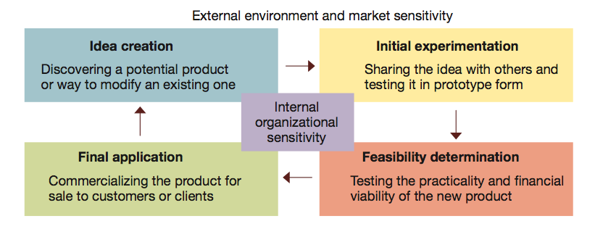
The Innovation Process
- The wheel of innovation:
- Imagining
- Designing
- Experimenting
- Assessing
- Scaling
- Commercializing innovation turns ideas into economic value added
Disruptive Innovation and Technology
- Disruptive innovation creates products/services that are so widely used that they largely replace prior practices and competitors

Characteristics of Innovative Organizations
- Strategy and culture: Corporate strategy and culture support innovation – entrepreneurial spirit is emphasized
- Structures: horizontal and organic designs, use skunkworks
- An ambidextrous organization uses integrated creative teams to simultaneously be good at both producing and creating
- Systems: Break down barriers such as time and distance, use technology to help employees collaborate
- Top management: Lead in ways that encourage and allow people’s creative potential to operate fully
- Staffing:
1. Make creativity an important criterion in the hiring process
2. Allow creative talents to fully operate
3. Put people in key innovation roles:
- Idea generators
- Information gatekeepers
- Product champions
- Project managers
- Innovation leaders
Organizational Change
Change Leaders
- A change leader or change agent, tries to change the behaviour of another person or social system
- Status quo managers like to keep things the way they are
Models of Change Leadership
- In top-down change, the change initiatives come from senior management
- In bottom-up change, change initiatives come from all levels in the organization
- Integrated change leadership combines the advantages of top-down and bottom-up
Incremental and Transformational Change
- Reactive change responds to events as or after they occur
- A performance gap is a discrepancy between a desired and an actual state of affairs
- Planned change aligns the organization with the anticipated future changes
- Unplanned change occurs spontaneously or randomly
- Incremental change bends and adjusts existing ways to improve performance
- Transformational change results in a major and comprehensive redirection of the organization

Forces and Targets for Change
- Internal pressures:
- Aspiration-performance discrepancies
- Life-cycle forces
- Changes in top management
- Tasks
- People
- Culture
- Technology
- Structure
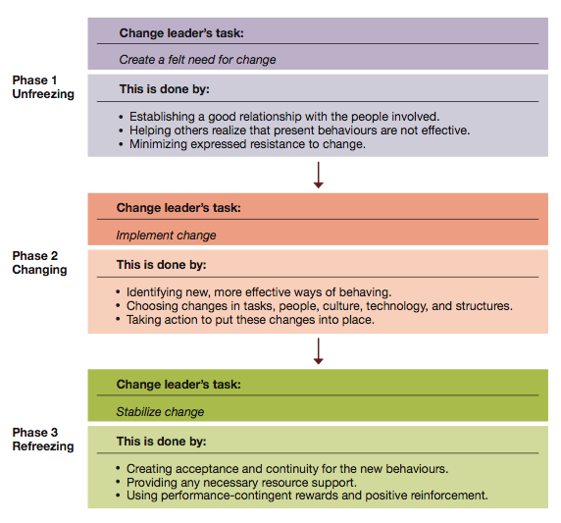
Managing Planned Change
Phases of Planned Change
- Unfreezing is the stage during which a situation is prepared for change
- Changing is the phase where a planned change actually takes place
- Refreezing is the phase at which change is stabilized
Change Strategies
- A force-coercion strategy pursues change through formal authority and/or the use of rewards or punishment – relies on legitimate power
- A rational persuasion strategy pursues change through empirical data and rational argument – relies on expert power
- A shared power strategy pursues change by participation in assessing change needs, values, and goals – relies on referent power
- Action research is the change process based on the systematic collection of data and then selection of a change action based on what the analyzed data indicates
- Appreciative inquiry identifies unique qualities/strengths of an organization that can be built on to improve performance

Resistance to Change
- Why people may resist change:
- Fear of the unknown
- Disrupted habits
- Loss of control
- Work overload
- Dealing with resistance to change:
- Check the benefits – People should know ‘what’s in it for me”
- Check the compatibility – keep the change as close as possible to existing values and ways of doing things
- Check the simplicity – Make the change as easy as possible to understand and use
- Check the “tryability” – Allow people to try change little by little
Challenges of Technological Change
- Improvisational change makes continual adjustments as changes are implemented
Organization Development
Organization development is a shared power effort to improve an organization’s ability to solve problems and improve performance
Organization Development Goals
- Outcome goals focus on the task accomplishments
- Process goals focus on the ways people work together
How Organization Development Works
- Establish a working relationship
- Diagnosis – helps with unfreezing
- Active intervention – helps with changing
- Evaluation – helps with refreezing
- Achieve a terminal relationship
- Action research is a collaborative process of collecting data, using it for action planning, and evaluating the results
- Data gathering
- Data analysis and feedback
- Action planning
- Action implementation

Organization Development Interventions
- An OD Intervention is structured activity that helps create change for organization development
- Individual interventions:
- Sensitivity training
- Management training
- Role negotiation
- Job redesign
- Career planning
- Team interventions:
- Team building
- Process consultation
- Intergroup team building
- Organization-wide interventions:
- Survey feedback
- Confrontation meeting
- Structural redesign
- Management by objectives

