223 Final Exam

CHAPTER 1:
- Know what the following terms mean and be ready to define them:
  - Customer Value: The difference between the perceived benefits versus the perceived costs of an exchange.
  - Customer Satisfaction: the extent to which a products perceived performance matches a buyers expectations.
  - Customer Relationship Management (CRM) managing detailed information about individual customers and carefully managing customer touchpoints to maximize customer loyalty.
  - Demarketing is marketing to reduce demand temporarily or permanently; the aim is not to destroy demand but to reduce or shift it.

It is possible for a customer to have a low perceived value of a product but be highly satisfied. This means there is a great difference between perceived value (high) and the actual expectation (low) after using the product.
Value proposition: the full positioning of a brand - the full mix of benefits on which it is positioned.
Maslow’s hierarchy of needs
1. Biological and Physiological needs - air, food, drink, shelter, warmth, sex, sleep.
2. Safety needs - protection from elements, security, order, law, stability, freedom from fear.
3. Social Needs (Love and belongingness) - friendship, intimacy, affection and love, - from work group, family, friends, romantic relationships.
4. Esteem needs - achievement, mastery, independence, status, dominance, prestige, self-respect, respect from others.
5. Self-Actualization needs - realizing personal potential, self-fulfillment, seeking personal growth and peak experiences. “What a person can be, (s)he must be.”
2. *** Know the meanings of the following CRM terms:
Customer retention Customer retention rate refers to the percentage of buyers who continue to buy the product /service from one period of interest to the next.
Customer acquisition (conversion) In marketing, a conversion occurs when a prospective customer takes the marketer's intended action. For example, if a subscriber to Fido switches to Rogers as a result of a promotion program, a customer conversion takes place. If a prospective consumer has visited a marketer's web site, the conversion action might be making an online purchase, or submitting a form to request additional information. The conversion rate is the percentage of consumers who take the intended action. In CRM, conversion rate typically refers to the percentage of consumers who switch from on brand to another on a long term basis.
Customer churn (attrition, turnover) is a measure to represent how severe the loss of clients or customers to other brands is. It is usually measured as the percentage of customers that are lost to all other brands from one period of interest to the other.
Up-selling: Promoting higher priced but higher-end versions of products/services with advanced and better product attributes than the products/services that consumer has been buying.
Cross-selling is the action or practice of selling an additional product or service to an existing customer.
“Share-of-wallet” alculate the percentage of a specific consumer's spending for a type of good or service that goes to a particular company.
Customer life-time value: : In marketing, customer lifetime value (CLV), lifetime customer value (LCV), or lifetime value (LTV) and a new concept of "customer life cycle management" is the present value of the future cash flows attributed to the customer relationship. Use of customer lifetime value as a marketing metric tends to place greater emphasis on customer service and long-term customer satisfaction, rather than on maximizing short-term sales.
Customer equity the total combined customer lifetime values of all of the company’s current and potential customers.

3. *** Various Marketing Management Philosophies: Marketing concept, and ****societal marketing concept.

Societal marketing: concept is the idea that a company should make good marketing decisions by considering consumers’ wants, the company’s requirements, consumers’ long-term interests, and society’s long-run interests.
The marketing mix is the set of tools (four Ps) the firm uses to implement its marketing strategy. It includes product, price, promotion, and place (channels of distribution).
An integrated marketing program is a comprehensive plan that communicates and delivers the intended value to chosen customers.
Marketing Concepts: a philosophy that holds that achieving organizational goals depends on knowing the needs and wants of target markets and delivering the desired satisfactions better than competitors do.
Product concept: the idea that consumers will favour products that offer the most in quality, performance, and innovative features and that the organization should therefore devote its energy to making continuous product improvements.
Sustainable marketing: socially and environmentally responsible marketing that meets the present needs of consumers and businesses while also preserving or enhancing the ability of future generations to meet their needs
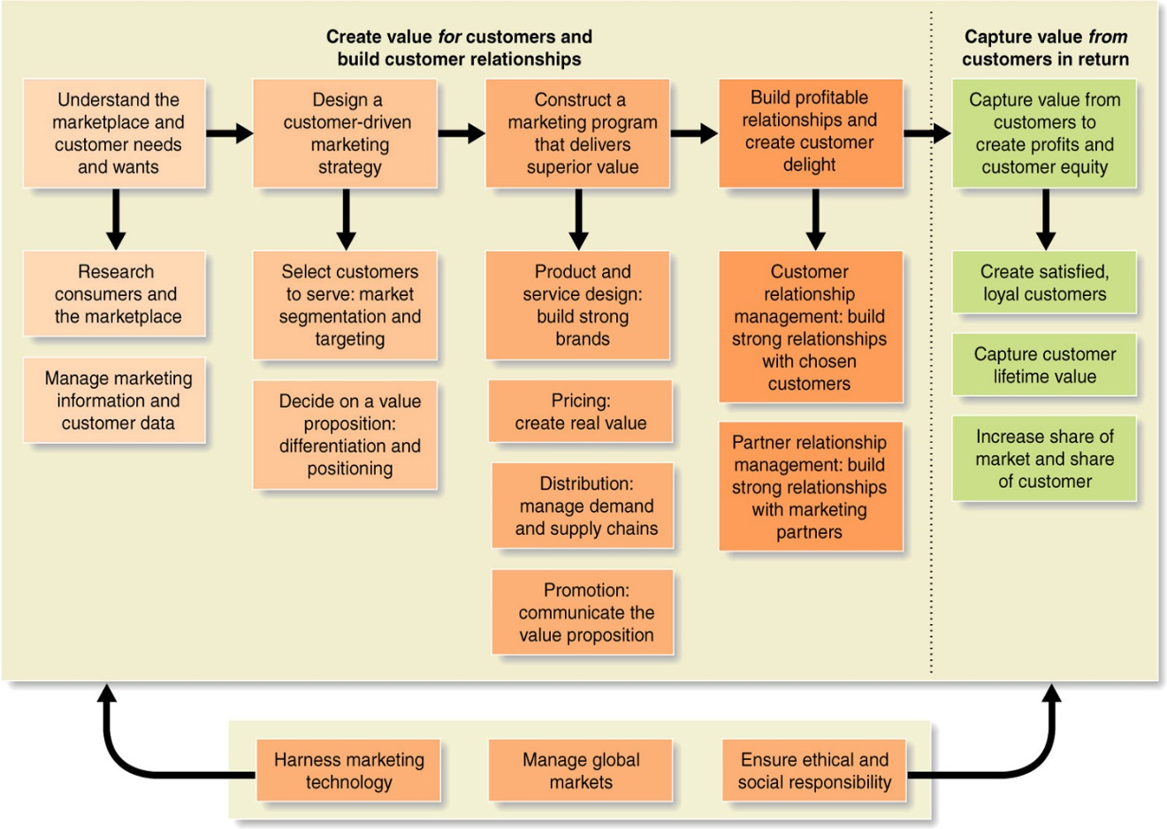
One of the central ideas that you should not miss is that the firm, through a customer driven market strategy, creates superior value for the customers and in return captures value from the customers. Note also how the marketing mix (product, price, distribution, and promotion) plays a central role in creating value for the customers. That is, the firm creates value for its customers by setting the right price, providing the right product, communicating and promoting it in the right manner and marketing it where the consumer wants.

CHAPTER 2:
- The important concept is that strategic planning takes place at two levels: (1) Corporate Level, and (2) Business Unit Level. Corporate level objectives become constraints for the SBU (Strategic Business Unit). SBU objectives, in turn, become constraints for the marketing managers to meet. So, the managers at the firm level try to meet the objectives set at the higher levels of a company.
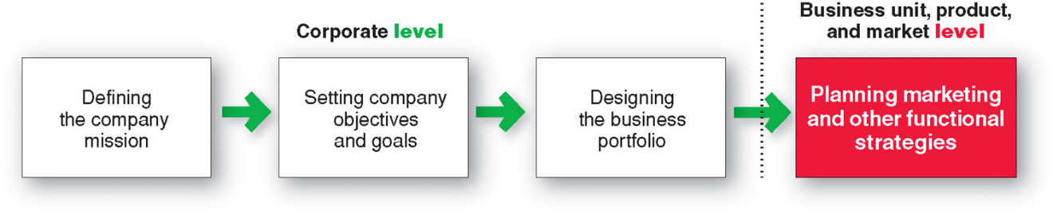
- Portfolio analysis is a major activity in strategic planning whereby management evaluates the products and businesses that make up the company
One of the objectives is to assign strategic roles to each of the SBU’s in the portfolio.
Strategic business unit (SBU) is a unit of the company that has a separate mission and objectives that can be planned independently from other SBU’s. An SBU can be a
  - Company division
  - Product line within a division
  - Single product or brand
BCG Matrix
Relative market share = (My market share) / (Best competitor’s market share)
5. ******GROWTH STRATEGIES:
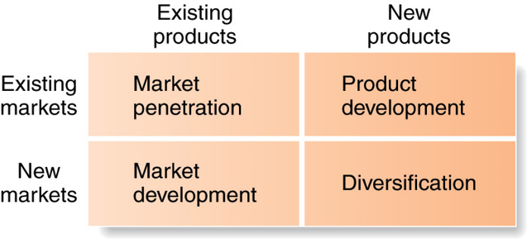
6. 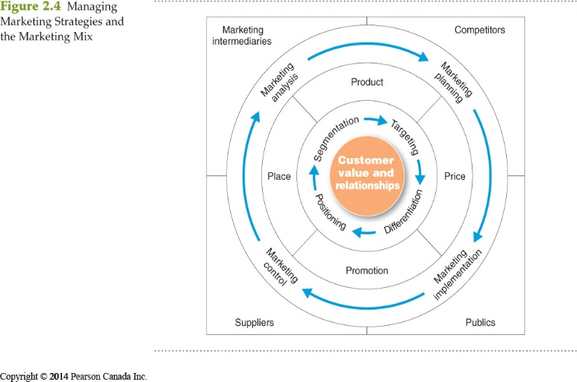
Consumers stand in the centre. The goal is to create value for customers and build profitable customer relationships. Next comes marketing strategy—the marketing logic by which the company hopes to create this customer value and achieve these profitable relationships. The company decides which customers it will serve (segmentation and targeting) and how (differentiation and positioning). It identifies the total market, then divides it into smaller segments, selects the most promising segments, and focuses on serving and satisfying the customers in these segments. Guided by marketing strategy, the company designs an integrated marketing mix made up of factors under its control—product, price, place, and promotion (the four Ps). To find the best marketing strategy and mix, the company engages in marketing analysis, planning, implementation, and control. Through these activities, the company watches and adapts to the actors and forces in the marketing environment.
Differentiation and positioning are two components of what is called the “value proposition”, what the company promises as value to our customers through its actions and communication programs such as advertising, publicity, etc. The promised value should be unique and different than that of competition (“differentiated”) and clearly defined in the minds of the consumers (“positioned well”). Read the section on STDP well.
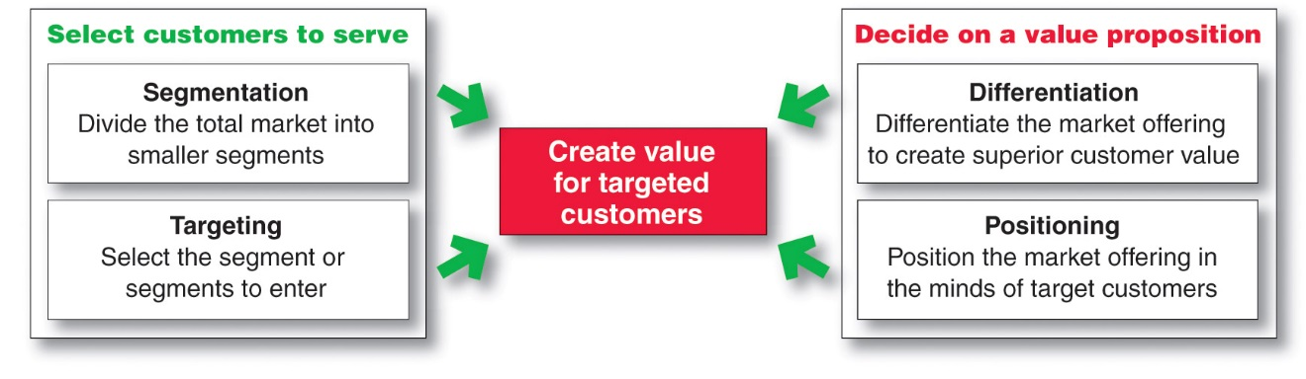
7. *****Marketing Mix:
8. Action plans, budgets, and forecasts are essential components of the plan. Also, the plan assigns responsibilities by identifying who will do what to achieve the objectives for the period under consideration. Another critical item in the plan is the specification of various controls to monitor progress towards the goals, and what to do if there are significant deviations of actual results from the planned targets. Do not try to memorize this table

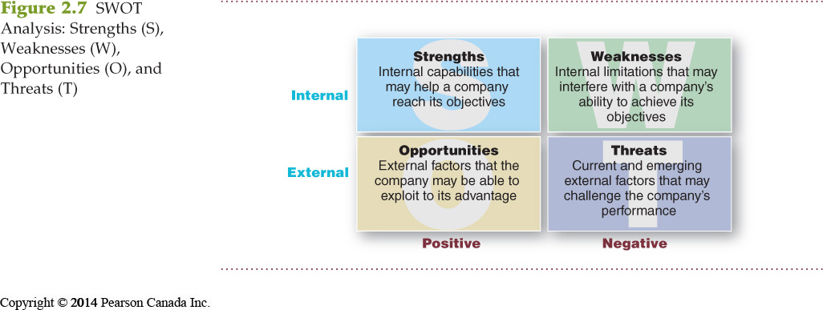
Market targeting is the process of evaluating each market segment’s attractiveness and selecting one or more segments to enter.
Return on marketing investment (Marketing ROI) is the net return from a marketing investment divided by the costs of the marketing investment. Marketing ROI provides a measurement of the profits generated by investments in marketing activities.
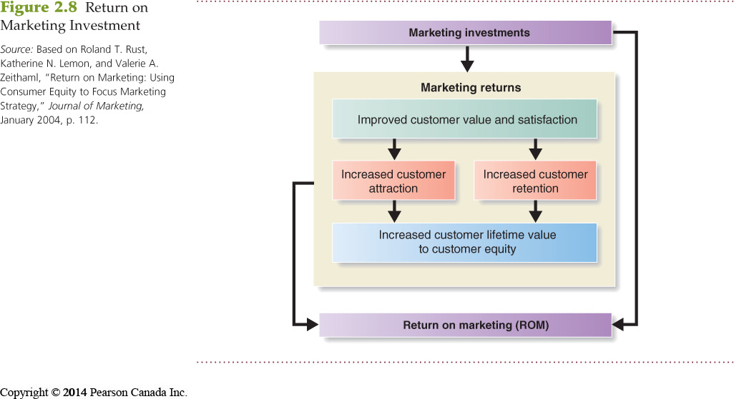
Chapter 3
Microenvironment
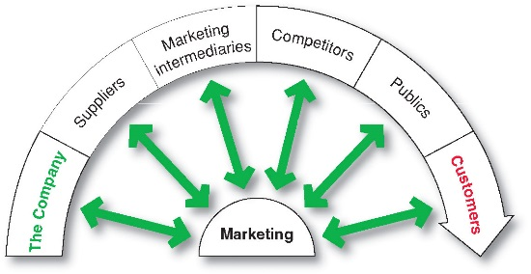
Macro environment
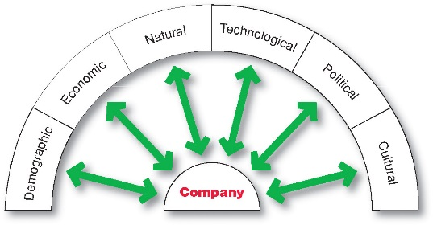
Marketing intermediaries: firms that help company promote, sell, and distribute its products to final buyers.
In microenvironment, marketing intermediaries include: resellers, physical distribution firms, marketing services agencies and financial intermediaries.
In the micro environment, competitors and customers are very crucial. When we examine our competitors, we should focus our attention on how many competitors there are, what their roles have been (leader, challenger, follower, niche player) in the industry, what the major thrust of their strategy is (what they focus on, whether they are the cost leader, how to they differentiate their products and services, their current financial situation, their relative sizes, and their financial performance.
As far as the Macro Environment is concerned, I emphasized in our discussions the demographic environment and the political environment:
Demographic Environment: Demography is the study of human populations in terms of size, density, location, age, gender, race, occupation, and other statistics
Demographic environment is important because it involves people, and people make up markets
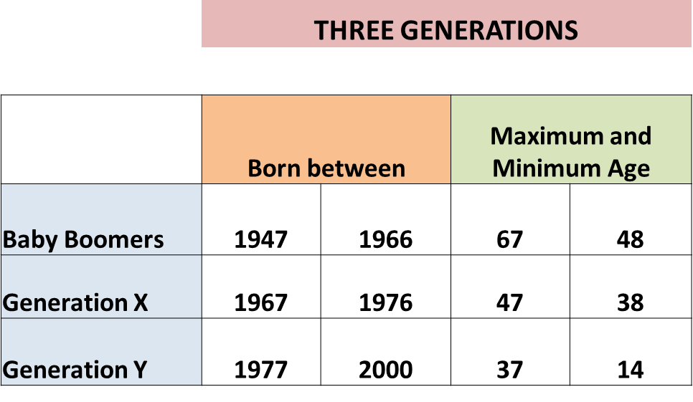
***** Research in marketing, sociology, and anthropology shows clearly that there are some broad similarities in the opinions, attitudes, interests, and behavior of the people who are of the same generation.
***** The following questions are important:
Baby Boomers
- Born between 1947 and 1966: 9.8 million
- Baby boom in Canada started and finished later than U.S.
- Represent 30% of the population, make up 40% of the workforce and earn more than 50% of all personal income.
- Many mini-segments exist within the boomer group
- Entering peak earning years as they mature
Generation X includes
- people born between 1967 and 1976: 7 million (“MTV generation”)
- High parental divorce rates
- First generation of latchkey children
- Maintain a cautious economic outlook
- Respond to socially responsible companies
- Less materialistic, skeptical, highly mobile
- Family comes first
- Lag behind on retirement savings
- Becoming one of the primary target segments

Generation Y
Also called millennials (or echo boomers) include those born between 1977 and 2000: 10.4 million
  - Children of the baby boomers
  - Represent approximately 20 % of the population
  - Comfortable with technology, “plugged-in generation”.
  - Includes: Tweens (ages 11–12), Teens (13–19), Young adults (20’s)
  - Technology is a way of life with them

Changes in the Canadian Household:
Important trends in the Canadian Household
  - The nuclear family has led to the “crowded nest” with boomerang kids, and extended families
  - Delayed marriages
  - Common-law arrangements
  - Fewer children
  - High divorce rate
  - Single-parent families
  - Increasing number of working women: 48% of work force
  - More dual-income families
  - Increasing number of stay-at-home dads

Education and Ethnic Diversity:
One of the major demographic trends in Canada is that the Canadian population is becoming better educated and more ethnically diverse. Diversity includes more than just ethnicity: gay/lesbian population, different religions and races, consumers with disabilities, etc..
Cultural Environment:
Cultural environment: institutions and other forces that affect a society’s basic values, perceptions, preferences and behaviours.
Core beliefs and values are passed on from parents to children and are reinforced by schools, churches, business, and government.
Secondary beliefs and values are more open to change. Believing in marriage is a core belief; believing that people should get married early in life is a secondary belief.
Marketers have some chance of changing secondary values but little chance of changing core values. Example of secondary cultural values are: popular music, movie personalities, clothing norms, ect.
Political environment consists of laws, government agencies, and pressure groups that influence or limit various organizations and individuals in a given society. TABLE 3.2
Value marketing involves ways to offer financially cautious buyers greater value—the right combination of quality and service at a fair price
Chapter 4
- What is “sustainable marketing” and how it is different than “societal marketing concept”? Sustainable marketing: Meeting needs of consumers while preserving the ability of future generations to meet their needs
It differs from societal marketing concepts in the way that sustainable marketing focuses on the importance of preserving future generation needs as for societal marketing looks at the current generations needs and long term wants.

- Marketing receives much social criticism from various publics some of which is very justified. These criticisms center on the main argument that marketing practices of firms hurt individuals, society as a whole, and other firms. What are these criticisms?
Individual
- High Prices
- Deceptive Practices
- High-Pressure Selling
- Shoddy, Harmful, or Unsafe Products
- Planned Obsolescence
- Poor Service to Disadvantaged Consumers
Society as a whole
- False wants and too much materialism
- Too few social goods
- Cultural pollution
- Two major grassroots movements have emerged to monitor and affect marketing practices: consumerism and environmentalism.
Consumerism is the organized movement of citizens and government agencies to improve the rights and power of buyers in relation to sellers. Media definition: “Consumerism is encouraging the purchase of goods in ever greater amounts.”
Environmentalism is an organized movement of concerned citizens, businesses, and government agencies to protect and improve people’s living environment. Environmentalists are not against marketing and consumption; they simply want people and organizations to operate with more care for the environment. The marketing system’s goal, they assert, should not be to maximize consumption, consumer choice, or consumer satisfaction but, rather, to maximize life quality.

Chapter 5
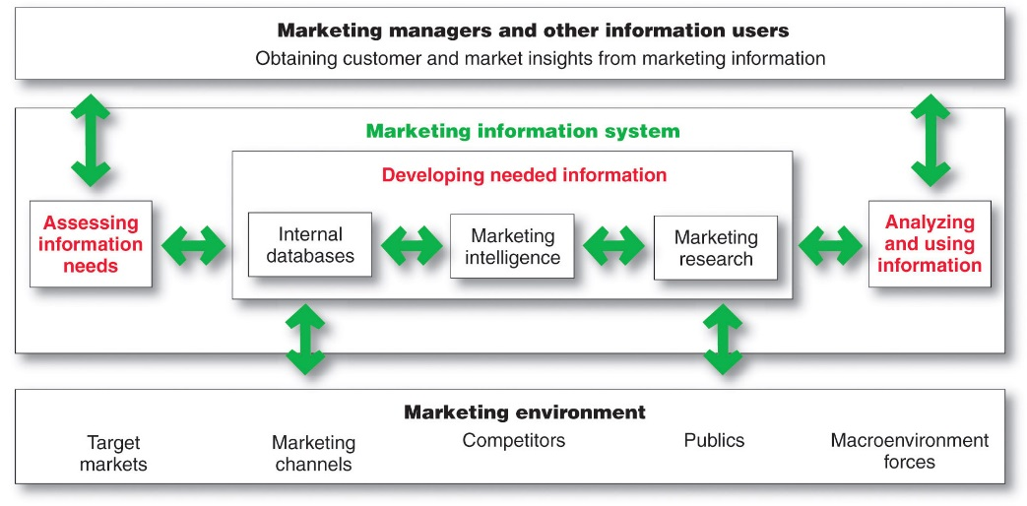
Marketers obtain information from the following:
Internal data, marketing intelligence and marketing research
Internal Data: Information collected from different sources within the company, and stored within the organization’s information system
- Accounting system
- Operations/production
- Sales reporting system
- Past research studies
Internal data are cheap, quick, and easy
May not be in a usable form for the decision to be made
Primary data: Information collected for the specific purpose at hand.
- It is usually very impractical or costly to study the whole target market (called “population” in statistics.
- Instead, we take a sample from the “population” of interest, and then use the guidance of statistical theory to make inferences about population related characteristics.
- Sampling typically requires three types of major decisions: For example, if we want to study the perception of Concordia University students about the quality of education they are getting, we may take a
  - A sample of students (sampling units (who to sample))
  - Randomly select them from a database of students who are currently enrolled (sampling procedure (how to sample))
  - And decide to take a sample of, say, 500 students (sample size (number of sampling units to select)).

Data collection methods:
- Survey and interview
- Observational
- Focus group interview
- Brain wave research (EEG)
- Eye movement tracking

Secondary data: information that exists somewhere, having been collected for another purpose.
Advantages of Secondary Data:
- Obtained quickly
- Less expensive than primary data
Limitations of Secondary Data:
- Information may not exist or may not be usable, or if it exists, it may be in units that you do not want or may not cover the period of interest.

Exploratory Research:
- Consists of initial observations or data about a phenomenon of interest
- Typically involves review of already available information (secondary data)
- Used when the marketer does not have an understanding of the topic, or topic is new.
- Through exploratory research we define the marketing problem and then formulate hypotheses to be tested in further studies.
Descriptive Research:
- Attempts to describe the characteristics about a population or phenomenon of interest.
- Answers questions such as who, what, where, when, how, how much.
- Frequencies, averages, and correlations etc. are typically used in descriptive research.
- Histograms, pie charts, summary statistics (means, percentages etc.) are typical outputs
- Very popular type of research in social sciences.
- Example: A survey reporting the findings regarding the “Demographic and psychographic characteristics of our customers who own and use loyalty cards.”
Causal Research: Experimentation
- We test specific hypotheses about the effects of CHANGES of one or more causes on other variables.
- Involves experimentation.
- The “causes” that are manipulated in experiments are elements of the marketing mix.
- Examples: Laboratory tests (such as simulated shopping market test), field tests (such as standard or controlled market tests).

Below you will find examples of information developed for decision making for a cellular phone company. Which of the three components of the marketing information system (that is, internal databases, competitive marketing intelligence, or marketing research) is likely to develop or have developed the information? (See pages 146-149)
a) Relating frequency of phone calls over a month to type of credit card owned to examine if certain credit card owners call others more frequently. (Answer: Internal databases)
b) Beliefs and attitudes of cellular phone owners regarding various call plans. (Answer: Marketing Research)
c) Periodic reports regarding the call plans offered by competitors, prices charged, and the changes in call plans over time. (Answer: Competitive marketing intelligence).
Chapter 6
The figure has three major components: (1) Environmental Stimuli (on the left), (2) Individual (in the center), and (3) Individual’s responses (on the right). It is important to notice that the marketing mix that is controlled by a firm is conceptualized as a component of the environmental stimuli that affect individual consumer behavior. Marketers try to understand these links between stimuli and response, manipulate the stimuli (i.e. the marketing mix) to generate the response they desire. Another feature of the model is that it involves two feedback loops: (1) Competitors learn from the buyer responses what aspects of their strategy are working, (2) consumers learn from their own consumption experiences which they use in similar buying situations subsequently.
1. These factors may be highly related to various types of buyer responses such as whether to purchase the product, where to purchase it, which brand to buy, when to purchase it, how much to purchase, whether to recommend the product to someone else, etc.).
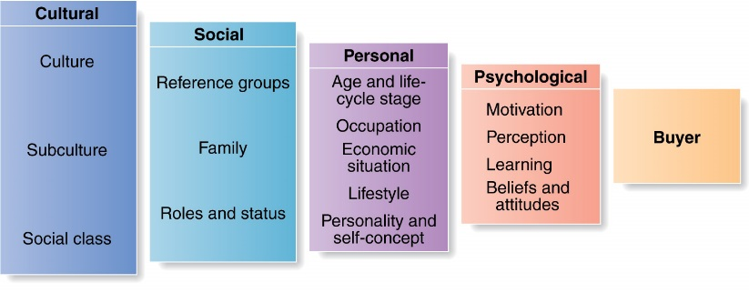
2.
Membership groups: Groups with direct influence and to which a person belongs; family, friends, organizations, military, professional associations, ect.
Aspirational Groups: Groups an individual wishes to belong to: a young hockey player that wants to be like Crosby or 10 year old that wants to be like their older sibling
Word-of-mouth (WOM) influence and buzz marketing
Opinion leaders are people within a reference group who exert social influence on others
Also called influentials or leading adopters
Marketers identify them to use as brand ambassadors so that they will put in a positive WOM for the marketer’s brand.
Online Social Networks are online communities where people socialize or exchange information and opinions
Characteristics affecting Consumer Behaviour:
CULTURE: is the learned values, perceptions, wants, and behaviour from family and other important institutions of the society (such as educational institutions, religion, etc.)
Subcultures:
  - Regional subcultures (Atlantic provinces, Quebec, Central Canada, the Prairies, BC, northern territories).
  - Founding Nations: Aboriginals (1.17 million (3.7 %) including Metis and Inuit). People reporting English as their mother tongue (57 %), and French as their mother tongue (22 %).
  - Ethnic Consumers:
    - 200,000 immigrants every year.
    - 70 % of visible minority was born outside Canada !
    - Chinese make up 3.7 percent of the Canadian population.
  - Blacks:
    - Canadians who identify themselves as black in the 2006 census make up the third largest visible minority in Canada.
  - Multilingual Society:
    - 20 % of Canadians report that they speak a mother tongue other than French or English.
    - Advertising and other marketing communications are being delivered in different languages.

PERSONAL
- Age and life-cycle stages
- Importance of trigger events during life
- Occupation
- Economic trends in: personal income, savings and consumer debt, and interest rates
LIFE STYLE
- Lifestyle (psychographics) -> measures a consumers AIO (activities, interests, opinions) to capture information about a person’s pattern of acting and interacting in the environment
    - Activities (work, hobbies, shopping, sports, social events)
    - Interests (food, fashion, family, recreation)
    - Opinions (about themselves, business, social issues, products, global issues such as climate change..)
- Psychographic segmentation utilizes life styles as a major segmentation variable.
PERSONAL
- Personality and self-concept:
- Consumers are likely to choose brands with personalities that match their own and improve their self-concept (self-esteem).

Psychological factors: Motivation
A motive is a need that is sufficiently pressing to direct the person to seek satisfaction.
- Physiological needs: Hunger, thirst
- Safety needs: security, protection
- Social needs: sense of belonging, love
- Esteem needs: self-esteem, recognition, status
- Self-actualization needs: self-development and realization

Psychological Factors: Perception
Perception is the process by which people select, organize, and interpret information to form a meaningful picture of the world from three perceptual processes:
1. Selective attention is the tendency for people to screen out most of the information to which they are exposed
2. Selective distortion is the tendency for people to interpret information in a way that will support what they already believe
3. Selective retention is the tendency to remember information that supports one’s attitudes and beliefs.

Psychological Factors: Beliefs and Attitudes
- Beliefs about brand attributes
- These are characteristics a consumer ascribes to a brand.
- “Molson Dry has no bad aftertaste”.
- “Prius is a technologically advanced car.”
- “Kraft cheddar cheese has a sharp taste.”
- “Customer service at TD bank is superb.”
  - Beliefs may be positive or negative or neutral
  - Various beliefs that a person holds may be contradictory or some of them may be inaccurate
- Overall Brand Evaluation (How much one likes or dislikes brand.
  - Usually expressed as a 5 or 7 point rating that ranges from “poor” to “excellent, or “prefer the least” to “prefer the most”.
  - “The smart phone that I prefer the most is iPhone.”
  - “I think the exterior design of Acura SUV is the best among the various SUV’s on the market.”
  - “I really like 5 Gum”.
- The more a consumer likes a brand the more (s)he is likely to buy it.
For those products that the consumer is highly involved with we may expect a sequence of developments as follows:
Consumer Decision process for high-involvement products/services
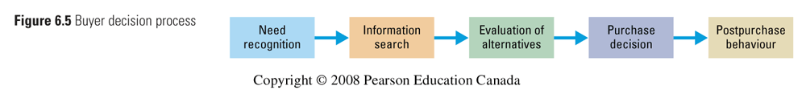
COMPLEX DECISION MAKING: Consider a high involvement decision process that you went through (such as deciding which university to attend). Describe how you went through the above stages of the decision process.
- Sources of information: Personal sources—family and friends
- Commercial sources—advertising, Internet
- Public sources—mass media, consumer organizations
- Experiential sources —handling the product, visually examining the product, using the product
Post Purchase Decision
- The satisfaction or dissatisfaction that the consumer feels about the purchase
- As we discussed before, satisfaction involves a relationship between:
  - Consumer’s expectations
  - Product’s perceived performance
- The larger the gap between expectation and performance, the greater the consumer’s dissatisfaction
- Cognitive dissonance is the discomfort caused by a post-purchase conflict caused by “I wish I had known that” kind of discovery

6. Types of buying behavior:
- Degree of consumer involvement (Low - High) (How important is the purchase and the product to the consumer?)
  - High involvement products are expensive, risky, purchased less frequently, and highly self-expressive, involve long term commitment, and are related to important occasions.
- Degree of perceived differences across available alternatives (Few - Significant) (How different are the alternatives to the consumer? Can the consumer tell?)
  - Consider wine versus digital camera.
Sometimes consumers learn about products although they are not actively searching for information about them. This is called “passive learning”. For example, you may learn the jingle for a product that you overhear from the TV even when you are preparing a sandwich for yourself in the kitchen. Another example: you may forget about your exposure to an advertisement but you may recall the brand name that may have been mentioned in that advertisement. The fact that “passive learning” takes place is used by marketers in marketing products that fall into “habitual buying” category.
The Buyer Decision Process for New Products
Influence of Product Characteristics on Rate of Adoption: Which Products are Adopted Rather Quickly by Buyers?

- Relative Advantage: The degree to which the innovation appears superior to existing products. cell phone vs smart phone
- Compatibility: The degree to which the innovation fits the values and experiences of potential consumers. the switch from cellular to smart phones
- Complexity: The degree to which the innovation is difficult to understand or use. how difficult is it to get a new smart phone?
- Divisibility: The degree to which the innovation may be tried on a limited basis. can I try the phone before buying it?
- Communicability: The degree to which the results of using the innovation can be observed or described to others. did you see people enjoying the benefits of a smart phone before buying it

Adoption Process is the mental process an individual goes through from first learning about an innovation to final regular use (adoption).
- Stages that a consumer goes through in the adoption process include: AIETA

Chapter 8
MAJOR GROUPS of segmentation variables: (1) Geographic, (2) Demographic, (3) Psychographic, and (4) Behavioural. Each group involves several segmentation VARIABLES (such as age, gender, family size, etc.). And for each segmentation variable we have what are called the “LEVELS” of that segmentation variable (such as male and female for segmentation variable gender). Typically, we specify the profiles of the segments that we identify in terms of the segmentation VARIABLES and their LEVELS. (For example, Gender: Female, Georgraphic Density: Urban, Benefits Sought: Economy and durability, Loyalty Status: None, etc.)
Market segmentation involves dividing the market into smaller groups with distinct needs, characteristics, or behaviours that might require separate marketing strategies or mixes
Market targeting (targeting) is the process of evaluating each market segment’s attractiveness and selecting one or more segments to enter
Differentiation involves actually differentiating the market offering to create superior customer value.
Positioning consists of arranging for a market offering to occupy a clear, distinctive, and desirable place relative to competing products in the minds of target consumers.
Benefits segmentation
- Benefits are relatively high level (abstract) needs and wants that are satisfied by a product/service.
- Product features, style, design, etc. reside in the product. Benefits are what the product features mean in terms of meeting needs and wants.
- Examples of some benefits: economy, ease of use, convenience, improvement of health, durability, portability, reliability, reduction of personal risk, reduction of financial risk, ease of repair, less pollution, etc.
- Different segments may value different benefits of a given product: Toothpaste: some may value “whitening of teeth” more than other benefits while others may value “cavity prevention” more.
Multiple segmentation is used to identify smaller, better-defined target groups.
Geodemographic segmentation is an example of multivariable segmentation that divides groups into consumer lifestyle patterns.
Intermarket (cross-market) segmentation divides consumers into groups with similar needs and buying behaviours even though they are located in different countries
Example: Tweens whose parents earn $ 100,000 or more per year and live in metropolitan areas with population more than 1 million in different countries.
Example: Upper middle class consumers with university education in China, India, Russia, and Brazil.
Targeting
- Evaluate the relative attractiveness of various segments.
- Select the segment(s) (that is, targets) to be served.
You may want to target more than one segment
Behavioural Segmentation: Dividing a market in segments based on consumer knowledge, attitude, uses, or responses to a product
Psychographic Segmentation: Dividing a market into different segments based on social class, lifestyle, or personality characteristics.
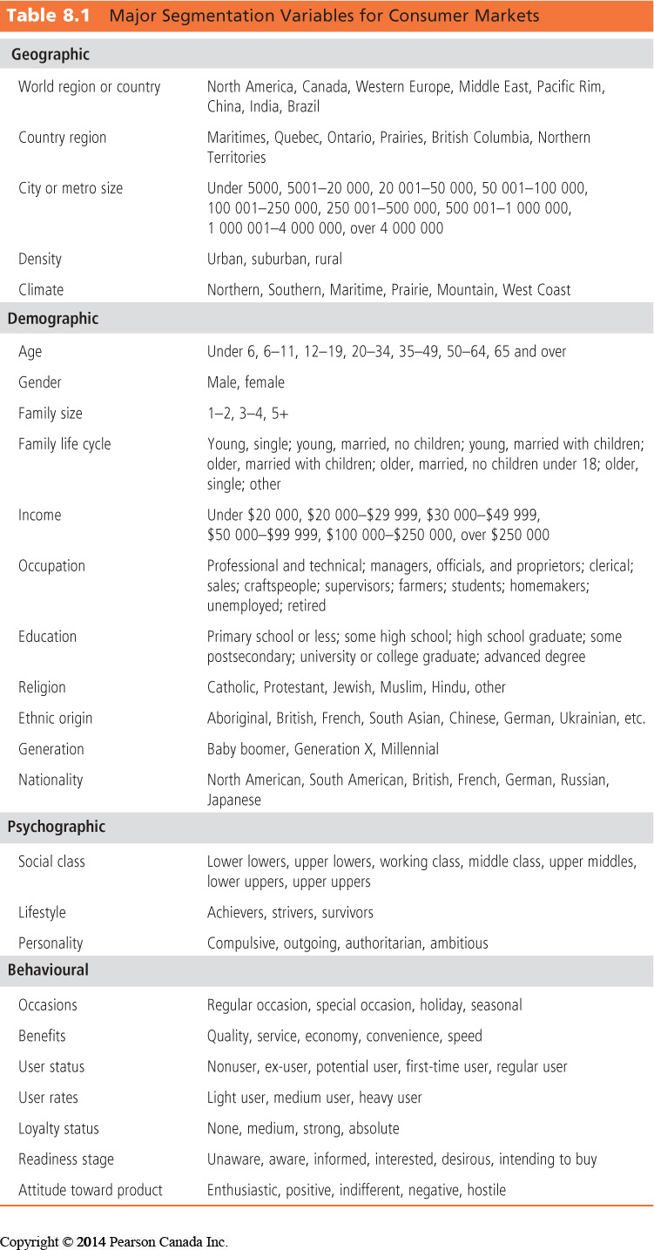

Choosing target marketing strategy: whether to use undifferentiated, differentiated or concentrated marketing:
- Company resources (Use concentrated marketing if resources of the company are scarce).
- The degree of product variability (differentiated marketing is more suitable for products that can be varied in design, package, etc.)
- Product’s life-cycle stage (Undifferentiated marketing when the product is first introduced, and differentiated marketing during the maturity stage).
- Market variability (Use undifferentiated marketing if the consumers are very similar in terms of their needs and wants, their behaviour and characteristics)
- Competitors’ marketing strategies (If competitors use differentiated marketing, you should not use undifferentiated marketing).

Product position is the way the product is defined by consumers on important attributes—the place the product occupies in consumers’ minds relative to competing products.
Summary perceptions and image regarding a brand’s unique benefit as it differentiates the brand from others.
Choosing a Differentiation and Positioning Strategy
Product differentiation: differentiated on features, performance, or style and design
Service differentiation: differentiated on speedy, convenient or careful delivery
Channel differentiation: differentiation through the way they design their channel’s coverage, expertise, and performance
People differentiation: hiring and training people better
Image differentiation: perceived difference based on a strong, distinctive image conveying the product’s distinctive benefits and positioning
Selecting an Overall Positioning strategy from a set of value propositions
Value proposition is the full mix of benefits upon which a brand is positioned. It is what the company promises to the consumer.
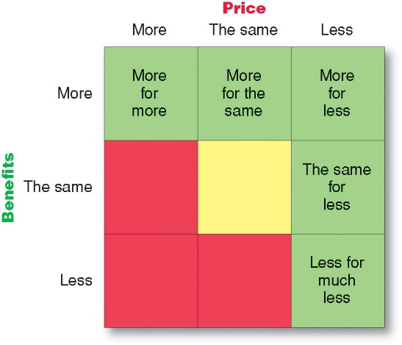
Chapter 9
Note that your text defines a product as “anything that can be offered to a market for attention, acquisition, use, or consumption that might satisfy a want or need.” In this sense, a product may refer to physical objects, services, experiences, persons, places, organizations, and ideas.
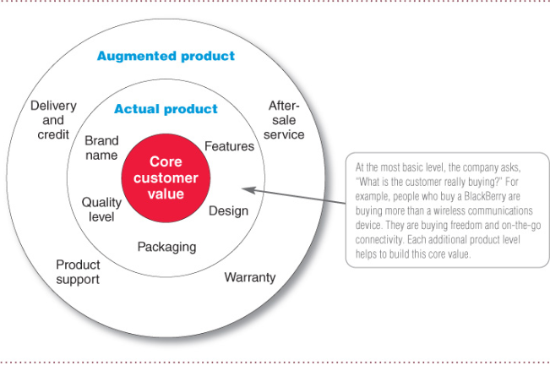
- Core product:
  - Problem solving services or benefits that consumers purchase the product for
  - “We want to produce holes, but we buy drills and bits.”
  - “In the factory we make cosmetics, in the store we sell hope.”
- Actual product
- Augmented product: additional services and benefits
Product Attributes
- Basic idea: products are made up of attributes -- a product modification involves changes in one or more of these attributes.
- There are three types of attributes:
  - Features: physical characteristics (weight, length, colour, etc), ingredients, materials used in producing the product, added services, components, performance, price, esthetic characteristics (design), “buttons”, etc.
  - Functions: How product works, the functions it performs for the consumer
  - Benefits: Benefits of using the product to the consumer. Benefits can be direct or indirect. Examples: convenience, user friendliness, saving time, healthiness, wholesomeness, fun, exciting, effectiveness, economy, luxury, safety, status, prestige, thrill, better mood, self-expression, etc.
- A feature permits a function which provides a benefit.
Classification of Consumer Products
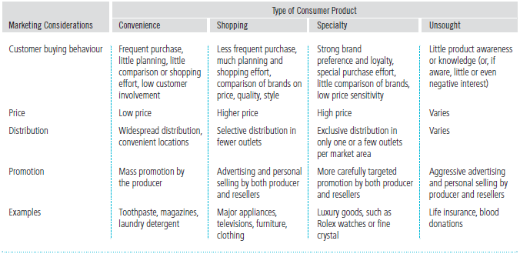

Widespread distribution simply means a channel strategy of being available in as many retail locations as possible. For example, in a metropolitan area of population of two million or so, this may actually mean being available in hundreds of retailers.
Exclusive distribution is a channel strategy that is at the other extreme when it is compared to widespread distribution: only a few stores in a metropolitan area may carry a product at a few stores (for example, there may be one or two retailers that market Ferrari in a relatively big city).
Selective distribution is a channel strategy that is in between the widespread and exclusive distribution strategies: your product may be marketed by much fewer retailers compared to widespread distribution. For example, shopping products of home theaters may be offered by 30-40 retailers in a city.
Brand Equity: the differential effect that knowing the brand name has on customer response to the product and its marketing.
Strong brand equity typically depends on
- Differentiation and positioning in the minds of the consumers (what makes the brand stand out)
- Relevance (how consumers feel the brand meets their needs)
- Knowledge (how much consumers know about the brand. Awareness)
- Esteem (how highly consumers regard and respect the demand).
Strong Brand equity provides certain competitive advantages:
- Strong consumer awareness and loyalty which lead to stable sales and higher profits.
- Leverage with resellers in channel relationships.
- Can launch product line and brand extensions with confidence and less budget.
- Protects against fierce price competition.

Individual Product and Service decisions
Manufacturer’s brands: brands owned by a company ex: BMW, Crest, Dove
Private (store) Brands: Brands owned by a specific store to compete with the manufacturer’s brands ex: President’s choice, Kenmore, Compliments, Mastercraft.
- Dominance of manufacturer’s brands have been challenged by private label branding used by retailers
- Issues: slotting fees, increased profitability of private label for retailers, and control of shelf space

Brand Development strategies
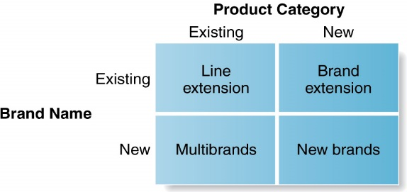
Useful and relevant when a firm introduces a new product into an existing product line, or introduces a new product into a different product category than it is already serving. The critical question, then, is to decide whether you are going to use your established brand name or use a new brand name for the new product. There are advantages and disadvantages associated with each choice. You need to be aware of them.
Line extension: introducing additional items in a product category under the same brand name; introducing new flavours, forms, colours, added ingredients, package sizes
Advantages:
- Low-cost and low-risk way of introducing variety
- Meets consumer desire for variety
- Helps to use excess capacity
- Helps to command more shelf space from retailers.
Disadvantages:
- May cause consumer confusion.
- Overextended product line may lose its brand meaning.
- May lead to “cannibalization” as discussed with regard to product line filling.
Brand extension: using a successful brand name to launch a new or modified product in a new category
- Gives a new product instant recognition and faster acceptance.
- Reduces new product introduction costs
- If the introduction fails, it harms the original brand name.
- Use only if the consumers perceive the expertise of the original brand to be relevant to the extended product (Texaco milk?)

Multibrands: introducing additional brands within the same product category
- Offers a way to establish different features and appeal to different buying motives and segments
- Locks up reseller “shelf space” and limits competition
- Allows for protection of a major brand by setting up “flankers” or “fighter” brands. (Seiko markets lower priced Pulsar to protect its major brand Seiko)
New brands: creating a new brand name when entering a new product category (protecting the identity of the previously established brand)
Product line
A group of products that are closely related because they may…
- function in a similar manner
- are sold to the same target customer groups
- be marketed through the same types of outlets
- fall within similar price ranges
- be derivatives of a basic platform in terms of sizes, types, colors, qualities, prices, or only a few product attributes (such as fragrance, taste, etc.).
Product Line stretching: adding products that are higher and / or lower priced than the existing line (stretching up and / or down).
- “Luxury” vs. economy” versions of the product.
- “Economy” versions are sometimes called “flankers” or “fighting” brands.
- Stretching up may add prestige to a product line and may improve brand identity.
Product Line filling: adding more items within the present range of the product line
- Product line filling is overdone if it results in cannibalization (“stealing sales from another of your brands”) and customer confusion.

Brand extension: extending an existing bland name to new product categories.
Product Mix: consists of all the product lines and items that a particular seller offers for sale
Number of items in each product line is the depth of that product line. Product line filling an product line extension creates deeper product lines.
All of the products above constitute the product mix of the firm. Number of product lines in the product mix is the width of the product mix
Product Mix Width: The number of product lines a company carries.
Product Mix Depth: The number of versions offered of each product in the line.
Consistency of the product mix: How closely related the product lines are in end use, production requirements, distribution channels, or some other way.
Decision regarding the above shape a the product strategy of a company. A company may
A) add or drop a number of product lines
B) lengthen or shorten its existing product lines
C) add different versions of to a product line to increase its depth or drop existing versions (models, packages, etc.)
D) The company may pursue a more or less consistent product mix.
Characteristics of Services
Service: any activity or benefit that one party can offer to another that is essentially intangible and does not result in the ownership of anything.
Types of Service Industries: Government, Private not-for-profit organizations, business organizations
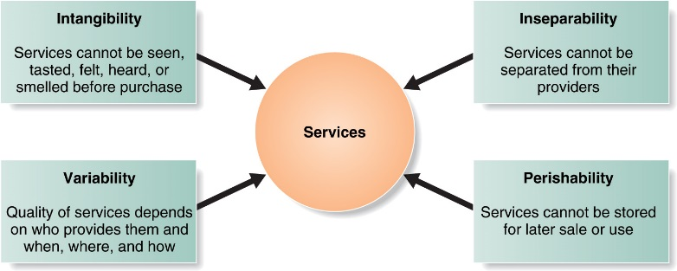
Implications of Service Characteristics for Effective Marketing
- Intangibility: Provide tangible and noticeable “signals” of service quality in terms of the place, people, price, equipment, communications material, etc.
- Inseparability: Improve customer-service provider interaction and communication.
- Variability: Provide training to reduce variability. Monitor service delivery by different service providers at different locations and times.
- Perishability: Manage demand better during periods of slow demand through promotion because services can not be stored. Also, reduce cost of service delivery during the slow periods.
Co-branding: Using two or more established brand names on the same product
Chapter 10
What are the major reasons for new product failure? (The vast literature on this topic suggests that one of the critical reasons for failure is that many new products do not offer any new benefits to the consumers. They are not unique: they do not offer any new solutions to consumer problems. For this reason they are very difficult to differentiate. The consumer take a look at the “new market offering”, asks “what is in it for me” and the answer is “nothing new”. So, there may be no desire to try the product.)

Typically, the new product development process for a firm involves the following stages:
  - New product idea generation: is the systematic search for new-product ideas
  - Idea screening: identify good ideas and drop the bad (conducted by a management team and involves concepts similar to SWOT analysis)
  - Concept development and testing: Product idea is an idea for a possible product that the company can see itself offering to the market
Product concept is a detailed version of the idea verbalized and presented in a way that is meaningful consumer. Concept testing is finding out if the product would be liked by consumers.
  - Marketing strategy development: Test marketing is the stage at which the product and marketing program are introduced into more realistic marketing settings. Provides the marketer with experience in testing the entire marketing program (4 P’s) before full introduction.
  - Business analysis
  - Product development
  - Test marketing: Testing the designed marketing strategy (4P’S) under realistic market conditions
  - Commercialization

Note that in reality the transition from one stage to another is not really smooth and the product development teams may go down the list a few stages and then may feel the need to go back to a previous stage. Therefore, real life product development efforts may involve many loops where the development team may visit some of the earlier stages and modify what they did.
New Product Development (NPD): consumers seek better services, greater convenience, newer fashion and taste, more durable and reliable products, more value for money. It also opens new doors for growth and replaces “old and tired” products.
Types of Test Markets:
Standard test markets are small representative markets where the firm conducts a full marketing campaign and uses store audits, consumer and distributor surveys, and other measures to gauge product performance. Results are used to forecast national sales and profits, discover product problems, and fine-tune the marketing program.
Controlled test markets are panels of stores that have agreed to carry new products for a fee. In general they are less expensive than standard test market, faster than standard test markets, but competitors gain access to the new product.
Simulated test markets are events where the firm will create a shopping environment and note how many consumers buy the new product and competing products. Provides measure of trial and the effectiveness of promotion. Researchers can interview consumers.
Product Life Cycle (PLC)
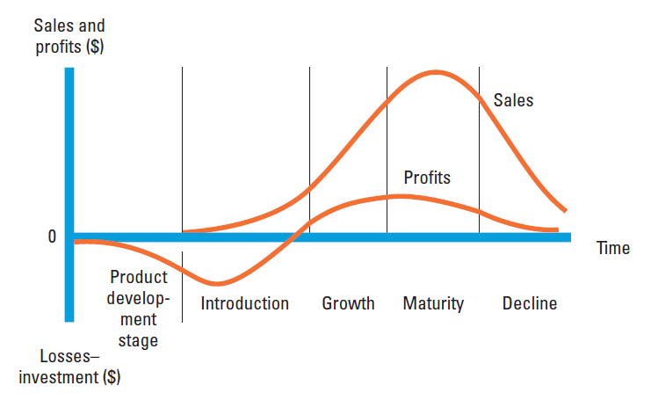
Also, another major recent development is that new product development is no longer accomplished through single step transitions from one stage to the next. That is, it is not a “relay race” where you pass on the development of the new product from one stage to the next. Instead, new product development teams handle many of the steps simultaneously and “move down the “field of new product development” as a team as in “rugby” or “soccer” where the team may have to retreat back if need arises.
The Marketing strategy statement consists of 3 parts.
The first part describes the target market; the planned value proportion; and the sales, market share, and profit goals for the first few years
The second part of the marketing strategy statement outlines the product’s planned price, distribution, and marketing budget for the year.
The Third part of the marketing strategy statement describes the planned long-run sales, profit goals, and marketing mix strategy.
Test Marketing: the stages of new product development in which the product and its proposed marketing program are tested in realistic market settings

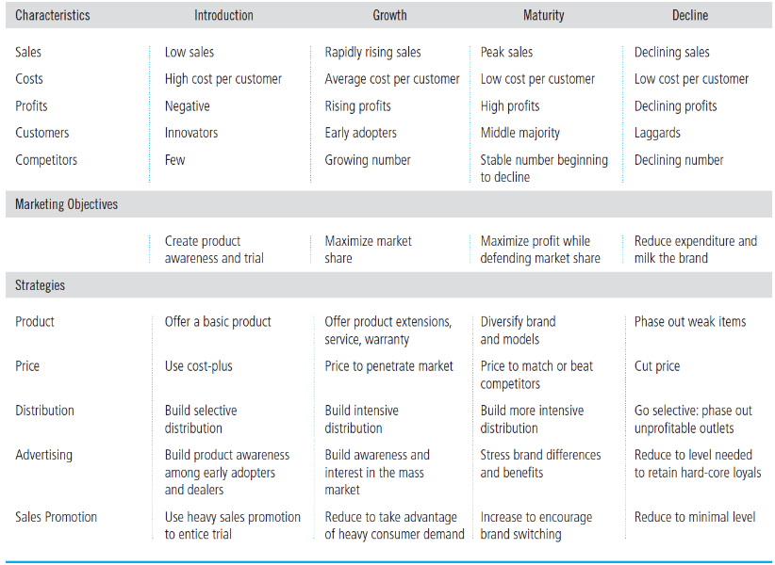
Note that the top one half of the table presents the characteristics of various stages in the PLC. The following row in the table summarizes the major objectives of the firm for the life-cycle stages. Finally, the bottom half of the table summarizes how the marketing mix is modified as a product moves through the stages of the PLC. Please understand this table VERY WELL. Think of a product/service for each stage and consider if the entries in the table make sense.
In the maturity phase of a product, product managers should do more than simply ride along with or defend their mature products – a good offence is the best defence, they should consider modifying the market, product, and marketing mix.
In modifying the market, the company tries to increase consumption by finding new users and new market segments for its brands.
Chapter 11
The following figure summarizes how product costs and consumer perceptions of value put limits on prices at the lower and upper ends, respectively. The price is typically set within this range of lower and upper ends. Where it actually ends depends on competitors’ prices, company objectives, and other factors internal and external to the company,
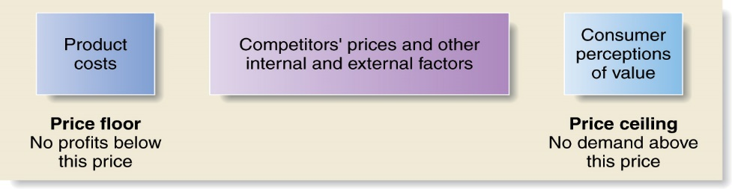
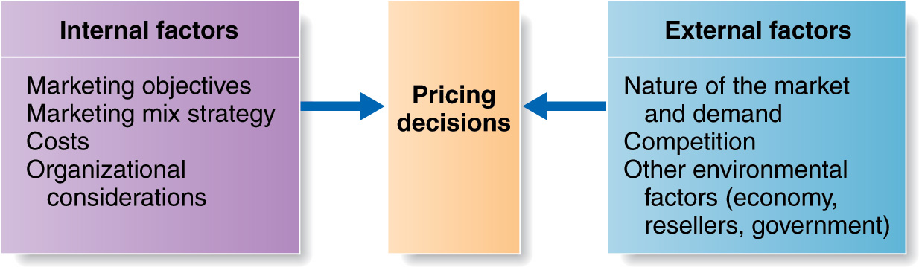
Product Costs
Consumer Perceptions of Value

The above figure summarizes the factors that affect pricing decisions. This is a nice summary and gives you a “bird’s-eye view” of the subject matter and the discussion in the book. Note that pricing decisions of a firm are affected by factors that are related to (1) the firm (internal factors) and (2) the micro and macro environment in which the firm operates (external factors). The specific level at which the price is set by a firm depends on costs as well as consumer perceptions of value.
INTERNAL FACTORS AFFECTING PRICING DECISIONS:
Fixed Costs: costs that do not vary with production or sales level. (ex: bills, rent…)
Variable Costs: Costs that vary directly with the level of production. (ex: cost to make a product. Each product adds a certain amount to the final cost)
Total Costs: the sum of the fixed and variable costs for any given level of production
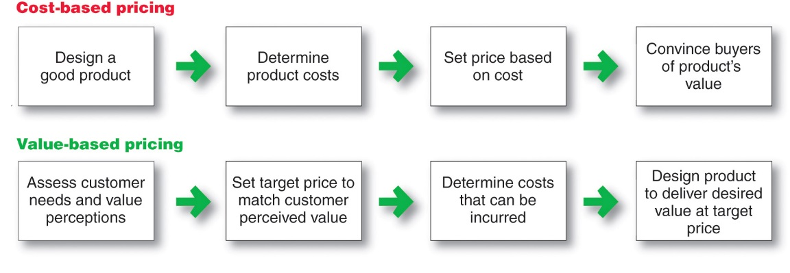
Good-value pricing at a fair price: just the right combination of benefits and services at a price perceived to be fair by the consumers.
Usually involves offering more benefits for a given price or the same benefits for less price
Value-added pricing:
Attach value-added features and services to differentiate your offer and support higher prices.
Allows a company to:
    - Escape price competition
    - Justify higher prices without losing market share.
    - Stag umbrellas example.
Adding value to the perceived benefit though product, services, personnel and image.
Price strategies should be consistent with the other elements of the marketing mix. “Price-Product image consistency.
Economies of scale is the reduction in the long run average cost (LRAC) as volume increases.
If we expect economies of scale in our operations as we increase volume in the long run, we have the opportunity to lower prices while keeping profit margins constant or even increase them.
Experience curve is another factor to consider in pricing. : Learning to reduce costs due to accumulated experience.
As the company gains experience with the manufacturing and marketing of a product, it may be possible to decrease certain costs due to “accumulated experience”, that is, LEARNING
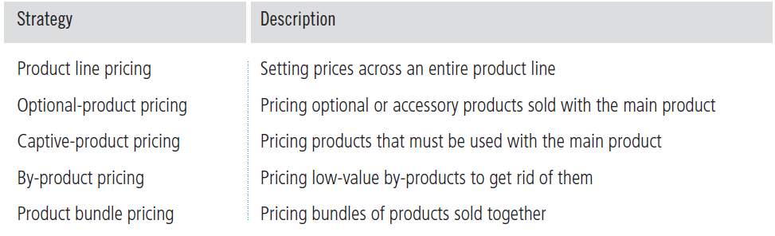
External Factors to Consider in Pricing: the Market and Demand
- Demand curve: a curve that shows the number of units the market will buy at different possible prices in a given time period
  - Law of Demand: As price increases quantity demanded decreases (and vice versa).
- Price Elasticity of Demand is Calculated as
  - E= - (% change in quantity demanded / % change in price)
  - When E < 1, the demand is said to be “inelastic”. E > 1.0 is elastic.
  - Interpret E=2.5 versus E=0.5. What do they mean?
- Elastic demand (demand changes greatly for a small change in price):
  - Consumers are very price sensitive
  - should lower price to maximize revenue (why?)
- Inelastic demand (demand hardly changes when there is a small change in price):
  - Consumers are not very price sensitive
  - should raise price to maximize revenue (why?)
- Market skimming pricing: setting a high price to skim maximum revenues layer by layer, from the segments willing to pay the high price. Price drops in steps over time
- Market penetration pricing: setting a low price for a new product to attract a large number of buyers and achieve a large market share. Enter the market with a very competitive (or low) price and stay there.
When to use skimming versus penetration pricing:
- LRAC is expected to go down considerably due to economies of scale or the firm currently enjoys economies of scale.
- “Build” strategy (“increasing market share”) is strategically important for the firm.
- The product is not difficult to copy by competitors.
Use Market Penetration Pricing when
- The firm has a secret know-how or patent regarding the manufacturing process of the product. Therefore, it is not possible for the competitors to imitate the product at least in the short run.
- There are different price sensitivities across various segments of the population. Some of these consumers are not price sensitive.
- Innovators and early adopters are anxiously waiting for the introduction of an innovation.
Price adjustment strategies
Discount and allowance pricing
- Cash discount: cash discount, seasonal discount, quantity discount
- Quantity discount
- Functional discount - offered to trade (that is, channel members) for performing certain functions for the manufacturer (such as advertising, logistics, point-of-purchase displays, special promotions that require additional labour, etc).
- Seasonal discount
- Allowances –
  - trade-in allowances (Bring in your “old diswasher” we’ll reduce the price of the new one you buy by $ 1,500.)
  - promotional allowances (Reduction in price that a manufacturer offers to wholesalers and retailers to carry out promotional activities for the manufacturers: advertise in flyers, assist in product demonstrations in store, setting of point of purchase displays, etc.).
  - Note that “functional discount” above is a more general term since it may refer many functions performed by middlemen for the manufacturer other than promotion.
(“Too many price cuts may bleed a positive brand identity to death!!!)
Promotional Pricing
- Temporarily pricing below list price, sometimes below cost, to increase short run sales
- Special-event pricing (pricing during “Boxing week”) (Occasion related marketing)
- Loss Leaders: Used in retailing to “build traffic”
- Cash rebates: Cash payment to a buyer when the buyer presents a proof of purchase
- Use of Coupons
- Low-interest financing (for “big ticket” items)
- Extended warranties or free maintenance (Change perceived value of your product not its nominal price).
- Price matching guarantee: what does it say to the consumer?
- Potential Limitations of promotional pricing:
  - Can damage brand image
  - Easily copied by competitors, may lead to price wars
  - Customers wait for deals, do not buy at “regular” price
Psychological Pricing
- Considers the consumer psychology (perceptions) about prices rather than only economics.
- Price in itself may have information for the consumer (“price as a signal” of quality for example).
- Consumers may “interpret” what price levels and price changes mean.
  - “Cheap product means low quality”.
  - “They lowered price to get rid of junk”.
  - “Greedy banks increased their fees again.”
- Find out consumers’ “reference prices” (expected prices) by research before setting or changing your prices.

Cost-plus, also called markup pricing, involves simply adding a standard markup to the unit cost of the product. The markup is usually defined as a percentage of the price. In such cases,

.

If the unit cost of a product to a manufacturer is $ 49.00 and the manufacturer wants to have a 30 percent mark-up on the price that it charges to the retailers, what should be the price that the manufacturer charges to the retailers? (Answer: $ 70.00).

Imagine that you are a retailer and import the above product from a manufacturer from overseas. You estimate the shipping cost per product to be about $ 2.00. Insurance expenses covering your inventory per product during transportation and subsequent storage are estimated to be $1.40. You will also pay a 15 percent tariff based on the price that you pay to the manufacturer. As a retailer, you would like to have a markup of 25 percent on the price that the consumer pays. What is the price to the consumer?

Manufacturer’s price: $ 70.00
Tariff paid to government: ($ 70.00 x 0.15) $ 10.50
Shipping cost: $ 2.00
Insurance cost: $ 1.40
Total (Cost of the product to the retailer) $ 83.90

$$Price to the consumer=\frac{Unit Cost to the Retailer}{1.0-Retailer^{'}s markup}=\frac{83.90}{1.0-0.25}=\$ 111.87$$

Price Escalation: Note how a product that costs $ 49.00 to the retailer ends up being marketed to the consumer for $ 111.87. The sharp increase in price due to mark-ups of the intermediaries and costs such as transportation, insurance, warehousing, product handling, etc. is called price escalation. It is an important issue especially in international marketing and when there are several levels of intermediaries in a marketing channel.
Markup pricing is a popular tool since it is easy to do.
Cost plus pricing completely ignores the perceived value of a product and how much a consumer is willing to pay for a product. The approach is “completely blind about demand”. If it is applied without considering perceived value of a product cost-plus pricing assumes that there will be demand for the product irrespective of the level of price.

Calculation of Break-Even (BE) Volume:
To “break-even” means the marketer makes no profits but incurs no losses either. It simply covers its costs with the revenue it generates. By definition, at break -even volume, total revenue (TR) equals total cost (TC). That is: TR = TC
We also know that total cost is simply the sum of total fixed cost (TFC) and total variable cost (TVC). So,
TR = TFC + TVC= TFC + (VC x Q)
Where VC is variable cost per unit and Q is the total volume (number of units that are produced and sold).
It can be easily shown that Break Even (BE) Volume is equal to the right hand side of the formula below:

This formula simply says that break-even volume is calculated by dividing total fixed cost by the difference of the price and the unit variable cost.
Assume that total fixed costs for product A in your firm are $ 600,000. You would like to market the product at a price of $ 35.00. Your cost accounting department estimates that the variable cost for a unit of Product A is likely to be $ 20.00. How many units do you need to sell to break even?

$$Break Even \left(BE\right) Volume=\frac{Total Fixed Cost}{(Price-Variable cost per unit)}=\frac{\$ 600,00}{\$ 35.00-\$ 20.00}=\frac{\$ 600,00}{\$ 15.00}=40,000 units$$

- The market and Demand: How does the type of competition (pure competition, monopolistic competition, oligopolistic competition, and pure monopoly) in an industry affect pricing decisions (see p. 360)?

Type of Competition | Characteristics | Examples
Pure Competition | Many buyers and Sellers  Uniform products  No single buyer or seller influences price | Wheat, financial securities, vegetables,
Monopolistic Competition | Many buyers and sellers  Product differentiation and segmentation exists.  Prices vary over a range since differentiated brands can charge higher prices than undifferendiated brands.. | Most branded products fall into this category (Sony, Roots.)
Oligopolistic Competition | Few sellers who are highly sensitive to each others’ pricing activities.  Price decreases are followed. May lead to price war.  Prices increases are not followed. | Automobile manufacturers, airlines, supermarket chains.
Pure Monopoly: (May be regulated by government.) | Government monopoly  Patent protection | SAQ  Pharmaceutical companies

Assume that you have the data. TFC = Total Fixed Cost = $ 350,000
Q = Total Number of Units Produced and Sold = $ 40,000 (Forecasted)
Variable Cost per Unit = $ 8 (Estimated by Accounting Department)
However, this time you want to make a profit of $ 100,000. What should be your selling price?
All you need to do to determine your price in this case is to add your target profit to the NUMERATOR of the BE VOLUME formula given above and solve for PRICE:
Now, solve for PRICE:
(PRICE – 8) x 40,000 = 450,000
(40,000 x PRICE) - 320,000 = 450,000
(40,000 x PRICE) = 770,000
PRICE = $ 19.25 per unit
Check the above result:
TR = PRICE x Q = $ 19.25 x 40,000 = $ 770,000
TC = TFC + TVC = TFC + (VC x Q) = $ 350,000 + (8 x 40,000) = $ 670,000
Profit = TR – TC = $ 770,000 - $ 670,000 = $ 100,000 (Yes, expected total profit is $100,000. Our calculations are correct.)
Note that price increases can increase total revenue when demand is inelastic (not sensitive to price changes). We expect just the opposite when price decreases. Also note that the expected changes mentioned on page 4 of the document are related to total revenue, NOT total profit (which is equal to total revenue minus total cost).
Other external factors affecting pricing decisions are competitors’ costs, prices and their offerings, economic conditions, reseller’s reactions to price levels, government, social concerns etc. Although this discussion seems to be very straightforward and conceptually easy, many students forget them in an exam setting.

Chapter 12
How channel Members add value:
Intermediaries (members of the channels of distribution) may operate more efficiently than manufacturers in making goods available to target markets.
Intermediaries use their specialization and scale of operations to reduce costs of distribution.
They provide the demanded assortment of products.
They provide time, place and possession utility (Make the product available when and where it is needed).
Channel Members add value by Performing Critical Functions
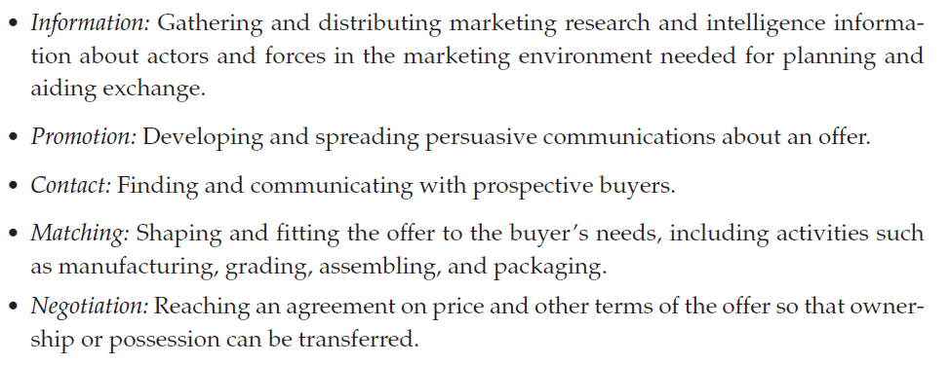
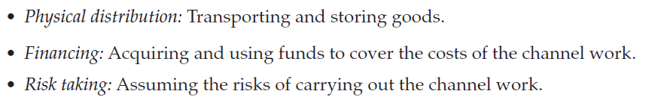

Direct Marketing Channels: a marketing channel that has no intermediary levels
Indirect Channels: a marketing channel containing one or more intermediary levels.
Multichannel Distribution system: combines both types of channels
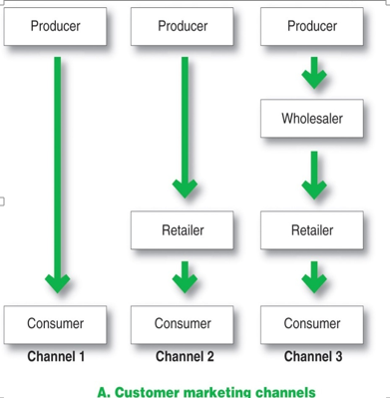
Channel 1: direct channel/ no intermediates. Ex: Amazon, Avon
Channel 2 and 3: Indirect channels with intermediaries
Each box is a level in the marketing channel. The retailer boxes have a horizontal relationship and the producer to consumer have a vertical relationship
Multichannel Distribution System
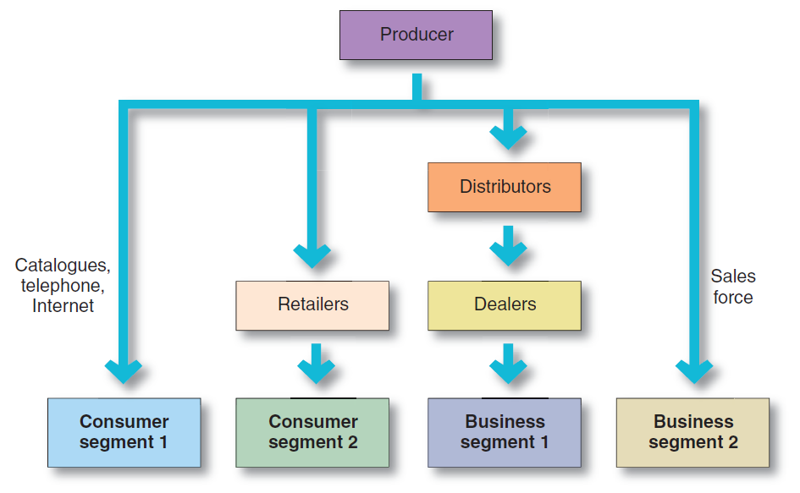

Multichannel Distribution Conflict
- Occurs when channel members disagree on roles, activities, responsibilities or rewards (such as revenues, profit sharing etc.).
- Types of Conflict:
- Horizontal conflict: occurs among firms at the same channel level (e.g. regional distributors of a company disagreeing with each other)
- Vertical conflict: occurs among firms at different channel levels (e.g. manufacturer and wholesaler disagreeing with each other). Example: Vertical Conflict between Goodyear and its chain of outlets when Goodyear decides to market its products through mass merchandisers such as Sears and Walmart
Vertical Marketing Systems to Reduce Conflict and Gain Control in Channels:
  - Producers, wholesalers, and retailers act as a unified system
  - One channel member owns, has contracts with, or has so much power that they all cooperate
  - Benefits should include greater control, less conflict, and economies of scale due to the size of the system

Vertical Marketing Systems (VMS)
A distribution channel structure in which producers, wholesalers, and retailers act as a unified system. One channel member owns the others, has contracts with them, or has so much power that they all cooperate.
Types of VMSs
- Corporate: a vertical marketing system that combines successive stages of production and distribution under single ownership; channel leadership is established through common ownership
- Contractual: a vertical marketing system in which independent firms at different level of production and distribution join together though contracts
    - Franchise: a contractual vertical marketing system in which a channel member, called franchisor, links several stages in the production-distribution process.
- Administered: a vertical marketing system that coordinates successive stages of production and distribution though the size and power of one of the parties
Channel Design Decisions
Number of marketing intermediaries
Intensive (or extensive) distribution stocks the product in as many outlets as possible (Hundreds of outlets):
- Used mainly for convenience products
- Provides maximum geographic coverage and convenience.
Selective distribution is the use of more than one but fewer than all of the intermediaries who are willing to carry the company’s products (Tens of outlets)
- The manufacturer can develop good working relationships with channel members
- Gives good market coverage with more control and less cost than intensive distribution mentioned above.
Exclusive distribution gives a limited number of dealers exclusive rights to distribute the company’s products in their territories (Only a few outlets)
- Generates stronger dealer support and more control over dealer prices, promotion and services.
- Enhances brand image. Allows for higher markups

Designing International Distribution Channels
- Channel systems can vary from country to country
- Must be able to adapt channel strategies to the existing structures within each country
Consider both channels between nations and channels within nations
Transportation and logistics may become very critical.
There are large differences in the number and types of channel intermediaries that serve each country.
Large-scale retailers that dominate North America. However, small independent retailers serve large populations in other countries (90,000 points of sale for Nokia in India).
Also, there may be many levels between the seller and the buyer (example: six levels in certain industries in Japan).
Establishing your own traditional channel (other than direct marketing) will be too expensive in many countries.

Chapter 14
Marketing Communication Mix (also called The Promotion Mix)

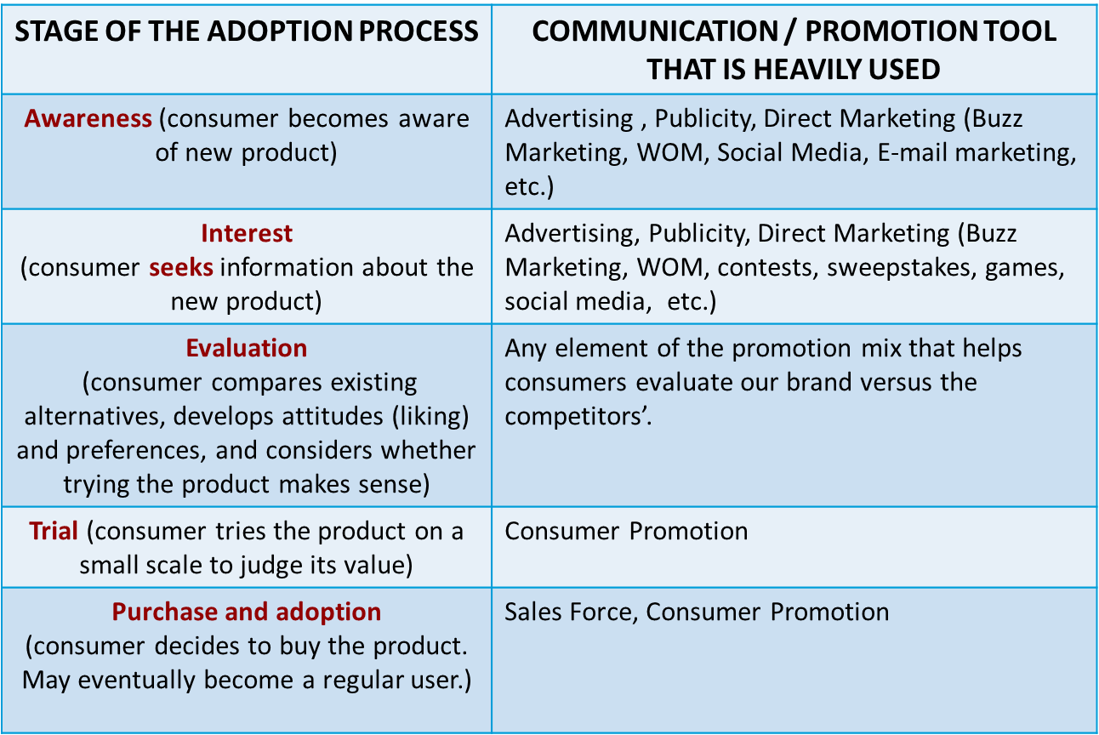
It is important for you to notice that stages of the adoption process present a process that can be used by marketers: a group of consumers may be “moved” through the buyer readiness stages by a firm that uses the elements of the communication mix in an integrated manner by paying attention to the effective use of different elements of the communication mix in combination and then varying this combination from one stage to the next.

IMC (Promotion) Mix: integrate communication tools into an overall campaign
- FOR NEW PRODUCTS:
  - We can follow the stages of the consumer ADOPTION PROCESS MODEL (see page 204 of your text) to design a communication / promotion mix and to integrate the elements of the mix.
  - Help consumers pass through the stages of the adoption process quickly and without reservations so that they purchase the product and become regular users (adopters) of our new product.
- FOR PRODUCTS THAT ARE NOT BREAKTHROUGH INNOVATIONS:
  - We can follow the stages of the BUYER READINESS STAGES MODEL.

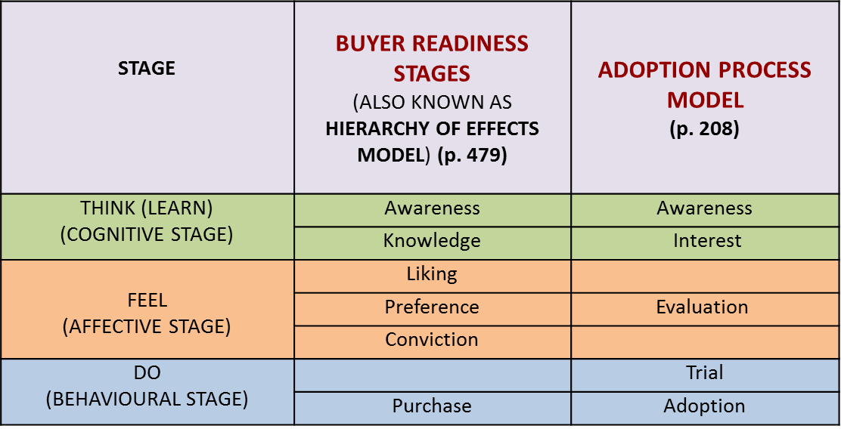
The above models are used to build Communication/Promotion campaigns. The central idea is to help consumers progress from one stage to another by using the tools that are presented on slide 2 in parallel and/or sequential fashion. So, all the tools that are used in a campaign should build up consumer response towards a common goal. That is why we need Integration of the Communication Mix.
Promotion tools: advertising, personal selling, sales promotion, public relations, direct marketing
Steps in Developing Effective Marketing Communications
- Identify your target audience. (Who will you address?)
- Determine your communication objective in terms of consumer response. (What do you want to achieve?)
- Determine your budget. (How much will you spend?)
- Design your message. (What do you want to say?)
- Choose your communication mix and media. (Where do you want to communicate?)
- Integrate communication tools into an overall campaign. (In what sequence and when?)
- Execute and Collect feedback. (Did my message achieve its objective?)
- Note: Steps 6 and 7 are typically executed jointly.

Designing a Message
- Message content: Message content uses appeals or themes designed to produce desired results
- Rational appeals: relate to the audience’s self-interest (economy, safety, convenience, durability, portability, etc. )
- Emotional appeals: stir up negative or positive feelings using humour, fear, pride, joy, affection, sympathy, or even disgust
- Moral appeals: related to the audience’s sense of right versus wrong (based on humanistic, cultural and religious values)
- Message Structure:
- Should we draw a conclusion? Better off raising questions and letting consumers reach their conclusions after being exposed to the communication
- Should we present the strongest argument first? Presenting the strongest argument first gets attention but the ending will be anticlimactic.
- Should we present only the strengths of our product or both its strengths and shortcomings (also called one-sided versus two-sided argument): With educated and experienced buyers and those who may have opposing views use two-sided arguments.
- Message Format:
- Print advertising: decide on headline, copy, illustrations, colours, etc. For radio
- Radio advertising: Choose words, sounds, voices, music.
- Personal presentation: Plan body posture, facial expression, dress, hairstyle. Et.

6. Many companies use a mix of promotion (communication) elements. Given their promotion budgets, some companies allocate a bigger percentage of their budgets to sales force (as in industrial marketing), some others however allocate a bigger percentage to advertising (as in consumer marketing by Procter and Gamble), while others emphasize promotion to the retailers and wholesalers (as practiced by certain consumer and industrial marketing companies). These strategies are known as pull and push strategies.
Push Versus Pull Communication / Promotion Mix Strategies

Communication/  Promotion Mix | Objectives, Results
Pull | Try to stimulate demand. Focus on consumer. Attempt to differentiate and position your product clearly. Build brand identity. Or, try to create consumer response immediately. Use mainly advertising, consumer promotion, direct marketing, and publicity. Typically preferred by consumer goods marketers with healthy budgets for communication.
Push | Try to gain the support of the channel members in “pushing” your product down the distribution channel to your consumers. Focus on the cooperation and assistance of the wholesalers and retailers in successfully marketing of your product to the consumers at the point of purchase. Build strong relationships with the channel intermediaries using a sales force. Emphasize trade discounts more in your promotion budget. Typically preferred by companies marketing industrial products (business to business marketing). Also preferred by smaller companies with weaker budgets for communication / promotion purposes.
- Many large B2C companies use a combination of the two strategies typically having a larger proportion of the promotion budget for “pull”.
- They typically put more of their funds into advertising, followed by consumer promotion, trade promotion (including personal selling), direct marketing, and public relations.

Chapter 15
Given the definition of a target market, any advertising campaign should start with the setting of the objectives of the campaign. As mentioned in Figure 15-1 of your text, the objectives of the campaign are not always to generate immediate sales (although all communication programs ultimately aim this in the long run). The company may have communication rather than immediate sales objectives, and these objectives typically involve objectives associated with the Buyer Readiness stages (that is, “moving” the target market through the various stages towards sales). Some ads simply aim to inform the consumer (building awareness and knowledge in the introduction stage of the product life cycle). Some others attempt to build brand identity (brand image) and affect consumer preferences so that the consumer will develop a positive attitude toward a brand and like it. An important stage to follow is conviction: consumer is convinced that the advertised brand is the best answer to her/his needs and wants. The efforts to build preference and overall liking try to persuade the consumers in terms of the clear and distinctive benefits (value) the brand offers. Some other advertisements are simply “teasers” in a long campaign to build curiosity and interest for the subsequent stages of the campaign. We also have ads that we can call “reminders” to avoid erosion of the brand identity especially during the maturity stage. Reminder ads may also emphasize special occasions (such as mothers’ day, valentines day, etc.) to potential buyers.

Given a target market, and having specified the objectives of an advertising campaign and determined the overall budget for the campaign, an advertising message needs to be created. For this purpose, a “message strategy” is spelled out which is brought to life through a “creative concept” (also called “Big Idea”) that advertising experts suggest. What do we mean by “message strategy” and “creative concept”. Is “message strategy” different than “product differentiation”? (Answer: the two terms refer to very similar ideas).

Advertising Decisions
- Set objectives:
  - Inform (build awareness), remind or persuade?
- Set advertising budget: A bigger budget is needed
  - In the introduction stage of the PLC
  - When the company wants to build market share
  - When competitors advertise heavily
  - When the brands are not easy to differentiate
  - In the B2C markets than in B2B markets
- Create the advertising message:
- Create a general “Message Strategy” that will be communicated to your consumers. Identify the key benefit(s) to be communicated and the positioning points to be made.
Example: “E-trade makes investment decisions easy.”
- Bring the message strategy to life with a distinctive, interesting, and memorable creative concept (called also “Big Idea” in advertising circles).
Example: Given the e-trade message strategy on the previous slide, an advertising agency came up with the “Talking Baby” creative concept
- Choose your execution style:
  - Slice of life
  - Lifestyle
  - Mood or image
  - Personality symbol (“Ronald McDonald”, E-Trade baby, “Mr. Clean”, Aflac Duck, Energizer Bunny).
  - Technical expertise in making the product
  - Scientific evidence
  - Testimonial or endorsement
- Selecting Advertising Media
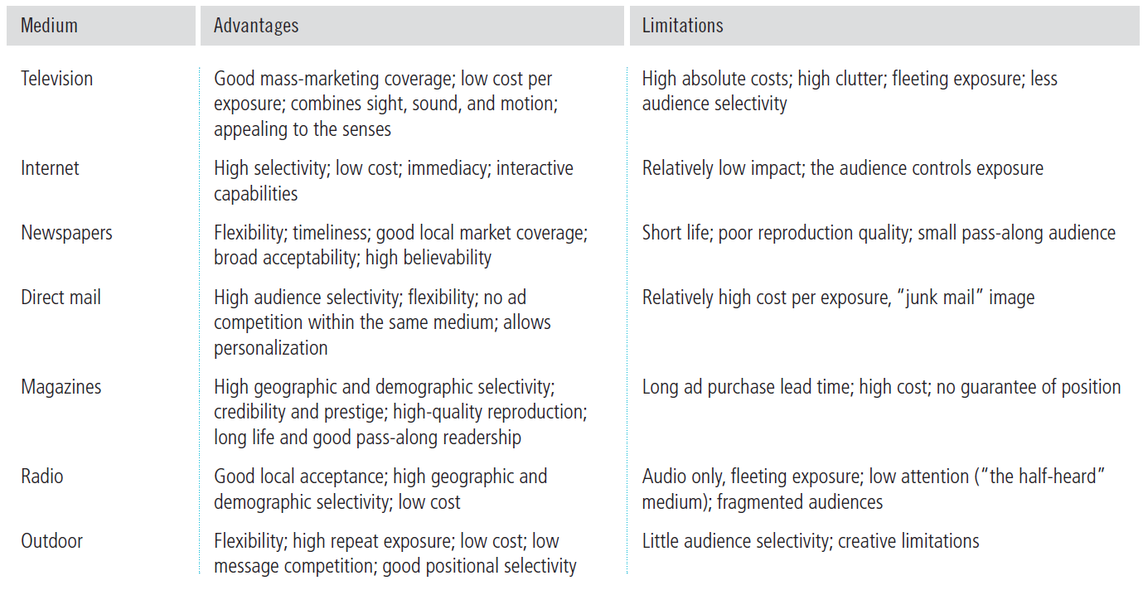

Public Relations
- Builds good relationships with the company’s various publics (including government)
- Builds a good company and brand image
- More believable than advertising, highly credible
- Reaches a wide spectrum of prospects which may be otherwise missed
- Low cost compared to many other forms of promotion
Public Relations Tools

Buzz Marketing and Social Media
- These publicity tools recognize the importance of opinion leaders and reference groups in consumer behavior
- Buzz Marketing: Cultivating opinion leaders (innovators and early adopters) and getting them to spread word-of-mouth about a product or service in their social networks.
Online social networks are a form of Online Marketing
Chapter 16
Personal Selling
The Role of the Sales Force
  - Two-way personal communication
  - More effective than advertising in complex selling situations (product and related service are technically complex, involve many details that need periodic attention, etc.)
  - Effective sales people work in the “boundary” between a firm and its customers:
    - The sales force works to represents the company to customers
    - They also represent the customers to the company
The goal of the personal selling process is to get new customers and obtain orders from them
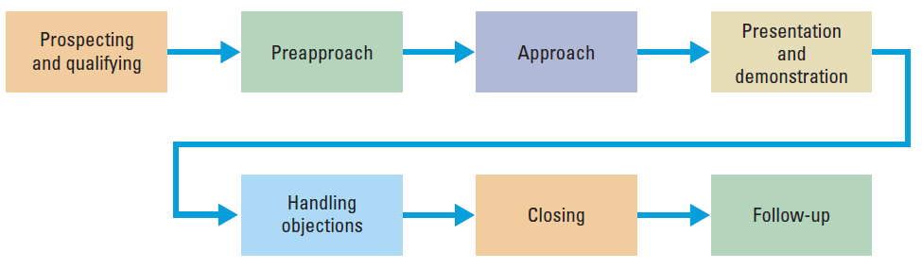
Handling buyer objections to your product immediately and effectively just when such objections are raised
Team selling is used to service large, complex accounts. A team is responsible for serving designated customer accounts
It is simply difficult for sales personnel to consider the interests of both the customer and the firm at the same time.
Note that the selling process does not end with the “closing” of the sale. The sales people need to “follow-up” and nurture “long term relationships” (CRM emphasis).
Sales Promotion:
Sales promotion refers to the short-term incentives to encourage purchases or sales of a product or service:
- Consumer promotions: sales promotion tools used to boost short-term customer buying and involvement or enhance long-term customer relationship. Pull strategy
- Trade promotions: sales promotion tools used to persuade resellers to carry a brand, give it shelf space, promote it in advertising, and push it to consumers. Push strategy
- Sales force promotions (Business promotion): sales promotion tools used to generate business leads, stimulate purchases, reward customers, and motivate salespeople.

Factors in the Growth of Sales Promotions
- Product managers are under pressure to increase current sales
  - This leads to short term orientation (“Save the day”).
- Companies face more competition than ever before
- Competing brands offer less differentiation
- Consumers have become more deal-oriented

Sales promotions have typically been used to stimulate trial, acquire new users, encourage brand switching especially for variety seeking consumers, increase purchase quantity per purchase occasion, reduce out-of-fashion inventory, generate cash inflow in a hurry, etc. Recently, however, companies began to adapt sales promotion programs to cement long-term consumer relationships. What are the major tools for that are used for building and sustaining long term relationships with consumers? “patronage rewards”, Air Miles, Frequent Flier Points, club marketing programs, etc that are used in CRM but they are essentially promotion tools

Major Sales Promotion Tools:

Chapter 17
This chapter deals with one of the important recent developments in marketing. Also, note that if a manufacturer decides to engage in direct marketing, all of the functions associated with the related channels of distribution have to be performed by the manufacturer.

Direct Marketing

Direct marketing is:
- A marketing channel without intermediaries
- An element of the promotion mix
- Fastest-growing form of marketing
- Most web oriented than any other channel
(Note that the term “direct marketing” is used to describe BOTH a type of marketing channel and a major element of the marketing communications mix.)

How is the new model of direct marketing different than the traditional approaches to direct marketing? (The essence of the difference is that the new “model” of direct marketing uses internet and other forms of electronic channels and improves their effectiveness with the use of extensive databases involving consumer purchase patterns, preferences, and demographics. These databases allow the companies to customize their messages and other offerings (products etc.) to each individual in the target market.)

Benefits of Direct Marketing to Buyers
- “never close their doors”: available 24/7
- Provide convenience: Do not have to search for or travel to store
- Provide vast assortments (almost unlimited selection)
- Provide comparative information that is more objective and complete than the information that can be provided by some sales attendants
- Provide interactive media that are immediate and interactive (ask questions, interact with sales personnel and technical assistants by e-mail, phone, etc.)
Benefits of Direct Marketing to Sellers
- Use direct marketing tools to build relationships with consumers
- Can target a selected small group of consumers by using databases.
- Can customize communication and promotion efforts
- Can receive direct feedback from individual consumers.
- Use tools that are very efficient (cost per consumer is very low).
- Avoid the costs expense of maintaining a store (rent, insurance and utilities)
- Use tools that are highly flexible in terms of making adjustments to prices and programs.
- Can reach customers globally that can not be reached otherwise.

Forms of Direct Marketing
  - Direct mail: may involve letters, printed advertisements, brochures, product samples, CD’s, DVD’s, e-mail, text messaging,
  - Catalog marketing: Sears, Land’s End, L. L. Bean are classical examples.
  - Telephone marketing (also called telemarketing): Outbound or inbound telemarketing. “Junk phone call during dinner time” image. National Do Not Call List in Canada.
  - Direct-Response Television Advertising: Infomercials, short TV ads with a toll-free number to call for ordering, home shopping channels.
  - Kiosk marketing: Kiosks are information and ordering machines in stores, airports, malls, and other places with high consumer traffic.
  - New digital media: Mobile phones, podcasts, vodcasts.
  - Online Marketing: offer fresh. Original and inexpensive ways to reach fragmented audiences. Difficult to control content.

Online Marketing

Customer database is an organized collection of comprehensive data about individual customers or prospects, including geographic, demographic, psychographic, and behavioral data

Online marketing involves all efforts to market product/services and build customer relationships over the internet. It is the fastest form of direct marketing.

- Company (corporate/brand) website: these sites are designed to build customer goodwill, collect customer feedback, and supplement other sales channels rather than sell the product directly. They:
- Provide information
- Create excitement
- Build relationships
Marketing Site: these sites interact with consumers to move them closer to a direct purchase or other marketing outcomes.
- Viral Marketing: the internet version of word-of-mouth marketing; websites, videos, email messages, or other marketing events that are so infectious that customers will want to pass them along to their friends.
- Consumer to consumer (C2C) online marketing
  - occurs on the Web between interested parties over a wide range of products and subjects:
  - Kijiji
  - Ebay
  - Craigslist
  - Social networks (Facebook, Twitter, Pinterest, YouTube)
Placing ads and promotion online:
- Online advertising is advertising that appears while consumers are surfing the Web, including display ads, search-related ads, online classifieds, and other forms.
- Banners are banner-shaped ads found on a website.
- Interstitials are ads that appear between screen changes.
- Pop-ups are ads that suddenly appear in a new window in front of the window being viewed.
- Rich media ads incorporate animation, video, sound, and interactivity
Alliances and affiliate programs are relationships where online companies promote each other
Permission-based marketing allows users to opt in or opt out of e-mail marketing (important development in marketing)

Chapter 19
Restrictions on trade zones
- Restrictions on trade between nations include:
- Tariffs : taxes on certain imported products designed to protect domestic products.
- Quotas: Limits on the amount of foreign imports that will be accepted to a country in certain product categories.
- Exchange Controls: Limits on the amounts of foreign exchange handled by a foreign firm or limits on the exchange rates against some currencies.
- Non-tariff trade barriers: product standards that aim to restrict imports, excessive host-country regulations that are biased against imports.

International Trade Zones
Certain countries have formed free trade zones or economic communities. These are groups of nations organized to work towards common goals in the regulation of international trade.
- European Union (EU)
- North American Free Trade Agreement (NAFTA): $ 697 billion in trade in 2009 !
- Trans-Pacific Partnership
- Canada-EU trade agreement: in the works
- Canada-Columbia free trade agreement (also with Israel, Chile, Costa Rica, Peru, Jordan, Panama).

Economic Attractiveness of a country
Industrial structure:
- Substance economies: the vast majority of people engage in simple agriculture. They offer limited market opportunities
- Raw material exporting economies: these economies are rich in one or more natural recourses but poor in other ways. These countries are good markets for large equipment, tools, supplies and trucks. If there are many foreign residents and a wealthy upper class, they are also a good market for luxury goods.
- Emerging economies (industrializing economies): fast growing in manufacturing results in rapid overall economic growth.
- Industrial economies: major exporter of manufactured goods, services, and investment funds. They trade goods among themselves and also export them to other types of economies for raw materials and semi-finished goods.
Income distribution
Deciding how to enter a foreign market
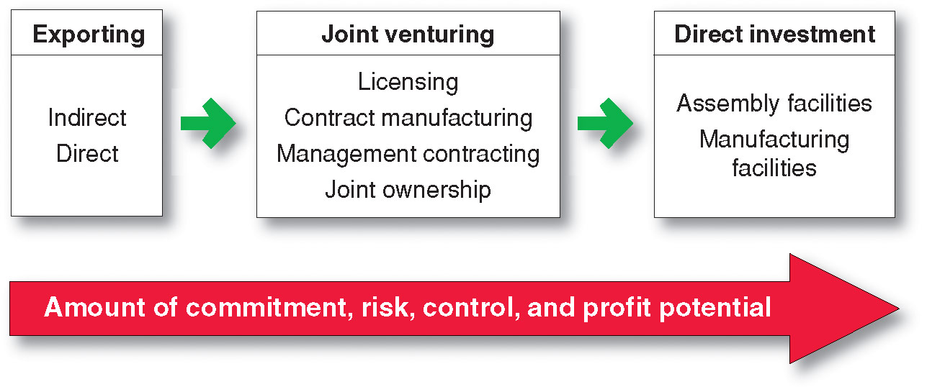
All the above consequences of a market entry strategy increase as we move from left to right
It is important that a company truly understands who they are working with if they partner for their global markets. Even finding an exporting agent can be quite difficult. This link brings the instructor to the USDA Foreign Agricultural Service listing of types of export agents and their focus.
- EXPORTING:
- Indirect exporting involves working through independent international marketing intermediaries.
  - Less involvement, less risk
- Direct exporting is when the firm handles its own exports.
  - Greater involvement, greater risk, greater potential return
  - Can be done through:
    - Set up a domestic export department
    - Set up an overseas sales branch
    - Send home-based sales people abroad
    - Export through foreign-based distributors or agents
- Joint venturing is when a firm joins with foreign companies to produce or market products or services (Risky in terms of technological knowhow)
- Direct investment is the development of foreign-based assembly or manufacturing facilities (most risky option but provides the most control over operations).

International Marketing Strategy: A very important strategic concern in international marketing is whether and how much to modify our four P’s that we execute in our home country to the local conditions of the international market we target. This issue is known as “standardization versus adaptation”. That is, should we keep our marketing strategy constant across some targeted international markets or adapt our strategy to local conditions.
Standardization is cost efficient.
Adaptation, however, allows us to respond to local conditions better.
Standardization versus adaptation is usually discussed with respect to product and advertising. However, the same issue is also valid for pricing and channels of distribution. Understand the issues involved with regard to “standardization versus adaptation” of marketing strategy in international markets. Be aware that there is no simple answer and each company has to consider the unique issues involved in each case. In general, however, there seems to be a trend towards recognizing the differences across international markets especially in advertising and channels of distribution as an extension of the idea of “thinking globally but acting locally”. However, it is not unusual for us to see products that are completely standardized across markets (such as soft drinks (Coke, Pepsi), laundry detergents, cellular phones, toothpaste, shampoos, television sets, personal computers, etc.)

