Midterm REVIEW
Chapter 1: What is Organizational Behaviour?
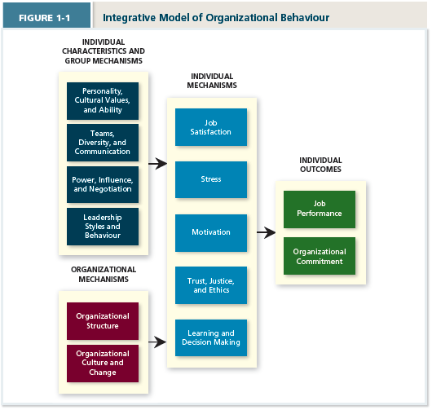
Chapter 2: Job Performance
Job Performance = set of employee behaviours that contribute, either positively or negatively, to organizational goal accomplishment
Task Performance = employee behaviours that are directly involved in the transformation of organizational resources into goods/services
- Routine Task = routine/predictable
- Adaptive = task demands that are novel/unpredictable
- Creative = ideas/outcomes that are novel AND useful
Handling emergency situations, work stress, solving problems creatively, learning new work tasks, interpersonal/cultural adaptability
Citizenship Behaviour – voluntary employee activities, that may or may not be rewarded, that contribute to improve the overall quality of setting in which work takes place
- Organizational
  - Helping = assisting coworkers
  - Courtesy = keeping coworkers informed about relevant matters
  - Sportsmanship = maintaining good attitude with coworkers
- Interpersonal/Organizational
  - Voice = speaking up and offering constructive suggestions
  - Civic Virtue = participating in company at deeper than normal level
Ex. Taking extra classes for future use
  - Boosterism = representing company positively in public
- Counterproductive Behaviour – employee behaves intentionally to HINDER organization
  - Serious Organizational – Sabotage (destruction of equipment), Theft (stealing)
  - Minor Organizational = Wasting resources, Substance Abuse = less productive at work
  - Minor Interpersonal = gossiping = unconfirmed facts, incivility = rude communication
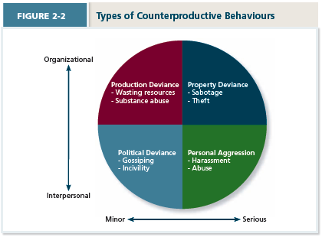
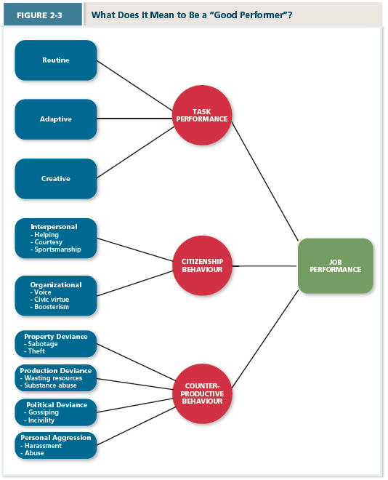
  - Serious Interpersonal = harassment, abuse

Chapter 3: Organizational Commitment
- Desire to remain a member of the organization
- Employees who are not committed engage in withdrawal behaviors
Forms of Commitment
- Affective – due to emotional attachment – you WANT to stay (friends, good boss, good atmosphere)
- Continuance – due to awareness of cost of leaving – you NEED to stay (upcoming promotion, good pay, community is good)
Only commitment that higher levels lead to lower job performance
- Normative – due to feeling of obligation = you OUGHT to stay (boss has invested in me, company gave me my start, boss has helped me out personally)
Erosion Model – fewer bonds = more likely to quit (AFFECTIVE)
Social Influence Model – employers with direct links to “leavers” more likely to leave
Embeddedness – an employees’ desire to remain a member of the organization due to a feeling of obligation (CONTINUANCE commitment)
- Caused by LINKS – organizational = worked here so long, community = close friends
- Caused by FIT – organizational = my job uses my skills, community = I like community
- Caused by SACRIFICE – organizational = don’t want to lose benefits, community = people respect me
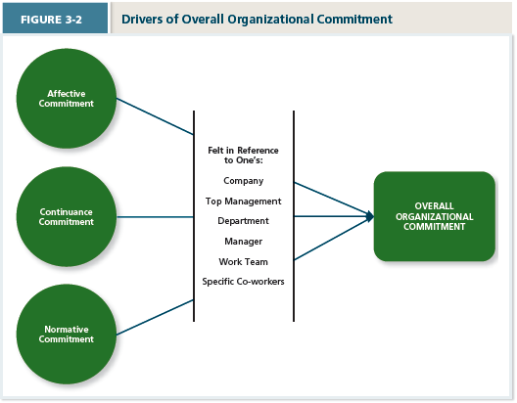
Responses to Negative Events
- Exit – active, destructive response – ends organizational membership
- Voice – active, constructive response – attempts to improve situation
- Loyalty – passive, constructive response – don’t say anything but hope for better
- Neglect – passive, destructive response – interest/effort in job decline
Psychological Withdrawal – NEGLECT – actions that provide mental escape from work (daydreaming, cyber loafing, moonlighting)
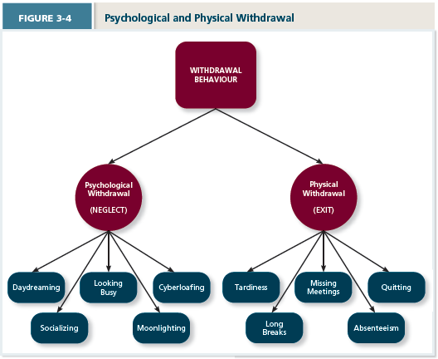
Physical Withdrawal – EXIT – actions that provide a physical escape from work (quitting, tardiness, absenteeism)

Three Models for Predicting Outcomes
- Independent Forms = withdrawal behaviors are UNCORRELATED (unpredictable)
- Compensatory Forms = withdrawal behaviors are NEGATIVELY CORRELATED (more of one leads to less of other)
- Progression = withdrawal behaviors are POSITIVELY CORRELATED (one leads to another)
NOTE: Psychological contracts = reflect employees beliefs about what they owe the organization and what the organization owes them (transaction and relational) BUT relational is decreasing as people have less trust in companies
Chapter 4: Job Satisfaction
- Value Percept Theory
  - People evaluate job satisfaction according to specific facets of the job
  - Dissatisfaction = (V_{want} – Vh_{ave})(V_{importance})
  - Work itself Coworker Supervisor Promotion Pay
- Job Characteristic Theory (VISAF)
  - Variety – Meaningfulness – increasing variety increases job satisfaction
  - Identity – Meaningfulness – how do I fit into the end product?
  - Significance – Meaningfulness – is what you’re doing adding value (can you see end?)
  - Autonomy – Responsibility of Outcomes – are you responsible for outcome?
  - Feedback – Knowledge of Results – do I hear about how I do?
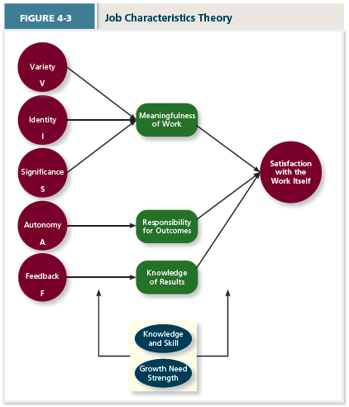
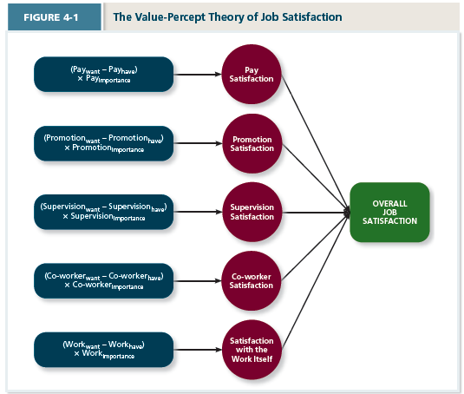
HBC Case – Coworkers painting toys – they got to control the speed of the belt – by involving the workers you improved the satisfaction with work itself and supervisors, you then increased there autonomy to improve work flow

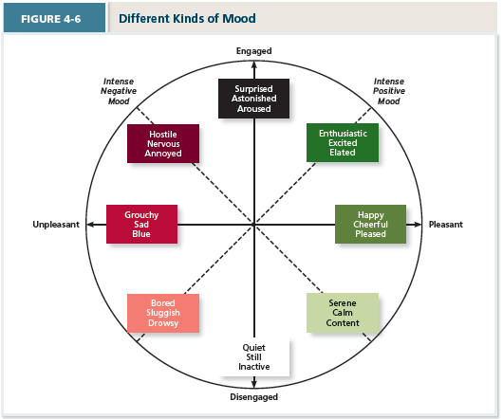
Satisfaction levels fluctuate on any given day. Rises and falls in job satisfaction are triggered by positive and negative events that are experienced. Those events trigger changes in emotion that eventually give way to changes in mood
- Mood – states of feeling that are mild in intensity and last for an extended period of time (not directed at anything)
- Emotions – intense feelings often lasting short durations that are clearly directed (at someone or something)
- Affective Events Theory – Describes how workplace events can generate emotional reactions that impact work behaviours
- Emotional Labour – the management of their emotions that employees must do to complete their duties successfully (think cashiers have to hold back irritation)
- Emotional Contagion – The idea that emotions can transfer from one to another

Chapter 5: Stress
- Is defined as a psychological response to demands (stressors) that exceed a person’s capacity or resources resulting in a negative consequence (strain)
Transactional Theory of Stress
- Primary Appraisal = is this stressful?
  - Hindrance Stressors – stressful demands that are perceived as hindering progress
    - Work
      - Role Conflict – two conflicting expectations
      - Role Ambiguity – lack of information regarding what needs to be done
      - Role Overload – number of demanding roles is too high (too many things)
      - Daily Hassel – minor day to day things that get in way
    - Non-work = Work family conflict, negative life events, financial uncertainty
  - Challenge Stressors – stressful demands that are perceived as opportunities for growth
    - Work
      - Time Pressure – perception that there is not enough time
      - Work Complexity – degree to which work exceeds capabilities
      - Work Responsibility – obligations that a person has to others
    - Non-Work = family time demands, personal development, positive life events
- Secondary Appraisal = how do I cope?
  - Behavioral Methods – physical activities to DEAL with stressor
    - Problem Focused = work harder, seek assistance
    - Emotion Focused = seek support, engage in alternative activities
  - Cognitive Methods – how to deal with stressors mentally
    - Problem Focused = strategize, self-motivate
    - Emotion Focused = avoid/distance/ignore problem
Strain
- Physiological Strain – reactions from stressor that harm the body (high heart rate, getting sick)
- Psychological Strain – negative psychological reactions from body (anxiety, depression, burnout)
- Behavioral Strain – patterns of negative behavior (smoking, over-eating)
To help offer SOCIAL SUPPORT – help one receives when confronted with stressful demands
- Instrumental Support = help to address stressor directly
- Emotional Support = help to address associated emotional distress symptoms
TYPE A = tend to experience more stressors and see more situations as stressful
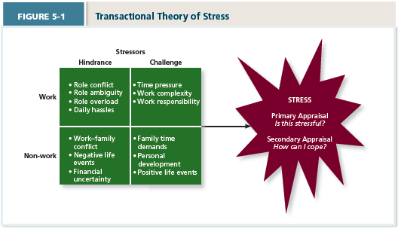

Chapter 6: Motivation
- Defined as the energetic forces that initiate work-related effort and determine its direction, intensity, and persistence
- Goal Setting Theory – goals are primary drivers of intensity and persistence of effort and need to be accepted by both worker and boss (need to be specific and difficult – but not impossible)
- Expectancy Theory – describes the cognitive process that employees go through to make choices among different voluntary responses
  - Expectancy – the perceived probability that individual effort will result in a certain level of performance
  - Instrumentality – perception that a particular level of performance will result in attaining a desired outcome (reward)
  - Valence – the attractiveness/importance of the performance reward to the individual 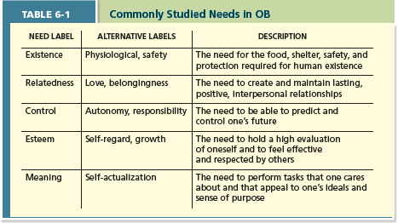
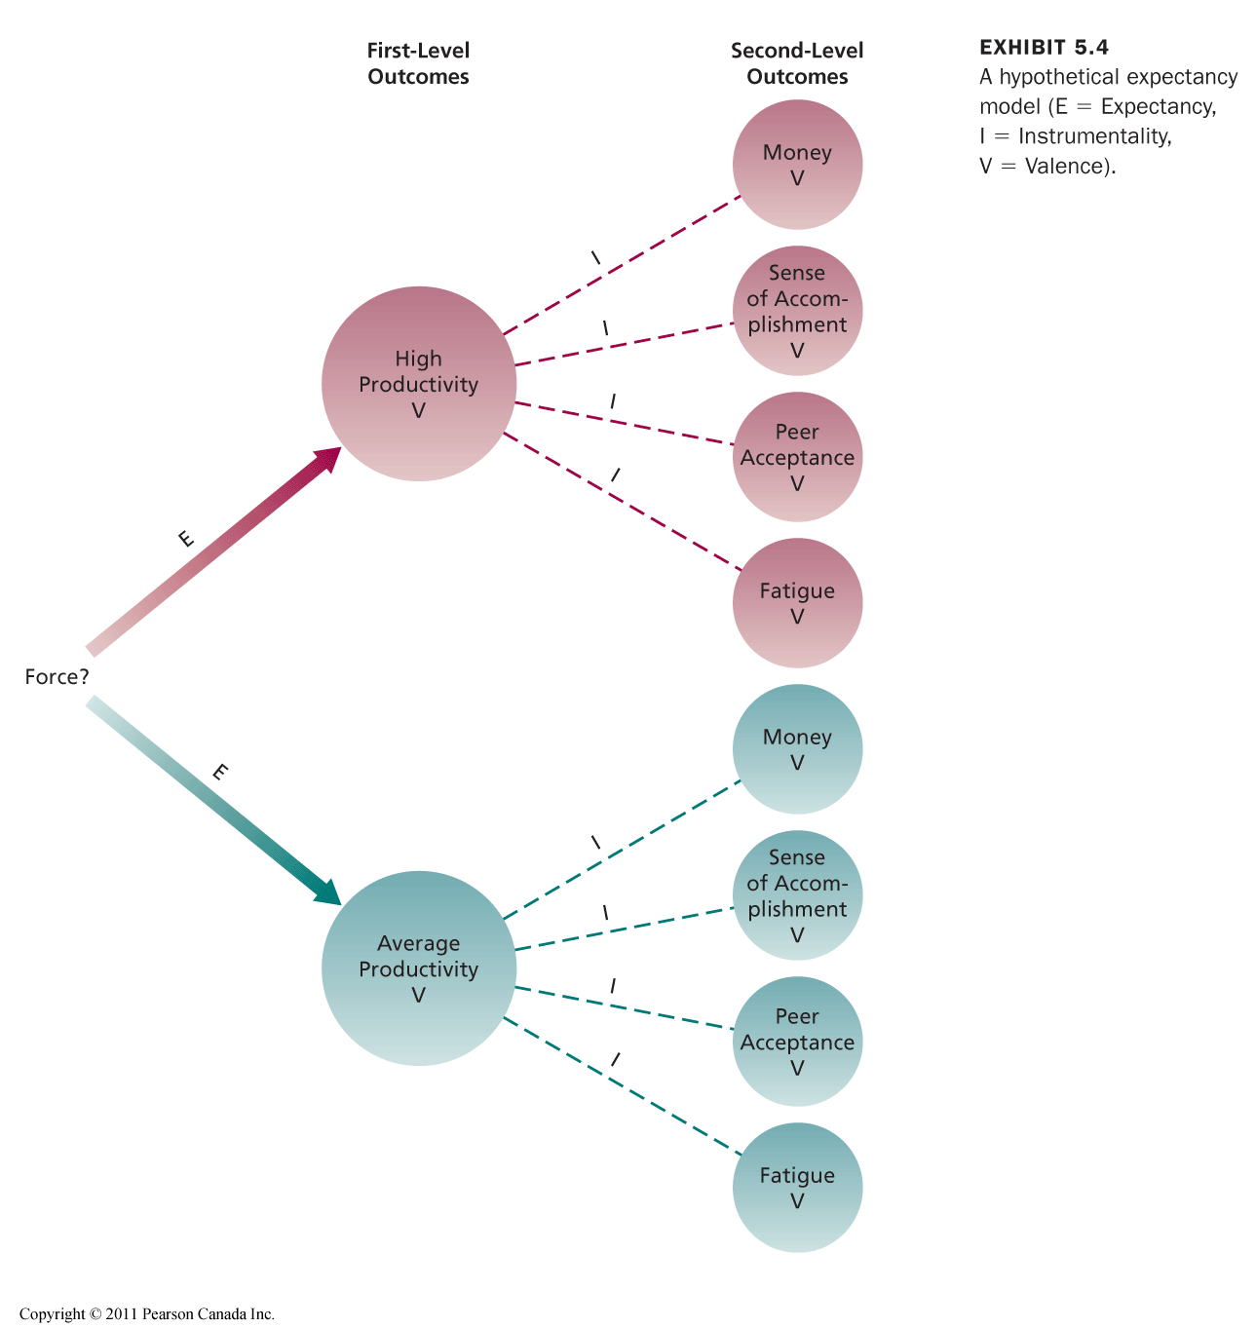

Chapter 7: Trust, Justice, and Ethics
- Trust - willingness to be vulnerable to an authority based on positive expectations about the authority’s actions and intentions.
  - disposition-based: one’s personality includes a general propensity to trust others
    - Trust Propensity: A general expectation that the words, promises, and statements of individuals can be relied upon
    - If disposition is high, you are more likely to “blind trust” a stranger
  - cognition-based: it’s rooted in a rational assessment of the authority’s trustworthiness
    - Trustworthiness: Characteristics or attributes of a person that inspire trust, including competence, character, and benevolence
    - Ability: The skills, competencies, and areas of expertise that enable an authority to be successful in some specific area (we trust doctors to do surgery)
    - Benevolence: The belief that an authority wants to do good for a trustor, apart from any selfish or profit-centered motives
    - Integrity: The perception that an authority adheres to a set of values and principles that the trustor finds acceptable (authority walk the walk)
  - Affect-based: it’s rooted in feelings toward the authority that go beyond any rational assessment of trustworthiness (once we build a relationship, this takes over)
- Justice - the perceived fairness of an authority’s decision making and can be used to explain why employees judge some authorities as more trustworthy than others. The fairness of an authority’s decision making can be judged along four dimensions:
  - Distributive justice reflects the perceived fairness of decision-making outcomes
  - Procedural justice reflects the perceived fairness of decision-making processes
    - Created when authority adhere to the rules of fair process
    - Voice: giving employees a chance to express opinion during decision process
    - Correctability: employees a chance to request appeal when they feel the procedure worked ineffectively
    - 4 Rules: Consistency, bias suppression, representativeness, and accuracy rules help ensure that procedures are neutral and objective
  - Interpersonal justice reflects the perceived fairness of the treatment received by employees from authorities
    - Respect Rule: whether authorities treat employees with dignity & sincerity
    - Propriety Rule: reflects whether authorities refrain from making improper or offensive remarks
  - Informational justice reflects the perceived fairness of the communications provided to employees from authorities
    - Justification Rule: authorities explain decision making procedures and outcomes in a comprehensive manner
    - Truthfulness Rule: requires those communications to be honest
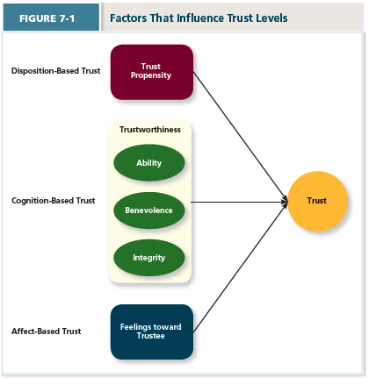

Chapter 8: Learning and Decision Making
- Learning is a relatively permanent change in an employee’s knowledge or skill that results from experience
- Decision making refers to the process of generating and choosing from a set of alternatives to solve a problem
  - Learning allows employees to make better decisions by making those decisions more quickly and by being able to generate a better set of alternatives
  - Expertise: the knowledge and skills that distinguish experts from novices

- Employees gain both explicit and tacit knowledge as they build expertise
  - Explicit knowledge is easily communicated and available to everyone
  - Tacit knowledge, however, is something employees can only learn through experience

- Employees learn new knowledge through reinforcement and observation of others. That learning also depends on whether the employees are learning-oriented or performance-oriented.
  - Reinforcement (Contingencies of Reinforcement)
    - Positive: A reinforcement in which a positive outcome follows a desired behavior
      - Most Common
    - Negative: a reinforcement in which an unwanted outcome is removed following a desired behavior – (Increases desired behavior
      - IF you have a certain task, and doing well removes that task, you will likely do better
    - Punishment: An unwanted outcome that follows an unwanted behavior
    - Extinction: the removal of a positive outcome following an unwanted behavior
      - Also very common, ex. Class clown, take away the attention he is getting
  - Schedules of Reinforcement: the timing of when contingencies are applied/removed
    - Continuous: a schedule in which a specific consequences follows each occurrence of a certain behavior (impractical, not effective once reward is removed)
    - Fixed Interval: a schedule whereby reinforcement occurs at fixed intervals
    - Variable-Interval: reinforcement happens at random periods
    - Fixed Ratio: A schedule whereby reinforcement occurs following a fixed number of desired behaviors (ex. Piece rate pay system)
    - Variable-Ratio: behaviors are reinforced after varying number of them have been exhibited (how slots work, you are randomly rewarded on ratio of $ put in)
Attribution Theory suggests that when people have a level of familiarity with the person being judged they will do the following:
- Consensus: used to attribute cause, did others act the same way under similar conditions?
- Distinctiveness: whether the person being judged acts in a similar fashion under different circumstances
- Consistency: where the person behaved this way before under similar circumstances
Other Decision Making Errors
- Selective Perception: tendency for people to see their environment only as it affects them and as it is consistent with their own expectations
- Projection Bias: the fault perception by decisions makers that others think, feel, and act as they do
- Social Identity Theory: people identify themselves according to the various groups to which they belong and judge others according to the groups they associate with
- Heuristics: simple and efficient rules of thumb that allow one to make decisions more easily
- Availability Bias: the tendency to base judgements on information that is easier to recall
- Fundamental Attribution Error: is the tendency for people to judge others’ behaviors as being due to internal factors such as ability or attitudes
- Self-Serving Bias: when one attributes one’s own failure to external factors and success to internal factors
- Anchoring Bias – common human tendency to rely too heavily on the first piece of info offered
- Halo Effect – drawing a general impression about an individual based on a single characteristic
- Framing Bias – the way a question is “framed” often has influence on how people answer it
- Representativeness Bias (Gambler Fallacy) – tendency to assess the likelihood of an event by comparing it to a similar event and assuming it will be similar
- Contrast Effects – a person’s evaluation is affected by comparisons with recent encounters
- Selective Attention/Availability – people selective interpret what they see based on their interests, background, experience, etc.
- Stereotyping – judging someone on the basis of your perception of the group to which that person belongs

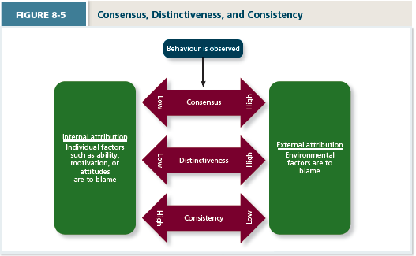

Chapter 9: Personality, Cultural Values, and Ability
- Personality refers to the structures and propensities inside a person that explain his or her characteristic patterns of thought, emotion, and behavior. It also refers to a person’s social reputation – the way he or she is perceived by others
- Traits – recurring trends in peoples responses to their environment
- Cultural values are shared beliefs about desirable end states or modes of conduct in a given culture that influence the expression of traits
- Ability refers to the relatively stable capabilities of people to perform a particular range of different but related activities
Personality capture what people are like, ability reflects what people can do
The “Big Five” factors of personality (CANOE) include:
- Conscientiousness (e.g., dependable, organized, reliable)
  - Has biggest influence on job performance
  - Conscientious employees prioritize accomplishment striving – a strong desire to accomplish task-related goals as a means of expressing one’s personality
    - I.E desire to work, channel effort towards tasks, and work longer
    - Negatively related to alcohol/drug consumption (less prone to risk)
- Agreeableness (e.g., warm, kind, cooperative)
  - Communion Striving – strong desire to obtain acceptance in personal relationships as a means of expressing personality
  - “Getting along”, not “getting ahead”
  - Good for some jobs (customer service), bad for others
- Neuroticism (e.g., nervous, moody, emotional)
  - Second most important (flipside is called emotional stability)
  - Generally, few jobs see neuroticism as beneficial
  - Negative Affectivity – a dispositional tendency to experience unpleasant moods
  - Neurotic employees experience lower job satisfaction
  - Neurotic people are more likely to appraise day-to-day situations as stressful
  - Cause of Type A behavior type
  - Neurotic people tend to hold an external locus of control (events are uncontrollable)
- Openness to experience (e.g., curious, imaginative, creative)
  - Also called “inquisitiveness: or “intellectualness”
  - Jobs with rapid changes in demand benefit from openness (associated with adaptability, and built-in desire to learn)
- Extraversion (e.g., talkative, sociable, passionate)
  - Easiest to judge in zero acquaintance situations (two people just met)
  - Status Striving – strong desire to obtain power and influence within social structure as means of expressing one’s personality
  - Direct work efforts to “moving up” and strong reputation
  - Extroverts have higher positive affectivity – a dispositional tendency to experience pleasant, engaging moods (such as enthusiasm and excitement)
  - Tend to be more management ready
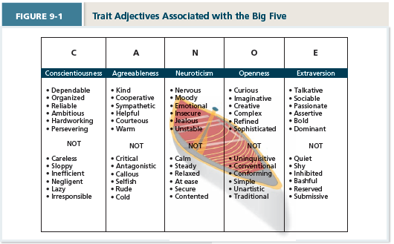
- Culture: the shared values, beliefs, motives, and interpretations that result from common experiences of members of a society and are transmitted across generations
- Hofstede’s dimensions of cultural values include:
  - Individualism-collectivism – degree to which culture has loosely knit social frame work or tightly knit (collective)
  - Power distance – degree to which culture prefers equal power distribution or unequal (high)
  - Uncertainty avoidance – degree culture tolerates ambiguous situations (low) or feels threatened by them (high)
  - Masculinity-femininity – degree culture values stereotypically male trains or female
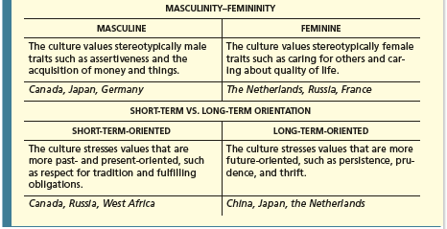
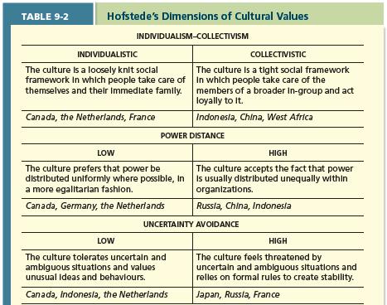
  - Short-term vs. long-term orientation – degree culture stresses values that are past/present oriented (short term) or future oriented (long term orientation)
What does it mean to be Able? – G Factor (Verbal, Quantitative, Perceptual, Reasoning, Spatial)
Cognitive abilities – capabilities related to the use of knowledge to solve problems
- Verbal ability: various capabilities associated with understanding and expressing oral/written communication (two are not necessarily related – dyslexia)
  - Oral expression – ability to communicate ideas by speaking
  - Written expression – ability to communicate ideas by writing
  - Most important in jobs that depend on understand and communicating ideas to others
- Quantitative ability: capabilities associated with doing basic math operations and selecting formulas to solve math problems
- Reasoning ability: diverse set of abilities associated with sensing and solving problems using insight, rules, and logic
  - Problem Sensitivity – ability to sense there is a problem (or will be one soon)
  - Reasoning Ability – Deductive (use general rules to solve problems) or Inductive (ability to piece together and infer)
  - Originality – ability to develop clever and novel solutions to problems
- Spatial ability: capabilities associated with visual and mental representation and manipulation of objects in space
  - Perceptual ability: capacity to perceive, understand, and recall patterns of information
- General cognitive ability, or “g,” the general level of cognitive ability that plays an important role in determining the more narrow cognitive abilities (you tend to score higher on all individual abilities if you can process information effectively)
Emotional intelligence is a set of abilities related to understand and use of emotions that affect social functioning
- Self-awareness: ability to recognize and understand one’s own emotions
- Other awareness: the ability to recognize and understand others’ emotions
- Emotion regulation: ability to recover quickly from emotional experiences
- Use of emotions: degree to which people can harness emotions and employ them to improve their chances of being successful in what they are doing (ex. Book writing focusing emotion of time crunch to push through writers block)

Chapter 10: Teams, Diversity, and Communication
Team: two or more people who work interdependently over some time period to accomplish common goals related to some task-oriented purpose
Model of Team Development (FSNPA):
  - Forming (members orient themselves within boundary of team) Storming (members remain committed to their own ideas) Norming (members realize they need team effort and compromise) Performing (members are comfortable with their role and work) Adjourning ( members experience anxiety as they disengage)
  - When teams are formed with clear expectations you often jump to performing
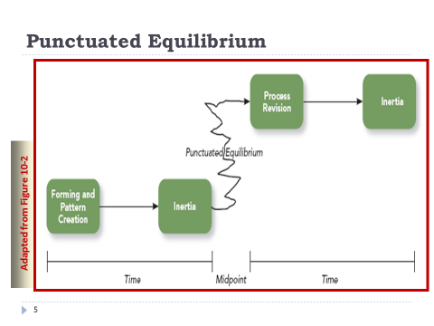
Model #2: Punctuated Equilibrium (inertia, midpoint (revision), inertia)
  - Members make assumptions and establish pattern of behavior and continue it for half the project (inertia), at midpoint members realize that they need to change task paradigm to complete project, they plan new approach (process revision) and they complete task with new plan (inertia)

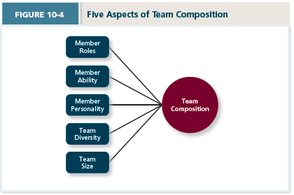
Team composition: the mix of the various characteristics that describe the individuals in team
  - Member Roles: behavior a person is expected to display in given context
    - Ex. Leader-staff teams have clear leader, Team task roles have orienteer – energizer – and devil’s advocate (each member is equal though), Team building roles have encourager – compromiser – harmonizer
  - Member Ability – members possess a wide variety of abilities/strengths
    - Disjunctive tasks: team member with highest level of ability relevant to task with have most influence on outcome
    - Conjunctive tasks: outcome of group relies on weakest link
    - Additive tasks – outcome relies on combination of each member’s contribution
  - Member Personality
  - Team Diversity: the degree to which team members are different from one another
    - Value in Diversity Problem Solving Approach: a theory that supports team diversity because it provides a larger pool of knowledge and perspectives
    - Similarity-Attraction Approach: a theory explaining that team diversity can be counterproductive because people tend to avoid interacting with others who are unlike them
    - Which is correct depends on length of time team has been together
    - Surface Level Diversity: diversity of observable attributes such as race (this tend to disappear over time)
    - Deep-level Diversity: diversity of attributes that are inferred through observation or experience (such as personality) and grow over time
  - Team size (4-5 is ideal) but more complex = more people, simple = less people
Communication: the process by which information and meaning is transferred from sender to receiver
Communication is a process through which much of the work in a team is accomplished.
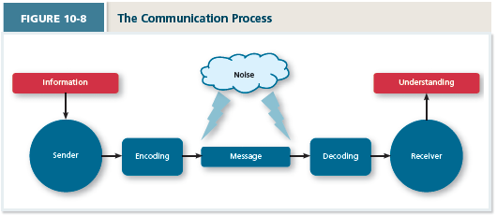
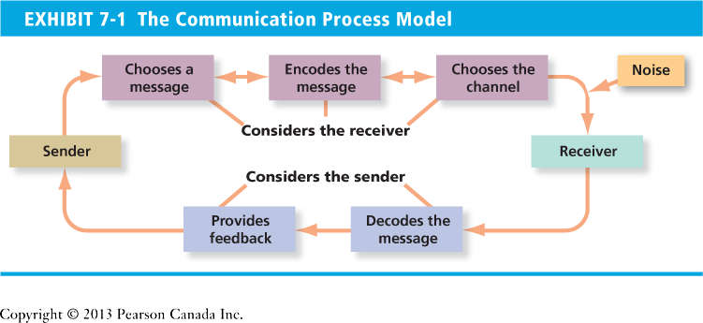

Chapter 11: Power, Influence, and Negotiation
Power – the ability to influence the behavior of others and resist unwanted influence in return
Types of Power
- Organizational Power
  - Legitimate: power based on a position of authority inside the organization (often called “formal authority”) given by some given title
    - Limited to only being able to do what is within reason of position
  - Reward: power based on the control of resources/benefits (ex. Managers have control over raises)
  - Coercive: power based on the ability to hand out punishment (ex. Managers can fire)
    - Generally referred to as the poorest form of power to use regularly
- Personal Power
  - Expert: power based on expertise or knowledge (being the only person to ask for a specific task put you in a position of power)
  - Referent: power based on the attractiveness and charisma of the leader (power based on loyalty/affection to a particular person)
Contingency Factors (situations that lead to increase/decrease the degree to which people can use power to influence others)
- Substitutability: the degree to which people have alternatives in accessing the resources that a leader controls (if you are the only one with a resource, you are in power)
- Discretion: degree to which managers have the right to make decisions on their own (ex. If boss has to follow corporate policy, their ability to influence you is reduced)
- Centrality: how important a person’s job is and how many people depend on that person to accomplish their tasks (a person who performs critical tasks has more power)
- Visibility: How aware others are of a leader and the resources that leader can provide (if everyone knows you have power, you will in turn have higher ability to influence)
Influence – the use of behaviors to cause behavioral or attitudinal changes in others
- Influence Tactics
  - Rational Persuasion: the use of logical arguments and facts to show someone that a request is worthwhile (often done with superiors)
  - Consultation: a tactic whereby the target is allowed to participate in deciding how to carry out or implement a request (increases commitment of target as now they have personal stake in outcome)
  - Inspirational Appeal: tactic designed to appeal to one’s values and ideals, thereby creating an emotional reaction (you must have insight of the targets values)
  - Collaboration: tactic whereby the leader makes it easier for the target to complete a request by offering to work with and help the target

  - Ingratiation: the use of favors, compliments, or friendly behavior to make the target feel better about the influencer (“sucking up”, works in long-run)
  - Personal Appeal: tactic in which the requestor asks for something based on personal friendship or loyalty
  - Exchange Tactic: tactic in which the requestor offers a reward in return for performing a request
  - Appraising: tactic in which the requestor clearly explains why performing the request will benefit the target personally

  - Pressure: tactic in which the requestor attempts to use coercive power through threats
  - Coalition: tactic in which the influencer enlists other people to help influence the target
Responses to Influence Tactics
  - Internalization: response where target agrees with and becomes committed to the request
  - Compliance: response where target is willingly to do what is asked but with a degree of ambivalence
  - Resistance: when a target refuses to perform a request and puts effort to avoid having to do it
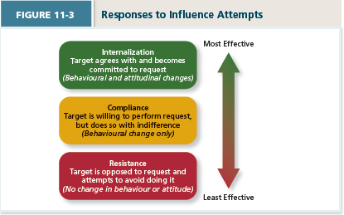
Conflict Resolution
Conflicts arise when two or more people perceive their goals are in opposition
Five styles to handle conflict:
- Competing: one party attempts to get his own goals met without concern for other party’s results
- Avoiding: one party wants to remain neutral, stay away from conflict, or postpone the conflict to gather information or let things cool down
- Accommodating: one party gives in to the other and acts in a completely unselfish way (used when issue isn’t really that important to one person)
- Collaboration: both parties work together to maximize outcomes (assertive & cooperative)
- Compromise: conflict is resolved through give and take concessions
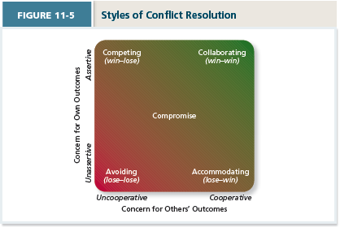
Negotiations: a process in which two or more interdependent individuals discuss and attempt to reach an agreement about their differences
- Distributive Bargaining: strategy in which one person gains and the other loses (think car dealer, for every dollar saved by the buyer the dealer loses a dollar)
- Integrative Bargaining: strategy that achieves an outcome that is satisfying for both parties (collaboration, much preferred)
BATNA: negotiators best alternative to a negotiated agreement (bottom line)
Chapter 12: Leadership Styles and Behaviors
Leadership: the use of power and influence to direct the activities of followers toward goal achievement
Leader-Member Exchange Theory: a theory describing how leader-member relationships develop over time on a dyadic basis
- New member relationships are typically marked by a role taking phases
  - leader provides an employee with job expectations and the follower tries to meet those expectations
  - leader tries to get a feel for talent level and motivation of employees
- For some the role taking phase is supplemented with the role making phase
  - Follower voices his own expectations for the relationship, resulting in a free-flowing exchange of opportunities and resources for activities and effort
- This leads to two general types of leader-member dyads
  - High Quality Exchange – marked by frequent one-on-one exchanges of information between leader and member, mutual influence, support, and attentions
    - These form the leaders “in group” and is characterized by higher levels of communication, mutual trust, and respect
  - Low Quality Exchange – marked by more limited exchange of information, influence, latitude, support and attention
    - Form “out group” and is characterized by lower levels of communication, trust, respect, and obligation
  - Employees who are likeable, competent, and similar to the leader fall in the “in group”
Leader Effectiveness: the degree to which the leader’s actions result in the achievement of the unit’s goals, the continued commitment of the unit’s employees. And the development of mutual trust, respect, and obligation in leader-member dyads (there is no generalized profile of effective leaders) (there is no generalized profile of effective leaders)
Leader Emergence – the process of become a leader in the first place (there is no generalized profile of effective leaders) (some traits are predictive of this)
- Note that many trait-leadership correlations are weak in magnitude and the focus on leader traits holds less practical relevance than a focus on leader actions
Leadership decision Making Styles
- Autocratic Style: a leadership style where the leader makes the decision alone without asking for opinions or suggestion of the employees in the work unit
  - Employees provide information the leader needs
- Consultive Style: leader presents the problem to employees asking for their opinions and suggestions before ultimately making the decision himself (employees have “some say”)
- Facilitative Style: leader presents the problem to a group of employees and seeks consensus on a solution making sure his opinion receives no more weight than anyone else’s
- Delegative Style: leader gives the employee the responsibility for making decisions within some set of specified boundary conditions
  - Note that participation takes up time (downside) and some employees see it as an interruption to work)
Time Driven Model of Leadership – suggests that seven factors, including the importance of the decision, the expertise of the leader, and the competence of the followers combine to make some decision-making style more effective than others in a given situation
- Decision Significance: is the decision significant to the success of the project
- Importance of Commitment: is it important employees “buy in” to decision
- Leader Expertise: does the leader have knowledge on problem
- Likelihood of Commitment: how likely is it that employees trust leaders decision
- Shared Objectives: do employees share and support the same objectives as leader
- Employee Expertise: do employees have significant knowledge on problem
- Teamwork Skills: do employees have the ability to work together productively
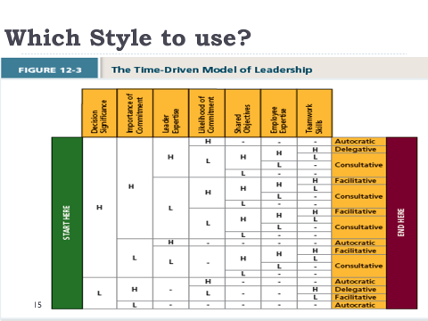
Day to Day Leadership Behaviors
- Initiating Structure reflects the extent to which the leader defines and structures the roles of employees in pursuit of goal attainment
- Leader who are high on initiating structure play a more active role in directing group activities and prioritize planning, scheduling, and trying out new ideas. They might emphasize meeting deadlines, describe explicit standards of performance, ask employees to follow formalized procedures and criticize poor work when necessary
- Initiating structure has a strong positive relationship with employee motivation and a moderate positive relationship with perceived leader effectiveness, job satisfaction, and unit performance
- Consideration reflects the extent to which leaders create job relationships characterized by mutual trust, respect for employee ideas, and consideration of employee feelings
- Leaders who are high on consideration create a climate of good rapport and strong, two way communication, and exhibit deep concern for the welfare of their employees
- Consideration has a strong positive relationship with perceived leader effectiveness, employee motivation, and job satisfaction while also having a moderate positive relationship with unit performance
Transformation leadership involves inspiring followers to commit to a shared vision that provides meaning to their work while also serving as a role model who helps followers develop their own potential and view problems from new perspectives (motivational approach to leadership)
- Laissez-Faire: when leader avoids leadership duties (ineffective, passive)
- Transactional Leadership – leader rewards or disciplines the follower on the basis of performance
  - Passive Management by Exception – leader waits for mistakes and makes corrections as necessary (passive, ineffective)(stick)
  - Active Management by Exception – leader arranges to monitor mistakes actively and takes corrective action when required (passive/active)
  - Contingent Reward – leader attains follower agreement on what needs to be done using rewards in exchange for adequate performance (active, effective)(carrot)
- Transformational (most active and effective approach)(most culturally accepted) Made up of:
  - Idealized Influence – the power held by a leader who behaves in ways that earn the admiration, trust, and respect of followers, causing followers to want to identify with an emulate the leader
  - Inspirational Motivation – leader behaves in ways that foster enthusiasm for and commitment to a shared vision of the future
  - Intellectual Stimulation – leader behaves in ways that challenge followers to be innovative and creative by questioning assumptions and reframing old situations in new ways
  - Individualized Consideration – leader behaves in ways that help followers achieve their potential through coaching, development, and mentoring

Chapter 13: Organizational Structure
Organizational Structure: formally dictates how jobs and tasks are divided and coordinated between individuals and groups within a company
Organizational Chart: a drawing that represents every job in the organization and the formal reporting relationships between those jobs
Elements of Organizational Structure
- Work Specialization – the degree to which tasks in an organization are divided into separate jobs
  - Also referred to as “division of labor”
  - Highly specialized jobs can cause organizations to lose the ability associated with employees who can be flexible in wat they do
  - Managers struggle with job satisfaction which is increased with more job variety
- Chain of Command – answer to the question of who reports to whom, and signifies formal authority relationships
  - Can be seen as the specific flow of authority down through the levels of an organization and is necessary to attain order, control, and predictable performance
- Span of Control – represents how many employees each manager has responsibility for
  - Narrow Span of Control (few employees)(TALL)– allow managers to be much more hands on with employees, giving them more opportunity to use directive leadership styles while developing close mentoring relationships with employees
    - Requires many levels of managers that can be costly and if it is too narrow employees can become resentful of their close supervision and long for more latitude in day to day activities
  - Wide Span of Control (many employees)(FLAT)
- Centralization – dictates where decisions are formally made in organizations
  - Centralized = only top managers have authority to make decisions
  - Decentralized = low employees are empowered to make decisions
    - Decentralizing becomes necessary as company grows
    - Some decisions must remain centralized as companies grow (such as pay structures and procedures)
- Formalization – the degree to which rules and procedures are used to standardize behaviors and decisions in an organization
Mechanistic Organizations – are efficient, rigid, predictable, and standardized organizations that thrive in stable environments – they have a structure that relies on high levels of formalization, a rigid and hierarchical chain of command, high degrees of work specialization, centralization of decision making, and narrow spans of control
Organic Organizations – are flexible, adaptive, and outward focused, and thrive in dynamic environments – they have a structure that relies on low levels of formalization, weak or multiple chains of command, low levels of work specialization, and wide spans of control
Organizational Structure Forms:
- Simple Structures – an organizational form that features one person as the central decision-making figure (BASIC DESIGN with 1 level)
- Bureaucratic Structures – form that exhibits many of the facets of a mechanistic organization
  - Functional – employees are grouped by the functions they perform (finance, marketing, etc.)
    - Efficient when organization as a whole has narrow focus, few products, and stable environment – problem is functions focus on their own goals and not those of the organization
  - Multidivisional – employees are groups by product, geography, or client
    - Each division operates relatively autonomously and has its own functional groups
    - Product Structure – employees are grouped by product (sometimes products are so diverse, such as Proctor and Gamble, where a salesman can’t sell all)
    - Geographic Structure – employees are grouped by region (to deal with localized problems and nuances such as culture)
    - Client-based Structure – employees are organized around serving customers best (think banks with small business, commercial, and personal account staff)
  - Matrix Structure – complex form of organizational structure that combines a functional and multidivisional grouping
    - Very flexible (can’t make teams based on employee skill) and can therefore adjust to external variables faster
    - There are two chains of command, two groups with which to interact, and two sources of information to consider (can be complex and difficult) (think about if one manager has power to gives raises, who would you listen to more?)
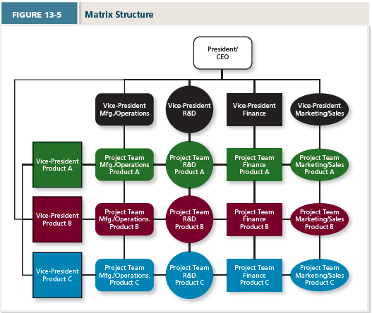
Chapter 14: Organizational Culture and Change
Organizational Culture is the shared social knowledge within an organization regarding the rules, norms, and values that shape the attitudes and behaviors of its employees
- Employees learn about most important aspects of culture through other employees (explicit communication or observation)
- Individual goals and values grow over time to match those of the company you work for
Culture Components
- Observable Artifacts – aspects of an organization’s culture that employees and outsiders can easily see
  - Symbols – images an organization uses to convey messages (logos, websites, etc.)
  - Physical Structures – organization and design of buildings and internal offices
  - Language – jargon, slang, and slogans used within an organization
  - Stories – anecdotes, accounts, legends, and myths passed down from cohort to cohort within an organization
  - Rituals – daily/weekly planned routines that occur within company (ex. Casual Fridays)
  - Ceremonies – formal events, generally performed in front of an audience of organizational members (such as awards for meeting cultural expectations)
- Espoused Values – the beliefs, philosophies, and norms that a company explicitly states (such as in its mission statement, formal documents, or verbal statements by employees/management)
- Basic Underlying Assumptions – the ingrained beliefs and philosophies of employees (employees simply act on them rather than question their validity of their behavior in a given situation)
General Culture Types
- Fragmented – employees are DISTANT and DISCONNECTED
- Mercenary – employees think they are ALIKE but are not friendly to one another
- Networked – employees are friendly to one another, but everyone thinks differently and does his own thing
- Communal – employees are FRIENDLY and all think ALIKE
Maintaining an Organizational Culture
- Attraction-Selection-Attrition (ASA) – a theory that states that employees will be drawn to organizations with cultures that match their own personality, organizations will select employees that match, and employees will leave or be forced out if they are not a good fit
- Socialization – the primary process by which employees learn the social knowledge that enables them to understand and adapt to the organizations culture
- Anticipatory Stage – begins as soon as a potential employee develops an image of what it would be like to work for the company (personal research, interview process, etc.)
- Encounter Stage – begins the day an employee starts work, during which the employee compares the information as an outsider to the information learned as an insider
  - Reality Shock – mismatch of information that occurs when employee finds that aspects of working at a company are not what the employee expected it to be
- Understanding and Adaptation – final stage during which newcomers come to learn the content areas of socialization and internalize the norms and expected behaviors of the organization (this part never really ends … but you want people to move through it fast, some cultures are more promoting of this)
Person-Organization Fit – the degree to which a person’s values and personality match the culture of the organization
- High levels of job satisfaction and less stress about their day-to-day tasks leads to stronger organizational commitment (also higher levels of trust in management)
- Less related, but organizational fit positively affects citizenship behaviors
Managing Socialization
- Realistic Job Previews – process of ensuring that a prospective employee understand both the positive and negative aspects of the job
- Orientation Programs – a common form of training during which new hires learn more about the organization
- Mentoring – process by which a junior-level employee develops a deep and long-lasting relationship with a more senior-level employee with the organization


