Fat Pre-Meal Exercise
Olive Oil 40 squats
Avocado 20 Wall extensions
10 Pushups
Protein
Boiled Egg
Omega 3 Mid-Meal Exercise
Spinach 15 Squats
Salmon 10 Wall Extensions
5 Pushups
Fiber
Broccoli
Spinach
Flaxseeds
Extra Post-Meal Exercise
ACV 20 Minute walk
Lemon Squats
Grapefruit Juice Pushups
Extra
Brief lifting 90 minutes after
Cold shower 1 hour/40 minutes after
Great Sleep
Since your body can use stored glycogen for about 1.5 hours, it makes sense to do this type of run when you will be running about 2 hours or a bit longer.

7 surprising things that make blood sugar control easier
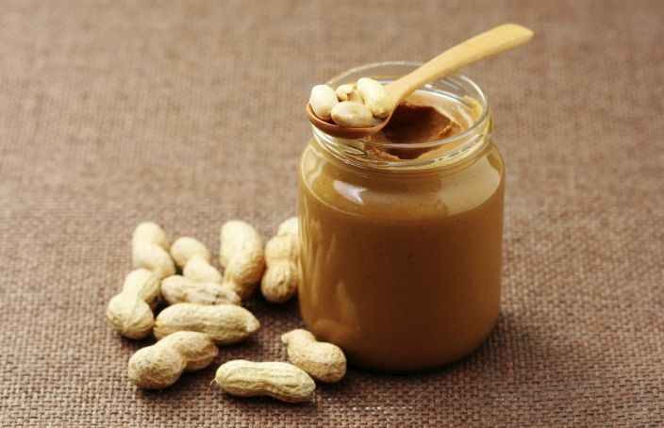
Jun 24 2015

1

Being asleep. Being awake. Hot weather. Cold weather. Seems there’s no end to the number of things that can raise your blood glucose levels. No wonder diabetes management can be such an obstacle course.
But it’s not all doom and gloom. For every factor that unexpectedly sends your blood sugars spiralling out of control, there’s an equally unexpected – and often enjoyable – way to keep them under control.

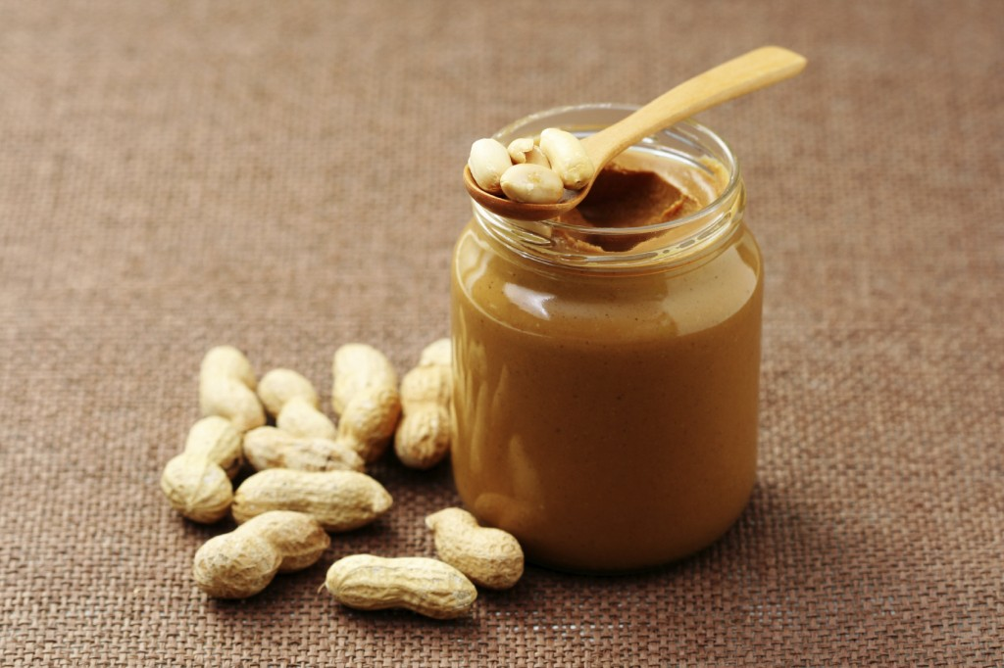

1. Peanut butter

