Services Marketing Notes
Chapter 1: Introduction to Services Marketing

Services dominate most economies and are growing rapidly:
- Services account for more than 60% of GDP worldwide
  - Almost all economies have a substantial service sector
- Most new employment is provided by services
- Strongest growth area for marketing

Understanding services offers you a personal competitive advantage

Forces Transforming the Service Economy0
- Government Policies
- Social Changes
- Business Trends
- Advances in IT
- Globalization

These forces create new markets, increase demand for services and create more intense competition.

Customers these days have more choices and exercise more power.

Success hinges on
- Understanding customers and competitors
- Viable business models
- Creation of value for customers and firms
- Increased focus on services marketing and management

Services involve a form of rental, offering benefits without transfer or ownership.

Definition: Services are economic activities offered by one party to another and most commonly employ time-based performances to bring about desired results.

There are five broad categories within non-ownership framework of which two or more may be combined:
- Labour and expertise rentals
- Rented goods services
- Defined space and place rentals
- Access to shared physical environments
- Access to and usage of systems and networks

In exchange for their money, time, and effort, service customers expect to obtain value (benefits) from
- access to goods, labor, facilities, environments, professional skills, and/or networks and systems;
- normally do not take ownership of any of the physical elements involved.

Nature and Characteristics of a Service

Intangibility: Services cannot be seen, tasted, felt, heard, or smelled before purchase.

Heterogeneity/Variability: Quality of services depends on who provides them and when, where, and how.

Inseparability: Services cannot be separated from their providers.

Perishability: Services cannot be stored for later sale or use.

Four Broad Categories of Services

- People processing
- Customers must physically enter the service factory and co-operate actively with the service operation
- Managers should think about process and output from customer’s perspective
- Possession processing
- Customers are less involved compared to people processing services
- Production and consumption are separable
- Mental Stimulus processing
- Ethical standards required when customers who depend on such services can potentially be manipulated by suppliers
- Physical presence of recipients not required
- Core content of services is information-based
- Can be inventoried
- Information processing
- Information is the most intangible form of service output
- May be transformed into more permanent forms of service output
- Line between information processing and mental stimulus processing may be blurred.

Chapter 2: Consumer Behaviour in a Service Context

Pre-Purchase Stage
Need awareness
- A service purchase is triggered by an underlying need
- Needs may be due to:
  - People’s unconscious minds (e.g., aspirations)
  - Physical conditions (e.g., chronic back pain)
  - External sources (e.g., marketing activities)
- When a need is recognized, people are likely take action to resolve it

Information search
- When a need is recognized, people will search for solutions.
- Several alternatives may come to mind and these form the evoked set
  - Evoked set – set of possible services or brands that a customer may consider in the decision process
- When there is an evoked set, the different alternatives need to be evaluated before a final choice is made

Evaluation of alternatives
- Service attributes (Multi-attribute model)
  - Search attributes help customers evaluate a product before purchase
    - Style, color, texture
  - Experience attributes cannot be evaluated before purchase—must “experience” product to know it
    - Vacations, sporting events, medical procedures
  - Credence attributes are product characteristics that customers find impossible to evaluate confidently even after purchase and consumption
    - Quality of repair and maintenance work

Perceived risk
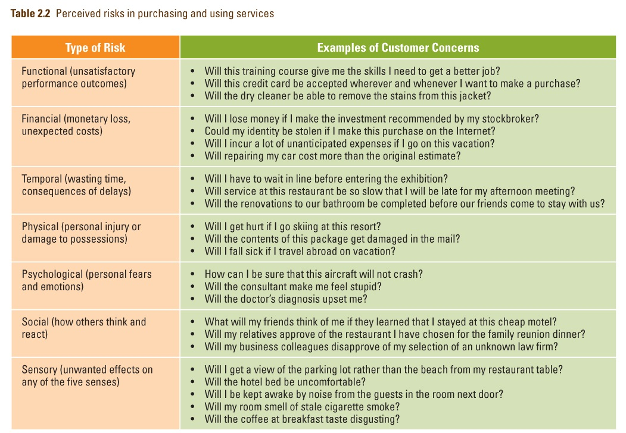

- Service expectations
  - Customers evaluate service quality by comparing what they expect against what they perceive
    - Situational and personal factors also considered
  - Expectations of good service vary from one business to another, and differently positioned service providers in same industry
  - Expectations change over time
  - Desired Service Level: Wished-for level of service quality that customer believes can and should be delivered
  - Adequate Service Level: Minimum acceptable level of service
  - Predicted Service Level: Service level that customer believes firm will actually deliver
  - Zone of Tolerance: Range within which customers are willing to accept variations in service delivery

- Purchase decision

High-contact and Low-contact Services
High-contact Services
- Customers visit service facility and remain throughout service delivery
- Active contact between customers and service personnel
- Includes most people-processing services

Low-contact Services
- Little or no physical contact with service personnel
- Contact usually at arm’s length through electronic or physical distribution channels
- New technologies (e.g. Web) help reduce contact levels

Medium-contact Services lie in between.

The Servuction System
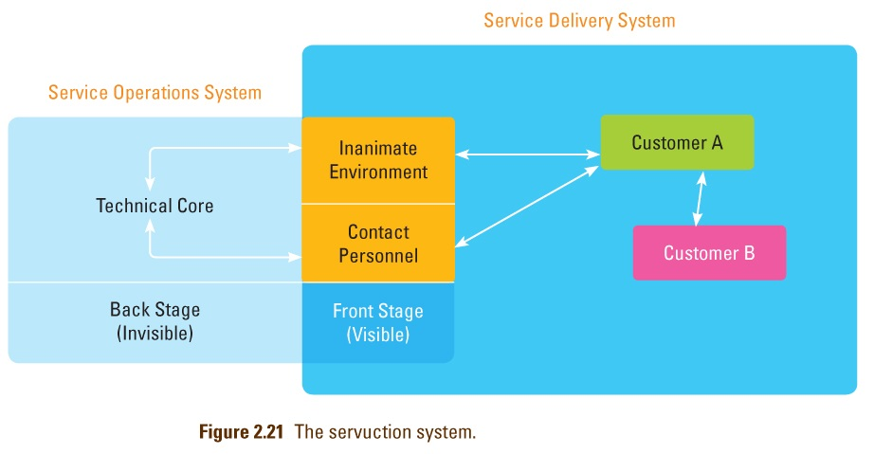

- Visible front stage and invisible backstage
- Service Operations system
  - Technical core where inputs are processed and service elements created, usually backstage
  - Includes facilities, equipment, and personnel

- Service Delivery System (front stage)
  - Where “final assembly” of service elements takes place and service is delivered to customers
  - Includes customer interactions with operations and other customers

The Expectancy-disconfirmation Model of Satisfaction

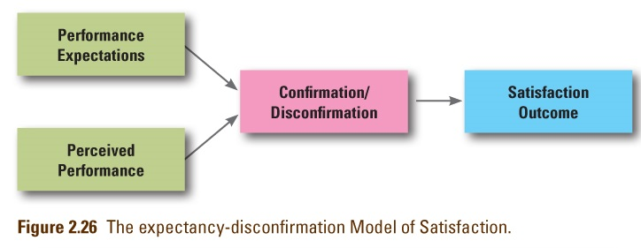

Satisfaction: attitude-like judgment following a service purchase or series of service interactions.

Customers have expectations prior to consumption, observe service performance, compare it to expectations.

Satisfaction judgments are based on this comparison
- Positive disconfirmation if better than expected
- Confirmation if same as expected
- Negative disconfirmation if worse than expected

Research shows that delight is a function of 3 components
- Unexpectedly high levels of performance
- Arousal (e.g., surprise, excitement)
- Positive affect (e.g., pleasure, joy, or happiness)

Once customers are delighted, their expectations are raised.

If service levels return to previous levels, this may lead to dissatisfaction and it will be more difficult to “delight” customers in future.

Chapter 3: Positioning Services in Competitive Markets

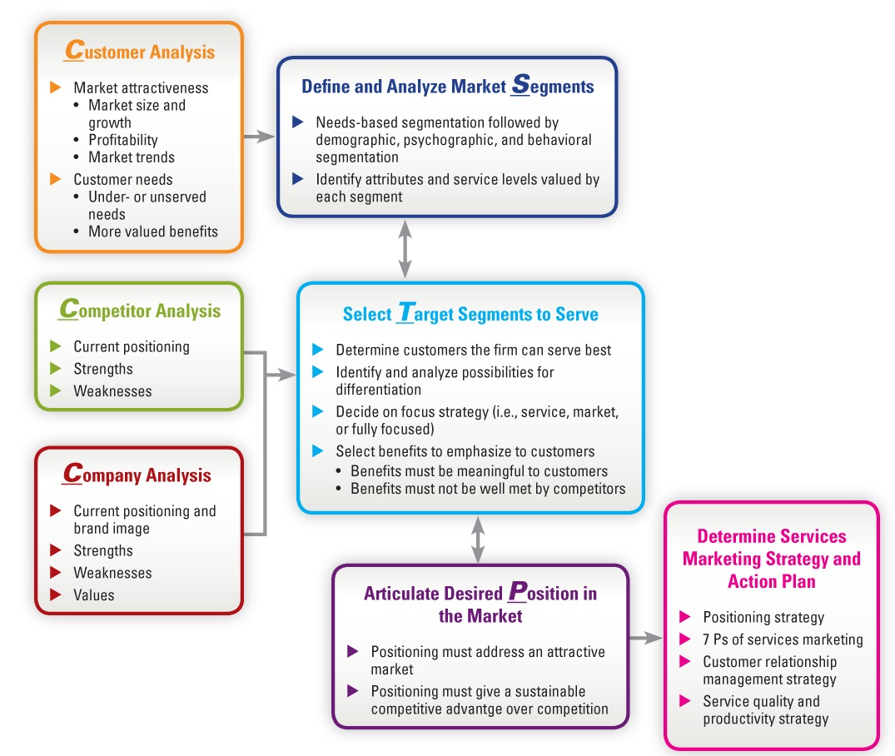

Market Segmentation
Firms vary widely in ability to serve different types of customers
- Adopt a strategy of market segmentation, identifying what parts the market can serve best
- A market segment is composed of a group of buyers sharing common needs, purchasing behavior, consumption patterns, etc.
Various ways to segment markets are:
- Demographics ― on its own will not result in meaningful segments
- Psychographic segmentation – useful for strengthening brand identity and creating emotional connection
- Behavioral segmentation – focuses on observable behavior
  - Needs-based segmentation – focuses on what customer’s want

We use research to identify and prioritize which attributes of a given service are important to specific market segments BUT people may have different priorities according to:
- The purpose of using the service
- Who makes the decision
- Timing of use
- Whether the service is used alone or in a group

Determinant Attributes: determine buyer’s choices between competing alternatives

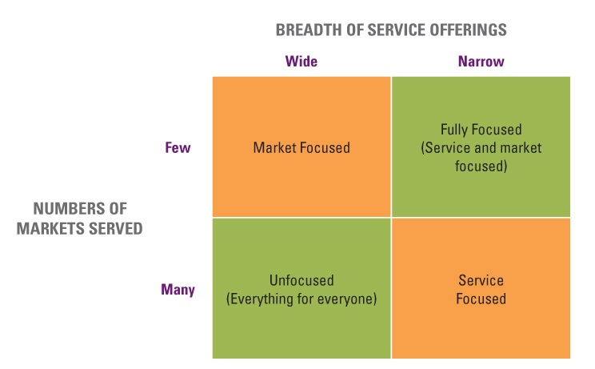
Fully focused
- Limited range of services to narrow and specific market
- Developing recognized expertise in a well-defined niche may provide protection against competitors and allow firms to charge premium prices

Unfocused
- Broad markets with wide range of services raises concern of becoming a “jack of all trades and master of none”

Market focused
- Narrow market segment with wide range of services
- Need to make sure firms have operational capability to do and deliver each of the different services selected
- Need to understand customer purchasing practices and preferences

Service focused
- Narrow range of services to fairly broad market
- As new segments are added, firm needs to develop knowledge and skills in serving each segment

Four Principles of Positioning Strategy
- Must establish position for firm or product in minds of target customers
- Position should provide one simple, consistent message
- Position must set firm/product apart from competitors
- A company cannot be all things to all people - must focus its efforts

Developing an Effective Positioning Strategy
Segmentation, Targeting and Positioning integrates with Customer, Competitor and Company analyses to give us a positioning statement

Target audience
- Specific group(s) of people that the brand wants to sell to and serve

Frame of reference
- Category the brand is competing in

Point of difference
- Most compelling benefit offered by brand that stands out from competitors

Reason to believe
- Proof that brand can deliver the benefits that are promised

Positioning Maps: a tool that is typically confined to two attributes (can be 3D but rare) that is used to visualize competitive positioning and map developments of time
- It is a useful way to represent consumer perceptions of alternative products graphically
- Display relative performance of competing forms on key attributes
- The challenge is to ensure that:
  - Attributes employed in maps are important to target segments
  - Performance of individual firms on each attribute accurately reflects perceptions of customers in target segments
- Predictions can be made of how positions may change in light of future developments
- Simple graphic representations are often easier for managers to grasp than tables of data or paragraphs of prose
- Charts and maps can facilitate “visual awakening” to threats and opportunities, suggest alternative strategic directions

Chapter 4: Developing Service Products

The Flower of Service
There is a CORE product surrounded by supplementary services.

Facilitating Services:
- Information: customers often require info about how to obtain and use a product
- Order Taking: customers need to know what is available and may want to secure commitment to delivery. The process should be polite, fast and accurate.
- Billing: Bills should be clear, accurate and intelligible
- Payment: Transactions should be simple and convenient

Enhancing Services
- Consultation: offer advice and consultation tailored to each customer’s needs
- Hospitality: Treat customers as welcome guests
- Safekeeping: customers should not have to worry about the personal possessions they bring with them to a service site
- Exceptions: customers appreciate flexibility when they make special requests and expect responsiveness

In a well designed and well-managed service organization, the petals and core are fresh and well-formed.

Market positioning strategy helps to determine which supplementary services should be included.

Managerial Implications
- Not every core product is surrounded by supplementary elements from all eight clusters.
- Nature of product helps to determine which supplementary services must be offered.
- People-processing and high contact services tend to have more supplementary services.
- Firms that offer different levels of service often add extra supplementary services for each upgrade in service level.

Product Lines and Brands
Most service organizations offer a line of products.

They may choose among 3 alternatives:
- Single brand to cover all products and services
- A separate, stand-alone brand for each offering
- Some combination of the two extremes
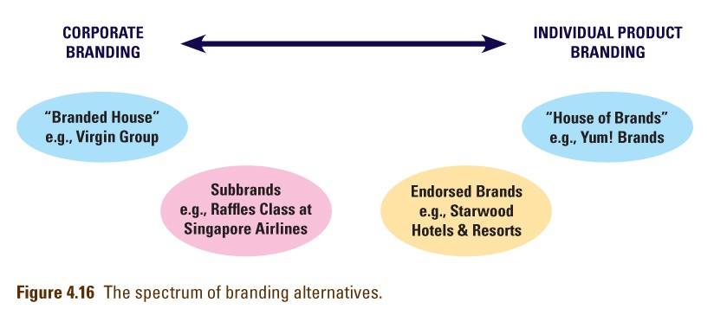

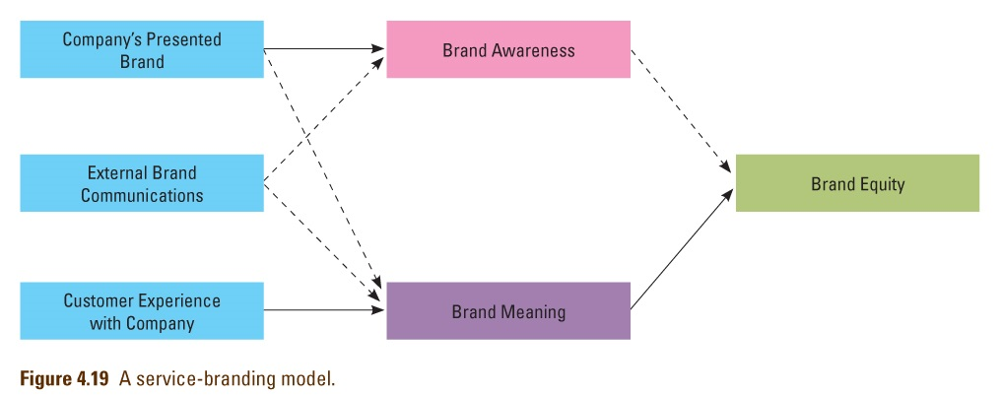

Four Key Ways to Build Strong Brands:
- Dare to be different
- Determine your own fame
- Make an emotional connection
- Internalize the brand

Hierarchy of New Service Categories
- Style changes
- Visible changes in service design or scripts
- Service improvements
- Modest changes in the performance of current products
- Supplementary service innovations
- Addition of new or improved facilitating or enhancing elements
- Process-line extensions
- Alternative delivery procedures
- Product-line extensions
- Additions to current product lines
- Major process innovations
- Using new processes to deliver existing products with added benefits
- Major service innovations
- New core products for previously undefined markets

Success Factors in New Service Development
Market synergy
- Good fit between new product and firm’s image/resources
- Advantage vs. competition in meeting customers’ needs
- Firm understands customer purchase decision behavior
Organizational factors
- Strong interfunctional cooperation and coordination
- Internal marketing to educate staff on new product and its competition
- Employees understand importance of new services to firm
Market research factors
- Scientific studies conducted early in development process
- Product concept well defined before undertaking field studies

Chapter 5: Distributing Services Through Physical and Electronic Channels

Distribution in a Services Context
In a services context, we often move nothing.
- Experiences, performances, and solutions are not being physically shipped and stored.
- More and more informational transactions are conducted through
electronic and not physical channels

Distinguishing Between Distribution of Supplementary and Core Services
Most core services require physical locations.

Many supplementary services are informational; can be distributed widely and cost-effectively via other means. (telephone, internet)

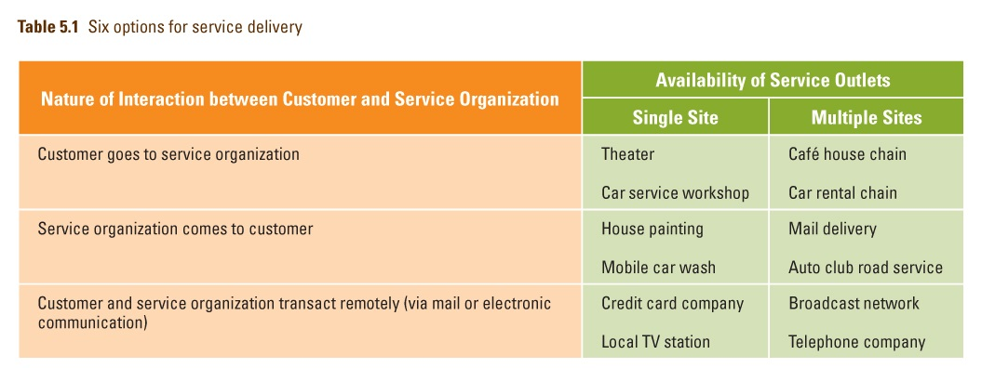

Determining the Type of Contact
Customers visit service site
- Convenience of service factory locations and operational schedules important when customer has to be physically present
Service providers go to customers
- Object of service is immovable
- Needed for remote areas
- Greater likelihood of visiting corporate customers than individuals
Service transaction is conducted remotely
- Achieved with help of logistics and telecommunications

Channel Preferences Vary Among Customers
Consumers choose from personal, impersonal, and self-service channels.

People rely on personal channels when they perceive services as complex and risky or/and they have social motives.

Individuals with greater confidence and knowledge about a service tend to use impersonal or self-service channels.

Places of Service Delivery
Mini stores
- Creating many small service factories to maximize geographic coverage
  - Automated kiosks
- Separating front and back stages of operation
  - Taco Bell
- Purchasing space from another provider in complementary field
  - Dunkin Donuts with Burger King
Locating in Multipurpose Facilities
- Proximity to where customers live or work
  - Service Stations

Cost, productivity and access to labor are key determinants to locating a service facility

Locational constraints
- Need for economies of scale
  - Hospitals
- Operational requirements
  - Airports
- Geographic factors
  - Ski Resorts

Information and Physical Processes of Augmented Service Product

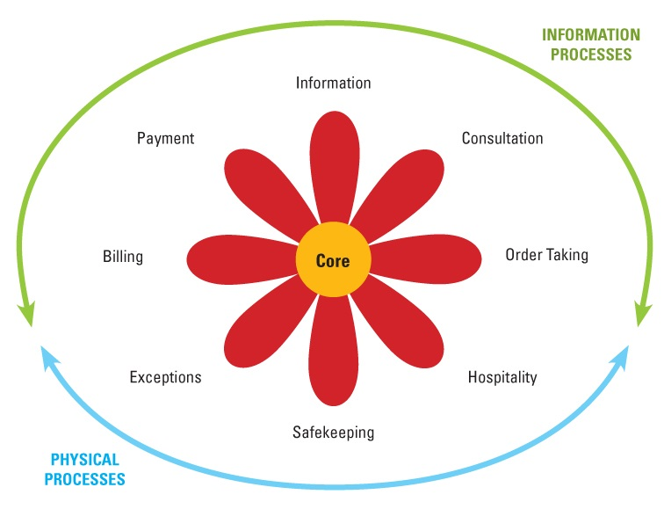

Distribution of Supplementary Services in Cyberspace
Five of the supplementary services are information-based and can be distributed electronically:
- Information
- Consultation
- Order-taking
- Billing
- Payment

Service Delivery Innovations Facilitated by Technology
Technological Innovations
- Development of “smart” mobile telephones and PDAs, and Wi-Fi high-speed Internet technology that links users to Internet from almost anywhere
- Voice-recognition technology
- Smart cards
  - store detailed information about customer
  - Act as electronic purse containing digital money

Electronic channels can be offered together with physical channels, or take the place of physical channels.

E-Commerce
Among the factors luring customers to virtual stores are:
- Convenience
- Ease of search
- Broader selection
- Potential for better prices
- 24-hour service with prompt delivery

Integrating mobile devices into the service delivery infrastructure can be used as means to:
- Access services
- Alert customers to opportunities/problems
- Update information in real time

Splitting Responsibilities for Supplementary Service Elements
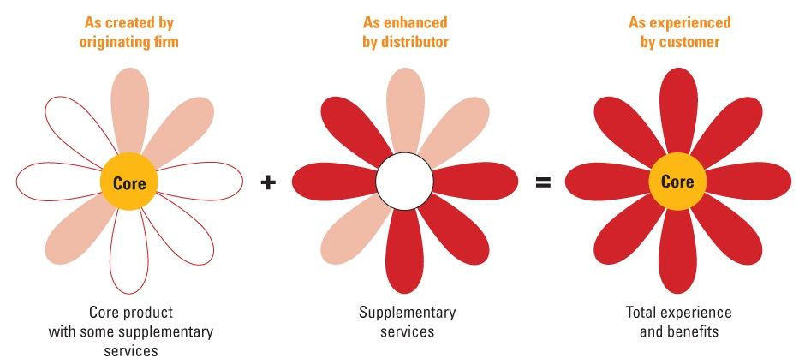
Challenges that arise for the original supplier are that they must act as a guardian of the overall process and ensure that each element offered by intermediaries fits the overall service concept.

Franchising: Popular way to expand delivery of effective service concept, without a high level of monetary investments compared to rapid expansion of company-owned and managed sites
- Franchisor provides training, equipment and support marketing activities. Franchisees invest time and finance, and follow copy and media guidelines of franchisor
- Growth-oriented firms like franchising because franchisees are motivated to ensure good customer service and high-quality service operations

Study shows significant attrition rate among franchisors in the early years of a new franchise system
- One third of all systems fail within first four years
- Three fourths of all franchisors cease to exist after 12 years

Disadvantages of franchising
- Some loss of control over delivery system and, thereby, over how customers experience actual service
- Effective quality control is important but yet difficult
- Conflict between franchisees may arise especially as they gain experience

Alternative: license another supplier to act on the original supplier’s behalf to deliver core
product, e.g.
- Trucking companies
- Banks selling insurance products

Chapter 6: Setting Prices and Implementing Revenue Management

Revenue and Profit Objectives
- Gain Profit
  - Make the largest possible profit
  - Achieve a specific target level, but do not seek to maximize profits
  - Maximize revenue from a fixed capacity by varying prices and target segments over time (uses revenue management systems)
- Cover Costs
  - Cover fully allocated costs, including corporate overhead
  - Cover costs of providing one particular service, excluding overhead
  - Cover incremental costs of selling one extra unit to one extra customer

Patronage and User Base-Related Objectives
- Build Demand
  - Maximize demand, provided a certain minimum level of revenue is achieved (ex. Many NGO’s)
  - Achieve full capacity utilization, especially when high capacity utilization adds to the value created for all customers
- Build a User Base
  - Encourage trial and adoption of a service
  - Build market share and/or a large user base

The Pricing Tripod

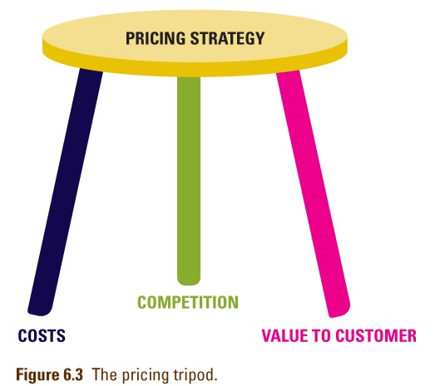

- Cost-Based Pricing
Traditional costing approach
- Emphasizes expense categories (arbitrary overheads allocation)
- May result in reducing value generated for customers

Activity-Based Costing (ABC) management systems
- Link resource expenses to variety and complexity of goods/services produced
- Yields accurate cost information

- Value-Based Pricing
Value exchange will not take place unless customer sees positive net value in transaction.

Net Value = All perceived benefits to customer - All perceived outlays (money, time, effort)
Monetary price is not only perceived outlay in purchasing, using a service.

When looking at competing services, customers are mainly comparing relative net values.

Managing perception of value
- Increase and communicate the value of a service
- Reduce related monetary costs
- Reduce non-monetary costs
  - Time costs
  - Effort
    - Physical costs
    - Psychological costs
    - Sensory Costs

Defining total user costs:
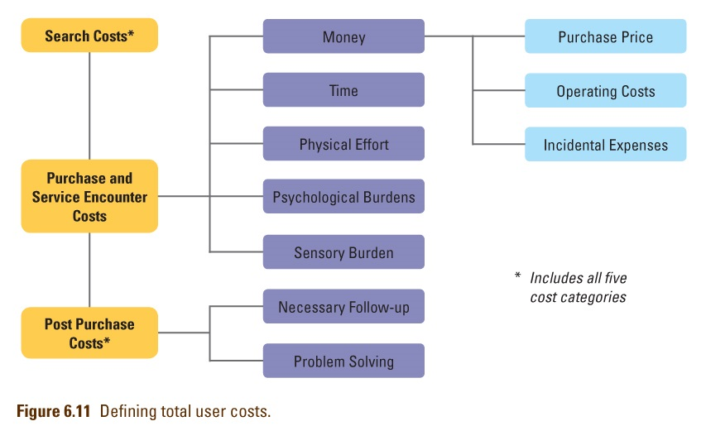

- Competition-Based Pricing
Price competition is reduced when:
- Non-price-related costs of using competing alternatives are high
- Personal relationships matter
- Switching costs are high
- Time and location specificity reduces choice

Revenue Management
Revenue management is price customization
- Charge different value segments different prices for same product based on price sensitivity

Most effective when:
- Relatively high fixed capacity
- High fixed cost structure
- Perishable inventory
- Variable and uncertain demand
- Varying customer price sensitivity

Revenue management uses mathematical models to examine historical data and real time information to determine
- What prices to charge within each price bucket
- How many service units to allocate to each bucket

Rate Fences
Rate fences deter customers willing to pay more from trading down to lower prices.

- Physical Fences
  - Basic product (size of rental car, seat location in theatre)
  - Amenities (valet parking, free breakfast at hotel)
  - Service level (butler, priority wait-listing)
- Non-physical Fences
Transaction Characteristics
- Time of booking (discounts for advance purchases)
- Location of booking (customers charged lower price if they book online)
- Flexibility of ticket usage (fees for cancelling, non-refundable reservation fees)
Consumption Characteristics
- Time or duration of use (early bird special in restaurant before 6pm, must stay at least 5 nights)
- Location of consumption (prices vary by location, price depends on departure location)
Buyer Characteristics
- Frequency or volume of consumption (member of certain loyalty-tier with the firm get priority pricing)
- Group membership (child/senior discounts, corporate rates)
- Size of customer group (group discounts based on size of group)
- Geographic location (local customers are charged lower rates than tourists)

Ethical Concerns in Pricing
Customers are vulnerable when service is hard to evaluate as they assume that higher price indicates better quality

Many services have complex pricing schedules
- Hard to understand
- Difficult to calculate full costs in advance of service
Quoted prices not the only prices
- Hidden charges, many kinds of fees
Too many rules and regulations
- Customers face unfair fines and penalties & may feel constrained, exploited

Chapter 7: Promoting Services and Educating Customers

Specific Roles of Marketing Communications
- Position and differentiate service
- Promote contribution of personnel and backstage operations
- Add value through communication content
- Facilitate customer involvement in production
- Stimulate or dampen demand to match capacity

Intangibility influences the nature of communication tasks.
- Intangible nature of services provides problems to consumers
- Intangibility is considered as the root source of service advertising difficulty

Advertising Strategies for Overcoming Intangibility

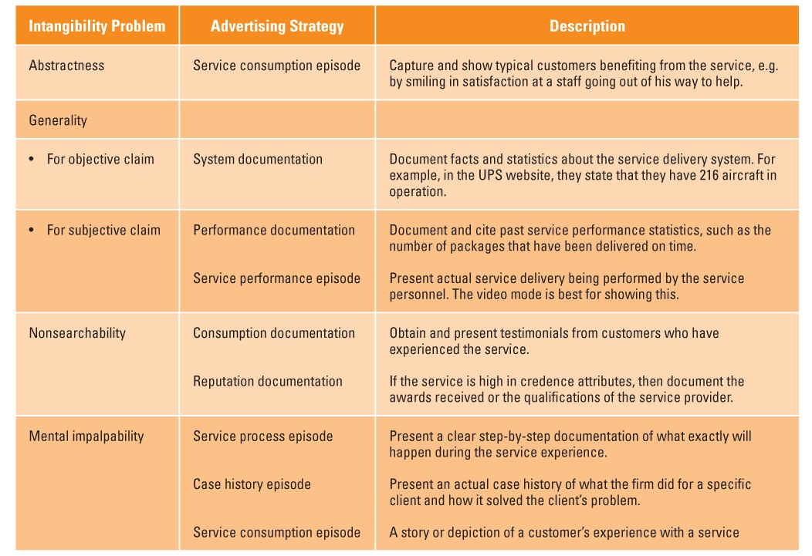
The 5 W’s Model
- WHO is our target audience?
- WHAT do we need to communicate and achieve?
- HOW should we communicate this?
- Where should we communicate this?
- When do communications need to take place?

Target Audience: Three Broad Groups
Prospects
- Employ traditional communication mix because prospects are not known in advance
Users
- More cost effective channels
Employees
- Secondary audience for communication through public media
- Shape employee behavior
- Part of internal marketing using company-specific channels

Educational and Promotional Objectives in Service Settings
- Create memorable images of specific companies and their brands
- Build awareness/interest for unfamiliar service/brand
- Compare service favorably with competitors’ offerings
- Build preference by communicating brand strengths and benefits
- Reposition service relative to competition
- Reduce uncertainty/perceived risk by providing info and advice
- Provide reassurance (e.g., promote service guarantees)
- Encourage trial by offering promotional incentives
- Familiarize customers with service processes before use
- Teach customers how to use a service to best advantage
- Stimulate demand in off-peak, discourage during peak
- Recognize and reward valued customers and employees

Sources of Messages Received by Target Audience

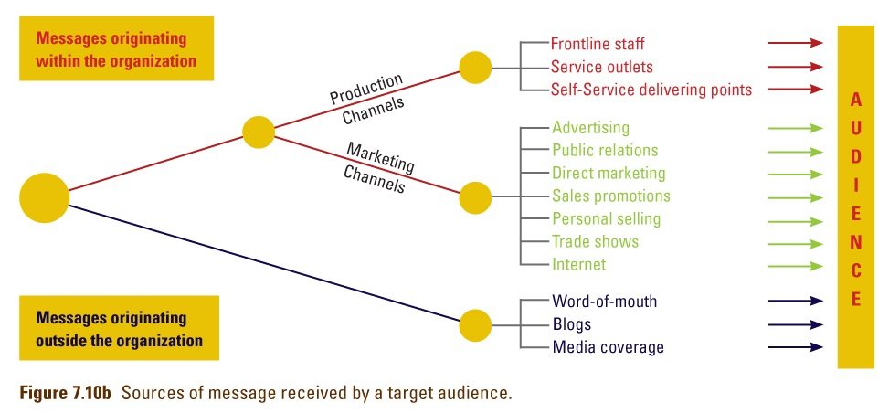

Strategies for Corporate Design
Service firms employ a unified and distinctive visual appearance for all tangible elements (logos, uniforms, facilities)

Useful in competitive markets to stand out, be instantly recognizable in different locations, and strengthen brand image (McDonalds golden arches, Shell logo)

How to stand out and be different?
- Use colors in corporate design
- Use names as central element in their corporate designs
- Use trademarked symbol rather than name as primary logo
- Create tangible recognizable symbols to connect with corporate brand names

