Chapter 2: Strategy & Human Resources Planning

Strategic Planning & Human Resources
-People are the most important assets.
Strategic Planning – Procedures for making decisions about the company's long-term goals and strategies.
Human Resources Planning – The process of anticipating and providing for the movement of people into, within, and out of an organization.
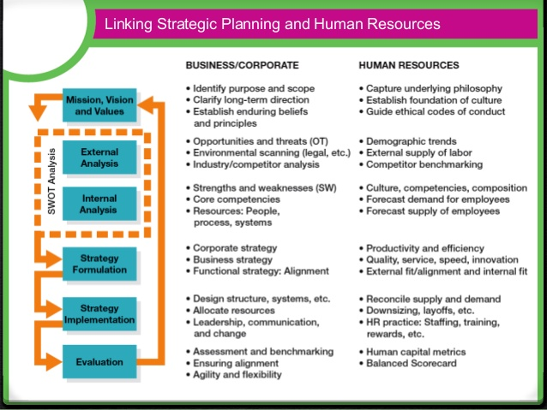
Strategic Human Resources Management – The pattern of human resources deployments and activities that enable an organization to achieve its strategic goals.

Linking the Process
-Good HR managers marry HRP to the strategic planning process for their organization as a whole.
-Two areas of focus are strategy formulation & strategy implementation.

Step 1: Mission, Vision, and Values
Mission - The basic purpose of the organization as well as the scope of operations.
Strategic Vision - A statement about where the company is going and what it can become in the future; clarifies the long-term direction of the company and its strategic intent.
Core Values - The strong and enduring beliefs and principles that the company uses as a foundation for its decisions.

Step 2: External Analysis
-They must analyze the ongoing opportunities and threats.
-Can be done through:
Environmental Scanning - Systematic monitoring of the major external forces influencing the organization.
- The Business Environment
  - All the external factors in the general environment - factors a firm cannot directly control but that can affect its strategy.
- The Remote Environment
  - Part of the business environment. It includes forces over which they virtually have no control.
    - Economic and Ecological Changes
    - Technological Changes
    - Demographic Changes
    - Social Changes
    - Legal and Regulatory Changes
- The Competitive Environment
  - Narrower than the remote environment and firms have a greater ability to affect it.
    - Customers
    - Rival Firms
    - New Entrants
    - Substitutes
    - Suppliers

Step 3: Internal Analysis
-An organization must examine their strengths and weaknesses
-Experts argue that a firm's success is made from its:
Core Capabilities - Bundles of people, processes, and systems that distinguish and organization from its competitors and deliver value to customers.
- Value Creation - What the firm adds to a product or service by virtue of making it; the amount of benefits provided by the product or service once the costs of making it are subtracted.
Sustaining a Competitive Advantage Through People
- The resources must be valuable.
- People are are source of competitive advantage when they improve the efficiency and the effectiveness of a company.
- The resources must be rare.
- People are a source of competitive advantage when their knowledge, skills, and abilities are not equally available of their competitors.
- The resources must be difficult and intimate.
- People are a source of competitive advantage when the capabilities and contributions of a firm’s employees cannot be copied by others.
- The resources must be organized.
- People are a source of competitive advantage when their talents can be combined and deployed to work on new assignments at a moment's notice.

Types of Talent and Their Composition in the Workforce
-Managers need to determine whether people are available internally or externally, to execute an organization's strategy.
Strategic Knowledge Workers - Have unique skills that are directly linked to the company’s strategy and are difficult to replace.
Core Employees - Have skills that are quite valuable to a company but are not particularly unique or difficult to replace.
Supporting Workers - Have Skills that are less strategic value to the firm and are generally available in the labour market.
External Partners - Have skills that are unique but frequently not directly related to a company’s core strategy.
Cultural Audits - Audits of the culture and quality of work life in the organization.
-Firms survey its employees about how they feel about a number of issues.
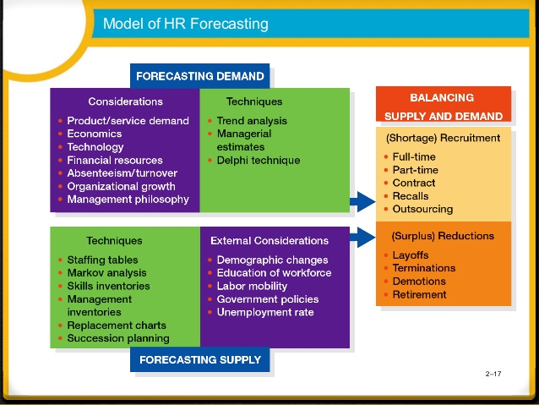
Values Based Hiring - The process of outlining the behaviours that exemplify a firm's corporate culture and then hiring people who are a fit for them.

Forecasting
- Managers forecast the following:
- Demand of Labour
- Trend Analysis - A quantitative approach of forecasting labour demand based on an organizational
- Management Forecasts - The opinions of supervisors, department managers, experts, or others knowledgeable about the organization's future employment needs. index such as sales.
- Supply of Labour
- Staffing Tables - Graphic representations of all organizational jobs, along with the numbers of employees currently occupying those jobs and future employment Requirements.
- Markov Analysis - A method for tracking the pattern of employee movements through various jobs.
- Quality of Fill - A metric designed to assess how well new hires are performing on the job.
- Skill Inventories - Files of personal education, experience, interests, and skills that allow managers to quickly match job openings with employee backgrounds.
- Replacement Charts - Listings of current jobholders and people who are potential replacements if an opening occurs.
- Succession Planning - The process of identifying, developing and tracking key individuals for executive positions.
- Balancing supply and Demand considerations
- Human Capital Readiness - The process of evaluating the availability of critical talent in a company and comparing it to the firmès supply.

Step 4: Formulating Strategy
Swot Analysis - Comparison of strengths, weaknesses opportunities, and threats for strategy formulation purposes.
Corporate Strategy
-Includes the markets in which it will compete, against whom, and how.
- Concentration strategies focus on a limited portion of the industry.
- Growth & Diversification
  - As companies grow their strategic choices tend to focus on geographic, volume, and product expansion.
  - Growth hinges rely on 3 elements:
- Increase employee productivity.
- A greater number of employees.
- Employees developing or acquiring new skills.
- Mergers and Acquisitions
- Strategic Alliances and Joint Ventures
Business Strategy
-Viewed in terms of domain navigation.
-More focused on how the company will compete against rival firms to create value for customers.
- Low-Cost Strategy: Compete on Productivity and Efficiency
  - Keeping your price low enough so that you can offer an attractive price to customers.
  - Can be done through productivity, and outsourcing
- Differentiation Strategy: Compete on unique value added
  - Providing something unique and distinctive to customers.
  - Based on high product quality, innovative features, speed to market, or superior service.
Functional Strategy: Ensuring Alignment
-Translate strategic priorities into functional areas of the organization.
-Involves all of the business but there needs to be a clear alignment between HR and the organization's strategy.
- Vertical Fit/Alignment
  - Focuses on the connection between the business objective and the major initiatives in HR.
- Horizontal Fit/ Alignment
  - Ensure that their HR practices are aligned with one another internally to establish a configuration that is mutually enforcing.

Step 5: Strategy Implementation
-HRM is instrumental to almost every aspect of strategy implementation (strategy, structure, systems, style, skills, staff or shared values).
Dealing With a Surplus of Employees
- Layoffs
  - Usually based on seniority and/or ability.
  - Reduced workweek, reduced shifts, and transfers to related companies.
- Attrition - A natural departure of employees from organizations through quits, retirements, and deaths
  - Hiring Freeze - A practice whereby new workers are not hired as planner or workers who have left the organization are not replaced.
- Termination - Practice initiated by an employer to separate an employee from the organization permanently
  - Severance Pay - A lump-sum payment given to terminated employees by an employer at the time of an employer initiated termination.

Step 6: Evaluation and Assessment
- Firms needs to establish a set of desired objectives as well as the metrics they will use to monitor how well their organization delivered against those objectives.
Benchmarking - The process of measuring one's own services and practice against the recognized leaders in order to identify areas for improvement.
Measuring a Firm's Strategic Alignment
- Strategic Mapping and the anced Scorecard
  - Balanced Scorecard - Measurement framework that helps managers translate strategic goals into operational objectives.
    - Four related cells: Financial, customer, processes and learning
- Measuring Horizontal Fit
  - Organizations must identify objectives they would like to achieve, identify each of the HR practices to reinforce those objectives, rate them 5 to -5.

Ensuring Strategic Flexibility For The Future
Organizational Capability - The capacity of the organization to act and change in pursuit of sustainable competitive advantage.
Coordination Flexibility - Occurs through rapid reallocation of resources to new or changing needs.
Resource Flexibility - Having people who can do many different things in different ways.

Chapter 3: Equity and Diversity in Human Resources Management

Employment Equity
Employment Equity - The employment of individuals in a fair and unbiased manner
-It contributes to the bottom line by broadening the base of qualified individuals for employment, training, and promotions and by helping employers avoid costly human rights complaints.
-Enhances an organization's ability to attract and keep the best qualified employees, which results in a broader set of skills.
-Enhances employee morale by offering special measures such as flexible work schedules and work sharing.
-The Canadian Charter of Rights and Freedoms, the federal Canadian Human Rights Act (CHRA), pay equity and employment equity acts are the governing pieces of legislation with employment equity.

Designated Groups
Designated Groups - Women, Visible Minorities, Aboriginal People, and persons with disabilities who have been disadvantaged in employment.
-They make up 60% of Canada's workforce.
-High unemployment, occupational segregation, pay inequities, and limited opportunities for career progress.
-Women tend to be concentrated in occupations that are accorded lower status and pay.
-Aboriginal people face low educational achievement and lack of job experience.
-People with disabilities face attitudinal barriers, physical demands that are unrelated to job requirements, and inadequate access to the technical and human support systems where they would need assistance.
-Visible Minorities vary in their labour force profiles and in their regional distributions.

The Legal Framework
- Canadian Charter of Rights and Freedoms
  - Fundamental freedoms, democratic rights, mobility rights, legal rights, equality rights, language rights.
  - Charter only protects the right of government and public-sector employees (Not private-sector).
- The Canadian Human Rights Act
  - Every individual should have an equal opportunity with other individuals to make himself or herself the life that he or she is able and wishes to have, consistent with his or her duties and obligations as a member of society, without being hindered in or prevented by doing so by race etc.
  - Protects federal jurisdiction however, there are provincial laws and rights
  - Bona Fide Occupational Qualification (BFOQ) - A justifiable reason for discrimination based on business reasons of safety or effectiveness.

Pay Equity
- Make it illegal for employers to discriminate against individuals on the basis of job content.
-Helps address the discriminatory portion of the historical wage gap between women and men and to ensure that salary ranges reflect the value of the work performed.
- Pay Equality
  - Employers are required to pay women the same as men doing the same job
  - Fair pay for individual women employees.
- Pay Equity
  - Fair pay for entire occupations, which are dissimilar, within an organization, such as nurses to electricians.
Employment Equity Act (1995)
- Employer is required to
  - Provide its employees with a questionnaire that allows them to indicate whether they belong to one of the four designated groups.
  - Identify jobs in which the percentage of designated groups falls below in the labour market.
  - Communicate information on employment equity to its employees and consult and collaborate with employee representatives.
  - Identify possible barrier in existing employment systems that may limit designated groups.
  - Develop and employment equity plan aimed at promoting and equitable workplace.
  - Make all reasonable efforts to implement the plan.
  - Monitor, Review, and revise the plan from time to time.
  - Prepare an annual report on its employment equity data and activities.
Implementation of Employment Equity In Organizations

Step 1: Senior Management Commitment
-Commitment to employment equity plan necessities a top-down strategy (CEO or Owner publicly introduces written policy describing the organization's commitment to employment equity).
-Regulations must be thoroughly communicated at all levels of the organization.

Step 2: Data Collection and Analysis
- The development of an internal workforce profile is an important tool in employment equity planning. (Without this information an organization would not be able to determine where it stands relative to the internal and external workforce).
- Stock Data - Showing the status of designated groups in occupational categories and compensation levels.
- Flow Data - Refer to the distribution of designated groups in applications, interviews, hiring decisions, training and promotional opportunities, and terminations.
- Underutilization - Designated groups that are not utilized or represented in the employer's workforce proportional to their numbers in the labour market.
- Concentration - Designated groups whose number in a particular occupation or level are high relative to their numbers in the labour market.

Step 3: Employment Systems Review
Employment Systems - means by which employers carry out personnel activities such as recruitment, hiring, training and development, promotion, job classification, discipline and termination.
- Systematic Discrimination - The exclusion of member of certain groups through the application of employment policies or practices based on criteria that are not job related.
- Special Measures - Initiatives designed to accelerate the entry, development and promotion of member of designated groups from among the interested and qualified workforce.
- Reasonable Accommodation - Adjusting the working conditions or schedules of employees with disabilities or religious preferences.

Step 4: Establishment of a Work Plan
-A narrative statement or summary of the conclusions drawn from the examination of the workforce analysis forms part of the employment equity workplan.
-The summary should include any restrictions face in hiring due to collective agreements, staff movements, or the need for specialized skills in a particular profession.
-Should Include:
- Numerical goals with time frames, with descriptions on how to achieve these goals
- Explanations about the proposed improvement in employment systems

Step 5: Implementation
-The success of plan implementation depends of senior management's commitment to the process.

Step 6: Evaluation, Monitoring and Revision
- Monitoring progress, the employer will be able to evaluate the overall success of the equity initiatives used to achieve a representative workforce, as well as respond to organizational and environmental changes.

Sexual Harassment
Sexual Harassment - Unwelcome advances, requests for sexual favours, and other verbal or physical conduct of a sexual nature in the working environment.
-Two main sources of employers duty to prevent harassment in the workplace are:
- Human rights legislation, which prevents harassment only on the basis of the designated ground in the legislation.
- Common law obligation to treat workers with decency and respect. This is a fairly new development of common law. However, it applies to all forms of harassment that make the workplace intolerable to the worker. If the employer fails to stop the harassment, it is in breach of the employment contract.
-The Ontario Human Rights Code identifies three kinds of sexual harassment:
- When someone says or does things to you of sexual nature and you don't want or welcome it.
- A person who has authority or power to deny you something, makes sexual suggestion that you don't want or welcome.
- A person with authority or the power to deny you something important punished you or threatens to do something for refusing the sexual request.

Managing Diversity
Diversity Management - The optimization of an organization's multicultural workforce to reach business objectives.
- Diversity management is voluntary employment equity is not.
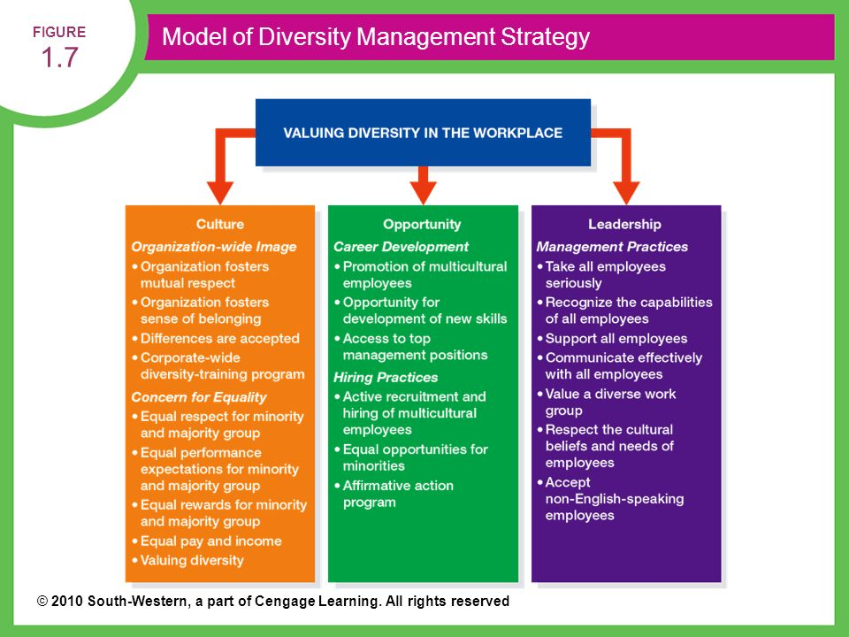

Chapter 4: Job Analysis and Work Design

Relationship of Job Requirements and HRM Functions
Job - A group of related activities and duties.
Position - The different duties and responsibilities performed by only one employee.
Job Family - A group of individual jobs with similar characteristics.
- Recruitment
  - Job Specification - A statement of the needed knowledge, skills, and abilities of the person who is to perform the job.
  - Recruiters need to know the job specifications for the positions they are to fill.
- Selection
  - Job Description - A statement of the tasks, duties, and responsibilities of a job to be performed.
  - Managers and supervisors use job descriptions to select employees and orient them to jobs.
- Training and Development
  - Any discrepancies between the knowledge, skills, abilities, and other factors demonstrated by a jobholder and the requirements contained in the description and specification for that job provide clues to training needs.
- Performance Appraisal
  - The requirement contained in the description of a job provide criteria for evaluating the performance of the holder of that job.
- Compensation Management
  - In determining the rate to be paid for performing a job, the relative worth of the job is one of the most important factors.
- Legal Compliance
  - A systematic collection of job data ensures that a job's duties match its job description.

Job Analysis
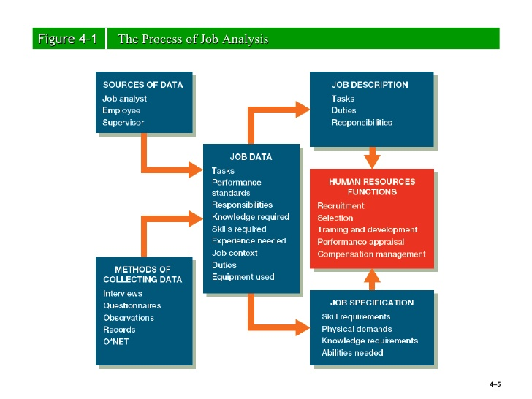
Job Analysis - The process of obtaining information about jobs by determining the duties, tasks, or activities of jobs.

- Gathering Job Information
  - Interviews, Questionnaires, Observation, Diaries.
- Controlling the Accuracy of Job Information
  - A job analyst should be alert for employees who tend to exaggerate the difficulty of their jobs to inflate their egos and their paycheques.
The NOC and Job Analysis
-The purpose of the NOC is to compile, analyze, and communicate information about occupations.

Approaches to Job Analysis
- Position Analysis Questionnaire
  - A questionnaire covering 194 different tasks that, by means of a five point scale, seek to determine the degree to which different tasks are involved in performing a particular job.
- Critical Incident Method
  - A job analysis method by which important job tasks are identified for job success.
- Task Inventory Analysis
  - A organization-specific list of tasks and their descriptions used as a basis to identify components of jobs.
- Competency-Based Analysis
  - Relies on building job profiles that look at the responsibilities and activities of jobs and the worker competencies necessary to accomplish them.
- HRIS and Job Analysis
  - Advanced computer applications of job analysis combine job analysis with job evaluation and the pricing of organizational jobs.
Job Descriptions
Job Description - A statement of the tasks, duties, and responsibilities of a job to be performed.
- Job Title
  - Physiological importance to the employee, should provide indication of duties of the job, should indicate the level of the role.
- Job Identification Section
  - Departmental location of the job, the person who the job holder reports, and the date that the job description was last updated.
  - A job statement usually appears at the bottom, which distinguishes the job from other jobs.
- Job Duties, or Essential Functions Section
  - Stress the responsibilities all the duties entail and the results they are to accomplish, in order of importance.
- Job Specification Section
  - The skills required to perform a job.
  - The physical demands the job places on the employee performing it.
Problems With Job Descriptions
- If they are poorly written, using vague rather than specific terms, they provide little guidance to the jobholder.
- They are sometimes not updated as job duties and specification change
- They may violate the law by containing specifications not related to job success.
- They can limit the scope of activities of the jobholder, reducing organizational flexibility.

Job Design
Job Design - An outgrowth of job analysis that improves jobs through technological and human considerations to enhance organizational efficiency and employee job satisfaction.
-Concerned with changing, modifying, and enriching jobs to capture the talents of employees while improving organizational performance.
- Behavioural Concerns
  - Job Enrichment - Enhancing a job by adding more meaningful tasks and duties to make the work more satisfying or rewarding
  - Employee Empowerment - Granting Employees power to initiate change, thereby encouraging them to take charge of what they do.

  - Job Characteristics Model
- Skill Variety - The degree to which a job entails a variety of different skills.
- Task Identity - The degree to which the job requires completion of a whole and identifiable piece of work.
- Task Significance - The degree to which the job has substantial impact on the lives or work of other people.
- Autonomy - The degree to which the job provides substantial freedom, independence, and discretion to the individual in scheduling the work and determining the procedures to be used in carrying it out.
- Feedback - The degree to which carry out the work activities required by job results in the individual being given direct and clear information about the effectiveness of his or her performance.
- Industrial Engineering Considerations
  - Industrial Engineering - A field of study concerned with analyzing work methods and establishing time standards.
- Ergonomic Considerations
  - Ergonomics - An interdisciplinary approach to designing equipment and systems that can be easily and efficiently used by human beings.

Designing Work for Groups and Teams
- Employee Involvement Groups - Groups of employees who meet to resolve problems or offer suggestions for organizational improvement
- Employee Teams - An employee contributions technique whereby work functions are structured for groups rather than individuals and team member are given discretion in matters traditionally considered management prerogatives, such as process improvements, product or service development, and individual work assignments.
- Virtual Teams - A team with widely dispersed members linked together through computer and telecommunications technology.
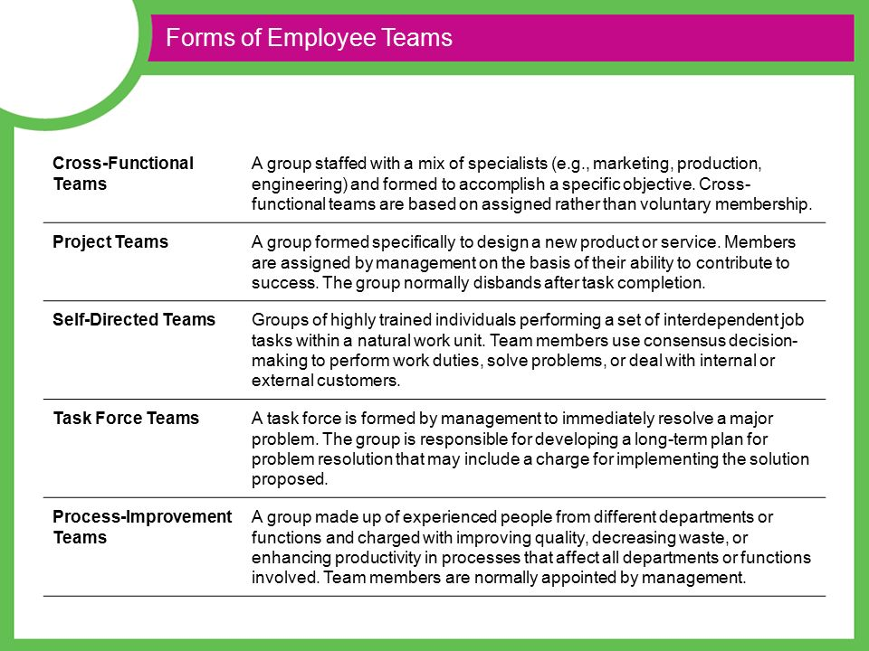
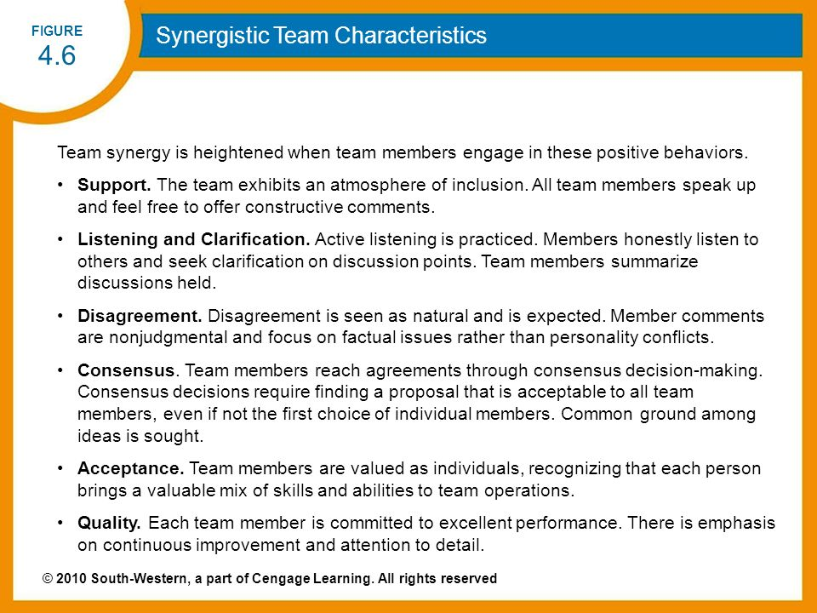
- Flexible Work Schedules
  - Compressed Workweek - The number of days in the workweek is shortened by lengthening the number of hours worked per day.
  - Flextime - Flexible working hours that permit employees the option of choosing daily starting and quitting times provided they work a set number of hours per day or week.
  - Job Sharing - The arrangement whereby two part-time employees perform a job that otherwise would be held by one full-time employee.
  - Telecommuting - Use of personal computers, networks, and other communications technology to do work in the home that is traditionally done in the workplace.

Chapter 5: Expanding the Talent Pool: Recruitment and Careers
Employee Profiles - Profiles of workers developed by studying and organization’s top performers to recruit similar types of people.

Strategic Aspects of Recruiting
- Who should do the Recruiting?
  - Large firms have their own HR in house recruiters.
  - Small organizations may use and HR generalist, if the organization has no HR team then their managers will hire for them.
  - Recruiting Process Outsourcing (RPO) - The practice of outsourcing and organizations recruiting function to an outside firm.
- Should a firm recruit internally or externally?
  - Most managers try filling job vacancies through promotions and transfers, therefore they can capitalize on the investment they already made.
  - If there is limited talent to chose from they will try and hire externally.
- Labour Markets
  - Internal Labour Markets - Workers are hired into entry level jobs, higher levels are filled within
  - A tight labour market, one with low employment will seek assistance from local agencies.

- Regional Global Labour Markets
  - Global Sourcing - The business practice of searching for and utilizing goods and services around the world.
  - Firms locate in places with talent and resources near by, usually by their competitors.
  - Branding - A company’s efforts to help existing and prospective workers understand why it is a desirable place to work.

Recruitment Channels
- Recruiting Internally
  - Internal job postings
  - Identifying talent through performance appraisals
    - 9 box Grid - A comparative diagram that includes appraisal and assessment data to allow managers to easily see and employees actual or potential performance.
  - Skill Inventories and Replacement Charts
    - Skill Inventories - Files of personal education, experience, interests, and skills that allow managers to quickly match job openings with employee backgrounds.
    - Replacement Charts is a chart that shows people who can take someone's place if they leave the firm.
- Recruiting Externally
  - Advertisements
    - Websites, newspapers etc.
  - Walk-ins and Unsolicited Applications and Resumes
  - The Internet, Social Networking, and Mobile Recruiting
    - Passive Job Seekers - People who are not looking for jobs but could be persuaded to take new ones given the right opportunity
  - Job Fairs
  - Employee Referrals
    - Nepotism - A preference for hiring relative of current employees.
  - Re-recruiting
    - The process of keeping track of and maintaining relationships with former employees to see if they would be willing to return to the firm.
  - Executive Search Firms
    - Outside firms that help employers find the right person for the right job.
  - Educational Institutions
  - Professional Associations
  - Labour Unions
  - Public Employment Agencies
  - Private Employment and Temporary Agencies
    - Usually used for recruiting abroad
  - Employee Leasing
    - The process of dismissing employees who are then hired by a leasing company (which handles all HR related activities) and contracting with that company to lease back the employees.

Improving The Effectiveness of Recruiting
- Using Realistic Job Previews
  - Informing applicants about all aspects of the job including both its desirable and undesirable facets.
- Surveys
- Recruiting Metrics
  - Quality of Fill Statistics - A metric designed to assess how well new hires are performing on the job.
  - Time to Fill - The number of days from when a job opening is approved to the date the candidate is selected.
  - Yield Ratios - The percentage of applicants from a recruitment sources that make it to the next stage of the selection process.
  - Costs of Recruitment
    - Applicant Tracking System - A software application recruiters use to post job openings, screen resumes, contact potential candidates for interviews via email, and track the time and costs related to hiring people.

Career Management: Developing Talent Over Time
- The Goal Matching Individual Needs and Organizational Needs
  - The Employee's Role
    - Identify their knowledge, skills, abilities, interests and values and to seek information about their career options in conjunction with their managers.
  - The Organization's Role: Establishing a Favourable Career Development Climate
    - Provide employees with the right information to to get the to reach their goals and develop their career.
  - Blending the Goals of Individuals Employees With The Goals of the Organization
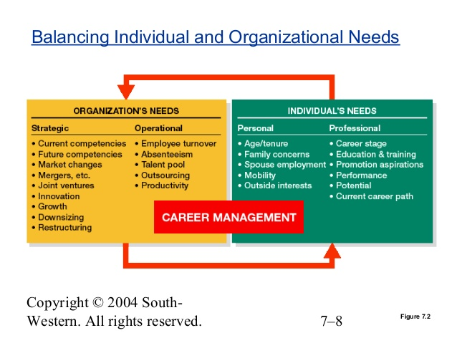

- Identifying Career Opportunities and Requirements
  - Begin With a Competency Analysis
  - Identify Job Progressions and Career Paths
    - Job Progressions - The hierarchy of jobs a new employee might experience, ranging from a starting job to jobs that successively require more knowledge and or skill.
    - Career Path - Lines of advancement in and occupational field within an organization
  - Track Career Strategies
- Preparation for work
- Organizational entry
- Early career
- Midcareer
- Late Career
  - Recognize Different Career Paths
    - Can be done through promotions, transfers, demotions, and exits.
    - Transfers - Placement of an individual in another job for which duties, responsibilities, status , and remuneration are approximately equal to those of the previous job.
    - Promotion - A change of assignment to a job at a higher level in the organization.
    - Relocation Services - Services provided to an employee who is transferred to a new location which might include help in moving, selling a home, orienting to a new culture, and/or learning a new language.
    - Outplacement Services - Services provided by organizations to help terminated employees find a job.
  - Consider Dual Career Paths for Employees
  - Consider the Boundaryless Career
  - Help Employees Progress Beyond Career Plateaus
    - Career Plateau - A situation in which, for either organizational or personal reasons, the probability of moving up in the career ladder is low.
    - Sabbatical - And extended period of time in which an employee leaves and organization to pursue other activities and later returns to his or her job.
- Career Development Initiatives
  - Career Planning Workbooks and Workshops
  - Career Counselling
    - The process of discussing with employees their current job activities and performance, personal and career interests and goals, personal skills, and suitable career development objectives.
    - Fast-Track Program - A program that encourages new managers with high potential to remain with an organization by enabling them to advance more rapidly than those with less potential.
  - Mentoring
    - Individuals who coach, advise, and encourage individuals of lesser rank.
  - Networking
    - The process of establishing mutually beneficial relationships with other businesspeople, including potential clients and customers.
  - Career Self Management Training

Chapter 6: Employee Selection

Overview of the Selection Process
Selection - is the process of choosing individuals who have relevant qualifications to fill existing projected job openings.
- Begin With Job Analysis
  - Analyze jobs to develop job descriptions and specifications, this helps identify the individual competencies employees need for success.
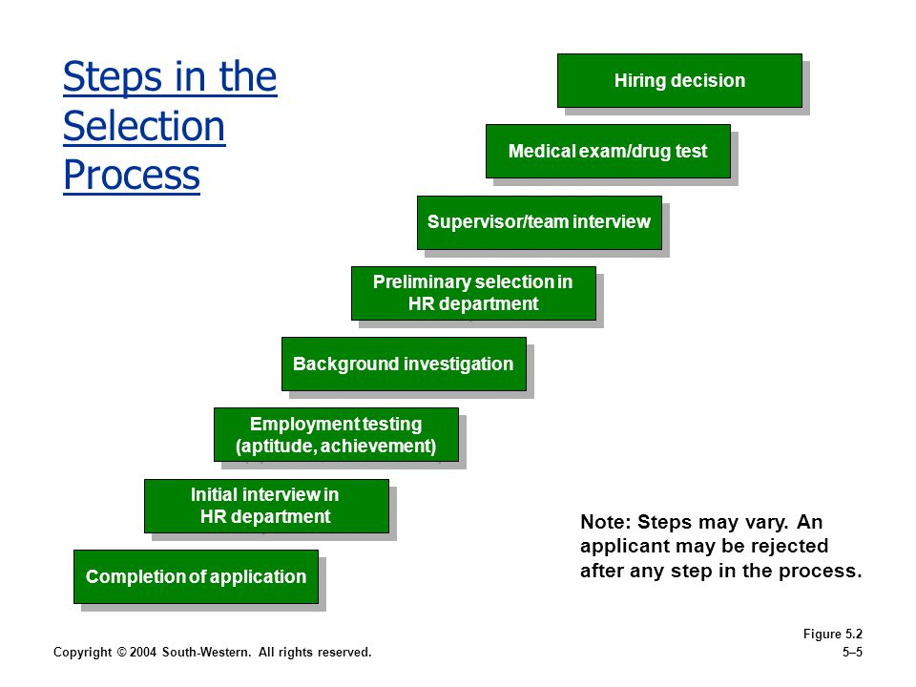
  - Managers then use selection methods such as interviews, references and pre employment tests to measure the applicant KSAOs (Knowledge, skills, ability, other factors) against the competencies required for the job.
- The Selection Process
  - The number of steps in the selection process vary not only by the company but by the job that's being filled. The Selection process usually looks like the diagram.
- Obtaining Reliable and Valid Information
  - Reliability - The degree to which interviews, tests and other selection procedures yield comparable data over time.
  - Validity - The degree to which a test or selection procedure measures a person's Attributes.
Initial Screening
- Cover Letters & Resumes
- Internet Checks & Phone Screening
  - Internet checks for social media, etc. Phone screening, phone interview.
  - Video Resumes - Short video clips that highlight applicants qualifications beyond what they can communicate on their resumes.
- Application Forms
  - Include: application date, educational background, experience, allowed to work in Canada, references.
  - Weighted application blank (WAB) - The use of a common standardized employment application that is designed to distinguish between successful and unsuccessful employees.

Employment Interviews
- Nondirective Interview
  - An interview in which the applicant is allowed the maximum amount of freedom in determining the course of the discussion, while the interviewer carefully refrains from influencing the applicant's remarks.
- Structured Interview
  - An interview in which a set of standardized questions with an established set of answers is used.
- Situational Interview
  - An interview in which an applicant is given hypothetical incident and asked how he or she would respond to do it.
- Behavioral Description Interview (BDI)
  - An interview in which an applicant is asked questions about what he or she did in a given situation.
- Panel and Sequential Interviews
  - Panel - An interview in which a board of interviewers questions and observes a single candidate.
  - Sequential - A format in which a candidate is interviewed by multiple people, one right after another.
- Methods for Administering Interviews
  - Video and Phone Interviews
  - Computer Administered (Automated) Interviews
    - Done through the internet, employers can look at it anytime.
- Guidelines For Employment Interviewers
  - Interviewer Training
Understand the Job > Establish an interview plan > Establish and maintain rapport and listen actively >
Pay attention to nonverbal cues > Provide information as freely and honestly as possible > Use questions Effectively > Separate facts from inferences > Recognize biases and stereotypes > Avoid the “Halo Error” >
Control the course of the interview > Standardize the questions asked pg. 222
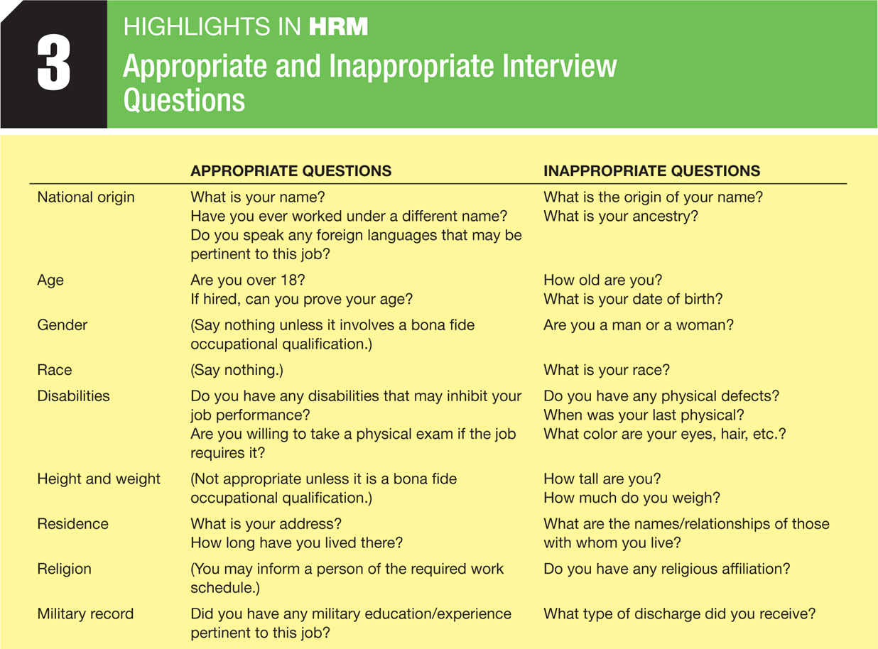
  - Employment equity: Are Your Questions Legal

Post-Interview Screening
- Reference Checks
- Background Checks
- Credit Checks
  - Mainly for banks, and positions of trust

Pre Employment Tests
Pre Employment Tests - An objective and standardized measure of a sample of behaviour that is used to gauge a person’s KSAOs relative to other individuals.
- Types of Tests
  - Job Knowledge Tests
    - CPA, CFA, Etc.
  - Work Sample Tests
    - Perform tasks of the work required on the job.
  - Assessment Centre Tests
    - A process by which individuals are evaluated as they participate in a series of situations that resemble what they might need to handle the job.
  - Cognitive Ability Tests
    - Measure mental capabilities such as general intelligence, verbal fluency, numerical ability, and reasoning ability.
  - Biodata Tests
    - Collect biographical information about candidates that has been shown to correlate with on the job success.
    - Candidates are questions about events and behaviours that reflect attitudes, experiences, interests, skill, and abilities.
  - Personality and Interest Inventories
    - Extroversion - The degree to which someone is talkative, sociable, active, aggressive and excitable.
    - Agreeableness - The degree to which someone is trusting, amiable, generous, tolerant, honest, cooperative, and flexible.
    - Conscientiousness - The degree to which someone is dependable and organized and perseveres in tasks.
    - Neuroticism - The degree to which someone is secure, calm, independent, and autonomous.
    - Openness to Experience - The degree to which someone is intellectual, philosophical, insightful, creative, artistic, and curious.
  - Polygraph Tests
    - Lie detector that measure the changes in breathing, blood pressure, and pulse of a person who is being questioned.
  - Honest and Integrity Tests
    - Mainly used in retail stores where employees can steal merchandise and cash.
  - Physical Ability Tests
  - Medical Examinations
    - Given to ensure that the health and fitness of applicants are adequate to meet the job requirements.
  - Drug Testing
    - Addiction to drugs or alcohol is considered a disability, Read more on page 232-233

- Determining The Validity of Tests
  - Criterion Related Validity - The extent to which a selection tool predicts, or significantly correlates with, important element of work behaviour.
Two Types of Criterion-related Validity
- Concurrent Validity - The extent to which test scores (or other predictor information) match criterion data obtained at about the same time from current employees.
- Predictive Validity - The extent to which applicants test score match criterion data obtained from those applicants/employees after they have been on the job for an indefinite period.
Regardless Cross Validation is Essential
- Cross Validation - Verifying the results obtained from a validation study by administering a test or test battery to a different sample (drawn from the same population)
  - Content Validity - The extent to which a selection instrument, such as a test, adequately samples the knowledge and skills needed to perform a particular job.
  - Construct Validity - The extent to which a selection tool measures a theoretical construct or trait.

Reaching A selection Decision
- Summarizing Information About Applications
  - An employer is interested in what an applicant can do and will do.
    - Can Do - factors include a candidate's knowledge and skills, as well as the aptitude (the potential for acquiring new knowledge and skills.
    - Will Do - factors include the candidate's motivation, interest, and other personality characteristics.
  - An employer usually makes a candidate evaluation form.
- Decision Making Strategy
  - Clinical Approach
    - Decision makers review all the data on the applicants, then individuals who have been successful in that job make a decision. Different people will come up with different solutions because they weigh thing differently.
    - Can be biased and people may hire people like themselves.
  - Statistical Approach
    - Compensatory Model - A selection decision model in which a high score in one area can make up for a low score in another area.
    - Multiple Cutoff Model - A selection decision model that requires an applicant to achieve a minimum level of proficiency on all selection dimensions.
    - Multiple Hurdle Model - A Sequential strategy in which only the applicants with the highest scores at an initial test stage go on to subsequent stages.
    - Selection Ratio - The number of applicants compared to the number of people hired.
- Final Decision

Chapter 7: Training and Development

The Scope of Training
-Many new employees come equipped with most of the knowledge, skills, and abilities needed to start work, others require extensive training before they can contribute to the organization.
-Businesses spend nearly four times as much on informal instruction as they do on formal instruction.
- A Strategic Approach to Training
  - To ensure that a firm's training and development investment has the maximum impact possible, a strategic and systematic approach should be used that involves four phases:
- A needs assessment based on the firm's competitive objectives: What training does the firm really need?
- Program Design: Given those needs, how should the training program be designed or structured.
- Implementation: How can the firm tell if the training program is really working.
- Evaluation: How can the firm tell if the training program is really working.
  - Chief Learning Officer - A high-ranking manager directly responsible for fostering employee learning and development within the firm.

Phase 1: Conducting the Needs Assessment
- Organizational Analysis
  - Examination of the environment, strategies, and resources of the organization to determine where training emphasis should be placed.
- Task Analysis
  - The process of determining what the content of a training program should be on the basis of a study of the tasks and duties involved in the job.
  - Competency Assessment - Analysis of the sets of skills and knowledge needed for decision oriented and knowledge intensive jobs.
- Person Analysis
  - Determination of the specific individual who need training.

Phase 2: Designing the Training Program
- Developing Instructional Objectives
  - Instructional objectives - Desired outcomes of a training program
- Assessing The Readiness of the and Motivation of Trainees
  - Trainee Readiness - refers to whether or not the experience and knowledge of trainees have made them ready to absorb the training.
  - Trainee Motivation - Help employees understand the link between the effort they put into training and the payoff.
- Incorporating the Principles of Learning
  - Goal Setting
    - When trainers take the time to explain the trainings goals and objectives to trainees or when trainees are encouraged to set goals of their own, effort is likely increased.
  - Meaningfulness of Presentation
    - Trainees will be better able to learn new information if it is presented using terminology they can understand, and when it is connected with things familiar to them.
  - Modelling
    - Real life demonstrations, visual aids, pictures, and drawings.
  - Individual Learning Differences
    - People learn at different rates and different ways, therefore they should teach in different ways.
  - Active Practice and Repetition
    - Should be given frequents opportunities to practice their job tasks in the way they will ultimately be expected to perform them.
  - Whole Vs. Part Learning
    - Better to break down into parts, easier to learn.
  - Massed Vs. Distributed Learning
    - Spacing out training will result in faster learning and longer retention.
  - Feedback and Reinforcement
    - Behaviour Modification - A technique that operates on the principle that behaviour that is rewarded, or positively reinforced, will be exhibited more frequently in the future, whereas behaviour that is penalized or unrewarded will decrease in frequency.
    - Spot Rewards - Programs that reward employees on the spot when they do something well in the training process.
  - Characteristics of Instructors
    - Often a good trainer is one who shows a little more effort or demonstrates more instructional preparation.

Phase 3: Implementing the Training Program - Training Delivery Methods
- On the Job Training
  - A method by which employees are given hands on experience with instructions from their supervisor or other trainer.
  - Apprenticeship Training - A system of training in which a worker entering the skilled trades is given thorough instruction and experience, both on and off the job, in the practical and theoretical aspects of work.
- Special Assignments
  - Involve assigning trainees, who are often but not always on managerial tracks, to different jobs in different areas of a firm, often in different regions and countries.
- Cooperative Training, Internships, And Governmental Training
  - Cooperative Training - A training program that combines practical on-the-job experience with formal educational classes
- Simulations
  - Sometimes it is impractical or unwise to train employees on the actual equipment used on the job if it is expensive or dangerous.
- E-Learning
  - Learning that takes place via electronic media
    - Learning Management System - Online system that provides a variety of assessment, communication, teaching and learning opportunities.
    - Just-in-time-training - Training delivered to trainees when and where they need it to do their jobs, usually via computer or the internet.
- Behaviour Modelling
Learning Points > Modelling > Practice > Feedback
- Blended Learning
  - The use of multiple training methods to achieve optimal learning on the part of trainees.
- Role-Playing
- Coaching
- Case Studies
- Seminars and Conferences
- Classroom (Lecture) Instruction

Step 4: Evaluating The training Program
- Criterion 1: Reactions of participants
- Criterion 2: Learning
  - Testing the knowledge before and after training will help determine how much they’ve learned.
- Criterion 3: Behaviour
  - Transfer of Training - The effective application principles learned to what is required on the job.
To maximize:
- Feature identical elements - Have conditions in the training program come as close as possible to the job
- Focus on General Principles, if necessary - When jobs change or the work environment cannot be matched exactly, trainer often stress the general principles.
- Establish a climate for transfer - Embrace the strategic changes in their organizations are seeking to implement and reinforce and reward employees for developing the new skills.
- Give employees transfer strategies - Relapse Prevention (teaches individuals how to anticipate and cope with the inevitable setbacks they will encounter back on the job)

- Criterion 4: Results, or ROI
  - ROI = Benefits of Training/Training Costs
  - Benchmarking

Additional Training and Development Programs
- Orientation and Onboarding
  - Orientation - The formal process of familiarizing new employees with the organization, their jobs, and their work units.
  - Onboarding - The process of systematically socializing new employees to help them get on board with the organization.
- Basic Skill Training
- Team Training and Cross Training
  - Cross Training - The process of training employees to do multiple jobs within the organization.
- Ethics Training
  - Chief Ethics Officers - High ranking managers directly responsible for fostering the ethical climate within a firm.

Chapter 8: Performance Management

Performance Management Systems
Performance Management - The process of creating a work environment in which people can perform to the best of their abilities.
Performance Evaluations - The result of an annual or biannual process in which a manager evaluates an employee's performance relative to the requirements of his or her job and uses the information to show the person where improvements are needed and why.

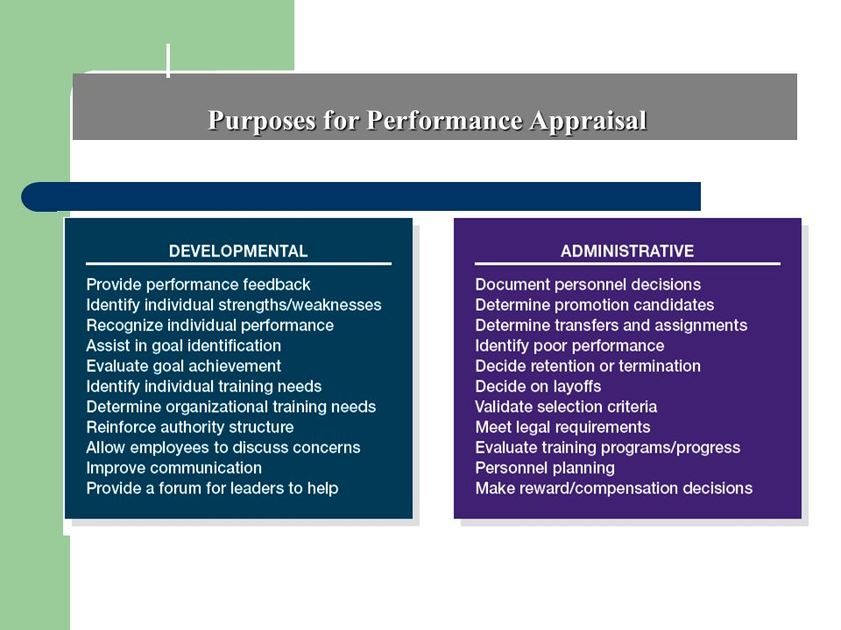
- Purposes of Performance Management
  - Administrative Purposes - Provide input that can be used for the entire range of HRM activities such as promotions, transfers, layoffs, and pay decisions
  - Developmental Purposes - Gives managers a concrete framework they can use to gather information about an employee's performance, provide employees with feedback, and discuss an employee's goals and how they align with the organization's goals.

Developing An Effective Performance Management System
- What Are Performance Standards?
  - Should be based on job-related requirements derived from a job analysis and reflected in an employee's job description and job specifications.
    - Strategic Relevance - The extent to which the performance standards relate to the strategic objectives of the organization in which they are applied.
    - Criterion Deficiency - The performance standards should capture the entire range of an employer's performance.
    - Criterion Contamination - There are factors outside of an employee’s control that can influence his or her performance.
    - Reliability - Stability or consistency of a standard to the extent which individuals tend to maintain a certain level of performance overtime.
      - Calibration - A process whereby manager meet to discuss the performance of individual employees to ensure that their employee evaluations are in line with one another.
    - Fairness and Acceptability
- Legal Issues (See page 292)
- Who Should Appraise An Employee’s Performance?
  - Manager or Supervisor Evaluation - A performance evaluation done by an employee’s manager and often reviewed by a manager one level higher.
  - Self-Evaluation - A performance evaluation done by the employee being evaluated, generally on an evaluation form completed by the employee prior to the evaluation meeting.
  - Subordinate Evaluations - A performance evaluation of a superior by an employee, which is more appropriate for developmental than for administrative purposes.
  - Peer Evaluation - A performance evaluation done by one’s fellow employees, generally on forms compiled into a single profile for use in the evaluation meeting conducted by the employer's manager.
  - Team Evaluation - A performance evaluation that recognizes team accomplishment rather than individual performance
  - Customer Evaluation - A performance evaluation that includes evaluation from both a firm’s external and internal customers.

Putting It all Together: 360 Degree Evaluations
360-Degree Evaluation - A performance evaluation done by different people who interact with the employee, generally on forms compiled into a single profile for use in the evaluation meeting conducted by the employee's manager.
- Training Appraisers
  - Establishing an Evaluation Plan
    - Most effective when it follows a systematic process that begins by explaining the objectives of the firm's performance management system.
  - Eliminating Rating Errors
    - Distributional Rating Error - Occurs when a single rating is skewed toward an entire group of employees.
    - Error of Central Tendency - A performance rating error in which all employees are rated about average
    - Leniency or Strictness Error - A performance rating error in which the appraiser tends to give employees either unusually high or low ratings
    - Forced Distribution - A performance ranking system whereby raters are required to place a certain percentage of employees into various performance categories.
    - Temporal (Recency) Error - A performance rating error in which the evaluation is based largely on the employee's most recent behaviour rather than on behaviour throughout the evaluation period.
    - Contrast Error - A performance rating error in which an employee’s evaluation is biased either upward or downward because of comparison with another employee just previously evaluated.
    - Similar to me Error - A performance rating error in which an appraiser inflates the evaluation of an employee because of a mutual personal connection.
  - Feedback Training
    - Should provide some pointers managers can use to provide performance feedback to employees on an ongoing basis and during formal evaluations and feedback sessions.

Performance Evaluation Methods
- Trait Methods
  - Designed to measure the extent to which an employee possesses certain characteristics such as dependability, reactivity, initiative, and leadership - that are viewed as important for the job and the organization in general.
  - Traits tend to be vague and subjective.
    - Graphic Rating Scales - A trait approach to performance rating whereby each employee is rated according to a scale of characteristics.
    - Mixed-Standard Scale Method - A trait approach to performance rating similar to other scale methods but based on comparison with (better than, equal to, or worse than) a standard
    - Forced Choice Model - A trait approach to performance rating that requires the rater to choose from statements designed to distinguish between successful and unsuccessful performance.
    - Essay Method - A trait approach to performance rating that requires the rater to compose a statement describing employee behaviour.
- Behavioural Methods
  - Which actions should or should not be exhibited on the job.
    - Critical Incident - An unusual event that denotes superior or inferior employee performance in some part of the job.
    - Behaviourally Anchored Rating Scale (BARS) - A behavioural approach to performance rating that consists of a series of vertical scales, one for each important dimension of job performance.
    - Behaviour Observation Scale (BOS) - A behavioural approach to performance rating that measures the frequency of observed behaviour.
- Results Methods
  - Results evaluations often give employees responsibility for their outcomes while giving them discretion over the way they accomplish them (within limits).
    - Productivity Measures - Based upon Sales, production, profits.
    - Management by Objectives - A philosophy of management that rates the performance of employees based on their achievement of goals set mutually by them and their manager.
    - Balanced Scorecard - Measurement framework that helps managers translate strategic goals into operational objectives.
      - Four related cells: Financial, customer, processes and learning
- Which Performance Evaluation Method Should you Use?
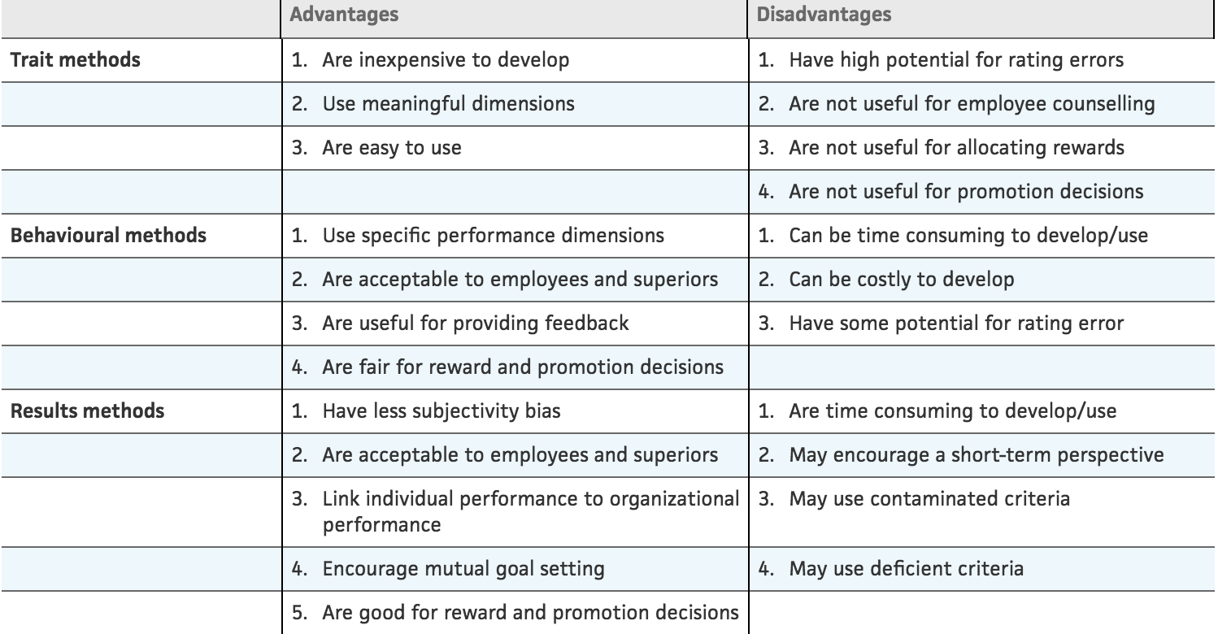
Performance Evaluation Meetings and Feedback Sessions
- Types of Performance and Evaluation Meetings and Feedback Sessions
  - Tell and sell - The ability to persuade an employee to change his or her behaviour in a certain way.
  - Tell and listen - Communicates the strong and weak points of an employee's job performance for the first part of the session. The employees feeling about the evaluation are thoroughly explored.
  - Problem Solving - It seeks to obtain the employee’s buy-in for a mutually agreed-upon way to overcome obstacles and improve the person’s performance.
- Conducting The Performance Evaluation Meeting or Feedback Session
  - Ask for a self evaluation
  - Invite Participation
  - Express Appreciation
  - Be supportive and demonstrate that you care
  - Minimize criticism
  - Establish Goals
  - Follow up Day to Day
- Improving Performance
  - Identifying Sources of Ineffective Performance
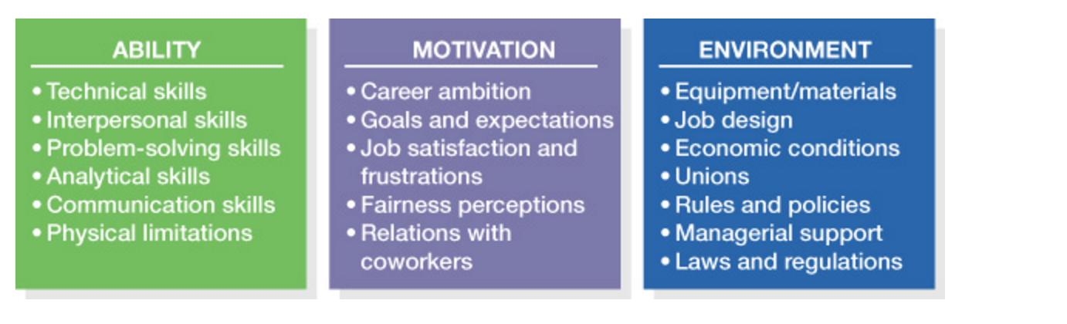
  - Performance Diagnosis

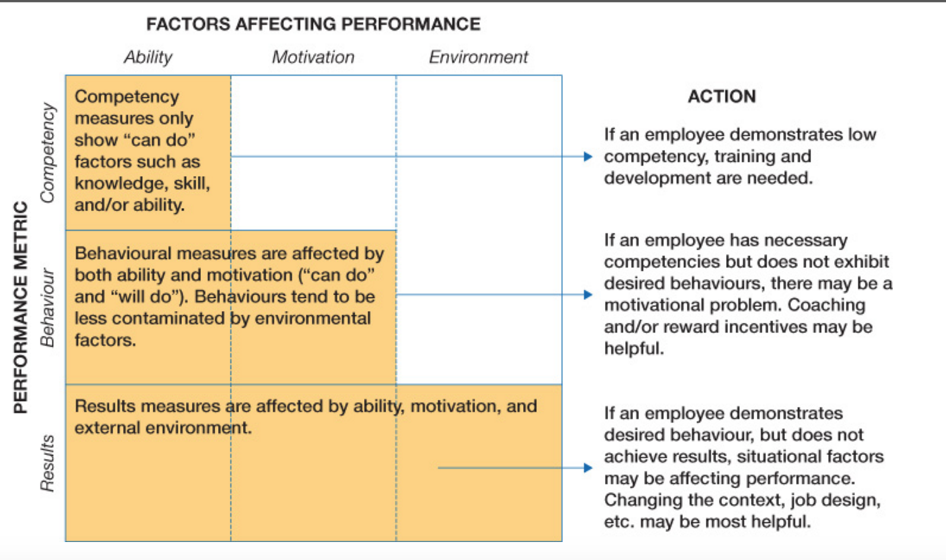

  - Managing Ineffective Performance
    - Training, Transferring, or Motivation.
  - Focus on Changing Behaviour, Not The Person

