CMN1160 –Defining the Field

Textbook
- Mass Communication in Canada, Eighth Edition
- oupcanada.com/MassCom8e
Age of Enlightenment
- Rise of rational thought
- People started to take responsibility for rulers and laws
- 4 questions:
- What are the ideas that are appropriate to discuss?
- How do we ensure that people have access to debates?
- How do we make sure that people can engage in action and debates?
- Is everyone that speaks equal to everyone else?
Radio
- Radio (1900s)
- How do we respond to messages that we hear?
- Manufacturers consent (1922)
- Messages over the radio are a great way to control the population
- The impact of the radio was studied from the 1920s-1930s
- In the 1940s, people studied how the German propaganda with the Nazi population worked. Could it happen in Canada?
- Radio as propaganda for buying products
- Radio as an educator (later TV, then the internet)
- Administrative message
- What’s the best way for conveying a message?
- Communicative breakdown causes society not to run effectively
- What’s the difference between the tools that we use to communicate and society?
Importance of Media
- Primary agent of socialization –pervasive
- Used to communicate with others
- Information source
- Entertainment/info-tainment
- Some think that the news is getting dumbed down
- We care more about the Kardasians than what is going on in Northern Canada
- The Daily Show is the most watched news show for 18-24 year olds
- Agenda-setting
- The media is not telling us what to think but what to think about it
- Global economy
- Collapsing time and space
- Binding/unifying (or fragmentive?)
- Brings people together in a shared cultural experience
- You can choose specific types of news to read (ex. only liberal, only conservative)
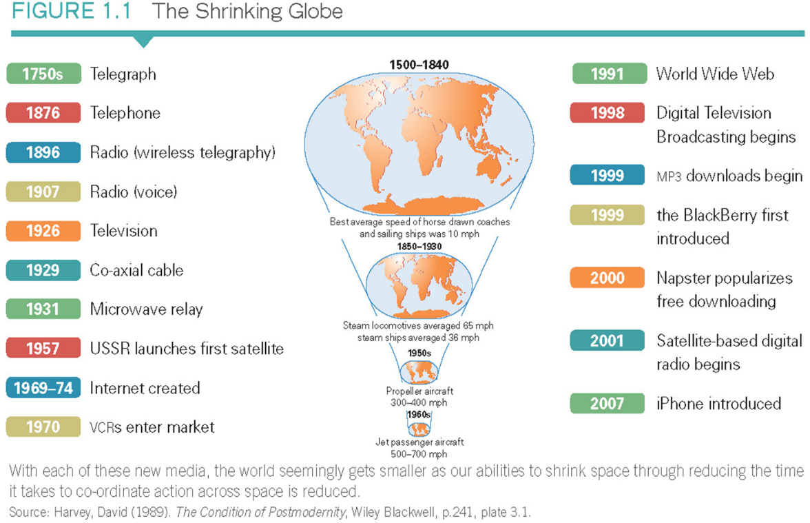
Media Trends
- Convergence
- (Blurring of sectoral boundaries)
- Technological – end of distinction between content and carriage
- Content –producing content vs carriage –providing infrastructure to distribute content
- Doing both used to be illegal until the late 90s
- Commercial – bundling of services
- Bundling used to be illegal until the late 90s
- Corporate – consolidation of media companies
- Vertical integration –controls the entire production process
- Horizontal integration –expanding into another area that doesn’t have anything to do with your industry
- As companies begin to converge, the issue of quality comes up
- Also, it becomes homogenous
- Regulatory uncertainty
- Control of diffusion of content?
- How do we protect intellectual property?
- How do we censer content?
- How do we protect domestic content?
- Canadian content rules?
- How do we protect Canadian content and the industry?
- Liberalism vs paternalism
- Do we lift all regulation and make it a free market?
- Or, do we have restrictions?
Old Media vs New Media
- Old media
- Limited supply of homogenous content
- Undifferentiated reception and effect
- Delivered to passive mass audience
- Emerging Digital Media
- Multiple and diverse sources
- Multiple and diverse content
- Varied and unpredictable reception and effect
- Delivered fragmented audience
Models of Communication
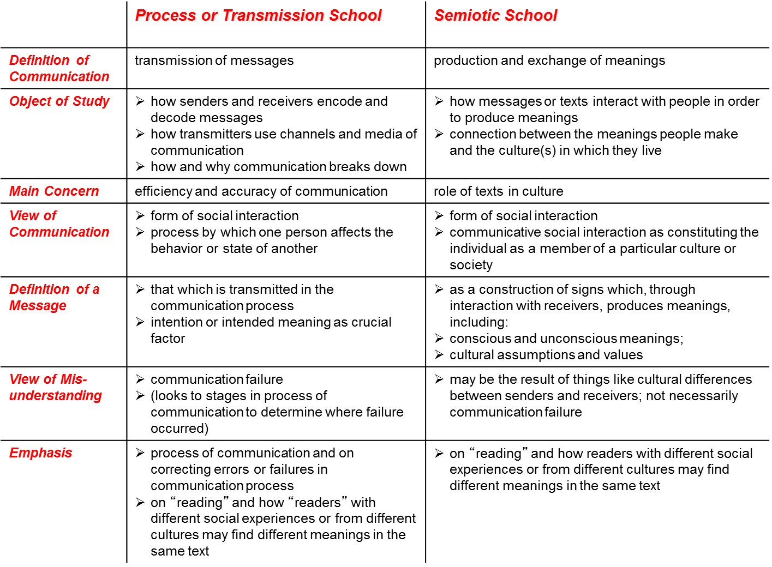

Shannon and Weaver Model
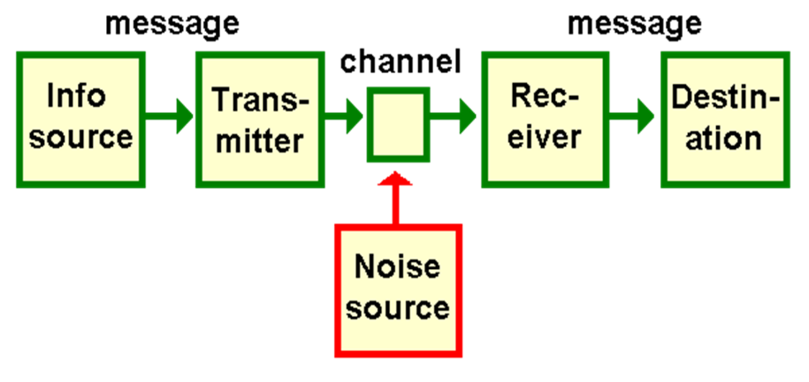
- 3 key problems:
- Technical problem
- How do we ensure the accuracy of a messages from Point A to Point B?
- Semantic problem
- How precisely is meaning conveyed?
- Effectiveness problem
- How do we ensure that the desired message has the desired behavioural effects?
- Noise sources:
- Semantic noise
- Ex. frosh week with sloppy speech from drinking
- Channel noise
- Ex. static
- Environmental noise
- Anything that impacts your ability to decode a message, ex. your roommate playing music while you’re trying to read a text
- Limitations:
- Doesn’t acknowledge the social context of the recipient
- Communication is more effective on a face-to-face basis than face-to-many basis
- Based on the idea of a sender-receiver model, sender is active and receiver is passively receiving the message passively the way it was meant to be perceived (which is not true)
- Accused of being an information focus model
Semiotic School
- How do audiences find and create meaning in light of cultural differences?
- We have to study:
- Signs
- Systems within the signs are organized in
- Cultures within the signs are organized in
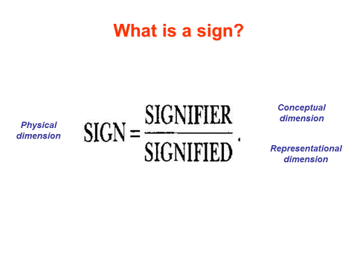
Barthes’ Two Orders of Signification
- Two levels of meaning:
- Denotation
- That which is inscribed, literally
- Everyday meaning of a sign
- Connotation
- Reading a sign in terms of cultural ideology
- Sign meets and interacts with ideas, values, beliefs and emotions of users
Models of Communication
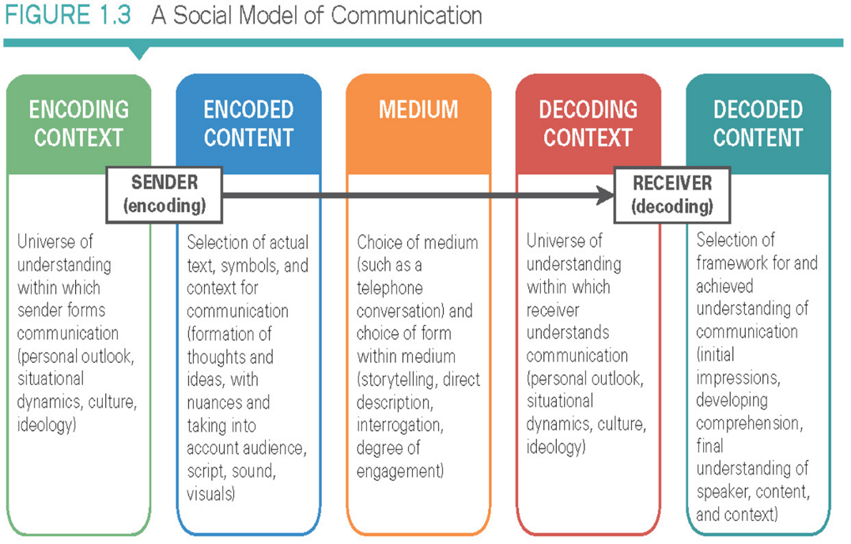

7 Media Literacy Concepts
- All media are constructions
- Questions to ask ourselves:
- Who created the message and why are they sending it?
- What techniques are being used to hold our attention?
- What lifestyle messages are being promoted?
- What’s omitted? What’s the message not telling us?
- How might different people interpret the same message?
- Audiences negotiate meaning in media
- Media have commercial implications
- Media contain ideological and value messages
- Media have social and political implications
- Form and content are closely related
- Each media has unique aesthetic form
4 Components of Mass Media
- Media messages – news items, novels, etc
- Mass media – stuff that ‘carries’ messages (i.e. infrastructure – from cables to books)
- Mass communication – process of how messages reach the audience on a large scale
- Production and dissemination of mass information and entertainment
- Decentralised production and wide accessibility
- Interactive exchange
- Mass audiences – diverse, unrelated in terms of nationality, gender, class, age, ‘tastes, etc
The Dimensions of Mass Media
- A distinct set of activities
- Involving particular technological configurations
- Associated with formally-constituted institutions and organizations
- Acting within certain laws, rules, and understandings
- Carried out by persons occupying certain roles: organizational dimensions of the media
- Conveying information, entertainment, images, and words
- To or among members of society: the mass audience?

