Year 1
Group 1
DESIREE LEWIS
MIKE KOSZIWKA
SOPHIA YUAN
KANWAL VERMA
ANDRES CISNEROS
IRFAN KHIMJI
GARY CAMACHO
THOMAS KIM
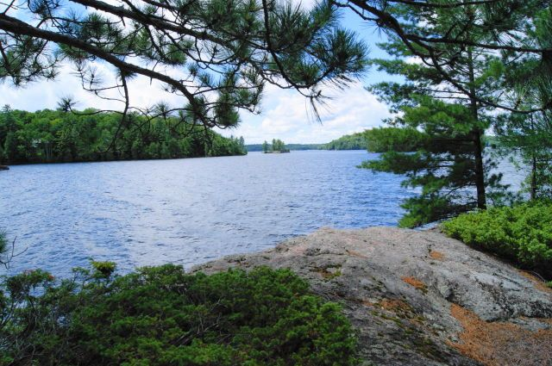
Whitemoose Resort Strategic Plan
Table of Contents

A. Determinants of Strategy 3
A.1 Environmental Assessment 3
A.1.1 Economic Forces 3
A.1.2 Competitive forces 4
A.1.3 Technological Force 6
A.2 Resource Assessment 6
A.2.1 Human Resources 6
A.2.2 Financial Resources 10
A.2.3 Facility Resources 11
A.2.4 Technology Resources 11
A.2.5 Synergies 11
A.3 Statement of Management Values 13
A.3.1 Normative Values 13
A.3.2 Economic Values 13
B. The Long Range Plan 14
B.1 Mission and Rationale 14
B.2 Long Range Goals and Rationale 14
B.3 Overall Policies and Rationale 16
C. The Year’s Strategy 19
C.1 Goals and Rationale 19
C.2 Major Policies and Rationale 20
C.4 Appendices to this Year’s Plan 23
C.4.1 Selected Economic Scenarios 23
C.4.2 Market Survey 64
D. Implementation 68
D.1 Strategic Decision Sheet and Rationale 68
E. Meeting Minutes 72

WHITEMOOSE RESORT

Whitemoose Resort is a two star economy hotel situated in the heart of northern Ontario. It provides guest quality experience at an affordable price and superior comfort in its 55 rooms. Amenities include restaurant, bar and meeting room. Your northern experience comes with summer fun like hiking, canoeing, fishing and hunting, along with winter classics like skiing and snowmobiling coupled with a breathtaking views natural landscapes.
Although we offer superior accommodations to the economy market we stride to gain a portion of the luxury market by offering higher quality services at our restaurant and bar as well as the option to host corporate functions in our meeting rooms. The nearby golf course makes our location more attractive to high end guests while the provincial park may hinder the amount of economy guest as it offers camp grounds.
Overall we are confident in our advertising and marketing strategy to draw our expected capacity daily while ensuring our facilities and staff are well maintained and available to guests.

Determinants of Strategy

A.1 Environmental Assessment

The external environment produces several opportunities and constraints in the resort simulation that can be explained with the use of three key forces, economic, competitive and technology. The information below exists outside our resort and is a combination of things that can help or hinder our internal efforts.

A.1.1 Economic Forces

We have two market segments that demand will be drawn from, economy and luxury market. This will include persons of all age groups, mixed marital statuses, various occupations, all income levels and varying interests. The market can also be either normal meaning that the expected amount of people are attracted to the area or alternate which increases demand substantially as above average customers will come to the resorts. We also have a few market constraints for each segment. The luxury market customers will always go to a luxury resort first if there is one available, but they will go to an economy resort if there isn’t a luxury resort options. On the other hand the economy customers will never go to a luxury hotel because they are cost conscious, so if there is no economy resort option this portion of the market will be lost. Our primary challenge will be determining the best strategy to deal with every possible outcome of the market we attract as this will directly influence the bargaining power of consumers.
Our location is a newly opened tourist area where we have the opportunity to be one of the first to provide accommodations. The potential for growth in this area is exponential as the provincial government is also promoting the area. The nearby provincial park offers outdoor activities as well as a quite, relaxing atmosphere for those looking to get away from the city. The government also recently open a golf course to attract more people to the area which can boost the attractiveness of the area for high end clientele.
The interest rate is relatively low on borrowing at a rate of 4.3% which will make it easier to start our business as well as expand it in the future. One thing we must be wary of is the initial cost of our hotel as there is an inflation rate of approximately 50% depending on which facilities we upgrade or downgrade. Our investment opportunities also have low rates of return at 2% and 5% which makes it difficult to raise funds from interest or would require long-term commitment that we may not be able to do as liquidity will be an issue if the business does poorly in the first few years. We also have to pay close attention to the base tax rate of 25% on business income between $100,001 to 500,000 as excess net income will propel us into higher taxation brackets hindering our overall profitability.
Our available labour market requires salaries between $20-40,000 per year, with average salaries at $27-29,000 depending on our choice of economy or luxury class hotel. Although we have an abundance of workers the quality of the services they provide will correlate to their salaries so we have to keep these numbers in mind when determining how many staff members we require as well as the optimal salary to offer.
The bargaining power of suppliers is limited as the provincial government has created multiple supply chains to ensure the prosperity of this area.

A.1.2 Competitive forces

Our market consist of two competitors however we are all start-up businesses with the same amount of initial capital and access to the same resources. This makes it difficult to gage who will have competitive advantage as there is no benchmark. With no barriers to entry, no established competitors, and no existing market, we have to consider all the possibilities.
Our competitor can be direct, that is operating in the same market segment (economy or luxury) or they can be indirect, operating in a different market segment. Since we have two competitors it is also possible to have both a direct and indirect competitor that is one that operates in our market and the other operating in a different market.
The provincial park’s campgrounds could be another competitor but on a very small level as we are focused on tourist, whom rarely travel prepared to camp. This attraction could hinder our sales especially in the economy market as camping is usually cheaper than staying at a resort. On the other hand this attraction could work in our favour by bringing previous campers to the resort the following year as camping is sometimes strenuous and some of the campers may only be camping because there was no resort option before this year in the area. Overall the provincial park maybe a competitor but it’s primarily an ally as its advertising budget will help draw more people to the area possibly creating higher demand, but definitely creating awareness of our resort.
Pricing our rooms is based on what number of stars we decide to have. Each star rating has a price cap with 1-star able to charge a maximum of $110, 2-star having a maximum of $150, 3-star with $230 and 4-star being capped at $300. As there is no pre-determined benchmark each resort is free to choose the price they feel will be both competitive in attracting customers as well as feasible to their bottom line profit requirements.
Number of rooms offered by the resorts in total will play a vital role as scarcity will occur if we set this too low and oversupply will damage our profitability. As previously mentioned luxury customers will go to an economy resort but economy customers will not go to a luxury resort. Where room supply is concerned this means that if the luxury hotels have excess demand it can be transferred to the economy resorts that have excess supply, however economy hotels with excess demand can only transfer this demand to other economy resorts otherwise the sales are lost. If sales are lost it could hinder future demand or the resorts may have to take action to upgrade facilities to accommodate higher capacity.

A.1.3 Technological Force

As a newly opened area the development of mature technology such as water supply, electricity, street lights, roads, etc. have already been established.
The resorts will be built using the best in machinery and skilled contractors to deliver a sound structure and speedy renovation. The facilities for each hotel will have the same physical attributes however use of variable costing will determine the level of quality.
Innovative decisions support systems as well as functional information systems are available to all resorts. The ability to effectively integrate these systems into your strategy will determine market penetration net income and ultimately market capitalization
Communications technologies are available to all resorts like mobile devices, internet, social networks, etc. Effectively use of these tools can ensure management is working together and attempt to provide better customer service.

A.2 Resource Assessment

A.2.1 Human Resources

Our management teams consist of a president, personnel manager, facilities manager, maintenance manager, marketing manager, and three analysts. Together we form over twenty-five years of knowledge and experienced making us capable of executing the resort simulation with ease as long as we collaborate together efficiently. Details of our human capital are outline below.

Desiree Lewis, President
Desiree Lewis has ten years of experience in business management. With a solid background in accounting, finance and marketing she is able to foresee various strategies and implement dynamic changes to ensure continued profitability within the organization. Although her professional experience in largely focused in the area of financial services, Desiree strides to gain maximum exposure to all industries to ensure superior understanding of competitive business structures. As a fourth year student at York University she has a firm understanding of accounting which will aid her in managing our debt accumulation, budget allocation, and investment strategy while her business savvy and competitive drive will be an asset for dealing with potential mergers and acquisitions. Desiree’s strong focus on team work and sense of community motivates her to achieve our corporate goals.

Kanwal Verma, Facilities Manager
Kanwal Verma has working knowledge in the property management industry and can readily apply her skills to the management of our facilities. Her expertise will ensure adequate hotel star rating as well as marketable hotel size at a competitive price. Kanwal’s education background in accounting will aid her in distributing her allotted budgetary funds among the facilities offered at our resort while monitoring the department’s financial position. Her variable costing strategy will be a profitable addition to our team’s objective of achieving maximum market penetration. Economics is not her forte so dealing with the demand of customers and ensuring supply will require aid happily rendered by our analyst team.

Irfan Khimji, Maintenance Manager
Irfan Khimji’s background in administrative studies allows him to disseminate task effectively in his role as maintenance manager. He has excellent interpersonal skills and is highly motivated to offer the best service to our customers. Clean rooms and adequate staff to guest ratios are just a few of the many contributions Irfan brings to the table. His past experience in the hotel industry will prove an asset as he knows the inner workings of this industry and can rapidly apply these skills to new development in our own hotel. Although he lacks skills in the areas of accounting and finance, his ability to quickly learn new task and develop new skills is a testimony to his commitment to our team.

Andres Cisneros, Marketing Manager
Andres Cisneros is a fourth year student in the BAS program at York majoring in Marketing. He has also attained valuable experience as a market researcher for a leading organic cosmetic company, where he learned the skills necessary to assess market demand and size in a rapidly growing industry. Past courses in his specialization like marketing research, marketing for competitive advantage, and marketing strategy will help him determine our target market, advertising strategy, and sales forecast. His role as marketing manager includes a detailed analysis of the purchase of a market survey however as statistical analysis is not his strong point he will be assisted by our analyst in this endeavour.

Gary Camacho, Personnel Manager
Gary Camacho is currently working towards his certification in Human Resources management. As the youngest member of our management team Gary’s lack of experience is overcome by his tenacity and genuine care for employees, making him a great fit for our personnel manager. His specialized skills in recruitment enables him to align compensation packages with budgetary limitations to achieve optimal competitive advantage in our work force. It is important that our employees see Gary as someone they can talk to about personal issues that may affect their working abilities so he extends an open door policy to all new recruits.
Sophia Yuan, Financial Analyst
Sophia Yuan hails from the accounting and transportation industries with higher education in administrative studies. As a third year student at York University, her major attributes are financial and budget control as well as software analysis. As one of our financial analyst she is tasked with the responsibility of working on data management, budget flows, and variance analysis. The use of decision support software will allow her to formulate “what if” scenarios to find an optimal use for our organizational resources. Based on her experience she can also aid various departments with budget management and resource allocation.

Mike Kosziwka, Financial Analyst
Mike Kosiwka has been business oriented all his life and is appropriately experienced in start up ventures. He believe that he can bring good leadership and best practice skills to our organization by helping with team structure, resource synergy, task delegation, team motivation and operation tactics in a competitive environment. His past experiences are a mix of successful and failed business ventures which provides us valuable “what if" scenarios that will allow us to avoid mistakes and make sound decisions. Mike’s educational background in finance allows him to have financial planning and report writing skills as well as experience in dealing with dividend and share issuance policy that will be relevant to his role as financial analyst. His advanced computer skills and understanding of business psychology allows him to understand the importance of thinking like our customers and competitors to optimize business decisions. Mike plans on using the above mentioned skills and traits to maximize my group’s learning experience in this project and to propel our resort to the top and earn those extra marks.

Thomas Kim, Environmental Analyst
Thomas Kim’s major in management science gives him the flexibility to apply both economic trends and statistical analysis to his role as environmental analyst. With a background in the financial institutions, Thomas brings valuable managerial skills and a broad understanding of business theories and strategies. His superior knowledge of external forces enables him to provide detailed assessment of our competitors and resources. Although he lacks organizational skills, Thomas makes up with his market and environmental analysis capabilities.

A.2.2 Financial Resources

We have $4.6 million of start-up capital gained through the issuance of 1 million common shares. Due to this influx of cash we are restricted by our shareholder’s agreement from issuing additional share until our third year of operations. During of our third year we can issue up to 150,000 shares per year however we are limited to a maximum of 1.4 million common shares over our lifetime.
Aside from investment capital we have excellent credit at the bank and have been given a line of credit with an interest rate of 4.3% per annum. Although we do not have a maximum of the amount of money we can use from the line of credit we must maintain a debt to equity ratio of 40% or less to continue operations. If this ratio increases beyond the 40% requirement in any given year it is mandatory that we repay the loan to bring the ratio with the 40% cap.

In addition to the above financing structure there are two investment opportunities that can be added to our wealth management strategy. Investment A is conservative in nature with an expected rate of return of 2% give or take a 0.75 percentage point stranded deviation. Our second option, Investment B, is a bit more risky yielding a 5% expected rate of return with a 5 percentage point stranded deviation.

A.2.3 Facility Resources

Whitemoose resort is a two star economy resort offering fifty-five rooms, bar, restaurant and meeting room each with an array of services. We provide equipment for seasonal attractions like hiking, canoeing, fishing, hunting, skiing and snowmobiling.

A.2.4 Technology Resources

We have the latest computer hardware and software to conduct budget analysis and financial reporting. We have been given a superior Decisions Support System (DSS) to assist in the performance of “What if” scenarios analysis to find the optimal strategy to penetrate the market. Our DDS software is also intergraded with our financial reporting system to ensure timely and accurate financial statements as well as cash flow projections. The management team has access to state of the art communication technology like smart phones, social networks, text and email to ensure the flow of vital strategy information across the board.

A.2.5 Synergies

Synergy is achieved when all resources are pooled together in the most effective, functional manor. We believe that working together as a team has greater potential for better result than our individual capabilities. The structure of our resort starts with the president with the highest level of authority, however our organization is organic so the analysts, facilities, maintenances, marketing and personnel manager all come after the president. This structure will promote fluid communication between the managers and the president. We choose this type of structure to ensure that we work together by removing the barriers found in hierarchical structures.
Our management team is a combination of third and fourth year students with the exception of one second year student. We all have a unique range of skills and expertise with backgrounds in accounting, finance, marketing, administrative studies, management and human resources. We outlined each other strengths and weaknesses to optimize synergy. For example our president, Desiree, is the most experienced of all our members in both work and education and has an array of skills in three of the six areas above, however she is meticulous and tends to over think various scenarios. To aid her in minimize the weakness we have three analysis to provide simulations and environment assessments so that her decisions are not made alone but as part of the team. Our financial analyst, Mike, is excellent with numbers and analysis, but not very keen in the area of marketing. For this we have Andres, who can help Mike decipher the how to meet our market demand and optimize supply in the simulation. Gary is the HR candidate and we wanted to put the skills he has learned to the test by making him the HR manager. We know that he has the least experience but we all want to ensure this is a learning experience for him and help him in any way we can. Irfan’s strength is in management as he can delegate and has great interpersonal skills. This is why he was chosen as the maintenance manager. He’s not very good with numbers. Kanwal and Sophia are both administrative studies majors and have a good grasp on accounting and business policy. Both can aid Irfan with the numbers as well as him implement new goals and policies for the group. Finally our environment analyst, Thomas is all about numbers. He shows great command in solving complex formula and statistics is his expertise as a management science major. This major weakness is organization, but our president has that well under control with due dates and check-ups to ensure everyone is on track. Overall our group synergy is right where is should be as we are all still learning about each other, but as we progress it should increase substantially.

A.3 Statement of Management Values

A.3.1 Normative Values

Customer service is our number one priority at Whitemoose resort as we need repeat business to stay in the industry. We want our customers to feel at home and relaxed at our resort by providing quality service.
Employee Retention in at the heart of our structure as we believe when you join our organization you become part of our family. We want to ensure that all team members feel a part of the northern experience as much as our guest by providing competitive wages, adequate training and job security.
Social Responsibility plays a vital part in our organizations as our natural surrounding is where we achieve our bottom line. We want to stride to preserve the environment we inhabit as much as possible to ensure our continued success but more importantly our wild life for future generations.

A.3.2 Economic Values

As a start up business we don’t have a lot of resources at our disposal and want to be successful while maintaining perpetual growth. For this we have adapted a moderate risk tolerance where we want to spend a little bit more than required if it gives our customers better quality, while being conservative in investment spending and debt accumulation.
Our primary focus will be in the economic market segment as we believe luxury does not have to come at a high cost. We want to offer our clientele affordability so that low and middle income families can take time to enjoy nature

The Long Range Plan

B.1 Mission and Rationale

Whitemoose Resort strides to bring affordability and comfort to the economy hotel industry while focusing on quality customer service and employee retention to achieve profitability and perpetual growth for our stakeholders.
Rationale:
We want to instil a strong corporate culture in our employees that our customers come first while at the same time showing we share their value and embrace their personal experiences into our organization. Our mission is intended to send a positive message to both our shareholders and the community that we inhabit that we care about them and want to exhibit positive changes to ensure economic growth. As a start-up company it is imperative that our shareholders see us at profitable within the first few years to ensure future investment, while our community needs to see us as a positive influence.

B.2 Long Range Goals and Rationale

Goal 1 – Become the market leader by achieving 51% market capitalization by year 5.
Rationale:
This goal directly correlated to our final mark in this class as the winner of the simulation is based on highest market capitalization and will gain a bonus of 4% added to their mark. By having 51% of the market, we will be attracting a large number of customers and in turn large net income. We hope to achieve this goal by effectively using our resources as well as a combined advertising, marketing and dividend issuance strategy.
Goal 2 – Gain total resource effective greater than of 10 points by year 5
Rationale:
Synergy is a measure of our resource effectiveness (TRE) which in turn shows how well we are able to plan for various simulation outcomes. There are 4 sections in which we are given a synergy rating and a rating of 1 in each sections shows that we have achieved equilibrium with our actual market. We want to achieve at minimum 2.5 points in each category by the end of our 5th year of operations to ensure that we are not only meeting the market requirements but also exceeding expectations. We hope to use this factor to attract new investment and repeat customers, overall improving our net profitability.

Goal 4 – Increase sales by at least 30% by year 5
Rationale:
As a start-up venture we have to achieve sustainable profitability in order to keep existing investors as well as to attack new investment to our business. We set our target as an increase to the percentage of sales so that we can show continuous growth and hopefully increase in net income, not loss yearly. This correlates to our mission for profitability as well as growth for our shareholders.

Goal 5 – Maintain average hotel capacity of 75% yearly
Rationale:
Capacity is based on demand as well as supply. If the market demand is high we will all have adequate capacity however we want to maintain a 75% capacity regardless of the demand. To do this we will implement strategic marketing and adverting plans as well as continuously improve our service excellence to attract clientele from both the economy and hopefully luxury market.

Goal 6 – Improve customer service by 5% yearly
Rationale:
As outline in our values and mission customer service is of high importance. Although we cannot directly measure this goal we can implement strategies that infer this goal is being met. For example improvements in the number of customers being services, total resource effectiveness, market penetration are all good indicators that we are achieving good customer relations.

B.3 Overall Policies and Rationale

Policy 1 – Achieve group participation of at least 85% attendance at all scheduled meetings.
Rationale:
By motivating group members to attend meeting and rewarding creativity we can improve our overall synergy by ensure we are all on the face page. Group participation is especially important because of the extensive knowledge and work required to complete the simulation. We want our group to feel that they are part of something that will enable them to achieve higher learning. While to appreciate that all our lives are busy we also want to instil as sense of priority for this assignment among other tasks. We offer our members to opportunity to participate through various means of communications like social networking on Facebook, instant messaging with text and BBM as well as email.

Policy 2 – Build profitable facilities
Rationale:
We have to opportunity to enter a new market and want to offer the best that is available to us while ensuring longevity in our business. This requires facilities that not only meet the demand of our customers but also provide with net income over the lifetime of our business. Our internal strategy should be able to produce the optimal scenarios where of business can grow exponentially and offer adequate facilities to our clients.

Policy 3 – Increase variable cost for both the bar & restaurant by 5-10% yearly
Rationale:
Variable cost improves the quality of service provided by our restaurant and bar facilities. Having an overall policies to continuously work on improving this ratio is necessary to fulfil our commitment to superior customer service but more importantly this improved the profitability of our bar and restaurant tying into our goals as well.

Policy 4 – Increase advertising and marketing expenditures by 5% yearly
Rationale:
Advertising and marketing directly affect the amount of people drawn to both the area and our hotel. Without continued improvements to this strategy our resort will suffer from either a lack of interest or lack of demand in the area. It is essential to our resort survival to ensure these two expenditures are competitive with our rivals.

Policy 5 – Minimize loss from investment
Rationale:
When we invest the idea is to earn interest that is higher that the taxes we will incur on this income. A minimize loss policy is an automatic characteristic of investment strategy. We have added it to our overall policies to ensure that any investment venture we decide to enter into is reviewed on a continuous basis to ensure we do not lose money in the long run.
Policy 6 – Minimize debt accumulation
Rationale:
As a moderately conservative organization we want to ensure our debt is minimize over the years as we want to maintain adequate levels of liquidity. The idea behind this policy is that if we have to ensure debt it should be to attain a specific goal and a repayment plan should be established before the debt is incurred. Our simulation also has a requirement is maintain a debt/equity ratio of 40% or less so this policy also reinforces this rule.

The Year’s Strategy

C.1 Goals and Rationale

Goal 1 – Achieve 33% market penetration in our first year of operation
Rationale:
This goal is meant to start us off in the right direction for achieving our long term goal of gaining 51% of the market. By starting with a minimum of one third the market we ensure that we have an equal share while not falling behind the other members. This will give us the opportunity to achieve our overall goal and win the simulation.

Goal 2 – Total resource effectiveness (TRE) greater than 6 points yearly
Rationale:
Total Resource Effectiveness is an important measure our ability to allocated our budget effectively and achieve overall synergy. By creating a goal to achieve a minimum of 6 points we want to have at least 1.5 points in each of the four categories. In additions this correlates with our goal to achieve at least 10 points by year 5 of our operations while also achieving our mission to improve quality.

Goal 4 – Gain net income in year 1 of $100,000 minimum
Rationale:
In order to achieve profitability we must gain net income in our first year. The $100,000 minimum is to ensure that we can begin repayment of any loans incurred during our first year in year 2. This goal will also aid in setting a benchmark for the achievement of our long term goal to increase income by 30% by year 5.
Goal 5 – Achieve hotel capacity of 85% in year 1
Rationale:
Our facilities are new and we want to ensure maximum exposure in our first year. To achieve this, a minimum of 85% capacity has been set. This will tell us if our marketing and advertising strategy is working and where we may want to implement change in coming years. It also allows us to implement our long-term goal of maintaining an average of 75% capacity by year 5.

C.2 Major Policies and Rationale

Policy 1 – Develop tools to improve group communication
Rationale:
Keeping our group connected is essential to our overall success and this begins with communication. Developing the right set of communications techniques to improve coherency and understanding of all members will allow us to function more efficiently as a team and complete this assignment with expected results.

Policy 2 – Build resort with three facilities
Rationale:
As part of our initial investment in our resort we have to decide what facilities will be more suitable to our budget. The number of rooms and star rating play a pinnacle role in this decision, but we are also given the option to have up to five additional facilities. Setting a requirement to build a minimum of three of the five will keep us competitive with our rivals while not using our entire budget on hotel capital investment. This policy could also implement our long term policy to build profitable facilities by first building the ones that seem most likely to generate profit, like the restaurant and bar.

Policy 3 – Adhere to budget for each department
Rationale:
The budget is set by the president who is aware of all things going on at the resort. It is important that at the beginning of any venture that the budget remains intact as not adhering to it could spell disaster for the overall project. This why we feel it is necessary to make adhering to the budget a policy. Team members need to understand that there allowance is based on strategic calculations. The budget is not rigid as it does give each department a substantial allowance but at the same time capping there spending.

Policy 4 – Hire appropriate number of staff to successfully operate all hotel facilities
Rationale:
Based on our expected occupancy levels there is a nominal about of staff that we need to have to meet market demand. It is essential that we hire the right amount of people so that we can both meet demand and not exceed it too much. This policy ensures that the formula for nominal staff is used and that the minimum is hired.

Policy 5 - Repay 10% of debt accumulation each year of with net income
Rationale:
As a moderately conservative organization it is part of our values to maintain low debt. We want to instill debt repayment from the start of all debt to make certain we do not exceed our debt/equity ratio cap. Setting a policy to repay 10% of debt each year seems reasonable when we have net income to use. This policy will also increase forward planning when any debt is being considered as a strategy will also have to be formulated to repay it at the same time.

Policy 6 – Implement a conservative investing strategy
Rationale:
When we have funds left over for investment we want to secure our investments. While we like the idea of making interest income we do not want to incur loss from investment in any way. Therefore we want to invest in the more conservative investments but are open to slightly riskier ones so long as our initial investment is not lost.

C.4 Appendices to this Year’s Plan

C.4.1 Selected Economic Scenarios

C.4.1.1 Market Scenarios

There are many possible combinations of scenarios for the two markets; however, they are generally consisted with the basic four forms, such are EEE, EEL, ELL, and LLL. For each of these forms we will give three representative scenarios based on the most possible to-be-existed combination to get a comprehensive understanding of the markets. For the general learning process of this assignment we are not assuming any resort to be ours, instead we will analyze the scenarios and use the changes in outcome to influence our decision as to what our implementation will be like.
We are now firstly going to try the EEE combination with the three representative scenarios as 112, 122, and 222. Each scenario will be followed up with main points that we gathered from doing the analysis. Ultimately these learning points will help us in our optimization to come up with the best strategy for our predicted market.

MARKET 1, SCENARIO 1 – ECONOMY 1-STAR, ECONOMY 1-STAR, ECONOMY 2-STAR
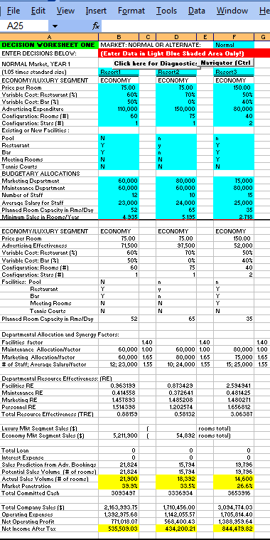
Main Points of Learning

Economy customers still want the best bang for their buck. In the scenario above, charging double the price of the 1-star, the two stars makes considerably higher net income. This shows us that customers want facility options, nicer rooms and in the economy case, will spend up to the upper limit of their budget to enjoy their vacation.
Another point of interest in this scenario is that the entire luxury market is being drawn to the 2 star resort. This shows us that in a scenario that hosts three economy resorts we want to be at least a 2-star offering the most facilities to attract the luxury market over the other economy hotels. This ensures that we are maximizing market share.
In comparing the two 1-star resorts we place them at the exact same level except that resort 1 was given a bar. This difference accounts for approximately 100,000 in net income, 20% of potential earnings. Showing that having a bar and a restaurant is very important as they can be very profitable.
Total Resource Effectiveness (TRE) in this scenario is low for all three resorts. This shows that Resorts 1 and 2 are actually below the market norm. Resort 3 is still low by our standards (we have a goal of hitting at least 6 TRE each year) but it gives us insight as to how we must allocate spending to raise TRE. Here it shows that the more money you spend on certain aspects the higher your TRE will be based on stars and number of rooms. In our case the equations from the simulation text allow us to see that by spending close to the minimum allotment on maintenance we receive a very low RE score. We will look into the effects of rising this value later.

MARKET 1, SCENARIO 2 – ECONOMY 1-STAR, ECONOMY 2-STAR, ECONOMY 2-STAR
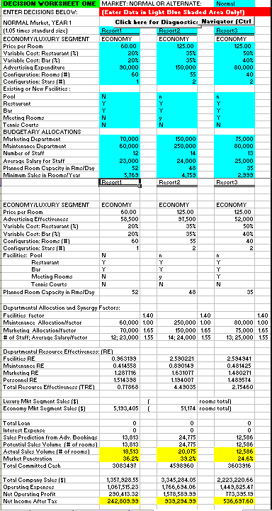
Main Points of Learning

In this scenario we attempted to raise TRE of each resort. In comparing resort 2 and 3, we kept everything very similar but significantly increase marketing and maintenance allocations. Surprisingly this did not result in a large jump in TRE in comparison to the previous scenario. However it did result in a large increase in Net Income, suggesting either that TRE is not significant to Net Income as it pertains to this simulation.
Again we noticed that the luxury market flocked to resort 2, which we believe is the result of marketing and maintenance spending. It is clear that raising these numbers results in increases in demand for your resort and specifically almost 25% more market share over another resort with every other aspect the same.
This analysis shows that there still is a demand for the lower level resorts in an economy market. Resort 1 was still able to capture 36% market share, which hints that the luxury customers went to, and filled the rooms in resort 2 and spilt over into resort 3. Economy patrons went first to resort 1 and spilled into resort 3. The main point of learning from this scenario is that you don’t want to be the middle resort, the one that gets spill from the top and the bottom. We understand that attractiveness and awareness of your hotel may be the single most important part of the simulation to get people to come to your resort.

MARKET 1, SCENARIO 3 – ECONOMY 2-STAR, ECONOMY 2-STAR, ECONOMY 2-STAR
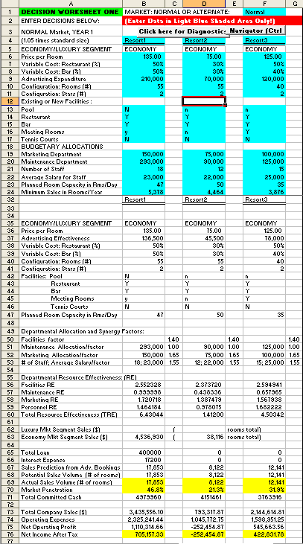
Main Points of Learning

This case was what we had determined to be our worst case scenario for a market of all economy resort with the same star rating. So we tried to make it so it was possible for two hotels to survive. We did this by using what we learned from the previous two scenarios to maximize the attractiveness of our resort.
We have determined that our capital resources are not enough to establish our resort at $4.6million. We will have to borrow funds in order to allow for large expenditures in marketing, maintenance and advertising as large budgets brought Resort 1 market share of 46.8% and $700,000 of Net Income. This shows that if a scenario was to happen where three hotels of the same star level existed, you want to be the resort with the highest maintenance, marketing and advertising expense.
In this scenario we also see a correlation between TRE and Net Income (NI). The lowest NI had the lowest TRE, where as the other two resorts have similar differences in TRE and NI. We found that when large allocations of resources were placed in maintenance our TRE went up the most. We also found that marketing and advertising must have similar budget allocations, which makes sense as there is no point in spending money on marketing with no advertising budget, you’ll just end up with a bunch of relevant, but useless information.
This analysis gave us a strong understanding of how to be defensive in the first year. By maximizing the attractiveness of our resort we can ensure survival through even the worst case scenarios and thrive in the best case scenarios while dealing out significant damage to our competitors.

Next we will look at the EEL combination with the three representative scenarios as 113, 123, and 223; we have elected not to do a scenario with a 4 star resort as our formulas have shown that there is not enough funds to start a resort with 4 stars and it is very unlikely that a group will try. Each scenario will be followed up with main points that we gathered from doing the analysis. Again, these learning points will help us in our optimization to come up with the best strategy for our predicted market.

MARKET 2, SCENARIO 1 – ECONOMY 1-STAR, ECONOMY 1-STAR, LUXURY 3-STAR
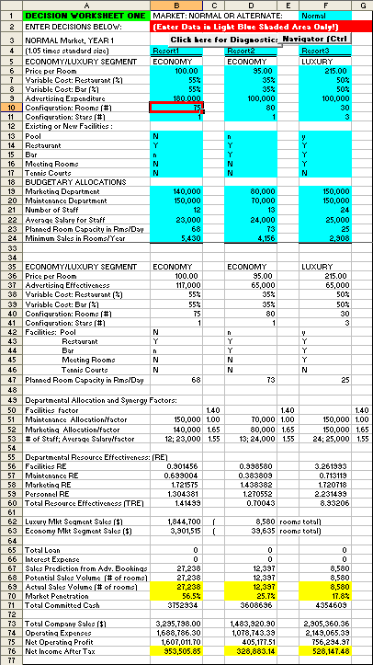
Main Points of Leaning

As we took our first attempt at our second economy we made sure to keep in mind our learning from the previous market. We made sure that one resort had higher maintenance, advertising and marketing than its direct competitor. And again it showed us that it can make an extremely significant difference, in the form of an additional 25% of the market share and over $600,000 in net income!
This analysis shows that it is very possible for a 1 star resort to make more money than a lone 3 star. The major significance in this scenario is the market share numbers. With the 3 star only receiving 18% of the market we directed our focus to why that is. We know that all luxury customers went to the 3 star and that no economy customers will go up to the 3 star resort. So this would suggest that we need to bring more luxury customers to the market to raise the number of rooms sold. This can be done, we assume, by increasing marketing and advertising and will be attempted in the next scenario.
The other main point from this scenario is the amount of TRE that the luxury resort achieved. This is the first time we have seen a TRE of above our target of 6. The main difference when looking back on previous results is the Personnel RE. By having a large number of employees that are being paid a larger amount of money it increases PRE significantly, and important factor to consider when we attempt to maximize our TRE.

MARKET 2, SCENARIO 2 – ECONOMY 1-STAR, ECONOMY 2-STAR, LUXURY 3-STAR
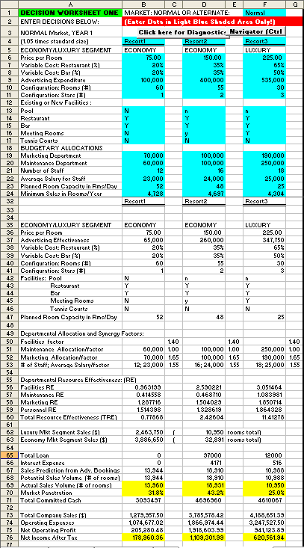
Main Points of Learning

This was our first scenario where we were able to have a resort obtain a net income of over a million dollars. We spent more time on this scenario and learned that there is a maximum number of customers that can be attracted to the market.
The million came from a large market share of a large market. We found that advertising expenitures from each resort seem to go into a pool that increases the amount of rooms sold but does not direct those rooms to any one hotel; that stat is influenced by TRE and marketing and maintenance budgets. This means that it doesn’t matter who has the highest advertising expenditure as much as it matter who has the more attractive hotel. What we do not want to happen is to spend a large amount of money on advertising and neglect marketing and maintenance which would result in losing customers we paid to attract to our competitors.
This scenario also shows that resort two attracted the spill over from the full luxury resort, this allows us to charge top dollar for the two star hotels and it will still attract all the luxury patrons and a fair amount of economy patrons.

MARKET 2, SCENARIO 3 – ECONOMY 2-STAR, ECONOMY 2-STAR, LUXURY 3-STAR
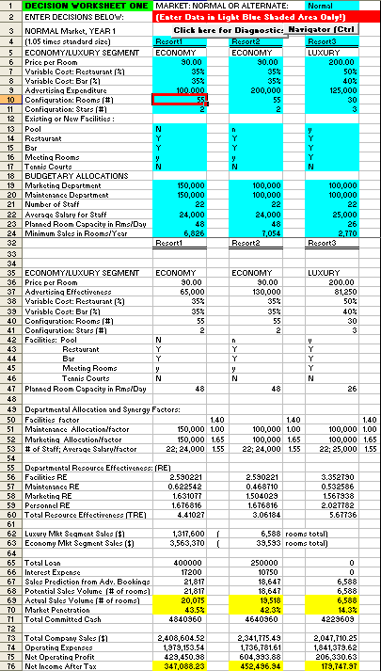

Main Points of Learning

This scenario was somewhat confusing as it seemed to contradict the previous scenario and learn from it. Here in one of our worst case scenarios we have a representation of what seemed apparent in the previous scenario. We made resort 2’s advertising larger than resort 1, but made resort 1’s marketing and maintenance budget higher than resort 2’s by the same total value as the difference in advertising expenses. This yielded a troubling result. Resort 2 ended up with the higher Net Income after we predicted the opposite. As a check we completely reversed the scenario and found that resort 2 still had a higher NI. This shows us that there is a random factor that is at work within the simulation that makes it impossible to figure it out completely. This is probably the most important piece of learning material found in this analysis as it is true that no market scenario can be predicted, and even if number can be accurately predicted there is no way to predict what your customers are going to do. From this we have adopted the idea to perform a defensive strategy this year, a maxi min, in an attempt to maximize our chances of not being withdrawn from the simulation.

MARKET 3, SCENARIO 1 – ECONOMY 1-STAR, LUXURY 3-STAR, LUXURY 4-STAR
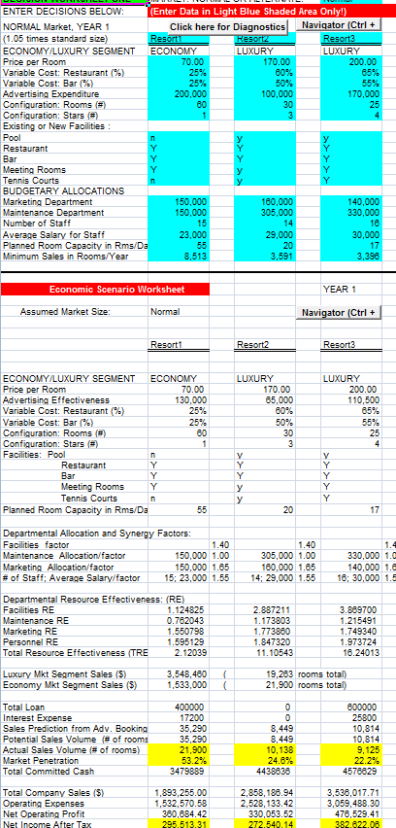
Main Points of Learning

Even against two much higher quality properties it is still clear that a 1 star hotel can out perform the luxury properties. By ensuring there is enough rooms to meet demand a 1 star hotel can be quite successful.
However, TRE is very low, which is starting to show that higher star properties have an advantage where TRE is concerned. In order to be above 6 we feel that a 2 star resort is necessary.

MARKET 3, SCENARIO 2 – ECONOMY 2-STAR, LUXURY 3-STAR, LUXURY 3-STAR
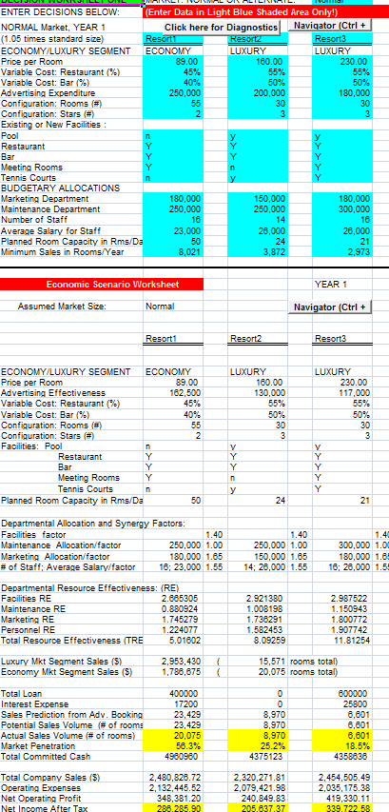
Main Points of Learning

Scenario 2 simulates one economy and two luxury resorts. Due to the cost of building a 2 star resort vs. a 3 star, the 2 star should have more rooms to handle demand.
Resort 1 has the highest market penetration, although do not have enough facilities available, and do not have to spend too much on variable costs of restaurant and bars and still attract over 50% of the market.
The main thing to learn from this analysis is that customers in the luxury market can be influenced by higher advertising expenditures and go to a resort that has fewer facilities for a lower price. However, with the difference in price and offering of facilities, it is apparent that in a luxury case, it is more important to offer more facilities to increase net income.
The TRE of the 2 star resort falls under our goal of 6. We think this is because of maintenance and personal, as maintenance is operating at below market standards. Investing more money in our maintenance department may help to increase this.

MARKET 3, SCENARIO 3 – ECONOMY 2-STAR, LUXURY 3-STAR, LUXURY 4-STAR
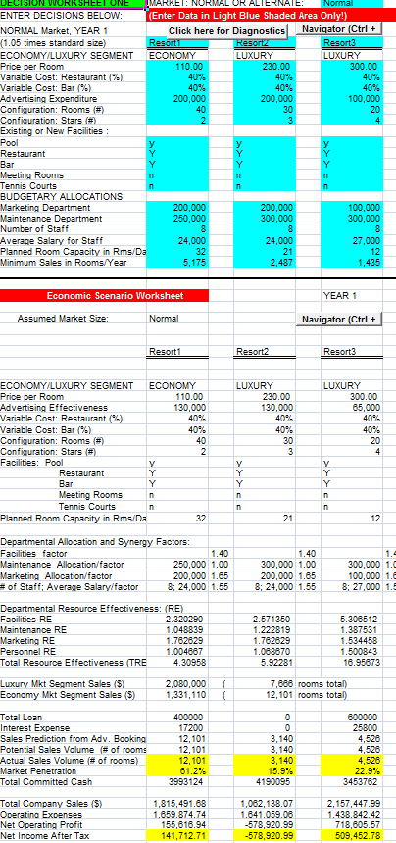
Main Points of Leaning

In this scenario we could see a comparison between different star hotels with the same facilities available, customers gravitate to the resort with the best price. The market penetration of the 2 star resort is over the 60% of the market, showing us again that room number is very important.
While resort 3 earns the highest net income, this seems to be because they have the highest sales and lowest operating expenses. This shows that sales can be earned by offering the same facilities as your competitors but spend less on things like advertising.

MARKET 4, SCENARIO 1 – LUXURY 3-STAR, LUXURY 3-STAR, LUXURY 4-STAR
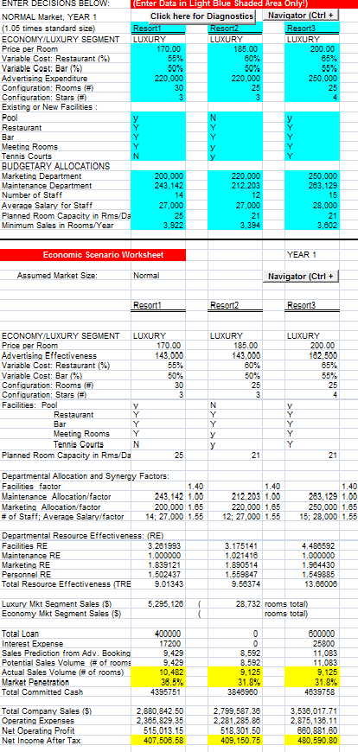
Main Points of Learning

In this scenario we can see customers tend to spend more money to enjoy their vacations and enjoy more facilities.
The TRE of these 3 resorts are high, well over our goal of 6, showing a link between more stars and higher TRE once again.
The difference in rooms sold is no related to net income. In this simulation it is clear that managing operating expenses is just as important as selling rooms. Also, pricing policies are important to ensure your making the most profit off your rooms. Selling 10 rooms at 10 dollars profit per room is clearly not as good as selling 4 rooms at 40 dollars profit per room.

MARKET 4, SCENARIO 2 – LUXURY 4-STAR, LUXURY 3-STAR, LUXURY 3-STAR
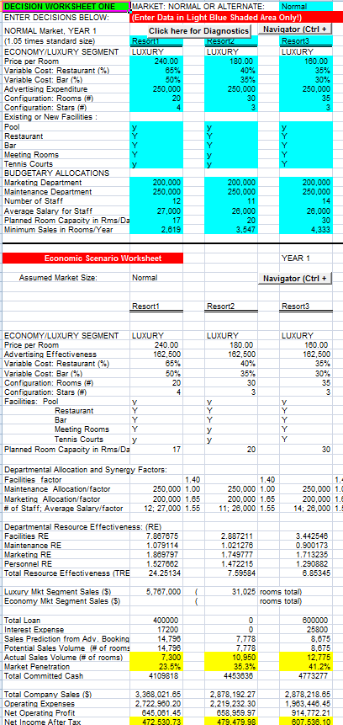
Main Points of Learning

Here we can see that using the same Advertising Expense and Marketing and Maintenances department, the Lowest price do attract customers.
Although Resort 1 provides the better restaurant and bars services, it does not seem to customers from the 3 stars hotels. Resort 2 and 3 provide the same level facilities and again it shows that lowest price wins the customers. Therefore, the facilities are an important topic in strategy as they affect customers’ choices influenced heavily by price.
Moreover, highest room price and highest hotel stars definitely increase the TRE, which is 4 times more of our goals, but has the lowest market penetration.

MARKET 4, SCENARIO 3 – LUXURY 3-STAR, LUXURY 3-STAR, LUXURY 3-STAR
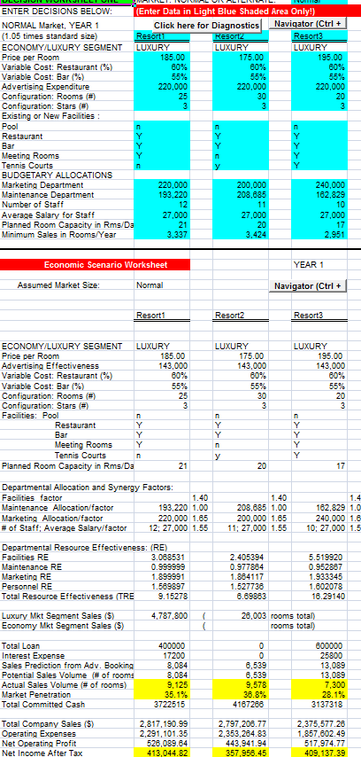
Main Points of Learning
This simulation showed that tennis courts don’t seem to affect demand significantly. The difference in price vs having tennis courts is clearly too high at only 10 dollars.
The marketing and maintenance department are different amounts, however it does not seem affect TRE by that much. On the other hand, by adding a facility, TRE is affected considerably.
Price vs Facilities is astronomically important when dealing with resorts all falling in the same star rating.

C.4.1.2 Optimization Strategy

For this section we have decided to select the market that we feel is most likely to occur, a EEL with two, 2-star resorts and one 3-star resort. We then performed six separate scenarios that revolved directly around the market survey. This gave us a broad view of what can potentially happen when our main competitor (the other 2-star resort) does or does not buy a market survey in combination with us purchasing one and not purchasing one. First we will show our base case, compared to the alternate market where we have it optimized assuming we bought a survey and our competitors did not. Then we will expand with different scenarios, each scenario will include the normal market case and the alternate case, optimized by those who purchased the survey. Each scenario will follow with main point of learning from each simulation.

SCENARIO 1 – NORMAL AND ALTERNATE MARKET RESORT 1 BUYS SURVEY, RESORT 2 NO SURVEY

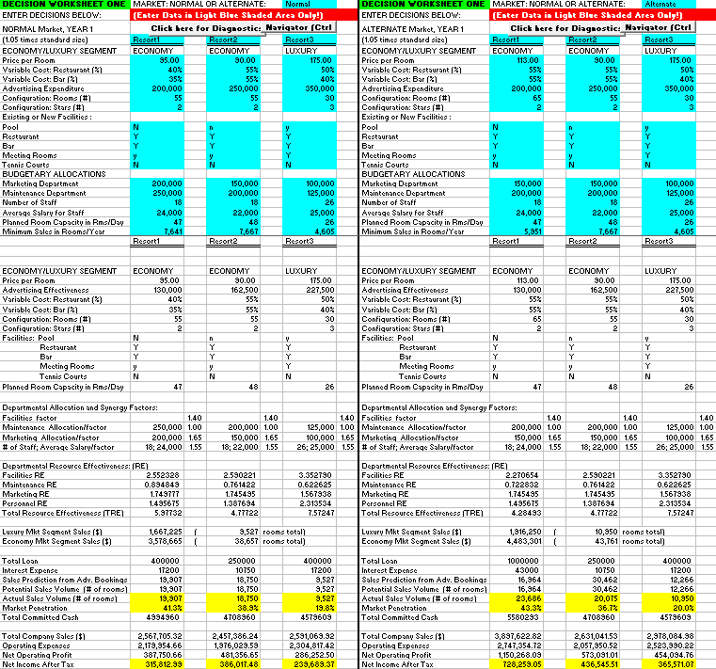

Main Points of Learning
This simulation shows clearly the advantage that exists when an alternate market occurs and you bought a survey and your competitor does not. The difference of over $400,000 in Net Income is double to cost of the survey which gives a 100% return on the investment.
There is only a 4% market share swing with the alternate occurring, however the big difference is the amount we are able to charge for our rooms, which directly results in an increase in Net Income
We also played with borrowing more money and increasing our amount of rooms, this also directly resulted in an increase in Net Income.

SCENARIO 2 – NORMAL AND ALTERNATE MARKET RESORT 1 BUYS SURVEY, RESORT 2 BUYS SURVEY

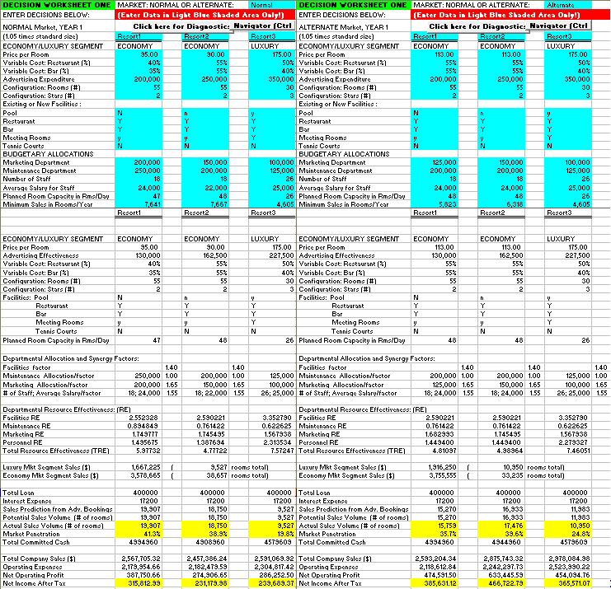

Main Points of Learning

This simulation shows the effect of each resort having a market survey. And this simulation shows that by keeping the same numbers that were optimized in the previous case, each competitor can still profit.
So our main benefit from doing this analysis is that we want to be the company that spends more on advertising to capture the market assuming both companies purchase a survey. However, in both cases the amount of Net Income earned in addition with the optimized numbers is not greater than the price of the survey. And the risk of your opponent having a survey over you still seemed to increase Net Income of the resort that didn’t purchase the survey as well. This is important to know because it shows that only if your opponent has not purchased a survey will purchasing a survey be worth it.

SCENARIO 3 – NORMAL AND ALTERNATE MARKET RESORT 1 NO SURVEY, RESORT 2 NO SURVEY

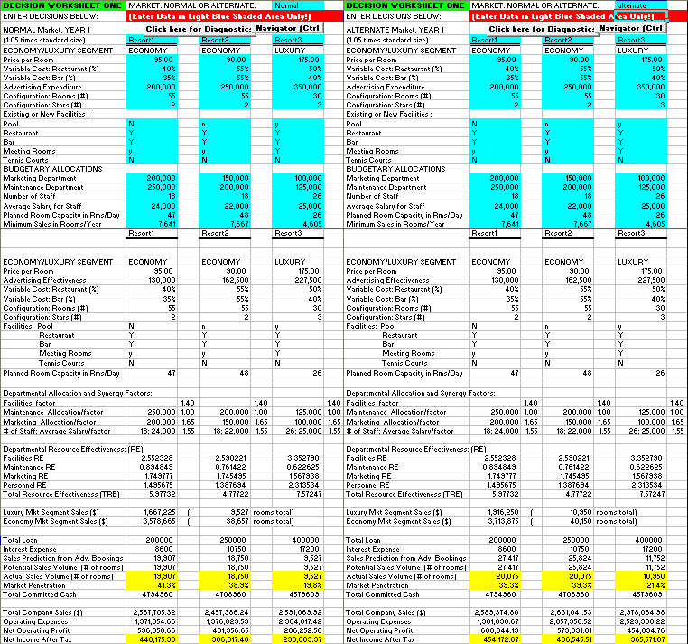

Main Points of Learning
This scenario simply shows that if no one purchases a survey everyone can still be profitable, and it allows us to borrow 200k less funds, which saves on interest expense and helps our balance sheet.

Conclusion
In conclusion to this analysis, it seems apparent without doing any calculations that if you do not buy a market survey it it still survivable should an alternate market occur. However the main issue is that if your competitor buys one and you don’t you let your opponent get ahead of you by a net of $100,000 plus the differences in the balance sheet. So this leads us to believe that buying a market survey is the most competitive result.

C.4.1.3 Sensitivity Analysis

For our groups sensitivity analysis we decided to test the sensitivity of Advertising Expenditure, Marketing Expense, and Maintenance Expense as it relates to both Net Income in our simulations and Total Resource Effectiveness. We will begin by showing a screenshot of our simulation at what we believe to be optimized levels as per our previous analysis. We then will tweak these three values to check and see which affects our two targets the most and the least to further help us optimize our situation.

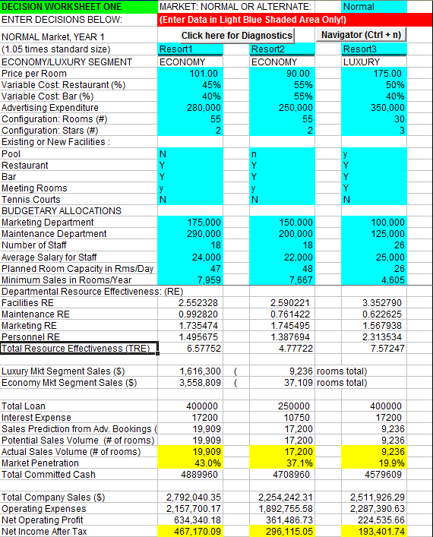

Sensitivity Analysis
Advertising Expense | Net Income | TRE
250000 | 461614.77 | 6.57752
260000 | 463634.61 | 6.57752
270000 | 465499.31 | 6.57752
280000 | 467170.09 | 6.57752
290000 | 468608.17 | 6.57752
300000 | 463608.17 | 6.57752
Range | 6993.4 | 0.00000
Marketing Expense
145000 | 469529.72 | 6.33473
155000 | 469571.59 | 6.41979
165000 | 469264.41 | 6.50057
175000 | 468608.17 | 6.57752
185000 | 463608.17 | 6.65103
195000 | 458608.17 | 6.72143
Range | 10963.42 | 0.38670
Maintenance Expense
260000 | 456618.14 | 5.94735
270000 | 461353.87 | 6.10656
280000 | 465631.56 | 6.26402
290000 | 469571.59 | 6.41979
300000 | 473009.48 | 6.57396
310000 | 467822.69 | 6.7266
Range | 16391.34 | 0.77925

Main Points of Learning

The clearest piece of information we can get is that advertising has no effect on TRE, which makes sense as the calculations in the resort manual do not have advertising expenditure in them
The next is that within our ranges it is evident that TRE continues to climb the more you allocate funds to that budget. So, in that sense we know that in order to have TRE over 6, we must spend a large amount on Maintenance, Marketing, and the other fields that affect TRE.
Maintenance expense was our most sensitive value both in Net Income and TRE. This shows us that Maintenance has a peak amount that should be spent on it, and you must sacrifice a strong amount of Net Income for high TRE
Marketing had a relatively low impact on TRE, and a moderate effect on Net Income, this analysis showed that Marketing has a wide range of optimal scenarios, and at some levels provides a large TRE boost for a small loss to Net Income
Advertising Expense had the lowest sensitivity in our analysis. However, it is apparent that when room price stays the same at a near optimal level, advertising expense would have a negligible effect. We tested it outside the confines of this document after the fact and we saw that advertising brings more customers to the market, and if room price and advertising are raised in tandem, then there is a significant sensitivity in Net Income. We also found that there is an upper limit on how many customers can come to the market, so there is a point where advertising becomes ineffective and drops the Net Income by the additional advertising expense.

C.4.1.4 Worst Case Scenarios
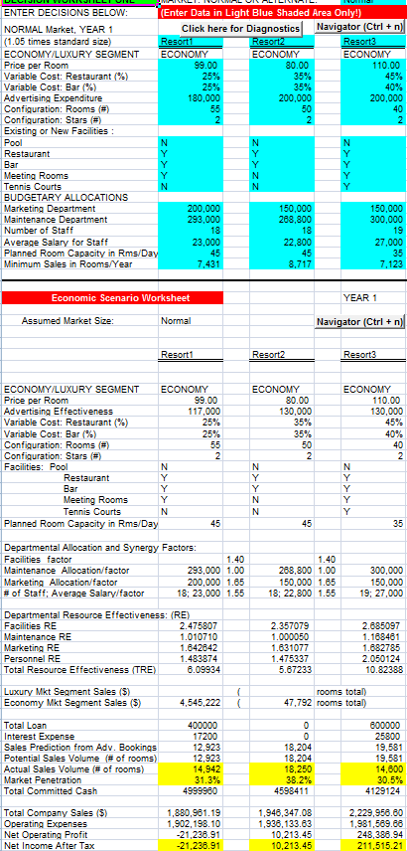
The worst case scenario: Assumed: In normal market

Analysis:
The worst scenario will be competitors in the same market segment, all being two star hotels.
- Resort 1 has the lowest net income compare with competitors.
- Resort 2 has lowest price get the highest market penetration also by high % of variable cost with resort 2.
- Resort 3 has highest TRE and highest net income, because they offer larger variable costs at the restaurant and bar, as well they offer more facilities
- Resort 2 and 3 spent more on advertising than resort 1.
- Resort 2 and 3 has higher room capacities than resort 1 because of high advertising expenditure.
The way to fix the problem:
- Increasing the Advertising expense from $180,000 to $ 220,000 try to maximize advertising effectiveness
- Increasing the Variable Costs to at least have the same vc% with the resort 2
- Increasing the room capacity % try to attribute to 90% of maximize room capacity
Results:
Resort 1 earns the highest Net Income of $344177.54 and the highest market penetration of 35.7%, in order to obtain our goal of market penetration of 36%, we had to increase advertising. We could decrease our spending on our marketing department to $150,000, and use loans to increase the advertising to $220,000 which will maximize the attractiveness of the market. However, without changing the room price, we increase our variable cost of restaurant and bars to at least same with one of our competitors which has the lowest room price and higher variable cost than us in order to earn customers. Moreover, we need to increase our room capacities by increasing the advertising and variable cost. Therefore, we could win the market by maximising market penetration to achieve highest Net income while controlling costs. Also, we could reach our goals by 36% market shares, TRE close to 6, and Net income close to $350,000 in our first year.
After fixed planned for normal market: 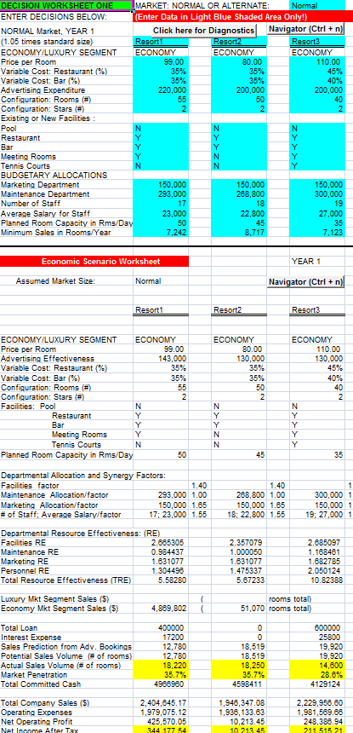
The worst case scenario: Assumed: In alternative market 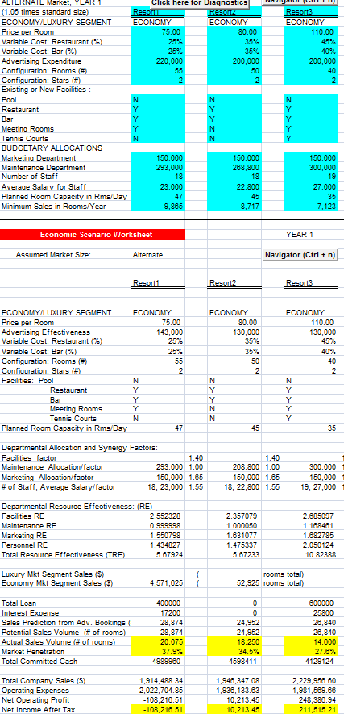
Analysis:
The worst scenario will be competitors are in the same market segment, all being two star hotels.
- Resort 1 is using low pricing to attract customers, also with the largest budget on advertising to promote the hotel, it boasts high operating expenses.
- Resort 2 has low facilities available compared with the other competitors and middle choice of restaurant and bar services.
- Resort 3 has the highest price compare with competitors, more facilities, and more variable cost on restaurant and bar, has spend same amount advertising with resort 2 which lower than the resort 1.
- The way fix problem by:
- Decreasing the advertising expenditure to same amount with our competitors $200,000, save $20,000.
- Decreasing the maintenance department budget to $270,000 which saves $20,000 as well
- Increasing the room price to the planed amount of $99, because the low price does lead the market penetration, but costs money.
- increase the variable cost budget by saving from advertising, maintenance department budget, and increased the room price.
Results:
Resort 1 will get the highest Net Income of $425243 and the highest market penetration of 38% which is over our planned market shares, the main reason to success in this market is to allocate more funds to our attractiveness through variable costs and personal, maintenance, and marketing. The lowest room price is not the only way to attract customers, middle price with the best service qualities will capture more market share.
After fixed planned alternate market: 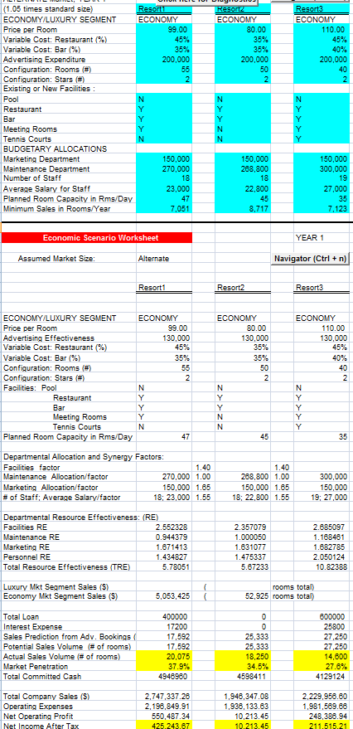

C.4.2 Market Survey

This analysis provides details on how the decisions of whether the market survey beneficial to purchase was calculated.

Given :
Market Survey Cost $200,000
Market Survey Accuracy 93%
Probability of a Normal Market Occurrence 62%
Probability of an Alternate Market Occurrence 38%

Let :
N Normal Market
A Alternate Market
S_{N} Survey perdition Normal Market
S_{A} Survey perdition Alternate Market

Probabilities for a Normal Market Prediction (S_{N})
State of nature | Prior Probability | Conditional Probability | Joint Probability | Posterior Probability
N | 62% | 93% | 0.62 x 0.93 = 57.66% | 0.5766 / 0.6032 = 95.59%
A | 38% | 7% | 0.38 x 0.07 = 2.66% | 0.0266 / 0.6032 = 4.41%
Total | 100% | 100% | P(S_{N}) = 60.32% | 100.00%

The posterior probability shows that if the survey predicts a normal market, there is a 95.59% probability that it will occur and a 4.41% probability that the alternate market will occur.

Probabilities for an Alternate Market Prediction (S_{A})
State of nature | Prior Probability | Conditional Probability | Joint Probability | Posterior Probability
N | 62% | 7% | 0.62 x 0.07 = 4.34% | 0.0434 / 0.3968 = 10.94%
A | 38% | 93% | 0.38 x 0.93 = 35.34% | 0.3534 / 0.3986 = 89.06%
Total | 100% | 100% | P(S_{A}) = 39.68% | 100.00%

The posterior probability shows that if the survey predicts an alternate market, there is a 89.06% probability that it will occur and a 10.94% probability that the normal market will occur.

Decision Tree

Analysis

Expected profit without purchasing the Market Survey:
EVP1 = 448,175 x 0.6200 = 277,869
EVP2 = 454,172 x 0.3800 = 172,585
EMV (w/o survey) = EVP1 + EVP2 = 450,454

Expected profit when Market Survey is purchased and predicts a Normal Market:
EVP3 = 315,813 x 0.9559 = 301,886
EVP4 = 454,172 x 0.0441 = 20,028
EVS_{N} = 0.6032 x (301,886 + 20,028) = 194,179

Expected profit when Market Survey is purchased and predicts a Alternate Market:
EVP5 = 448,175 x 0.1094 = 49,019
EVP6 = 728,259 x 0.8906 = 648,606
EVS_{A} = 0.3968 x (49,019 + 648,606) = 276,818

Expected profit when Market Survey is purchased:
EMV (w/ survey) = 194,179 + 276,818 = 470,996

Total profit gain/loss from purchase of market survey:
EVSI = EMV (w survey) - EMV (w/o survey) - $200,000
= 470,996 - 450,454 – 200,000
= - 179,458

Conclusion
Using the Posterior probabilities calculated we were able to work backwards with the Net Income values produced by our simulation to determine whether the market survey should be purchased. Although the purchase of the market survey would be extremely helpful if an alternative market occurs, yielding profits of $728k the expected values analysis led to the conclusion that the market survey should not be purchased. The final expected profit calculations gave us a profit of $450k without the purchase and $470k with the purchase. The $20k variance does not justify the expenditure of $200k for the survey as can be seen in the negative outcome of EVSI at a loss of $179,458.

Implementation

D.1 Strategic Decision Sheet and Rationale

Implement this Decision Sheet for (check one): We are not purchasing a market survey.
Financial Decisions:
New Share Issue in shares (not available before year 3) | 0
Dividend to be paid as a percentage of current year net income | 0%
Amount to be Borrowed | $280,000
Amount to be Repaid | $0
Investment Amount in lower risk investment (A) | $0
Investment Amount in higher risk investment (B) | $0
Configuration Decisions
Increase rooms by (rooms) | 55
Change stars by (# or –#) | 2
Add New Pool | No or No Change
Add New Restaurant | Yes
Add New Bar | Yes
Add New Meeting Rooms | Yes
Add New Tennis Courts | No or No Change
Yearly Decisions:
Price Per Room (averaged over the year) | $101.00
Variable Cost of Restaurant Consumables (enter 0 if no restaurant) | 45%
Variable Cost of Bar Consumables (enter 0 if no bar) | 40%
Advertising Allocation | $270,000
Marketing Overhead Allocation | $175,000
Maintenance Allocation | $290,000
Staff Allocation | 18
Average Salary for Staff | $24,000
Planned Room Capacity | 47
Minimum Yearly Sales | 7,877

Rationale:

Marketing and Advertising Allocation
We allocated $175,000 to the Marketing department and $270,000 to the advertising budget because these two areas affect our ability to generate profits directly. Our learning curve from various “what if” simulations showed that advertising increased the amount of customers drawn to the area, while marketing influence the portion of this market that we were able to capture. Although we do not know for certain what any of our competitors’ strategies are we took into consideration the minimum amounts to be allocated according to the simulation and optimized this value to reach our current levels. We felt that our budget would be a good test of the elasticity of demand during the first year without wasting any resources as market penetration is the primary goal of the simulation and this can only be accomplished by advertising to establish the Whitemoose Resort brand.

Maintenance Department Allocation
The Maintenance department handles the quality of service with provide at our resort. The nominal maintain expense was calculated to be $293,000 however we felt $290,000 was an adequate amount taking into consideration that the nominal expenditure is dependent on demand. We hope that by investing $290,000 into maintenance we will ensure quality service to our customers that is equivalent or above the 2-star level when the actual results are completed.

Facilities Department Allocation
The facilities department was given up to 75% of our working capital to ensure we erect the best hotel within that budget. Our initial decision to have a 2-star hotel was a combination of group normative values to be moderately conservative as well as the result of various simulation trials. Taking into consideration that the economy market will not go to a luxury resort, but the luxury market will go to an economy resort finalized this decision. On the off chance that both our competitors have the same thought process we added additional funds to marketing and advertising as well as increased variable cost to ensure we survive the worst case scenario. Our final capital cost for the facilities was $3,572,654 which included the building of a 55-room resort, as well as bar, restaurant and meeting room.

Personnel Department Allocation
The personnel department was the most difficult to gage as we had to plan for the number of staff on duty to meet market demand as well as their starting salaries. One of our values lies with the employees as we feel employee retention is vital to our success, however we also had to take into consideration the fact that we are a start-up business can cannot give employees all the trimmings. The nominal amount of staff our expected capacity yield was 18 (14 for the hotel, 3 for the restaurant and 1 for the bar). Given our hotel rating of 2-star the average salary is $27,000, but we decided to lower our initial salaries to $24,000 so that we left room from growth over the years. The difference of $3,000 per staff member allowed us to employ the 18 staff members required, and our total effectiveness did not suffer too much of a decrease as both are part of the calculation.
Investment and Debt Allocation
The issuance of shares did not produce enough income to satisfy our group goals. As a moderately conservative organization we felt it would be better for our bottom line to borrow only what was required to ensure our success. With this in mind our president determined that $280,000 was the minimum loan we should take from our line of credit. The two investment options did not have enough expected return for us to justify borrowing funds for investment. Investment A was too conservative with returns of 2%, as our borrowing rate is 4.3% and Investment B has the possibility of earning us 5% however we determined that the borrowing rate combined with the tax consequences made this option not feasible. We will keep both these options in mind when our business is producing income that can be allocated without the expense of borrowing.

Meeting Minutes

DATE : | Wed. Jan 25, 2012
Members Attendance :(Checkmark ONLY members present)
 | DESIREE LEWIS |  | KANWAL VERMA
 | MIKE KOSZIWKA |  | ANDRES CISNEROS
 | SOPHIA YUAN |  | IRFAN KHIMJI
 | THOMAS KIM |  | GARY CAMACHO
 | HUSSEIN BAHGAT
Topics :
Team members background and how they can aid the simulation
Simulation strategy, division of roles
Organizational Goals, what we want to accomplish
Decisions:
Decided who best fits each role and defined the tasks to be preformed
Assigned each member a task of writing our mission statement and values
Assigned each member a task of coming up with long term and short term goals / policies
Assigned members to try the simulation and come up with profitable scenarios

DATE : | Wed. Feb 1, 2012
Members Attendance :(Checkmark ONLY members present)
 | DESIREE LEWIS |  | KANWAL VERMA
 | MIKE KOSZIWKA |  | ANDRES CISNEROS
 | SOPHIA YUAN |  | IRFAN KHIMJI
 | THOMAS KIM |  | GARY CAMACHO
 | HUSSEIN BAHGAT
Topics :
Mission statements and values (assigned in previous meeting)
Management policies and goals (assigned in previous meeting)
Simulation and profitable scenarios (assigned in previous meeting)
Outlines Report parts and assigned members various task
Decisions:
Resort Structure – 2 star, 55 rooms, $99/room, Facilities (bar, restaurant, meeting room)
Due Thurs Feb 2 – Final budget outline
Due Fri Feb 3 – Each member personal outline for Personnel department
Due Sun Feb 5 – Each member analysis of their assignment parts

