PO101 QUIZ 2

Constitution: They provide body of rules and principles according to which a state is governed
Rule of Law: It is the primary intent of the constitution (democratic requirements)
Foundations for Power:
- Executive (law implementers)
Horizontal power relations
- Judiciary (Law adjudicators)
- Legislative (law-maker)
Levels of Government: Vertical power of relations
- Unitary system: central government has power over regional government e.g Britain and France
- Federal system: central and regional governments each have power, cannot overrule each other both are equal e.g Canada, Mexico
Written Constitution: America, Mexico
Unwritten Constitution: Britain
Both: Canada
Unwritten Constitution:
- Parliament
- Court Judgement
Conventions: Customs and traditions developed over time that guide the government and is essential, not outlined in any documents. (cannot be enforced by the courts)
Relations between State and Citizen:
- British Tradition: Parliament to safeguard rights of citizens, not courts
- American Tradition: set out rights in Bill of rights, enforced in courts

Parliamentary System: (Fusion of power)
- Canadian System: power is concentrated to a few decision makers with majority government
US Political System: (Separation of Powers)
- President: Has no budget, only can execute the legislation
- Legislative: House of representative and senate control the legislation and financing.
Free Votes: Leader tells party to vote according to values.
Centralization Spectrum:
- Most Centralized (Unitary) 1 Major Government
- Most Decentralized (Confederation) Regional power have more power than national government, Central government is weak
- Devolution: Central Government delegates powers, responsibility to regional government’s, can take them back

U.S Federation has become more centralized
- Constitutional amendments (bill of rights) Limited state Rights
- Court interpretations favoured central government (Residual Clause had limited effect)
- US presidents pushed central government powers to limits
- Domestic and international crises enhanced central government powers (ww2)
Election: A form of choosing political representatives
Elections are Critical:
- Popular sovereignty (Citizens must be able to “throw them out) direct citizen to representative link.
- Fair Political Competition (it is the key to the most minimal version of democracy)
- Achieving political Equality (Citizens should have equal rights to participation)
- Organizing Majority Rule (If each vote is to be counted equally, the decision of the majority must be accepted
Single-Member Plurality System
- One representative per geographic area (ridings, district) (direct representation-citizen)
Proportional Representation System
- Representation (# of seats) directly proportional to share of popular vote received (# of votes) If 30% of the electorate support a particular political party, then roughly 30% of seats will be won by that party.
- Mechanics: Party Lists, Single Transferable vote (STV)
German Hybrid Model:
- Mixed member proportional system
- 2 votes: Candidate, party lists
- Small parties must get 5% to get people in the house
Hippocratic Oath:
- The Oath Doctors take, relates to the Greek culture
Physician-Assisted Suicide: Involves a doctor knowingly and intentionally providing a person with the knowledge or means require to commit suicide, including counseling about lethal doses of drugs, prescribing such doses, or supplying of drugs. (Medical practitioner does not administer the lethal dosage)
Active Euthanasia: The physician administers the lethal dosage
Passive Euthanasia: When the patient is in extreme pain, doctors will take them off life support or relieve them from their pain.
Parliamentary Supremacy:
- The legislative branch has absolute sovereignty, is supreme over other branches of government (including executive and judiciary)

Political Parties:
- Groups of people with roughly similar values and political aims that aggregate diverse idea and interests (trying to appeal to the most groups)

Categorizing parties
Cadre vs. Mass Parties
- Differences have diminished over time, all are electoral-professional parties
- Tendency for both mass and cadre parties to become “catch-all parties”
Party Systems:
- Consist of the interactions of parties with each other and the overall political system
- Can Change over time e.g Canada (liberal dominated)
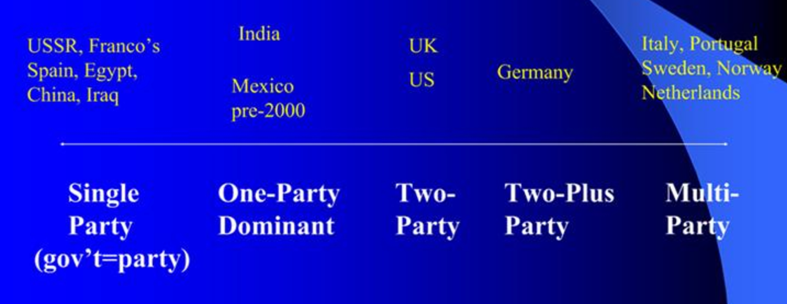

Iron Law of Oligarchy:
- All organizations eventually become dominated by small groups of leaders
Party goals
- Nominate a candidates and contests elections
- Seeks to gain power
What underlay Leave Vote: BREXIT
- Nationalism
- Concern about migration and immigration
- Fear of globalization
- Immigration and sovereignty
Post BREXIT:
- Soft BREXIT: giving priority to the single market including free movement of workers and plethora of EU obligation
- Hard BREXIT: taking back as much as possible from the EU



