BIOL*1090 - "Getting Good Grades" Answers
YOUR QUESTION:
How do I get good grades in the ‘Introductory Cell Biology’ portion of BIOL*1090?

MY ANSWER:
Along with the general PDF readings provided to you, it would be quite useful to be absolutely clear on the terms and concepts outlined below.
(NOTES - This is NOT everything; just some of the key things).
Relevant diagrams (drawing/labelling) that are used to describe the terms/concepts/processes should also be practiced.

Questions
- The cell theory main tenets.

- What is an electron microscope? How does it differ from a light microscope? What is the difference between a transmission electron microscope and a scanning electron microscope?

- What allows an organism to be classed into a prokaryote; a eukaryote; an animal; a plant? What are the major differences between prokaryotes and eukaryotes?

- What is an organelle?

- What are the basic properties of living cells?

- Dimensions: millimetre; micrometre; nanometre; the symbols used in each case and their interrelationship.

- The light spectrum. General wavelengths in nanometres.

- What is fluorescence? What are fluorescent proteins? How are fluorescent proteins used in modern biology? How might fluorescent proteins be used to study organelle dynamics? To understand protein activity?

- What is a lipid? How is a lipid bilayer fashioned? What is meant by amphipathic? What is meant by membrane fluidity? What are the major factors that affect membrane fluidity?

- What is an unsaturated lipid; a saturated lipid? What is meant by "liquid crystal"? What is the transition temperature of a membrane? What happens during the change from liquid crystal to crystalline gel state? Why is cholesterol a major player in membrane dynamics?

- What is the fluid mosaic model of the membrane? What are integral; peripheral; lipid-anchored proteins?

- Why are biological membranes asymmetrical?

- What are glycolipids; glycoproteins; glycosylation?

- What is a micelle; liposome?

- What does a dynamic biological membrane signify? What is lateral movement of a lipid? What is a flippase and how is it involved in membrane dynamics? What is signal transduction?

- What is the ‘lipid raft’ concept?

- How are substances moved across cell membranes? Facilitated diffusion vs simple diffusion? Gated channels? Mechano-gated channels? The glucose transporter (general mechanism); Facilitated diffusion? Active transport? General functions of biological membranes?

- The endosymbiont theory and its implications? Difference between endomembrane system and organelles of purported endosymbiont origins?

- What is cisternum/cisternae; lumen?

- How is the constitutive secretory pathway different from a regulated one?

- Exocytosis? Endocytosis? Donor compartment? Recipient compartment?

- What is meant by pulse-chase? What is the outcome of pulse-chase experiments?

- What is ultracentrifugation? Cell free system?

- Rough ER; Smooth ER and their functions? Perinuclear ER?

- Trace the path of a protein from the cytosol to the ER. What is meant by co-translational import? Post-translational import? How are the two processes different? How is the translational import of an integral membrane protein facilitated?

- What is a signal sequence? Signal sequence hypothesis? What is a translocon? Why are some proteins retained in the ER?

- What is the ERGIC? Golgi body? VTC? Cis-Golgi network versus trans-Golgi network?

- COPI; COPII; Clathrin-coated vesicles? N- and O-linked glycosylation? Dictyosome? Functions of Golgi bodies? Anterograde/retrograde transport; tethering/docking of a vessel; v-SNARES; t-SNARES

- Lysosomes; Vacuoles; Peroxisomes; Microbodies; PTS; Autophagosomes

- Plastids - features; protein targeting to a plastid

- Chloroplasts - thylakoids; grana; stroma; antenna system; reaction system; chlorophyll; STD; TDD; TIC; TOC

- Mitochondria - characteristic features; OMM; IMM; porins; cardiolipin; cristae; matrix; oxidative phosphorylation; electrochemical gradient; electron transport chain; TIM22; TIM23; TOM; cytochrome-c

- Apoptosis; blebbing; phagocytosis

- Nucleus - nucleolus; chromatin; nuclear envelope; nuclear lamina; Lamin-A; nuclear pore complex; Nuclear import model

- Cytoskeleton - structure, function of microtubules; microfilaments; intermediate filaments; dynamic instability; catastrophe, MTOC; MAPs; myosin; kinesin; dynein; G-actin; F-actin; ABPs

- ECM; cell wall; gap junctions; plasmodesmata; glycocalyx

Answers
- The three main tenants of cell theory are: cells are the structural units of life, all living organisms are composed of one or more cells, and cells can only arise from the division of a pre-existing cell.

- An electron microscope uses a beam of electrons to illuminate the specimen on the slide and a set of magnetic lenses to magnify it, while light microscopes only use light to illuminate specimens. Electron microscopes have higher resolution than light microscopes. Transmission Electron Microscopes (TEM) and Scanning Electron Microscopes (SEM) both use electron beams, but TEMs transmit the beam directly through the specimen (requiring a very thin specimen) while SEMs use the beam to scan over the surface of the specimen.
- Prokaryotes (literally "before nucleus") lack a nucleus and instead have a "nucleoid region" where their DNA is found, while eukaryotes ("true nucleus") have DNA which is compartmentalized within the nucleus. Prokaryotes also lack membrane-bound organelles and do not have the same level of structural complexity found in eukaryotic cells. Animal cells and plant cells can be differentiated based on structure: animals cells have lysosomes and centrosomes which plant cells lack, while plant cells have a large central vacuole, chloroplasts, and a cell wall.

- An organelle is a compartment defined by a membrane, which has a characteristic content (eg. native proteins) and a specific function.

- The basic properties of living cells are as follows: cells are organized and complex; cells are governed by a genetic program; cells can reproduce; cells use energy; cells carry out chemical reactions; cells carry out mechanical activities; cells respond to stimuli; cells self-regulate; cells evolve.

- Millimetre (mm): 1.0 mm =$1.0 ×{10}^{-3}$ m
Micrometre (μm): 1.0 μm = $1.0 ×{10}^{-6}$ m
Nanometre (nm): 1.0 nm = $1.0 ×{10}^{-9}$ m

- The visible light spectrum occurs in the 400nm-700nm region of the light spectrum. The approximate lengths of violet, blue, yellow, and red light are 400nm, 500nm, 600nm, and 700nm, respectively; the smaller the wavelength, the higher the energy (eg. red = low energy).

- Fluorescence is emission of light by a substance which has absorbed light or some other electromagnetic radiation; it is a form of luminescence. Fluorescent proteins are proteins that give off light/a faint glow; these have been isolated from various sources such as jellyfish and can be used to analyse protein synthesis/transport and other intercellular mechanisms (fluorescence microscopy).

- A lipid is a non-polar organic molecule with long chains of hydrocarbons attached to a "head" region (eg. glycerol; joined to three fatty acid "tails", it forms a triglyceride). A lipid bilayer is formed when phospholipids (a phosphate head group w/two fatty acid tails) congregate in water and naturally orient their hydrophilic heads to heir aqueous surroundings (either the extracellular space or cytosol), and their hydrophobic tails together in the middle. The term amphipathic refers to the dual nature of the phospholipid in that it has both hydrophilic (polar) regions and hydrophobic (non-polar) regions. Membrane fluidity (the rigidity/flexibility of the plasma membrane) is affected by two major factors: temperature and its lipid composition (eg. saturated v. unsaturated).

- Saturated lipids have no double bonds in their hydrocarbon chains, meaning they are straight and pack tightly; unsaturated lipids can have one or more double/triple bonds, making them kinky and unable to pack together. In general, a membrane high in saturated lipids will be a "crystalline gel" (less fluid), while a membrane high in unsaturated lipids will be a "liquid crystal" (more fluid). The transition temperature of a membrane is the temperature at which it makes the change from a crystalline gel state to a liquid crystal state, meaning the heat energy absorbed by the plasma membrane becomes kinetic energy, allowing movement/less packing of the membrane. Cholesterol is a type of lipid molecules that can change the state of the plasma membrane depending on its composition; cholesterol will make a highly-saturated lipid membrane more fluid, but will reduce fluidity in a highly-unsaturated lipid membrane.

- The fluid mosaic model of the cell membrane is a model which describes the state of the membrane (fluid, constantly moving) with respect to the many proteins, glycoproteins, and glycolipids found within it (mosaic, in reference to its many components or "pieces"). There are three categories of protein which can be found in/on the plasma membrane: integral proteins (proteins which penetrate the plasma membrane entirely, often in the form of channels), peripheral proteins (proteins attached to either the outer or inner plasma membrane), and lipid-anchored proteins (proteins attached to a lipid within the bilayer, only partially penetrating the membrane).

- Biological membranes are asymmetrical because each layer has a distinct lipid composition to allow for specific functions. For example, the outer leaflet of the plasma membrane contains many glycoproteins and glycolipids which are used to receive stimuli in the form of hormones and other compounds from the extracellular space and adjacent cells; the presence of such proteins and lipids on the inner leaflet would be illogical.

- Glycosylation is the process by which a sugar/carbohydrate is bonded or added to a compound. The most evident glycosylated compounds within the cell are glycoproteins (proteins bonded to a carbohydrate) and glycolipids (lipids bonded to a carbohydrate).

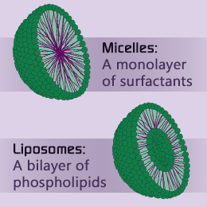
- A micelle is an aggregate formed by phospholipids in solution that is "solid", ie. it consists of a single layer of phospholipids with their polar heads facing outward and their non-polar tails facing inward. A liposome is a "bubble" formed by phospholipids, ie. a double layer of phospholipids that contain a region in their center (liposomes can be used to deliver drug/medicinal treatments for this reason).

- A dynamic biological membrane signifies that proteins and lipids can move about the membrane freely, and accumulate/travel to where they are needed depending on the situation. The lateral movement of a lipid is its movement horizontally (eg. moving past its neighbours on the same side of the bilayer, keeping its tails in the non-polar space). A flippase is an enzyme that facilitates movement from one leaflet to the other (eg. outer to inner); it is required because it is extremely difficult for the polar head region of a phospholipid to pass through the non-polar region created by the tails of all of the other phospholipids in the layer. Signal transduction is the overall process in which information carried by extracellular messenger molecules is translated into changes that occur inside a cell (eg. protein detects change outside of cell, passes on "information" by triggering reaction within inner membrane protein, which creates another reaction that continues throughout cell).

- The lipid raft concept is the idea that certain lipids in the plasma membrane can congregate and function as a "raft" that floats along the surface of the membrane and carries select types of proteins. This idea of the raft acting as a "functional compartment" is controversial.
- Substances are moved across cell membranes in four different ways: simple diffusion, diffusion through a channel, facilitated diffusion, and active transport. Simple diffusion involves the passing of small, non-charged molecules (eg. H₂O) across a membrane, while diffusion through a channel allows small charged ions to cross the cell membrane through a protein channel. Three channels exist: voltage-gated (respond to electrochemical change), ligand-gated (respond to binding of a specific compound), and mechano-gated (respond to physical change, eg. cell stretch).
Facilitated diffusion allows compounds to move via a change in conformation of the protein channel; for example, glucose would bind to the inside of such a facilitative transporter, and its presence would result in the channel changing shape to allow the glucose through. Active transport is the only method of diffusion that works AGAINST the concentration, and requires energy input in the form of ATP to work.
Generally, biological membranes functions to protect and enclose the cell, define compartments, control the movement of material into/out of cell, also for interaction with stimuli and other cells, and provide a scaffold for biochemical activities.

- The endosymbiont theory is the theory that eukaryotic cells evolved from anaerobic, heterotrophic prokaryotes that had consumed aerobic prokaryotes without digesting them. This would imply that such organelles (mitochondria and chloroplasts) would have their own DNA and prokaryotic features such as their own DNA, a size similar to bacteria, a double membrane, and processes (eg. protein synthesis) similar to bacteria; all of these are true. Organelles of the endomembrane system, on the other hand, are encoded by the cell, have a single membrane, and are found strictly in eukaryotes.
- Cisternae (singular: cisternum) are the flattened, interconnected sacs that make up the smooth and rough endoplasmic reticulum and the Golgi. The lumen is the inside of these sacs, which contain native proteins and enzymes unique to each organelle.

- The constitutive secretory pathway involves the constant synthesis of materials which are transported in secretory vesicles and discharged from the cell into the extracellular space. The regulated secretory pathway involves the synthesis of materials and their storage in secretory granules, which are only discharged in response to a specific event/stimulus.

- Exocytosis is the process by which materials are "shipped" out of the cell, moving from the center outward to the cell membrane. Endocytosis is the movement of materials from outside the cell to the inside, where they are brought to the cytoplasm and digested/recycled by the cell.

- Pulse-chase is a form of autoradiography involving the use of radioactively-tagged amino acids. It refers to the two phases of the process: the pulse (incubation with the tagged amino acids) and the chase (incubation with normal amino acids). The result is the synthesis of cell proteins that are radioactively tagged, which can then be observed as they move throughout the endomembrane system.

- Ultracentrifugation is the use of a centrifuge and the principles of density/buoyancy to separate proteins/nucleic acids in a solution based on their mass and density (they will separate into distinct bands), allowing different kinds of proteins to be studied independently. Cell-free systems isolate different parts/organelles of the cell so that their distinct features and processes can be analysed without interference of normal cell functions.

- The rough ER is the site of protein (secretory, integral) and phospholipid synthesis within the cell, as well as a site of glycosylation and protein folding. Its membrane is also continuous with that of the nucleus, in a region known as the perinuclear ER. The smooth ER is the site of steroid hormone synthesis in endocrine cells, detoxification in liver cells, carbohydrate metabolism, and the source of muscle contraction (due to sequestering/release of Ca⁺²).

- Co-translational import is the import of proteins during their translation, ie. a free ribosome is docked mid-translation to the translocon of the ER so that the protein is translated directly into the ER lumen. Post-translational import is the import of proteins that have been fully translated in the cytosol on a free ribosome, and then imported into an organelle (eg. chloroplasts, mitochondria). Integral proteins are imported through a translocon which is "hinged"; when it encounters the hydrophobic sequence within the protein, the translocon spits it out into the membrane and continues translating, leaving a portion of the protein facing the cytosol and a portion facing the lumen.

- A signal sequence is a portion of amino acids within a protein that act as an address to "direct" a protein to its required target compartment. All proteins contain some form of a signal sequence; proteins travelling to the ER, mitochondria, or chloroplasts have one near their amino (5') end, while proteins travelling to the nucleus have one near their carboxyl (3') end.

- ERGIC: Endoplasmic Reticulum Golgi Intermediate Compartment - space between ER and cis-Golgi face where vesicles bound for the Golgi fuse to form a network of vesicles and tubules
VTC: Vesicular Tubular Cluster - the name for the conjoined vesicles/tubules found in the ERGIC
Golgi body: the 8 (or fewer) cisternae that compose the Golgi, including the CGN, cis-, medial-, and trans-cisternae, and the TGN
CGN: Cis-Golgi Network - the face of the Golgi closest to the ER where proteins enter; determines which proteins proceed and which are returned to the ER.
TGN: Trans-Golgi Network - the face of the Golgi farthest from the ER where proteins are sorted and transported out to their respective target compartments.

- Vesicular protein coats help to form the shape of the vesicle as well as select its cargo.
Type of Protein Coat | Function
COPI | Moves from ER to Golgi (retrograde); returns native ER proteins
COPII | Moves from Golgi to ER (anterograde); brings proteins to Golgi for further processing/distribution
Clathrin | Moves from Golgi to other cellular compartments/membranes; distributes proteins throughout cell
N- and O-linked oligosaccharides are sugar groups that are attached to proteins. N-linked oligosaccharides can only be found on proteins synthesized in the ER, and may move on to the Golgi for further modification. O-linked oligosaccharides are synthesized and modified within the Golgi specifically. The Golgi cisternae (also known as dictyosomes) each have a unique content and all serve different needs in terms of protein synthesis and modification. Vesicle transport is achieved in four steps: the vesicle is targeted to a compartment, the vesicle is targeted via Rab proteins, the vesicle is docked to the compartment via SNARE proteins (v-SNARE on the vesicle, t-SNARE on the target compartment), fusion of the vesicle with the compartment.
- Lysosomes and vacuoles are two organelles found only in animal and plant cells respectively, but they each serve a similar purpose. Lysosomes of animal cells have an acidic pH internally, and they have a membrane high in glycoproteins to resist self-degradation. They function as digestive compartments of the cell and engage in autophagy (organelle turnover). Lysosomes fuse with autophagic vacuoles from the ER to form an autolysosome, consuming the contents of the vesicle. The residual body formed when the contents are gone can either be released from the cell (exocytosis) or retained (lipofuscin granules). Plant vacuoles also act as digestive vesicles, but they also store solutes, macromolecules, and toxins, as well as provide turgor pressure to maintain plant cell structure. Peroxisomes are microbodies which are responsible for redox reactions and the consumption of hydrogen peroxide (H₂O₂). They can also move using extensions called peroxules.

- Plastids are flexible organelles with a double membrane, and are often enclosed in an ER "cage". They are extremely versatile, and different kinds of plastids are interconvertible (eg. proplastid can become chloroplast (green), chromoplast (all colour but green), leukoplast (white/clear)). They contain a matrix/stroma, and can also make dynamic extensions known as stromules to move around. They have their own DNA and ribosomes, as well as porins in their outer membrane. Proteins are targeted for plastids using an N-terminal target peptide.

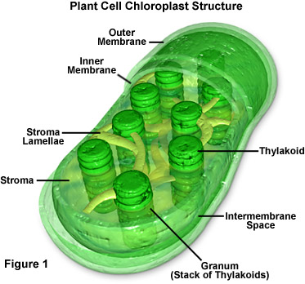
- Chlorophyll - light-absorbing photopigment found within chloroplasts in its many thylakoids
Antenna system - the complex of chloroplast pigments on each thylakoid that trap light of various wavelengths, transferring excitation energy to the reaction center
Reaction center - the middle point of the antenna system which uses the excitation energy toward photosynthetic processes
STD - Stroma Targetting Domain - signal sequence that targets a protein to the stroma of a chloroplast
TTD - Thylakoid Transfer Domain - signal sequence that targets a protein to the thylakoid membrane or lumen of a chloroplast
TIC - Translocon of Inner Chloroplast membrane
TOC - Translocon of Outer Chloroplast membrane

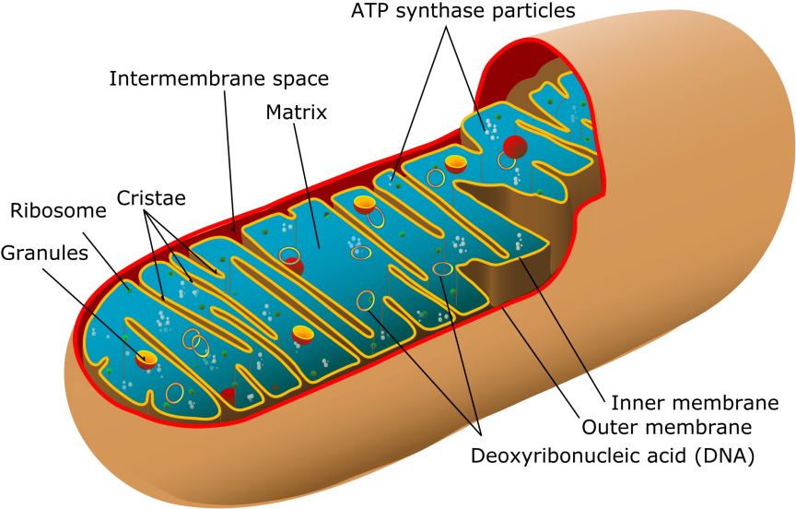
- The OMM (outer mitochondrial membrane) has a high lipid:protein ratio, in order to insulate the electrochemical gradient produced within the intermembrane space during oxidative phosphorylation. It also contains porins, which are large channel proteins that are freely permeable when they are open. In contrast, the IMM (inner mitochondrial membrane) has a high protein:lipid ratio, as it contains a number of electron carriers required for oxidative phosphorylation. It also contains cardiolipin, a lipid found in bacterial membranes.

- Apoptosis is the process of regulated cell death. Characteristics of the process include cell shrinkage, "blebbing" (a "bubbling" off of the cell), fragmentation of DNA/nucleus, loss of attachment to other cells, and engulfment by phagocytosis. Phagocytosis is a form of endocytosis carried out by phagocytes, in which they envelope and consume materials such as an apoptotic cell.

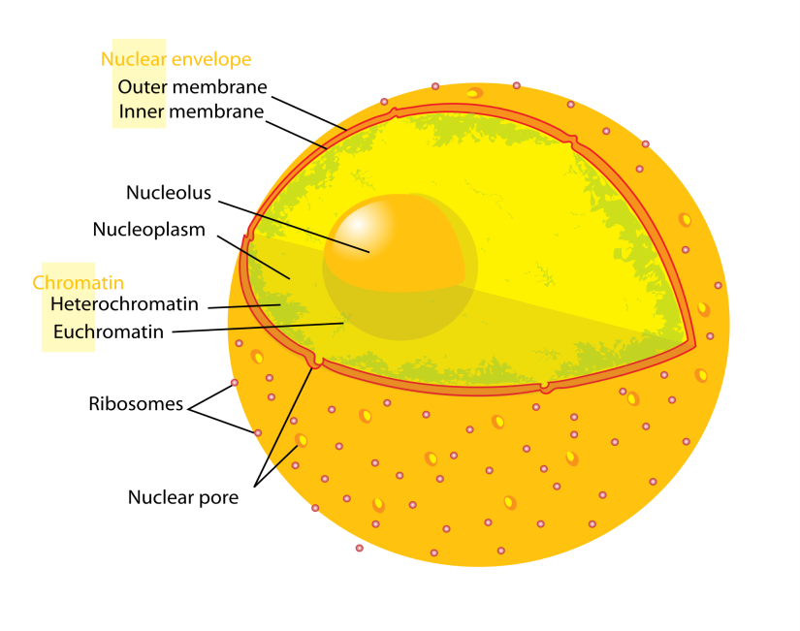
- Lamins are a type of intermediate filament that are attached to the inner membrane of the nucleus via integral proteins. They act as structural support as well as a binding site for chromatin.
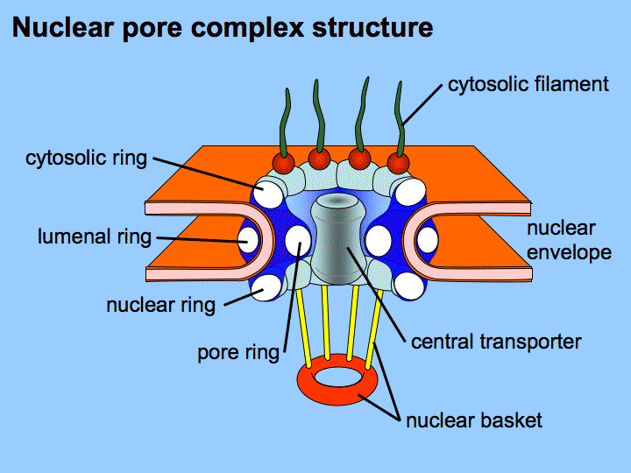
The Nuclear Pore Complex (NPC) is a protein complex (nucleoporins, NPCs) that sits in nuclear pores and extends into the nucleoplasm and the cytosol. The NPC allows for the passive diffusion of small, uncharged molecules and facilitates the movement of large molecules into/out of the nucleus (including rRNA, tRNA, proteins, ribosomal subunits).
The NPC recognizes a Nuclear Localization Signal near a protein's C' terminus; this protein also interacts with an importin heterodimer before it enters the NPC. The protein passes through the NPC with the importin heterodimer, which becomes associated with the G-protein Ran. A GTP molecule causes the protein-heterodimer complex to dissociate, pulling Ran and one of the importins out while the protein and other importin travel into the nucleus.

Cytoskeletal Element | Monomers | Function | Associated Motor Proteins
Microtubule (25 nm)  (polar) | α-tubulin  and β-tubulin  (form protofilaments) | Movement of vesicles, organelles; organization; support; movement of flagella/cilia | Kinesin (+ end directed); dynein (- end directed)
Intermediate Filament  (10-12 nm)  (non-polar) | α-helix domains (monomer/dimer is polar, tetramer is not) | Structural support, mechanical strength (stable) | NONE
Microfilament  (8 nm)  (polar) | G-actin (forms F-actin) | Maintenance of cell shape; cell movement; cytokinesis; muscle contraction | Myosin (mediates muscle contraction)

Dynamic Instability - Unstable nature of microtubules make it well suited to quick assembly and dissembly
Catastrophe - Rapid disassembly of microtubule at minus-end (opposite of "rescue")
MAPs - Microtubule-Associated Proteins - modulate assembly/function of MT, facilitate MT-organelle interactions
MTOC - Microtubule Organizing Center (eg. centrosome)
ABPs - Actin Binding Proteins - facilitate polymerization of G-actin into F-actin

- ECM - Extracellular Matrix - An organized network of extracellular materials that is present beyond the immediate vicinity of the plasma membrane (secreted by the cell); serves as site for cell attachment, physical support, contains regulatory factors, defines tissues
Cell wall - Found in plants, fungi, bacteria; structural support, protection; convey biochemical signals
Plasmodesmata - Small tubes/holes in plant cell walls that allow for cell-cell interaction
Gap junction - The equivalent to plasmodesmata in animal cells
Glycocalyx - A cell coat of carbohydrate molecules due to glycoproteins and glycolipids; provides a barrier to some particles, cell-cell and cell-ECM interactions, protection, binds regulatory factors

