Organizational Behaviour

Chapter 1: Organizational Behaviour

Organizational behaviour (OB) – field of study devoted to understanding, explaining and ultimately improving the attitudes and behaviours of individuals and groups in the organizations.

Human resource management – field of study that focuses on the applications of OB theories and principles in organizations.

Strategic management – field of study devoted to exploring the product choices and industry characteristics that affect an organization’s probability.

Scientific management – using scientific methods to design optimal and efficient work processes.

Bureaucracy – an organizational form that emphasizes the control and coordination of its members through a strict chain of command, formal rules and procedures, high specialization, and centralized decision-making.

Human relations movement – field of study that recognizes that the psychological attributes of individual workers and the social forces within work groups have important effects on work behaviours.

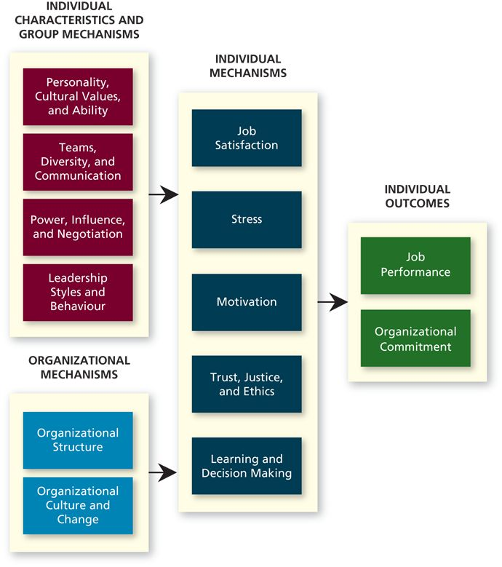

Organizational Behaviour helps us to:
- understand organizational behaviour and events
- explain organizational behaviour and events in organizations.
- Predict and manage organizational behaviour
Based on informed opinion and systematic study.

Resource-based view
- a model that argues that rare and inimitable resources helps firms maintain competitive advantage.
- What Makes a Resource Valuable:
  - The resource being rare in a short supply.
  - Imitable factors – incapable of being imitated or copied such as:
    - History (experience, wisdom, knowledge)
    - Numerous small decisions (small decisions are hard to find and copy)
    - Socially complex resources (culture, teamwork, trust and reputation)
The Scientific Method

Theory -> Hypotheses -> Data -> Verification -> (back to theory)

Theory – a collection of verbal and symbolic assertions that specify how and why variables are related, as a well as the conditions in which they should (and should not) be related.

Hypotheses – written predictions that specify relationships between variables.

Correlation – the statistical relationship between two variables, abbreviated r, it can be positive or negative and range from 0 (no statistical relationship) to +- 1 (a perfect statistical relationship)

Meta-analysis – a method that combines the results of multiple scientific studies by essentially calculating a weighted-average correlation across studies (with larger studies receiving more weight).

End of the Chapter Questions
  - What is the definition of “organizational behaviour” (OB)?
  - What are the two primary outcomes in studies of OB?
The two primary outcomes in organizational behaviour are job performance and organizational commitment.
  - What factors affect the two primary OB outcomes?
  - Why might firms that are good at OB tend to be more profitable?
  - What is the role of theory in the scientific method?
  - How are correlations interpreted?

Chapter 2: Job Performance

Job performance – employee behaviours that contribute positively or negatively to the accomplishment of organization’s goals.

Citizenship Behaviour – voluntary employee behaviours that contribute to organizational goals by improving the context in which takes places.
Counter-productive behaviour (negative behaviour that takes out the company’s behaviour)

Task performance – employee behaviours that are directly involved in the transformation of organizational resources into the goods or services that the organization produces.

Routine task performance – well-known or habitual responses by employees to predictable task demands.

Adaptive task performance - thoughtful responses by an employee to unique or unusual task demands.

Creative task performance – ideals or physical outcomes that are both novel and useful.

How do organizations identify the behaviours that underline task performance?
Behaviour Title | Examples of Activities
Handling emergencies or crisis situations | - Quickly analyzing options for dealing with danger or crises and their implications; making spilt-second decisions based on clear and focused thinking.
Handling work stress | -Remaining composed and cool when faced with difficult circumstances or a highly demanding workload or schedule; acting as a calming and settling influence to whom others can look for guidance.
Solving problems creatively | - Turning problems upside-down and inside-out to find fresh new approaches; integrating seemingly unrelated information and developing creative solutions.
Dealing with uncertain and unpredictable work situations | - readily and easily changing gears in response to unpredictable or unexpected events and circumstances effectively adjusting plans, goals, actions, or priorities to deal with changing situations.
Learning work tasks, technologies, and work situations | Quickly and proficiently learning new methods or how to perform previously unlearned tasks; anticipating change in the work demands and searching for and participating in assignments or training to prepare for these changes.
Demonstrating interpersonal adaptability | Being flexible and open-minded when dealing with others; listening to and considering others’ viewpoints and opinions and altering own opinions and altering own opinion when it is appropriate to do so.
Demonstrating cultural adaptability | Willingly adjusting behaviour or appearance as necessary to comply with or show respect for others’ values and customs; understanding the implications of one’s actions and adjusting approach to maintain positive relationships with other groups, organizations, or cultures.

Job analysis – a process by which an organization determines requirements of specific jobs.

National Occupation Classification (NOC) – a national database of occupations in Canada, organizing over 30 000 job titles into 520 occupational group descriptions.

Citizenship behaviours – voluntary employee behaviours that contribute to organizational goals by improving the context in which work takes place. 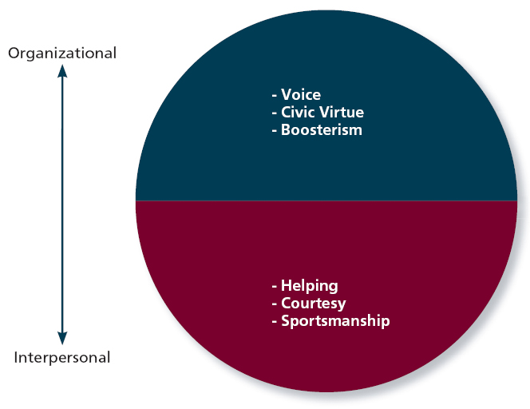
Interpersonal citizenship behaviour – going beyond normal job expectations to assist, support, and develop co-workers and colleagues.
Helping – assisting co-workers who have heavy workloads, aiding them with personal matters, and showing new employees the ropes when they are first on the job.
Courtesy – sharing important with co-workers.
Sportsmanship – maintaining a positive attitude with co-workers through goods and bad times.
Organizational citizenship behaviour – going beyond normal expectations to improve operations of organization, as well as defending the organization abd being loyal to it.
Voice – speaking up to offer constructive suggestions for change, often in reaction to a negative work event.

Civic virtue – participation in company operations at a deeper-than-normal level through voluntary meetings, readings, and keeping up with news that affects the company.

Boosterism – positively representing the organization when in public.

Counterproductive behaviour – employees behaviours that intentionally hinder organizational goal accomplishment.
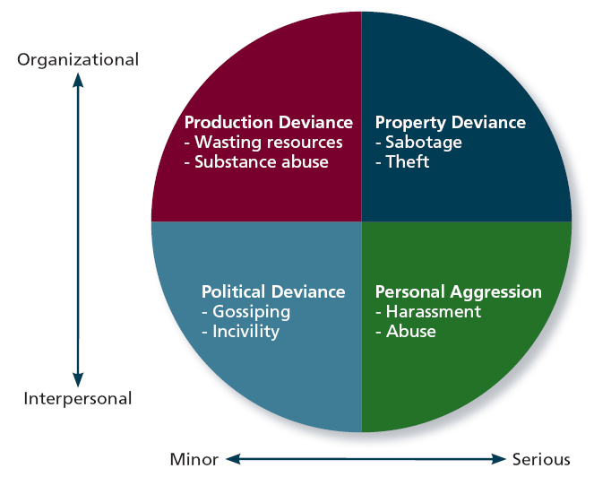
Four categories of counterproductive behaviour:

Property deviance – behaviours that harm the organization’s assets and posessions (includes sabotage and theft)
Production deviance – intentionally reducing organizational efficiency of work output (wasting resources, substance abuse)
Political deviance – behaviours that intentionally disadvantage other individuals (gossiping, incivility)
Personal aggression - hostile verbal and physical actions directed toward other employees (harassment and abuse).

What Does IT Mean to be a “Good Performer”
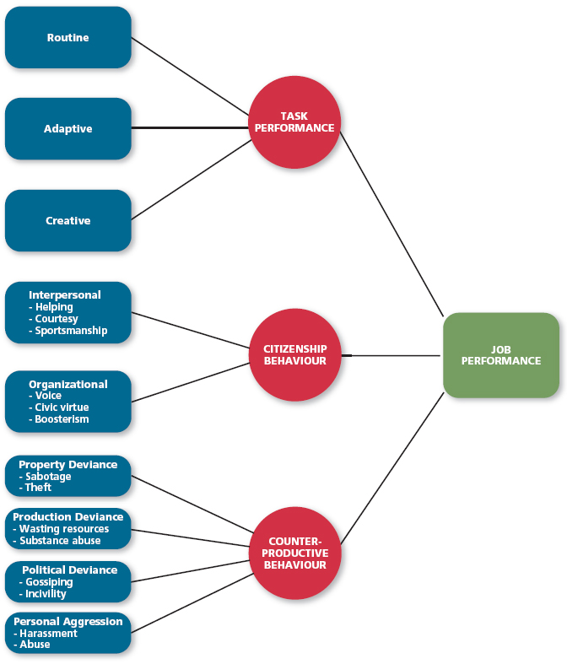
Application: Performance Management
- Management by objectives (MBO)
  - Based on whether the employee achieves specific performance goals
- Behaviourally anchored rating scales (BARS)
  - Assess job performance behaviours
  - Uses critical incidents to create a measurement scale
- 360-Degree Feedback
  - Collect performance information from supervisor and others with firsthand knowledge
- Forced ranking
  - Managers rank their employees:
  - E.g., the top 20 percent (A players), the vital middle 70 percent (B players), or the bottom 10 percent (C players)

Chapter 2 Questions
- What is job performance?
- What is task performance?
- How do organizations identify the behaviours that underlie task performance?
- What is citizenship behaviour? And the types of Citizenship Behaviour?
- What is counterproductive behaviour? And the types of counterproductive behaviour and factors?
- What does it mean to be a good performer?
- How can organizations use job performance information to manage employee performance?

Chapter 3: Organizational Commitment
Organizational commitment – an employee’s desire to remain am ember of an organization.
Withdrawal behaviour – employee actions that are intended to avoid work situations.

Three Forms of Organizational Commitment
Affective commitment
an employee’s desire to remain a member of an organization due to a feeling of emotional attachment.
Erosion model – a model that suggests that employees with fewer bonds with co-workers are more likely to quit the organization.
Social influence model – a model that suggest that employees with direct linkages to co-workers who leave the organization will themselves become more likely to leave.

Continuance commitment
an employee’s desire to remain a member of an organization due to awareness of the costs of leaving.
Embeddedness – an employee’s connection to and sense of fit in the organization and community.e

Normative commitment
An employee’s desire to remain a member of an organization due to a feeling of obligation.

Focus of commitment – the people, places, and things that inspire a desire to remain a member of an organization.

Reacting to negative works a work…
Voice – an active, constructive response in which individuals attempt to improve the situation.
Loyalty – a passive, constructive response that maintains public support for the situation while the individual privately hopes for improvement.

Withdrawals
Exit – a response to a negative work event in which one becomes often absent from work or voluntarily leaves the organization.
Neglect – a passive, destructive response to a negative work event in which one’s interest and effort in work decline.

Psychological Withdrawal
Psychological withdrawal – mentally escaping the work environment.
Daydreaming – a form of psychological withdrawal in which one’s work is interrupted by random thoughts or concerns.
Moonlighting: a form of psychological withdrawal using work time and resources to complete something other than their job duties, such as assignments for another job.
Socializing – a form of psychological withdrawal in which one verbally chats with co-workers about non-work topics.
Looking busy – a form of psychological withdrawal which one attempts to appear consumed with work when not performing actual work tasks.
Cyber loafing- a form of psychological withdrawal in which employees surf the internet, email and instant message to avoid doing work-related activities.

Physical Withdrawals
Tardiness – a form of physical withdrawal in which employees arrive late to work or leave work early.
long breaks – a form of physical withdrawal in which employees take longer-than-normal lunches or breaks to spend less time at work.
Missing meetings – a physical withdrawal in which employees take longer-than-normal lunches or breaks to spend less time at work.
Absenteeism – a form of physical in which employees do not show up for an entire day of work.
Quitting – form of physical withdrawal in which employees voluntarily leave the organization.

Types of Models
Independent forms model – a model that predicts that the various withdrawals behaviors are uncorrelated, so that engaging in one type of withdrawal has little bearing on engaging in other types.
Compensatory forms model – a model indicating that the various withdrawal behaviors are negatively correlated, so that engaging in one type of withdrawal makes one less likely to engage in other types.
Progression model - a model that the various withdrawal behaviors are positively correlated, so that engaging in one type of withdrawal makes one more likely to engage in other types.

The Changing Employer to Employer Relationship
Psychological contracts – employee beliefs about what employees owe the organization and what the organization owes them.

Chapter 4: Job Satisfaction
Job satisfaction – a pleasurable emotional state resulting from the appraisal of one’s job or job experiences; represents how a person feels and thinks about his or her job.

Work Values
Values – things that people consciously or unconsciously want to seek or attain.
Value-percept theorey – a theory that argues that job satisfaction depends on wehther the employee perceives that his or her job supplies those things that he or she values.
Dissatisfcation = (Vwant – Vhave) * (Vimportance)

Commonly assessed work values:
- Pay
- Promotions
- Supervisions
- Co-workers
- The work itself
- Altruism
- Status
- Environment
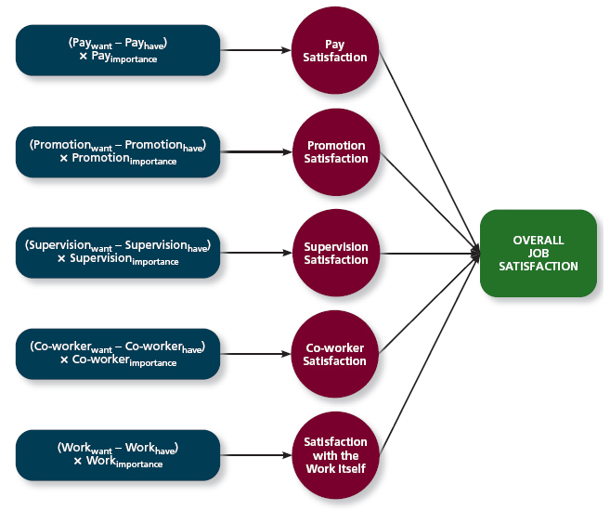

pay satisfaction – employees’ feeling about the compensation for their jobs.
Promotion satisfaction – employees’ feelings about how the company handles promotions.
Supervision satisfaction – employees’ feelings about their boss, including his or her competency, communication, and personality.
Co-worker satisfaction - employees’ feelings about their co-workers, including their abilities and personalities.
Satisfaction with the work itself - employees’ feelings about their actual work tasks.

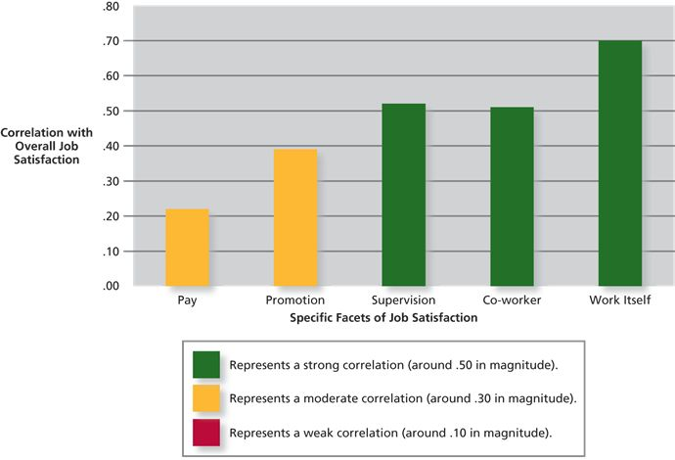

Critical Psychological States
- Meaningfulness of work
  - A psychological state indicating the degree to which work tasks are viewed as something that counts in the employees’ system of philosophies and beliefs.
- Responsibility for outcomes:
  - Degree to which employees feel that they are key drivers of work quality.
- Knowledge of results
  - The extent to which employees know how well they are doing.

Job Characteristics Theory (Graph)
A theory that argues that five core characteristics (variety, identity, significance, autonomy and feedback) combine to result in high level of satisfaction with the work itself.

Five Characteristics:
- Variety
  - The degree to which a job requires different activities and skills.
- Identity
  - The degree to which a job offers completion of a whole, identifiable piece of work.
- Significance
  - The degree to which a job really matters and impacts society as a whole.
- Autonomy
  - The degree to which a job allows individual freedom and discretion regarding how the work is to be done.
- Feedback
  - The degree to which the job provides information about how well the holder is doing.
Overall, job characteristics are moderately to strongly related to work satisfaction.

Not all employees want the above job characteristics), their desire is depended on these two variables:
- Knowledge and skill
  - The degree to which employees have the aptitude and competence needed to succeed on their job.
- Growth need strength
  - The degree to which employees desire to develop themselves further.

Job Enrichment
When job duties and responsibilities are expanded to provide increased levels of core job characteristics.

Moods and Emotions
Moods – states of feeling that are mild in intensity, last for an extended period of time, and are not directed at anything.
Emotions – intense feelings, often lasting for a short duration, that are clearly directed at someone or some circumstance.
Affective events theory – a theory that describes how workplace events can generate emotional reactions that impact work behaviours.
Emotional labour – the need for management of their emotions that employees must do to complete their job successfully.
Emotional contagion – the idea that emotions can be transferred from one person to another.

Positive emotions – employees’ feelings of joy, pride, relief, hope, love and compassion

Negative emotions – employees’ feelings of fear, guilt, shame, sadness, envy and disgust.

How Important is Job Satisfaction
Job Satisfaction leads to Job Performance and Organizational Commitment.

A Little Chart to summarize Overall Job Satisfaction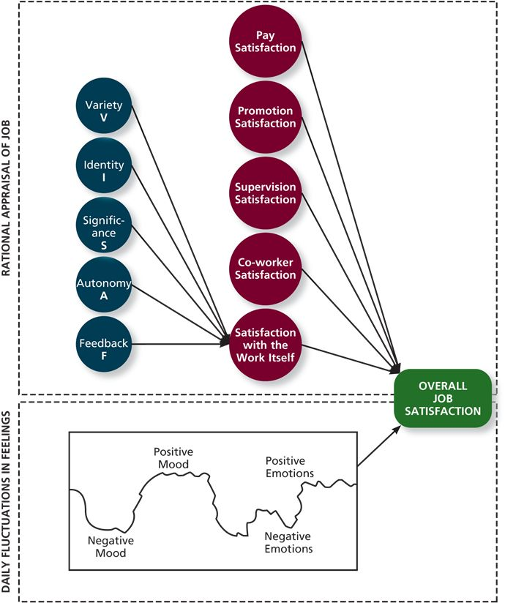

Chapter 5: Stress
Stress – The psychological response to demands when there is something at stake for the individual, and when coping with these demands would tax or exceed the individual’s capacity or resources.
Stressors – demands that cause the stress response.
Strains – negative consequences of the stress response.

Transactional theory of stress – a theory that explains how stressful demands are perceived and appraised, as well as how people respond to the perceptions of appraisals.

Primary appraisal – evaluation of whether a demand is stressful and, if it is, the implications of the stressor in terms of personal goals and well-being.

Benign job demands – job demands that are not appraised as being stressful.

Hindrance Stressors
Hindrance stressors – stressors that tend to be appraised as thwarting progress toward growth and achievement.

Role conflict – others’ having differing expectations of what an individual needs to do in a role.
Role Ambiguity – a lack of direction and information about what needs to be done in a role.
Role overload – an excess of demands on an employee preventing him or her from working effectively
Daily hassles – minor day-to-day demands that interfere with work accomplishment.

Work-Challenge Stressors
Challenge stressors – stressors that tend to be appraised as opportunities for growth and achievement.

Time Pressure – the sense that the amount of time allotted to do a job is quite enough.

Work complexity – the degree to which job requirements tax or just exceed employee capabilities.

Work responsibility – the number and importance of the obligations that an employee has to others.

Non-work Hindrance Stressors
Work-family conflict – a form of role conflict in which the demands of a work role hinder the fulfillment of the demands in a family role (or vice versa)
Negaive life events – events such as divorce or death of a family member that tend to be appraised as a hindrance.
Financial uncertainty – uncertainties with regard to the potential for loss of livelihood, savings, or the ability to pay expenses.

Non-work Challenge Stressors
Family time demands – the amount of time committed to fulfilling family responsibilities.
Personal development – participation in activities outside of work that foster growth and learning.
Positive life events – events such as marriage or the birth of a child that tend to be appraised as a challenge.

How do People copy with Stressors
Secondary appraisal – when people determine how to cope with the various stressors they face.

Coping – behaviours and thoughts used to manage stressful demands and the emotions associated with the stressful demands.

Behavioural coping – physical activities used to deal with a stressful situation (ex. One with a lot of time pressure may cope by working faster)

Cognitive coping – thoughts used to deal with a stressful situation (one may have thoughts on how to accomplish the task more efficiently)

Problem-focused coping – behaviours and cognitions of an individual intended to manage the stressful situation itself.

Emotion-focused coping – behaviours and cognitions of an individual intended to help manage emotional reactions to the stressful demands.

Examples of Coping Strategies
Behavioural Methods (Problem focused) | - Working harder  - Seeking assistance  - Acquiring additional resources.
Behavioural metohds (emotion-focused) | - Engaging in altenrative activities  - Seeking support  - Venting anger.
Cognitive methods (problem-focused) | - Strategizing  - Self motivation  - Changing priorities
Cognitive methods (emotion focused) | - Avoiding, distancing, and ignoring.  - Looking for the positive in the negative  - Reapprasing.

The Experience of Strain
Physiological strains – reactions from stressors that harm the human body.

Psychological strains – negative psychological reactions from stressors such as depression, anxiety and anger.

Burnout – the emotional, mental, and physical exhaustion from coping with stressful demands on a continuing basis.

Behavioural strains – patterns of negative behaviours that are associated with other strains.

Accounting for Individuals in the Stress Process
Type A Behaviour Pattern – people tend to experience more stressors, to appraise more demands as stressful, and to be prone to experiencing more strains.
Factors that affect Type A Behaviour patterns: social support, instrumental support and emotional support.

How Important is Stress
Hindrance stressors have an weak negative effect on Job Performance.
Hindrance stressors have a strong negative effect on Organizational Commitment.
Challenge stressors have a weak positive relationship with job performance.
Challenge stressors have a moderate positive correlation with organizational commitment.

Chapter 6: Motivation
Motivation – a set of energetic forces that determine the direction, intensity, and persistence of an employee’s work effort.

Intensity: strength of effort
Persistence: how long you stick with something
Direction: directed to goals

Intrinsic motivation – desire to put forth work effort due to common sense that task performance serve as its own reward.

Extrinsic motivation – desire to put forth work effort due to some contingency that depends on task performance.

Expectancy Theory
Expectancy theory – a theory that describes the cognitive process employees go through to make choices among different voluntary responses.
Premise: People will be motivated to perform work activities that they find attractive, feel they can accomplish, and lead to valued outcomes
Employees need to see clear links between effort, performance and outcomes
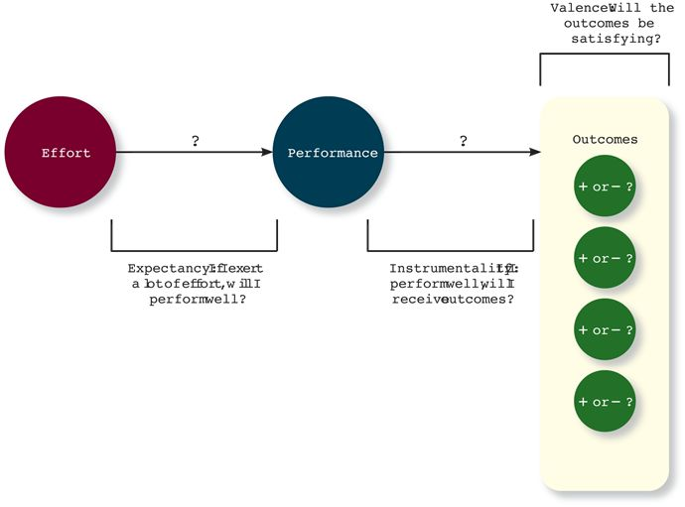
Expectancy – the belief that exerting a high level of effort will result in successful performance on some task.
- (E -> P)
- Subjective, Probabiltiy, ranging from 0 to 1
- Affected by Self-efficacy – the belief that a person has the capabilities needed to perform the behaviours required on some task.
Instrumentality – the belief that successful performance will result in some outcome or outcomes.
- (P -> O)
- subjective probability, ranging from 0 to 1.
Valence – the anticipated value of the outcomes(s) associated with successful performance.
- V
- Can be positive, negative or zero.
- Items that make things more positively valenced:
- Needs – groupings or clusters of outcomes viewed as having critical psychological or physiological consequences.

Motivational Force
= E-> P * sum[ (P->O) * V) ]

Goal Setting Theory
Goal setting theory – a theory that views goals as the primary drivers of the intensity and persistence of effort.

Assigning employee specific and difficult goals will result in higher levels of performance.

Specific and difficult goals – goals that stretch an employee to perform at his or her maximum level while staying within the boundaries of his or her ability.

Assigned versus Self-Set Goals?
Self-set goals – the internalized goals that people use to monitor their own progress.
Self-set goals usually pertain:
- Increased intensity and persistence of effort
- Creation of strategies.

What can managers do?
Develop monitors on task performance.

Feedback – update on the progress towards goal attainment.
Task complexity – the degree to which the information and actions needed to be complete a task are complicated.
Goal commitment – the degree to which a person is determined to reach the goal.

S.M.A.R.T goals – goals that are Specific, Measurable, Achievable, Results-based and Time-Sensitive Goals.

Equity Theory
Equity theory – a theory that suggests that employees create a mental ledger of the outcomes they receive for their job inputs, relative to some comparison other.

Your Outcomes / Your Inputs = Other’s Outcomes / Other’s Input = Equity

Equity distress – an internal tension that results from being over rewarded or under rewarded relative to some comparison other.

Cognitive distribution – a re-evaluation of the inputs an employee brings to a job, often occurring in response to equity distress.

Psychological Empowerment
Psychological empowerment – an energy rooted in the belief that tasks are contributing to some larger purpose.

Four Concepts of psychological empowerment:

Meaningfulness – a psychological state reflecting one’s feelings about work tasks, goals, and purposes, and the degree to which they contribute to society and fulfill one’s ideals and passions.

Self-determination – a sense of choice in the initiation and continuation of work tasks.

Comptence – the capability to perform work tasks successfully.

Impact – the sense that a person’s actions “make a difference” – that progress is being made toward fulfilling some important purpose.

Summary: Why Are Some Employees More Motivated than Others
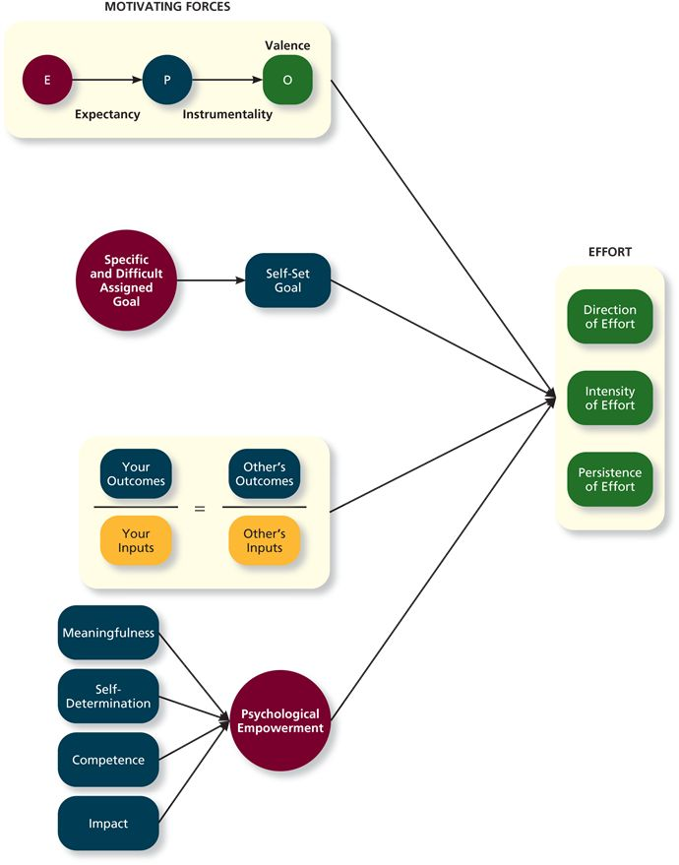

How Important is Motivation

- Motivation has a strong positive effect on Job Performance.
- Motivation has a moderate correlation on Organizational Commitment.
- Strongest job performance effect is self-efficacy/ competence
- Difficult goals are the second most powerful motivating force
- The motivational force described by Expectancy Theory is the next most powerful
- Perceptions of Equity have a somewhat weaker effect on task performance

Chapter 7: Trust, Justice and Ethics

Trust
Reputations depend on many things, but one of the most factors is trust. Trust is defined as the willingness to be vulnerable to an authority based on positive expectations about the authority’s actions and intentions.

Trust can come from different kinds of factors such as:
- Disposition-based trust
  - Trust that is rooted in one’s own personality, as opposed to careful assessment of the trustee’s worthiness.
- Cognition-based trust
  - Trust that is rooted in a rational assessment of the authority’s trustworthiness.
- Affect-based trust
  - Trust that depends on feelings towards the authority that go beyond any rational assessment of trustworthiness.

Disposition-based trust
Based on a trustee’s worthiness. Some trustors are known to have a high level in trust propensity – a general expectation that the words, promises, and statements of individuals and groups can be relied upon.

Cognition-based Trust
When knowledge is gathered to gauge the authority’s trustworthiness, cognition-based is used.
Trustworthiness – characteristics of attributes that inspire trust, including abilities, character and benevolence.

Abilities – the skills, competencies, and areas of expertise that enable an authority to be successful in some specific area.
Benevolence – the belief that an authority wants to do good for a trustor, apart from any selfish or profit-centered motives.
Integrity – the perception that an authority adheres to a set of values and principles that the trustor finds acceptable.

Affect-based Trust
With affect-based trust, we trust because we have feelings for the person in question; we really like them and have a fondness for them.

Types of Trust Graph (Summarized)
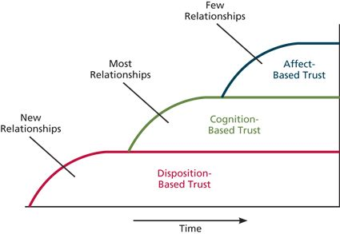

Justice

Distributive Justice
Reflects the perceived fairness of decision-making outcomes.

Procedural Justice
Reflects the perceived fairness of decision-making processes.

Interpersonal Justice
Reflects the perceived fairness of the interpersonal treatment received by employees from authorities.

Informational justice
The perceived fairness of the communications provided to employees from authorities.

Ethics

Four Component Model of Ethical Decision Making
a model that argues that ethical behaviours result from the multistage sequence of moral awareness, moral judgement, moral intent and ethical behaviour
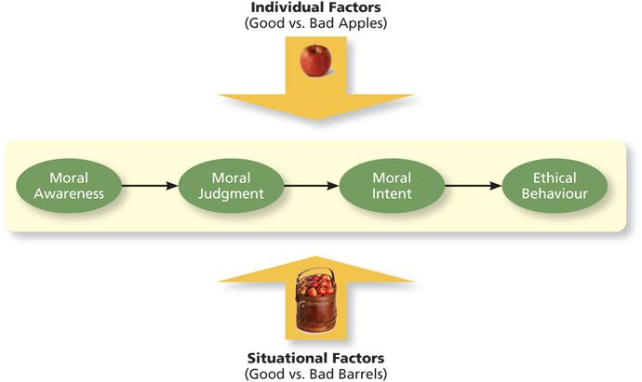
Moral Awareness
- Recognition that a moral issue exists in a situation.
- What factors determine whether a personal ‘sees’ the moral issue at stake and being awared?
  - Moral intensity – the degree, to which an issue has ethical urgency, varies based on the potential for harm and social pressure.
    - In grand theft auto, it may been thought that the ethicality of the hidden scenes was never considered due to it’s minor size and effect.
  - Moral attentiveness – the degree to which people chronically perceives and considers issues of morality during their experiences.
    - In the case of Grand Theft Auto, they weren’t morally attentive enough to recognize the hidden scenes represented an ethical issue.
Moral Judgement
- When an authority can accurately identify the “right” course of action.
- What determines whether a personal understands the right course of action versus the wrong course?
  - Cognitive moral development
    - As people age and mature, they move through several states of moral development, each more mature and sophisticated than the prior one.
  - Moral principles
    - Prescriptive guide for making moral judgements.
Moral Intent
- An authority’s degree of commitment to the moral course of action.
- What influences whether someone intends to the right thing?
  - Moral identity – the degree to which a person views himself or herself as a moral person.
  - Organizational Culture / Norms (ex. Economic pressures from assigned goals or specific incentives can encourage people to set aside for their moral judgement, at least for their time)
Moral Behaviour
- Turning intention into actual moral behaviour.

Reasons why we might engage in unethical behaviour:
- We didn’t realize there was an ethical issue (no awareness)
- Because we had no (or wrong) moral judgment (Not being able to accurately determine an ethical solution)
- Because we have the best intentions but something prevented us to act (intention but no behaviour)
- OR weak intentions (we want to do the right thing, but don’t really care about the situation)

- According to the 4-Component Model, we might do ‘the right thing’ but it isn’t necessarily considered ethical if we didn’t intentionally mean to act ethically.

Corporate social responsibility – a perspective that acknowledges the responsibility of a business encompasses the economic, legal, ethical and citizenship expectations of society.

Chapter 8: Learning and Decision Making

Learning – a relatively permanent change in an employee’s knowledge or skill that results from experience.
Decision-making – the process of generating and choosing from a set of alternatives to solve a problem.

With learning comes more effective decision making and the increases of probability of making an accurate and sound decision.

Expertise – the knowledge and skills that distinguish experts from novices.

Types of Knowledge
Explicit Knowledge
- Knowledge that is easily communicated and available to everyone.
- Knowledge that can be found through books, Wikipedia and general information.
Tacit knowledge
- Knowledge that is learning through experience.
- Example: learning to ride a bike, you can’t explain how you do it, you just know how to do it. (highly personal)
- Difficult to describe; knowledge in practice, in action.

Methods of Learning
Employees are known to learn explicit and tacit knowledge through reinforcement (i.e. rewards and punishments), observation and experience.

Reinforcement
Operant conditioning – learning by observing the link between our voluntary behaviour and the consequences that follow it.

The Four contingencies of reinforcement

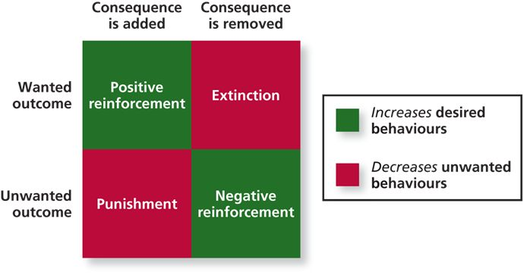
Two contingencies are used to increase desired behaviour:
- Positive reinforcement – a reinforcement contingency in which a positive outcome follows a desired behaviour.
  - Examples: increased pay, promotion and praise.
- Negative reinforcement – when an unwanted outcome is removed following a desired behaviour.
  - E.g. perform a task to so that you will not be reminded (e.g. wear a hard hat to stop reminders or taken down signs or penalties), perform well or stop unwanted task.
Two Contingencies used to decrease undesired behaviours:
- Punishment – an unwanted outcome that follows an unwanted behaviour such as Suspension.
- Extinction – the removal of a positive outcome following an unwanted behaviour.
  - Example: perhaps an employee gets attention from co-workers when he or she acts somewhat childishly at work. Finding a new way to remove the attention would be a purposeful act or accidental.
At work, if we want to improve, we first use POSTIVE REINFORCEMENT, but if it doesn’t work, then EXCTICTION would most likely be better to use than punishment.

Schedules of Reinforcement
- The timing of when contingencies are applied or removed.
- Continuous reinforcement – a schedule of reinforcement in which a specific consequence follows each and every occurrence of a certain behaviour.
- Fixed interval schedule – a schedule whereby reinforcement occurs at fixed time periods.
- Variable interval schedule – a schedule whereby reinforcement occurs at random time periods.
- Fixed ratio schedule – a schedule whereby reinforcement occurs following a fixed number of desired behaviours.
- Variable ratio schedule – a schedule whereby behaviours are reinforced after a varying number of them have been exhibited.
Variable schedule works the best to motivate such as at school to read chapters before class and maybe get a pop quiz from it.

Learning Through Observation
Social learning theory- theory that argues that people in organizations learn by observing others.
Behavioural modelling – when employees observe the actions of others, learn from what they observe, and then repeat the observed behaviour.
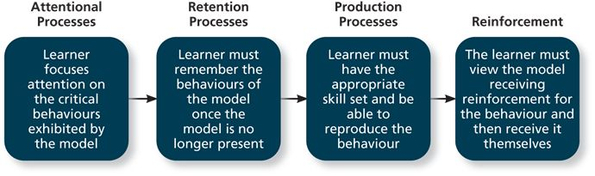

Goal Orientation
Learning orientation – a predisposition or attitude according to which building competence is deemed more important by an employee than demonstrating competence.
Performance-prove orientation – a predisposition or attitude by which employees focus on demonstrating their competence so that others think favourably of them.
Performance-avoid orientation – a predisposition or attitude by which employees focus on demonstrating their competence so that others will not think poorly of them.

Methods of Decision Making
- Programmed decisions – decisions that are somewhat automatic because the decision maker’s knowledge allows him or her to recognize the situation and the course action to be taken.
  - May come across as a ‘gut feeling’ or intuition.
    - Intuition – an emotional judgement based on quick, unconscious gut feelings.
- Non-programmed decisions
  - Decisions made by employees when a problem is new, complex, or not recognized.
  - Common at senior levels of the organization.
  - With a non-programmed decision, a rational decision-making model can be used as a step-by-step approach to making decisions that is designed to maximize outcomes by examining all available alternatives.

Decision-Making Problems
- Limited Information
  - All decision-makers are subject to bounded rationality – the notion that people do not have the ability or resources to process all available information and alternatives when making a decision.
  - In making decisions, bounded reality causes two major problems where people have to filter and simplify information to make sense of their complex environment and the myriad potential choices they face. This simplification leads them to miss information when perceiving problems, generating and evaluating alternatives or judging the results.
  - Second, because people cannot possibly consider every single alternative when making a decision, they satisfice. Satisficing – what a decision maker is doing who chooses the first acceptable alternative considered.
- Faulty Perceptions
  - Selective perception – the tendency for people to see their environment only as it affects them and as it is consistent with their expectations.
    - “You only see what you want to see”
  - Projection bias – the faulty perception by decision makers that other thinks, feels, and act as they do.
    - Project our own thoughts, attitudes onto others.
  - Social identity theory – people that identify themselves according to the various groups to which they belong and judge others according to the groups they associated with.
  - Stereotypes – occur when people make assumptions about others based on their social group membership.
  - Availability bias – the tendency for people to base their judgements on information that ie easier to recall.
- Faulty Attributions
  - Fundamental attribution error – the tendency for people to judge others’ behaviours as being due to internal factors such as ability, motivation or attitudes.
  - self-serving bias – when one attributes one’s own failures to external factors and successful to internal factors.
  - Three types of situations to attribute cause:
    - Consensus - used by decision makers to attribute cause; whether other individuals behave the same way under similar circumstances.
    - Distinctiveness – used by decision makers to attribute cause; whether the person beings judged acts in a similar fashion under different circumstances.
    - Consistency - used by decision makers to attribute causes whether this individual has behaved this way before under similar circumstances.
- Escalation of commitment.
  - A common decision-making error, in which the decision maker continues to follow a failing course of action.
  - Why? It can happen by pressure from groups because we don’t want to seem different from others.

Chapter 9: Personality, Cultural Values and Ability
Personality – refers to the structures and propensities inside a person that explains his or her characteristic patterns of thought, emotion, and behaviour; personality reflects what people are like and creates their social reputation.
Traits – recurring regularities or trends in people’s responses to their environment.
Cultural values – shared beliefs about desirable end states or modes of conduct in a given culture that influence the expression of traits.
Ability – relatively stable capabilities of people for performing a particular range of related activities.

The Big Five Taxonomy (People think of as C.A.N.O.E)
- It composes of conscientiousness, agreeableness, neuroticism, openness to experience, extraversion. And are used to describe personality.
- Conscientiousness – dimension of personality-reflecting traits like being dependable, organized, reliable, ambitious, hardworking and preserving.
  - Conscientious has the biggest influence on job performance.
  - Prioritizes accomplishment striving – a strong desire to accomplish task-related goals as a means of expressing one’s personality.
  - Work harder and longer on task assignments.
- Agreeableness – dimension of personality-reflecting traits like being kind, cooperative, sympathetic, helpful, courteous, and warm.
  - Agreeable people prioritize communion striving, which reflects a strong desire to obtain acceptance in personal relationships as a means of expressing one’s personality.
  - Focuses on “getting along”
  - Beneficial in some positions, not as beneficial in others (such as customer interface jobs, or customer service jobs because they want to try to please everybody)
- Extraversion – dimension of personality-reflecting traits like being talkative, sociable, passionate, assertive, bold and dominant.
  - Easiest to determine in zero acquaintance situations – situations in which two people have just met.
  - They prioritize status striving – a desire to obtain power and influence within a social structure as a means of expressing personality.
  - Extraverted employees tend to be high in positive affectivity – a dispositional tendency to experience pleasant, engaging moods such as enthusiasm, excitement and elation.
- Neuroticism – dimension of personality-reflecting traits like being nervous, moody, emotional, insecure, jealous and unstable.
  - Synonymous with negative affectivity - dispositional tendency to experience unpleasant moods such as hostility, nervousness and annoyance.
  - More likely to appraise situations as stressful and less likely to believe they can cope with stressors that they experience.
  - They tend to hold an external locus control where they believe that the events that occur around them are driven by luck, chance, or fate.
- Openness to experience – dimension of personality-reflecting traits like being curious, imaginative, creative, complex, refined and sophisticated.
  - known as “inquisitiveness” or “intellectualness”
  - valuable in what types of jobs?
    - Artistic and scientific fields
    - High levels of creative performance.
    - Useful where employees need to generate novels and useful ideas.

Cultural Values
Cultural – the shared beliefs, motives, identifies and interpretations that result from common experiences of members of a society and are transmitted across generations.
- Influences the development of our developments
- Also shapes the way our traits are expressed.

Gerrt Hofstede’s Study of five basic dimensions
- Individualism/collectivism
  - The degree to which a culture has a loosely knit social framework (individualism) or a tight social framework (collectivism)
- Power Distance
  - The degree to which a culture prefers equal power distribution (low power distance) or an unequal power distribution (high power distance)
- Uncertainty avoidance
  - The degree to which a culture tolerates ambiguous situations (lower uncertainty avoidance) or feels threatened by them (high uncertainty avoidance)
- Masculinity/femininity
  - The degree to which a culture values stereotypically males traits (masculinity) or stereotypically female traits (femininity)
- Long-term vs Short-Term Orientation
  - The degree to which a culture stresses values that are past and present oriented (short-term orientation) or future-oriented (long-term oriented)

Cultural Values from Project Globe

- Power Distance
- Uncertainty Avoidance
- Collectivism
  - Institutional
  - In-group collectvism
- Gender Egaliarianism
- Assertiveness
- Future Orientation
- Performance Orientation
- Humane Orientation

Why is Knowing Culture important?
Ethnocentrism – one who views his or her cultural values as “right” and values of other cultures as “wrong”.
Workplaces need to avoid the ethnocentrism effect.
Cultural Differences can influence many things…
- Reactions to change
- Management Style
- Reward Preferences

What does it mean for an employee to be “able”?
- Abilities to capture what people can do.
- Spilt up into three categories; cognitive, emotional and physical.

Cognitive
- Capabilities related to the use of knowledge to make decisions and solve problems.
- Verbal Ability – various capabilities associated with understanding and expressing oral and written communication
- Quantitative Ability – capabilities associated with doing basic mathematical operations and selecting and apply formulas to solve mathematical problems.
- Reasoning Ability – a diverse sense of abilities associated with sensing and solving problems using insight, rules and logic.
- Spatial Ability – capabilities associated with visual and mental representation and manipulation of objects in space.
- Perceptual ability – the capacity to perceive, understand, and recall patterns of information.
- General cognitive ability – the general level of cognitive ability that plays an important role in determining the more narrow cognitive abilities.

Emotional Ability
- Emotional intelligence – a set of abilities related to the understanding and use of emotions that affect social functioning
  - self-awareness – the ability to recognize and understand the emotions in oneself.
  - other awareness – the ability to recognize and understand the emotions that other people are feeling.
  - Emotional regulation – the ability to recover quickly from emotional experiences.
  - Use of emotions – the degree to which people can harness emotions and employ them to their chances of being successful in whatever they are seeking to do.

Physical Ability
Strength – the degree to which the body is capable of exerting force.
- Static strength – the ability to lift, push or pull very heavy objects.
- Explosive strength – short burst of energy to move him or herself or an object.
- Dynamic strength – exert force for a prolonged period of time (dynamic = in promotion)
Stamina - the ability of a person’s lungs and circulatory system to work efficiently while he or she is engaging in a prolonged physical activity.
Flexibility – the ability to bend, stretch, twist or reach.
- Extent flexibility – needed to work in a small compartment or an awkward position.
- Dynamic flexibility – required in a job with movement – e.g., quick bends, stretches, twists, or reaches.
Coordination – the quality of physical movement in terms of synchronization of movements and balance.
- Gross body coordination – the ability to synchronize movements of the body in motion.
- Gross body equilibrium - the ability to maintain the balance of the body
Psychomotor Ability – capabilities associated with manipulating and controlling objects.
- Fine manipulative abilities – ability to do precise work.
- Control movement abilities – making price adjustments using machinery
- Response orientation – choosing the right action quickly in response to different signals.
- Response time – how quickly an individual responds to signaling information.
Sensory ability – capabilities associated with vision and hearing.

How Important is Personality
- Conscientiousness affects job performance.
  - Key driver of typical performance – performance in the routine conditions
  - More likely to engage in citizenship behaviours.
  - Tend to be more committed.
- Ability is a driver of maximum performance – performance in special circumstances that demand a person’s best effort.

Chapter 10: Teams, Diversity and Communication
Team – two more people who work interdependently over some time period to accomplish common goals related to some task-oriented purpose.

Type of Teams
Work team - a relatively permanent team in which members work together to produce goods and/or provide service.
Management team – a relatively permanent team that participates in managerial-level tasks that affects the entire organization.
Parallel team – a team composed of members from various job within the organization that meets to provide recommendations about important issues.
Project team – a team formed to take on one-time tasks, most of which tend to be complex and require input from members from different functional areas.
Action team – a team of limited duration that performs complex tasks in contexts that tend to be highly visible and challenging.
Virtual team – a team in which the members are geographically dispersed and interdependent activity occurs through e-mail, Web conferencing and instant messaging.

Stage of Team Development
- Forming
  - Try to understand the boundaries and expectations.
- Storming
  - Remain committed to ideas – can trigger conflict.
- Norming
  - Realize that they need to work together to accomplish team goals.
- Performing
  - Members are comfortable working within their roles – the team makes progress toward goals.
- Adjourning
  - Disengage. Members may experience anxiety and other emotions.

Punctuated Equilibrium
At the initial team meeting, members make assumptions and establish a pattern of behaviour that lasts for the final half of its life.

Two Models of Team Development
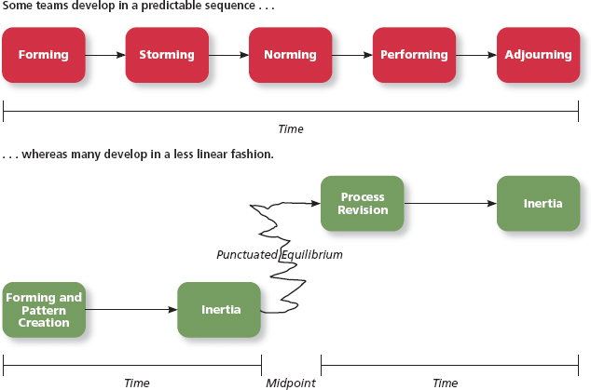

Task Interdependence
Task interdependence – the degree to which team mebers interact and rely on other team members for information materials, and reosurces needed to accomplish work for the team.
- Pooled Interdependence (LOOK FROM THE BOOK!)
  - Lowest degree of coordination
  - Members complete their work independently
- Sequential interdependence:
  - Different tasks are done in a prescribed order
  - Specialists
  - Interactions?
  - Hands-offs (outputs become inputs)
  - Challenges? (if you have group work and all have handoffs and one person is late submitting, then they’re all considered late)
- Reciprocal Interdependence
  - Members are specialized to perform specific tasks.
  - Not a strict sequence
  - Members interact with a subset of members
  - E.g.,: you ask a nurse a question, and he/she goes to the doctor, specialist, then goes back to the nurse to tell you the answer
- Comprehensive Interdependence
  - Requires the highest level of interaction and coordination
  - Each member has a great deal of discretion – collaborative effort
  - E.g.,

The highest one is comprehensive, the lowest is pool!

Other Interdependence
Goal interdependence – the degree to which team members have a shared goal and align their individual goals with that vision.
Outcome interdependence – the degree to which team members share equally in the feedback and rewards that result from the team achieving its goals.

Team Composition
The mix of the various characteristics that describe the individuals who work in the team.
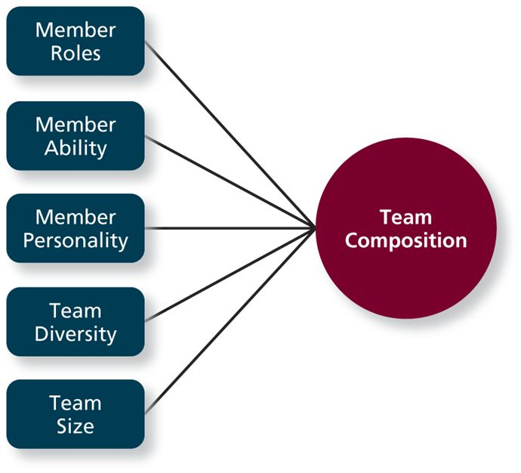

Member Roles
role – the behaviours a person is expected to display in a given content:
leader-staff teams – the leader makes decisions for the team, provides direction and control.
- team task roles – beheaviours tha facilitate the accomplishment of team tasks.
- Team building roles – behaviours that influence the quality of the team’s social culture.
- Individualistic role behaviours that benefit the individual at the expense of the team.

Member Ability
- Members’ ability – team members provide a wide array of abilities, both physical and cognitive.
  - Disjunctive tasks – tasks with an objectively verifiable best solutions.
    - E.g., the bigger the team, the better solution
  - Conjunctive tasks – the team’s performance depends on the abilities of the “weakest link.”
    - E.g.,
  - Additive tasks – tasks for which the contributions resulting ‘adds up’
    - E.g., when you have big project and need everyone’s help to finish

Members Personality
- Agreeable
  - Tend to be cooperative and trusting
  - Promote positive attitudes and smooth interpersonal interactions
- Conscientious
  - People tend to be dependable work hard to achieve goal
- Extraverted
  - Perform effectively in interpersonal contexts
  - More positive and optimistic in general

Team Diversity
- Surface-level diversity
  - Refers to diversity regarding observable attributes
  - Race, ethnicity, sex and age
  - Differences tend to decrease over time – overcome stereotypes
  - Need to be aware of similar-to-me bias
- Deep-level Diversity
  - Attributes that are less easy to observe initially
  - But that can be inferred after more direct experience (values, attitudes, etc.)
  - Differences tend to decrease over tine – can reduce effectiveness
Value in diversity problem-solving approach – a theory that support team diversity because it provides a larger a larger pool of knowledge and perspectives.

Similar-attraction approach – a theory explaining that team diversity can be counterproductive because people tend to avoid interacting with others who are unlike them.

Team Composition: Size
- A larger team tends to be better:
  - For management and project teams
  - Not for production tasks
- Ideal number?
  - Impossible to say for certain
  - Research on student work groups – tend to be most satisfied with 4 and 5
  - Something called PROCESS LOSS…

Team Processes and Communication
Team process – the different types of activities and interactions that occur within a team as the team works towards its goal.

Why are some teams more than the sum of their parts?
Process gain – when team outcomes are greater than expected based on the capabilities of the individual members.
Process loss – loss considered to have occurred when team outcomes are less than expected in view of the capabilities of the individual members.
- Process loss can come from a coordination loss or motivational.
- Coordination loss – when members have to work to not only accomplish their own tasks but also coordinate their activities with the activities of their teammates.
- Motivational loss – the loss in team productivity that occur

Taskwork Processes
Taskwork processes – the activities of team members that relate directly to the accomplishment of team tasks.

