Module 8: Some Environmental Concerns

Acid Rain

How does this happen?

When atmospheric carbon dioxide dissolves in water it forms carbonic acid.
CO₂ (g) + H₂O (ℓ) H₂CO₃ (aq)
The acid formed dissociates partially generating small amounts of hydrogen ions.
H₂CO₃ (aq) H⁺ (aq) + HCO₃⁻ (aq)
The hydrogen ions formed are responsible for the weakly acidic nature of rain.

- The pH Scale
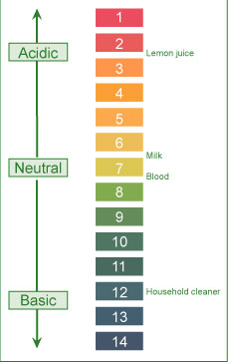

The acidity (a measure of hydrogen ion concentration) of a solution is conveniently described in terms of pH scale.
According to this scale, if:
pH < 7: solution is acidic
pH > 7: solution is basic
pH = 7: solution is neutral

- pH Laboratory
This virtual laboratory provides a visual example of how different substances can effect the pH balance. This activity should also remind you of the health and safety aspects of working in a laboratory discussed in Module 4.

- ↑ Acidity = ↓ pH
Based on the concentration of carbonic acid and small amounts of other natural acids, the estimated pH of rain (as well as fog, dew and snow) under normal atmospheric conditions should be around 5.3.
Field measurements in many areas, on the other hand, show much lower pH values (4.1- 4.5).

Higher acidity (lower pH) is due to the reactions of NO_{x} and SO_{x} present in the atmosphere.
Various reactions of these oxides lead to the formation of acids. The dissociation of formed acids generates hydrogen ions and hence higher acidity (or lower pH).

2 SO₂ (g) + O₂ (g) + 2 H₂O (ℓ) 2 H₂SO₄ (aq)
H₂SO₄ (aq) H⁺ (aq) + HSO₄⁻ (aq)
HSO₄⁻ (aq) H⁺ (aq) + SO₄²⁻ (aq)
4 NO₂ (g) + O₂ (g) + 2 H₂O (ℓ) 4 HNO₃ (aq)
HNO₃ (aq) H⁺ (aq) + NO₃⁻ (aq)

Environmental Effects

- Material Damage :
Marble and limestone (CaCo3) used in many historic and irreplaceable statues and buildings (e.g. the Parthenon in Greece, the Taj Mahal in India) react with acid in the rain.

The reaction leads the formation of calcium salts the formation of calcium salts. The solubility of these salts in water is much greater than that of marble in water. The dissolutionof formed calcium salts leads to roughened surfaces, removal of material and loss of carved details from the buildings and statues.

- Forest Damage :
Considerable damage to trees has been reported in various parts of North America and Europe. Acid rain has been implicated with slower growth, injury and destruction of forests and has been attributed to be a contributing factor to the declining health of trees by damaging their leaves, limiting the nutrients available to them or exposing them to toxic substances released from soil due to the change in pH.

Acid rain is implicated in depleting the nutrient supply to the trees by;
- Attacking the leaves whose protective coating has already been destroyed due to the attack by other atmospheric pollutants such as O3 and NOx
- Mobilizing various metals (Al, Pb, etc) in the soil that attact the roots.

Inadequate nutrient supply increases the possibility of destruction due to disease, drought, insects or high winds.

- Corrosion of Metals;
The corrosion process is accelerated in the presence of acid. Thus, iron structures, bridges, railroads etc. show a faster rate of corrosion (rusting) in acid rain predominant areas. Studies indicate that even painted or plated iron corrodes more rapidly in such areas.

The reaction occurs in two steps with hydrogen ions (formed from the dissociation of acid) being involved in the first step of the reaction. The overall reaction, conversion of iron to its oxide (rust), can be represented as follows:

- Aquatic Life
Aquatic life is quite susceptible to changes in pH. Reduced pH has led to lakes with no fish or other living beings. Acid rain has been shown to reduce fish population, kill individual fish and in some cases eliminate fish species entirely from a body.

Adverse effects of acid rain on aquatic life:
- Lowering of pH well below the required value about 6.5 for healthy aquatic life.
- Increasing aqueous concentration of metals (Al, Pb, etc.) due to their higher solubility at lowered pH.

Both low pH and increased aluminum levels are directly toxic to fish. In addition, low pH and increased aluminium levels cause chronic stress leading to smaller size and lower body weight. These factors in turn make the fish less able to compete for food and habitat.

- Control Strategies
Some suggested control technologies

- Reduction of SOx emissions by using emission control technologies;
Progress has been made in reducing the emissions of sulfur dioxide. The major strategies under consideration include;
- Using coal with low sulfur content
- Removing sulfur from the coal before using
- Using chemicals to neutralize acidic sulfur dioxide

In view of the substantial cost involved in using any of the above strategies individually or in combination, the progress in this direction has been rather slow in North America. In Japan, using the above technologies in particular the use of scrubbers (for the neutralization of acidic sulfur dioxide) has led to considerable decrease in sulfur dioxide emissions.

- Reduction of NOx emissions by using emission control technologies;
Catalytic converters are now in use in automobiles to reduce the emission of oxides of nitrogen.

- Using cleaner energy sources (such as alcohol and hydrogen) in transportation
These cleaner energy sources are being explored. A number of projects all over the globe are in progress. In some parts of the US there is limited use of alcohol to replace gasoline in cars. There are considerable numbers of investigations in progress pertaining to the use of hydrogen as a fuel.

- Developing and/ or using alternate energy (hydroelectric, nuclear, wind) sources;
Hydroelectric, nuclear and wind power are being used in many parts of the world. However, the progress in their development is very slow primarily due to high initial costs and environmental issues.

Global Warming

How does this happen?
Global warming refers to an increase in the Earth’s average temperature. This warming is the result of increased absorption by the atmosphere of infrared (IR), a major source of heat, radiated back from Earth's surface. This is due to an increase in concentration of gases that trap heat in the atmosphere. These gases are often called greenhouse gases.

The principal greenhouse gases that enter the atmosphere due to human activities include:
- Carbon dioxide (CO₂): It enters the atmosphere due to the burning of fossil fuels (oil, natural gas, and coal), waste materials, and as a result of other chemical reactions.

- Methane (CH₄): Main sources of emission are the production and transport of fossil fuels, livestock, agricultural practices and organic waste decay.

- Nitrous oxide (N₂O): It is emitted during agricultural and industrial activities as well as during the combustion of fossil fuels and waste materials.

- Fluorinated gases: These fluorine containing compounds are emitted from a variety of industrial processes and are sometimes called High Global Warming Potential (GWP) gases.

Based on measured concentrations of various greenhouse gases, computer models have been developed to predict the extent of global warming. It is estimated that the temperature of the atmosphere may increase anywhere from 1.5 ºC to 3.5 ºC during the next fifty years.

- Environment Effects

Climate changes;
Human activities such as burning of fossil fuels, deforestation, industrial processes and some agricultural practices release greenhouse gases. These gases trap energy in the atmosphere causing it to warm.

Changes in sea level due to melting of polar ice caps;
The North Pole is warming up faster than the rest of the world. The Arctic sea ice is in a state of ongoing decline as shown by the data from the National Snow and Ice Data Center (NSIDC) IN the US.
Possibility of droughts and increased frequency of heat waves due to warming;
Based upon detailed analysis using computer climate models and other relevant data, it is concluded that in the next few decades increasingly dry conditions may be encountered across much of the globe.

Changes in ecosystems;
As many animals and plants survive within a narrow range of climatic conditions, some animal species are shifting towards higher elevations. Many species even face extinction. As ocean temperature rise, the coral reefs will continue to decline.

Effects on Human Heath;
Global warming may lead to increased temperature-related illness, air pollution due to higher temperatures, and possible spread of some infectious diseases.

- Control Strategies
Reduction in CO₂ emissions: The governments all over the globe are working to reduce their country's carbon dioxide emissions by:
- Promoting that alternate non-fossil sources such as hydroelectric, solar, nuclear and wind are developed and used
- Capturing the carbon dioxide generated by burning fossil fuels
- Supporting new fuels and technologies (like electric cars) to reduce carbon dioxide emissions from transport
- Setting 'carbon budgets' to cap overall carbon dioxide emissions.

Encouraging energy conservation: This will lead to lesser energy consumption and hence lower production and reduced emissions.

Using carbon dioxide sinks: A carbon dioxide sink is any resource (natural or artificial) that captures and stores atmospheric carbon dioxide. Natural carbon dioxide sinks include forests, oceans and soil. Thus replanting forests is being encouraged globally.

Some of the artificial carbon dioxide sinks being studied involve removing carbon dioxide from the atmosphere and storing it in rocks, injecting it deep into the oceans or trapping it via chemical reactions.

- Present Situation
Key events to limit global warming

1988—Intergovernmental Panel on Climate Change
In 1988, United Nations Environment Program (UNEP) and World Meteorological Organization established Intergovernmental Panel Climate Change (IPCC)to focus on;
- Assessment of scientific knowledge
- Examination of the environmental, economic and social impacts
- Formulation of response strategies
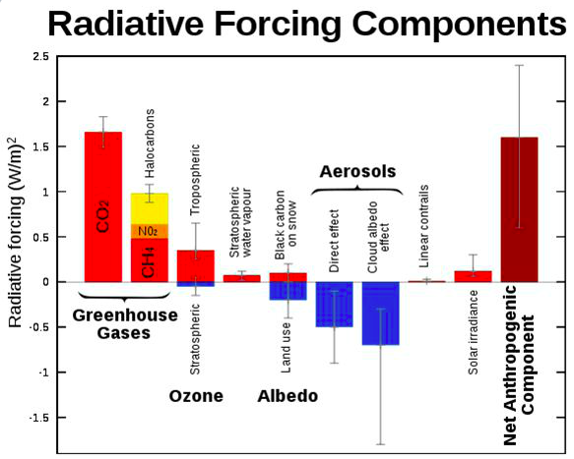

2007 – Intergovernmental Panel on Climate Change
A report released by the Intergovernmental Panel on Climate Change (IPCC) in 2007 stated that global warming is clearly evident from diverse observations such as;
- Increases in average air and ocean temperatures
- Widespread melting of snow and ice
- Rising global average sea level

The report emphasizes that global warming could irreversible damage to the planet. It s concluded and strongly suggested by scientists that global, sweeping, concerted action is urgently needed to drastically reduce greenhouse gas emissions, In addition, a report on the global economic impact of global warming (The Stern Report) suggests that it could shrink the global economy by 20%.

1997 – Kyoto protocol
In order to limit global warming (due to the trapping of heat in the atmosphere by greenhouse gases), the Kyoto protocol was signed in 1997. The document calls for industrialized nations to cut their emissions of greenhouse gases.
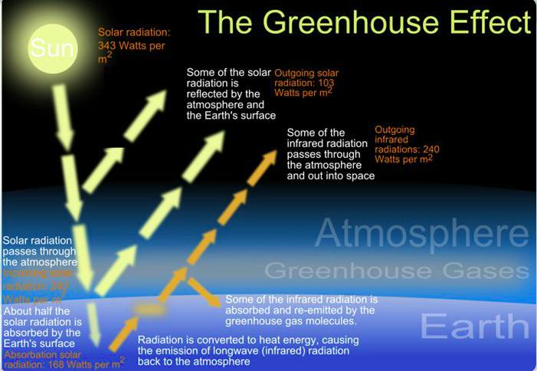

Today – Kyoto protocol
Kyoto protocol participation map as of February, 2012
- Green: indicates countries that have ratified the treaty (annex 1 and 2 countries in dark green)
- Brown: no intention to ratify
- Red: countries which have withdrawn from the protocol
- Grey: no position taken or position unknown
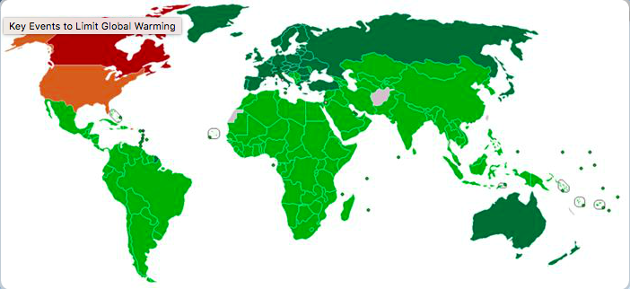

Summary
However, the progress in the implementation of diverse measures to control the emission of greenhouse gases and thereby limit the extent of global warming is going to be slow. The reason for this is the present situation of the global economy and hence the reluctance of governments to implement tighter environmental controls on emissions.

Ozone Depletion

How does this happen?
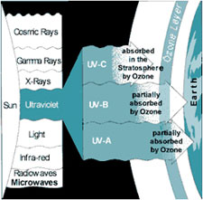
Click on image to enlarge.

Ozone plays a double role in our environment:
- In our immediate atmosphere, it acts as an air pollutant contributing to photochemical smog
- In the stratosphere (in conjunction with oxygen), it filters the solar ultraviolet (UV) radiation, thus protecting us against its harmful effects
In our immediate atmosphere exposure to ozone may occur in operations involving:
- High-intensity UV light such as mercury vapor lamps, plasma torches, glass blowing, etc.
- High-voltage electrical equipment
- Welding
In all the above operations, the interaction of high energy with oxygen in the surrounding atmosphere leads to the formation of O₃:
3 O₂ (g) + Energy 2 O₃ (g)

- Ozone Formation

In the stratosphere, oxygen and ozone interact with energy (ultraviolet radiation) from solar radiation to form a dynamic system involving the following reactions:

- When ultraviolet light strikes oxygen molecule, individual oxygen atoms are produced.
O₂ + Energy 2 O

- The combination of atomic oxygen with oxygen molecule leads to the formation of ozone.
O₂ + O O₃

- The interaction of ozone molecule with ultraviolet light splits it into a molecule of oxygen and an atom of oxygen.
O₃ + Energy O₂ + O

- Recombination of ozone molecule with an oxygen atom leads to the formation of oxygen molecule.
O₃ + O 2 O₂

The above processes occur repeatedly and are together called ozone-oxygen cycle or Chapman cycle. This constitutes the O₂/O₃ screen that filters out the ultraviolet component of the solar radiation.

- Environmental Concern
The environmental concern in the case of ozone is its stratospheric depletion, which leads to less efficient filtration of harmful solar UV rays. The depletion is caused by both natural (water vapour, nitric oxide) as well as human-made (chlorofluorocarbons, halons) sources.

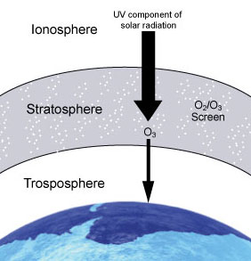

These manufactured chemicals, containing chlorine and/or bromine are called "ozone-depleting substances" (ODS). The use and popularity of these chemicals is due to their stability and low toxicity.

Chloroflurocarbons (CFCs) and halons have been used as:
- Foam-blowing agents  - Solvents | - Fire-extinguishing agents  - Refrigerants

However, their stability and long lifetime (up to several centuries) allows them to reach the stratosphere. The interaction of these molecules with ultraviolet light in the stratosphere leads to the generation of chlorine and bromine which in turn destroy stratospheric ozone.

- Effects of Depletion
The effects of increased intensity of ground-level UV radiation

Stratosphere ozone depletion leading to less efficient filtration of the ultraviolet radiation from the sun, will increase the intensity of ground level UV radiation. This increased intensity may have adverse effects on:
- Humans
- Agriculture and forestry
- Materials
- Marine ecosystems

Humans;
Such adverse effects include;
- Higher probability of sunburns, skin cancer and premature aging of skin
- More cataracts, eye diseases and blindness
- Immunosuppression (weakening of the human immune system)

Agriculture and forestry
Physiological and developmental process of major crop species (such as barley, rice and wheat) may be affected. The data available on the effect of more intense ultraviolet radiation on commercially important trees shows that plant growth is harmed.

Materials
Increased intensity of ultraviolet radiation may accelerate the degradation of materials such as fabrics, plastics, rubber and wood.

Marine ecosystems
- Increased intensity of ultraviolet radiation may;
- Damage marine life by decreasing the plankton. Such a decrease in plankton could disrupt the food chains leading to a shift in marine species in global waters
- Lead to decreased reproductive capacity reducing fish yields

- Control Strategies
In North America, the use of chlorofluorocarbons (as propellants in spray cans) was banned in 1978 in response to the threat of ozone depletion. The global response to the threat of ozone depletion came with the signing of the Montreal Protocol (in 1987). It set out to reduce and ultimately ban the manufacture and use of CFCs and other ozone depleting substances.

The international agreement has been effective in reducing risks in the long term; ultraviolet radiation remains a health hazard. In view of this, we as individuals should protect ourselves against it. NASA projections of stratospheric ozone concentrations from 1974 to 2060 if chlorofluorocarbons (CFCs) had not been banned.

