Module 7: Drugs and Medications

Introduction to Organic Chemistry

Organic chemistry deals with the study of carbon containing compounds and their reactions. Organic molecules are present in living organisms and in many products used in our everyday lives such as foods, household cleaning products, personal care products etc.

As the element carbon is present in the majority of drugs used today, some basic principles of organic chemistry (the study of carbon compounds) are discussed in this section.

The Element Carbon
The main characteristics of carbon that lead to the formation of such a large number of organic compounds (over 10 million known) with dramatically different physical and chemical properties include the ability to form:
- Covalent single, double and triple bonds with some other elements, including carbon.
- Covalent bonds with other carbon atoms to build chains and cyclic structures.
- Covalent bonds with elements such as hydrogen, nitrogen, oxygen and halogens.

In the structures shown below, each line (bond) represents a pair of electrons.
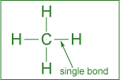 | 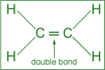 | 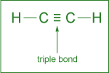
Single bond: formed by the sharing  of one pair of electrons. | Double bond: formed by the sharing  of two pairs of electrons. | Triple bond: formed by the  sharing of three pairs of electrons.

Arrangement of Atoms
Among the cyclic structures, the arrangement of carbon atoms in 5- or 6-membered rings is quite common. The hexagonal (6-membered) ring with three single and three double bonds is called a benzene ring.

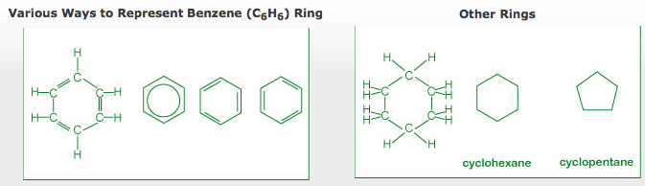
Functional Groups

- Alcohol
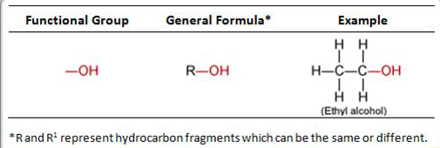

- Aldehyde

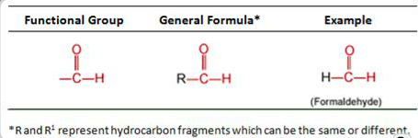

- Amine

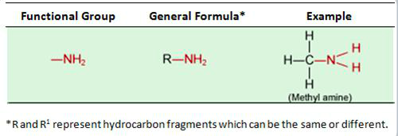

- Carboxylic Acid
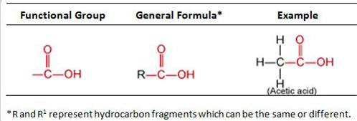

- Ester
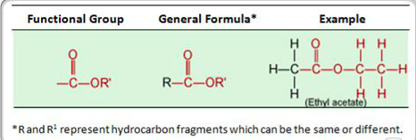

- Ether

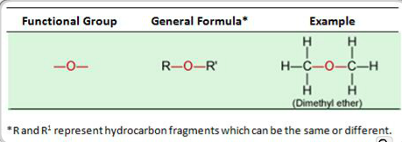

- Ketone
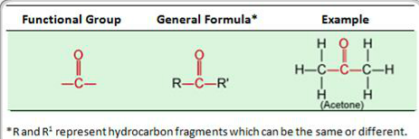

- More examples

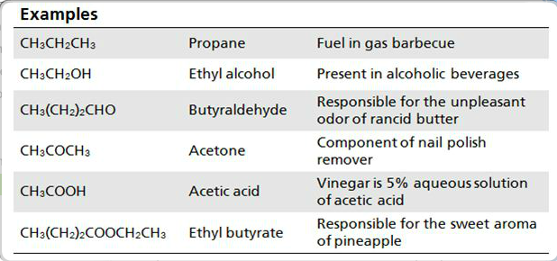

Many substances encountered in our everyday lives are composed of organic compounds containing one or more of the previously menttioned functional groups.

Treatment of Infections and Diseases

The Use of Chemicals as Drugs
This section explores the use of chemicals as drugs in the treatment of infections and diseases. A brief description of the classification and mode of action of such drugs is also presented.

Overview
From the Sumerians (2200 BC) to the present, the discovery and usage of drugs has gone through a number of phases such as:
- Medicinal preparations and concoctions from plants, minerals and animal sources.
- Isolation and the use of plant ingredients as medications.
- Synthesis and testing of a variety of chemicals as potential cures for ailments.
- New areas of research into marine plants and organisms as potential drugs.
- Molecular modeling in designing drugs.
Extensive research with the available sophistication in the field of medicine has led us to engineer molecules that can be used to improve the quality of life by preventing, moderating or curing illnesses.

Antibiotics
Antibiotics drugs are used to fight (prevention or treatment) bacteria that cause infectious diseases such as meningitis, pneumonia, tuberculosis, and so on.

Several different categories of antibiotics include;
- Penicillins
- Cephalosporins
- Tetracyclines
The discovery of a large number of chemically modified derivatives of these antibiotics led to the control of a large variety of bacterial infections. Antibiotics are isolated from bacterial sources, but can also be human made. Antibiotics act directly on bacteria and destroy them or inhibit their growth. Antibiotics will not kill viruses.

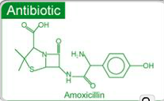

How do antibacterial drugs work?
The actual mechanism of antibacterial drugs is to alter or inhibit one of the following cellular stuctures/process;

- Cell wall synthesis: prevents new bacterial cells from forming by preventing formation of the cell wall.
- Cell membrane permeability: kills bacteria cells by causing breakdown of the outer cell membrane.
- Protein sunthesis: prevents the bacteria from converting proteins to energy, causing starvation and ultimate cell the death.
- Nucleid acid synthesis : keep bacteria cells from growing by interrupting DNA synthesis.
- Competitive inhibitor : mimics bacteria’s growth factors, thus preventing spreading of the bacteria.

Penicillins, Cephalosporins and Tetracyclines

Penicillins;
- Treat infections caused by bacteria
- Do not fight infections caused by viruses
- Mode of actions: affect the development of bacterial cell walls
Cephalosporins
- Cephalosporins have the structure similar to that of penicillins.
- Treat a much broader range of infections compared to penicillins
- Mode of action: affect the development of bacterial cell walls

Tetracyclines
- Chemicals stucture consisting of four rings
- Used to treat penicillins-resistant infections
- Mode of action : inhibit the synthesis of required bacterial proteins

Antiviral Drugs

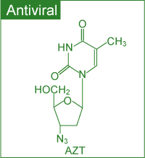

Antiviral drugs are used to treat (cure or control) viral infections such as flu, polio, herpes and AIDS (Acquired Immune Deficiency Syndrome). A different strategy has to be used to combat viruses, as these do not respond to antibiotics. Two commonly used strategies to fight viral infections include:

Prevention through vaccination
When a vaccine (consisting of inactivated virus) is injected, antibodies to fight off a virus are developed and stored in the body. The stored antibodies become available to fight future infection.

Use of antiviral drugs
Commonly used antiviral drugs (particularly for the treatment of the AIDS virus) fall into three classes:
- Nucleoside derivatives inhibit the synthesis of viral DNA, thus preventing the virus from spreading.
- Protease inhibitors, on the other hand, interfere with the viral protein formation, thus preventing their reproduction.
- A three-drug cocktail consisting of different nucleoside derivatives and protease inhibitors has shown considerable promise in the treatment of AIDS. This triple cocktail treatment is also known as Highly Active Antiretroviral Therapy (HAART). The success of the therapy is probably due to the cocktail's ability to disrupt the viral replication at different stages. It is important to note that the therapy is very expensive and patients must adhere to their dosing schedule.

Some major problems associated with multiple drug therapy are: Moderate effectiveness, lack of response in some cases, serious to severe side effects and drug resistance by the virus. Recent efforts in the fight against AIDS have been directed towards the development of: Viral entry inhibitors (i.e., the drugs that
will prevent HIV from attaching and consequently entering into the cell) and Vaccines.
Anticancer Drugs
Cancer involves an uncontrolled division of some cells of the body due to mutation of DNA within the healthy cells. These cells invade nearby tissue and spread throughout the body via the bloodstream or lymphatic system. Thus the chemical treatment of cancer (chemotherapy) involves drugs targeting rapidly dividing cells to kill the cancerous cells. Some chemotherapeutic agents include;

- Alkylating agents
- Antimetabolites
- Topoisomerase inhibitors
- Hormones

- Alkylating Agents
- Mode of action: due to their high reactivity, alkylating agents introduce defects in the DNA, thus killing the rapidly growing cells b preventing cell growth and multiplication.
- Alkylating agent drugs also affect the growth of normal cells and cause mutations.

- Antimetabolites:
- Metabolite is a general term for the organic compounds that are synthesized, recycled, or broken down in cells.
- Antimetabolites inhibit DNA synthesis, thus stopping cell replication.
- Mode of action: compete for binding sites on enzymes and are incorporated into nucleic acids.

- Topoisomerase inhibitors
- Topoisomerase inhibitors damage DNA which causes cell death.
- Mode of action; act against the topoisomerase enzymes to prevent cancer cell growth

- Hormone therapy
- Used against certain cancers that depend on hormones for their growth. This therapy is used primarily for the treatment of breast cancer and that of the sexual organs. As these tissues require hormones for their growth, the chemotherapeutic agent acts by inhibiting the hormone supply thus stopping the tissue growth.
- Mode of action: stop the production of certain hormones or change their mode of function.

Antidepressants
A deficiency of certain neurotransmitters (any chemical that carries impulses between nerve cells), particularly serotonin in the brain, seems to be partly responsible for causing clinical depression. Neurotransmitters are needed for normal brain function and mood control, in addition to other functions.
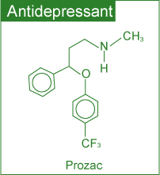
Although the effects of antidepressants are not fully understood, there is substantial evidence to show that antidepressants help to restore the brain’s chemical balance.

Commonly used antidepressants include:
- Selective Serotonin Reuptake Inhibitors (SSRIs) (e.g. Prozac, Paxil and Zoloft)
- Monoamine Oxidase Inhibitors (MAOIs) (e.g. Nardil, Marplan and Parnate)
- Serotonin and Norepinephrine Reuptake Inhibitors (e.g. Effexor)
- Norepinephrine and Dopamine Reuptake Inhibitors (e.g. Welbutrin)
- Tricyclics (e.g. Norpramine, Pamelor and Tofranil)

Whereas SSRIs target the serotonin levels only, tricyclics affect the brain levels of other neurotransmitters (including serotonin) as well.

Anti-Inflammatory Drugs
Inflammation is the first response of the immune system to infection or irritation characterized by pain, swelling, redness and heat. An inflammation results from the rapid transport of blood proteins and other substances to a damaged tissue site or an area under attack by a foreign organism.

Certain steroids are used as potent anti-inflammatory drugs. These suppress the inflammatory responses of the body, thus reducing inflammation.

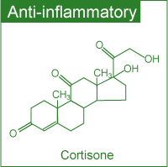

Use of OTC drugs
Whereas all types of drugs discussed earlier require a prescription, a considerable number of drugs are sold OVER THE COUNTER (OTC) without a prescription.

According to the Non Prescription Drug Manufacturers Association, in the US alone there are more than six hundred OTC drugs.

OTC drugs Criteria :

The criteria generally used by the regulatory agencies to designate a drug with OTC status or switch its status from Rx-to- OCT (i.e. from a prescription drug to one sold without a prescription.) involves a benefits-risk comparison and making sure that patients alone can achieve the desired medical result without endangering their safety.

Although OTC drugs allow patients to participate in their own health care, experts emphasize that the labels must be followed closely because OTC drugs are not without risk.

Aspirin- The best known OTC drug

Aspirin, was introduced more than a century ago. It has long been used as an :
- Analgesic (relieving from pain)
- Antipyretic (lowering fever)
- Anti- inflammatory ( reducing swelling )drug

Recent studies have shown its usefulness in treating heart attack and stroke

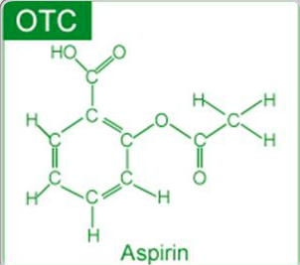

Aspirin- Effectiveness and Side effects

It is believed that Aspirin’s effectiveness as an analgesic, anti-inflammatory agent and its pretective effects against heart attacks and strokes are due to its ability to reduce the production of prostaglandins ( a hormone-like substance that promotes inflammation, fever and pain) and thromboxanes (responsible for platelet aggregation in he formation of blood clots)in the body.

Some possible side effects of Aspirin include;
- Stomach irritation
- Ringing in the ears
- Allergy
- Reye syndrome 9brain disorder )in children

Drug Delivery Systems
Active pharmaceutical ingredient (API) in a medicine is delivered to the body in many forms, such as tablets, gelcaps, liquids and so on. Some newer alternate methods for drug delivery have been developed with three major advantages:
- User convenience
- Improved drug performance
- Better patient compliance

Some of these methods include:

- Pulmonary delivery: The system is noninvasive and facilitates the rapid absorption of the drug on the large surface area of the lungs followed by rapid desorption into the bloodstream.
- Skin absorption: Skin patches are being used to deliver the medication via skin absorption.
- Nanocrystals: This method reduces the drug particle size to nanoscale (<400 nm) making it more soluble in body fluids.

Effects & Trends

Environmental Effects of Pharmaceuticals
Recent research has led scientists to be concerned about the environmental impact of old and/or expired medications that are discarded. The pharmaceuticals enter the environment mostly through raw or treated sewage.

Some of the effects observed include:
- Feminization of male fish due to estrogenic compounds: The signs of feminization in male fish have been concluded as a response to estrogen (in birth control pills) exposure.
- Slow development of fish and frogs due to certain antidepressants: Profound effects on spawning and other behaviours in shellfish can occur with antidepressants such as Selective Serotonin Reuptake Inhibitors (SSRIs).

Recent Trends in Pharmaceutical Development
In the field of pharmaceutical development the present trends include:
- A shift from blockbuster drugs (drugs that work for a large number of patients) to personalized medicine: In personalized medicine, therapies are catered towards genetic profiles of patients and their diseased cells.
- Exploring marine organisms in an attempt to obtain new compounds with therapeutic potential: Several of these compounds are being investigated as potential anticancer agents, analgesics and anti-inflammatory drugs.

Medications & Health
Drugs should not be considered risk-free chemical substances. It is strongly recommended by health professionals that patients should always bear in mind the fact that medications have side effects and may have serious interactions with other medications, dietary supplements, food and beverages consumed.

In order to reduce risks, it is strongly recommended that all individuals:
- Read drug labels carefully.
- Learn about the warnings of all drugs taken.
- Inform health care providers of all prescription and OTC drugs and dietary supplements taken.
- Keep a record of all medications taken.

