Marketing Study Notes Chapter 7
Chapter Objectives:
- Describe the importance of global marketing from the perspectives of the individual firm and the nation.
- Identify the major components of the environment for global marketing.
- Outline the basic functions of GATT, WTO, IMF, NAFTA, FTAA, and the European Union.
- Identify the alternative strategies for entering international markets.
- Differentiate between a global marketing strategy and a multi-domestic marketing strategy.
- Describe the alternative marketing mix strategies used in global marketing and explain the attractiveness of Canada as a target market for international marketers.

- Exporting refers to the marketing of domestically produced goods and services abroad.
- Importing refers to the purchasing of foreign goods and services.
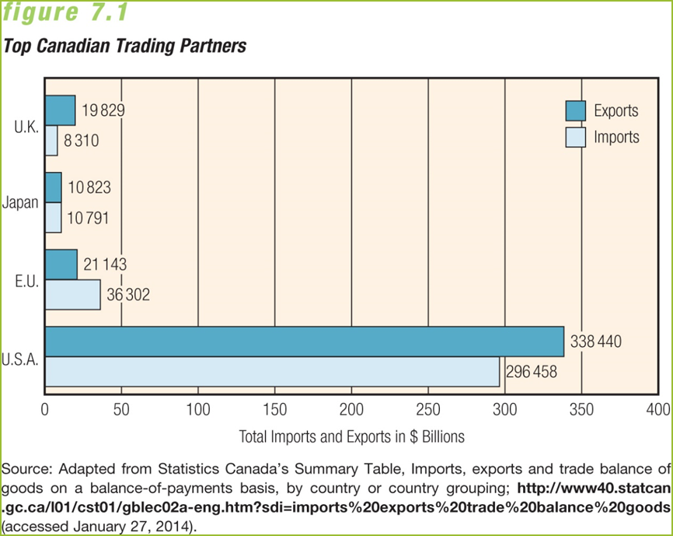

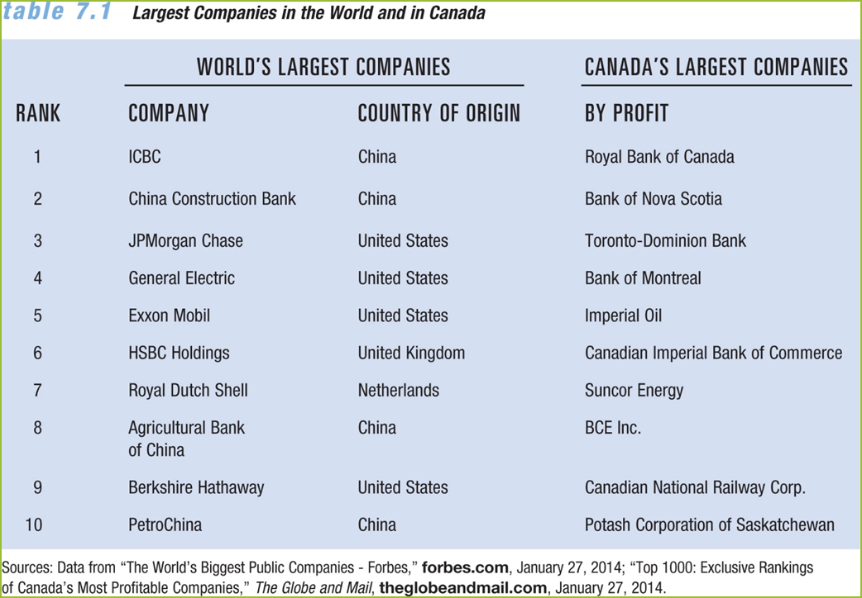

Benefits of Going Global:
- Additional revenue
- New insights into
customer behaviour
- Alternative distribution
strategies
- Advance notice of
new products
- Exposure to new
marketing techniques
The International Marketing Environment
- International economic environment
- International social-cultural environment
- International technological environment
- International political-legal environment
International Economic Environment:
- National factors: A nation’s size, per-capita income, and stage of economic development
- Infrastructure: Infrastructure is a nation’s underlying foundation for modern life (transportation, communications, banking, utilities, and public services)
- Exchange rate: An exchange rate is the price of one nation’s currency in terms of another nation’s currency.
- Fluctuations in rates make a nation’s currency more or less valuable, compared to that of other nations.
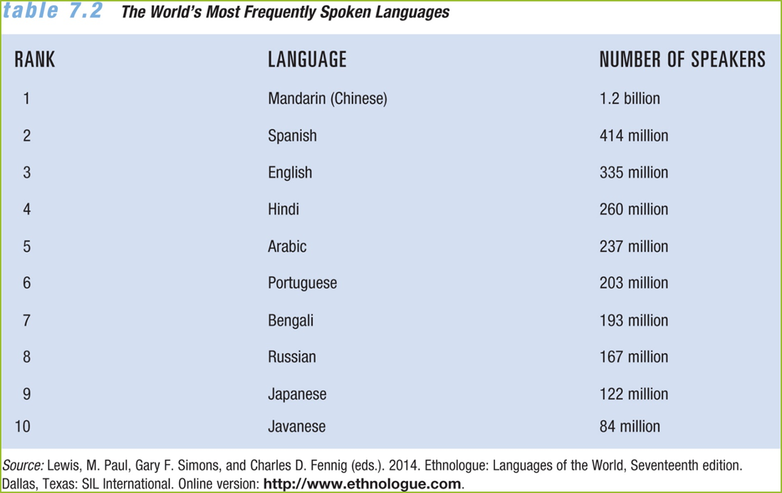
International Technological Environment:
- More than any innovation since the phone, the Internet has made it possible for both large and small firms to be connected to the entire world.
- The Internet transcends political, economic, and cultural barriers.
- It has allowed existing businesses to add new channels.
- It has helped developing nations compete with industrialized ones.
- Technology presents challenges for international marketers that include cultural responses to certain new technologies (example: genetic reengineering).
International Political-Legal Environment:
- International law involves treaties, conventions, and agreements.
- Since the 1990s Europe has pushed for mandatory ISO (International Organization for Standardization) certification, which ensures that a firm’s goods, services, and operations meet established standards.
- ISO has two standards: the 9000 series sets standards for goods and services; the 14000 series sets standards for operations to minimize harm to the environment.
- The International Monetary Fund (IMF) lends foreign exchange to nations that require it, in agreements that facilitate the entire process of world marketing.
- The Canadian legal environment includes trade regulations, tax laws, and import/export requirements.
- Government agencies involved in administering laws regarding international trade include Agriculture and Agri-Food Canada; Trade and Development Canada.
- Legal requirements in host nations can affect foreign trade, so firms follow local laws in certain nations while upholding principles found in Canadian law.
Multinational Economic Integration:
- A trend toward multinational economic integration has developed since the end of World War II.
- Ways to achieve multinational economic integration:
- Free-trade area—Allows participating nations to agree to the free trade of goods among themselves, abolishing tariffs and trade restrictions.
- Customs union—Establishes a free-trade area plus a uniform tariff with non-member nations.
- Common market—Extends a customs union by seeking to reconcile all government regulations affecting trade.
- There are two sides to the trade issue:
- Not everyone is happy about free trade, especially those who are concerned about jobs being outsourced to low-wage nations, factories being relocated overseas, and resulting pay cuts or potential job losses.
- Innovation and productivity tend to grow quickly with free trade, but workers often find themselves working longer hours for lower pay.

GATT and the World Trade Organization:
- The General Agreement on Tariffs and Trade (GATT) is a trade accord that has reduced worldwide tariffs and has existed for over six decades.
- Other results of this latest GATT conference:
- Reduced farm subsidies
- Increased protection for patents, copyrights, and trademarks.
- Included services under international trading rules
- Phased-out import quotas on textiles and clothing
- The World Trade Organization (WTO) is a 153-member organization created to succeed GATT—Now overseeing GATT agreements, mediating disputes, and reducing trade barriers.
- Unlike GATT, WTO decisions are binding, and nations go through rounds of negotiations to become members.
The International Monetary Fund (IMF):
- Organization of 188 countries
- Created in 1945, the IMF is governed by and accountable to the 188 countries that make up its near-global membership
- It’s goals are to:
- Foster global monetary cooperation, secure financial stability, and facilitate international trade
- Promote high employment and sustainable economic growth, and reduce poverty around the world
NAFTA:
- North American Free Trade Agreement (NAFTA)
- Accord removing trade barriers between Canada, Mexico, and the United States
- All three member nations have seen GDP increases
The Free Trade Area of the Americas (FTAA):
- Proposed Not Official. FTAA would be a free-trade area through the Western Hemisphere, from Alaska to Cape Horn, encompassing 34 nations, a population of 800 million, and a combined GDP of $11 trillion.
- It would be the world’s largest free-trade area, featuring no tariffs, streamlined customs, and no quotas or subsidies.
The European Union (EU):
- 28 Countries Customs union that is moving in the direction of an economic union by adopting a common currency, removing trade restrictions, and permitting free flow of goods and workers throughout the member nations
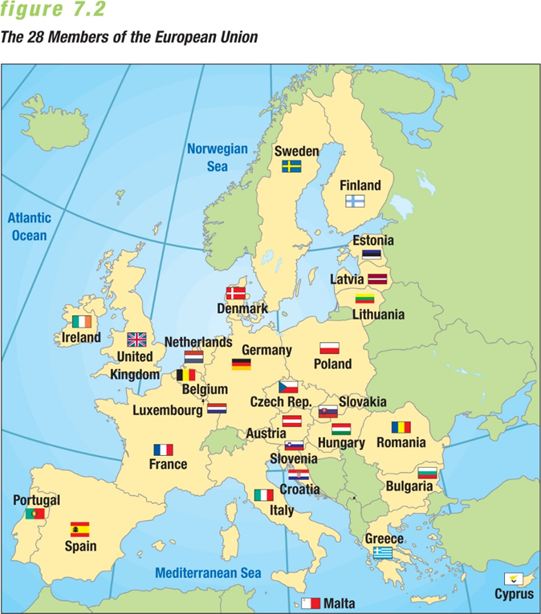
Going Global
  - Globalization now affects almost every industry and every individual in the world, at least in some way.
  - Firms may become global because they already have a strong domestic market that’s saturated with little chance of growth.
  - By evaluating key indicators of the marketing environment, marketers can move toward globalization at an optimal time.
Reasons for going global: globalization of customers, new customers in emerging markets, globalization of competitors, reduced trade barriers, advances in technology, and enhanced customer responsiveness

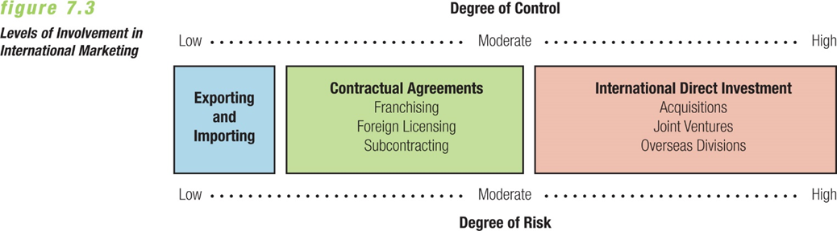
Contractual Agreements:
- A franchise is an agreement in which a wholesaler or retailer (franchisee) agrees to meet the operating requirements of a manufacturer or other franchiser.
- The franchisee gets the right to sell the products and use the franchiser’s name as well as its marketing and management services.
- One advantage of franchising is risk reduction by offering a proven concept.
- Foreign licensing is an agreement that grants foreign marketers the right to distribute a firm’s merchandise or use its trademarks, patents, or processes in a specific geographic area.
- If offers advantages over exporting, including access to a local partner’s marketing information and distribution channels, protection from legal barriers, no capital outlay, quick entry into a foreign market, and access to markets that are closed to imports or direct investments.
- Example: Beer companies, are licensed to be brewed and sold in other countries.
- Subcontracting is an agreement that allows the production of goods and services by local companies.
- Using local subcontractors can prevent mistakes involving local culture and regulations, can avoid import duties, and can lower costs.
International Direct Investment:
- Forms of direct investment:
- Acquisition of an existing firm in another country
- Setting up of an independent division
- Formation of joint ventures
Developing an International Marketing Strategy:
- Global marketing strategy
- Standard marketing mix with minimal modification in all foreign markets
- Multi-domestic marketing strategy
- Customization of marketing strategies to effectively reach individual markets
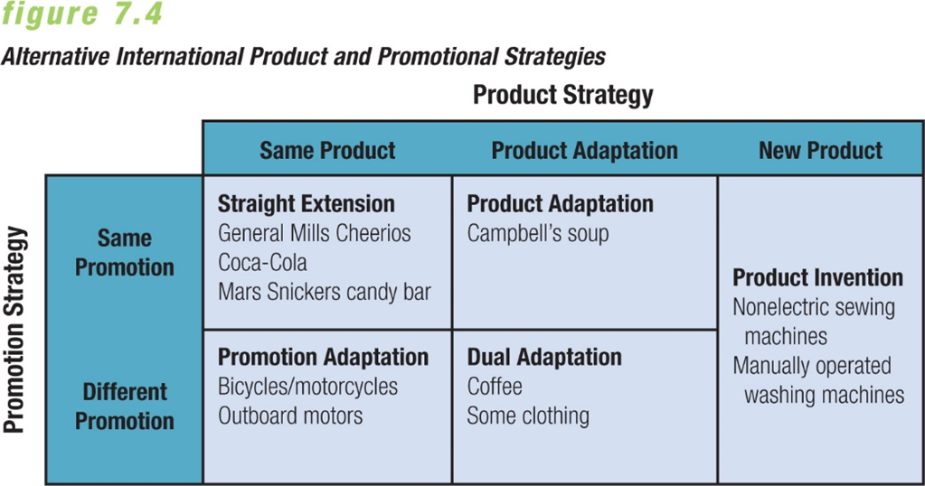

Pricing Strategy:
- Pricing can affect the success of an overall marketing strategy in foreign segments, and pricing decisions may be constrained by competitive, economic, political, and legal factors.
- Companies should adapt their pricing strategies to local markets and change them when conditions change.
- A key development has been the emergence of commodity marketing organizations that seek to control prices through collective action (such as OPEC).
Countertrade:
- In many nations, the only way a marketer can gain access is through countertrade—a form of exporting in which a firm barters products rather than selling them for cash.
- Less developed nations sometimes impose countertrade requirements when they lack the foreign currency to attain the products or services they need or want.
- It became popular two decades ago when firms wanted to conduct business in Eastern European nations that banned exchanges of hard currency
Canada as Target for International Marketers:
- Foreign marketers regard Canada as an inviting target:
- High level of discretionary income
- Relative political and economic stability
- Favourable attitude toward foreign investment
- Natural Resources

