Marketing Study Notes Chapter 6
Chapter Objectives:
- Explain each of the components of the business-to-business (B2B) market.
- Describe the major approaches to segmenting business-to-business (B2B) markets.
- Identify the major characteristics of the business market and its demand.
- Discuss the decision to make, buy, or lease.
- Describe the major influences on business buying behaviour.
- Outline the steps in the organizational buying process.
- Classify organizational buying situations.
- Explain the buying centre concept.
- Discuss the challenges of and strategies for marketing to government, institutional, and international buyers.
B2B Marketing:
- Business-to-business (B2B) marketing – Organizational sales and purchases of goods and services
- usually sell fewer standardized products to organizational buyers than to ultimate consumers. Purchases often require greater customization, more decision making, and usually more decision makers
- Advertising plays a much smaller role in the business market than in the consumer market
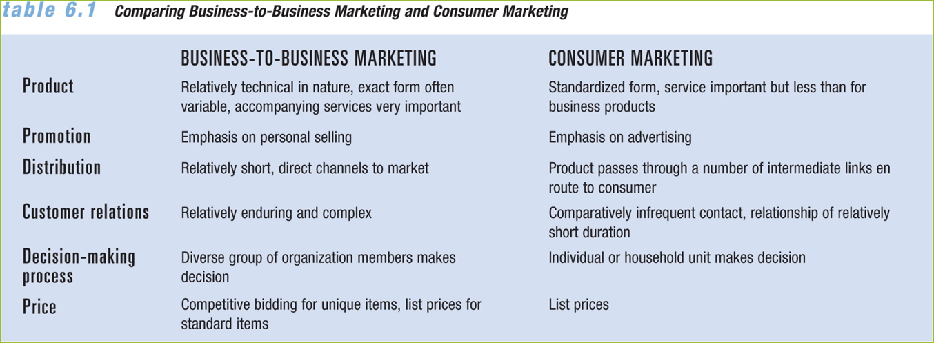
Influences in B2B markets:
- Environmental
- Organizational
- Interpersonal
- An organization’s goals must be considered in the B2B buying process
- Some companies focus only on B2B markets
Components of the Business Market:
- Commercial market – Individuals and firms that acquire products to support, directly or indirectly, production large portion of online sales. Largest in terms of the three segments.
- Trade industries – Retailers and wholesalers that purchase for resale
- Government (federal, provincial, municipal, foreign)
- Institutions (public and private)
- 91 percent of all Internet sales are B2B transactions
- Opens up foreign markets to sellers
Differences in Foreign Business Markets:
- May differ due to variations in regulations and cultural practices
- Businesses must be willing to adapt to local customs and business practices and research cultural preferences
Segmentation of B2B Markets:
- Segmentation helps marketers develop the most appropriate strategy
- Segmentation by demographic characteristics
- Grouping by size, based on sales revenues or number of employees
- Customer-based segmentation – Dividing a business-to-business market into homogeneous groups based on buyers’ product specifications
- North American Industry Classification System (NAICS) – Classification used by NAFTA countries to categorize the business marketplace into detailed market segments
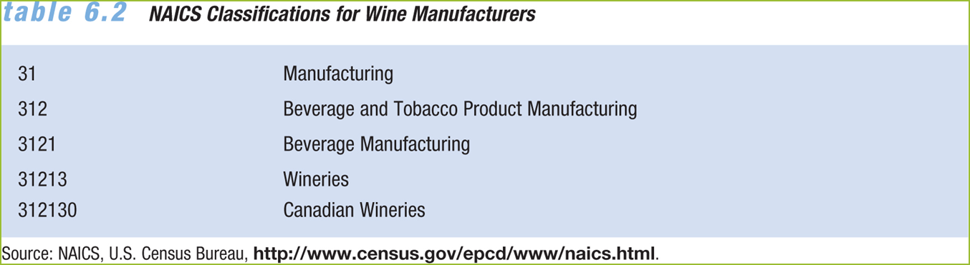
- End Use Segmentation: Segmenting a business-to-business market based on how industrial purchasers will use the product
- Segmentation by Purchase Category:
- Consider whether the customer has made previous purchases or this is the customer’s first order
- CRM customer relationship management systems can help segment customers in terms of the relationship between the business and the customer

Characteristics of the B2B Market:
- Geographic market concentration
- More concentrated than the consumer market
- Certain industries locate in particular areas to be close to customers.
- Due to the Internet, business markets may become less geographically concentrated
The Purchase Decision Process:
- Suppliers who serve B2B markets must work with multiple buyers
- The purchasing process is more formal and professional than the consumer market
- Purchasers require a longer time frame
- B2B involves more complex decisions
Evaluating International Business Markets:
- Global sourcing – Purchasing goods and services from suppliers worldwide
- Can bring significant cost savings but requires adjustments
- India, China, and Malaysia are the world’s top destinations for global IT sourcing, while Egypt, Jordan, and Vietnam recently moved up to make the top ten list.
Categories of Business Market Demand:
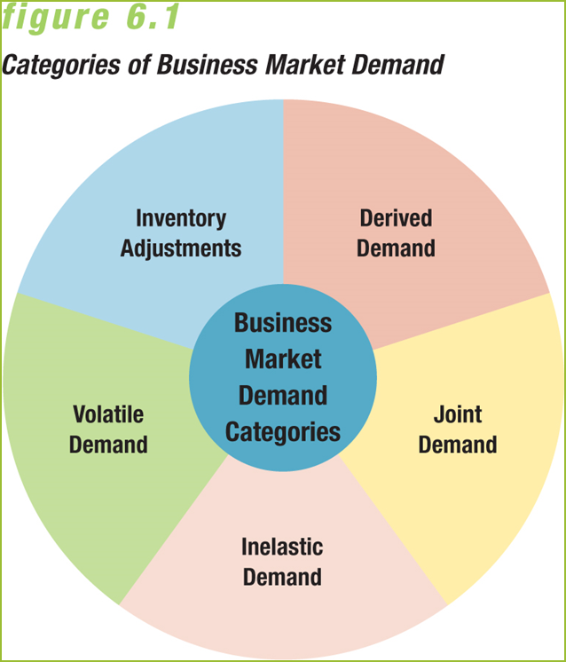
Derived Demand:
- The linkage between demand for a company’s output and its purchases of resources
- Example: Demand for computer microprocessor chips is derived from demand for personal computers
- Organizational buyers purchase:
- Capital items
- Expense items
Volatile Demand/Joint Demand:
- Volatile demand — Demand is more volatile in business markets; created by derived demand
- Example: Demand for gasoline pumps may be reduced if demand for gasoline slows down
- Joint demand — Demand for a product that depends on the demand for another product used in combination with it
- Example: If the supply of lumber falls, the drop in housing construction will affect the demand for concrete
Inelastic Demand:
- Derived throughout an industry; will not change significantly due to a price change
- Example: Construction firms will not necessarily buy more lumber if prices fall unless the overall demand for housing also increases
Inventory Adjustments:
- Adjustments in inventory and inventory policies can also affect business demand
- Just-in-time (JIT) – Inventory policies boost efficiency by cutting inventory and requiring vendors to deliver inputs as they are needed by the production process
- JIT leads to sole sourcing – Buying entirely from just one vendor
- Latest inventory trend
- JIT II – Leads suppliers to place representatives at the customer’s facility to work as part of an integrated, on-site customer-supplier team
- Inventory adjustments are vital to wholesalers and retailers too

- Firms acquiring finished goods have three options:
  - Make the good or provide the service in-house
  - Purchase it from another organization
  - Lease it from another organization
The Rise of Offshoring and Outsourcing:
- Offshoring – Movement of high-wage jobs from one country to lower-cost overseas locations
- Nearshoring – Moving jobs to vendors in countries close to the business’s home country
- Canada is an attractive nearshoring location for U.S. firms
- Outsourcing – Using outside vendors to provide goods and services formerly produced in-house
Reasons:
  - Cost reduction
  - Quality and speed of software maintenance and development
  - Greater value

Problems with Offshoring and Outsourcing:
- Cost savings are less than expected
- Can raise security concerns over proprietary technology or customer data
- Can reduce company’s ability to respond quickly to marketplace
- Can create conflicts between nonunion outside workers and in-house union employees
- Can negatively affect employee morale and loyalty
Environmental Factors on Business Decisions:
Environmental Factors
- Economic, political, regulatory, competitive, and technological considerations influence business buying decisions
- Multiple sourcing—ensures against shortages if one vendor cannot deliver on schedule. However, dealing with many sellers can be counterproductive and take too much time. Each company must set its own criteria for this decision.
Role of Merchandisers and Category Advisors:
- Merchandisers – Trade sector buyers who secure needed products at the best possible prices
- Functions of a merchandising unit:
- Determining needs
- Locating and evaluating alternative suppliers
- Making purchase decisions
- Systems integration – Centralization of the procurement function within an internal division or as a service of an external supplier
- Category advisor – Trade industry vendor who develops a comprehensive procurement plan for a retail buyer

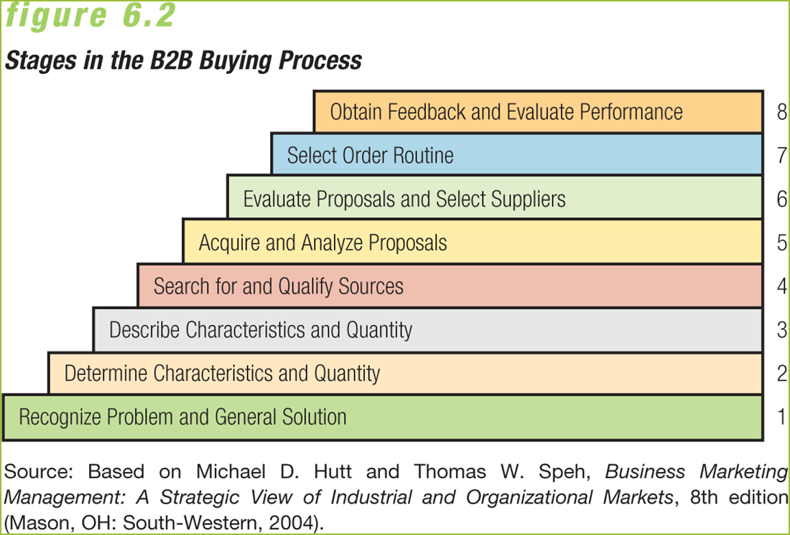
Classifying Business Buying Situations:
- Straight rebuy
- A recurring purchase decision in which a customer repurchases a good or service that has performed satisfactorily in the past
- Modified rebuy
- Situation in which a purchaser is willing to re-evaluate available options for repurchasing a good or service
- New-task buy: First-time or unique purchase situation that requires considerable effort by decision makers
- Reciprocity: Buying from suppliers who are also customers
Analysis Tools:
- Value analysis – Systematic study of the components of a purchase to determine the most cost-effective approach
- Vendor analysis – Assessment of supplier performance such as price, back orders, timely delivery, and attention to special requests
The Buying Centre Concept:
- Buying centre – Participants in an organizational buying action
- Buying centre roles
- Users – People who will use the good or service
- Gatekeepers – Control the information that all buying centre members will review
- Marketers have trouble identifying members of foreign buying centres because of cultural differences in decision-making methods
- International buying centres can change in response to political and economic trends
Developing effective Business to Business Marketing Strategies:
- Challenges of government markets
- The government buys products under two basic types of contracts:
- Fixed-price contracts
- Cost-reimbursement contracts
- Purchasing procedures largely determined by size of purchase
- Institutional buyers – schools, hospitals, libraries, foundations, clinics, churches, and not-for-profit agencies
- Widely diverse buying practices
- Multiple buying influences can affect buying decisions
- Group purchasing is an important factor
- International Buyers: Local industries, economic conditions, geographic characteristics, and legal restrictions must be considered
- Remanufacturing – efforts to restore older products to like-new condition
- Foreign governments are an important business market

