Marketing Study Notes Chapter 5
Chapter Objectives:
- Define Consumer Behaviour and describe the role it plays in marketing decisions
- Describe the personal determinates of consumer behaviour: Cultural, Social and Family influence
- Explain each of the personal determinants of consumer behaviour: needs and motives, perceptions, attitudes, learning, and self-concept theory.
- Distinguish between high-involvement and low-involvement purchase decisions.
- Outline the steps in the consumer decision process.
- Differentiate among routinized response behaviour, limited problem solving, and extended problem solving by consumers.
Consumer Behaviour:
- Process through which buyers make decisions
- Builds on understanding of human behaviour
- The relationship states that B = f(P, E).
- Behaviour (B) is a function (f) of the interactions of personal influences (P) and pressures exerted by outside environmental forces (E)
The Consumer Decision Process:
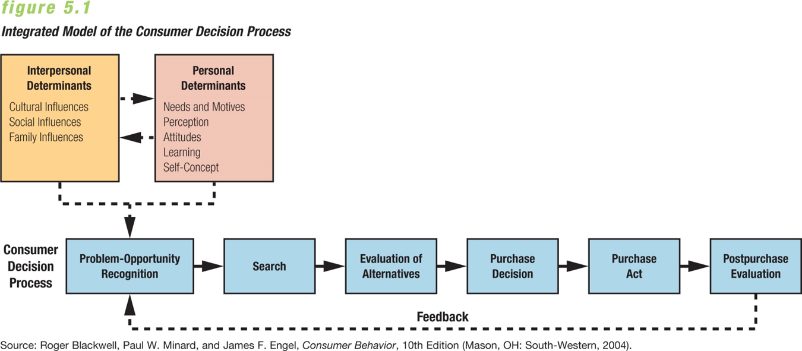
Interpersonal Determinants of Consumer Behaviour:
- Cultural influences
- Social influences
- Family influences

Cultural Influences:
- Culture refers to the values, beliefs, preferences, and tastes handed down from one generation to the next.
- It is the broadest environmental determinant of consumer behaviour, so marketers need to understand its role in consumer decision making, both here and abroad.
- Marketing strategies that work in one country or region may be offensive or ineffective in another, especially where population is quickly diversifying.
- Example: Canadians spend more on experiences and American’s like to accumulate wealth and products like cars, houses
- Cultural influences include
- Core values- broad and limited change
- Cultural values may change, but core values do not.
- Strong Canadian core values include a balance between individualism and collectivism, tolerance and acceptance, quality of life and peace
- Microcultures- sub cultures, nationality, geography, social group/ status
- Each culture contains microcultures—groups with their own distinct modes of behaviour—that in Canada differ by ethnicity, nationality, age, religion, geography, and urban versus rural location. EXAMPLES:
- Quebecois- tend to live in more cities than rural, more brand loyalty
- Chinese Canadians save 24% of annual income different from other Canadians who struggle with savings
- South-Asian Canadians- This group is expected to be the largest cultural group by 2031, younger generation

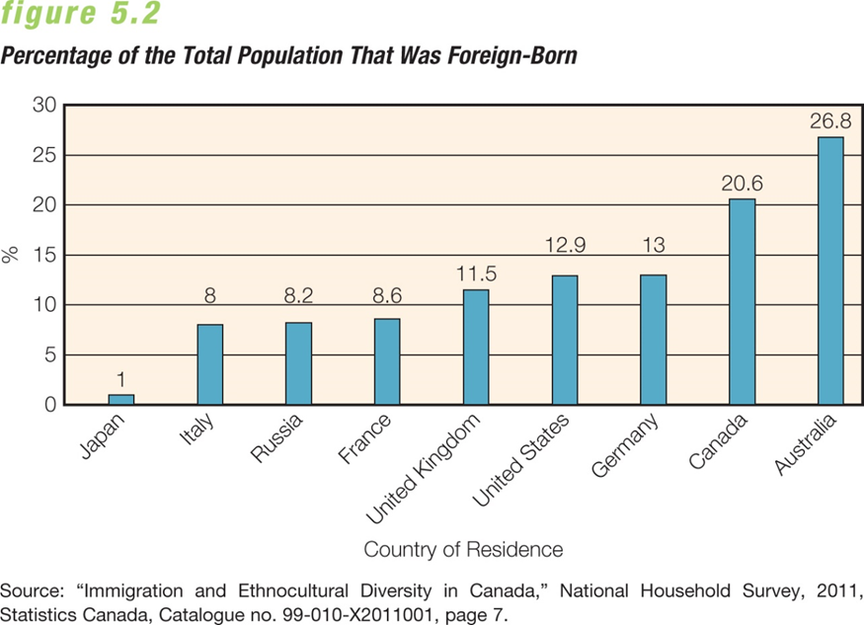

Social Influences:
- Includes- Reference groups, Social Classes and Opinion Leaders
- Every consumer belongs to a number of social groups.
- Groups influence an individual’s purchase decisions and behaviour in both overt and subtle ways.
- Groups establish norms, which are values, attitudes, and behaviours that a group deems appropriate for its members and even for nonmembers who aspire to join.
- Buying behaviour is affected by differences in group status and role.
- Status refers to the relative position of any individual member in a group.
- Role refers to formal or informal guides for behaviour that is expected of members who hold specific positions in the group.
- People often make purchases that reflect their status within a group, particularly regarding expensive purchases within affluent groups.
- The Asch Phenomenon Theory of psychologist S.E. Asch that individuals conform to majority rule, even if that majority rule goes against their beliefs
Reference Groups
- People or institutions whose opinions are valued
- Influence of reference group depends on two conditions:
- Purchased product must be seen and identifiable
- Purchased product must be conspicuous rare or unusual , something that not everybody owns
- Reference groups tend to create “elastic consumers”—consumers who make decisions to save or splurge in the same economy.
- Children are especially vulnerable to reference groups that they aspire to.
Social Classes:
- In North America, social class rankings are determined by occupation, income, education, family background, and residence location.
- Research has identified six classes in large and small North American cities—upper-upper, lower-upper, upper-middle, lower-middle, working class, and lower class.
- Income is not always the primary determinant of purchase behaviour, though ability to buy certain things has historically been a key factor in determining class.
- Family characteristics (such as occupation and income of one or both parents) are also critical elements.
- People in one social class may aspire to a higher class and exhibit buying behaviour common to that class rather than to their own.
- Marketers often attract consumers in higher social classes by offering exclusive memberships or special services not available to other buyers. Example BMW membership card
Opinion Leaders:
- Opinion leaders are trendsetters within a reference group who are likely to purchase new products before others in the group and then share their experiences and opinions via word of mouth.
- Generalized opinion leaders are rare; people with knowledge of or interest in specific products often take this role, found in all segments of the population.
- Information about goods and services may flow from the media (Internet, TV, radio, print) to opinion leaders and then to other consumers, or directly to consumers.
- Some opinion leaders influence purchases by others merely through their own actions, which consumers decide to emulate.
Family Influences:
- The family group is perhaps the most important determinant of consumer behaviour because of close and ongoing interactions among members.
- Each family has norms of expected behaviour, and different roles and status relationships for its members.
- The family structure in Canada is changing: There are more single heads of households due to separation or divorce. Women are having fewer children. More women and seniors are living alone.
Roles in Family Spending
- Autonomic role—partners independently make equal numbers of decisions
- Husband-dominant role—the husband makes most of the purchase decisions
- Wife-dominant role—the wife makes most of the purchase decisions
- Syncratic role—both partners jointly make decisions
- The increase in two-income households has changed household purchasing behaviour.
- Women have more say in large purchases and often take the lead—joint purchases are more likely.
- More shopping occurs in evenings and on weekends.
- Women now outspend men in the purchase of electronics and men are doing more of the grocery shopping and child care.
- Children and Teenagers influence family spending, they also tend to shop more online than older generations
Personal Determinants of Consumer Behaviour:
- Needs and motives
- Perception
- Attitudes
- Learning
- Self-concept
Needs and Motives:
- A need is an imbalance between the consumer’s actual and desired states.
- Someone who recognizes or feels a significant or urgent need then seeks to correct the imbalance.
- Marketers arouse this sense of urgency by making a need “felt” and suggesting a product to satisfy it.
- Motive- Inner state that directs a person toward the goal of satisfying a need
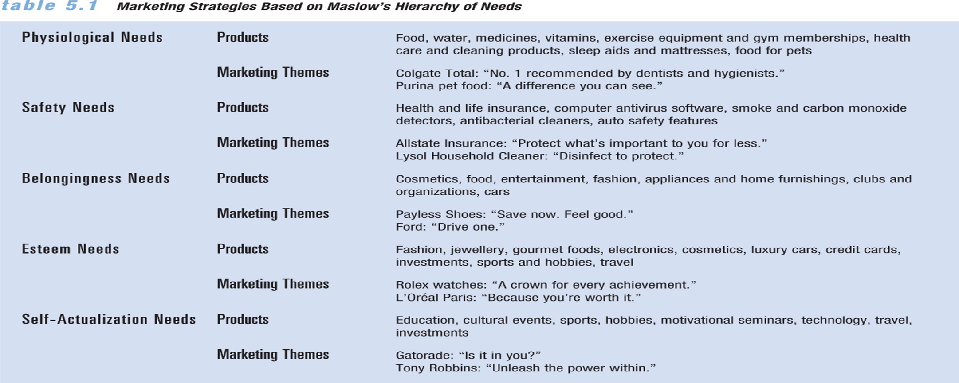
Perception:
- Meaning that a person attributes to incoming stimuli gathered through the five senses
- Stimulus factors—characteristics of the physical object (size, colour, weight, shape).
- Individual factors—unique characteristics of the individual (sensory processes, experiences with similar inputs, basic motivations, and expectations).
Perceptual Screens:
- Perceptual screens: the mental filtering processes through which all inputs must pass
- People ignore many ads and only respond to those who get their attention
- Marketers determine which stimuli evoke good responses, then create a message that stands out and gets the attention of prospective customers.
- Doubling the size of a print ad, use of white space, dark backgrounds, or colour also attract viewers.
- Word-of-mouth marketing can get attention by a more natural path of conversation.
- Technology—virtual reality displays information via merchandise tours and social media such as Facebook, Twitter, and LinkedIn.
- Selective perception leads to brand loyalty as customers tune out information that doesn’t match existing beliefs and expectations.
Attitudes:
- Person’s enduring favourable or unfavourable evaluations, emotions, or action tendencies toward some object or idea
- Every attitude has a cognitive, affective, and behavioural component.
- The cognitive component refers to the individual’s information and knowledge about an object or concept.
- The affective component deals with feelings or emotional reactions.
- The behavioural component involves tendencies to act in a certain manner.
- All components have stable, balanced relationships to one another to form an attitude about an object or idea.
Marketers have two choices regarding attitudes:
- (1) to encourage consumer attitudes that motivate purchase of a particular product, or
- (2) to evaluate existing consumer attitudes and make the product features appeal to them.
- If consumers view an existing item unfavourably, the seller may redesign it or offer new options.
Modifying the Components of Attitude:
- Attitudes frequently change in response to inconsistencies among the three components.
- Attitudes change when new information changes the cognitive or affective components of an attitude, such as when benefits are given or misconceptions are corrected.
- Attitudes change when buyers are engaged in new behaviour that gets them to try a product.
- Attitudes change when new technologies encourage consumers to change their attitudes.
Learning:
- Knowledge or skill that is acquired as a result of experience, which changes consumer behaviour
Learning process:
- Drive
- Cue
- Response
- Reinforcement
Apply Learning Theory to Marketing:
- Shaping refers to the process of applying a series of rewards and reinforcements to permit more complex behaviour to evolve over time.
- Both promotional strategy and the product itself play a role in the shaping process.
- The first step is getting consumers to try a product, possibly using a cue such as a sample or coupon.
- The second step is to entice the consumer to buy the product with little financial risk.
- The third step is to motivate the person to buy the item again at a moderate cost, with the only reinforcement being satisfactory performance.
- Finally, the consumer decides whether to buy the item at its true price without a discount.
Self-Concept Theory:
- Four components that influence purchasing decisions:
- Real self (objective view of a person)
- Self-image (how you see yourself)
- Looking-glass self (way others see you)
- Ideal self (what you want to aspire to be)
The Consumer Decision Making Process: Again for a visual KNOW THIS
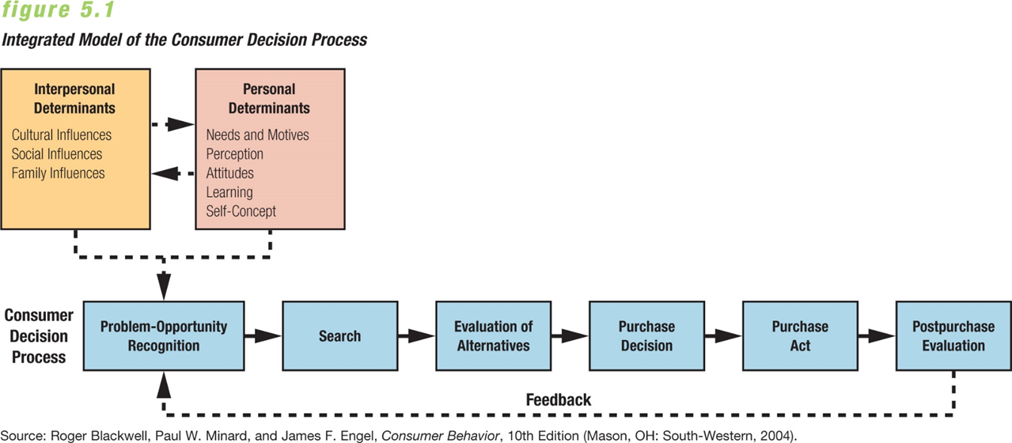
- High-involvement purchase decisions are those with greater levels of potential social or economic consequences.
- Low-involvement purchase decisions are routine purchases that pose little risk to consumers.
- Consumers invest more time and effort in high-involvement decisions, but they go through the steps for low-involvement decisions too.

- Problem or Opportunity Recognition:
- Consumer becomes aware of a significant discrepancy between the existing situation and a desired situation
- Search:
- consumer gathers information about attaining a desired state of affairs.
- The search identifies alternative ways to solve the problem using either internal sources (mentally reviewing or recalling past experience) or external sources (gathering opinions and information).
- The search identifies alternative brands to consider.
- The number of alternatives that a consumer actually considers is called the evoked set.
- In some searches the consumer knows the brands that merit further consideration; in others, external searches bring together this new information.

- Evaluation of Alternatives
- Consumer evaluates the evoked set of options, and as the search progresses, consumer accepts, distorts, or rejects information as it is received
- Evaluative criteria are the features that a consumer considers in choosing among alternatives.
- These criteria may be objective facts or subjective impressions.
- Common criteria include price, brand name, and country of origin, and can vary with the consumer’s age, income, social class, and culture
- Purchase Decision and Purchase Act
- After evaluating each alternative in the evoked set, the consumer decides where or from whom to make the purchase
- Post-Purchase Evaluation
- Buyer feels either satisfaction at the removal of the discrepancy between the existing and desired states or dissatisfaction with the purchase
- Cognitive dissonance which may increase in three cases:
- When the dollar value of the purchase increases
- When the rejected alternatives have desirable features
- When the purchase decision has a major effect on the buyer
Dealing with cognitive dissonance:
- It’s more often seen in high-involvement purchases. The consumer may focus on the item’s good points and ignore anything dissatisfactory.
- Marketers may help reduce cognitive dissonance by providing information that supports the chosen item.
- The consumer may decide to change products and vow to purchase the rejected item next time.

Classifying Consumer Problem-Solving Processes:
Routinized Response Behaviour:
- A consumer makes many routine purchases by choosing a preferred brand in a rapid problem-solving method called routinized response behaviour.
- The consumer has already set evaluative criteria and identified options, so any further external search is limited. It’s most common in buying very low-involvement products. Example Bread.
Limited Problem Solving:
- The consumer has already set evaluative criteria for a certain kind of purchase, but then encounters a new, unknown brand. The buyer spends a moderate amount of time and effort in external searches and in applying the evaluative criteria to assess the new brand.
- This limited problem solving is affected by the number of evaluative criteria and brands, the extent of external search, and the process for determining preferences. Example Shaving Razors.
Extended Problem Solving:
- The consumer feels that brands are difficult to categorize or evaluate, so begins to compare one with another. The consumer needs to understand the product features before evaluating alternatives.
- This extended problem solving refers to a lengthy external search, usually in high-involvement purchase decisions. Example Cars.

