Basic Computer
Ceg2136

Alexey Borisenko 4701816
Boris Smaryanakis 4623651

16 December
Objectives
Main objectives of this lab:
- Understanding the timing and control of a basic computer.

Sub-tasks:
- Drawing the design for a basic computer.
- Simulating and testing the functions of the computer on the altera board.
Experiment
Part I

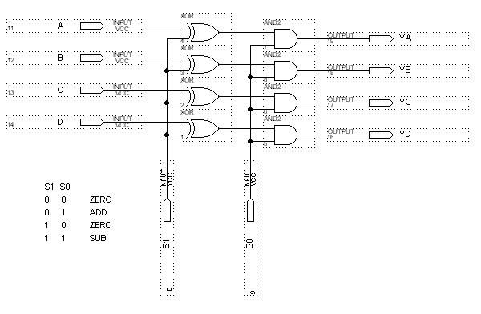 Figure 1 Adder controller circuit

The first part of the lab consisted of simply drawing the circuit (Figure 1) in the Altera graphics editor. The circuit was compiled and saved as “newaddrcntrl.gdf”.

Next, the “fc4bitadder.gdf” block file was used from lab 3 to complete the circuit on
figure 2. It was compiled, saved as “fc4bitadder2.gdf” and a default symbol file was created.

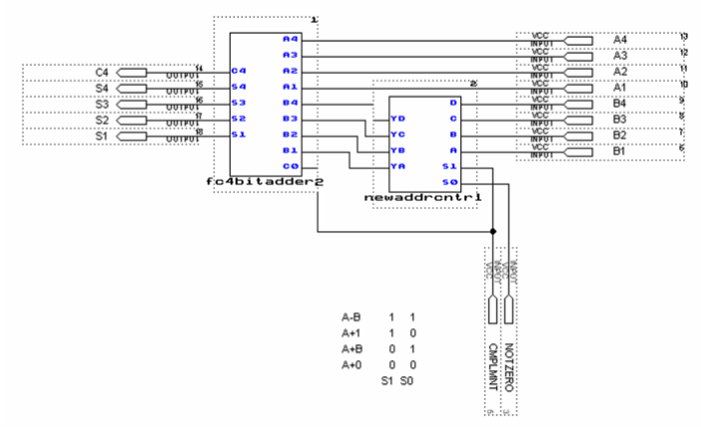

Figure 2 New adder diagram

Part II

Figure 3 4-bit up-counter
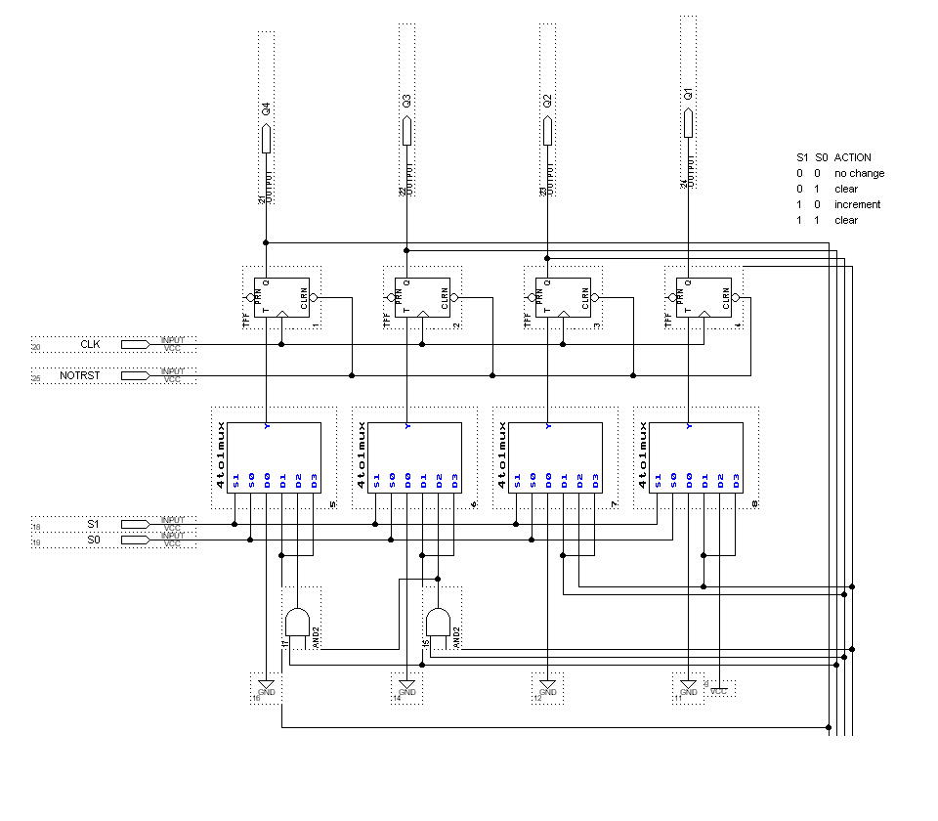

The circuit on figure 3 was drawn in the program, the “4to1mux.gdf” block file was taken from lab 3. The circuit compiled successfully; it was then saved as “4bitupcntr.gdf” and a default block symbol was created.

Part III

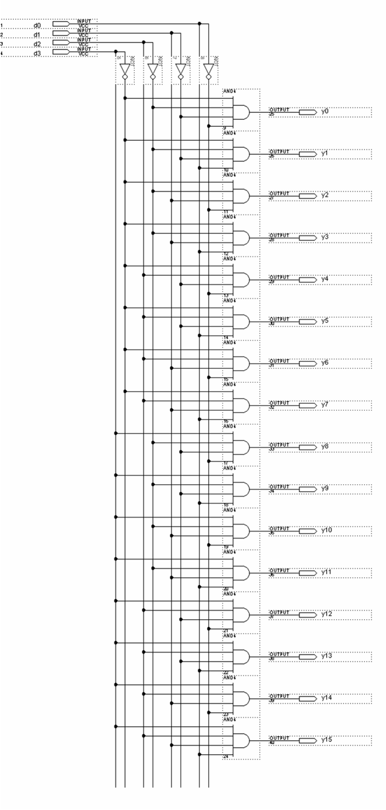

Figure 4 4to16 Decoder

The circuit on figure 4 was created, compiled and saved as “4to16decoder.gdf”. A default symbol was created.

Part IV

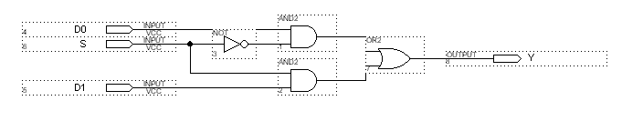

Figure 5 2to1 MUX

The 2to1 MUX, figure 5, was created, compiled and saved as “2to1mux.gdf”. A symbol file was created. Using this symbol file, the circuit on figure 6 was drawn.
It was compiled and saved as “quad2to1mux.gdf”. A default symbol file was created.
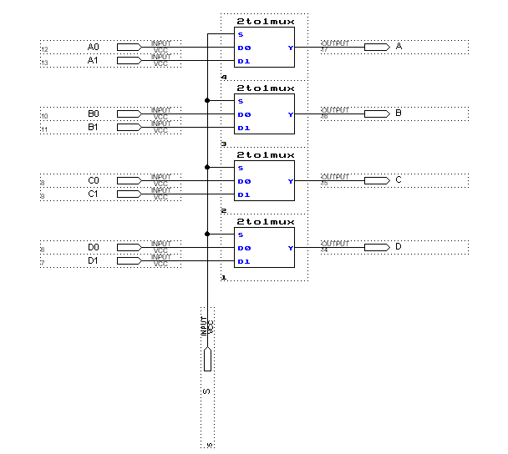

Figure 6 QUAD2to1 MUX

Part V

Part VI

Part VII

Part VIII

Problems encountered during the lab
Problems occurred during the assignment of pins. A number of pins on the altera board proved to be not working. The problem was fixed by downloading the program to the Altera board, setting the OP codes to 00 (ADD) and adding a number to zero. By looking at the LEDs and noting which ones do not light up when they should, we can conclude that either the input pin is not functional, or the output pin. Using this method the pins were reassigned until a working condition was met.
Knowledge acquired by the lab

The timing and control sequence of a basic computer was studied and understood.
The parts of a basic computer were observed.
Experience in troubleshooting circuits on the altera board was acquired.

Conclusion
All objectives were met, problems were dealt with and resolved, and overall the lab was successful.

