Chapter 18

microevolution, which is a change in frequencies of alleles or heritable phenotypic variants in a population over time. A population of organisms includes all the individuals of a single species that live together in the same place and time.
-Darwin recognized the importance of heritable variation within populations; he also realized that natural selection can change the pattern of variation in a population from one generation to the next. Scientists have since learned that microevolutionary change results from several processes, not just natural selection, and that sometimes these processes counteract each other.

18.1-Variation in Natural Populations
In some populations, individuals vary dramatically in appearance, but the members of most populations look pretty much alike. With suitable techniques, you could also document variations in their individual biochemistry, physiology, internal anatomy, and behaviour.
-phenotypic variation, differences in appearance or function among individuals of a population. If a difference is heritable, it is passed from generation to generation.

18.1a-Phenotypic Variation
We usually display data on quantitative variation in a bar graph or, if the sample is large enough, as a curve. The width of the curve is proportional to the variability—the amount of variation—among individuals, and the mean describes the average value of the character.
-natural selection often changes the mean value of a character or its variability within populations.

- quantitative variation: Variation that is measured on a continuum (such as height in human beings) rather than in discrete units or categories.

The existence of discrete variants of a character is called a polymorphism (poly= more morphos=form); we describe such traits as polymorphic. Example: The Cepaea nemoralis snail shells are polymorphic in background colour, number of stripes, and colour of stripes. Biochemical polymorphisms, like the human A, B, AB, and O blood types.

- qualitative variation:Variation that exists in two or more discrete states, with intermediate forms often being absent.

We describe phenotypic polymorphisms quantitatively by calculating the percentage or frequency of each trait. For example, if you counted 123 blue snow geese and 369 white ones in a population of 492 geese, the frequency of the blue phenotype would be 123/492 or 0.25, and the frequency of the white phenotype would be 396/492 or 0.75.
Phenotypic variation within populations may be caused by genetic differences between individuals, by differences in the environmental factors that individuals experience, or by an interaction between an individual’s genetics and the environment. As a result, genetic and phenotypic variations may not be perfectly correlated. Organisms with different genotypes often exhibit the same phenotype. For example, recall Gregor Mendel’s experiments with pea plants (plants with purple flowers have two different genotypes, even though they exhibit the same phenotype).
Conversely, organisms with the same genotype sometimes exhibit different phenotypes. Knowing whether phenotypic variation is caused by genetic differences, environmental factors, or an interaction of the two is important because only genetically based variation is subject to evolutionary change. At the same time, it is the phenotype of an individual organism, rather than its genotype, that is successful or not. In other words, natural selection operates on the phenotype, not the genotype. And it operates on the whole phenotype, not just one gene at a time.

Because environmental factors can influence the expression of genes, an organism’s phenotype is frequently the product of an interaction between its genotype and its environment. In our hypothetical example, the farmer may maximize yield by fertilizing and irrigating the more productive genotype of wheat.

How can we determine whether phenotypic variation is caused by environmental factors or by genetic differences? We can test for an environmental cause experimentally by changing one environmental variable and measuring the effects on genetically similar subjects.

Breeding experiments can demonstrate the genetic basis of phenotypic variation. For example, Mendel inferred the genetic basis of qualitative traits, such as flower colour in peas, by crossing plants with different phenotypes. Although simple crosses will not reveal the genetic basis of variations in quantitative traits, these characteristics will respond to artificial selection if the variation has some genetic basis.
Breeding experiments are not always practical, however, particularly for organisms with long generation times.

18.1b-Genetic Variation
An allele is one member of a gene pair that occupies a single location (locus) on a chromosome. A gene can have more than one possible allele, and occasionally several alleles. In diploid organisms, only two of these alleles are present in any gene pair, and haploid organisms have only one of each type of allele.
Genetic variation, the raw material moulded by microevolutionary processes, has two potential sources: the production of new alleles and the rearrangement of existing alleles. Most new alleles probably arise from small-scale mutations in DNA. The rearrangement of existing alleles into new combinations can result from larger-scale changes in chromosome structure or number, as well as from several forms of genetic recombination, including crossing-over between homologous chromosomes during meiosis, independent assortment of nonhomologous chromosomes during meiosis, and random fertilizations between genetically different sperm and eggs. This shuffling of alleles into new combinations can produce an extraordinary number of novel genotypes in the next generation. By one estimate, more than combinations of alleles are possible in human gametes, yet there are fewer than humans alive today. So unless you have an identical twin, it is extremely unlikely that another person with your genotype has ever lived or ever will.

18.1c-Natural Selection and Phenotypic Variation
Biologists measure the effects of natural selection on phenotypic variation by recording changes in the mean and variability of characters over time. Three modes of natural selection have been identified: directional selection, stabilizing selection, and disruptive selection (pic)

Directional Selection
Traits undergo directional selection when individuals near one end of the phenotypic spectrum have the highest relative fitness. Directional selection shifts a trait away from the existing mean and toward the favoured extreme (see Figure 18.5a). After selection, the trait’s mean value is higher or lower than before, and variability in the trait may be reduced.
Directional selection is very common. For example, predatory fish promote directional selection for larger body size in guppies when they selectively feed on the smallest individuals in a guppy population. Most cases of artificial selection are directional, aimed at increasing or decreasing specific phenotypic traits. Humans routinely use directional selection to produce domestic animals and crops with desired characteristics, such as the small size of Chihuahuas and the intense heat of chili peppers.

Stabilizing Selection
Traits undergo stabilizing selection when individuals expressing intermediate phenotypes have the highest relative fitness (Figure 18.5b). By eliminating phenotypic extremes, stabilizing selection reduces genetic and phenotypic variation and increases the frequency of intermediate phenotypes. Stabilizing selection is probably the most common mode of natural selection, affecting many familiar traits. For example, very small and very large human newborns are less likely to survive than those born at an intermediate weight.
Stabilizing selection can result from multiple selective forces acting on the same trait but in opposite directions.
Disruptive Selection
Traits undergo disruptive selection when extreme phenotypes have higher relative fitness than intermediate phenotypes (see Figure 18.5c). Thus, alleles producing extreme phenotypes become more common, promoting polymorphism. Under natural conditions, disruptive selection is much less common than directional selection and stabilizing selection. Example of disruptive selection in Galápagos finches.

18.2- Population Genetics
Populations are made up of individuals of the same species, each with its own genotype. In diploid organisms with pairs of homologous chromosomes, an individual’s genotype includes two alleles (either two copies of the same allele or two different alleles) at each gene locus. The sum of all alleles at all gene loci in all individuals is called the population’s gene pool.
To describe the structure of a gene pool, scientists first identify the genotypes in a representative sample and calculate genotype frequencies, the percentages of individuals possessing each genotype. They can then calculate allele frequencies, the relative abundances of the different alleles. For a locus with two alleles, scientists use the symbol p to identify the frequency of one allele, and q to identify the frequency of the other allele.

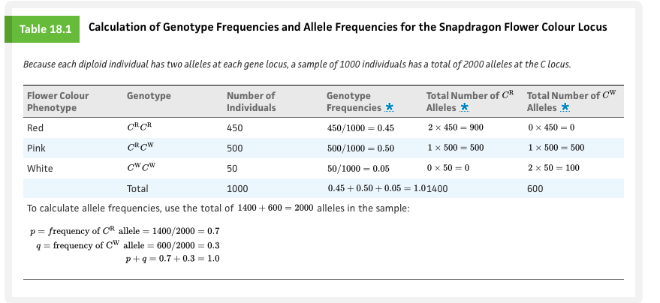

18.2b-The Hardy–Weinberg Principle
When designing experiments, scientists often use control treatments to evaluate the effect of a particular factor. The control tells us what we would see if the experimental treatment had no effect. However, in studies using observational rather than experimental data, there is often no suitable control. In such cases, investigators develop conceptual models, called null models, that predict what they would see if that particular factor had no effect. Null models serve as theoretical reference points against which scientists can evaluate their observations.
Early in the twentieth century, geneticists were puzzled by the persistence of recessive traits because they assumed that natural selection replaced recessive or rare alleles with dominant or common ones. Wilhelm Weinberg, tackled this problem independently in 1908. Their analysis, now known as the Hardy–Weinberg principle, specifies the conditions under which a population of diploid organisms achieves genetic equilibrium, the point at which neither allele frequencies nor genotype frequencies change in succeeding generations. Their work also showed that dominant alleles need not replace recessive ones, and that the shuffling of genes in sexual reproduction does not in itself cause allele or genotype frequencies to change.

The Hardy–Weinberg principle is a mathematical model that describes how genotype frequencies are established in sexually reproducing organisms. According to this model, genetic equilibrium is possible only if all of the following conditions are met:
- No mutations are occurring.
- The population is closed to migration from other populations.
- The population is infinite in size (i.e., there is no genetic drift; see Section 18.3c).
- All genotypes in the population survive and reproduce equally well (selection is not acting on the trait being considered).
- Individuals in the population mate randomly with respect to the trait being considered.
If all the conditions of the model are met, the allele frequencies of the population for an identified gene locus will never change, and the genotype frequencies will stop changing after one generation. The Hardy–Weinberg principle is thus a null model that serves as a reference point for evaluating the circumstances under which evolution may occur. If a population’s genotype frequencies do not match the predictions of this null model, evolution may be occurring. If allele frequencies change over time, evolution is occurring. Determining which of the model’s conditions are not met is a first step in understanding how and why the gene pool is changing (see “Using the Hardy–Weinberg Principle”).
*** Example in textbook

18.3-Evolutionary Agents
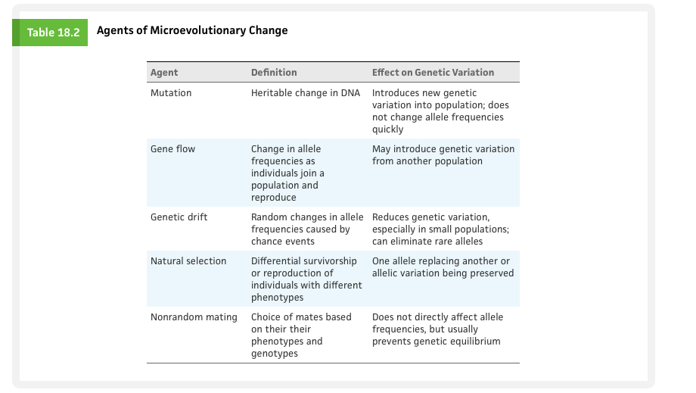

18.3a-Mutations
A mutation is a spontaneous and heritable change in DNA. Mutations are rare events: roughly one gamete in 100 thousand to one in 1 million will include a new mutation at a particular gene locus. New mutations are so infrequent, in fact, that they exert little or no immediate effect on allele frequencies in most populations. But over evolutionary time scales, their numbers are significant; mutations have been accumulating in biological lineages for billions of years. And because it creates entirely new genetic variations, a mutation can be a major source of heritable variation.
For most animals, only mutations in the germ line (the cell lineage that produces gametes) are heritable; mutations in other cell lineages have no direct effect on the next generation. In plants, however, mutations may occur in meristem cells, which eventually produce flowers as well as nonreproductive structures (see Chapter 34); in such cases, a mutation may be passed to the next generation and ultimately influence the gene pool.
We classify mutations based on their effect on an organism’s fitness, rather than on the underlying molecular changes and the mode of inheritance of the trait (e.g., dominant, recessive). It is not immediately known whether or not a new mutation will be advantageous, deleterious, or neutral.
Deleterious mutations alter an individual’s structure, function, or behaviour in harmful ways.

Lethal mutations can cause great harm to organisms carrying them. If a lethal allele is dominant, both homozygous and heterozygous carriers will, by definition, die from its effects; if recessive, it kills only homozygous recessive individuals. Manx cats have a recessive lethal allele for taillessness: homozygous dominant cats are normal, heterozygous cats have short tails and long legs, and homozygous recessive cats do not survive embryonic development.

Neutral mutations are neither harmful nor helpful. Because of the redundancy of the genetic code, several codons with different nucleotides in the third position may specify the same amino acid in the construction of a polypeptide chain. As a result, some DNA sequence changes—especially those in the third nucleotide of the codon—do not alter the amino acid sequence of the protein under construction. Not surprisingly, mutations at the third position appear to persist longer in populations than those at the first two positions. In other instances, mutations that change the amino acid sequence in a protein or even an organism’s phenotype may have no influence on its survival and reproduction. A neutral mutation might even prove to be beneficial later if the environment changes.
Sometimes a change in DNA produces an advantageous mutation, which confers some benefit on an individual that carries it. However slight the advantage, natural selection may preserve the new allele and even increase its frequency over time. Once the mutation has been passed to a new generation, other agents of microevolution determine its long-term fate.

18.3b- Gene Flow
Organisms or their genetic material (in the form of pollen, spores, or fertilized eggs) sometimes move from one population to another. If the immigrants reproduce, they may introduce novel alleles into a population, shifting its allele and genotype frequencies. This phenomenon is called gene flow and shows that populations are not completely closed, but can be open to migration.
Gene flow is common in some animal species. For example, young male baboons typically move from one local population to another after experiencing aggressive behaviour by older males. And many marine invertebrate eggs and larvae disperse long distances, carried by ocean currents.
Dispersal agents, such as pollen-carrying wind or seed-carrying animals, are responsible for gene flow in most plant populations.
The movement alone of individuals from one population to another is not sufficient to foster gene flow between two populations. The immigrants must also reproduce in the population they join, thereby contributing to its gene pool.
The evolutionary importance of gene flow depends on the degree of genetic differentiation between populations and the rate of gene flow between them. If two gene pools are very different, a little gene flow may increase genetic variability within the population that receives immigrants, and it will make the two populations more similar. But if populations are already genetically similar, even lots of gene flow will have little effect.

18.3c-Genetic Drift
Chance events sometimes cause the allele frequencies in a population to change unpredictably. This phenomenon, known as genetic drift, has especially dramatic effects on small populations, clearly violating the Hardy–Weinberg assumption of an infinitely large population size. Two general circumstances, population bottlenecks and founder effects, often foster genetic drift.
Population Bottlenecks
On occasion, a stressful factor such as disease, starvation, or drought kills a large proportion of the individuals in a population, producing a population bottleneck, a dramatic reduction in population size. This cause of genetic drift greatly reduces genetic variation even if the population numbers later rebound (Figure 18.7).

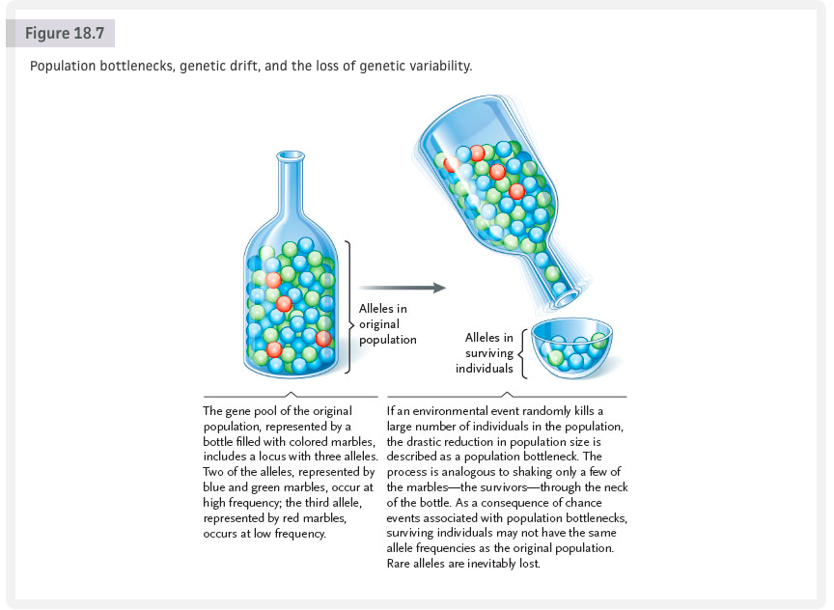

Founder Effect
When a few individuals colonize a distant locality and start a new population, they carry only a small sample of the parent population’s genetic variation. By chance, some alleles may be totally missing from the new population, whereas other alleles that were rare “back home” might occur at relatively high frequencies. This change in the gene pool is called the founder effect.
The human medical literature provides some of the best-documented examples of the founder effect. The Old Order Amish, an essentially closed religious community in Lancaster County, Pennsylvania, have an exceptionally high incidence of Ellis–van Creveld syndrome, a genetic disorder caused by a recessive allele. In the homozygous state, the allele produces dwarfism, shortened limbs, and polydactyly (extra fingers). Genetic analysis suggests that although this syndrome affects fewer than 1% of the Amish in Lancaster County, as many as 13% may be heterozygous carriers of the allele. All of the individuals exhibiting the syndrome are descended from one couple, who helped found the community in the mid-1700s. Assuming Hardy–Weinberg, the allele frequency is 0.075 in the Amish population compared to about 0.003 in the entire population.

Small Population Implications
A simple analogy clarifies why genetic drift is more noticeable (pronounced) in small populations than in large ones. When individuals reproduce, male and female gametes often pair up randomly, as though the allele in any particular sperm or ovum was determined by a coin toss. Imagine that heads specifies the R allele and that tails specifies the r allele. If the two alleles are equally common (i.e., their frequencies, p and q, are both equal to 0.5), heads should be as likely an outcome as tails. But if you toss a coin 20 or 30 times to simulate random mating in a small population, you won’t often see a 50:50 ratio of heads and tails. Sometimes heads will predominate and sometimes tails will—just by chance. Tossing the coin 500 times to simulate random mating in a somewhat larger population is more likely to produce a 50:50 ratio of heads and tails. And if you tossed the coin 5000 times, you would get even closer to a 50:50 ratio.
Genetic drift generally leads to the loss of alleles and reduced genetic variability; it therefore causes allele and genotype frequencies to differ from those predicted by the Hardy–Weinberg model.

Conservation Implications
Genetic drift has important implications for conservation biology. Because of their small population size, endangered species experience severe population bottlenecks, resulting in the loss of genetic variability. Moreover, the small number of individuals available for captive breeding programs may not fully represent a species’ genetic diversity. Without such variation, no matter how large a population may become in the future, it will be less resistant to diseases or less able to cope with environmental change.
For example, scientists hypothesize that an environmental catastrophe produced a bottleneck in the African cheetah (Acinonyx jubatus) population about 10 000 years ago. Cheetahs today are remarkably uniform in genetic make-up. Their populations are highly susceptible to diseases; males also have a high proportion of sperm cell abnormalities and a reduced reproductive capacity. These observations support the hypothesis of a bottleneck resulting in a high frequency of deleterious alleles in the population. Thus, limited genetic variation, as well as small numbers, threatens populations of endangered species.

18.3d-Genetic Variation in Populations
How much genetic variation actually exists within populations? In the 1960s, evolutionary biologists began to use gel electrophoresis to identify biochemical polymorphisms in diverse organisms. This technique separates two or more forms of a given protein if they differ significantly in shape, mass, or net electrical charge, as a result of mutation-induced changes in the underlying amino acid sequence. The identification of a protein polymorphism allowed researchers to infer genetic variation at the locus coding for that protein.
This approach revealed much more genetic variation in natural populations than anyone had imagined. For example, nearly half the loci surveyed in many populations of plants and invertebrates are polymorphic. Advances in molecular biology now allow scientists to survey genetic variation directly, and researchers have accumulated an astounding knowledge of the structure of DNA and its nucleotide sequences. In general, studies of chromosomal and mitochondrial DNA suggest that every locus exhibits some variability in its nucleotide sequence among individuals from a single population, between populations of the same species, and between related species. However, some variations detected in the protein-coding regions of DNA may not affect phenotypes because, as explained in Section 13.4a, they do not change the amino acid sequences of the proteins for which the genes code.

18.3e-Natural Selection and Genetic Variability
The Hardy–Weinberg model requires all genotypes in a population to survive and reproduce equally well. But as you know, inherited traits can enable some individuals to survive better and produce more offspring than others. Natural selection is the process by which such traits become more common in subsequent generations. Thus, natural selection violates a requirement of the Hardy–Weinberg equilibrium and causes allele and genotype frequencies to differ from those predicted by the model.
Although natural selection can change allele frequencies in a population, it is the phenotype of an individual organism, rather than any particular allele, that is successful or not. When individuals survive and reproduce, their alleles, both favourable and unfavourable, are passed to the next generation. Of course, an organism with harmful or lethal dominant alleles will probably die before reproducing, and all the alleles it carries will share that unhappy fate, even those that are advantageous.
To evaluate reproductive success, evolutionary biologists consider relative fitness, the number of surviving offspring that an individual produces compared with the numbers left by others in the population. Thus, a particular allele will increase in frequency in the next generation if individuals carrying that allele leave more offspring than individuals carrying other alleles. Differences in the relative success of individuals are the essence of natural selection.
Natural selection tests fitness differences at nearly every stage of an organism’s life cycle. One plant may be fitter than others in the population because its seeds survive colder conditions, because the arrangement of its leaves captures sunlight more efficiently, or because its flowers are more attractive to pollinators. However, natural selection exerts little or no effect on traits that appear during an individual’s postreproductive life. For example, Huntington disease, a dominant-allele disorder that first strikes humans after the age of 40, is not subject to strong selection. Carriers of the disease-causing allele can reproduce before the onset of the condition, passing it to the next generation.

18.3f-Nonrandom Mating
The Hardy–Weinberg model requires individuals to select mates randomly with respect to their genotypes. This requirement is, in fact, often met; humans, for example, generally marry one another in total ignorance of their genotypes for digestive enzymes or blood types.
Nevertheless, many organisms mate nonrandomly, selecting a mate with a particular phenotype. Snow geese, for example, usually select mates of their own colour, and human women are more likely to marry men who are taller than they are. If one phenotype is preferred by most potential mates, mating is not random. Hence the next generation will contain fewer heterozygous offspring—and more homozygous offspring—than the Hardy–Weinberg model predicts.
Inbreeding is a special form of nonrandom mating in which genetically related individuals mate with each other. Self-fertilization in plants and a few animals is an extreme example of inbreeding because offspring are produced from the gametes of a single parent. However, other organisms that live in small, relatively closed populations often mate with related individuals. Because relatives often carry the same alleles, inbreeding generally increases the frequency of homozygous genotypes and decreases the frequency of heterozygotes. Thus, recessive phenotypes are often expressed.

18.4-Maintaining Genetic and Phenotypic Variation
18.4a-Diploidy
The diploid condition reduces the effectiveness of natural selection on harmful recessive alleles. (Note that only a few recessive alleles are harmful.) Although such alleles are disadvantageous in the homozygous state, they may have little or no effect on heterozygotic individuals. Thus, recessive alleles can be protected from natural selection by the phenotypic expression of the dominant allele.

18.4b-Balanced Polymorphisms
In a balanced polymorphism, two or more phenotypes are maintained in fairly stable proportions over many generations. Natural selection preserves balanced polymorphisms when heterozygotes have higher relative fitness, when different alleles are favoured in different environments, and when the rarity of a phenotype provides an advantage.
Heterozygote Advantage
A balanced polymorphism can be maintained by heterozygote advantage, when heterozygotes have higher relative fitness than either homozygote. As Darwin first discovered in his experiments on corn, the offspring of crosses between two homozygous strains of the same species often exhibit a robustness described as hybrid vigour. Apparently, being heterozygous at many gene loci provides some advantage, perhaps by allowing organisms to respond effectively to environmental variation.
The best-documented example of heterozygote advantage at a specific gene locus is the maintenance of the HbS (sickle cell) allele, which codes for a defective form of hemoglobin in humans. As you learned in Chapter 10, hemoglobin is an oxygen-transporting molecule in red blood cells. The hemoglobin produced by the HbS allele differs from normal hemoglobin (coded by the HbA allele) by just one amino acid. In HbS/HbS homozygotes, the faulty hemoglobin forms long, fibrous chains under low oxygen conditions, causing red blood cells to assume a sickle shape (as shown in Figure 10.1). Homozygous HbS/HbS individuals often die of sickle cell disease before reproducing. However, in tropical and subtropical Africa, HbS/HbA heterozygotes make up nearly 25% of many populations.

Why is the harmful allele maintained at such high frequency in some populations? It turns out that sickle cell disease is common in regions where malaria is prevalent (Figure 18.8). Malaria is a disease transmitted by mosquitoes, in which parasites infect red blood cells. When heterozygous HbA/HbS individuals contract malaria, their infected red blood cells assume the same sickle shape as those of homozygous HbS/HbS individuals. The sickled cells lose potassium, killing the parasites, which limits their spread within the infected individual. Heterozygous individuals often survive malaria because the parasites do not multiply quickly inside them, their immune systems can effectively fight the infection, and they retain a large population of uninfected red blood cells. Homozygous HbA/HbA individuals are also subject to malarial infection, but because their infected cells do not sickle, the parasites multiply rapidly, causing a severe infection with a high mortality rate.

Therefore, HbA/HbS heterozygotes have greater resistance to malaria and are more likely to survive severe infections in areas where malaria is prevalent. Thus, natural selection preserves the HbS allele in these populations.
Selection in Different Environments
Genetic variability can also be maintained within a population when different alleles are favoured in different places or at different times. For example, the shells of European garden snails range in colour from nearly white to pink, yellow, or brown, and may be patterned by one to five coloured stripes (see Figure 18.1a). This polymorphism, which is relatively stable through time, is controlled by several gene loci. The variability in colour and striping pattern can be partially explained by selection for camouflage in different habitats.

Predation by song thrushes (Turdus ericetorum) is a major agent of selection on the colour and pattern of these snails in England. When a thrush finds a snail, it smashes it against a rock, using it like an anvil, to break the shell. The bird eats the snail, but leaves the shell near its “anvil.” Researchers collected the broken shells near an anvil and compared the phenotypes of captured snails to a random sample of the entire snail population. Their analyses indicated that thrushes are visual predators, usually capturing snails that are easy to find. Thus, well-camouflaged snails survive, and the alleles that specify their phenotypes increase in frequency.
The success of camouflage varies with habitat, however. Local subpopulations of the snail, which occupy different habitats, often differ markedly in shell colour and pattern. The predators eliminate the most conspicuous individuals in each habitat; thus, natural selection differs from place to place. In woods where the ground is covered with dead leaves, snails with unstriped pink or brown shells predominate. In hedges and fields, where the vegetation includes thin stems and grass, snails with striped yellow shells are the most common. In populations that span several habitats, selection preserves different alleles in different places, thus maintaining variability in the population as a whole.

18.5a-The Evolution of Adaptive Traits
An adaptive trait is any product of natural selection that increases the relative fitness of an organism in its environment. Adaptation is the accumulation of adaptive traits over time, and examples range across all levels of biological organization, from the molecular to the ecological. For example, the water-retaining structures and special photosynthetic pathways of desert plants and the warning coloration of poisonous animals can be interpreted as adaptive traits. Note, however, that for adaptation to occur there must first be phenotypic variation for selection to act on.

In fact, we can concoct an adaptive explanation for almost any characteristic we observe in nature. But such explanations are just fanciful stories unless they are framed as testable hypotheses about the relative fitness of different phenotypes and genotypes. Unfortunately, evolutionary biologists cannot always conduct straightforward experiments because they sometimes study traits that do not vary much within a population or species. In such cases, they may compare variations of a trait in closely related species living in different environments. For example, one can test how the traits of desert plants are adaptive by comparing them to traits in related species from moister habitats.

When biologists try to unravel how and why a particular adaptive characteristic evolved, they must also remember that a trait they observe today may have had a different function in the past. For example, the structure of the shoulder joint in birds allows them to move their wings first upward and backward and then downward and forward during flapping flight. But analyses of the fossil record reveal that this adaptation, which is essential for flight, did not originate in birds. Some predatory nonflying dinosaurs, including the ancestors of birds, had similarly constructed shoulder joints. Researchers hypothesize that these fast-running predators may have struck at prey with a flapping motion similar to that used by modern birds. Thus, the structure of the shoulder may have evolved first as an adaptation for capturing prey, and only later proved useful for flapping flight. This hypothesis—however plausible it may be—cannot be tested by direct experimentation because the nonflying ancestors of birds have been extinct for millions of years. Instead, evolutionary biologists must use anatomical studies of birds and their ancestors, along with theoretical models about the mechanics of movement, to challenge and refine the hypothesis.

18.5b-Factors Constraining Adaptive Evolution
We often marvel at how well adapted an organism is to its environment and mode of life. However, the adaptive traits of most organisms are compromises produced by competing selection pressures. Sea turtles, for example, must lay their eggs on beaches because their embryos cannot acquire oxygen under water. Although flippers allow the females to crawl to nesting sites on beaches, they are not ideally suited for terrestrial locomotion. Their structure reflects their primary function, swimming.
Moreover, no organism can be perfectly adapted to its environment because environments change over time. Natural selection preserves alleles that are successful under the prevailing environmental conditions. Thus, each generation is adapted to the environmental conditions under which its parents lived. If the environment changes from one generation to the next, adaptation will always lag behind.
Another constraint on the evolution of adaptive traits is historical. Natural selection is not an engineer that designs new organisms from scratch. Instead, it acts on new mutations and existing genetic variation. Because new mutations are fairly rare, natural selection works primarily with alleles that have been present for many generations. Thus, adaptive changes in the morphology of an organism are often based on small modifications of existing structures. The bipedal (two-footed) posture of humans, for example, evolved from the quadrupedal (four-footed) posture of our ancestors. Natural selection did not produce an entirely new skeletal design to accompany this radical behavioural shift. Instead, existing characteristics of the spinal column and the musculature of the legs and back were modified, albeit imperfectly, for an upright stance.
Evolution is the unifying theory in biology, drawing together virtually every aspect of the discipline. Microevolution focuses on variation, selection, selective advantages, and natural selection at the population level. Populations make up species, and speciation occurs when populations become diverse enough to be considered separate species. Macroevolution—evolution that occurs at or above the species level—is where we turn next.

