KIN 2Y03 AXIAL SKELETON
DIVISIONS OF THE SKELETAL SYSTEM
Axial Skeleton
- 80 bones
Appendicular Skeleton
- 126 Bones
Girdles: attachment sites between axial and appendicular skeleton
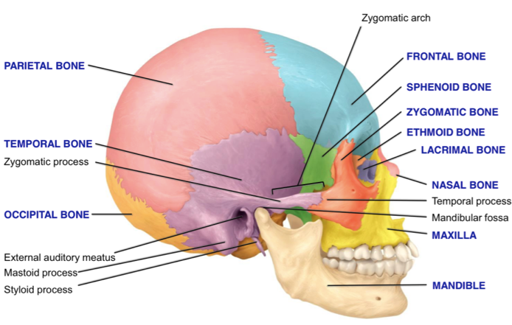
BONE SURFACE MARKINGS- fig 7.2
Ridges: Bony feature sticking out so tendon can attach onto bone
Projection: Attachment point for muscles/ligaments that cross a joint
- Process (small) , tuberosity (large), tubercles (round bumps)
Openings: ex. Foramen
Depressions: fossa (shallow), notches, grooves
Condyle: smooth, round articular surface
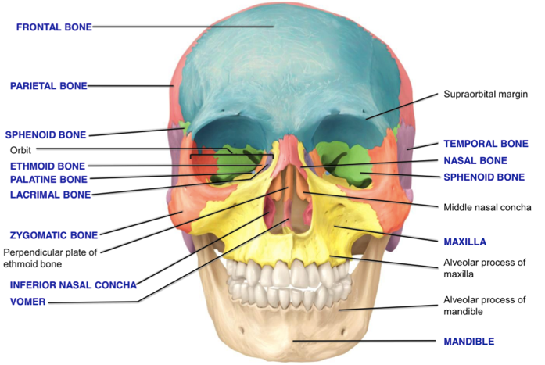
Facet: small flat articular surface

THE SKULL
- 22 separate bones + 6 auditory ossicles + 1 hyoid bone
- Cranial bones (8)
  - 2 parietal, 2 temporal, 1 frontal, 1 occipital, 1 sphenoid, 1 ethmoid
- Facial bones (14)
  - 2 maxilla, 2 zygomatic, 2 palatine, 2 lacrimal, 2 nasal, 2 inferior nasal conchae, 1 vomer, 1 mandible
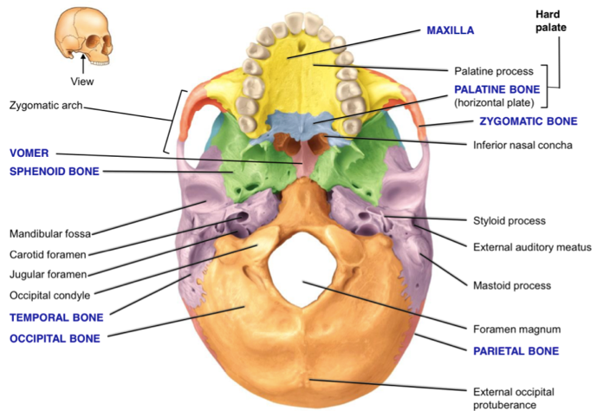
  - Mandible: only movable bone of skull, joins with temporal
CRANIAL BONES
- Frontal:
- Forehead, roof of orbit, anterior cranial floor
- Originally 2 bones that fuse together by age 6
- Super orbital margins: ridges on top of orbit, thick so orbit doesn’t break when you get hit in the eye
- Parietal (2): sides/roof of cranial cavity
- Temporal (2): back/lateral, cranial floor
- Mastoid process: attachment point for neck
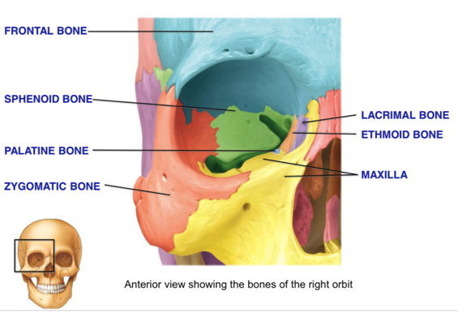
- Styloid process: attachment point for tongue/neck muscles
- External auditory meatus: hole to reach midde/inner ear
- Zygomatic process: indent in cheek bone
- Sphenoid: mostly inside skull, butterfly shape, part of orbit/cranial floor
- Joins with ALL other cranial bones
- Ethmoid: has cribaform plate (separates nasal/cranial cavities)
- Perpendicular plate: superior/posterior portion of nasal septum
- Middle/superior nasal concha: ridges
- Occipital:
- External occipital protuberance: bump at back, joints ligaments to hold head upright
- Foramen magnum: where spinal chord attaches to brain stem
- Occipital condyle: joins with first cervical vertebrae, allows nodding/tilting head

FACIAL BONES
- Nasal (2): bridge of nose, anterior roof of nasal cavity
- Lacrimal (2): Smallest bone of face
- Has canal with lacrimal sac
- Zygomatic (2): Cheek, portion of orbit
- Temporal process: works with zygomatic process (of temporal bone) to form zygomatic arch
- Maxilla (2): upper jaw, floor of orbit, some nasal cavity, most of hard pallet
- Palatine process: roof of mouth
- 2 bones fuse together during embryonic stage
- Cleft palette: maxillary bones not fusing together
- Mandible: Strongest/largest of face, joins with temporal bone at mandibular fossa
- Vomer: inferior/posterior region of nasal septum
- Continues down nose as hyaline cartilage
- Inferior nasal concha (2): have ridges to create turbulent flow of air
- Palatine (2): L shape
- Jugular foramen: where veins drain blood from skull
- Carotid artery: where arteries enter brain
****Alveolar process in maxilla/mandible
- Creates spaces so teeth can fit (TEETH NOT BONES)

HYOID BONE
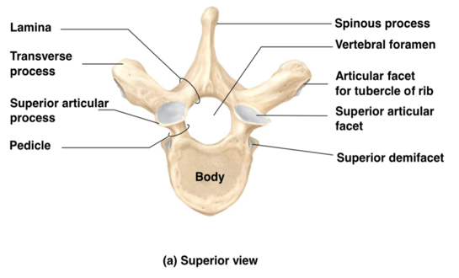
- Doesn’t joint with any other bone- “floating”
- Attachment point for tongue muscles and neck muscles to elevate larynx
- U shaped

VERTEBRAL COLUMN
- 26 vertebrae
  - 7 cervical, 12 thoracic, 5 lumbar, 1 sacral (5 fused), 1 coccygeal (4 fused)
- At birth, only 1 concave curve, after development there are 4 curves
- Cervical curve: develops when we get head muscles
- Thoracic: stays the same as infancy
- Lumbar: formed when we walk/stand
Spinous process (7): provide attachment point for muscles that move column
Lamina & Pedicle: on both sides of vertebrae
- Has notch that creates hole for spinal chord to exit (forms intervertebral foramina when stacked)
Vertebral Foramen: hole in vertebrae
- When stacked creates canal for spinal chord
Transverse process: On both sides
- Attachment for muscle, forms joint for rib
Superior Articular Process: allows vertebrae to join with each other
Superior Articular Facet: flat articulating surface where you actually create joint w/ vertebrae above it
Inferior Articular Process: to form joint with vertebrae below
Articular Facet for Tubercle of Rib: For bent part of rib
Superior demifacet: Where head of rib will join with vertebrae

REGIONAL DIFFERENCES- CERVICAL
Atlas: C1
- No body, spinous process, larger foramen, holes in transverse process for vessels, holds skull on rest of vertebrae
Axis: C2
- Body gets larger as you move down
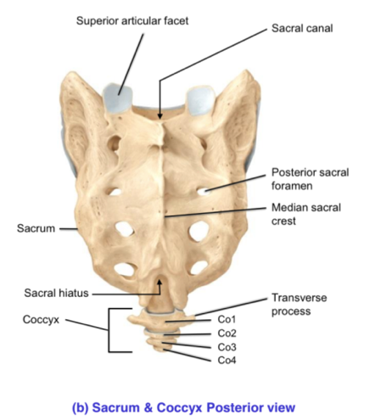
- Spinous process splits
- Dens: Ball-like trailer hitch for atlas – allows swivel movement around axis

REGIONAL DIFFERENCES- THORACIC&LUMBAR
- Sup/Inf facet points front and back
- Spinous process gets more squared as you move down

REGIONAL DIFFERENCES- SACRUM/COCCYX
- Sacrum: Fuses in late teens – complete by 30yrs
- Coccyx: Starts fusing at 29, ends by 30
- Intervertebral foramina become sacral foramen after fusion
- Sacral hiatus: opening as bottom of sacrum

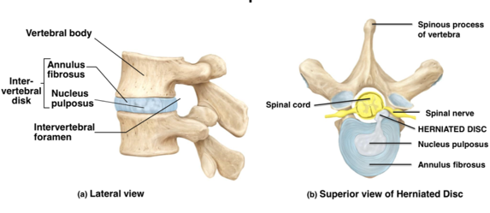
INTERVERTEBRAL DISCS
- Fibrocartilage: in between bodies of vertebrae
  - Gives support/flexibility, absorbs shock
  - Annulus: surrounds outside of disk
  - Nucleus: gelatinous fluid in middle
THORACIC CAGE
12 pairs of ribs
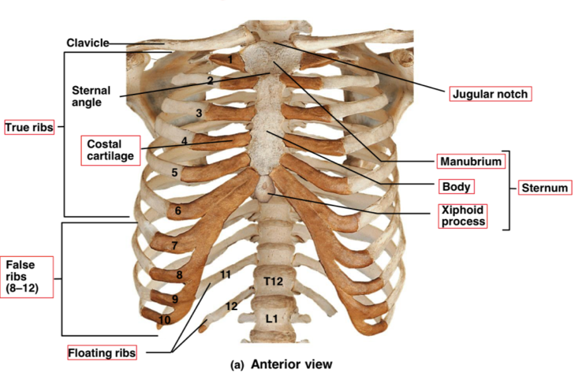
- 7 pairs of true ribs
- 5 pairs of false ribs
  - 3 are vertebrochondral
  - 2 are “floating” or vertebral
Sternum: 3 separate bones that fuse together as you age
- Xiphoid process: hyaline cartilage that becomes bone at 40yrs
False ribs: don’t attach directly to sternum
- Their cartilage attaches to cartilage of rib 7
Floating ribs: attach to vertebrae, not sternum

