ADM 2337: Human Resource Management

Chapter 1: the world of human resource management
HR is a critical organization; it’s the management of humans. HRM is the managing of human capital to achieve organization goals. Human capital is the knowledge, skill, training, education and expertise of individuals that have economic value to an organization, it is intangible.
Words to describe how important people are to organization: human capital, human resource, intellectual assets and talent management.
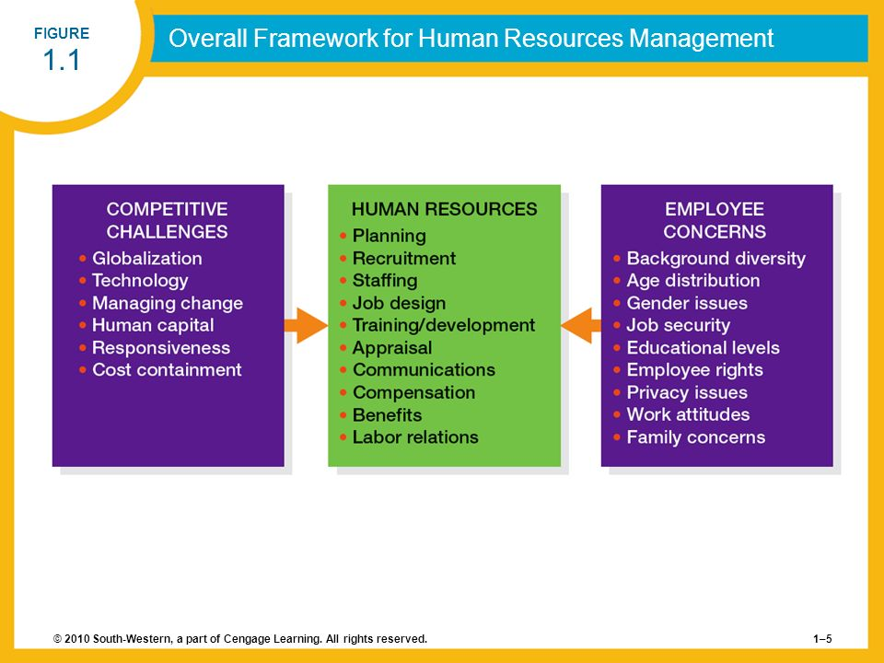

- Competitive challenges:
1: Responding strategically to changes in the local and global marketplace:
Examples of means the organization uses to modify the way they operate to be more successful is:
- Six sigma: set of principles and practices whose core idea include understanding customer needs, doing things right the first time, and striving for continuous improvement.
- Reengineering: the fundamental rethinking and radical redesign of business processes to achieve dramatic improvements in cost, quality, service, and speed.
- Downsizing: planned elimination of jobs.
- Outsourcing: contracting out work that was formerly done by employees.
- Change management: change management is a systematic way of bringing about and managing both organizational changes and changes on the individual level.
- Organizations that have been successful in engineering change:
- have linked the change to business strategies.
- show how the change creates quantifiable benefits.
- engage key employees, customers, and their supplies early when making a change.
- make an investment in implementing and sustaining change.

- Strategic changes:
- Reactive change: changes that occur after external forces have already affected performance.
- Proactive change: change initiated to take advantage of targeted opportunities.

Globalization is the trend to opening foreign markets to international trade and investment. The first major trade agreement of the 20th century was made in 1948, following World War 2 called the General Agreement on Tariffs and Trade (GATT), it established rules and guidelines for global commerce between nations and groups of nations.

2: Setting and achieving corporate social responsibility and sustainability goals.
Some people worry that free trade is creating a “have/have not” world economy, in which the people in developing economies and the world’s environment are being exploited by companies in richer/more developed countries. Concerns such as these have led to a new focus on Corporate Social Responsibilities, which is the responsibility of the firm to act in the best interests of the people and communities affected by the activities, or good citizenship.
Sustainability is closely related to corporate social responsibility, it refers to a company’s ability to produce a good or service without damaging the environment or depleting a resource.

3: advancing HRM with technology
Advancement in information technology have enable organization to take advantage of the information explosion.
Collaborative software: software that allow employees to interface and share information with one another electronically.
Advanced technology tends to reduce the number of jobs that require little skill and to increase the number of jobs that require considerable skill thus companies now look for Knowledge workers: workers whose responsibilities extend beyond the physical execution of work to include planning, decision making, and problem solving.

- Influence of technology on HRM:
- Human resource information system (HRIS): computerized system that provides current and accurate data for purposes of control and decision making. It helps lower administrative costs, increasing productivity, speeding up response times, improving decision making, and tracking a company’s talent.
- Relational in nature: connecting people with each other and with HR data they need.
- Transformational in nature: changing the way HR processes are designed and executed.

4: Containing the cost while retaining top talent and maximizing productivity.
- Downsizing:planned elimination of jobs. It is a tool used by companies to adjust to technological changes, globalization, and the firm’s business direction.
- Furloughing: situation in which an organization asks or requires employees to take time off for either no pay or reduced pay.
- Offshoring: the business practice of sending jobs to other countries.
- Nearshoring: the process of moving jobs closer to one’s home country
- Outsourcing: contracting out work that was formerly done by employees.
- Employee leasing: process of dismissing employees who are then hired by a leasing company (which handles all HR-related activities) and contracting with that company to lease back the employees.
- Productivity enhancements

5: Responding to the demographic and diversity challenges of the workforce.
- Demographic change
- diversity/immigration challenge
- Age distribution of employees
- Gender distribution of the workforce

6: Adapting to educational and cultural shifts affecting the workforce.
- Education of the workforce
- Cultural changes
- Employee rights
- Concern for privacy
- The changing nature of the job
- Changing attitudes toward work
- Balancing work and family

- The partnership of line managers and human resource departments:
Line managers: non-HR managers who are responsible for overseeing the work of other employees.

- Responsibilities of the HR manager:
- Advice and counsel
- Service
- Policy formulation and implementation
- Employee advocacy

- Competencies of the HR manager:
- Business mastery: business acumen, customer orientation, and external relations.
- HR mastery: staffing, performance appraisal, rewards system, communication and organizational design.
- Change mastery: interpersonal skills and influences, problem-solving skills, rewards system, and innovativeness and creativity.
- Personal credibility: trust, personal relationship, lived values, and courage.
Chapter 2: strategy and human resource planning
o Strategic planning: procedures for making decisions about the organization’s long-term goals and strategies.
o Human Resource planning (HRP): process of anticipating and providing for the movement of people into, within, and out of an organization.
o Strategic human resource management (SHRM): pattern of human resources deployments and activities that enable an organization to achieve its strategic goals.
Ø Step 1: mission, vision, and values
- Mission: basic purpose of the organization as well as its scope of organizations.
- Strategic vision: statement about where the company is going and what it can become in the future, clarifies the long-term direction of the company and its strategic intent.
- Core Values: strong and enduring beliefs and principles that the company uses as a foundation for its decision.

How do HR managers help embody the firm’s mission, vision, and values within the organization?
- Communicating them frequently, informally and formally via verbal or written communications.
- Recruiting and hiring employees whose values are consistent with the organization.
- Translating the mission, vision, and values into specific on-the-job behaviour and job descriptions and recognizing and rewarding employees based on them.
Ø Step 2: external analysis
- Environmental scanning: systematic monitoring of the major external forces influencing the organization.
2 environments:
- The business environment: consist of all the external factors in the general environment that can’t be directly controlled by the firm but can impact its strategy.

- The remote environment: forces that impact all firms which they have virtually no control such as changes in the economy, technological changes, demographic changes, and legal and regulatory changes.

1. Economic and ecological change: changes in the economy, including general, regional, and global conditions. During economic booms, firms are more likely to expand. During economic recessions, they generally contract.
2. Technological changes: technological changes such as automation have a broad effect on businesses- changes that they have had to adapt to strategically. Example: Internet.
3. Demographic changes and labor market trends: including age, composition, and literacy of the labor market, and immigration.
4. Social changes: such as people’s changing priorities toward work; the need for childcare, eldercare, adequate wages, and job security; educational priorities; and environmental and sustainability concerns.
5. Legal and regulatory changes: including laws, have broad effects in the remote environment. Any one change can require firms and entire industries to dramatically adjust their strategic direction.
6. Industry and competitive trends: new processes, services and innovations. Example: customers, rival firms, new entrants, substitutes and suppliers.

C. competitive environment: it is narrower than the remote environment and firms have a greater ability to affect it. This includes the firm’s customers, rival firms, new entrants, substitutes, and suppliers.
Ø Step 3: internal analysis
1. Core capabilities: integrated knowledge sets within an organization that distinguish it from competitors and deliver values to customers. (People, processes, and system = integrated knowledge)
2. Composition: composition is made up of strategic knowledge workers, core employees, supporting workers and external partners.

3. Corporate culture: VABE = values, assumptions, beliefs, expectations.

- Sustaining a competitive advantage through people:
- The resources must be valuable
- The resources must be rare
- The resources must be difficult to imitate
- The resources must be organized

- The type of talent and their composition in the workplace:
- Strategic knowledge workers
- Core employees
- Supporting workers
- External partners
- Corporate culture:
- Cultural audits: audits of the culture and quality of work life in an organization.
- Value - based hiring: the process of outlining the behaviours that exemplify a firm’s corporate culture and then hiring people who are a fit for them.

o Forecasting Demand and forecasting supply: forecasting is a critical element of planning (no need to define techniques, should know how it will impact and how different techniques apply to demand and supply)
- Managers focus on three key elements: forecasting the demand for labor, forecasting the supply for labor, and balancing supply and demand considerations.
o Forecasting Demand techniques:
· Quantitative approach: involves use of statistical or mathematical techniques. (Gives absolute results)
- Trend analysis: a quantitative approach to forecasting labor demand based on an organizational index such as sales.
· Qualitative approach: the ever-changing environment in which an organization operates contributes to this situation. This approach is less statistical and inexact approximations.
- Management forecasts: the opinions (judgments) of supervisors, department managers, experts, or others knowledgeable about the organization’s future employment needs.
- Delphi technique: attempts to decrease the subjectivity of forecasts by soliciting and summarizing the judgments of a preselected group of individuals. HR personnel can do this by developing a list of questions to ask the managers in their companies.
Forecasting should include the use of both quantitative and qualitative approaches.
o Forecasting Supply techniques:
· Staffing tables: Graphic representation of all organizational jobs, along with the numbers of employees currently occupying those jobs and future (monthly and yearly) employment requirements.
· Markov analysis: a method for tracking the pattern of employee movements through various jobs.

· Quality of fill: A metric designed to assess how well new hires are performing on the job.
· Skill inventories: files of personnel education, experience, interests, and skills that allow managers to quickly match job openings with employee backgrounds.
· Replacement charts: listing of current jobholders and people who are potential replacements if an opening occurs.
· Succession planning: the process of identifying developing, and tracking key individuals for executive positions.

- Human capital readiness: the process of evaluating the availability of critical talent in a company and comparing it to the firm’s supply.
Ø Step 4: Formulating Strategy

SWOT analysis: comparison of Strength, Weakness, Opportunities and threats for strategy formulation purpose. It helps executives summarize the major facts and forecasts derived from external and internal analyses.

1. Corporate Strategy: includes the markets in which it will compete, against whom, and how. Focuses domain selection, the markets which it will compute.
a. Growth and diversification: as company grow, their strategies tend to focus on geographic, volume, and product expansion.
Growth hinges on three related elements:
- Increased employee productivity
- Greater number of employees
- Employees developing and acquiring new skills
b. Mergers and acquisitions.
c. Strategic alliances and joint ventures.
2. Business Strategy:
a. Low-cost strategy: competes on productivity and efficiency and minimizing waste.
b. Differentiation strategy: high product quality, innovative features, speed to market, or superior service. Compete on values added.
3. Functional Strategy/ ensuring alignment: HR policies and practices need to achieve two type of fit.
a. Vertical fit/ alignment: focuses on the connection between the business objectives and the major initiatives in HR.
b. Horizontal fit/ alignment: HR practices are aligned with one another internally to establish a configuration that is mutually reinforcing.
Ø Step 5: Strategy implementation
Managers must also ensure that the new plans are implemented effectively. Taking action: reconciling supply and demand.
Ø Step 6: Evaluate and asses
- Evaluation and assessment issues
Chapter 3: Equity and diversity in HRM
· Importance of understanding the legal environment:
1. Doing the right thing.
2. Underlining shared responsibilities.
3. Limited potential liability.
· Employment equity: the employment of individuals in a fair and nonbiased manner.
- Two main goals:
1. Redress past discrimination.
2. Prevent future discrimination.
Ø Designated groups: Women, visible minorities, aboriginal people, and persons with disabilities who have been disadvantaged in employment.
· Legal framework: don’t need to define them but know what they do and who they impact (employment equity rights)
1. The Canadian charter rights and freedom.
2. The Canadian human right act (CHRA)
3. Provincial laws
· Exemption:
- Bona Fide occupational Qualification/Requirement (BFOQ/BFOR): a justifiable reason for discrimination based on business reasons of safety or effectiveness.
· Reasonable accommodation: Adjustments in job content and working conditions that an employer may be expected to make in order to accommodate a person protected by human rights provisions.

· Enforcement of provincial human rights laws:
1. File a written complaint
2. Investigation and submission of report
3. If complaint is substantiated, settlement
4. If no agreement is reached, a human rights tribunal consisting of up to 3 members maybe appointed to further investigate the complaint.
· Pay equity: it is illegal to discriminate on the basis of job content.
- Equal pay for equal work
- Equal pay for work of equal value
· Employment equity: an attempt by an organization to actively recruit and select talented employees from traditionally under topped pools. It is NOT a government mandate that forces organizations to hire unqualified employees.
· Why we care about EE (employment equity)?
- Correct previous discrimination and prevent future ones.
- Occupational segregation
- Glass ceiling
· Implementation of employment equity in organizations:
1. Senior management commitment and assignment of accountable senior staff.
2. Data collection and analysis:
- Stock data: data showing the status of designated groups in occupational levels.
- Flow data: data that provides a profile of the employment decisions affecting designated groups.
- Self- identification form
3. Employment system reviews
4. Establishment of a work plan
5. Implementation
6. Evaluation, monitoring and revision.
· Diversity management: optimization of an organization’s multicultural workforce in order to reach business objectives.
· Reasons to have it:
- Better utilization of talent
- Increased marketplace understanding
- Enhance creativity
- Increased quality of team problem solving
- Greater understanding in leadership positions.
· Special measures are optional; they don’t need to be done.

Chapter 4: Job analysis and work design

- Job analysis is a process.
- Job: a group of related activities and duties
- Position: the different duties and responsibilities performed by one employee
- Job family: a group of individual jobs with similar characteristics

- Job requirements:

- Job specification: a statement of the needed knowledge, skills, and abilities (KSAs) of the person who is to perform a job
- Job description: a statement of the tasks, duties, and responsibilities of a job to be performed.
- Relationship of job requirements and HRM functions:

- Strategic HR planning: assess whether organizations Has the right #s and types of jobs to fulfill its strategy
- Recruitment: job specification must be determined on the basis of skills needed.
- Selection: job description must clearly state tasks and duties of positions to be filled
- Training and development: organization must determine how much it will invest to compensate for discrepancies between needs and KSAs of new hires; sometimes have no choice
- Performance appraisal: performance appraisal must be benchmarked against requirements of jobs description.
- Compensation management: worth of job also based on KSAs determined in job specification
- Legal compliance: vague and unrelated criteria for the above open room for charges of discrimination. It is a systematic collection of job data that ensures that a job’s duties matches its job description.

- What is job analysis?
- Job analysis: is the process of obtaining information about jobs by determining the duties, tasks, or activities of jobs.
- Should also included information on: tools needed, environment and times to be done, with whom, and required performance level.
- Ultimate purpose of job analysis is to improve organizational performance and productivity.

- Diagram from page 133.
- The source of data is from job analyst, employee, and supervisor.
- Methods of collecting data:
- Interviews: question individual employees and managers about the job under review.
- Questionnaires: circulate carefully prepared questionnaires to be filled out individually by jobholders and managers.
- Records
- O*nets.
- What are the main outputs of job analysis? Job description and specifications.
- Job description: job tasks, duties, responsibilities.
- Job specification: skill requirements, physical demands, knowledge requirement, abilities needed.

- Approaches to job analysis

- Four of the more popular methods are:

- The position analysis questionnaire system (PAQ): a questionnaire covering 194 different tasks that, by the means of a five-point scale, seeks to determine the degree to which different tasks are involved in performing a particular job.
- The critical incident method: job analysis method by which important job tasks are identified for job success.
- A task inventory analysis: organization-specific list of tasks and their descriptions used as a basis to identify components of jobs.
- A competency-based analysis: relies on building job profiles that look at the responsibilities and activities of jobs and the worker competencies necessary to accomplish them. It’s objective is to identify key competencies for organizational success, which includes such things as interpersonal communication skills, decision-making abilities, conflict resolution skills, adaptability, or self-motivations.

PAQ and task are similar because they ask questions, but the difference between them is that PAQ is a list of predetermined questions that are used for all jobs but task inventory is a list of questions made specifically for a job.
Competency- based analysis is different than the others because the others don’t take in account how dynamic the environment, such as technological advances, global changes, etc.

- Job description:

- Contains at least three parts:

- Job title: psychological importance for providing status to employee, provides some indication of what the duties of the job entail, and indicates the relative level occupied by its holder in the organization’s hierarchy.

- Job identification: includes departmental location of the job, the person to whom the jobholder reports, and the date the job description was last revised.

- Job duties: indicates the responsibilities all the duties entail and the results they are to accomplish, also indicates the tools and equipment used by the employee in performing the job.

- Job specifications are usually stated in the concluding section. It covers two areas:

- Skill required to perform the job
- Physical demands the job places on the employee performing it.

Job specifications should include: education or experience, specialized training, personal traits or abilities, manual dexterities, physical work environment, hazards employees may encounter, and interpersonal skills or key competencies necessary for the job.

- Advantage of job description:

- Employee: helps them learn their duties and to remind them of the results they are expected to achieve.
- Employer: basis for minimizing the misunderstanding that occur between managers and their subordinates concerning job requirements.

- Problems with job descriptions:

- If they are poorly written, using vague rather than specific terms, they provide little guidance to the jobholder.
- They are sometimes not updated as job duties or specifications not related to job success.
- They can limit the scope of activities of the jobholder, reducing organizational flexibility.
- They may violate the law by containing specifications not related to job success.

- Job design:

- Job design: an outgrowth of job analysis that improves jobs through technological and human considerations to enhance organizational efficiency and employee job satisfaction.
- Behavioural concerns: the job enrichment model and job characteristics model: two methods
- Job characteristics model: skill variety, task identity, task significance, autonomy and feedback.
- Psychological states: meaningfulness of the work performed, responsibility for work outcomes, and knowledge of the results of the work performed.
- Job outcomes: improve work performance, increased internal motivation, and lower absenteeism and turnover.
- Difference between job analysis and job design? Job design reflects subjective opinions about the ideal requirements if a job, while job analysis is concerned with objective and verifiable information about the actual requirements of a job.

- Job enrichment:
Might be asked about how to enrich a job in the exam. Also know how enrichment uses the job characteristics.
- Increasing the level of difficulty and responsibility of the job
- Allowing employees to retain more authority and control over work outcomes. Increases autonomy.
- Providing unit or individual job performance reports directly to employees.
- Adding new tasks to the job that require training and growth.
- Assigning individuals specific tasks, enabling them to use their particular competencies or skill.

- Flexible work schedules:

- Compressed workweek:
- Flextime:
- Job sharing:
- Telecommuting:

- Practice questions chapter 4:

- The process of obtaining information about jobs by determining their duties, tasks or activities is called? job analysis.
- All the following statements of job analysis are true except.. ? Job analysis is more important in large firms than in small ones. (It is important in all firms.)
- Which of the following is not a dimension of characteristic model? Intensity.

Chapter 5- Branding the Talent Pool: Recruitment and Careers
Branding: organization’s efforts to help existing and prospective workers understand why it is a desirable place to work.

Who should do the recruiting?
· Hr recruiters or generalists (large firms)
· Managers and/or supervisors (smaller firms)
· Work teams
· Recruiting Process Outsourcing (RPO)- the practice of outsourcing an organization’s recruiting function to an outside firm.

Should recruiting be internally or externally?
· Most managers try to follow a policy of filling job vacancies above the entry-level position through promotions and transfers.
· There are advantages and disadvantages to both
Labour markets: areas from which applicant are to be recruited.
· Tight market: high employment, few available workers. (think as not a lot of choices)
· Loose market: low employment, many available workers. (loose labour market you have a lot of choices)
- Define the markets at the standpoint of an EMPLOYER
Example of McDonald’s job posting:
Great start, great team, flexible schedules, workplace safety, rewards, second assistant managers, first assistant manager, restaurant manager. (This shows how a restaurant recruits candidates by attracting them using this criteria).
- Internal Recruiting
· Internal job postings
· Identifying talent through performance appraisals (e.g., 9 box grid).
· Skills inventories and replacement charts

- External Recruiting
· Ads
· Walk-ins, unsolicited applications and resumes
· The internet, social networking, mobile recruiting
· Job fairs
· Employee referrals
· Re-recruiting
· Executive search firms
- Improving effectiveness of recruiting
· Survey
· Recruiting Metrics
· Realistic Job Previews
- Career Management: Developing Talent over Time
· Goal is to match individual and organizational needs
- The employee role
- The organization role
· Recognizes different career paths (think about knowledge and skills gaps)
· Consider various career development initiatives.

Chapter 6: Employee selection

might get this in the exam https://www.entrepreneur.com/article/236026

- People who take risks in the right direction will have success in a big way if done correctly. One of the best predictors of a future behaviour is a past behaviour especially when it comes to performance, we tend to repeat our behaviours. But the article says that performance isn’t always the best thing to look at, it should also be about the risk and other factors about the individuals.

- Selection is: a process - a goal is to choose among individuals who have been recruited to fill existing or projected job openings. It is important because:
- Quality of human resources determines organizational performance. (organizational success)
- High cost of inappropriate selection decisions.
- Significant legal implications.
At the heart of everything we talk about is performance and legal implications.

- Importance of selection:
- Selection considerations:
- Person job fit: matching a person’s KSA to the job
- Person-organizational fit: matching the values of the individual to the values/ culture of the organization.

- Two main goals in selection:
- Maximize hits: occurs when hiring someone can they succeed on the job and also occurs when you don’t hire someone who wouldn’t have succeeded on the job.
- Minimize misses: occurs when hiring the wrong person who fails on the job and occurs when we don’t hire someone who could have succeeded on the job.

Miss  Inaccurate prediction  Person would have succeeded on the job | Hit  Accurate prediction  Person succeeds on the job
Hit  Accurate  Person would not have succeeded on the job | Miss  Inaccurate prediction  Person fails on the job

- Job performance:
- Has three types :
- task performance.
- organizational citizenship behaviours.
- counter productive job behaviours.
- Job performance is what we are trying to predict and our criterion (outcome), performance is the main thing we want to predict.

- Guidelines for avoiding legal problems:
- Selection criteria based on job analysis.
- Adequate assessment of applicant ability.
- Careful scrutiny of applicant-provided information.
- Written authority for reference checking.
- Save all records and information.
- Reject applicants who make false statements, on the premise of past performance predicts future performance.
27 % of applications have errors.

- Selection process:

Obtaining reliable and valid information.

- Reliability: the degree to which interviews, tests, and other selection procedures yield comparable data over time. It is a condition of validity but doesn’t need to be valid.

- Validity: the degree to which a test or selection procedure measures a person’s attributes. To be valid you need to be reliable.

The test can get us very useful information about a person’s skills but we tested the person for the wrong skills thus it was reliable but not valid. Example: testing someone on how well they work with others when the job requires them to work alone. Want a test that can be used by everyone and they can all come to the same conclusion and for the test itself to be valid.

- Initial screening:
- Looking at cover letters and resumes. Can be very subjective, assessment grids and softwares that can be used so that the process can be less subjective.
- Internet checks and phone screening. Be Careful of privacy.
- Application forms. Doing the assessment grid, allowing everyone to give you certain information.
- Online application.

- Employment interview:
Which interview would be more fair? Non-directive as by the applicants, but the actual more fair one is structural.
- Non-directive interview: very conversation like, not predetermined.
- Structured interview: has an assessment feel to it, have a list of questions that they have to answer and you are grading them as you are writing the answers down.
- Situational interview:
- Behavioral description interview (BDI):
- Panel interview:
- Sequential interview:

- Methods for administering interviews:
- Phone
- Computer and virtual
- Video and digital

- Guidelines for employment interviewers:
- Interviewer training
- Employment equity: are you questions legal.
- Know that they are looking for

- Post- interview screening:
- Reference checks
- Background checks
- Credit checked.

- Pre Employment test: know a few examples for each one, when do you need to apply them.
- Job knowledge
- Work sample
- Assessment centre
- Cognitive ability
- Biodata
- Personality and interest inventories
- Polygraph
- Honest and integrity
- Physical assessment
- Medical examination
- Drug test

- Determining the validity of test: read carefully.
- Criterion-related validity:
- concurrent
- predictive
- Content validity
- Construct validity: no way to measure them.

- Reliable and valid tools is useful:
- Intelligence is required for performance and intelligence can be measured reliably and validly by wonderlic personnel test (WPT) and the scores predict (are correlated with) task performance.
- Intelligence and WPT are construct validity (which requires a lot of tests).
- Criterion-related validity, the extent to which the test is related to performance, is the WPT and the task performance.
- Which one of the big 5 traits has the highest criterion-related validity/ most related to performance/ best predictor for performance? Contentiousness (dependability, reliability, etc.) is a good predictor for performance overall (work, study, etc)

- Reaching a selection decision:
- Summarizing information about applicants.
- Decision-making strategy.
- Approaches. Clinical and statistical approaches.
- Selection process: final decision
- Selection of applicant by department or immediate supervisor to fill vacancy.
- Notification of selection and job offer by the human resources department.

- Chapter 7: Training and Development
Training and development cost money, it is a cost that if done well is not a cost bec it is an investment. 5 billion dollars are spent on training.

- Training: tends to be narrowly focused and oriented toward short-term performance concerns.
- Development: broader and oriented toward future responsibilities, developing individual skills.

 | Training | development
focus | current | future
Use of work experiences | low | high
goal | Preparation for current job | Preparation for change
participation | required | voluntary
- Look at figure 7.1, 7.3. Showing that there is a number of process needed.

- Phase 1: conducting the needs assessment
- Organization analysis
- Task analysis: content of the training program and how it is related to the job.
- Person analysis: who will go on the training, who needs it.

- Phase 2: designing the training program
- Issues in training design
- Instructional objectives
- Trainee readiness and motivation
Strategies for creating a motivated training environment:
- Use positive reinforcement
- Eliminate threats and punishment
- Be flexible
- Have participants set personal goals
- Design interesting instruction
- Break down physical and psychological obstacles to learning.
- Principles of learning
- Characteristics of instructors.

- Video: obstacles to learning. (fixed mindset vs growth mindset, ted talk , the power of yet).
Praise the process/ growth and not intell., Reward for effort and process. https://www.youtube.com/watch?v=J-swZaKN2Ic

- Principles of learning figure 7.3 in textbook:
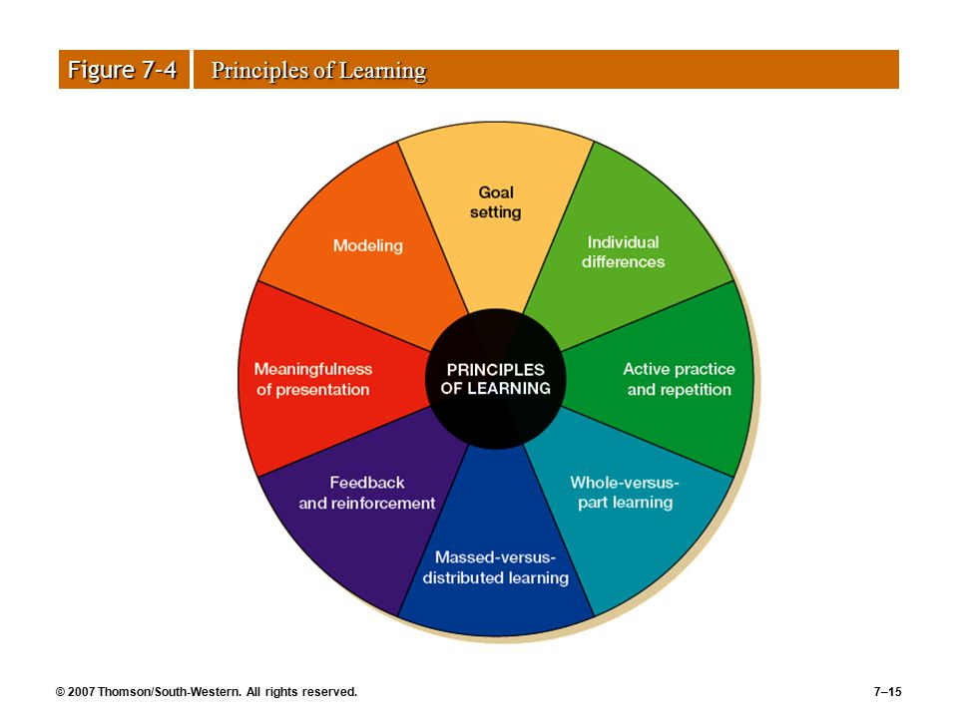
What are the outcome of goal-setting? It increases motivation which increase effort and that increase performance. What makes it effective? Goals should be S.M.A.R.T, you also need feedback.

- Characteristics of instructors:
- Knowledge of subject
- Adaptability
- Sincerity
- Sense of humour
- Interest
- Clear instructions
- Individual assistance
- Enthusiasm

- Phase 3: implementing the training program; choosing the instructional method:
- Nature of training
- Type of trainees
- Organizational extend of training
- Importance of training outcome

- Training methods : there are various training methods and will be more or less appropriate depending on what they are being trained for. Know what each one is for.
- On-the- job training (OJT)
- Special assignment

- Phase 4: evaluating the training program
Measure program effectiveness
- Reactions: ask questions to see people's reactions example: did you like the program? Would you recommend it? But reactions don’t capture whether people actually learn from the training or not. Will not waste a lot of money on this program based just on money.

- Learning: give a test to everyone a pretest than give them a test at the end so you can see the change, can also test them later on to make sure they retain the information they learned. Also learning doesn’t mean that they will implement what they learned to the job. Not confident that people actually learned from the training because something could have happened that contributed to the learning the people had but the training had no contribution to the learning. Give 2 departments a pretest than give training to only one department, test both departments again and the department given the training will do a lot better than the other department, now we can say that the training did help.

- Behaviour:
- Results, or return on investment (ROI): make sure that there is nothing else happening in the market that could have been the reason for the increase in sales.

- Additional topics in training and development:
Organization-wide training
- Orientation training
- Onboarding
- Basic skill training (becoming more ness.)
- Team and cross-training: teaching people how to work in teams, teach the team how to be more effective as a team.
- Ethics training: ethical guidelines

- cross training: the process of training employees to do multiple jobs within an organization.

- Chapter 8: Performance Management
Manager’s dislike performance appraisal, performance appraisal is used by HR to decide people’s pay, promotion, etc.

- Performance management: the process of creating a work environment in which people can perform to the best of their abilities.

- Performance evaluations: the result of an annual or biannual process in which a manager evaluates an employee’s performance relative to the requirements for his or her job and uses the information to show the person where improvements are needed and why. This is only part of the process of performance management. It is an event and it is also step 5 in the performance management process.

Add figure 8.1

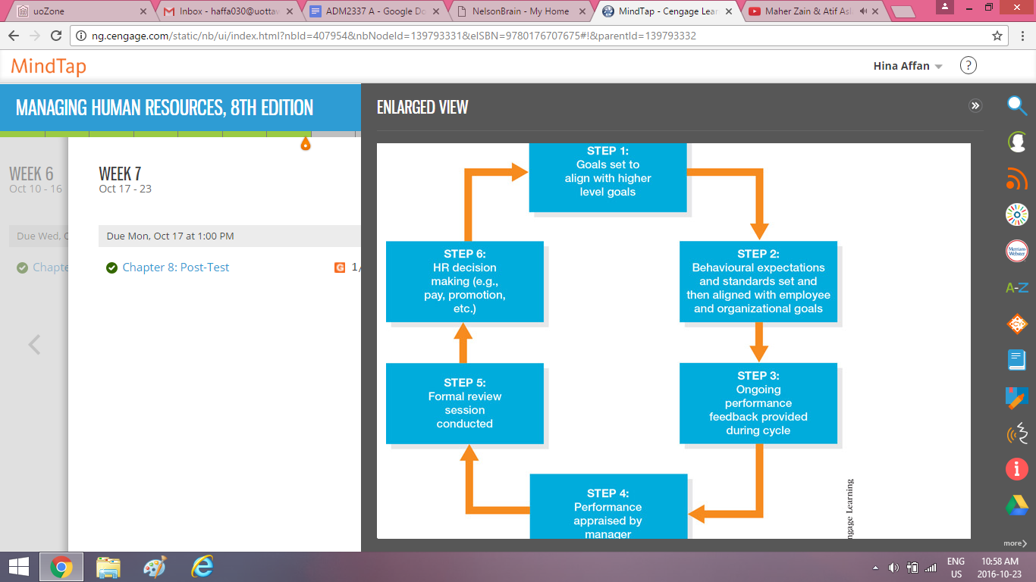

- The performance management has 2 purposes/ programs:
- 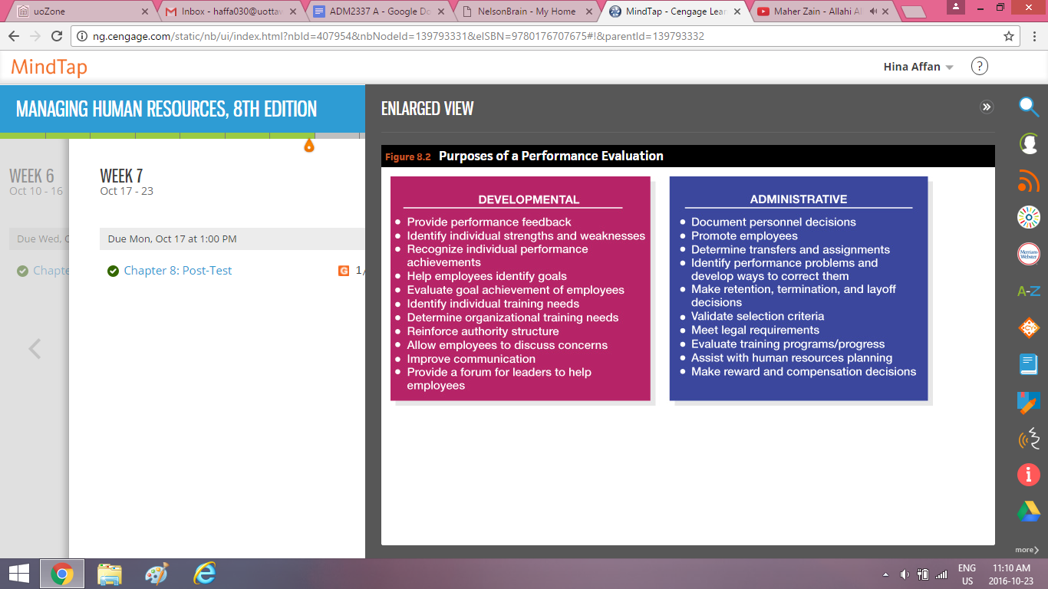
- Administrative purposes: compensation, job evaluation, and EE support.
- Development purposes: ind. Evaluation, training, and career planning. Developing the individual/ employees’.

- Appraisal programs sometimes fail:
- Lack of top-management information and support.
- Unclear performance standards.
- Rater bias.
- Too many forms to complete.
- Use of the appraisal program for conflicting purposes.

- Performance standards: figure 8.4
- Strategic relevance: performance standards linked to organizational goals and competencies
- Criterion deficiency: aspects of actual performance that are not measured
- Criterion contamination: elements that affect the appraisal measures that are not part of the actual performance
- Reliability: measures that are consistent across raters and over time.
- Fairness and acceptability

- Who should appraise an employee’s performance? Know what each one is impacting
- managers/ supervisors: it is fairly valid source of data, it is the most common type.
- Self-evaluations: employees are assessing themselves, it is good for developmental because they get to reflect on their own skills but it is not that good for administrative purposes because employees usually give themselves higher appraisals that they actually deserve, not fully accurate.
- Subordinate evaluations: employees are assessing managers, useful for sometime of data such as leadership skills, communication skills, etc. but with more technical skills it is not that good to get feedback.
- Peer evaluations:
- Team evaluations:
- Customer evaluation:

- 360-evaluation:
- It is a performance evaluation done by different people who interact with the employee, generally on forms compiled into a single profile for use in evaluation meeting conducted by the employee’s manager.
- Safeguards to ensure its maximum quality and acceptance, these traits make it effective:
- Ensure anonymity helps focus on the behaviour
- Make respondents accountable
- Prevent “gaming” of the system
- Use statistical procedures
- Identify and quantify biases

- Training appraisers: establishing an appraisal plan
- Provide an explanation of the performance appraisal system’s objectives
- Explain the mechanics of the rating system
- Alert raters to the weakness and problems of appraisal systems

- Rating errors:
These errors were don’t done consciously, which makes them very dangerous thus need to train the appraisers to notice these errors.
- Distributional errors: occur when a single rating is skewed toward an entire group of employees.
- Error of central tendency
- Leniency or strictness error: giving really bad scored or really good scores
- Forced distribution (was not on the slide)
- Temporal (recency) error
- Contrast error:
- Similar-to-me:

- Evaluation performance methods: just know the difference between the 3 methods
- Trait methods:
- Graphic rating scales:
- Mixed-standard scale:
- Forced-choice:
- Essay:

- Behavioural methods:
- Critical incident:
- Behavioural checklist
- Behaviourally anchored rating scales (BARS)
- Behaviour observation scales (BOS)

C) resulting methods:
- Productivity measures: appraisals based on quantitative measures.
- Management by objectives (MBO): it is goal-setting in action
- The balanced scorecard

- Appraisal interviews
- Tell and sell
- Tell and listen
- Problem solving
- Feedforward performance evaluation: focus is about future performance and positive

- Conducting the interview
- Invite participation: ask for self-assessment
- Change behaviour : problem solving focus
- Minimize criticism express appreciation
- Establish goals: be supportive

- Manage ineffective performance
- Possible courses of action
- Cautions

